

|  |  |  |
| --- | --- | --- |
| Ulster University |  |  |
|  |  | *Fannie Bichemin – Intern at Ulster University*  *Student at ENSEA (Ecole Nationale Supérieure de l’Electronique et de ses Applications)* |

|  |
| --- |
| Heart rate & Oxygen level monitor for babies |

Table of contents

Introduction 3

research 4

Heart rate monitor : AD8232 4

ECG front end : AD8232 Evaluation board 5

Feather M0 – Development board 5

Heart rate & BLE : MAX86165EVKIT 6

ECG & PPG :AFE4950EVM 6

ECG, PPG & BLE : AS7058 EVALUATION KIT 7

Conclusion 8

List of figures

Figure 1 : AD8232 board 5

Figure 2: Example of a heart rate displayed thanks to this board *(https://cdn.sparkfun.com/r/500-500/assets/0/d/f/d/0/HeartRate_Normal.png)* 5

Figure 3 : FTDI Basic board 5

Figure 4 : AD8232 Evaluation Board 6

Figure 5 : Feather M0 board 6

Figure 6 : Max86165EVKIT board 7

Figure 9 : AS7058 board 8

# Introduction

Sometimes, babies are born with the need to have their heart rate and oxygen levels monitored. We will do some research to try to create a prototype that can monitor these characteristics and send the values via Bluetooth to a mobile application. The aim is to create a device with electrodes and a ring sensor.

# research

## Heart rate monitor : AD8232

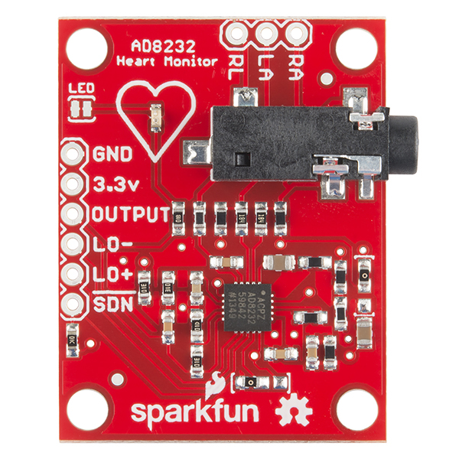

Information about this board is available on this website : [AD8232 (Rev. D) (analog.com)](https://www.analog.com/media/en/technical-documentation/data-sheets/AD8232.pdf)

A tutorial to program this board with Arduino is available here : [AD8232 Heart Rate Monitor Hookup Guide - SparkFun Learn](https://learn.sparkfun.com/tutorials/ad8232-heart-rate-monitor-hookup-guide/all)

Figure 1 : AD8232 board

* This board is used to measure the electrical activity of the heart.
* 2-3 electrode configurations available
* Leads-off detection is available
* It is possible to use this board with Arduino IDE to show heart rate waveform

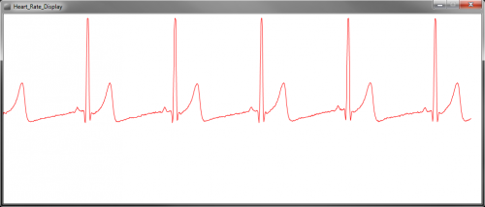

Figure 2: Example of a heart rate displayed thanks to this board *(https://cdn.sparkfun.com/r/500-500/assets/0/d/f/d/0/HeartRate_Normal.png)*

To use this electronic board, we need to connect a micro pro Arduino Board and a FTDI Basic board:

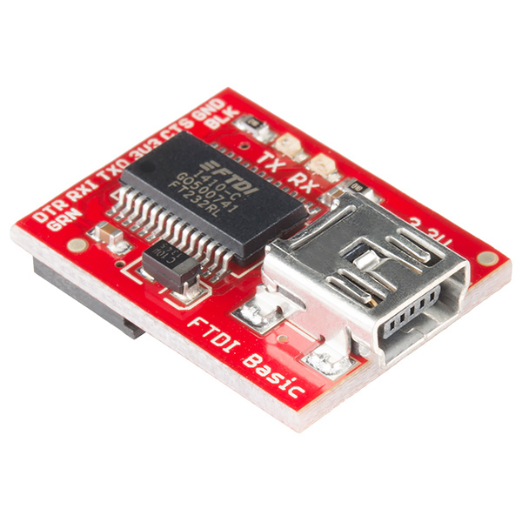

Figure 3 : FTDI Basic board

## ECG front end : AD8232 Evaluation board

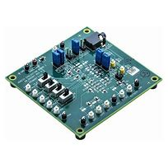

Figure 4 : AD8232 Evaluation Board

Datasheet of this board : [AD8232 Datasheet and Product Info | Analog Devices](https://www.analog.com/en/products/ad8232.html) & [ad8232.pdf (analog.com)](https://www.analog.com/media/en/technical-documentation/data-sheets/ad8232.pdf)

Evaluation Board user guide : [UG-514 (analog.com)](https://www.analog.com/media/en/technical-documentation/user-guides/AD8232-EVALZ_UG-514.pdf)

* Single lead ECG front end
* 2-3 electrodes configurations
* Remove additional noise
* Biopotential signal acquisition (This is the process of capturing electrical signals generated by living organisms. For example, we can record ECG, brain activity, muscle contractions or even eye movement)

## Feather M0 – Development board

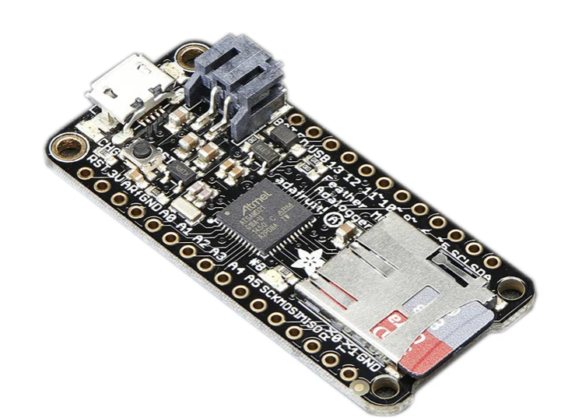

Figure 5 : Feather M0 board

Feather M0 Adafruit Pinout guide : [2796_pinout_v1_0 (rs-online.com)](https://docs.rs-online.com/92d7/0900766b81533f92.pdf)

Feather M0 Adafruit datasheet : [Atmel | SMART SAM D21 Datasheet (rs-online.com)](https://docs.rs-online.com/59f7/A700000008493302.pdf)

Feather M0 Adafruit user guide : [0900766b81533fc5.pdf (rs-online.com)](https://docs.rs-online.com/01cf/0900766b81533fc5.pdf)

* Development board
* MicroSD card holder included
* Lipoly battery (3.7V)
* It can be used with Arduino IDE

## Heart rate & BLE : MAX86165EVKIT

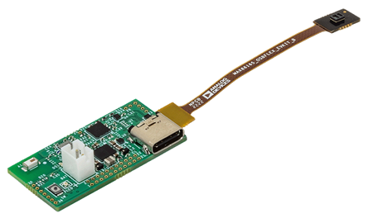

Figure 6 : Max86165EVKIT board

More information about this board : [MAX86165EVKIT Evaluation Board | Analog Devices](https://www.analog.com/en/resources/evaluation-hardware-and-software/evaluation-boards-kits/max86165evkit.html#eb-overview)

Datasheet of this board : [MAX86165 Evaluation System - Evaluates: MAX86165 (analog.com)](https://www.analog.com/media/en/technical-documentation/data-sheets/max86165evkit.pdf)

* Evaluation kit
* Heart rate detection
* LED driver with an IR emitter
* On board accelerometer
* Bluetooth Low Energy (LE)

## ECG & PPG :AFE4950EVM

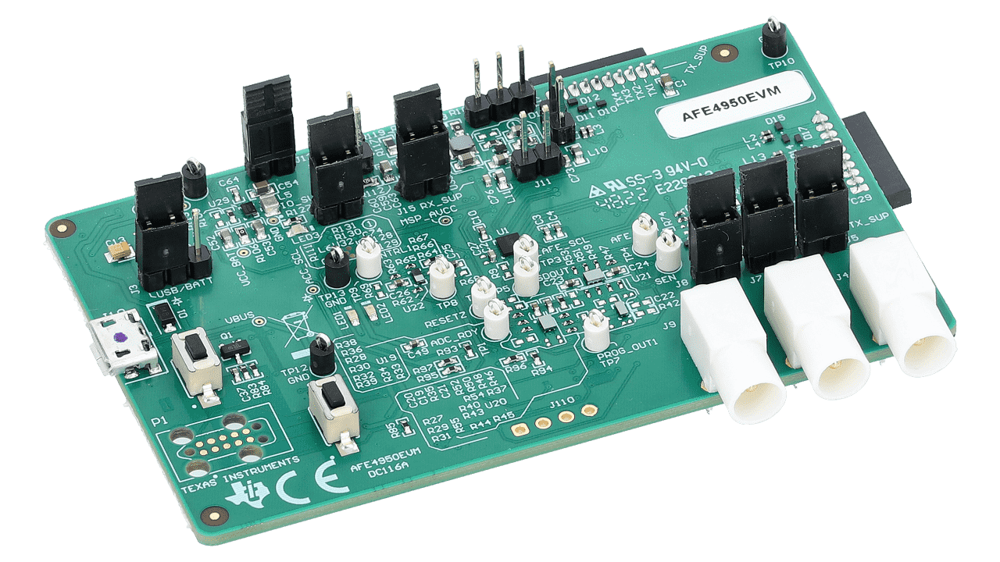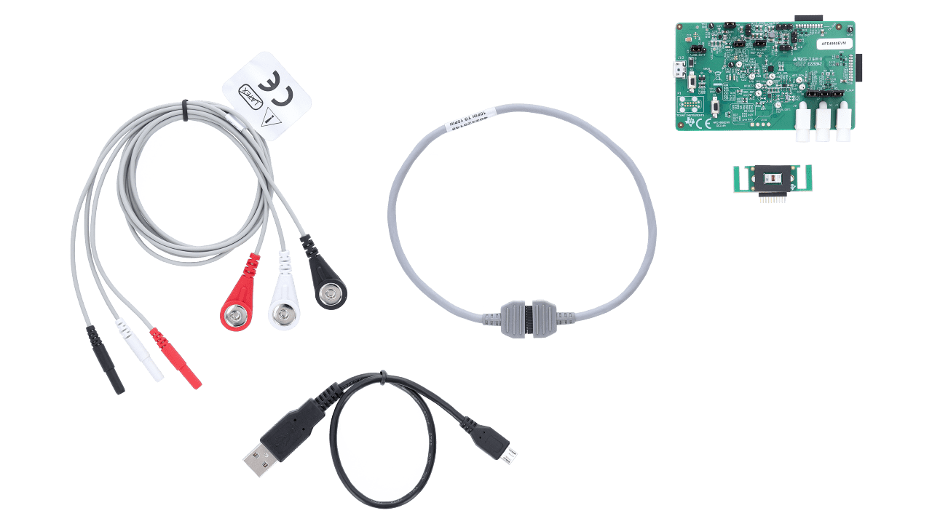

Figure 8 : electrodes and cable

Figure 7 : AFE950EVM board

More information about this board : [AFE4950EVM Evaluation board | TI.com](https://www.ti.com/tool/AFE4950EVM#order-start-development)

Datasheet of the main component: [afe4950.pdf (ti.com)](https://www.ti.com/lit/ds/symlink/afe4950.pdf?ts=1719495290807&ref_url=https%253A%252F%252Fwww.ti.com%252Fproduct%252FAFE4950%253Fbm-verify%253DAAQAAAAJ_____8Kvk72ZdOtq9rc7y_A2SF0VLVKM4gaahlkaL7AM5eAD4I7NyVhbKtjw6svmGehw4bHCfRGIvk7J4rLLoian3pyjYTSCvqf3feT8Is0AThlSIQAMPZB_CjrWz5r55z1w0u9Pwv-AuaIMOX7xL2g81GQ6u5lAUg-rhYn4TXa2JOFCjvsP4iSHpSweLV-Jz3eWeIi0qtRxjjusK9sSaV9s9VBnL90f6UUBY6x_1IjAjaOdwbO6shgr5iOj4m1HxvDc3iG9ZMc6AqBcBfFT2vX4LsjlKHBO2cIoaQj1pwTnlbwqk9KwCF46bmjVmZaqRQ)

* Evaluation board
* HRM, ECG & PPG
* Pulse oximetry measurements

## ECG, PPG & BLE : AS7058 EVALUATION KIT

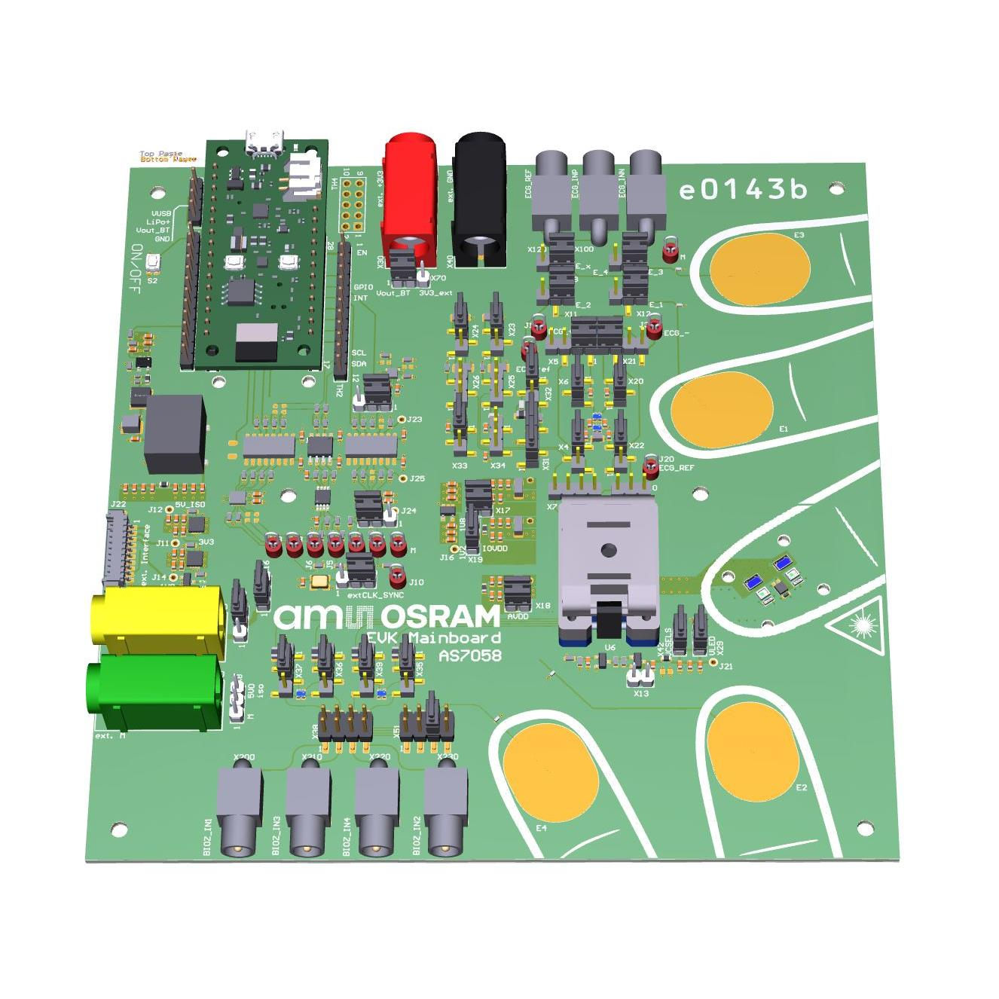

Figure 9 : AS7058 board

More information about this board : [AS7058 EVALUATION KIT ams-OSRAM USA INC. | Development Boards, Kits, Programmers | DigiKey](https://www.digikey.com/en/products/detail/ams-osram-usa-inc/AS7058-EVALUATION-KIT/21806168)

Datasheet of the main component: [AS7058_EVK_UG001052_1-00.pdf (ams-osram.com)](https://look.ams-osram.com/m/63b474f0cbcddb6/original/AS7058_EVK_UG001052_1-00.pdf)

* Evaluation board
* ECG & PPG
* Bluetooth Low Energy Board

# Conclusion

AS7058 board and AFE950EVM board are the best. In fact, ECG and PPG can be monitored with these boards.



AFE950EVM board would be the best for a baby because we can use electrodes. But, there is no Bluetooth module included on the board.



AS7058 board is good because there is a Bluetooth module. But, the way to collect data is not easy to use with babies. The solution could be to use wire and a new connector.