Prompt: “Write an essay that synthesizes material from at least three of the sources and develops your position on the notion that continued space exploration is productive and beneficial.”

Throughout history, human curiosity has always driven us to cross established cognitive boundaries. However, with the development of aerospace engineering, it has entered into an era that requires massive taxpayers’ funds support, leading to increasing debate about its intrinsic values. Facing these unsolved poverty and environmental crises on earth, shall we move our attention to the vast ocean of stars? The answer is clearly “yes.” Though space exploration is always accompanied with unpredicted risk and resource consumption, continuously pushing space exploration is not only productive and beneficial. It has transcended the political games among the individual countries, becoming the indispensable choice for ensuring human beings’ long-term survival, a catalyst for promoting deep cooperation globally, and the core motivator of expanding human moral and mental boundaries.
Firstly, the most basic benefit of space exploration is that it provides humans with the ultimate survival safeguard. When discussing space plans’ “productivity”, we cannot be limited to short-term economic return, yet ought to adopt a more macroscopic species evolutionary perspective. Just as famous cosmologist Stephen Hawking warned, if we do not build space colonies, humans are likely to be eliminated by a catastrophic disaster such as a “doomsday virus” (Source D). Hawking sharply points out that compared with nuclear weapons that requires large-scale facilities, biological threats such as gene engineering have strong invisibility, any little laboratory mistake may “create a virus that destroys us” (Source D). This argument profoundly reveals the extreme vulnerability of the Earth as a closed system. If we assimilate human beings as eggs in one basket, space exploration will no longer be only a scientific experiment, but will become the only effective risk-hedging strategy for the entire human race. Therefore, inputting the funds and energy into the space, is in fact buying an indispensable long-term survival insurance for human civilization. The strategic interest brought by profound insight cannot be measured by current financial deficits; after all, if losing the physical space for survival, any discussion about society development will become empty talk.
In addition, property for modern space exploration has changed profoundly; it is changing from a zero-sum game during the Cold War era to the “cooperative global undertaking” platform that coordinates all humans’ power. These paradigm shifts brought significant diplomatic and scientific benefits to international society. In 1962, President Kennedy, though foresighted points that space may become “a sea of peace or a new terrifying theater of war” (Source A), his core motivation at that time was still to ensure American “pre-eminence” status in the Cold War (Source A). However, just as scholar John M. Logsdon points out, today’s space exploration is no longer a single “national imperative.” Due to challenges with funding and technology, it must transform into a global career open to “representatives of all our countries” (Source B). This shift in motivation significantly improves the “productivity” of space exploration. When countries exchange technology and share funds for a common goal of landing on Mars or building a lunar base, the financial pressure of individual countries will be significantly released, and tangibly resolve geopolitical tensions on Earth. Furthermore, by observing the flow of federal research and development funds, it can be seen that NASA's budget for the fiscal year 2020 was approximately 14.8 billion US dollars, which is even less than a quarter of the Department of Defense's huge expenditure of about 62.4 billion US dollars (Source C). This indicates that compared to allocating vast sums of money to develop military weapons against fellow humans, investing a relatively small amount of funds in a joint human space program offers an extremely high cost-benefit ratio in terms of scientific breakthroughs and peace dividends.
Finally, it must be acknowledged that space exploration comes with significant moral risks and high costs of trial and error. However, this is precisely an excellent opportunity to temper human minds and social resilience. Some critics are concerned that space colonization is not only fraught with difficulties but may also lead to "orders of magnitude more" moral disasters due to hostile conflicts (Source F). Nevertheless, it is precisely this process of facing extreme risks and attempting to establish "real-world governance" to ensure safety that reflects the profound value of space programs. Risk should never be an excuse for stagnation but rather a whetstone for improving human civilization's institutions. As Marko Kovic has acknowledged, if properly planned, space colonization will bring "an enormous increase in expected moral value" (Source F), as it concerns the existence and well-being of trillions of potential lives in the future. More importantly, the public has shown extraordinary resilience towards the sacrifices made in this exploration. Even after the heart-wrenching Columbia space shuttle disaster, as many as 82% of the respondents still firmly believed that the manned space program "Should Continue" (Source E). This unwavering support in the face of adversity demonstrates that the benefits of space exploration have long transcended the purely material level; it has endowed modern society with a profound sense of purpose beyond the mundane. This spiritual force can inspire the curiosity of generations to come, and its spillover effect will greatly promote the development of basic education and science and technology on Earth.
In conclusion, looking towards the deep space is not an evasion of the responsibilities on Earth, but rather the most profound commitment to the future of human civilization. By providing crucial survival shelters, building bridges of cooperation that transcend national boundaries, and forging social resilience in the face of immense risks, continuous space exploration has irrefutably demonstrated its indispensable productivity and extraordinary benefits. Just as our predecessors braved the tempestuous seas in search of new lands, today we "choose to go to the moon... not because they are easy, but because they are hard" (Source A). It is precisely this unyielding spirit of outward exploration that has forged the indomitable greatness of humanity.
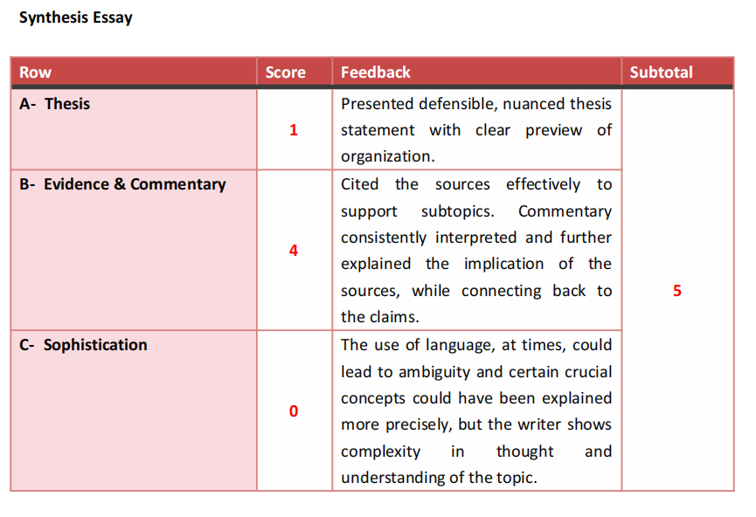
Prompt:“Write an essay that analyzes the rhetorical choices Thoreau makes to convey his message about the value of walking in nature.”

Rhetorical Analysis:
In the mid-19 Century, with the industrialization starts quickly changing America’s natural environment and social regulations, transcendentalism is born to defend human and nature’s internal virtues. As the leader of this trend, in his essay Walking, Henry David Thoreau critics the artificial boundaries that expand day by day.. To express his profound information that immersing into undamaged nature has surprised and resilience value, Thoreau use stark contrast between society obligation and natural freedom, noticeably mythological imagery and metaphor with contempt meaning. Through this rhetorical choice, Thoreau points out that the real walking is not only physical exercise, but a crucial spiritual reshape that confront the modern society’s trivialities and corruption.
Thoreau first juxtaposes stifling social obligation with liberate wilderness, erecting the value of walking. He says, when walking, when he cannot easily “shake off the village” and forget his “morning occupation,” he will feel “alarmed”. Through categorizing his daily work and social obligations as an invading existence that “will run in my head,” Thoreau depicts human civilization as a spiritual cage. The stark contrast between this restriction and the mass of nature physically and mentally notes that walking bring him to a “strange a country as I expect ever to see.” This juxtaposition emphasize his core argument: the society restrict human’s spirit, yet the unfettered behavior, walking into the forests, allow people to get the world off people’s back, rediscover their real, unbound self. The nature is not only presented as a physical space, but a crucial psychological asylum.
To further emphasize the degradation caused by human "improvements," Thoreau shifts to employ vivid, almost apocalyptic imagery to condemn those who seek to commodify the earth. He observes a "worldly miser" functioning as a surveyor, driving stakes into a prairie. Rather than viewing this as progress, Thoreau describes the surveyor standing in a "boggy stygian fen, surrounded by devils," ultimately declaring that "the Prince of Darkness was his surveyor." By alluding to the River Styx—the boundary of the Underworld in Greek mythology—and Satan himself, Thoreau drastically elevates his critique. He strips the surveyor of any dignified intent, framing the division and ownership of land as a fundamentally evil, hellish enterprise. This dark imagery forces the audience to view industrial expansion and land ownership not as economic triumphs, but as spiritual tragedies that "deform the landscape." In doing so, Thoreau asserts that the true value of nature lies in its untouched, undivided purity, which can only be appreciated by the walker who observes it without seeking to own it.
Finally, Thoreau utilizes dismissive metaphors to diminish the perceived importance of human affairs when compared to the grandeur of nature. As he distances himself physically from civilization, climbing a hill to view the "abodes of man afar," he equates human institutions—"church and state and school, trade and commerce"—to the burrows of woodchucks. Most strikingly, he reduces the realm of politics to a "narrow field" and ultimately to "the cigar-smoke of a man." This metaphorical reduction demonstrates a profoundly transcendent perspective. By likening the complex, often all-consuming political world to transient, inconsequential smoke, Thoreau diminishes the authority and relevance of human society. The dismissive tone empowers the reader to let go of societal anxieties. He argues that the political and economic systems that dictate modern life are ultimately insignificant compared to the eternal, enduring presence of the natural world that one encounters while walking.
In "Walking," Thoreau masterfully navigates the tension between the industrializing society of the 19th century and the pristine allure of the natural world. Through his strategic juxtapositions, hellish characterizations of land developers, and reductive metaphors regarding human institutions, he creates a compelling argument for the necessity of engaging deeply with the wild. Thoreau ultimately challenges his audience to reconsider their priorities, suggesting that salvation and truth are not found in the expansion of towns or the debates of politicians, but in the deliberate, mindful steps taken away from civilization and into the heart of the woods.

RW- 5 (1-4-0)
Presented defensible thesis with clear subtopics
Each subtopic was clearly presented. The use of evidence and commentary logically supports each claim and establishes a sound line of reasoning. The commentary mainly focused on interpretation; the implications and the tension between the reader and excerpt can be further explored and elaborated. For instance, would the reader object to the depiction of the Hellish landscape? How could that objection be justified? How would the text potentially address the objection?
Though phrasing and word choices may affect clarity and precision, language use does exhibit a degree of proficiency and complex thinking. Be mindful of the form of vocabulary as it is a recurring issue that reduces sophistication.
Prompt:“How does thinking about the future affect one’s ability to experience and appreciate the present?”

Humans have distinctive cognitive abilities compared to other animals: we can do time travel in our minds, construct and predict the future. However, as psychologist Richard DeGrandpre warns, this ability is often a double-edged sword. Though to some extent foresight and planning are the survival and progression of humanity, to a profound extent, the over fascinating to future consequences and compulsive planning will commodify the present, degrading the beauty of the current moment as a cornerstone of the road to the future, thereby completely exploiting our ability to “appreciate the moment”.
In literature, the pursuit of the futuristic utopia illusion is often the origin of tragedy. In his splendid work, The Great Gatsby, F. Scott Fitzgerald concretizes perfectly what DeGradpre says “redirecting our consciousness away from the present”. The protagonist Jay Gatsby put all his life, wealth, and consciousness into the green light towards the bay — an “anticipated eventuality” representing the reliving of the past with Daisy. Gatsby is helping with extravagant parties, but he was never truly enjoying the euphoria of the present; he lives under the grand anticipation of the future, leading his reality to become pale and powerless. Gatsby’s tragedy proves that: when we only see our current life as a “waiting room,” waiting for the train that drives to the future, we are actually “undervaluing our sense of the present,” giving up the right to experience reality.
Except for the extreme cases in literature, in today's highly involved society, “living for the future” has been involved in a systematic social pathology, which is so-called “hustle culture.” From a student's age, society starts continuously imparting an extreme opinion, “delay satisfaction.” High school students stay up late doing practice questions to get into top universities. College students rush around for various internships to prepare their resumes for job hunting. Working professionals sacrifice their health and time spent with their families in pursuit of the elusive "financial freedom" or retirement life. Under this mode, study is no longer pure happiness to discover the truth, working is not the progress of self-evaluation; all of them descend to the chip to get a specific consequence. Just as DeGrandpre said, we are “unintentionally” breaking current. When people are in a state of continuous anxiety and “planning things to come”, their brains are filled with worry and calculation about their future, leading them cannot get peace in a simple dinner or a weekend walk. When “present” is only seen as a strategy for the future, the meaning of life is hollowed out.
Of course, we cannot go to another extreme, advocating hedonism that does not care about any consequences. Completely giving up “anticipating and planning” for the future will lead to stagnation and chaos in life. Setting a target provides direction and meaning for the present’s movement. However, setting direction and “living in the future” are different in essence. A healthy life state should be “future-oriented but present-anchored”. The problem is that we often pass this borderline, making the “expectation about what the future could, should, or will be like” become the main strategy, becoming the tyrannical force dominating our emotions. Only when we realize that every achievement in the future is only an experience in the “present” time dimension, can we break this vicious circle.
In conclusion, DeGradpre’s claim hit the nail on the head of modern people’s mental crisis. Overprojecting consciousness to the future is a dangerous escape behavior. We must realize that life is not a rehearsal for a certain great performance in the future; life is every minute and every second of current life. If we do not learn how to sincerely feel and “appreciate life as a whole” while pursuing the target, no matter how splendid the future is, we will always be a flock of hollow creatures chasing the horizon.
AW- 5 (1-3-1)
Presented defensible thesis with clear subtopics
Students demonstrates an in depth understanding of the topic and context. Each subtopic is supported with sound reasoning. The pro-argument paragraphs included specific evidence and effective commentary, but the concession paragraph lacked supporting evidence to back up the claim.
Overall, the use of language delivered ideas clearly and showed a defined line of reasoning. Word choices imbued the essay with character and personality, which readers may appreciate.

