
Orivellum
Complete Installation & Setup Guide
v1.0 · August 2026 · For: Brian Fochtman

Table of Contents
1. Quick-Start Checklist
2. Prerequisites
3. Installation — Mac / Linux
4. Installation — Windows
5. Lemonade AI Server Setup
6. Recommended LLM Models for Lemonade
7. First Launch & Configuration
8. Mobile App (Expo Go)
9. Environment Variables Reference
10. Troubleshooting

1. Quick-Start Checklist
Use this checklist before you begin. Check each item off as you complete it.
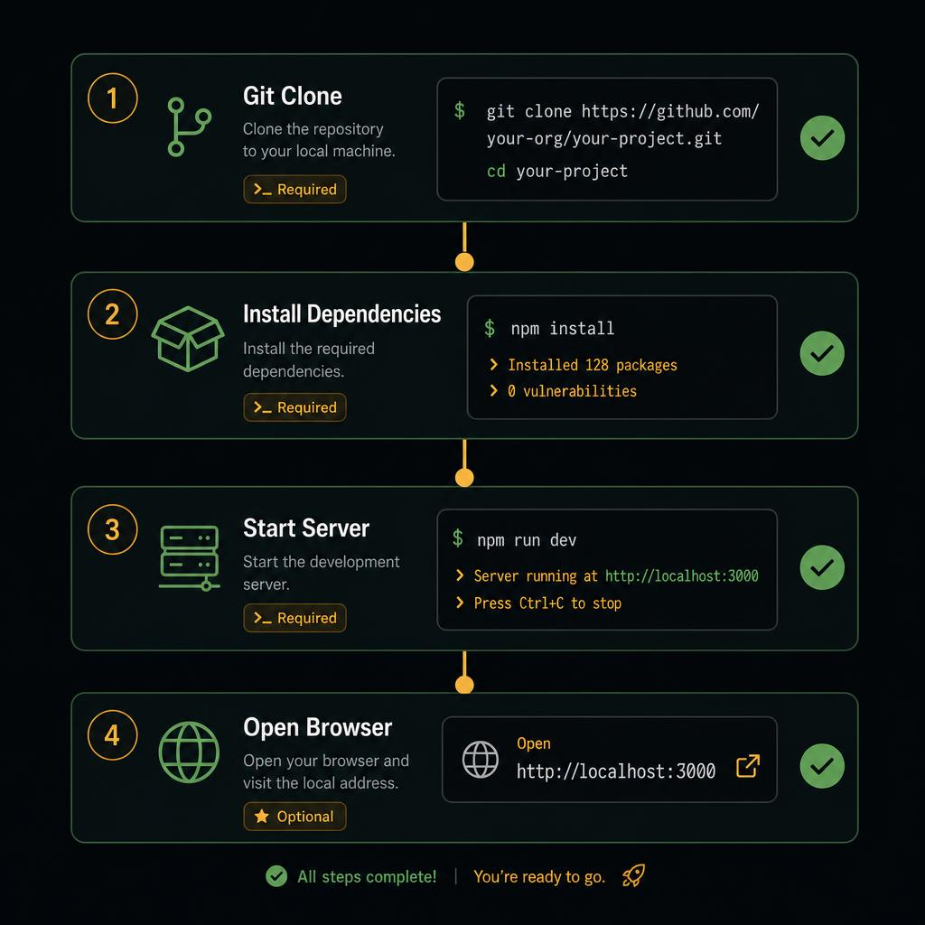
Four-step installation overview

Prerequisites checklist
- ☐ Git 2.35 +
- ☐ Node.js 18 LTS or 20 LTS
- ☐ pnpm 8 + (npm install -g pnpm)
- ☐ Python 3.12 +
- ☐ uv (pip install uv OR winget install astral-sh.uv)
- ☐ 8 GB RAM minimum (16 GB recommended for local LLM)
- ☐ AMD or NVIDIA GPU (optional — for Lemonade GPU acceleration)
- ☐ Expo Go app on your phone (optional — for mobile access)

Installation checklist
- ☐ Clone the repository
- ☐ Run pnpm install
- ☐ Run uv sync
- ☐ Copy and edit .env (optional)
- ☐ Start with bash scripts/dev.sh
- ☐ (Optional) Install Lemonade and load a model
- ☐ (Optional) Scan the QR code with Expo Go

2. Prerequisites

Node.js
Download the LTS release from https://nodejs.org. Run the installer and verify with:
node --version # must be 18.x or 20.x
✅ Use Node 20 LTS for best compatibility. Versions older than 18 are not supported.

pnpm
Orivellum uses pnpm workspaces. Install it globally after Node.js:
npm install -g pnpm
pnpm --version # should be 8 or higher

Python 3.12 + and uv
Python 3.12 or newer is required for the API server. uv is the recommended installer:
# Mac / Linux
curl -LsSf https://astral.sh/uv/install.sh | sh
# Windows (PowerShell)
powershell -c "irm https://astral.sh/uv/install.ps1 | iex"
✅ uv is much faster than pip. It creates a virtual environment and pins all dependencies automatically via uv.lock.

Git
Install from https://git-scm.com or via your package manager:
# Mac
brew install git
# Ubuntu / Debian
sudo apt install git
# Windows — included with Git for Windows installer

3. Installation — Mac / Linux

Step 1 — Clone the repository
git clone https://github.com/BFo/orivellum-main.git
cd orivellum-main

Step 2 — Install JavaScript / TypeScript dependencies
pnpm install
Installs all workspace packages (web UI, mobile app, shared libraries, API client). Expect 2–5 minutes on first run.

Step 3 — Set up the Python virtual environment
uv sync
Creates .venv and installs all Python packages from uv.lock. Subsequent runs complete in seconds.

Step 4 — Create your .env file (optional)
Copy the example and fill in any secrets you need:
cp artifacts/api-server/.env.example artifacts/api-server/.env
# Edit with nano, vim, or VS Code
✅ The app works without any .env file. AI model URLs and keys can also be set through the web Settings page.

Step 5 — Start the application
# API server + Web UI
bash scripts/dev.sh
# API server + Web UI + Expo mobile
bash scripts/dev.sh --mobile
The script starts FastAPI on port 8080, waits for a healthy response, then starts Vite on port 5173.
Open your browser to:
http://localhost:5173
⚠️ Keep this terminal open. Press Ctrl+C to stop all services at once.

4. Installation — Windows

Step 1 — Install prerequisites via winget
Open PowerShell as Administrator and run:
winget install OpenJS.NodeJS.LTS
winget install pnpm.pnpm
winget install astral-sh.uv
winget install Git.Git
Restart your terminal after installation so the new tools appear in PATH.

Step 2 — Clone and install
git clone https://github.com/BFo/orivellum-main.git
cd orivellum-main
pnpm install
uv sync

Step 3 — Development mode (Vite dev server + API)
In a PowerShell or Git Bash window:
# Git Bash
bash scripts/dev.sh
# PowerShell — set port then call bash
$env:API_PORT='8080'; bash scripts/dev.sh
✅ Git for Windows includes Git Bash. If bash is not found, install Git for Windows from https://git-scm.com/download/win

Step 4 — Production / Appliance mode (no dev server)
Builds the UI bundle once, then serves everything from a single FastAPI process:
.\scripts\start.ps1
# Skip rebuilding the UI (fast restart):
.\scripts\start.ps1 -SkipBuild
# With Expo mobile server:
.\scripts\start.ps1 -Mobile
Then open:
http://localhost:8080/orivellum-ui/
✅ Bookmark this URL and use Add to Home Screen in your browser for a near-native app experience.

Step 5 — Auto-start at Windows login (optional)
Register Orivellum as a Task Scheduler task so it starts automatically:
.\scripts\windows\register-boot.ps1
💡 After registration Orivellum starts at login. Run register-boot.ps1 -Unregister to remove it.

5. Lemonade AI Server Setup
Lemonade is a local LLM inference server compatible with the OpenAI API. It runs AI models on your own GPU (AMD ROCm or NVIDIA CUDA) or CPU, keeping every conversation and document 100% private and offline.
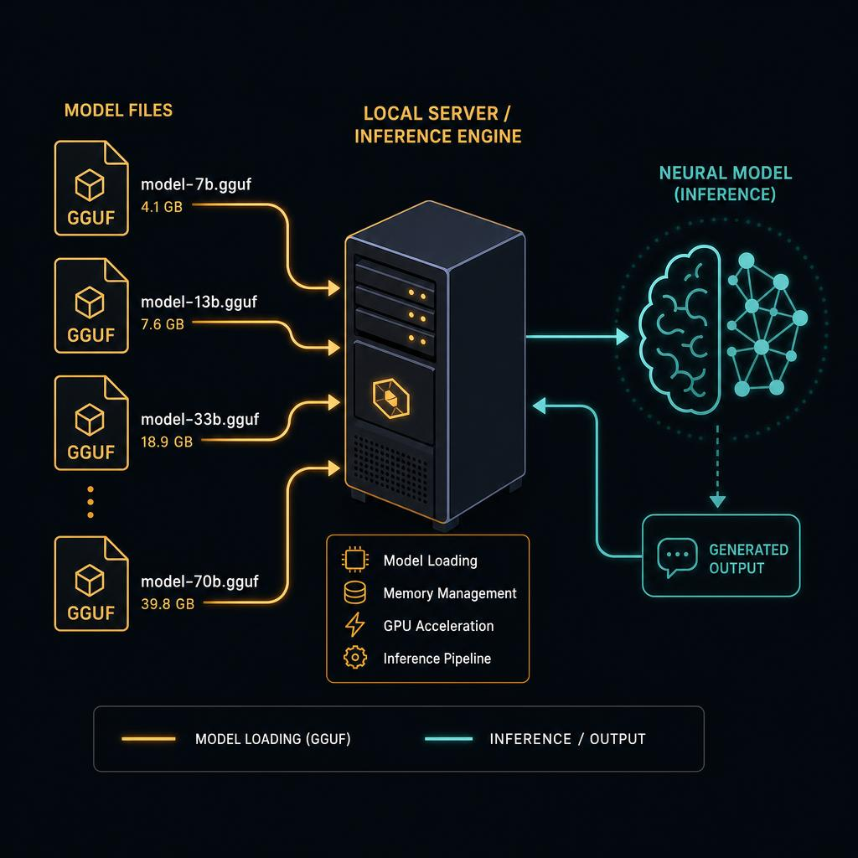
Lemonade loads GGUF model files and serves them via OpenAI-compatible API

Install Lemonade
Download and install from the official releases:
# AMD GPU (ROCm) or CPU
pip install lemonade-server
# NVIDIA GPU (CUDA)
pip install lemonade-server[cuda]
# Windows installer available at:
# https://github.com/lemonade-llm/lemonade/releases

Start the Lemonade server
# Default port 13305
lemonade serve
# Load a specific model on start
lemonade serve --model /path/to/model.gguf
# Custom port
lemonade serve --port 13305
✅ Lemonade defaults to port 13305, which matches the Orivellum default setting.

Connect Orivellum to Lemonade
- Open Orivellum in your browser
- Go to System page → Settings section
- Under "Local AI Model (Lemonade)" set the URL to:
http://127.0.0.1:13305/api/v1
- Optionally enter a Model ID from the table in Section 6
- Click Save Settings — the green indicator confirms the connection

GPU vs CPU mode
Lemonade automatically detects available hardware:
- AMD GPU (ROCm): fastest — requires ROCm 5.7+
- NVIDIA GPU (CUDA): fast — requires CUDA 12+
- CPU: works on any machine; 5–15x slower than GPU
⚠️ On CPU, use models with 4 billion parameters or fewer (Phi-4 Mini, Gemma 2 2B, Llama 3.2 3B). Larger models will be too slow for interactive use.

6. Recommended LLM Models for Lemonade
All models below are freely available in GGUF format from Hugging Face. They are OpenAI-API-compatible and work directly with Lemonade. Download them and load via the Lemonade CLI or web interface.
Quantization guide: Q4_K_M = smaller/faster, some quality loss • Q8_0 = larger/slower, near full quality
Model | Parameters | Quant | Best For | VRAM / RAM
Meta Llama 3.2 3B Instruct | 3B | Q8_0 | Fast chat, summaries, CPU | 3–4 GB
Meta Llama 3.1 8B Instruct | 8B | Q4_K_M | General purpose, documents | 5–6 GB
Meta Llama 3.1 8B Instruct | 8B | Q8_0 | General purpose — high quality | 9–10 GB
Mistral 7B Instruct v0.3 | 7B | Q4_K_M | General chat, good baseline | 5–6 GB
Microsoft Phi-4 Mini Instruct | 3.8B | Q4_K_M | CPU-friendly, reasoning tasks | 3–4 GB
Microsoft Phi-4 Mini Instruct | 3.8B | Q8_0 | CPU-friendly — high quality | 5–6 GB
Qwen 2.5 7B Instruct | 7B | Q4_K_M | Multilingual, code, analysis | 5–6 GB
Qwen 2.5 7B Instruct | 7B | Q8_0 | Multilingual — high quality | 8–9 GB
Google Gemma 2 9B IT | 9B | Q4_K_M | Long context, deep analysis | 6–7 GB
Google Gemma 2 2B IT | 2B | Q8_0 | Ultra-fast, any hardware | 2–3 GB
Mistral NeMo 12B Instruct | 12B | Q4_K_M | Extended context (128k) | 8–9 GB
Phi-3.5 Mini Instruct | 3.8B | Q4_K_M | Lightweight, low latency | 3–4 GB

✅ Start with Phi-4 Mini Q4_K_M if you are on CPU. For 8 GB VRAM, Llama 3.1 8B Q4_K_M offers the best quality-to-speed ratio. For 16 GB+ VRAM, Mistral NeMo 12B gives excellent context handling.
💡 Download GGUF models from: https://huggingface.co/models?sort=downloads&search=GGUF Search the model name above and look for files ending in -Q4_K_M.gguf or -Q8_0.gguf.

Loading a model in Lemonade
# Load a GGUF model file
lemonade load /path/to/Llama-3.1-8B-Instruct-Q4_K_M.gguf
# List all loaded models
lemonade list
# Example output:
# Llama-3.1-8B-Instruct-Q4_K_M (loaded) <-- use this name in Orivellum Settings

Setting the model in Orivellum
Copy the model name shown by "lemonade list" and paste it into the Model ID field in Orivellum Settings. Leave the field blank to let Lemonade use whichever model is currently loaded.

7. First Launch & Configuration

What you see on first launch
- The web UI opens at http://localhost:5173
- Dashboard shows a time-of-day greeting and empty sections
- Library (sidebar → Import) is where you upload your first documents
- Chat works immediately — try asking anything even without a local model

Connect a local AI model
- Start Lemonade and load a model (see Section 5)
- Open Orivellum → System page → Settings card
- Under "Local AI (Lemonade)" enter: http://127.0.0.1:13305/api/v1
- Click Save — the status indicator turns green

Import your first document
- Click Import in the sidebar
- Drag and drop a PDF, DOCX, EPUB, or image — or click to browse
- Orivellum extracts knowledge, auto-assigns it to a Work, and makes it searchable in Chat
✅ Works are like projects or books — they group related documents. Orivellum automatically suggests the right Work when you import.

Start your first chat
Click Chat in the sidebar. Scope a conversation to a specific Work using the Work selector at the top — the AI will draw exclusively from that Work's documents for precise, cited answers.

8. Mobile App (Expo Go)
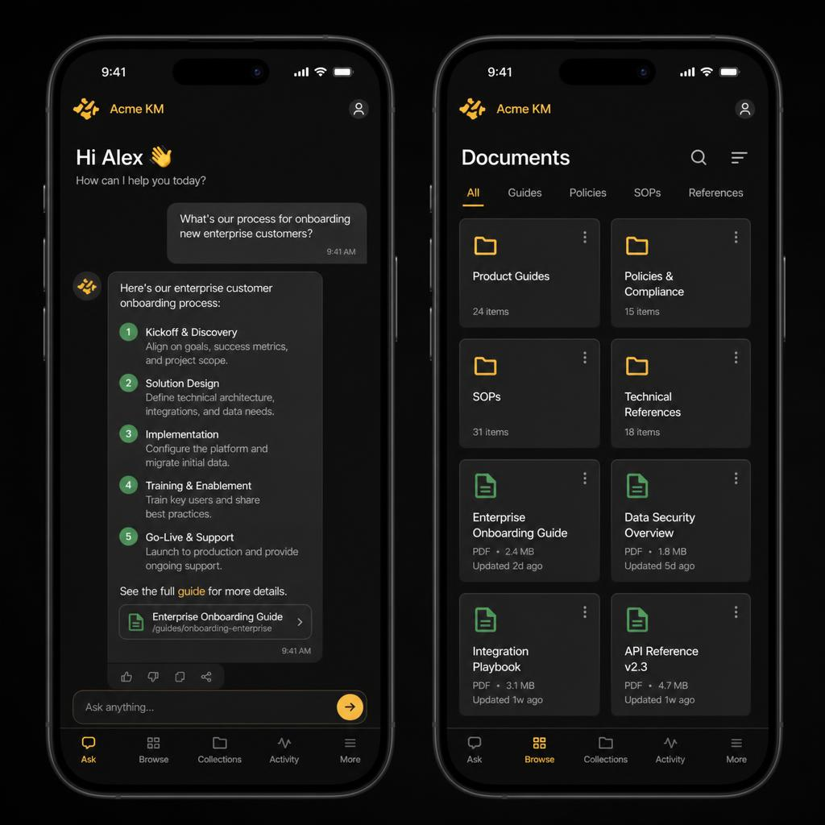
Orivellum mobile — chat and library views

Requirements
- iPhone (iOS 16+) or Android (10+)
- Expo Go installed from App Store or Play Store
- Same WiFi network as the computer running Orivellum

Start with mobile support
# Mac / Linux
bash scripts/dev.sh --mobile
# Windows PowerShell
.\scripts\start.ps1 -Mobile
Expo prints a QR code in the terminal. Scan it with your phone camera (iOS) or the Expo Go app (Android).

Configure the API address
The mobile app reads the server address from EXPO_PUBLIC_DOMAIN. Set it in the mobile .env file:
# artifacts/mobile/.env
EXPO_PUBLIC_DOMAIN=192.168.1.100:8080
# Replace 192.168.1.100 with your computer LAN IP
✅ Find your LAN IP: ipconfig (Windows) or ifconfig | grep 192.168 (Mac/Linux)

Features on mobile
- Chat with all your Works and documents — full AI context
- Upload files from your photo library or the Files app
- Listen to generated audiobooks with in-app player
- Browse and manage your knowledge library
- Mail steward — view and action AI-assessed Outlook emails
- Works, Books, Learn, Projects, and Write desk

9. Environment Variables Reference
Create artifacts/api-server/.env (copy from .env.example). All variables are optional — sensible defaults apply.
Variable | Default | Description
API_PORT | 8080 | Port for the FastAPI server
SESSION_SECRET | (auto-generated) | Cookie session secret — set a strong random string in production
LEMONADE_URL | http://127.0.0.1:13305/api/v1 | Lemonade API base URL
LEMONADE_MODEL | (blank = server default) | Model ID to request from Lemonade
AI_EXTRACTION_ENABLED | false | Enable LLM-powered knowledge extraction on import
TAVILY_API_KEY | (blank) | Tavily search key for online research feature
EXPO_PUBLIC_DOMAIN | localhost:8080 | API host:port used by the mobile app
DATA_DIR | ./data | Directory where Orivellum stores its database and files
DEBUG | 0 | Set to 1 for verbose API logging

10. Troubleshooting

API server does not start
- Check Python version: python --version — must be 3.12 or newer
- Re-run uv sync to ensure all packages are installed
- Check port 8080 is free: lsof -i :8080 (Mac/Linux) or netstat -ano | findstr :8080 (Windows)
# Start with verbose output to see the error
DEBUG=1 uv run python -m orivellum.api.main

Web UI shows a blank screen
- Ensure the API server started — dev.sh waits for it but check for crash messages
- Open browser console (F12) and look for red error messages
- Hard-reload: Ctrl+Shift+R (Windows/Linux) or Cmd+Shift+R (Mac)

Lemonade connection fails in Settings
- Verify Lemonade is running: curl http://127.0.0.1:13305/api/v1/models
- Check the URL exactly matches the Settings field — no trailing slash
- Ensure a model is loaded before sending messages
# Test Lemonade from the terminal
curl http://127.0.0.1:13305/api/v1/models
# Expected response:
# {"object":"list","data":[{"id":"..."}]}

Mobile app cannot connect to server
- Both phone and computer must be on the same WiFi network
- Set EXPO_PUBLIC_DOMAIN to your computer LAN IP (not localhost)
- Windows: allow inbound connections on port 8080 in Windows Firewall
# Windows PowerShell — open firewall port
New-NetFirewallRule -DisplayName 'Orivellum' -Direction Inbound -Port 8080 -Protocol TCP -Action Allow

Slow AI responses with local model
- Switch to a smaller quantization: Q4_K_M instead of Q8_0
- Use a smaller model: Phi-4 Mini 3.8B instead of Llama 3.1 8B
- Ensure Lemonade is using the GPU, not CPU: lemonade status
✅ Q4_K_M at 8B offers 90% of Q8_0 quality at about 55% of the file size and memory usage.

pnpm install fails on Windows
- Run PowerShell as Administrator
- Set execution policy: Set-ExecutionPolicy RemoteSigned
- Then re-run: pnpm install

