# Lab: Install SQL Server LocalDB And SQL Server Management Studio

Problems for exercises and homework for the "Databases and SQL" course from the official "Applied Programmer" curriculum.

## Install SQL Server LocalDB

Go to the following link on the Microsoft website and **download** SQL Server LocalDB: <https://download.microsoft.com/download/7/c/1/7c14e92e-bdcb-4f89-b7cf-93543e7112d1/SqlLocalDB.msi>

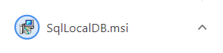

Perform a default installation of **SQL Server LocalDB**:

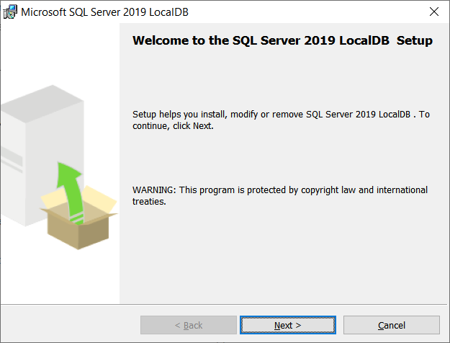

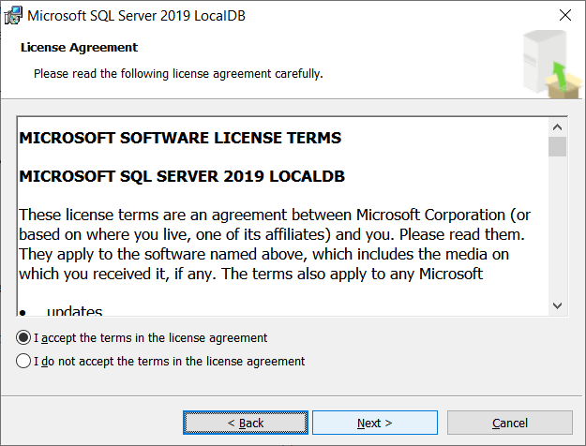

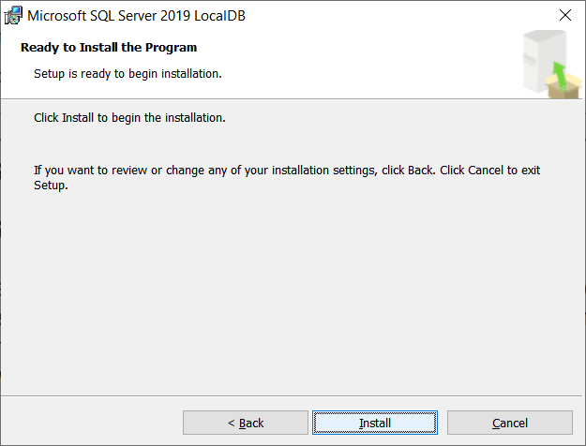

## Install SQL Server Management Studio

Download SQL Server Management Studio (SSMS): <https://docs.microsoft.com/en-us/sql/ssms/download-sql-server-management-studio-ssms>.

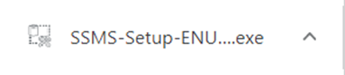

Follow the SSMS installation.

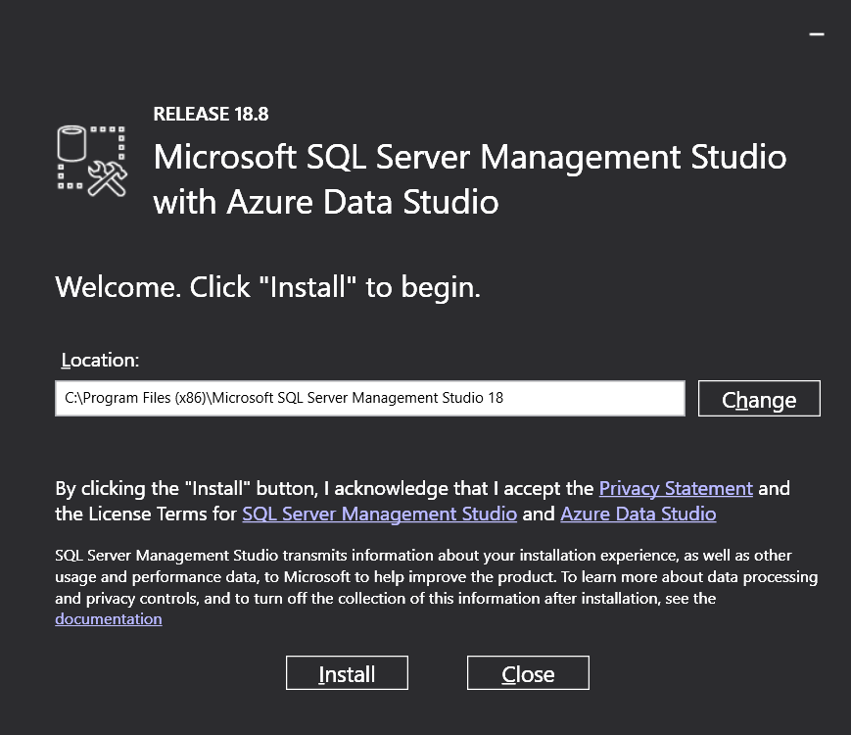

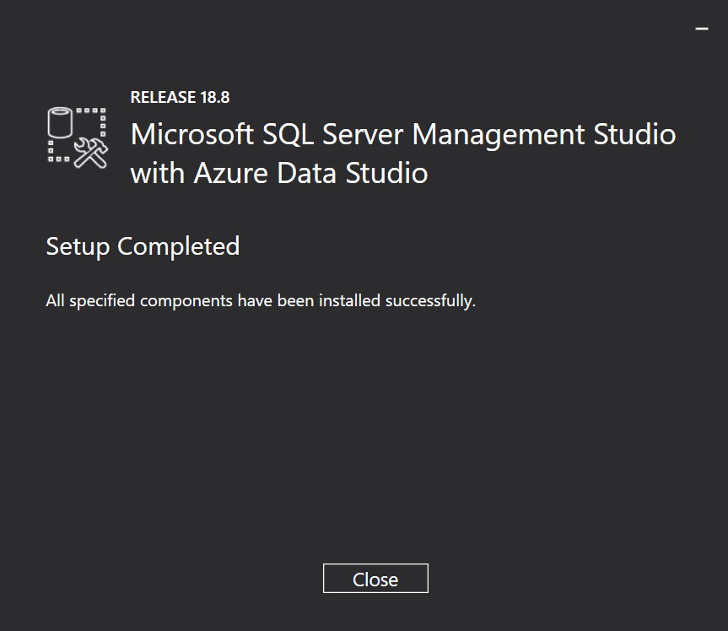

## Connect to SQL Server LocalDB

**Start** SQL Server Management Studio (SSMS).

**Connect** to the LocalDB database engine, using the following server name:

|  |
| --- |
| (localdb)\MSSQLLocalDB |

This is the “Connect” screen in SSMS:

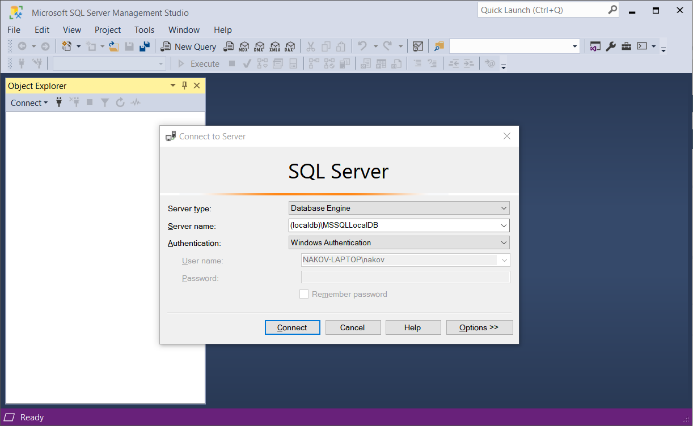

On successful connection, you will see the Object Explorer with the databases:

