# Lab: ORM and Entity Framework Overview

Problems for exercises and homework for the "**Databases Programming and ORM**" course from the official "Applied Programmer" curriculum.

You can check your solutions here: <https://judge.softuni.org/Contests/3149>

(delete all "**bin**"/"**obj**" folders)

Use the provided **skeleton** from resources! Do not change its methods, classes and namespaces!

## Import the SoftUni Database

Import the SoftUni DB into SQL Management Studio (if not yet imported) by **executing** the provided **.sql** script.

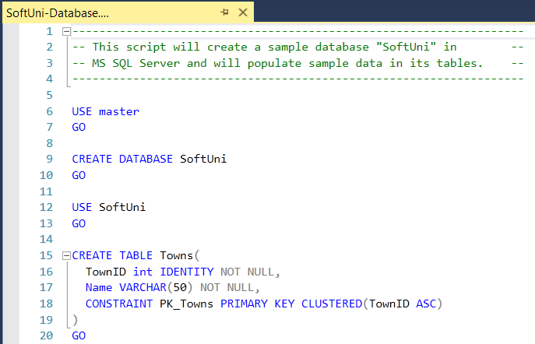

## Generate Database First ORM Model

Model the existing database by using **Database First** in Entity Framework Core.

### Create a New .NET Core App

First create a new empty **.Net Core** **Console Application** and after it is created open the **Package Manager Console**:

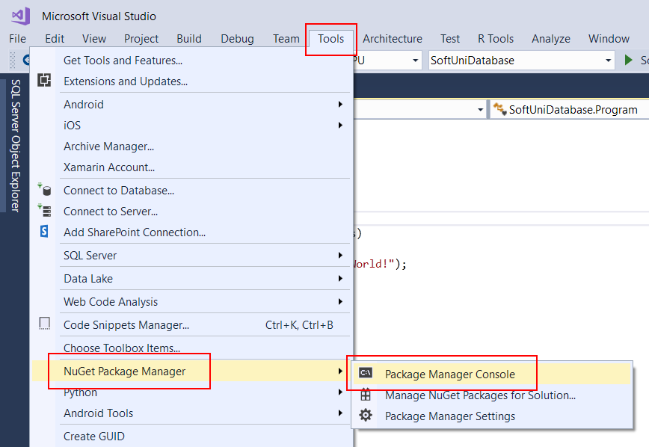

It will look something like this:

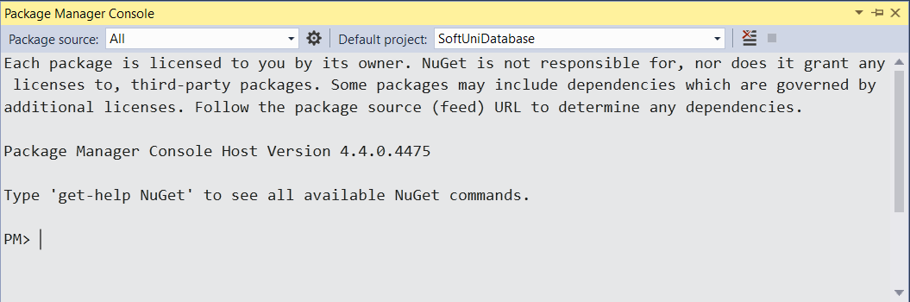

### Install SQL Server Tools for Entity Framework

Use it to run the following commands **one by one**:

|  |
| --- |
| Install-Package Microsoft.EntityFrameworkCore.Tools -v 3.1.3 |
| Install-Package Microsoft.EntityFrameworkCore.SqlServer -v 3.1.3 |
| Install-Package Microsoft.EntityFrameworkCore.SqlServer.Design |

***Note***: if **Package Manager Console** gives you **error** while trying to **execute the above commands** try using the following ones:

|  |
| --- |
| Install-Package Microsoft.EntityFrameworkCore.Tools -Version 3.1.3 |
| Install-Package Microsoft.EntityFrameworkCore.SqlServer -Version 3.1.3 |
| Install-Package Microsoft.EntityFrameworkCore.SqlServer.Design |

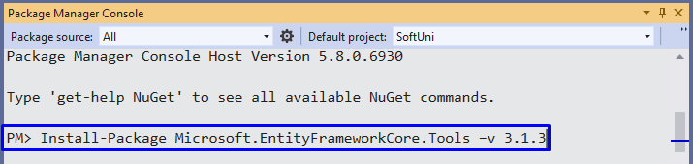

***Note***: **if** the installed **versions** **are** **newer** than these, your **solution** may be marked as **incorrect** when tested in the SoftUni judge.

These are the **packages** you will need, in order to **scaffold** our **SoftUniContext** from the **SoftUni** **database**.

### Generate EF Data Model from Existing DB

Next, we must **execute** the **command** to **scaffold** our **context** **class**. It will consist of 4 things:

* First, the name of the command:

|  |
| --- |
| Scaffold-DbContext |

* Second, the connection we will be using (our connection string):

|  |
| --- |
| -Connection "Server=<ServerName>;Database=<DatabaseName>;Integrated Security=True;" |

For **ServerName**, use the name of your local MS SQL Server instance or ".".

For **DatabaseName**, use the name of the database you want to use, in this case – **SoftUni**.

* Third, we need to declare our service provider, we’ll be using **Microsoft.EntityFrameworkCore.SqlServer**:

|  |
| --- |
| -Provider Microsoft.EntityFrameworkCore.SqlServer |

* And the fourth thing we’ll do, is to give it a directory where all of our models will go (e.g. **Models**):

|  |
| --- |
| -OutputDir Data/Models |

Our final command will look like this:

|  |
| --- |
| Scaffold-DbContext -Connection "Server=(localdb)\MSSQLLocalDB;Database=SoftUni;Integrated Security=True;" -Provider Microsoft.EntityFrameworkCore.SqlServer -OutputDir Data/Models |

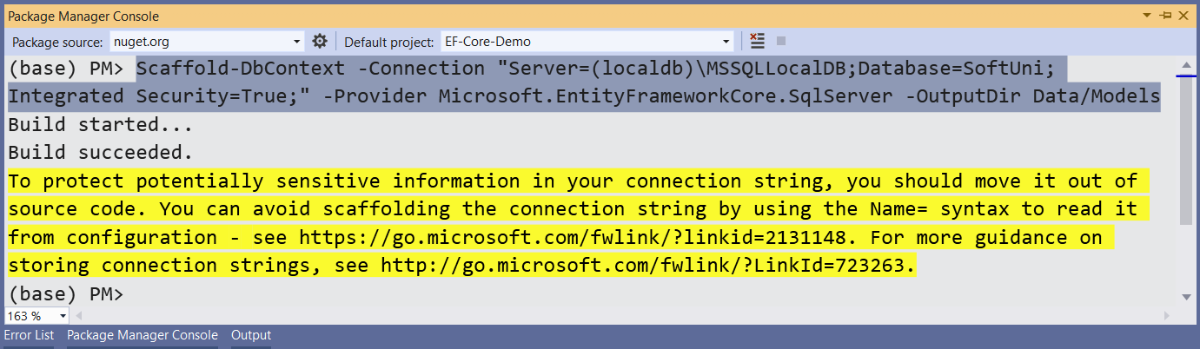

Execute the **whole command** on a **single line**.

### Customizing the Generated EF Data Model

Entity Framework Core has successfully **mapped the database schema to C# classes**. However, it isn't good enough with names – all classes have been **pluralized**.

* Use the **Solution Explorer** in Visual Studio to move the **SoftUniContext** class out of **Models** intothe **Data** folder and rename all of our classes properly.
* Use **right click →** [**Rename**] or the [**F2**] shortcut and press [**OK**] on this **pop** **up** **window** after each class:

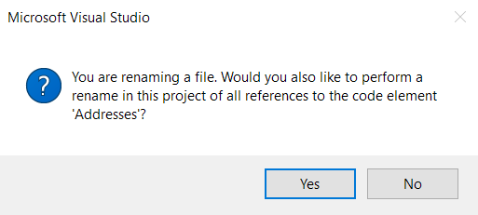

This way Visual Studio will also **rename** the **classes** **everywhere** they’re used.

The final result should look like this:

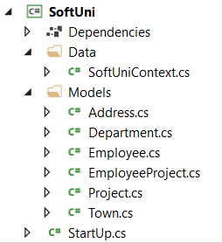

Don’t forget to fix the **SoftUniContext’s** namespace after moving it and add a reference to the **Models** namespace:

**Make** **sure** that your namespaces are **exactly** the same as these:

|  |
| --- |
| SoftUni  SoftUni.Data  SoftUni.Models |

### Remove Unneeded NuGet Packages

Finally, we can clean up the packages we won’t be using anymore from the package manager GUI or by running these commands:

|  |
| --- |
| Uninstall-Package Microsoft.EntityFrameworkCore.Tools -r  Uninstall-Package Microsoft.EntityFrameworkCore.SqlServer.Design -RemoveDependencies |

## Find Employees with Job Title

Create a method **public static string FindEmployeesWithJobTitle(SoftUniContext context)** in the class StartUp to print the **First Name** of all employees with **Job Title** equal to **“Design Engineer”**.

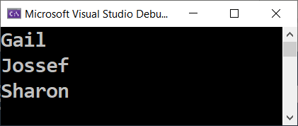

### Hints

Your **class structure** should follow the provided **project skeleton**, like this:

Get all employees and **filter** them using **context.Employees**. Then, select only the **First Name** of each employee and use **String.Join()** to return the array of names as a string to the method.

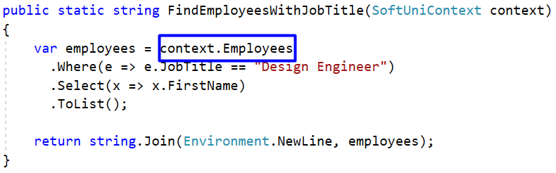

### Run Your Code in the Console

Invoke the **FindEmployeesWithJobTitle(SoftUniContext context)** method from the application entry point Main():

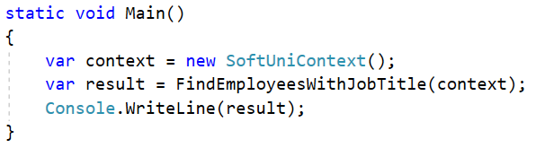

Press **[Ctrl+F5]** to run the application. Check if the result on the console is correct:



### Submit Your Code to Judge

**Save your files** in Visual Studio. Open your project’s source folder:

Delete the **“**bin**”** and **“**obj**”** folders from the **SoftUni** folder and create a **ZIP archive** of your solution:

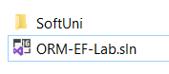 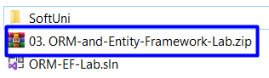

**Submit** the ZIP archive file in SoftUni judge:

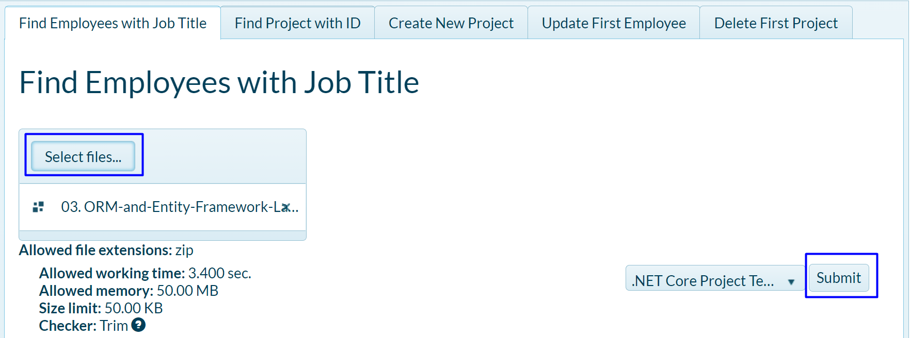

You should get 100 / 100 score:

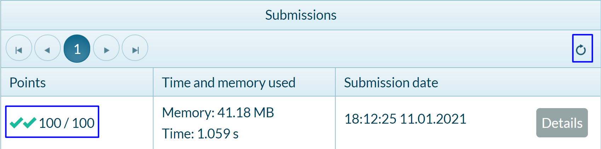

## Find Project with ID

Again, use the **context** and get all **Projects** from it. Use **.Find()** method to find the project with **ID 2** and return the **Name** of the project.



### Hints

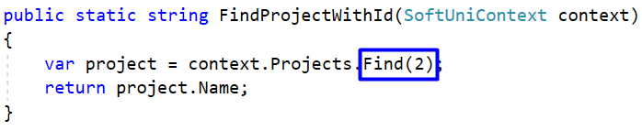

## Create New Project

Your task is to create a **new Project** in the **Projects** table.

### Hints

To create a new database **row** use the **.Add()** method of the corresponding **DbSet**. First, create a new **Project** **object** and give values to **Name** and **StartDate** properties.

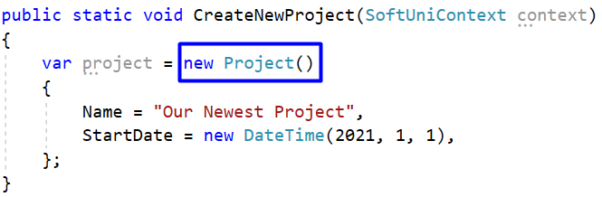

Then, add the object to the **DbSet** and do not forget to **save changes** the following way:

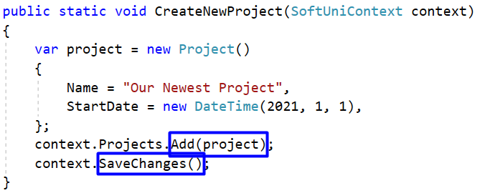

**Run** the app. There is no result displayed on the console.

### Check the Result in the DB

In order to check the result, go to **SQL Server Management Studio -> Object Explorer -> Databases -> SoftUni -> dbo.Projects**. **Right-click** on it and choose **Select Top 1000 Rows**.

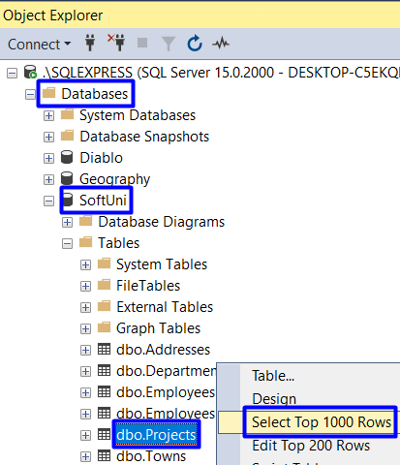

Scroll down to the **last entity**. It should be the one we added using a C# command in Visual Studio.



## Update First Employee

Get the **first employee** using **.FirstOrDefault()** method and change their **First Name** to **“Alex”**. Do not forget to **save changes**! In case there are no employees, return **empty string** to the method, else return the changed employee’s first name.

### Hints

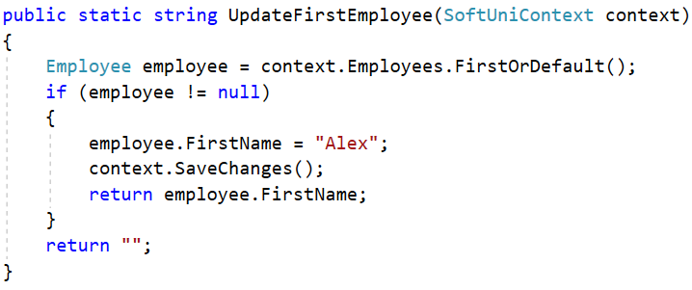

### Check result in the DB

This is the database entity **before** the code execution:



After the code execution, the entity **should be changed**:



## Delete First Project

Get the **first project** and delete it using the **.Remove()** method. Do not forget to **save changes**! The entity we should remove is the following:



### Hints

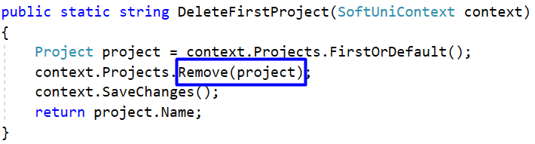

However, when the program is executed an **error message** appears.

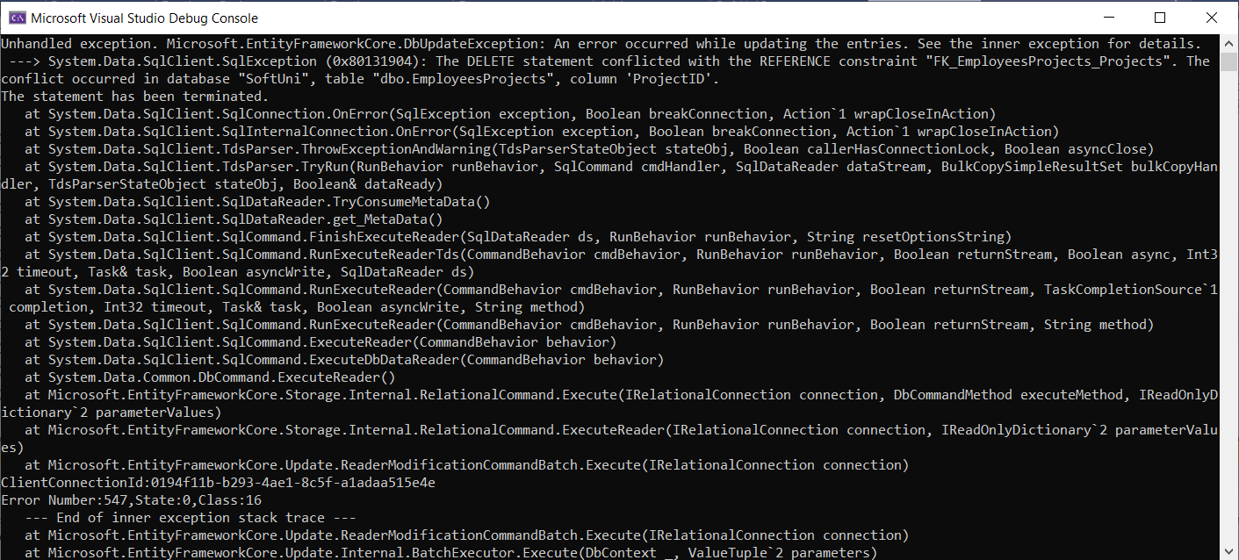

The reason for the error is that the **EmployeesProjects table** in the SoftUni DB contains a **ProjectID column**. So, entities from the Projects table **cannot be deleted** that way because some entities in the EmployeesProjects table contain the id of the project entity we want to delete. To solve that issue we may **first delete all enities** from the **EmployeesProjects** table, which contain our **ProjectId** (in our case with ProjectId=**1**). The command is the following:

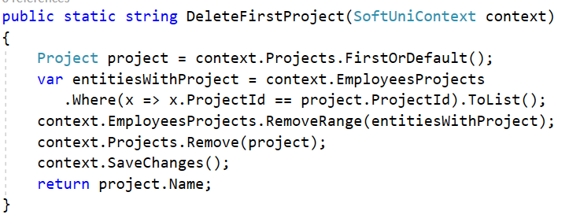

### Check result in the DB

Execute the program and see the result in the **Projects** table in the SoftUni DB.



You can also check the **EmployeesProjects** table. Now it does not contain entities with **ProjectId = 1**.

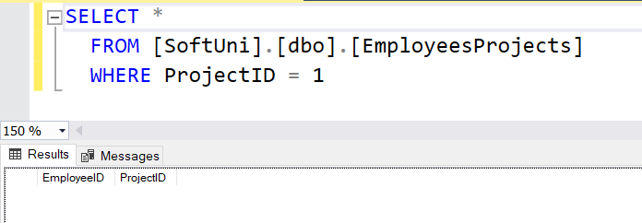

## Update Addresses

Write a **method** to update **TownId** to **2** for all **Addresses** with **AddressText**, containing the word **“Drive”**.

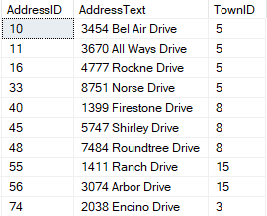 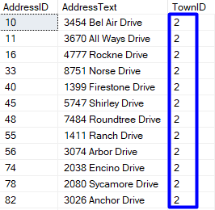

You can check the result in the **SoftUni DB** with this command:

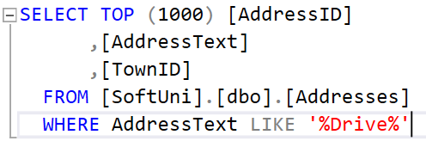

The method **UpdateAddresses(SoftUniContext context)** should return the **count** of **changed** addresses, converted to **string**.

