# Guide: Importing and Using “SoftUni” DB

Problems for exercises and homework for the "Databases and SQL" course from the official "Applied Programmer" curriculum. This guide explains how to **import and use the “SoftUni” database** from its SQL script.

## Import the “SoftUni” Database

**Unzip** the **02. Samples-Databases.zip** file, containing the databases. Start your SQL Server Manager Studio.

Let’s import the “**SoftUni**” **database**.

Note that if you have the **database already created**, you should first **delete** it and add it again, as shown below:

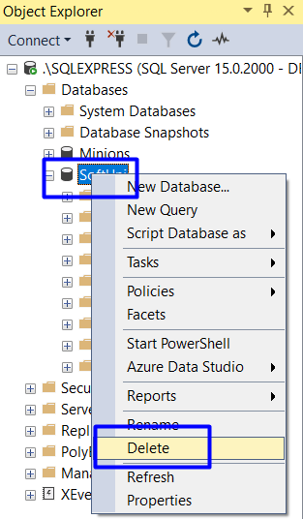 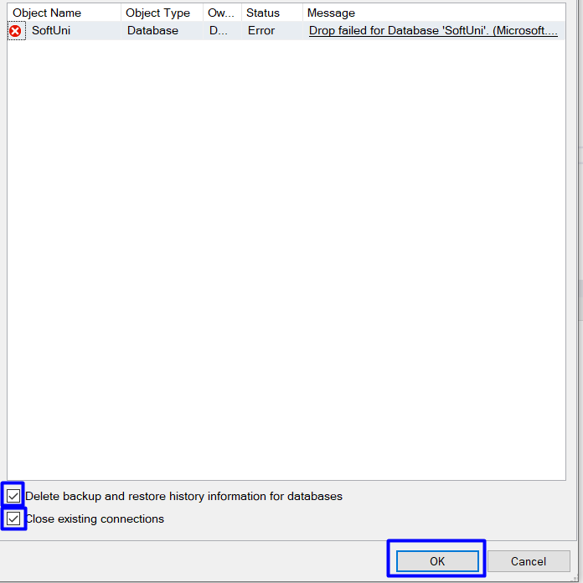

First, create a **new query** in SSMS by pressing the **[New Query]** button from the menu.

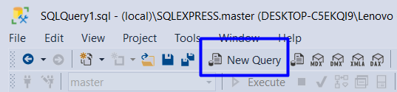

Next, **find** the database in your **file directory** and **drag** it to the **query** in SSMS the following way:

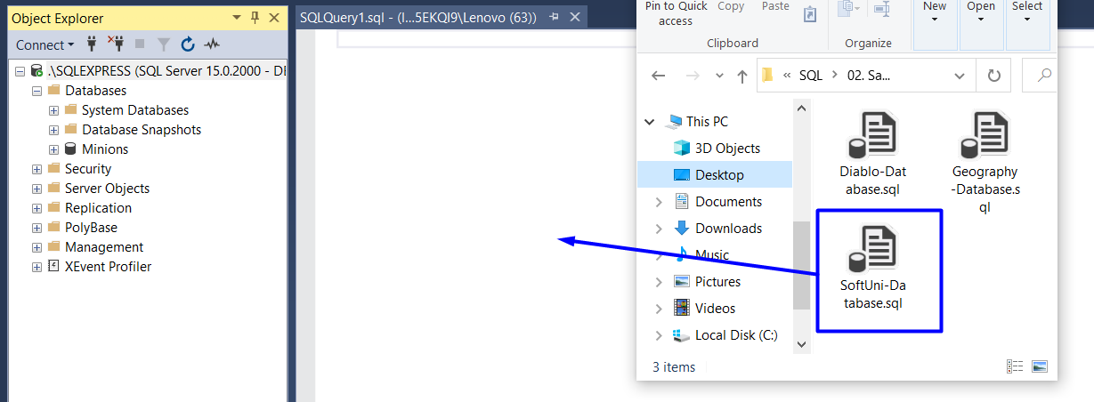

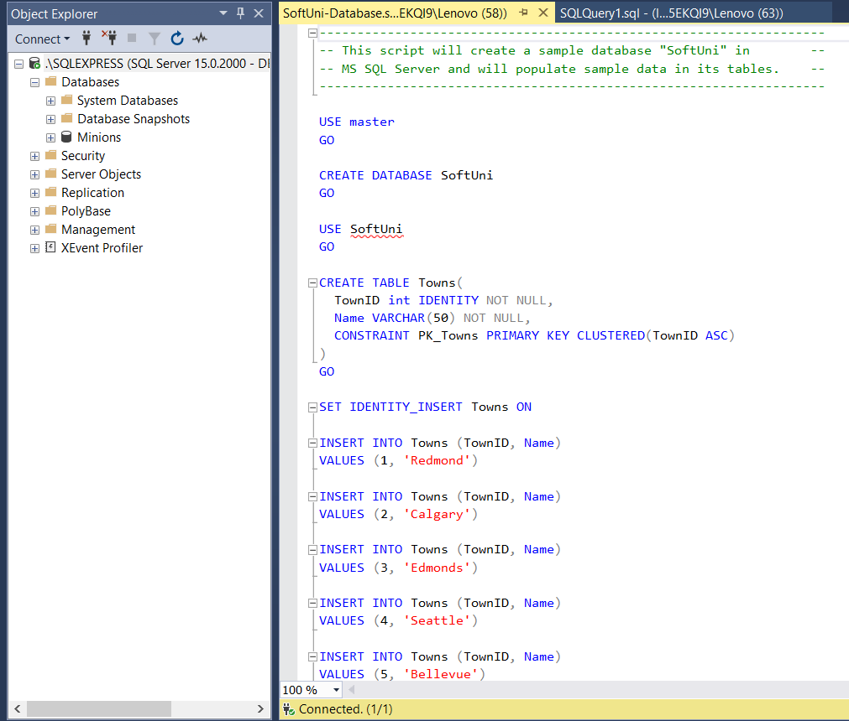

Then, press **F5** or **[Execute]** to **run the script** and create the database.

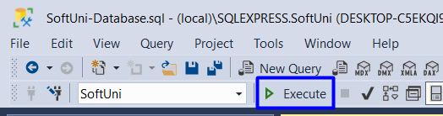

Then, **refresh** the **Object Explorer** and you should see the **newly created SoftUni database**.

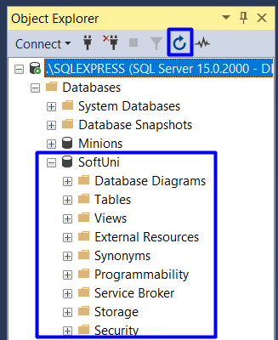

## Explorer the Database

Get familiar with the **SoftUni** database **schema** and **tables**. You will use them in the current and following exercises to write queries. The database tables are the following:

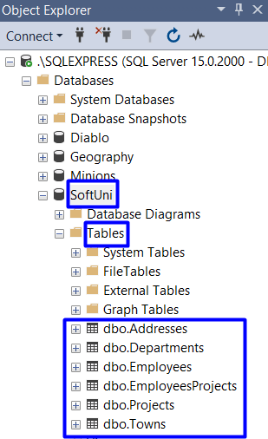

You can also **generate a DB diagram** for the SoftUni database:

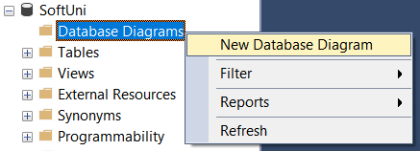

Select all tables and click **[Add]**:

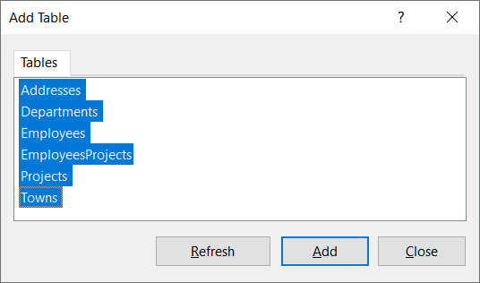

A database diagram will be generated and displayed. You can re-arrange the tables for better look and feel:

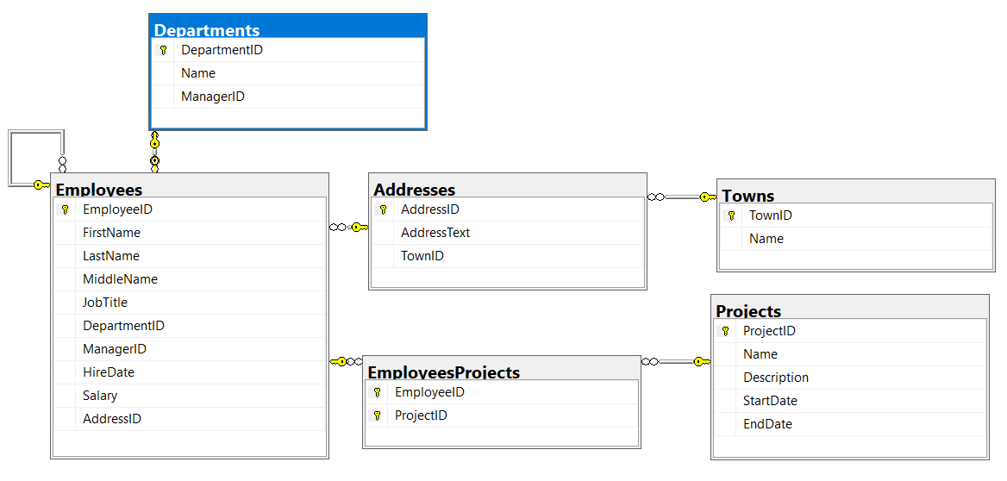

## Use the Database

First, select the “**SoftUni**” as **active database** in SQL Server Management Studio:

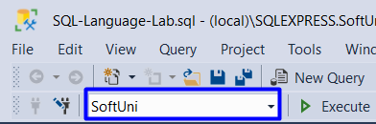

View the rows in the tables “**Departments**”:

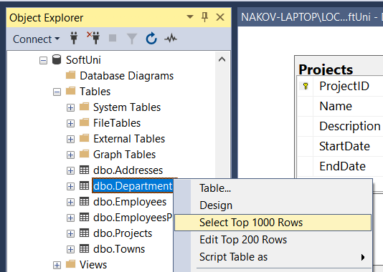

You will see the following output:

