SIMATS ENGINEERING (SAVEETHA SCHOOLOFENGINEERING)
Department of Computer Science & Engineering
CO1 - ASSESSMENT TOOL -1
Descriptive Written Exam

Course Code | CSA3717 | Course Title | Software Testing
CO Assessed | CO1 | Assessment | Assessment Tool 1: Descriptive Written Exam
Weight age | 50 % of CIA | Total Marks | 100
CO1Statement | Apply software testing principles to enhance the effectiveness of software quality assurance and improve defect detection strategies.(BL3)
Student Name | Balaguru S | Reg.No. | 192312070
Section/Batch | Slot A / 2023 | Date | 21-10-2026

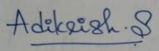
Code of Conduct:
I, Balaguru S, certify that this submission is my original work and that I have adheredtotheguidelinesspecifiedforthisassessment.Iunderstandthatanyviolationofacademicintegrity ruleswillresultindisciplinaryaction.
Signature of the student:
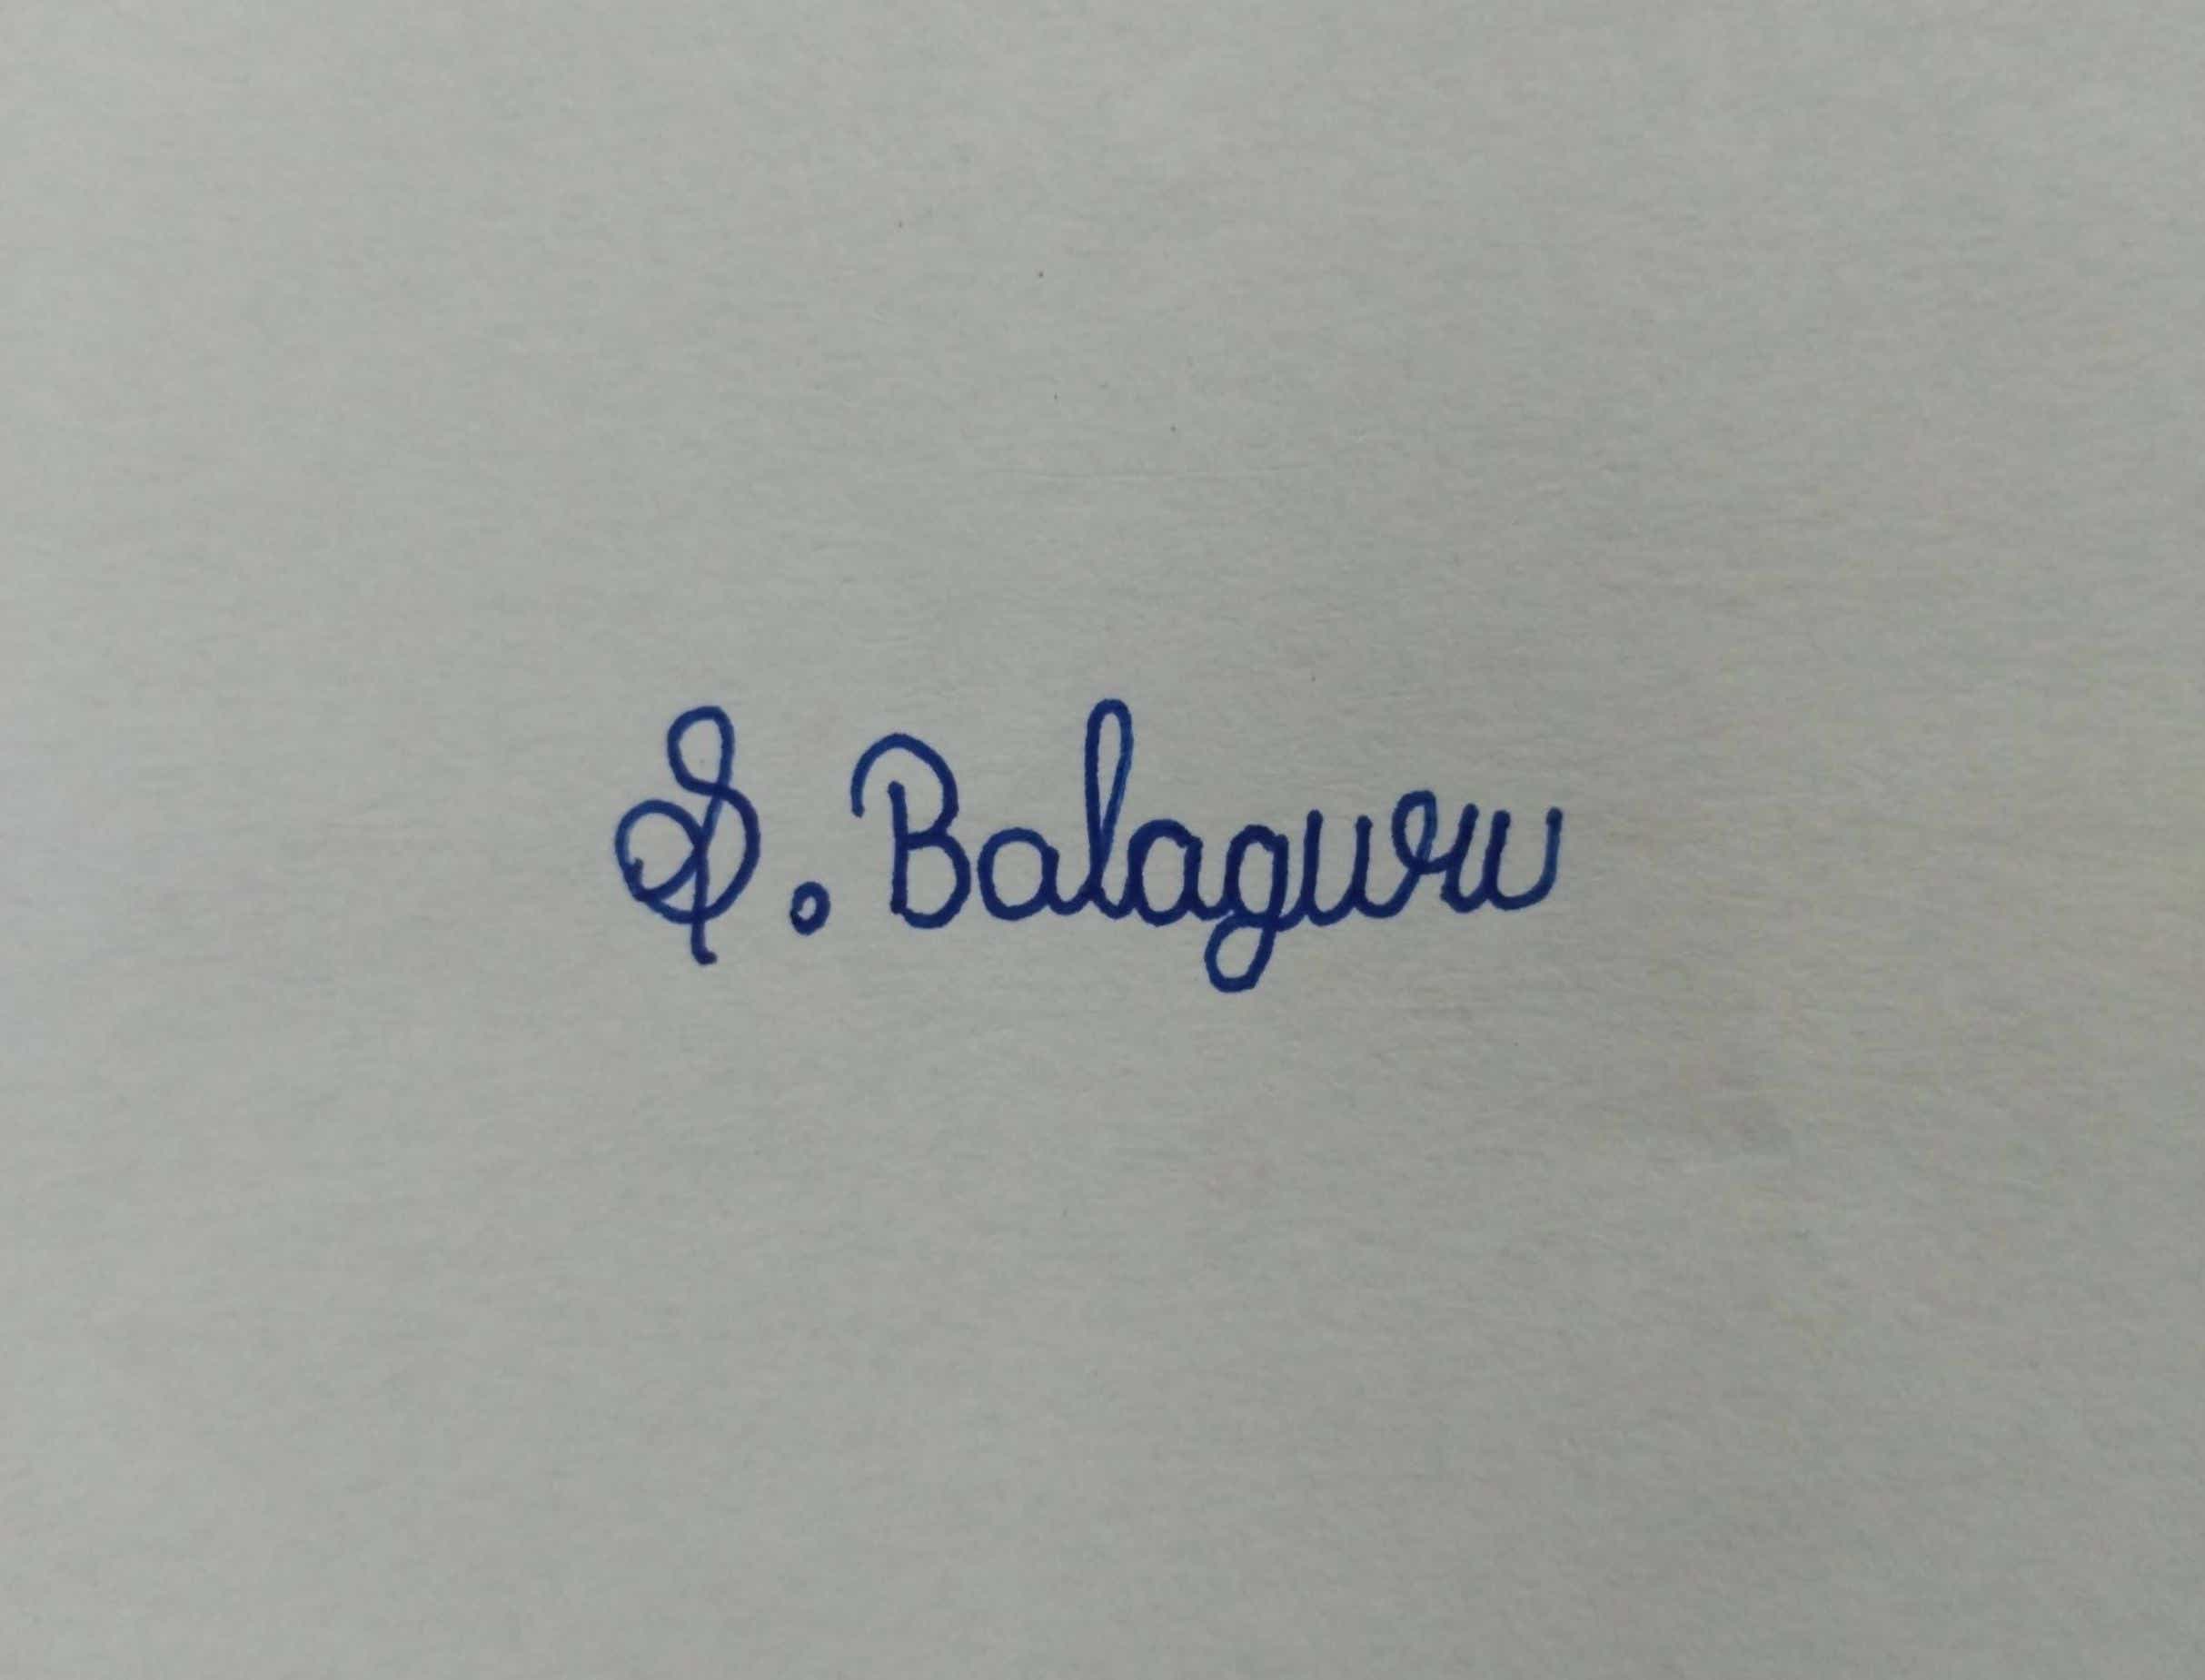

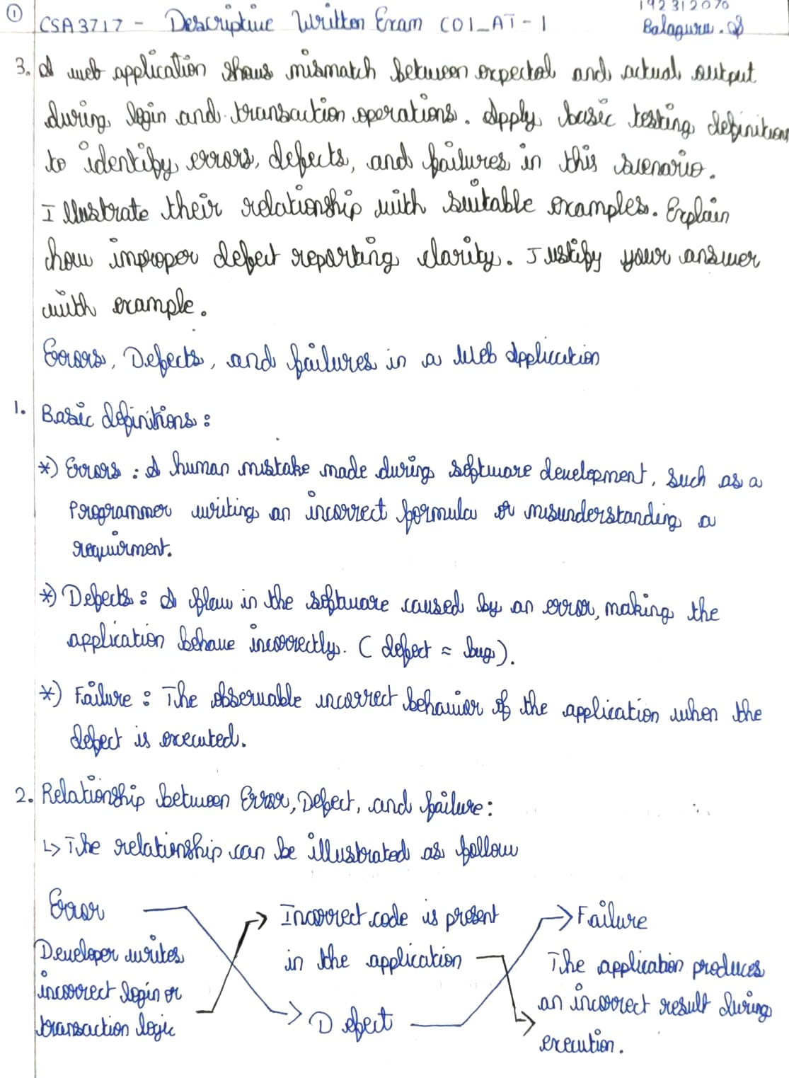
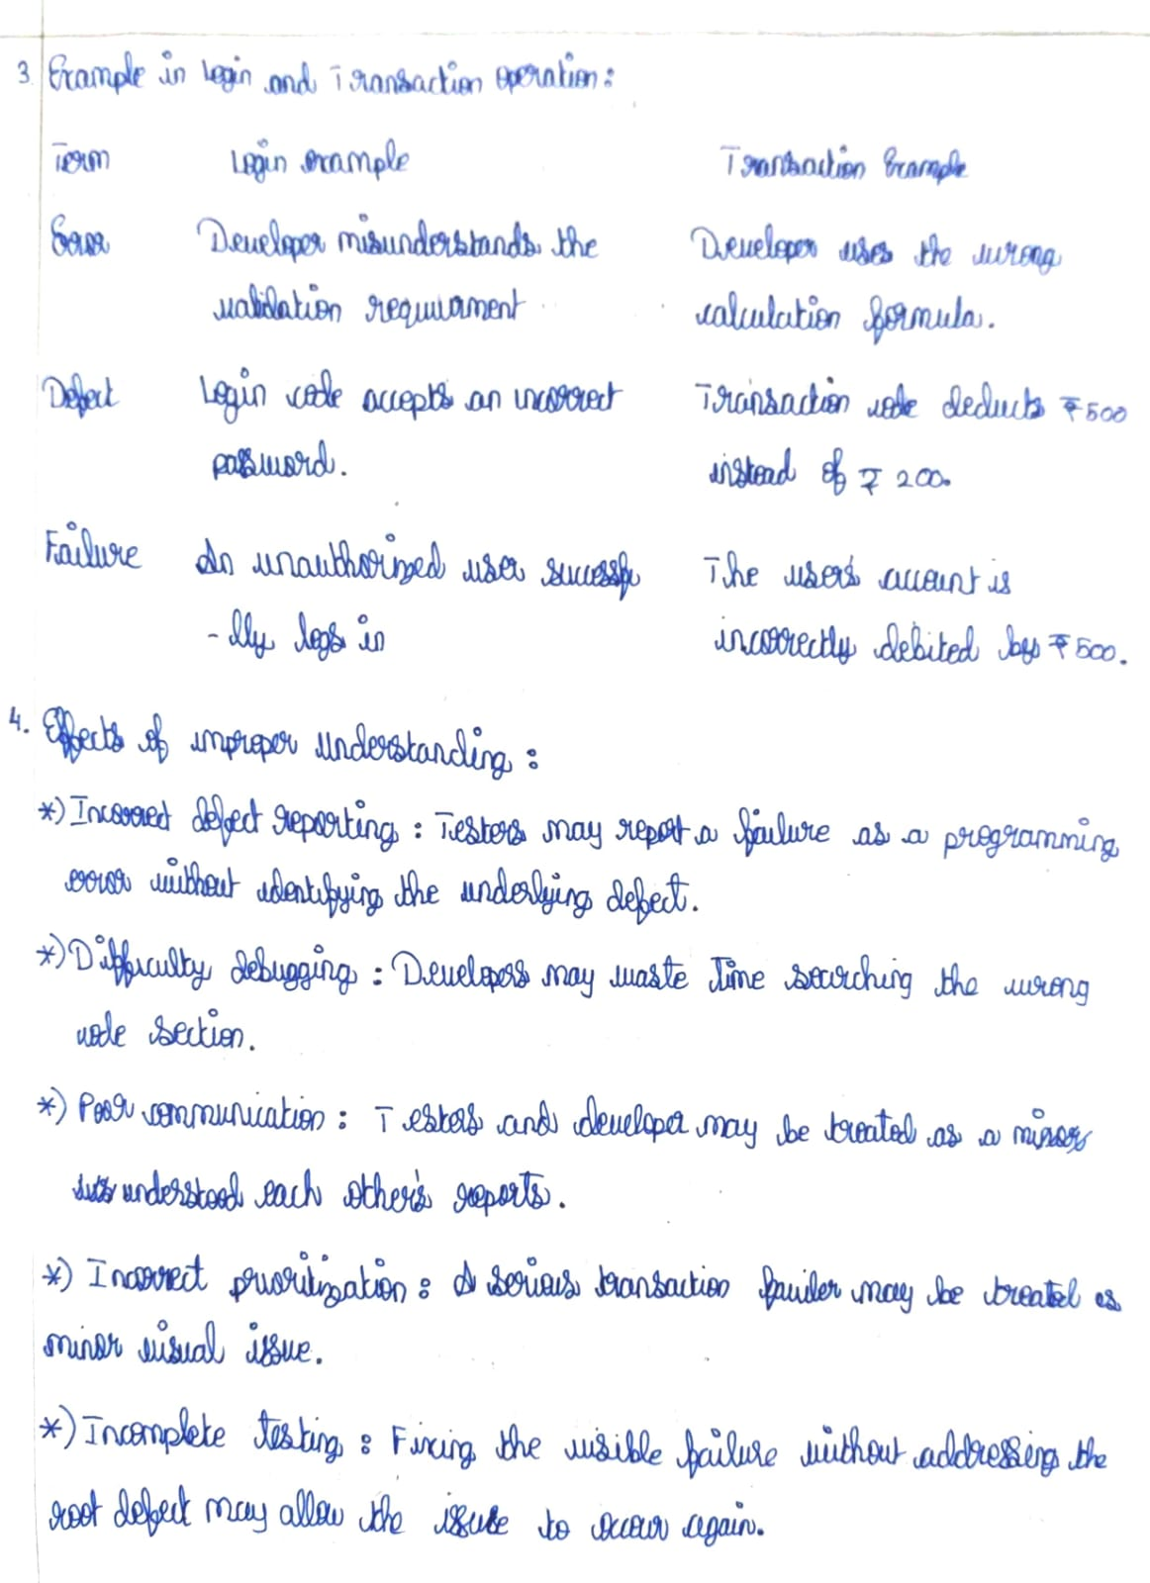
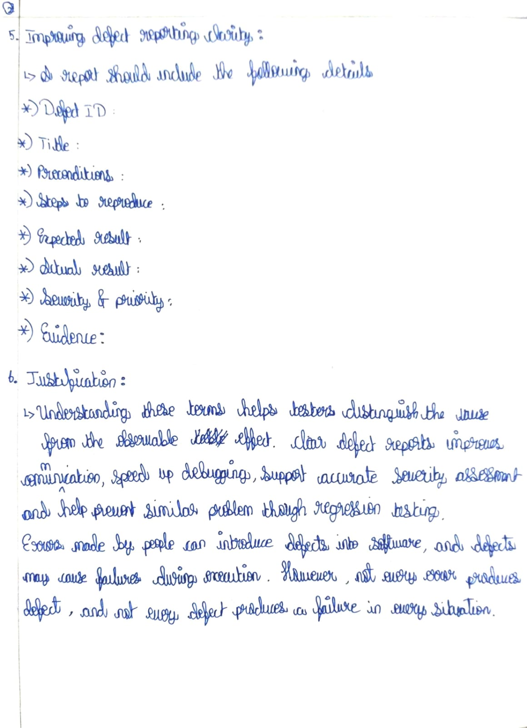
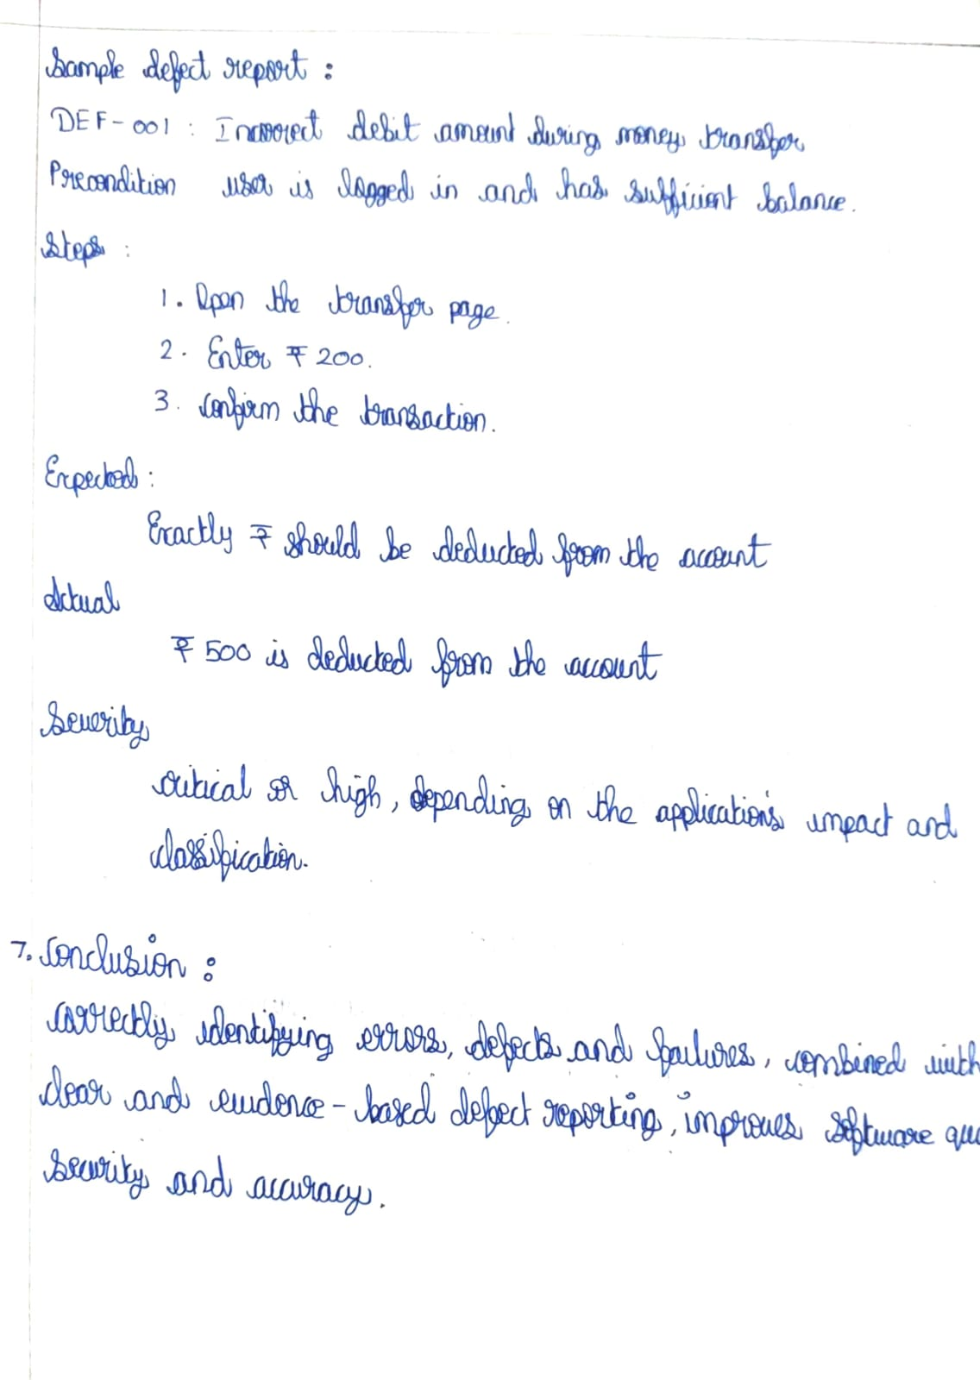
RUBRICS FOR CALCULATION:

Criteria | Weightage | Level 4 – Exemplary | Level 3 – Proficient | Level 2 – Developing | Level 1 – Beginning | Marks
Understanding of Concepts | 25% | Demonstrates thorough, accurate understanding of concepts | Good understanding with minor gaps | Basic understanding with some misconceptions | Poor understanding; major misconceptions
Explanation | 25% | Detailed, well-explained answers with relevant examples | Clear explanation with adequate details | Limited explanation; lacks depth | Poor or unclear explanation
Application | 20% | Effectively applies concepts with strong analytical ability | Applies concepts with minor errors | Limited application with weak analysis | No application or incorrect analysis
Organization | 15% | Well-structured answers with logical flow and coherence | Organized with minor issues in flow | Basic structure, lacks clarity | Poor organization, incoherent answers
Accuracy | 10% | Completely accurate and covers all required points | Mostly accurate with minor omissions | Partially correct with missing points | Incorrect answers with major gaps
.

