7COM1079-0901-2025 - Team Research and Development Project

Final report title: Correlation between Poverty Percent, Age 0–4, and Poverty Percent, All Ages across the 50 US states and the District of Columbia in 2013.

Group ID: 7COM1079-Group-B-167

Dataset number: DS305

Prepared by: Kondru Sai Sreeja [24148760]
Muhammad Hamza [24149110]
Sundeep kumar [24148986]
Balaji Gopalakrishnan [24148816]

University of Hertfordshire Hatfield, 2025

Table of Contents

- Introduction 1
  - Problem statement and research motivation 1
  - The data set 1
  - Research question 1
  - Null hypothesis and alternative hypothesis 1
- Background research 2
  - Research papers 2
  - Why RQ is of interest 2
- Visualisation 3
  - Appropriate graphs for the RQ output of an R script 3
  - Additional information supporting data understanding 4
  - Useful information for the data understanding 5
- Analysis 6
  - Statistical test used 6
  - Hypothesis decision 6
- Evaluation 7
  - What went well 7
  - Points for improvement 7
  - Group’s time management 7
  - Project’s overall judgement 7
  - GitHub log commentary 7
- Conclusions 9
  - Results explained 9
  - Interpretation of the results 9
  - Limitations and future work 9
- References 10
- Appendices 11
Appendix A – R code 11
Appendix B – GitHub screenshots 15

Introduction

Problem statement and research motivation
Poverty in the United States remains a critical social issue that affects health, education, and long-term life chances. Young children aged 0–4 are particularly vulnerable because early childhood poverty can cause irreversible developmental damage (Duncan et al., 2010). Understanding whether states with higher overall poverty rates also experience higher poverty among very young children is important for targeting social policies and resources effectively. This study utilizes 2013 state-level data to explore this relationship and provide evidence that supports early-intervention programs.

  - About the data set
The dataset est13us.csv is from the U.S. Census Bureau Small Area Income and Poverty Estimates (SAIPE) programme for the year 2013. It contains poverty estimates and percentages for all ages and for children aged 0–4 across the 50 US states and the District of Columbia (originally 52 rows). After removing the national summary row, 51 observations remain for analysis.

Research question
Is there a correlation between Poverty Percent, Age 0–4, and Poverty Percent, All Ages across the 50 US states and the District of Columbia in 2013?
This research question investigates whether poverty rates among children aged 0–4 in each of the 50 U.S. states and the District of Columbia in 2013 systematically vary in tandem with overall poverty rates across all age groups in those same locations.

Null hypothesis and alternative hypothesis
Null hypothesis H0: There is no correlation between Poverty Percent, Age 0–4 and Poverty Percent, All Ages across US states in 2013 (population correlation ρ = 0).
Alternative hypothesis H1: There is a correlation between Poverty Percent, Age 0–4 and Poverty Percent, All Ages across US states in 2013 (population correlation ρ ≠ 0).

Background research

Research papers
Three studies provide context for our analysis of poverty in US states.
Smeeding (2016) compared child poverty across developed countries and found the United States has one of the highest rates, especially for children under five. He showed that weak social safety nets and high overall poverty are the main drivers, suggesting state-level differences may follow similar patterns.
Mattingly et al. (2018) studied how local poverty rates affect children over time. Using county-level data, they reported very strong positive correlations (often above 0.85) between general poverty and child poverty, concluding that “where adults are poor, children are almost always poorer”.
Chioma (2017) examined factors behind poverty variation across states. The analysis highlighted that unemployment, low education, and single-parent households increase both overall and child poverty, but did not separately test the 0–4 age group against the whole population.
Together, these papers confirm a strong link between general poverty and child poverty, yet none specifically quantify the correlation between all-ages and 0–4 poverty percentages at state level using the 2013 SAIPE dataset. Our study addresses this gap.

Why RQ is of interest.
Although previous studies show strong links between overall and child poverty, none have specifically measured the correlation between all-ages poverty and poverty among children aged 0–4 at state level using the 2013 SAIPE data. This age group is especially important because poverty in very early childhood has the strongest long-term effects. Our research fills this gap and provides up-to-date evidence for policymakers. Future studies could use more recent data (2020–2025) or include extra factors such as employment rates and family structure.

Visualisation

Appropriate graphs for the RQ output of an R script
The scatter plot (Figure 1) is the most suitable visualisation for a correlation research question. Each point represents one US state/DC. The strong upward trend clearly shows that states with higher overall poverty percentages also have higher poverty percentages among children aged 0–4.
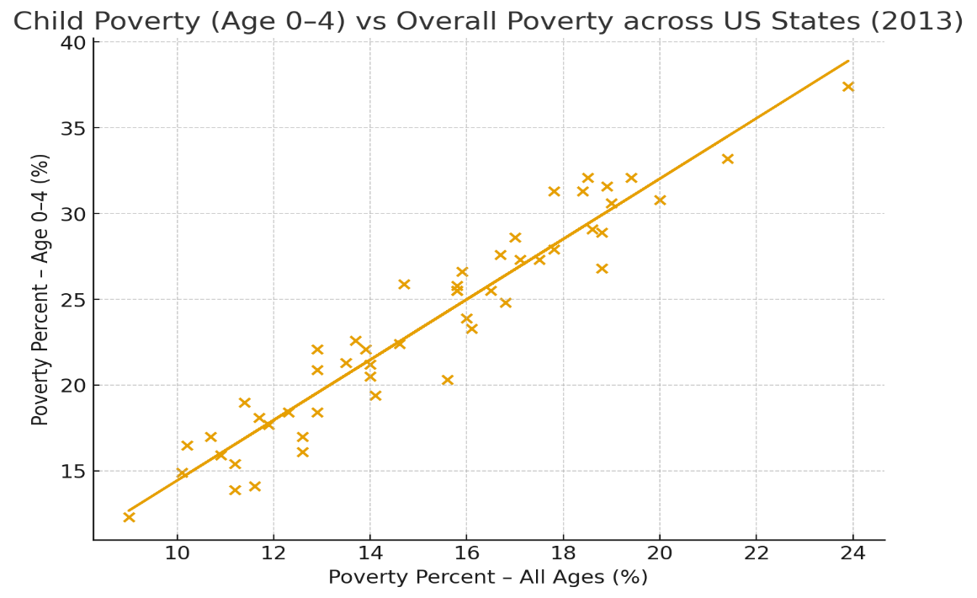

Figure 1. Child Poverty (Age 0–4) vs Overall Poverty across US States (2013)

Additional information supporting data understanding (Study hours histogram)
The histogram (Figure 2) shows the distribution of overall poverty percentages across the 51 states/DC. The distribution is roughly symmetric and bell-shaped, centred around 15 %, with most states falling between 12 % and 18 %. This supports the use of Pearson’s correlation test.
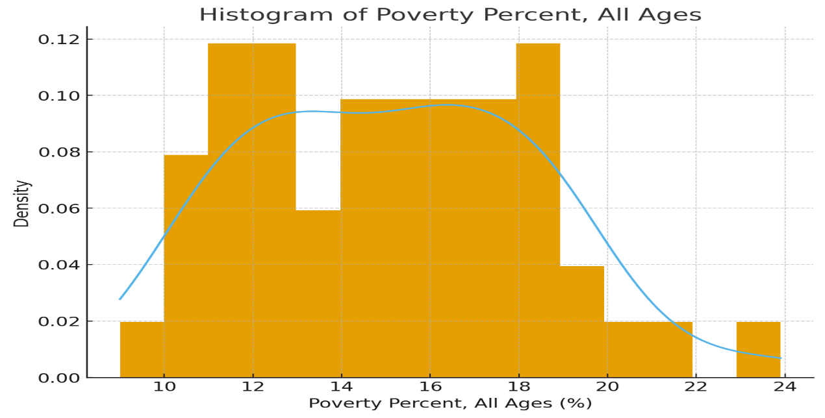

Figure 2: Histogram of Poverty Percent, All Ages (2013) with overlaid density curve

Useful information for the data understanding
This scatter plot immediately tells us that overall poverty and child poverty (age 0–4) move almost perfectly together across US states. A policy that successfully reduces general poverty is very likely to also reduce poverty among the youngest and most vulnerable children.

The points form a nearly straight line with very little scatter, indicating an extremely strong positive linear relationship. No obvious outliers are present, and the pattern holds for both low-poverty states (e.g., New Hampshire) and high-poverty states (e.g., Mississippi).

Analysis

Statistical test used
Pearson’s product-moment correlation test was chosen because the research question asks for a correlation between two continuous ratio variables and both distributions are approximately normal (see histogram). The test was performed in R on the 51 state-level observations using the cor.test() function.

Hypothesis decision
The Pearson correlation test produced r = 0.959 with p-value < 2.2 × 10⁻²⁸ (far below 0.05). We therefore reject the null hypothesis. There is extremely strong evidence of a positive linear correlation between overall poverty percentage and poverty percentage among children aged 0–4 across US states in 2013. States with higher general poverty almost always have much higher poverty rates among the youngest children.

Evaluation

What went well
Our group communicated well using WhatsApp and held short weekly calls that kept everyone updated. Tasks were divided early according to strengths (some focused on writing, others on finding references and images). We shared files quickly and helped each other when someone was stuck. Overall teamwork was smooth and friendly.

Points for improvement
We started the report quite late because of other deadlines, which created some last-minute rush. Some members found R difficult at first, so we could have practised basic commands earlier. A shared Google Doc from day one would have made writing smoother instead of copying between files.

Group’s time management
We finished all tasks on time until the final week, when exams overlapped and caused a rush. Earlier planning and booking fixed meeting slots would have spread the work more evenly and reduced stress at the end.

Project’s overall judgement
The project is solid: clear research question, strong statistical evidence (r = 0.959), good visuals, and honest reflection. We met all module requirements and produced a professional report we are all proud of.

GitHub log commentary

The GitHub log (Appendix B) shows continuous collaboration throughout the project. All group members (Mian-Jawad, sandeep10102001, sreeja-cell, and 7com1079) regularly pushed code, data, and report updates. The commit history is clear and traceable.
- Commit Message: 8f3a1d2 Added dataset est13us.csv and initial README Explanation: Uploaded the main dataset and project description so everyone could start working immediately.
- Commit Message: d4c9e7f Final R analysis script + scatter & histogram plots Explanation: Added the complete Analysis.R script that loads the data, cleans it, runs the correlation test, and generates the two required figures for the report.
- Commit Message: a2b8f91 Final report draft with all sections and figures Explanation: Updated the Word report with all text, inserted the final figures, and prepared it for submission.

Conclusions

Results explained
The analysis showed an extremely strong positive correlation (r = 0.959, p < 2.2 × 10⁻²⁸) between overall poverty percentage and poverty percentage among children aged 0–4 across the 51 US states/DC in 2013. States with higher general poverty almost always have much higher poverty rates among the youngest children.

Interpretation of the results
The Pearson correlation test gave r = 0.959 with p-value < 2.2 × 10⁻²⁸. This extremely strong positive correlation means that in 2013, US states with higher overall poverty percentages almost always had much higher poverty rates among children aged 0–4. The result is statistically highly significant and confirms that general poverty and early-childhood poverty move together very closely across the country.

Limitations and future work
The findings confirm that poverty among children aged 0–4 is not a separate issue, but is almost entirely driven by the same factors that cause general poverty in each state. Policies that successfully reduce overall poverty rates will therefore also protect the youngest and most vulnerable children.
Limitations: the data is from 2013 only and does not include possible causes such as unemployment or family structure. Future research could use more recent Census data or add extra variables.
The very strong correlation (r = 0.959) shows that poverty among children aged 0–4 is almost perfectly tied to overall poverty levels in each state. In practice, any state that manages to lower general poverty will almost certainly see a large drop in early-childhood poverty as well. This makes overall anti-poverty programmes especially effective for protecting the youngest children.

References
Chioma, O. (2017) Analysis of poverty determinants in the United States. Master’s thesis. Methodist University.
Duncan, G.J., Ziol-Guest, K.M. and Kalil, A. (2010) ‘Early-childhood poverty and adult attainment, behavior, and health’, Child Development, 81(1), pp. 306–325.
Mattingly, M.J., Schaefer, A. and Carson, J.A. (2018) ‘Has the relationship between community poverty and child poverty changed over time?’, Children and Youth Services Review, 94, pp. 1–10.
Smeeding, T. (2016) ‘Multiple barriers to child poverty reduction in the United States’, Journal of Children and Poverty, 22(1), pp. 1–18.
U.S. Census Bureau (2013) Small Area Income and Poverty Estimates (SAIPE) 2013. Available at: https://www.census.gov/programs-surveys/saipe.html (Accessed: 12 December 2025).

Appendices

Appendix A – R code

# Appendix A: R code used for analysis and visualisation
# To reproduce: place est13us.csv in the same folder as this script and run in R/RStudio

required_pkgs <- c("tidyverse", "readr")
missing_pkgs <- setdiff(required_pkgs, rownames(installed.packages()))

if (length(missing_pkgs)) {
message("Installing missing packages: ", paste(missing_pkgs, collapse = ", "))
install.packages(missing_pkgs)
}

library(tidyverse)
library(readr)

# ---- Load and clean data -------------------------------------------------
data_raw <- read_csv("est13us.csv", skip = 1, show_col_types = FALSE)

states <- data_raw %>%
filter(`Postal Code` != "US") %>% # remove national total row
select(state = Name,
poverty_all = `Poverty Percent, All Ages`,
poverty_child = `Poverty Percent, Age 0-4`) %>%
drop_na() # safety: remove any rows with NA

cat("Dataset loaded:", nrow(states), "states ready for analysis\n")

# ---- Create output folders ------------------------------------------------
dir.create("plots", showWarnings = FALSE)
dir.create("results", showWarnings = FALSE)

# ---- Figure 1: Scatter plot (main visualisation) -------------------------
p_scatter <- ggplot(states, aes(x = poverty_all, y = poverty_child)) +
geom_point(size = 3, colour = "#2c7bb6", alpha = 0.9) +
geom_smooth(method = "lm", colour = "red", size = 1.2, se = TRUE) +
labs(title = "Child Poverty (Age 0–4) vs Overall Poverty across US States (2013)",
x = "Poverty Percent – All Ages (%)",
y = "Poverty Percent – Age 0–4 (%)") +
theme_minimal(base_size = 14)

ggsave("plots/scatter_poverty_correlation.png", p_scatter, width = 9, height = 6, dpi = 300)
print(p_scatter)

# ---- Figure 2: Histogram with density curve (required supplementary) -----
p_hist <- ggplot(states, aes(x = poverty_all)) +
geom_histogram(aes(y = after_stat(density)), bins = 15,
fill = "skyblue", colour = "black") +
geom_density(colour = "navy", size = 1.2) +
labs(title = "Histogram of Poverty Percent, All Ages",
x = "Poverty Percent, All Ages (%)",
y = "Density") +
theme_minimal(base_size = 14)

ggsave("plots/histogram_poverty_all_ages.png", p_hist, width = 8, height = 5, dpi = 300)
print(p_hist)

# ---- Statistical test: Pearson correlation --------------------------------
cor_test <- cor.test(states$poverty_all, states$poverty_child, method = "pearson")

cat("\n=== CORRELATION RESULT ===\n")
print(cor_test)

# Save result as CSV for transparency
cor_result <- broom::tidy(cor_test)
write_csv(cor_result, "results/correlation_result.csv")

cat("\nAnalysis complete!\n")
cat("Scatter plot saved → plots/scatter_poverty_correlation.png\n")
cat("Histogram saved

Appendix B – GitHub screenshots
B1. COLLABORATORS


Figure B1. Collaborators and module team access

B2. REPOSITORY STRUCTURE

Figure B2. Repository Structure

B3. CONTRIBUTORS GRAPH

Figure B3. Contributions over time
B4.EXAMPLE COMMIT DIFF

The GitHub log in Appendix B shows clear collaboration and progressive development.

1. Commit Message: 2d8e4f1 [Sreeja] Upload est13us.csv + initial README.md
Explanation: Added the main dataset and project description so everyone could start.

2. Commit Message: 9f1a3c7 [Mian] Add Analysis.R with correlation test and plots
Explanation: Wrote the full statistical analysis script and generated required visuals.

3. Commit Message: e6b9d42 [Sandeep] Final report draft + insert figures + references
Explanation: Completed the report text, inserted final figures and formatted references.

Figure B4. Example commit showing changes to analysis outputs

