**Rob's web**

**More on switching-FET RF amplifiers**

[Home](http://www.robkalmeijer.nl/index.html) - [Techniek](http://www.robkalmeijer.nl/techniek/index.html) - [Electronica](http://www.robkalmeijer.nl/techniek/electronica/index.html) - [Radiotechniek](http://www.robkalmeijer.nl/techniek/electronica/radiotechniek/index.html) - [Radio amateur bladen](http://www.robkalmeijer.nl/techniek/electronica/radiotechniek/hambladen/index.html) - [Radio Communication](http://www.robkalmeijer.nl/techniek/electronica/radiotechniek/hambladen/radcom/index.html) - More on switching-FET RF amplifiers

Two recent TT items -- 'Using fast-switching power FETs as RF amplifiers' (July 1989, correction September) and '50-watts RF from low-cost FET at 7 MHz' (December 1989) - have underlined the feasibility of using switching- or audio-type power FETs, such as HEXFET packages, as HF power amplifiers working at useful power levels without undue circuit complications. This month it will be shown that switching-type FETs are capable of providing substantially more power output than the 12.5 watts-per-device suggested by Doug DeMaw, W1FB in the July item which was based on his QST article of April 1989 (feedback May).

Wes Hayward, W7Z01 and Jeff Damm, WA7MLH in the 'Technical Correspondence' column of QST, November 1989 point out that W1FB encountered two mayor problems in using switching-type HEXFETs. (1) considerable difficulty in obtaining reliable stability; and (2) the need to use a 24V supply in order to achieve reasonable output. They believe that both these problems can be overcome: "Our experience with HEXFET amplifiers is much more optimistic than that reported by Doug DeMaw. Stability is ensured if low-resistance, non-inductive terminations are used Useful output power is available from amplifiers with '12V' (13.5v) power supplies if a higher device quiescent current is used."

They outline two FET amplifiers: (1) an amplifier based on the IRF511 device (as used by W1FB) providing 8W CW or SSB PEP between 3.5-14MHz from a 13.5V supply; and (2) a high-power amplifier which can provide up to 50W for 14MHz CW from a 24-28V supply using a IRF530 device with a drive power of 1.5W.

W7Z01 and WA7MLH write: "Our experience with medium-power amplifiers using inexpensive FETs is very encouraging. They are generally easier to use and tame than bipolar transceivers at similar power levels Stability is ensured by a low-impedance gate-drive design without excess inductance in series with the gate. Amplifier performance is improved when higher-voltage power supplies are used, but practical results are still possible with 12V supplies."

Fig 1 shows the circuit diagram of their 8W amplifier as used for a portable 3.5/7MHz SSB transmitter. A broadband 2,1-turns-ratio bit larwound transformer at the output is followed by a low-pass-filter. Quiescent bias current is about 100mA and it should be noted that no ferrite-bead inductance is used. A similar amplifier with a 50-ohm output termination functions with a 1W output SSB driver when biased to only 25mA.

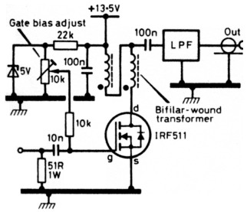  
Fig. 1: FET power amplifier based on IRF511 switching-type hexfet providing about 8W CW or SSB PEP between 3.5/14MHz from 13.5V supply.

Fig 2 is their higher-power amplifier using a larger, more robust FET, type IRF530 which, in the USA, costs less than $3 new in mail-order catalogues (about £3 + VAT in UK). In this case, a 2:1-turns-ratio step-down transformer provides a low-impedance drive input circuit. An LCC T-network is used for output and matching. Both the input and output networks are roughly similar to those commonly used for similar-power bipolar amplifiers: "Part of the bias is derived from RF drive. When RF drive is removed, the drain current drops to a very low level. The internally-generated noise also drops making this circuit especially useful for QSK (break-in) CW operation (an optional T-R switch for break-in operation is shown in Fig 2 with the reactance of Ltr and Ctr each about 500-ohms).

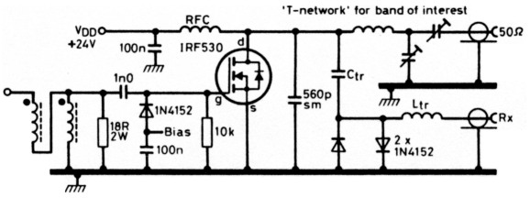  
Fig. 2: 50 W 14 MHz FET power amplifier based on low-cost IRF530 using 24-28V supply with 1.5W drive.

They conclude: "The IRF530 amplifier is capable of reliable high power from a 24-28V power supply. We have measured an RF output as high as 50 watts at 14MHz with a drive power of 1.5W. Similar output power is available on 3.5W when the amplifier is driven with nothing more than a crystal oscillator. Lower, but useful, output is available from this circuit with a 12V power supply."

Outline characteristics (at 25°C) for the IRF530 (N channel enhancement) device as given in the RS Components catalogue are:

|  |  |
| --- | --- |
| case | TO220(AB) |
| PΤ | 75W |
| RDS(max) | 0.18-ohm |
| II(max) | 10A |
| VDG | 100V |
| VDS | 100V |
| VGS(TH)max | 4V |
| IDSS(max), IGSS(max) | 500nA |
| tr, tf (max) | 150nS. |