**Intro TI**

***Project abstract***

**Nowadays, the IoT field is developing significantly, so the quality requirements of IoT devices is not only about the stable operation of itself but also a good ability in communicating with other IoT devices. Therefore, the demand of analyzing quality of the antenna is more necessary. However, the solutions, as well as devices that analyze the quality of the antenna, are still not popular and very expensive**.

***1.Introduction***

To measuring the quality of antenna, the RF loss that is created by the antenna will be analyzed. There are some machines/devices can do this task such as: **Voltage Standing Wave Ratio Meter** (SWR Meter or VSWR Meter), **Scalar Network Analyzer** (SNA), **Common Vector Network Analyzer** (VNA). But there are many disadvantages, just like that SWR meter does not measure the actual impedance of a load (the resistance and reactance), but only the mismatch ratio. Or about the SNA, broadband detectors are susceptible to spurious tones and broadband noise. In addition, because the calibration is scalar in nature, it is not as accurate as full vector calibration. Due to their lack of selectivity, scalar network analyzers tend to have limited dynamic range compared to vector network analyzers. The last is Common VNA, it has a high cost, large size.

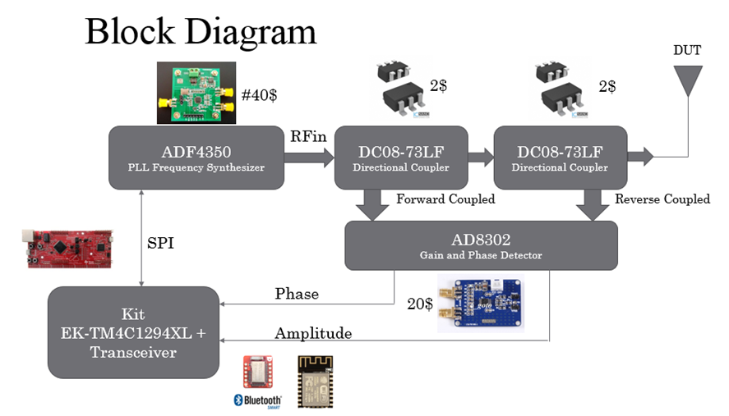

*Figure 1: Block diagram of the proposed project*

The AD8302 is a fully integrated system for measuring gain/loss and phase in numerous receive, transmit, and instrumentation applications. The AD8302 comprises a closely matched pair of demodulating logarithmic amplifiers, each having a 60 dB measurement range. By taking the difference of their outputs, a measurement of the magnitude ratio or gain between the two input signals is available. These signals may even be at different frequencies, allowing the measurement of conversion gain or loss. With this advantages, we will make a small size low-cost VNA device.

The device will base on many available advantages of VNA - a basic type of network analyzers that measures both amplitude and phase properties with following advantages: broadband, popular, low cost, small size...

**2.System Architecture.**

The device includes these modules: PLL Frequency Synthesizer, Gain and Phase Detector, MCU. MCU will control PLL Frequency Synthesizer to generate a signal at a specific frequency, Gain and Phase Detector receive the transmitted and reflected signal for comparing show the Amplitude and the Phase of the RF, MCU receives the Amplitude and the Phase from the Gain and Phase Detector and calculate the result.

**PLL Frequency Synthesizer**: IC ADF4350 generates the RF to perform measuring.

**Gain and Phase Detector**: IC AD8302 which receiving the transmitted wave and reflected wave for comparing show the Amplitude and the Phase of the RF.

**MCU + Transceivers**: Via Analog to Digital Converter module, MCU (EK-TM4C1294XL) receives the Amplitude and the Phase from the Gain and Phase Detector. With 2 parameters and the frequency which is generated in the PLL Frequency Synthesizer to analyze the reflected wave in the antenna. After that, the result will be shown on the LCD or other devices through Transceivers.

**3.Conclusion**

A device that analyzes qualities of the antenna in IoT devices with small size, low cost and meet the frequency requirements.

*(For further information about our project, please visit* [*here*](https://drive.google.com/open?id=0B5wonmSyqy0GYWFaSG92a25LVm8)*)*