Low-cost vector network analyzer – VNA for measuring the antenna of IoT devices

Nguyen Manh Thao
Computer Engineering Department
University of Information Technology HCMC
Ho Chi Minh city, Vietnam
Manhthao.spm@gmail.com
Phan Tri Dung
Computer Engineering Department
University of Information Technology HCMC
Ho Chi Minh city, Vietnam
14520203@gm.uit.edu.vn

The project presents a device that analyzes qualities of the antenna in IoT devices by using the low cost embedded modules. It's used for developing wireless communication devices. The low cost VNA based on the principle of comparison between transmitted wave and reflected wave on the antenna to compute the reflected factor and appreciate qualities of the antenna.

Introduction
Nowadays, the IoT field is developing significantly, so the quality requirements of IoT devices is not only about the stable operation of itself but also a good ability in communicating with other IoT devices. Therefore, the demand of analyzing qualities of the antenna is more necessary. However, the solutions, as well as devices that analyze the quality of the antenna, are still not popular and expensive.
To measuring the quality of antenna, the RF loss that is created by antenna will be analyzed. There are some machines/devices can do this task such as:
- Voltage Standing Wave Ratio Meter (SWR Meter or VSWR Meter)^{[1]}
- Scalar Network Analyzer (SNA)^{[2]}
- Vector Network Analyzer (VNA)^{[3][4]}

 | Cost | Size | Frequency
SWR Meter | Low | Small | < 600 MHz
SNA | Low | Large | High
Normal VNA | High | Large | High
Soc VNA | Still in research | Small | 4GHz–32GHz
After reviewing these solutions as well as devices, our team decides to make a device having all advantages above and get rid of all disadvantages:

- Cost: Low (Under 100$)
- Size: Small
- Frequency: ISM band such as 433 MHz band, 900 MHz band, 2.4 GHz band
- Intuitive and easy to use

Target, content and plan

Target
Research and fabricate a device that analyzes qualities of the antenna in IoT devices with the low cost, lightweight and meet the frequency band requirements. The device contains following modules:
- PLL Frequency Synthesizer
- Directional Couplers
- Gain and Phase Detector
- MCU + Transceiver
Block diagram:
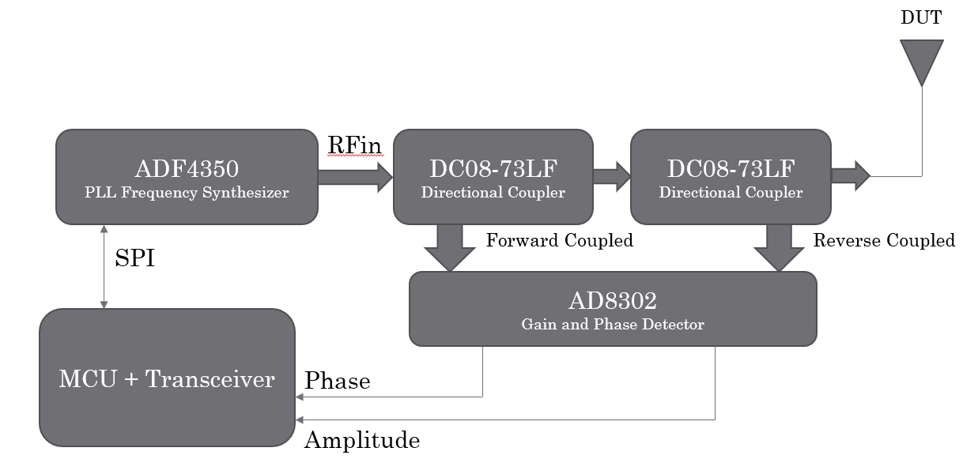

Content and plan
- Content 1: Review solutions as well as devices
- Content 2: Design schematic and block diagram
- Content 3: Programming libraries for the MCU to communicate with other modules, layout PCB
- Content 4: Connecting modules

MODULE DESCRIPTION AND PRINCIPLES
Before you begin to format your paper, first write and save the content as a separate text file. Keep your text and graphic files separate until after the text has been formatted and styled. Do not use hard tabs, and limit use of hard returns to only one return at the end of a paragraph. Do not add any kind of pagination anywhere in the paper. Do not number text heads-the template will do that for you.
Finally, complete content and organizational editing before formatting. Please take note of the following items when proofreading spelling and grammar:

PLL Frequency Synthesizer
To generate radio waves at a specific frequency, we chose a PLL Frequency Synthesizer IC - ADF4351 from Analog Devices company. IC ADF4351 is a Wideband Synthesizer with Integrated VCO which can generate waves from 35MHz to 4400MHz.
In our current prototype of VNA device, we use EVAL-ADF4351 board. This board is designed to allow the user to evaluate the performance of the ADF4351 frequency synthesizer for phase-locked loops (PLLs). It contains the ADF4351 integrated synthesizer and VCO, SMA connectors for the output signal, power supplies, a reference oscillator, and a USB connector. There is also a loop filter (35 kHz) on board. The price of EVAL-ADF4351 board is about 30USD from Chineses suppilers, quite low to make a low-cost device.

Directional Couplers
- Use either SI (MKS) or CGS as primary units. (SI units are encouraged.) English units may be used as secondary units (in parentheses). An exception would be the use of English units as identifiers in trade, such as “3.5-inch disk drive.”
- Avoid combining SI and CGS units, such as current in amperes and magnetic field in oersteds. This often leads to confusion because equations do not balance dimensionally. If you must use mixed units, clearly state the units for each quantity that you use in an equation.
- Do not mix complete spellings and abbreviations of units: “Wb/m2” or “webers per square meter,” not “webers/m2.” Spell units when they appear in text: “...a few henries,” not “...a few H.”
- Use a zero before decimal points: “0.25,” not “.25.” Use “cm3,” not “cc.” (bullet list)

Gain and Phase Detector
To analyze the difference between source waves from PLL Frequency Synthesizer module and reverse waves from the antenna under test, we use another IC from Analog Devices company - AD8302.
The AD8302 is a fully integrated RF IC for measuring amplitude and the phase between two independent input signals. The device can be used from low frequencies up to 2.7 GHz.
The AD8302 integrates two closely matched wideband logarithmic amplifiers, a wideband linear multiplier/phase detector, precision 1.8V reference, and analog output scaling circuits.
The applied input signal can range from -60 dBm to 0 dBm (ref 50 Ω), which corresponds to a 60 dB dynamic range.
Its price from Chineses suppliers is about 10USD for EVAL-board and 1USD for an IC.

Microcontroller and Transceiver
Currently, our VNA device can work dependently and show the measuring result on its LCD or on Android phone via Bluetooth connection.
For the Bluetooth connection between our VNA device and Android phone, we use Bluetooth module HC-05. Module HC-05 use Bluetooth 2.0 technology with very simple AT-commands interface to control via UART protocol.
For the MCU, we choose Tiva Connected Launchpad with ARM Cortex-M4F-Based MCU TM4C1294. The main reason is that Tiva Connected Launchpad supports Ethernet connection which helps our device access to the internet and can expand in future development. Besides, Tiva Connected Launchpad supports many connection interfaces such as UART, SPI, I2C,...

Difficulties
Due to boards from Genuine doesn't work correctly as the genuine board, there is some error in the result when compared to the professional device.

Development
In future development, we will develop a website for user to see the measure result. Web can run on many platform such as Windows, Mac, Linux, Android, iOS,…

References
- The ARRL Antenna Book (21st ed.), The American Radio Relay League, Inc., 2007, ISBN 0-87259-987-6
- Introduction to Network Analyzer Measurements Fundamentals and Background - National Instruments, http://www.ni.com/rf-academy
- Highly Integrated 4–32-GHz Two-Port Vector Network Analyzers for Instrumentation and Biomedical Applications, Johannes Nehring, Marco Dietz, Robert Weigel
- Introduction to Network Analyzer Measurements Fundamentals and Background - National Instruments, http://www.ni.com/rf-academy

