Low-cost vector network analyzer – VNA for measuring the antenna of IoT devices

Nguyen Manh Thao
Computer Engineering Department
University of Information Technology HCMC
Ho Chi Minh city, Vietnam
Manhthao.spm@gmail.com
Phan Tri Dung
Computer Engineering Department
University of Information Technology HCMC
Ho Chi Minh city, Vietnam
14520203@gm.uit.edu.vn

The project presents a device that analyzes qualities of the antenna in IoT devices by using the low cost embedded modules. It's used for developing wireless communication devices. The low cost VNA based on the principle of comparison between transmitted wave and reflected wave on the antenna to compute the reflected factor and appreciate qualities of the antenna.

Introduction
Nowadays, the IoT field is developing significantly, so the quality requirements of IoT devices is not only about the stable operation of itself but also a good ability in communicating with other IoT devices. Therefore, the demand of analyzing qualities of the antenna is more necessary. However, the solutions, as well as devices that analyze the quality of the antenna, are still not popular and expensive.
To measuring the quality of antenna, the RF loss that is created by antenna will be analyzed. There are some machines/devices can do this task such as:
- Voltage Standing Wave Ratio Meter (SWR Meter or VSWR Meter)
- Scalar Network Analyzer (SNA)
- Vector Network Analyzer (VNA)

 | Cost | Size | Frequency
SWR Meter | Low | Small | < 600 MHz
SNA | Low | Large | High
Normal VNA | High | Large | High
Soc VNA | Still in research | Small | 4GHz–32GHz
After reviewing these solutions as well as devices, our team decides to make a device having all advantages above and get rid of all disadvantages:

- Cost: Low (Under 100$)
- Size: Small
- Frequency: ISM band such as 433 MHz band, 900 MHz band, 2.4 GHz band
- Intuitive and easy to use

Target, content and plan

Target
Research and fabricate a device that analyzes qualities of the antenna in IoT devices with the low cost, lightweight and meet the frequency band requirements. The device contains following modules:
- PLL Frequency Synthesizer
- Directional Couplers
- Gain and Phase Detector
- MCU + Transceiver
Block diagram:
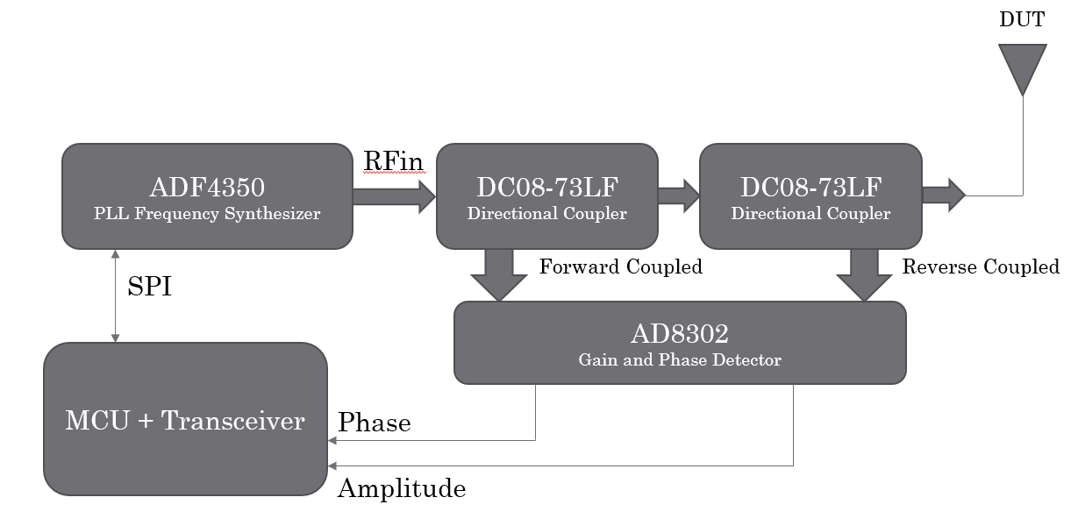

Content and plan
- Content 1: Review solutions as well as devices
- Content 2: Design schematic and block diagram
- Content 3: Programming libraries for the MCU to communicate with other modules, layout PCB
- Content 4: Connecting modules

MODULE DESCRIPTION AND PRINCIPLES

PLL Frequency Synthesizer
To generate radio waves at a specific frequency, we chose a PLL Frequency Synthesizer IC - ADF4351 from Analog Devices company. IC ADF4351 is a Wideband Synthesizer with Integrated VCO which can generate waves from 35MHz to 4400MHz.
In our current prototype of VNA device, we use EVAL-ADF4351 board. This board is designed to allow the user to evaluate the performance of the ADF4351 frequency synthesizer for phase-locked loops (PLLs). It contains the ADF4351 integrated synthesizer and VCO, SMA connectors for the output signal, power supplies, a reference oscillator, and a USB connector. There is also a loop filter (35 kHz) on board. The price of EVAL-ADF4351 board is about 30USD from Chineses suppilers, quite low to make a low-cost device.

Directional Couplers
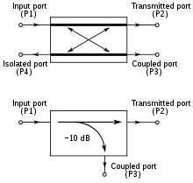
Two symbols used for directional couplers¹
- Directional couplers are most frequently constructed from two coupled transmission lines set close enough together such that energy passing through one is coupled to the other.
Identify applicable sponsor/s here. If no sponsors, delete this text box (sponsors).
- The main line is the section between ports 1 and 2 and the coupled line is the section between ports 3 and 4. Any port can be the input
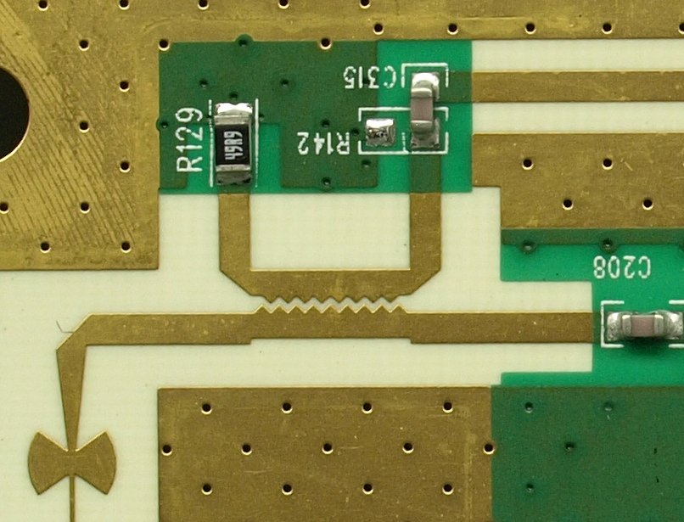
Microstrip Sawtooth Directional Coupler¹

- We use the IC DC08-73 Directional Coupler 0.3–2.7 GHz for our device because it has many advantages:
- Low cost
- Low profile
- Small SOT-6 package ●
- Available on tape and reel
- Available lead (Pb)-free and RoHS-compliant MSL-1 @ 260 °C per JEDEC J-STD-020
- The coupler will take out the feedback signal from the antenna and then transmit it to the AD to compare with the transmitted signal ( orginal signal).

Gain and Phase Detector
To analyze the difference between source waves from PLL Frequency Synthesizer module and reverse waves from the antenna under test, we use another IC from Analog Devices company - AD8302.
The AD8302 is a fully integrated RF IC for measuring amplitude and the phase between two independent input signals. The device can be used from low frequencies up to 2.7 GHz.
The AD8302 integrates two closely matched wideband logarithmic amplifiers, a wideband linear multiplier/phase detector, precision 1.8V reference, and analog output scaling circuits.
The applied input signal can range from -60 dBm to 0 dBm (ref 50 Ω), which corresponds to a 60 dB dynamic range.
Its price from Chineses suppliers is about 10USD for EVAL-board and 1USD for an IC.

Microcontroller and Transceiver
Currently, our VNA device can work dependently and show the measuring result on its LCD or on Android phone via Bluetooth connection.
For the Bluetooth connection between our VNA device and Android phone, we use Bluetooth module HC-05. Module HC-05 use Bluetooth 2.0 technology with very simple AT-commands interface to control via UART protocol.
For the MCU, we choose Tiva Connected Launchpad with ARM Cortex-M4F-Based MCU TM4C1294. The main reason is that Tiva Connected Launchpad supports Ethernet can expand in future development. Besides, Tiva Connected Launchpad supports many connection interfaces such as UART, SPI, I2C,...

Acknowledgment and Difficulties
Some modules don’t work stably

Development

References
The template will number citations consecutively within brackets [1]. The sentence punctuation follows the bracket [2]. Refer simply to the reference number, as in [3]—do not use “Ref. [3]” or “reference [3]” except at the beginning of a sentence: “Reference [3] was the first ...”
Number footnotes separately in superscripts. Place the actual footnote at the bottom of the column in which it was cited. Do not put footnotes in the reference list. Use letters for table footnotes.
Unless there are six authors or more give all authors’ names; do not use “et al.”. Papers that have not been published, even if they have been submitted for publication, should be cited as “unpublished” [4]. Papers that have been accepted for publication should be cited as “in press” [5]. Capitalize only the first word in a paper title, except for proper nouns and element symbols.
For papers published in translation journals, please give the English citation first, followed by the original foreign-language citation [6].

- https://en.wikipedia.org/wiki/Power_dividers_and_directional_couplers (references)
We suggest that you use a text box to insert a graphic (which is ideally a 300 dpi resolution TIFF or EPS file with all fonts embedded) because this method is somewhat more stable than directly inserting a picture.
To have non-visible rules on your frame, use the MSWord “Format” pull-down menu, select Text Box > Colors and Lines to choose No Fill and No Line.
- J. Clerk Maxwell, A Treatise on Electricity and Magnetism, 3rd ed., vol. 2. Oxford: Clarendon, 1892, pp.68-73.
- I.S. Jacobs and C.P. Bean, “Fine particles, thin films and exchange anisotropy,” in Magnetism, vol. III, G.T. Rado and H. Suhl, Eds. New York: Academic, 1963, pp. 271-350.
- K. Elissa, “Title of paper if known,” unpublished.
- R. Nicole, “Title of paper with only first word capitalized,” J. Name Stand. Abbrev., in press.
- Y. Yorozu, M. Hirano, K. Oka, and Y. Tagawa, “Electron spectroscopy studies on magneto-optical media and plastic substrate interface,” IEEE Transl. J. Magn. Japan, vol. 2, pp. 740-741, August 1987 [Digests 9th Annual Conf. Magnetics Japan, p. 301, 1982].
- M. Young, The Technical Writer’s Handbook. Mill Valley, CA: University Science, 1989.

