PIXIE Micro Transceiver
The common definition of PIXIE is a "Magical fairy that is somewhat mischievous". With respect to this common definition, the pixie TCVR would be a basic milli watt amateur radio transceiver that allows two way simple communications that seem magical in todays world of complex digital communications.
A search on the internet will reveal much researched data on the basic pixie transceiver. There are several design versions, but I consider the W1FB version the most basic and practical. The Pixie can be made to work on any HF amateur band by changing the value's of the mandatory out-put filter and the VXO crystal for the appropriate amateur band QRP frequency. The typical pixie has a 2N2222 for the transistors, but for power to about 1W consider changing the PA transistor to a 2N3053, 2N2219, or 2N5109. R4 is scaled appropriately. It is recommended to use toroid core inductors rather than discrete component inductors for the out-put filters. An RF BPF filter is more appropriate to cut-down AM band BCI.
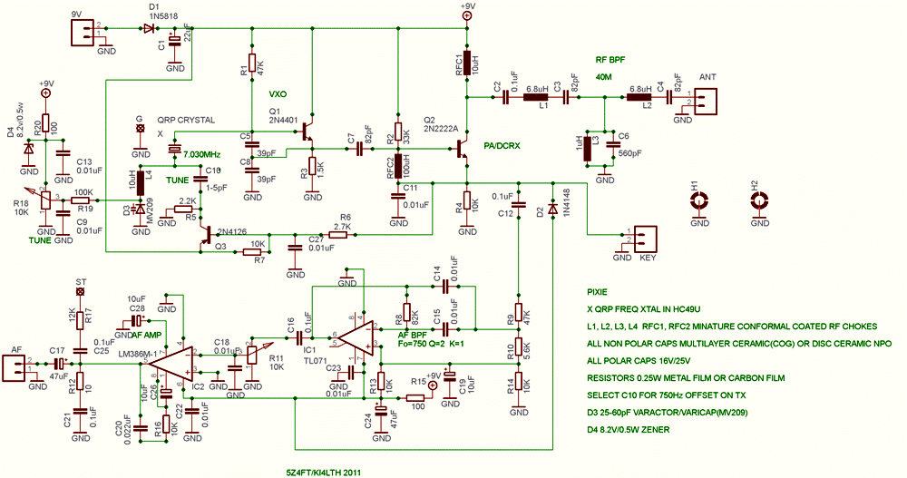

RF Filter values for the pixie, using standard value minature RF conformal coated epoxy inductors and NPO or COG capacitors.
