**Charmhigh Automatic Chip Mounter CHM-T36VA**

**Undocumented Features**

**(user contributed)**

**Table of Contents**

1. Revision History 2

2. System Inner Parameter Set 3

3. Threshold Adjust 5

4. Calibrating the origin 6

5. Focus of Up Camera 7

# Revision History

This document describes undocumented features of the CharmHigh software, as best as can be figured out. It supplements the user-contributed manual

CHM-T36VA_UserManual_OpenSource1p0, based on the software version CHM-T36A_V3615. The menus here use the new English translations given in the file smt_English_OpenSource1p0.qm that is distributed with the above manual.

# System Inner Parameter Set

In the “Set” / “System set” window, enter the password 20090318 and the following window opens.

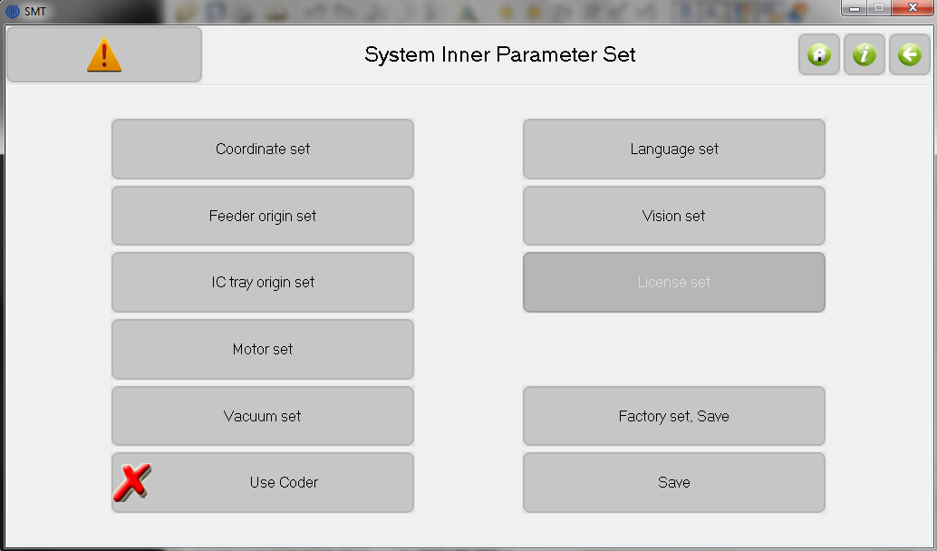

**Figure 2.1.** Window for setting the system inner parameters.

This window allows setting of various inner (low level) system parameters. One should use caution changing parameters here, since this window is primarily used to initially calibrate the machine at the factory.

1. **Coordinate Set:** Coordinates X\Y can be set for the following subsystems, which presumably describe their physical locations on the x-y stage. Some subsystems are blanked out, presumably since they can’t be changed.
   1. **Machine Distance:** Unknown
   2. **Coder pos calibrate:** Unknown
   3. **DownCamera coordinate:**
   4. **UpCamera coordinate:**
   5. **Nozzle1\2 coordinate:**
2. **Feeder origin set:** This defines the location coordinates X\Y for feeder numbers 1-29.
   1. **Pick coordinates:** Location of the component on the feeder tape.
   2. **Needle pull coordinate:** Location of the hole in the tape that gets advanced by the needle.
   3. **Initialize:** This window allows feeders 2-29 to have Pick and/or Needle pull coordinates to be set according to the calibration of feeder 1, since these relative locations are at known distances.
3. **IC tray origin set:** Defines the pick coordinates for the fixed IC tray, normally set as the center of the tray.
4. **Motor set:** Operating parameters for the X, Y, Angle and Z motors; for pulse, speed and acceleration.
5. **Vacuum set:** Operating parameters for vacuum subsystem.
   1. **Vacuum pump speed:** Presumably for pick operation.
   2. **Blow speed:** Presumably for place operation, release of vacuum and component.
   3. **Place component delay:**
   4. **Suck component delay:** Presumably for pick operation at feeders.
   5. **Suck IC delay:** Presumably for pick operation at IC trays.
   6. **Vacuum detection delay:**
6. **Use coder:** Guess is for use of angle coders on motors for closed-loop feedback.
7. **Language set:** Choose Chinese, English or Complex Chinese.
8. **Vision set:** Window for setting camera parameters.
   1. **Camera Up\Down:** Choose camera to display, normally up.
   2. **Threshold change:** Button steps through changes of 1, 3, 5 and 10. The left and right buttons changes the threshold. The center button displays the threshold, and when clicked you enter value.
   3. **Binary Image:** Black and white image displayed according to above threshold. This image is used by vision detection system.
   4. **Closure:** Unknown.
   5. **Pixel to mm:** Image offset in pixels multiplied by this number is offset in mm, which is then used for component placement. This number changes with up camera distance. Can be measured from known part size in mm divided by pixel size.
   6. **Update:** Assume saves the “Pixel to mm” conversion parameter.
   7. **R size X\Y:** Unknown. Range 1-100.
   8. **Calibrate:** Move to UpCamera looking at component.
   9. **Position:** Moves to PCB origin.
   10. **Image:** Bounding box displayed in blue when captured. Numbers below image are the size of box and presumably its uncertainty in pixels. The total screen size is 477 x 477 pixels.

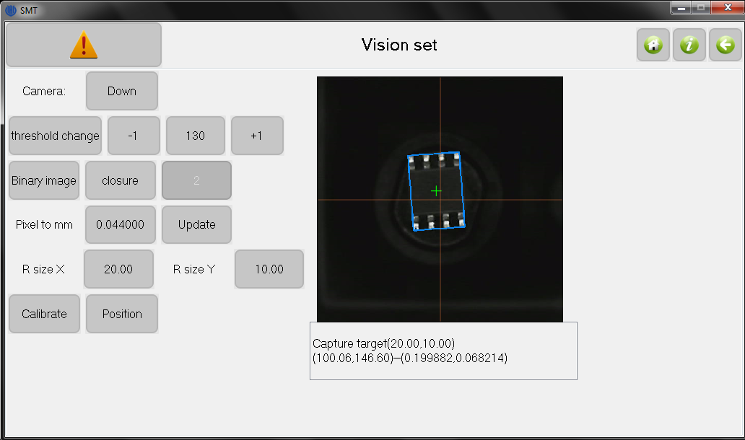

**Figure 2.2.** Widow for setting the vision parameters.

1. **License set:** Presumably sets license number associated with the machine.
2. **Factory set, Save:** Presumably saves current settings as a factory set, which can be restored in the regular menu (see section 12.3). This seems dangerous to use except at the factory.
3. **Save:** Save as current machine setting.

# Threshold Adjust

In the “Set” / “System set” window, type the password 74867430 and the following window will open. It is used to set the vision threshold.

The slider bar allows for fast adjustment of the threshold for optimizing its setting. The image on the right side shows the blue bounding box, when detected.

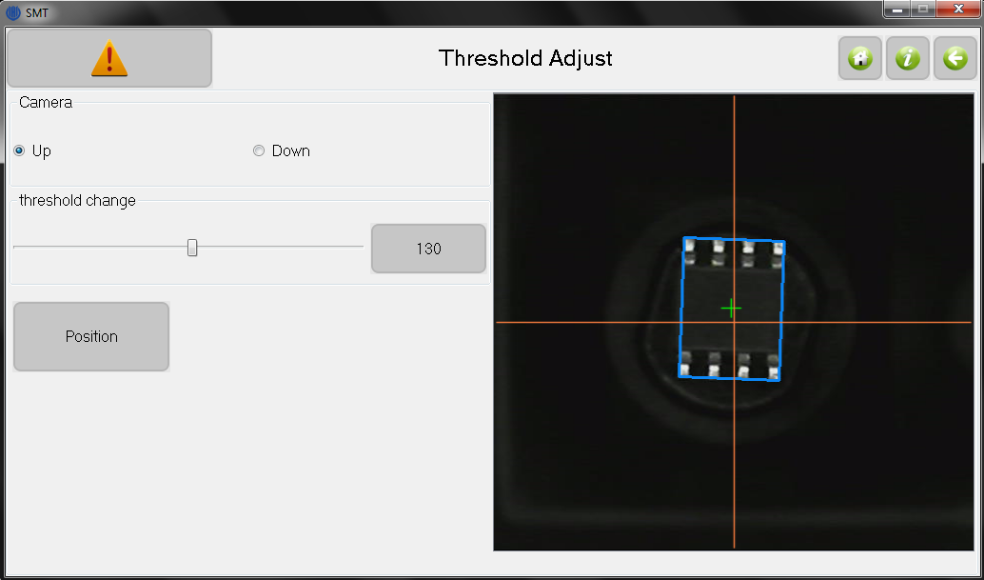

**Figure 3.1.** Window for easy setting of the vision threshold.

# Calibrating the origin

It is useful to understand how to set the various calibrations of the machine for reliable operation. The biggest area for confusion is the origin, which is also described with words like location, coordinate system or offset. A common problem with the CharmHigh documentation is the naming convention. Take for example the command “origin set”. What origin are you setting? It is not clear since origins and offsets are associated with the entire coordinate system, feeder, IC trays, nozzle1\2, pull needle, Up\Down Camera, PCB …

This issue is (hopefully) clarified with the revised English translation for all the menus, which associates names defined in the Glossary to each of these subsystems, to self-document the menu functions. For each button, the text format is noun / verb, the name and then the action associated with it.

The coordinate system can be understood as follows. The locations of parts are known since they are fixed by physically bolting the subsystems to the machine’s platten. These positions are measured at the factory with the coordinate system of the x-y stage, and then stored in the “inner system parameter” file. They can be viewed or changed as described in section 2.

However, only the relative distance between these positions are actually known, since during software boot the absolute position of the x-y stage may not be set reliably. This is because the stage position is defined by limit switches, and the arms on these switches can possibly bend or otherwise change over time. Tests has shown that these limit switches reliably set the absolute position to about 30 um, so normally one does not have to worry about this. But accidental operation can bend or change the limit switches in some way, changing the origin, so it is best after doing a boot or “origin set” to check the absolute location. The easiest way to do this is to use “Diagnostics” and select “DownCamera\Nozzle to PCB origin”. This reset location on the front PCB holder is shown in the green circle in Fig. 4.1 below. This has been found to reset to the same position in a reliable manner.

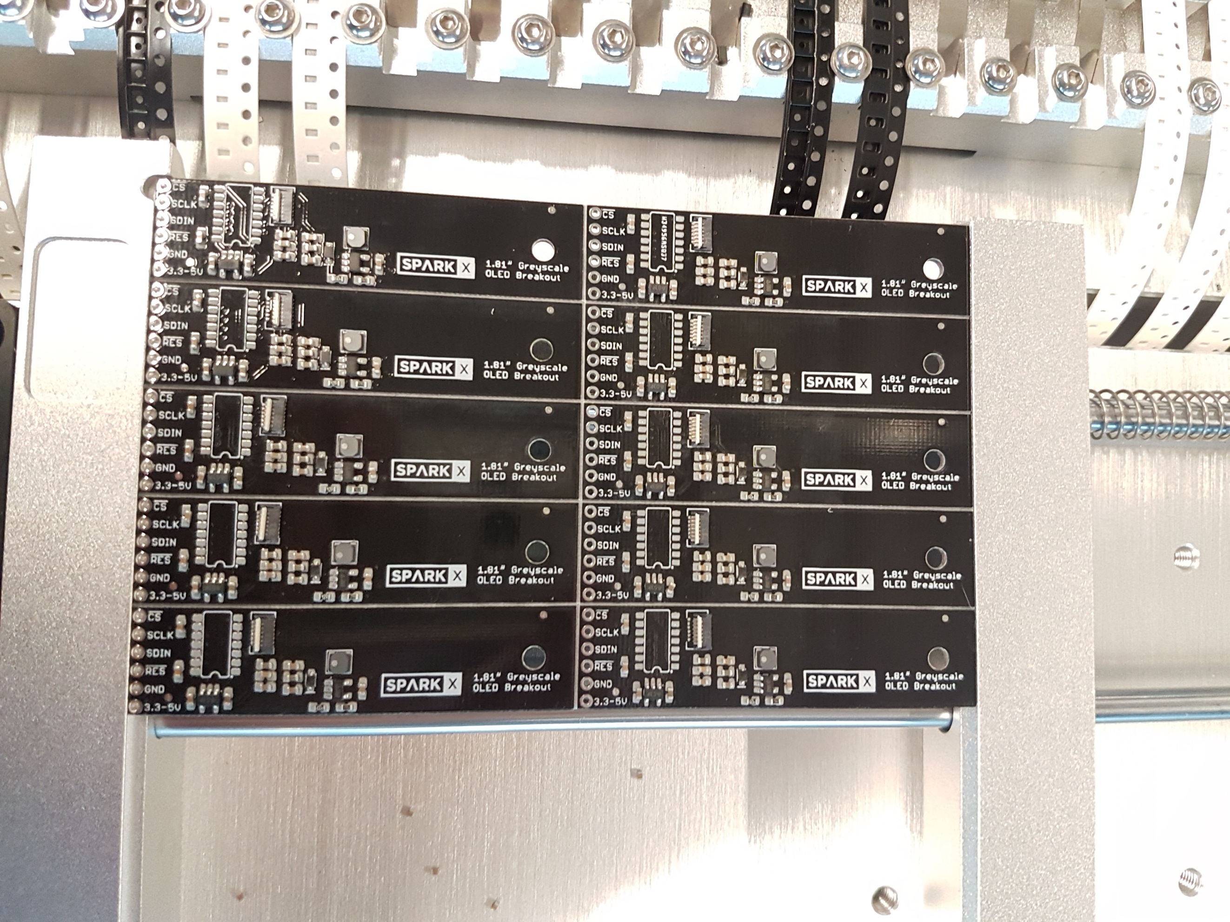

**Figure 4.1.** Photograph showing PCB properly set in holder at front-left stop, indicated by green circle.

The big problem comes if there is a change to the limit switch. This will appear as an offset to ALL the systems on the platen, such as the PCB, feeders and IC trays. Since all of these offsets are the same, it would be easiest to account for it by an “origin reset offset” that always gets added to the x-y coordinate. But this does not exist for the software system. Right now, one has to recalibrate all these parameters by adding in the new offset. This is a lot of work, so users should be talking to CharmHigh to add this feature.

# Focus of Up Camera

As noted by the Google group, the z-position of the up camera is not set well at the factory. Because the nozzle does not move up and down during the vision operation (presumably for speed), the bottom surface moves out of focus for large component heights.

Measurements have shown a component does not have a degraded focus if the bottom surface is about 6.5 to 13 mm above the top of the black vision block. The focus is still good from 5 to 15 mm. The nominal height of the nozzle is 7.5 mm, so best focus is for component heights 0 to 1 mm, and good focus is retained for heights to 2.5 mm. So thick components will not focus well.

Since the camera has intrinsically a large focus range, the obvious solution is to move the camera down by at least 2.5 mm to retain good focus, or 4 mm to have best focus for the entire height range. Moving the camera down decreases the image size, degrading accuracy a bit, so this is probably why the camera position was chosen so high.

Note that when moving the camera, you should probably measure and set the “pixel to mm” conversion factor that is seen in “Vision Set” window, Figure 2.2 above. This conversion factor can be computed by measuring the width of a component with calipers, in mm, and then dividing by the pixel width of the component displayed in the vision system below the image. It is important to set this parameter correctly because the offset measured by the up camera has to get converted to an offset in mm, which is then applied as an offset when placing the component. Using the wrong multiplier parameter will introduce an offset error.

Note that this multiplier parameter should ideally change with the height of the component. However, this change is small and thus introduces a negligible error since the offset magnitudes are so small.