User Manual

for

EyeVision
(Multi-object Tracking for the Eyelink-II System)

Version 1.0

28 May 2007

Contributors

Bahar Akbal | bahar.akbal@gmail.com | • Graphics Engine (selection & gelog)  • Analysis Tool (perf)
Elena Khan | ekhan@cs.umb.edu | • Introduction  • GraphicsEngine (interpreter)  • Analysis Tool (xml2xls)
Andreas Lennartz | andreas.lennartz@gmail.com | • Experiment Builder
Smitha Madhavamurthy | smitha@honnu.com | • Analysis Tool
May Wong | msint@cs.umb.edu | • GraphicsEngine (display)

Table of Contents

1 Introduction to EyeVision 1
1.1 How this document is arranged 1
1.2 Functional Description 1
1.3 Terminology 2
1.4 Prerequisite Software 2
1.5 Installation 3
1.5.1 EyeVision Installation 3
1.5.2 Interop Assemblies Installation 3
1.5.3 EVS Directory Layout 4
1.5.4 Types of Files (in order of appearance) 5
2 Experiment Builder 7
2.1 Starting the Program 7
2.2 Walk-through 7
2.3 Output of the Experiment Builder 13
2.4 Development 15
2.5 Source documentation 15
2.6 Known Issues 15
2.7 Further Improvements 15
3 Graphics Engine 16
3.1 the Interpreter 16
3.1.1 the GUI 16
3.1.2 the Parser 17
3.1.3 Development 17
3.1.3.1 Source Files 17
3.1.3.2 the GUI 17
3.1.3.3 Testing the GUI 18
3.1.3.4 Adding a New GUI to the Graphics Engine 18
3.1.3.5 Compilation Reference for the GUI 18
3.1.3.6 the Parser 19
3.1.3.7 External Libraries for the Parser 19
3.1.3.8 Testing the Parser (and more information about how it works) 20
3.1.3.9 Adding Parser Changes to the Graphics Engine 24
3.1.3.10 Compilation Reference for the Parser 24
3.1.4 Known Issues 25
3.2 the Display functionality (the GE “core”) 26
3.2.1 Usage of Graphics Engine 26
3.2.2 Required Libraries for GE moving objects 26
3.2.3 Connecting to EyeLinkII and Simulation offline mode 26
3.2.3.1 Run Graphics Engine in Simulation Mode 26
3.2.3.2 Run Graphics Engine in Eye Link Mode 26
3.2.4 Input Parameters for GE moving objects 27
3.2.5 Display and Move Objects on the Screen 27
3.2.5.1 Start of Graphics Engine 27
3.2.5.2 Before Objects Start Moving 27
3.2.5.3 Moving Objects 27
3.2.5.4 Objects Stop Moving 28
3.2.6 Monitor Frame rate setting for running Graphics Engine 28
3.2.7 Information in Graphics Engine Code 28
3.3 Target Selection 29
3.4 Output (the .gelog file) 30
3.4.1 GELog File Format 30
3.4.2 Development 31
3.4.3 Further Improvements 31
• Keeping partial GELog files for aborted trials: 31
• Repeating trials after resuming the session: 31
• Displaying warning message for incomplete target selections: 31
4 Analysis Tool 33
4.1 Introduction 33
4.1.1 Performance File Creation 33
4.1.2 Replay Trial 33
4.1.3 Excel File Creation 33
4.2 System Requirements 34
4.2.1 Libraries Required 34
4.2.2 File Structure Requirements 34
4.2.2.1 Executable 34
4.2.2.2 Input Files 34
4.2.2.3 Output Files 35
4.3 Implementation Details 36
4.3.1 Analysis Tool GUI 36
4.3.1.1 Screen Shot 36
4.3.1.2 Functionality Provided with the GUI 36
4.3.2 Compilation Options 37
4.3.3 Error Handling 37
4.3.4 Source code 38
4.3.5 Test cases 41
4.3.6 Enhancement Options 41
4.4 Sample File Formats 42
4.4.1 Sample Performance File from a session 42
4.4.2 Sample Display File for a Trial 43
4.4.3 Sample Excel File for a Trial 44
5 References 45

Table of Figures

Figure 1.1 Example of "still shot" visual attention test 1
Figure 1.2 How a multi-object tracking test works 2
Figure 2.1 Experiment Builder - Initial screen 7
Figure 2.2 Experiment Builder - Add block of trials (begin) 8
Figure 2.3 Experiment Builder - Add block of trials (completed) 9
Figure 2.4 Experiment Builder - List of blocks of trials 10
Figure 2.5 Experiment Builder – viewing different order of trial blocks 11
Figure 2.6 Experiment Builder - Naming the experiment 12
Figure 2.7 Experiment Builder - Saving the input parameters to a file 13
Figure 2.8 Experiment Builder - Example of .session file 14
Figure 3.1 List of files required to run the Graphics Engine 16
Figure 3.2 Graphics Engine GUI 16
Figure 3.3 List of files for Graphics Engine (interpreter) 17
Figure 3.4 List of files for Graphics Engine (GUI) 18
Figure 3.5 List of functions provided by Graphics Engine (interpreter) 19
Figure 3.6 Graphics Engine (interpreter) - example debug output (view 1) 21
Figure 3.7 Graphics Engine (interpreter) - example debug output (view 2) 23
Figure 3.8 Graphics Engine - Screenshot of target object submission 29
Figure 3.9 Graphics Engine - Example of GELog file format 31
Figure 4.1 Analysis Tool - Example of .xls (EVSview2) 34
Figure 4.2 Analysis Tool GUI 36
Figure 4.3 Analysis Tool - List of source files 41
Figure 4.4 Analysis Tool - Example of .perf file 42
Figure 4.5 Analysis Tool - Example of .display file 43
Figure 4.6 Analysis Tool - Example of .xls (EVSview1) 44

EyeVision
User Manual
Version 1.0

Introduction to EyeVision

How this document is arranged
This document presents information in three parts – one for each module of the EyeVision system. After this introductory section, there are sections for the Experiment Builder (first module), Graphics Engine (second module) and Analysis Tool (third module).

Functional Description
EyeVision (“EVS” for short) is a system for multi-object tracking experiments. It is designed to be an add-on for the Eyelink-II tracker in UMass Boston’s Visual Attention Lab. Currently, participants are tested using “still shots.” For example, they may be asked to find a smaller picture within a larger one, as in the following example:

Find this picture |  | → | 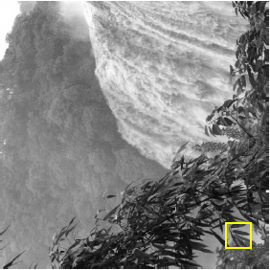  (example from http://www.cs.umb.edu/  ~marc/pubs/pomplun_imocs.pdf)

Figure 1.1 Example of "still shot" visual attention test

The EyeVision system allows for participants to be tested using moving objects. These “multi-object tracking” tests have the following format:

step 1 | step 2 | step 3 | step 4 | step 5
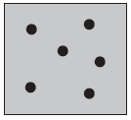 | 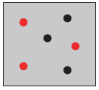 |  | 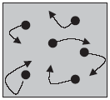 | 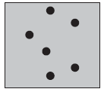  ?
The subject  sees  objects. | The “target”  objects  blink. | The targets  stop  blinking. | The  objects  move. | The subject  picks the  targets.
(pictures based on Cavanagh and Alvarez, “Tracking multiple targets with multifocal attention”,
TRENDS in Cognitive Sciences, July 2005.
Figure 1.2 How a multi-object tracking test works

In order to create these tests, the parameters of a test (for example, how many objects there are and how fast they move) are submitted to the Experiment Builder (first module of EVS). These parameters are fed into the Graphics Engine (second module of EVS), which displays the tests. The Graphics Engine is the only module that an experimental participant (or subject) interacts with. The Analysis Tool (third module of EVS) provides feedback to the experimenter: it can create a statistics file (one per participant, or “session”), can replay an individual test (participants sit for several tests, or “trials”), and can output an .xls file that shows the object locations and subject’s gaze at regular time intervals.

The three modules are stand-alone applications; they can be run independently of each other. For example, the experimenter can create an experiment with the Experiment Builder on Monday. He can then test subjects Tuesday through Thursday. Finally, he can use the Analysis Tool to create statistics for each session on Friday.

Terminology
The following terms are used for the EyeVision system:
- experiment – a set of sessions
- session – a set of trials lasting approximately 30 minutes. Each session shows the same set of trials in a different (random) order. In other words, each participant sees the same trials but in different order.
- trial – an individual test of visual attention
- subject – a participant in the research. A subject sits for one session.

So, if an experiment needs to test 100 people, then there must be 100 session files (one session file per subject). Each of those sessions will have the same number of trials (although in different order). Finally, the number of trials (i.e., individual tests) is determined by the experimenter.

Prerequisite Software
The obvious prerequisite is the Eyelink II system itself, which tracks and records a subject’s gaze (i.e., where on the screen the subject is looking). Since Eyelink provides gaze information, it is impossible to run experiments without it. However, the Graphics Engine is the only module that “talks” to Eyelink (during testing); the Experiment Builder and the Analysis Tool do not need Eyelink to be online for proper functioning. For development, even the Graphics Engine can run without Eyelink (via an edit to a function call and re-compilation).

The second prerequisite is Visual Studio 2005. Each module was developed with Visual Studio. So if any of the modules is going to be run on a machine, that machine must have VS installed.

The Graphics Engine requires three third-party libraries (described later in the document). These libraries are included in the installation .zip file and do not require any additional installation.

The Analysis Tool requires that the EDF2ASC.EXE file (from SR Research) be in C:\EVS\bin. This file is included with the EVS zip file.

The Analysis Tool provides an option to create an Excel spreadsheet (.xls) containing gaze and object location information. If this option will be used, then (1) Microsoft Office 2003 must be present on the machine and (2) the Primary Interop Assemblies (“PIA”) for Office 2003 must be installed. If these two pieces of software are not installed and the user tries to create an .xls file, he will see an error. The PIA is included in the installation .zip file and requires a separate installation step. Microsoft Office 2003 is not provided in the .zip file; it must be obtained separately.

Finally, it is assumed that the EyeVision system will be run on WindowsXP.

Installation

EyeVision Installation

The EyeVision system is provided as a .zip file. It unzips to a directory structure with EVS\ at the root. This EVS\ directory must be moved to the top-level C: directory because EyeVision expects all files to be located within C:\EVS.

The installation is simple:
- If there is already a C:\EVS directory, rename it. For example, you can rename it to something like C:\EVS.20070528 (The “F2” key on Windows is a shortcut to renaming files and directories.)
- unzip the provided .zip file to any location
- move or copy the unzipped EVS\ directory to C: The path to the EyeVision files now should be C:\EVS

Interop Assemblies Installation

As mentioned above, the Analysis Tool requires the Microsoft Primary Interop Assemblies (“PIA”) for the Excel spreadsheet creation functionality.

The installation procedure is as follows:
- Confirm that Microsoft Office 2003 is installed on the system. (If, for instance, Office 2002 is installed, the .xls functionality will not work. In this case, Office must be upgraded.)
- Check whether the PIA is already on the system.
Look for the file C:\Windows\assembly\Microsoft.Office.Interop.Excel.dll
If it is on the system, then the PIA is already installed
If it is not on the system, then the PIA is not installed
- If the PIA is on the system, confirm that it is version 11.0.0.0
The version can be seen either (1) by choosing View > Details in the Explorer window or (2) by right-clicking the file and choosing Properties
If the version is 11.0.0.0, then you do not have to do anything more.
If the version is something else, that other version must be uninstalled before proceeding.
- Locate the file C:\EVS\ext\AT\O2003PIA.EXE
This is a self-extracting executable provided by Microsoft. You can either run it from its current location or copy it somewhere else.
- Double-click the file to “unzip” it.
- After unzipping, locate O2003PIA.MSI. This file is the installer.
- Double-click O2003PIA.MSI to install the PIA. (This will install the PIA for all Office components even though EVS only needs the Excel component. Microsoft only distributes the PIA as a bundle.)

If you must upgrade Office and/or remove the PIA, follow this procedure:
- Confirm that the PIA is installed on the system. If the file C:\Windows\assembly\Microsoft.Office.Interop.Excel.dll is present on the system, then the PIA is present.
- Uninstall the PIA. Go to Start > Control Panel > Add or Remove Programs
- Highlight “Microsoft Office 2003 Primary Interop Assemblies”
- click Remove
- uninstall the older version of Microsoft Office
- install Office 2003
- follow the previous set of instructions for installing the PIA

EVS Directory Layout

The EVS directory structure is as follows:

C:\EVS
C:\EVS\bin
C:\EVS\doc
C:\EVS\ext
C:\EVS\experiments
C:\EVS\experiments\[exp_name]
C:\EVS\experiments\[exp_name]\images
C:\EVS\experiments\[exp_name]\perf
C:\EVS\experiments\[exp_name]\perf\Exp1_Sess1.perf
C:\EVS\experiments\[exp_name]\Sess1
C:\EVS\experiments\[exp_name]\Sess1\[exp_name]_Sess1.asc
C:\EVS\experiments\[exp_name]\Sess1\[exp_name]_Sess1.edf
C:\EVS\experiments\[exp_name]\Sess1\[exp_name]_Sess1.session
C:\EVS\experiments\[exp_name]\Sess1\Tr1
C:\EVS\experiments\[exp_name]\Sess1\Tr1\[exp_name]_Sess1_Tr1.display
C:\EVS\experiments\[exp_name]\Sess1\Tr1\[exp_name]_Sess1_Tr1.gaze
C:\EVS\experiments\[exp_name]\Sess1\Tr1\[exp_name]_Sess1_Tr1.gelog
C:\EVS\experiments\[exp_name]\Sess1\Tr1\[exp_name]_Sess1_Tr1.xls
C:\EVS\include (not used)
C:\EVS\src

where
- bin\ contains the EyeVision executables. The contents of the bin directories are the same as the Visual Studio Release\ (for C#) or release\ (for C) directories.
- doc\ contains documentation (i.e., this document)
- ext\ contains external/3rd-party libraries
- experiments\ is the top-level directory for experimental data
- [exp_name] is the name of an experiment. This name is the only name that the user is allowed to choose. All the other directory and file names are standardized and cannot be changed.
- images\ contains the bitmaps that the Graphics Engine will display during a session
- perf\ contains the .perf (performance/statistics) files for the experiment (one .perf per session)
- Sess1\ shows how session directories are named. Subsequent directories would be named Sess2\, Sess3\, ..., etc. Session directories contain .session and .edf files.
- Tr1\ shows how trial directories are named. Subsequent directories would be named Tr2\, Tr3\, ..., etc. The trial directories contain .gaze, .gelog, .display, and .xls files.
- src\ contains the source code

Types of Files (in order of appearance)

- .session – xml file containing set of trial descriptions (per session)
– created by Experiment Builder
– used by Graphics Engine
- .edf – binary data file containing gaze information (per session)
– created by Eyelink
– used by Analysis Tool
- .gelog – ascii file containing trial parameters, object locations and user selection
(per trial)
– created by Graphics Engine
– used by Analysis Tool
- .asc – asc file containing information from .edf file (per session)
– created by Analysis Tool using EDF2ASC.EXE (provided by SR Research)
– used by Analysis Tool to create .gaze files
- .gaze – asc file containing gaze info (per trial)
– contains the same info as the .asc file. (per trial)
The .asc file contains gaze info for the entire session.
The .gaze file contains gaze info for each trial.
– created from .asc by Analysis Tool
- .display – xml file containing both gaze and object location information (per trial)
– created by Analysis Tool by merging .gaze and .gelog files
– used to Analysis Tool for the replay functionality
- .xls – Excel file containing the same information as .display (per trial)
– provided as a user-friendly way to view the data
– created by Analysis Tool
– viewed by experimenter
- .perf – “performance” files; asc file containing summary/statistics (per session)
– created by Analysis Tool from each trial’s .gelog file
– used by third-party statistics program

Experiment Builder

Starting the Program
The Experiment Builder consists of a single executable file, C:\EVS\bin\EB\ExperimentBuilder.exe. Execution of this file (e.g. double-click) starts the application. The only prerequisite is that .NET 2.0 is installed on the host machine. There are no other dependencies.

Walk-through
After starting the application, the following screen will be displayed:

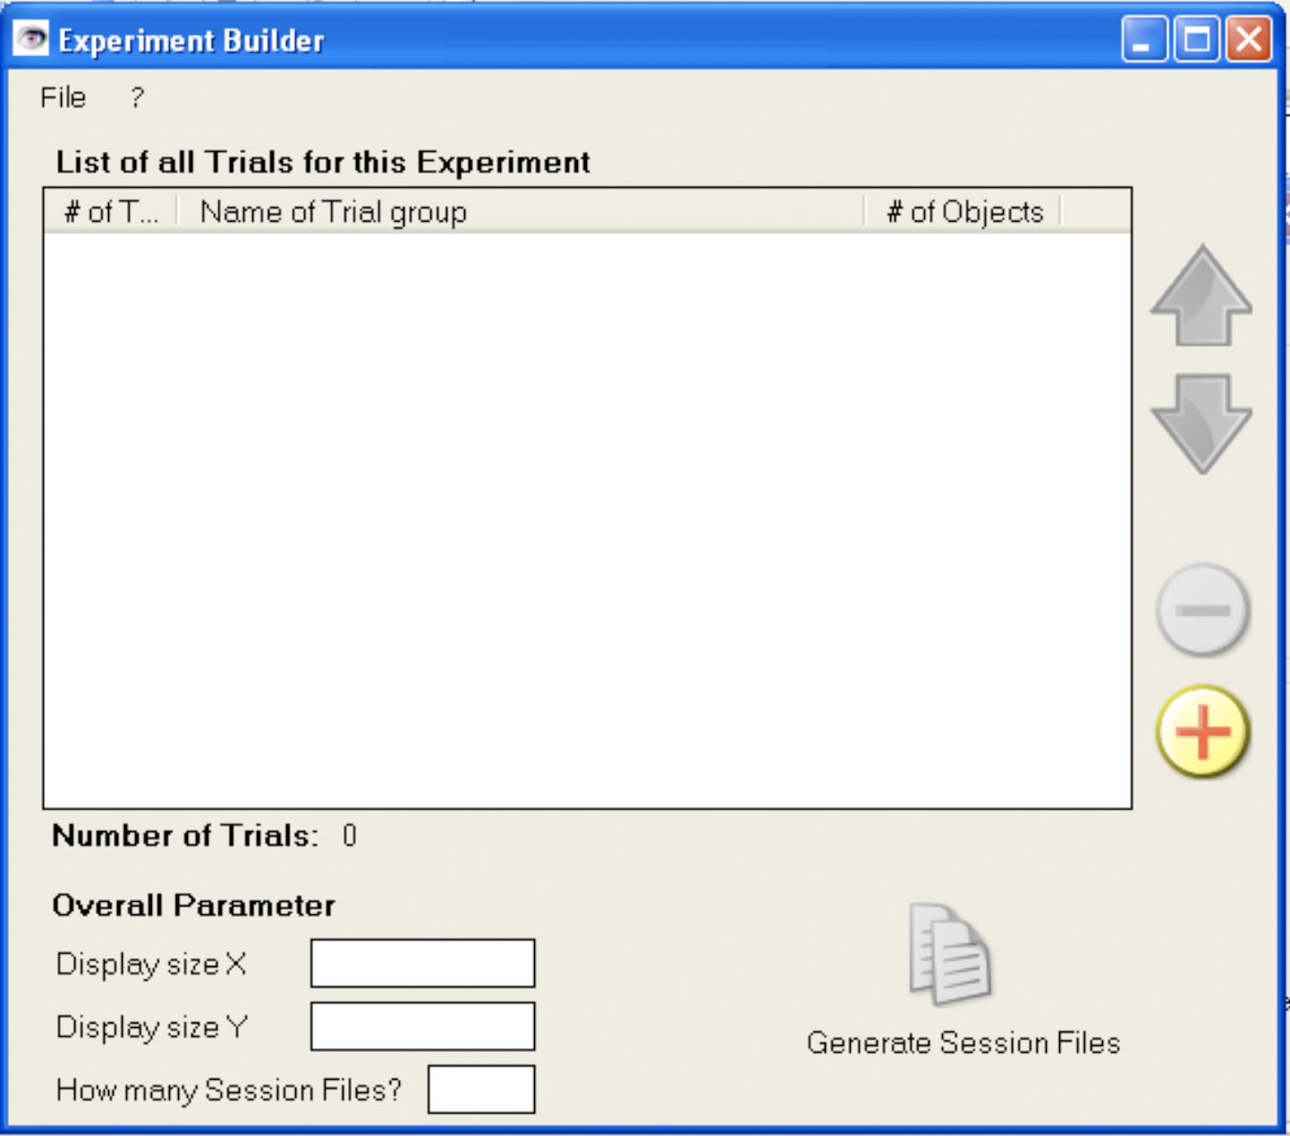
Figure 2.3 Experiment Builder - Initial screen

At the beginning, the only option the user has is either to load an existing experiment binary file (“.eb”) or to add a new block of trials to the empty session. To add a new block of trials, click the “+”-button. The following form will appear:

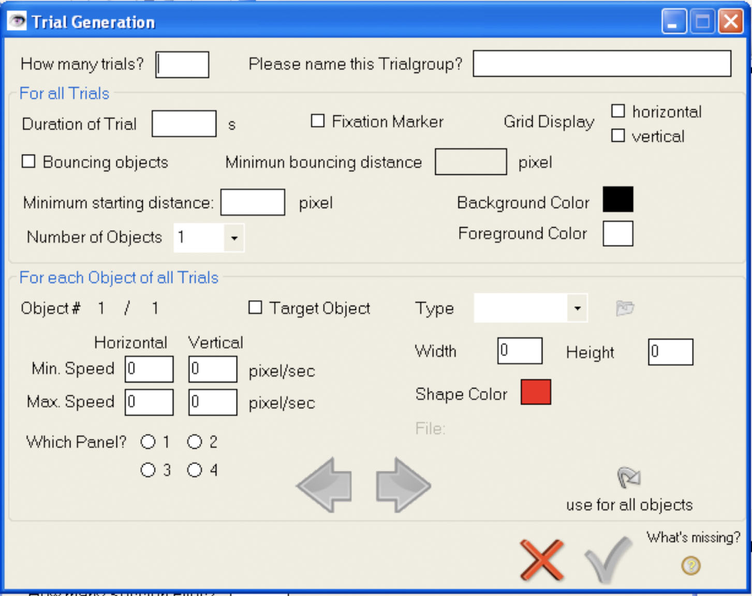
Figure 2.4 Experiment Builder - Add block of trials (begin)

Here the different parameters for a block of trials can be specified. These are:

For the whole block of trials:
- Numbers of trials for this block
- Condition name of trial block

For each block of trials, you can specify:
- Maximum duration of each trial
- If a fixation marker (a cross the user has to focus on during the experiment) should be displayed
- If a horizontal, vertical (or both) grid will be displayed, that separates the screen in different areas
- If the objects bounce off from each other
- When the objects are bouncing off, at which minimum distance they will do this.
- The minimum starting distance the objects are away from each other at the beginning of each trial
- The foreground color of each trial (click on the color to change it)
- The background color of each trial (click on the color to change it)
- The number of objects for each trial

For each object in each trial, the following parameters can be defined:
- If the objects is a target object (e.g., if it blinks at the beginning of a trial)
- The minimum and maximum speed for horizontal and vertical movement
- The area of the screen in which the objects is positioned at the beginning of each trial
- How the objects looks like. Can be either the pre-defined shapes Circle/Ellipse or Rectangle/Square or a random bitmap file.
- If the object should be a Circle/Ellipse or Rectangle/Square, either the X-and Y-Radius or the width and height in pixels can be specified
- If the object should be a Circle/Ellipse or Rectangle/Square, the color of the object can be defined (click on color to change it)
- If the type is bitmap, the user can choose the file from disk (click on the folder symbol)

To toggle between the different objects, the user can browse through them by clicking either on the left- or right-arrow. (Right-arrow: Next object, Left-Arrow: Previous object). If the user wants to use the parameter of one object for all objects, he just has to click on the “use for all objects”-button.

When all entries are filled, the user can add them to the Session List by clicking on the green checkmark. If he wants to close the window, he can click on the cross – all entered data will be gone. If the user thinks that he has entered all data needed, but the checkbox is still grayed out, he can get a list of missing parameters by clicking on the question mark below the text: “What’s missing?”

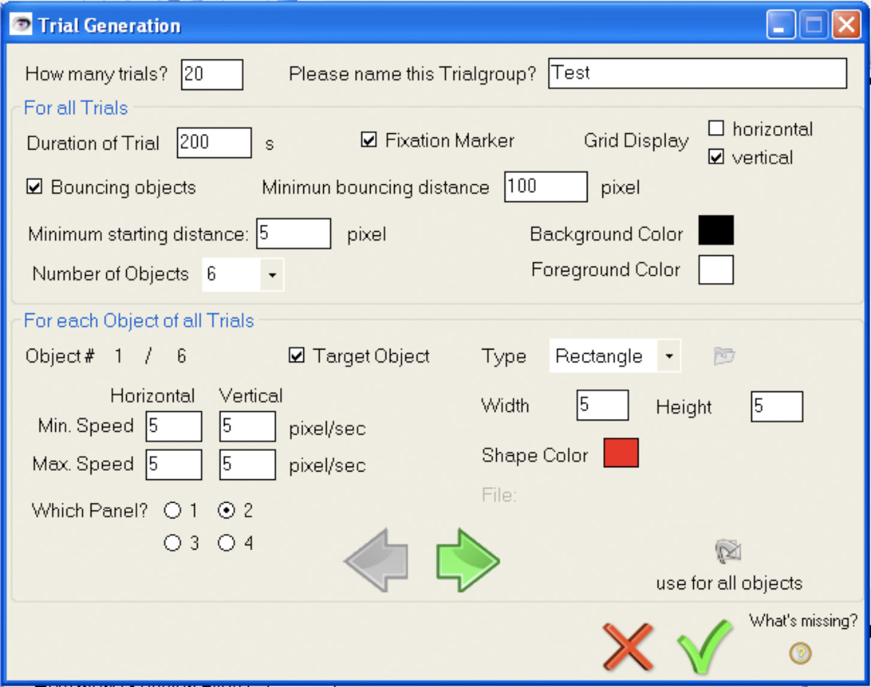
Figure 2.5 Experiment Builder - Add block of trials (completed)

After clicking on the checkmark, and adding another block of trial in the same way (clicking on the “+” button and entering the trial data), the application form will look like this:
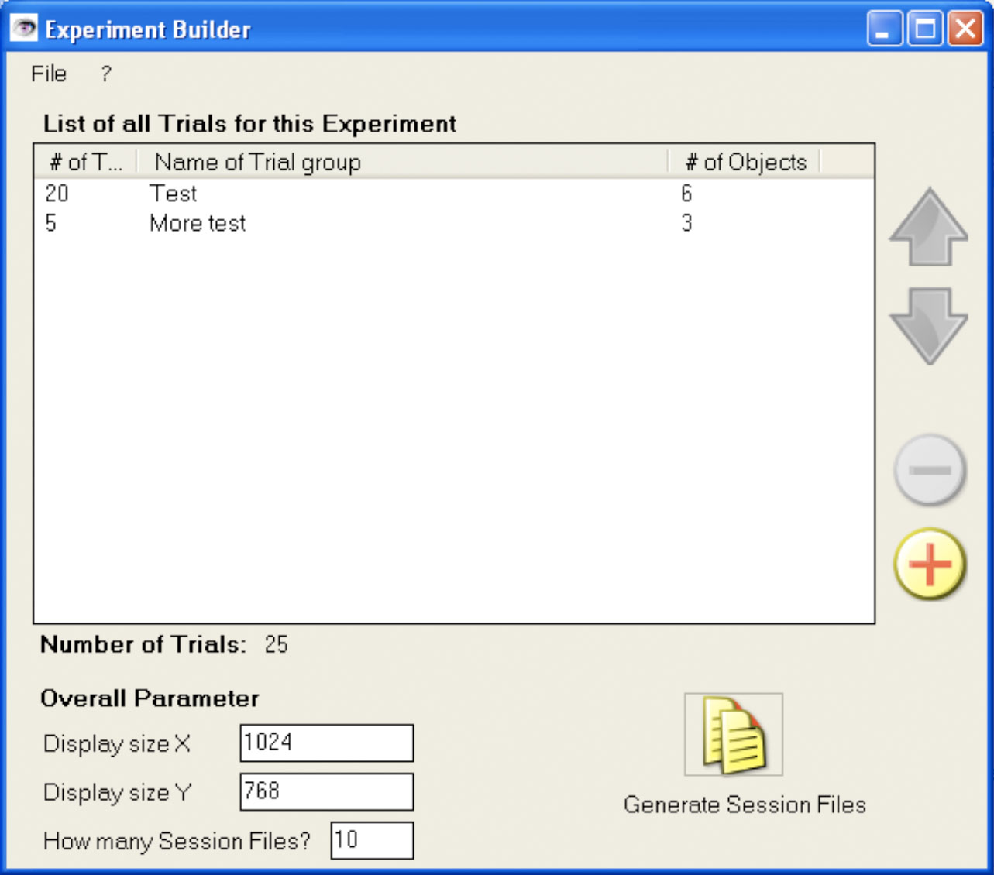
Figure 2.6 Experiment Builder - List of blocks of trials

By double-clicking on one of the trial block entries in the session list the entered data can be changed. By selecting an entry in the session-list the trial block can be deleted or moved by either using the buttons on the right (move up, move down, delete) or by right-click and using the appropriate menu entry in the appearing context-menu.

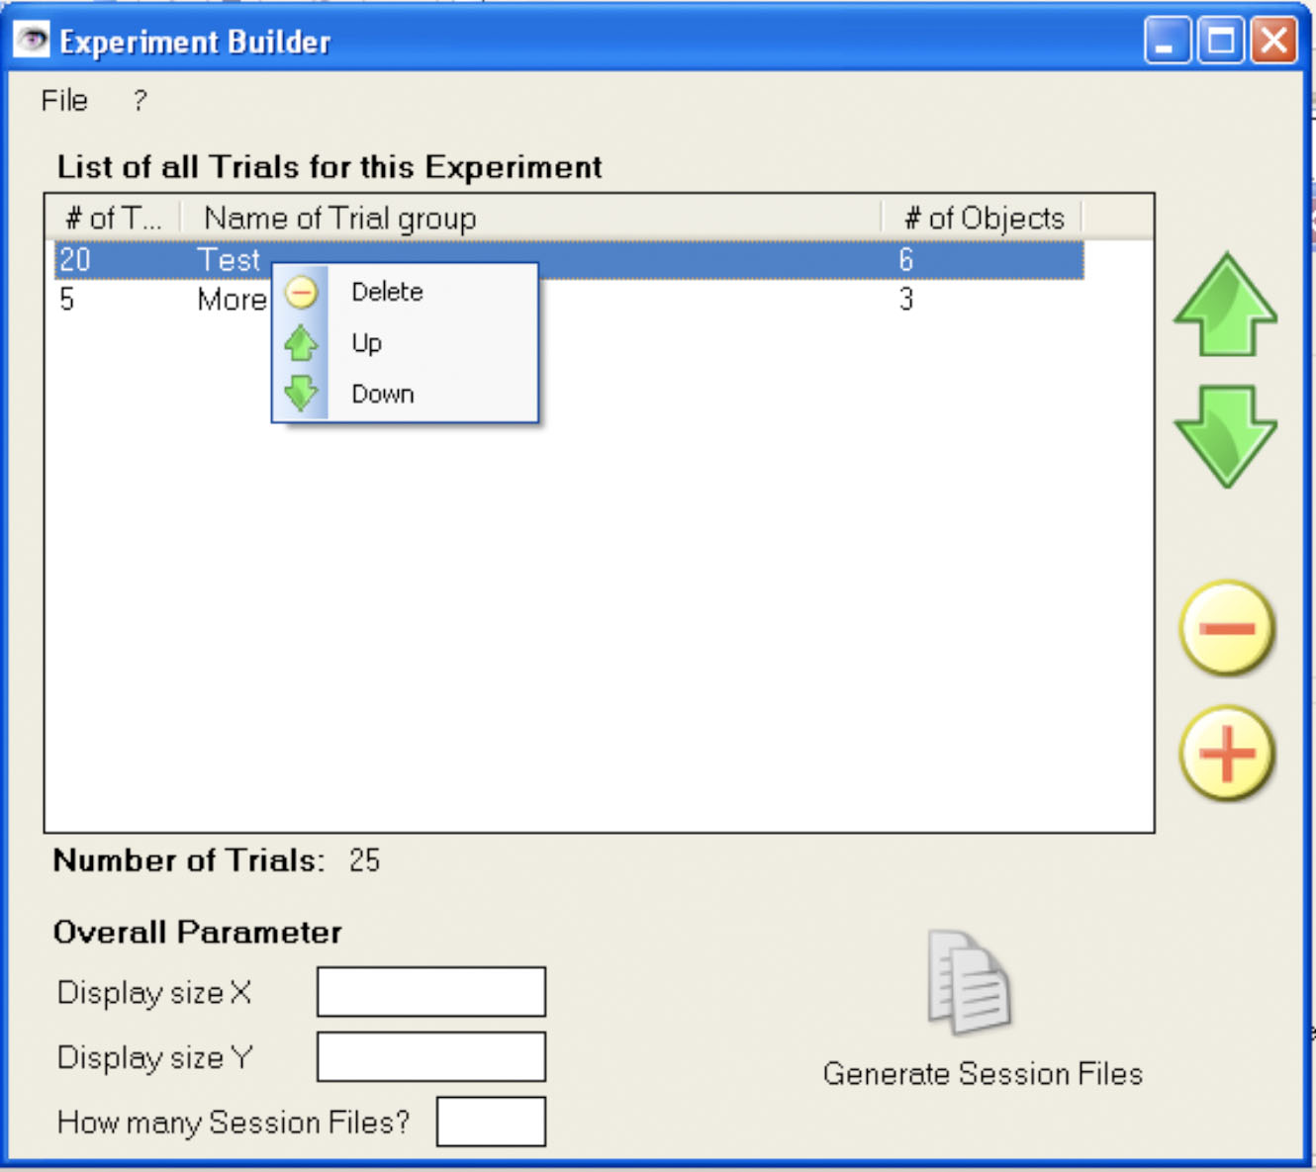
Figure 2.7 Experiment Builder – viewing different order of trial blocks

After all desired blocks of trials are added to the session list, the user can enter the needed display size (X-and Y values) for the experiment. Also, he can specify how many session files are needed. (E.g., the number of subjects he wants to do the experiment).
The Generation button will become clickable. After clicking this button, and dialog appears which asks him for the name of the experiment. If he enters a name already used, the user can use the delete-Button to delete the existing experiment. Otherwise, he can confirm the name with the OK-Buttons and all needed files will be created.

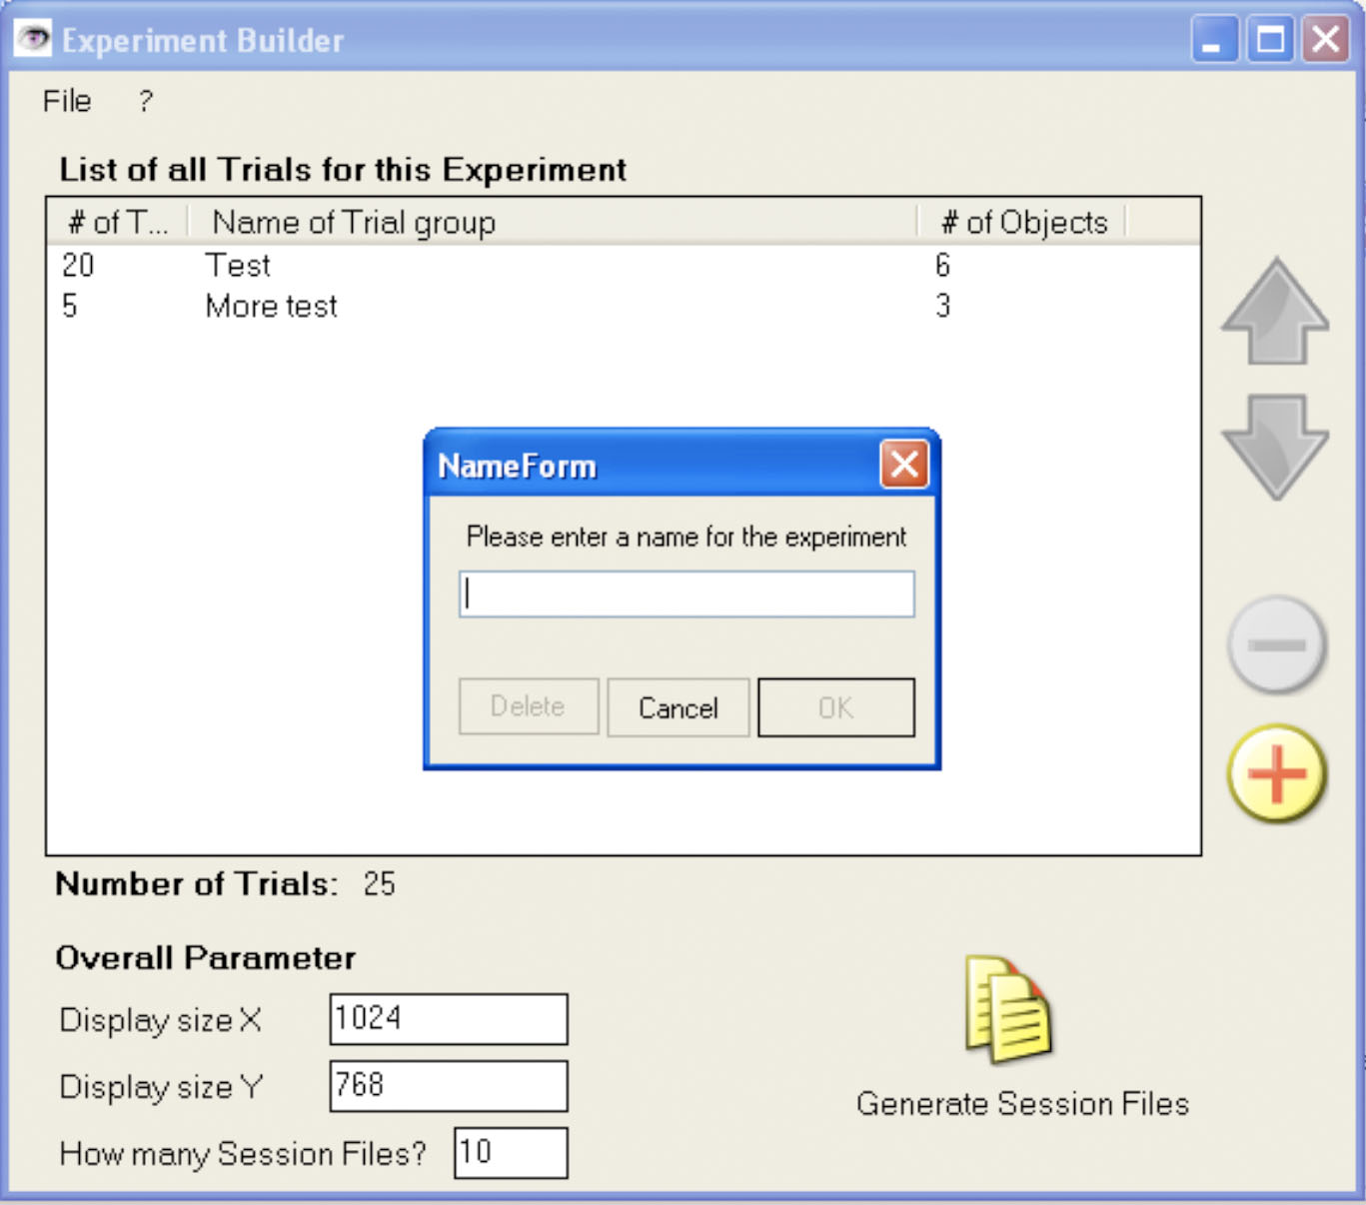
Figure 2.8 Experiment Builder - Naming the experiment

It is recommended to save the experiment data. This way, the entered data in the Experiment Builder can always be loaded again and used or modified to create more session files. In the Menu “File” there are entries to load and save the data in a binary file.

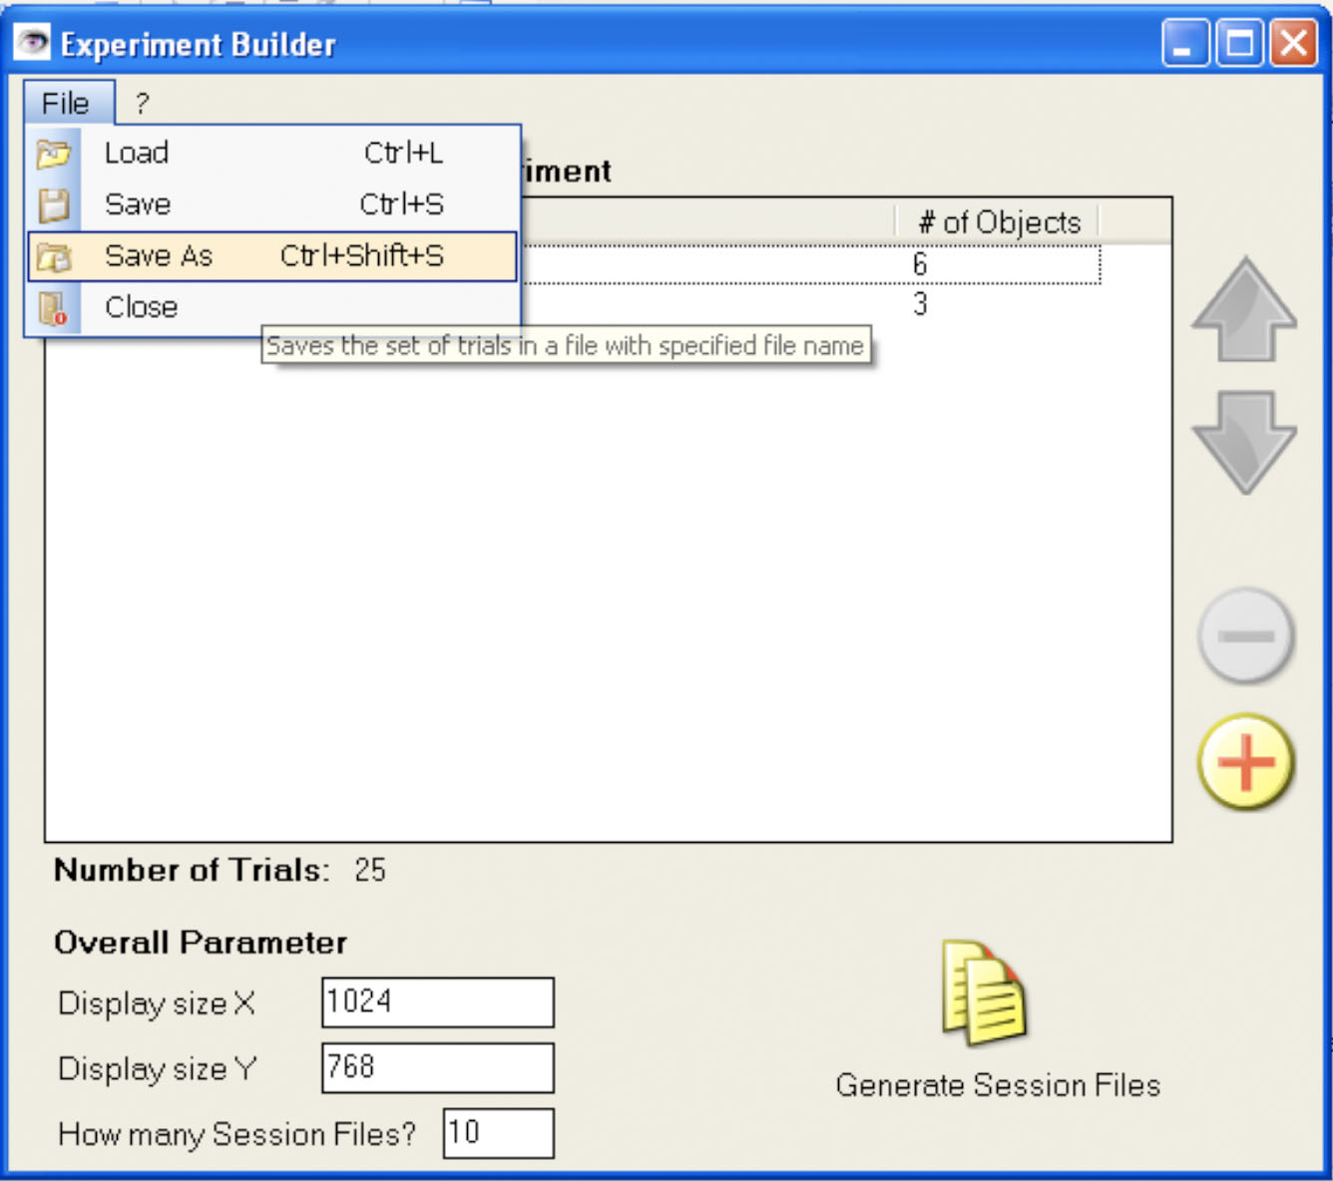
Figure 2.9 Experiment Builder - Saving the input parameters to a file

Output of the Experiment Builder
In the moment when the user creates the session files for his experiment, the Experiment Builder creates (if not already existing) the following directory structure.

C:\EVS
C:\EVS\bin
C:\EVS\doc
C:\EVS\ext
C:\EVS\experiments
C:\EVS\experiments\[exp_name]
C:\EVS\experiments\[exp_name]\Sess1
C:\EVS\experiments\[exp_name]\Sess1\[exp_name]_Sess1.session
C:\EVS\experiments\[exp_name]\Sess1\images (for bitmaps)
C:\EVS\include (for our .h files)

The session files are XML-files and will be stored for each different session X in the appropriate SessX-Folder. The name of the session file will be [exp_name]_SessX.session. The bitmaps generated by the Experiment builder are stored in the images folder for each Session.

Therefore, after generating the folder structure, the Experiment Builder generates the session-Files (“.session”), which are XML-Files that contain the session data. Furthermore, the images corresponding to the session-Files (e.g., the squares and circles to be displayed) are also generated. A session-File has the following structure:
<?xml version="1.0" encoding="ISO-8859-1"?>
<experiment>
<session>
<expName>MyExp</expName>
<sessNum>23</sessNum>
<displayX>1400</displayX>
<displayY>1050</displayY>
<numTrials>50</numTrials>
<trials>
<trial number="1">
<condition number="1">Condition Name goes here</condition>
<isFixMarker>1</isFixMarker> (0=false, 1=true)
<duration>15</duration>
<gridDisplay>2</gridDisplay> (0=no,1=H,2=V,3=HV)
<bgColorA>255</bgColorA>
<bgColorR>255</bgColorR>
<bgColorG>255</bgColorG>
<bgColorB>255</bgColorB>
<fgColorA>0</fgColorA>
<fgColorR>0</fgColorR>
<fgColorG>0</fgColorG>
<fgColorB>0</fgColorB>
<isBounce>0</isBounce> (0=false, 1=true)
<minBounceDist>10</minBounceDist> (null/empty? if not used)
<minStartDist>20</minStartDist>
<numObjects>3</numObjects>
<numTargets>1</numTargets>
<objects>
<object number="1">
<objPath>C:\bar\foo</objPath> (absolute path)
<objIsTarget>1</objIsTarget> (0=false, 1=true)
<objPanel>2</objPanel> (1,2,3 or 4)
<objMinSpeedH>5</objMinSpeedH>
<objMaxSpeedH>5</objMaxSpeedH>
<objMinSpeedV>5</objMinSpeedV>
<objMaxSpeedV>5</objMaxSpeedV>
</object>
<object number="2">
<objPath>C:\bar\foo2</objPath>
<objIsTarget>0</objIsTarget> (0=false, 1=true)
<objPanel>1</objPanel>
<objMinSpeedH>5</objMinSpeedH>
<objMaxSpeedH>5</objMaxSpeedH>
<objMinSpeedV>5</objMinSpeedV>
<objMaxSpeedV>5</objMaxSpeedV>
</object>
</objects>
</trial>
.
.
.
</trials>
</session>
</experiment>
Figure 2.10 Experiment Builder - Example of .session file

Development
The project files for Visual Studio 2005 and the source files are accessible. To make changes to the project, any IDE supporting .NET 2.0 can be used. The source code is written in C# and commented. There are no special requirements to compile this project besides basic .NET and C#-knowledge and an appropriate .NET 2.0 installation. No other libraries etc. are needed.

Source documentation
An xml-File is generated of the source code that contains the comments, object descriptions and additional docs for the source-code.

Known Issues
The Experiment Builder creates a perf\ directory in the wrong location (C:\experiments\perf). This extra directory does not impair the functioning of EVS in any way. The Analysis Tool creates the directory in the correct location (C:\experiments\[exp_name]\perf\).

Further Improvements
Nothing requested so far.

Graphics Engine

The Graphics Engine can be described in terms of its functional components. It must (1) read in the parameters from the session file; (2) display the individual trials that make up a session; (3) “ask” the subject for input (which objects were the original targets); and (4) write session information, object positions, and user selection to a logfile (the .gelog file).

The Graphics Engine executable is located in the C:\EVS\bin\GE\ directory. It requires several supporting libraries to be in the same directory. The directory listing is as follows:

GraphicsEngine.exe | the executable
DLPORTIO.dll | I/O library (required by GE core for Eyelink functionality)
eyelink_core.dll | Eyelink library
eyelink_exptkit20.dll | Eyelink library
eyelink_gdi_graphics.dll | Eyelink library
eyelink_w32_comp.dll | Eyelink library
FreeImage.dll | supporting library
iconv.dll | required by libxml2 library (for GEi parsing functionality)
libpng1.dll | supporting library
libxml2.dll | required by GEi for parsing session (xml) file
zlib1.dll | required by libxml2 library (for GEi parsing functionality)
Figure 3.11 List of files required to run the Graphics Engine

the Interpreter
The GE’s “interpreter” is responsible for reading in the parameters from the session file and passing the parameters to the GE’s display routines. It has two parts: (i) a GUI, which takes a session file as input and (ii) a parsing routine, which reads (and stores) the parameters from the given session file.

the GUI

The GUI appears when the Graphics Engine is started.

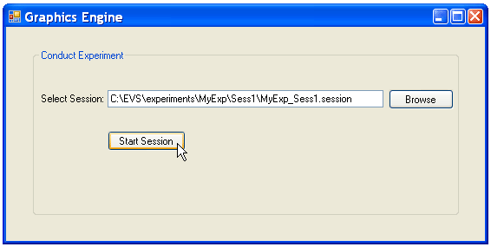
Figure 3.12 Graphics Engine GUI

The Browse button provides the standard Windows directory-browsing functionality.
Please note that it is important to maintain EVS’ naming and location conventions. Specifically, the Experiment Builder creates session files with the following location and name:
C:\EVS\experiments\[exp_name]\Sess[num]\[exp_name]_Sess[num].session

If a non-standard location is used, for example
C:\non-standard_directory\non-standard_filename.session
the behavior of the Graphics Engine is undefined.

Stated another way: Although the GUI will accept any file as input, the behavior of the Graphics Engine is undefined if EVS conventions are not followed.

the Parser

The session file name is passed from the GUI to the parsing routine. Since this part of the code is transparent to the user, it will not be described here. Instead, please look at the “Development” section for details about how the parser works.

It is important to note, however, that the parser requires the three libraries iconv.dll, libxml2.dll and zlib1.dll to be in the same directory as the Graphics Engine executable.

Development

The GEi code resides in three files:

libgeigui.lib | the GUI
interpreter.h | header file for parsing functionality
interpreter.c | parsing code
Figure 3.13 List of files for Graphics Engine (interpreter)

This section will describe how these files work.

Source Files
The C:\EVS\src\GEi folder contains the standalone code for the interpreter. This GEi folder is provided for development convenience; the developer can work on and test these components individually before incorporating the changes into the Graphics Engine.

There are two Visual Studio projects in the GEi folder: geiparser and libgeigui. If development is done on these two projects, the corresponding files (libgeigui.lib, interpreter.h, and/or interpreter.c) must be copied into the main Graphics Engine source tree (C:\EVS\src\GraphicsEngine\) in order to incorporate the changes into the Graphics Engine.

the GUI

The GUI is written in C++ and compiled as a static library. C++ was chosen for the following reasons:
- a GUI was mandatory for session file input. C# and C++ both offer a coding environment that facilitates GUI creation.
- since C++ is “closer” to C (the GE display functionality is written in C), it was reasoned that calling C++ from C would be more straightforward than calling C# from C.
- the GE display code is based on a template from SR Research. (The company provides templates to facilitate experiment creation.) They provide templates in both C and C++. C++ was the obvious choice to work in either of these two environments.
- If future versions of the GE are written in C++, the GUI can be used as is (or can be used as a template for an improved version).
- the GUI was created early in the project implementation. At that time, the benefits and drawbacks of using the various C flavors for the EVS implementation was unclear. So writing the GUI in C++ was an experiment in itself!

The GUI’s component pieces are

geiForm.h | the code describing the form
geiForm.resx | the Visual Studio “Display view” of the form
geiForm.cpp | the function calls for C (i.e., for the parser)
Figure 3.14 List of files for Graphics Engine (GUI)

These three files are compiled as libgeigui.lib, which is the file that must be added to the Graphics Engine source tree. A static library was used primarily to compartmentalize the translation between C and C++. In other words, the library is already C-friendly when it is incorporated into the Graphics Engine.

Testing the GUI
The libgeigui project includes a program for testing the GUI. It is located at C:\EVS\src\GEi\libgeigui\release\testgui.exe (there is also a debug version in the debug\ directory). This program runs only the GUI and provides no output. It is meant to (i) provide a visual check of the GUI and (ii) check that the GUI can be called from a C program.

Adding a New GUI to the Graphics Engine
After changes to the libgeigui project are made, the project must be recompiled. The output is the libgeigui.lib library. This library must be added to the Graphics Engine source tree in order to incorporate GUI changes into the Graphics Engine.

Compilation Reference for the GUI
Even though the library itself is C-friendly, there may be compilation errors when the library is compiled in with a C project. The following two errors were seen during the integration of the GUI into the Graphic Engine.

(1) errors resembling:
warning LNK4098: defaultlib 'MSVCRTD' conflicts with use of other libs; use /NODEFAULTLIB:library
error LNK2005: "private: __thiscall type_info::type_info(class type_info const &)" (??0type_info@@AAE@ABV0@@Z) already defined in LIBCMT.lib(typinfo.obj) MSVCRTD.lib
error LNK2005: "private: class type_info & __thiscall type_info::operator=(class type_info const &)" (??4type_info@@AAEAAV0@ABV0@@Z) already defined in LIBCMT.lib(typinfo.obj) MSVCRTD.lib
fatal error LNK1169: one or more multiply defined symbols found C:\Documents and Settings\elena\My Documents\Visual Studio 2005\Projects\libgeigui\Debug\testgui.exe

Fix this error by ignoring the libcmt.lib library:
Project > Properties > Configuration Properties > Linker > Input >
Ignore Specific Library = libcmt.lib

(2) runtime error:
When the Browse button is used in the GUI and the file type is changed, the directory listing
goes blank.

To fix this, add single-threading to the compilation options:
Project > Properties > Configuration Properties > Linker > Advanced >
CLR Thread Attribute = STA threading attribute (/CLRTHREADATTRIBUTE:STA)

the Parser
The parser is written in C. Its code is in interpreter.h and interpreter.c.

The parser is the “middleman” between the GUI and the GE display functionality. It reads the file entered from the GUI and passes the information in that file to the GE “core.” It provides three functions (declared in interpreter.h) in order to fulfill its duties:

initInterp() | • initializes the interpreter  • calls the GUI  • reads in the session parameters (parameters that are the same for all the trials) | called from run_trials() in w32_picture_trials.c
getTrialParams() | • gets the trials parameters (if there are 10 trials in a session, this function will be called 10 times) | called from run_trials() in w32_picture_trials.c
end Interp() | • cleans up (i.e., frees memory) after the session is over | called from run_trials() in w32_picture_trials.c
Figure 3.15 List of functions provided by Graphics Engine (interpreter)

External Libraries for the Parser

Since the session file is an xml document and C does not provide native xml-parsing functionality, the parser uses the libxml2 library (xmlsoft.org) from the Gnome project. Specifically, it uses a Windows implementation of libxml2 from www.zlatkovic.com/libxml.en.html provided by Igor Zlatković. The Windows version of libxml2 has two dependencies (iconv and zlib1), which is why all three libraries are required in the EVS system.

For runtime, the dynamic link libraries iconv.dll, libxml2.dll and zlib1.dll must be in the same directory as GraphicsEngine.exe. These libraries are also in C:\EVS\ext\GEi\[library]\bin\

For development, the compiler does not need the .dlls. It does require, however, access to the libraries’ include\ and lib\ directories. The library trees are included in the EVS\ directory:

C:\EVS\ext\GEi\iconv-1.9.2.win32\bin
C:\EVS\ext\GEi\iconv-1.9.2.win32\include
C:\EVS\ext\GEi\iconv-1.9.2.win32\lib

C:\EVS\ext\GEi\libxml2-2.6.27.win32\bin
C:\EVS\ext\GEi\libxml2-2.6.27.win32\include
C:\EVS\ext\GEi\libxml2-2.6.27.win32\lib

C:\EVS\ext\GEi\zlib-1.2.3.win32\bin
C:\EVS\ext\GEi\zlib-1.2.3.win32\include
C:\EVS\ext\GEi\zlib-1.2.3.win32\lib

Testing the Parser (and more information about how it works)

The parser is not a standalone program; it requires a driver (i.e., a program to call its functions). When it is run as part of the Graphics Engine, the run_trials() function serves as the driver. In the geiparser project, the file testinterp.c is the driver. The project compiles to geiparser.exe, which runs the GUI (as part of initInterp()) and shows how the session file is being parsed.

geiparser.exe will work with any xml file in the proper Experiment Builder format. For geiparser.exe testing purposes only, a correctly-formatted input file can have any name, can have any extension/suffix and can reside in any location. The output has the following form:

This is testinterp.c ...

Initialization - begin ...
Initialization - end

Get Session Info - begin ...
printSessionInfo - begin
session parameters are the same for all trials
sessionParams.expName = test
sessionParams.sessNum = 1
sessionParams.displayX = 1024
sessionParams.displayY = 768
sessionParams.numTrials = 4
printSessionInfo - end
Get Session Info - end

Get Trial Info - begin ...
printTrialInfo - begin
trialParams.trialNum=1
trial parameters can be different for each trial
trialParams.condNum=1
trialParams.condName=four_sectors
trialParams.isFixMarker=1
trialParams.duration=10000
trialParams.gridDisplay=3
trialParams.bgColorA=255
trialParams.bgColorR=0
trialParams.bgColorG=0
trialParams.bgColorB=255
trialParams.fgColorA=255
trialParams.fgColorR=255
trialParams.fgColorG=255
trialParams.fgColorB=255
trialParams.isBounce=1
trialParams.minBounceDist=50
trialParams.minStartDist=50
trialParams.numObjects=8
trialParams.numTargets=4
trialParams.objInfo[1].objnum=1
trialParams.objInfo[1].objPath=c:\\EVS\\experiments\\test\\images\\madsci.bmp
trialParams.objInfo[1].objIsTarget=0
trialParams.objInfo[1].objPanel=1
trialParams.objInfo[1].objMinSpeedH=100
trialParams.objInfo[1].objMaxSpeedH=150
trialParams.objInfo[1].objMinSpeedV=100
trialParams.objInfo[1].objMaxSpeedV=150
.
. [info for additional objects]
.
printTrialInfo - end
.
. [info for additional trials]
.
Get Trial Info - end

Cleanup - begin ...
Cleanup - end

Press <Enter> to close ...
Figure 3.16 Graphics Engine (interpreter) - example debug output (view 1)

The output shows what the parser is passing to the display code.

The session parameters are written to a global struct defined in interpreter.h:

struct sparams {
char * expName;
int sessNum;
int displayX ;
int displayY ;
int numTrials ;
} sessionParams ;

When the GE’s display code wants to know the screen resolution, for example, it references sessionParams.displayX and sessionParams.displayY. This data is constant throughout a session.

The trial parameters are also written to a global data structure:

struct tparams {
int trialNum ;
int condNum;
char * condName;
int isFixMarker ;
UINT32 duration ;
int gridDisplay ;
int bgColorA;
int bgColorR;
int bgColorG;
int bgColorB;
int fgColorA;
int fgColorR;
int fgColorG;
int fgColorB;
int isBounce ;
int minBounceDist ;
int minStartDist ;
int numObjects ;
int numTargets ;
struct oparams * objInfo; // pointer to an array of "struct oinfo"
// (created at runtime)
} trialParams ;

This data in this structure is re-written twice at the beginning of every trial – once to reset the struct (which makes debugging easier) and once to populate it with the parameters of the upcoming trial. Both these things happen in the getTrialParams() function.

The objInfo variable represents an array of structs, each of which holds information about one of the objects displayed during a trial. An object’s information is stored as follows:

struct oparams {
int objNum;
char * objPath;
int objIsTarget;
int objPanel;
int objMinSpeedH;
int objMaxSpeedH;
int objMinSpeedV;
int objMaxSpeedV;
} ;

If there are 8 objects in a specific trial, that trial’s objInfo variable will reference an array of 8 struct oparams. The array is created in getTrialParams() and populated in getObjsParams(). The array is freed when the trial parameters are reset.

There is also a DEBUG flag in interpreter.c which enables more output. When the flag is set to true, the parser also produces: (i) information about internal data structures, (ii) values of certain variables and (iii) notifications that it is entering and leaving a function.

The most obvious addition to the output with DEBUG enabled is the information about the two lookup tables that the parser uses:

This is testinterp.c ...

Initialization - begin ...
printTLookupTable - begin
param name=bgColorA offset in lookup table=24
param name=bgColorB offset in lookup table=36
param name=bgColorG offset in lookup table=32
param name=bgColorR offset in lookup table=28
param name=condName offset in lookup table=8
param name=condNum offset in lookup table=4
param name=duration offset in lookup table=16
param name=fgColorA offset in lookup table=40
param name=fgColorB offset in lookup table=52
param name=fgColorG offset in lookup table=48
param name=fgColorR offset in lookup table=44
param name=gridDisplay offset in lookup table=20
param name=isBounce offset in lookup table=56
param name=isFixMarker offset in lookup table=12
param name=minBounceDist offset in lookup table=60
param name=minStartDist offset in lookup table=64
param name=numObjects offset in lookup table=68
param name=numTargets offset in lookup table=72
param name=objInfo offset in lookup table=76
param name=trialNum offset in lookup table=0
printTLookupTable - end
printOLookupTable - begin
param name=objIsTarget offset in lookup table=8
param name=objMaxSpeedH offset in lookup table=20
param name=objMaxSpeedV offset in lookup table=28
param name=objMinSpeedH offset in lookup table=16
param name=objMinSpeedV offset in lookup table=24
param name=objNum offset in lookup table=0
param name=objPanel offset in lookup table=12
param name=objPath offset in lookup table=4
printTLookupTable - end
getSessionFile - begin
session file length = 48
session file = C:\EVS\experiments\test\Sess1\test_Sess1.session
return code = 0
getSessionFile - end
getXmlTree - begin
getXmlTree - end
getXmlRootNode - begin
root element: "experiment"
getXmlRootNode - end
getXmlSessionNode - begin
session element: "session"
getXmlSessionNode - end
getSessionInfo - begin
getSessionInfo - end
Initialization - end

Get Session Info - begin ...
Figure 3.17 Graphics Engine (interpreter) - example debug output (view 2)

The lookup tables can be thought of as a “poor man’s hashtable”. Given a parameter name, the lookup table returns the byte offset of that parameter’s location in its respective struct. As the output shows, the parameter bgColorA is stored 24 bytes from the beginning from the trial struct. The parameter objNum is stored at 0 bytes from the beginning of the object struct; that is, it is the first parameter stored in the structure. The parser uses these offsets to write a parameter’s value directly into the struct.

The primary goal of the lookup table was to avoid numerous if statements when parsing the parameters. For instance, there are 20 trial parameters that getTrialParams() has to identify and whose value it has to store in the trialParams structure. Using only if statements would have resulted in the following (pseudo) code:

string name = get_name_of_current_xml_node()
if name is “trialNum” do ...
else if name is “condNum” do ...
else if name is “condName” do ...
... 17 more if statements ...

Instead of this type of procedure, getTrialParams() does the following:
- looks for the xml node with the next trial number and then writes the trial number to trialParams.trialNum
- looks for the condition node and then writes the condition name and number to trialParams.condNum and trialParams.condName
- for the next 16 parameters/nodes:
- reads the parameter/node name
- checks if the name is in the lookup table (i.e., validates the parameter name)
- gets the offset value from the lookup table
- writes the parameter value into address_of_struct + offset
- when the parser gets to the objects node, it creates storage for the objects and then calls getObjsParams()

The getObjsParams() function works in a similar way. The getSessionParams() function only has to parse 5 parameters, so it does use if statements.

Adding Parser Changes to the Graphics Engine

There are two ways to change the parser’s code. The first way is to develop the parser using the geiparser Visual Studio project. After the parser is tested using geiparser.exe, the interpreter.c and/or interpreter.h files can be copied into the Graphics Engine source tree. The second way is to bypass the geiparser project and edit the files directly in the Graphics Engine source tree.

Compilation Reference for the Parser

The following couple of compilation errors were seen during integration of the parser with the GE “core” files. They are provided as a reference for future development.

(1) error:
error LNK2019: unresolved external symbol _getFileName referenced in function _getSessionFile
or
error LNK2019: unresolved external symbol _doGUI referenced in function _getSessionFileError
The getFileName() and doGUI() functions are provided by libgeigui.lib.
• The library must be in the same directory as interpreter.c
• The Visual Studio project must be told to use the library:
Project > Properties > Configuration Properties > Linker > Input > Additional Dependencies >
add “libgeigui.lib”
• The library must be added to the Solution
Solution Explorer > right-click the project name > Add > Existing Item >
change the “Files of type” to “All Files” > choose the library
• The project must be told to ignore the libcmt.lib library
(see the Compilation Reference for the GUI)

(2) errors resembling:
error LNK2019: unresolved external symbol _xmlParseFile referenced in
function _getXmlTree

These types of errors mean that the compiler cannot find the libxml2 library, which provides the “_xml...” functions.
• The compiler must be told where to find the include files for libxml2
Project > Properties > Configuration Properties > C/C++ > General >
Additional Include Directories > add the following three directories:
(i) C:\EVS\ext\GEi\iconv-1.9.2.win32\include
(ii) C:\EVS\ext\GEi\libxml2-2.6.27.win32\include
(iii) C:\EVS\ext\GEi\zlib-1.2.3.win32\include
• The compiler must be told where to find the libraries for libxml2
Project > Properties > Configuration Properties > Linker > General >
Additional Library Directories > add the following three directories:
(i) C:\EVS\ext\GEi\iconv-1.9.2.win32\lib
(ii) C:\EVS\ext\GEi\libxml2-2.6.27.win32\lib
(iii) C:\EVS\ext\GEi\zlib-1.2.3.win32\lib
• The compiler must be told to use the library:
Project > Properties > Configuration Properties > Linker > Input > Additional Dependencies >
add “libxml2.lib”

Known Issues
- As described above, the GUI accepts any filename, even though the GE only works correctly with session files conforming to EVS naming standards.
- There is no schema for validating the format of the session file. While this absence does not affect the functionality of the GE, it is mentioned here as a possible improvement for the future.

the Display functionality (the GE “core”)

Usage of Graphics Engine

The Graphics Engine is particularly used for Multi-Object Tracking experiments in the Visual Attention Lab. The program is run only for one session. One experiment consists of many sessions and one session consists of many trials.

Required Libraries for GE moving objects

eyelink_core.dll
FreeImage.dll
DLPORTIO.dll
eyelink_exptkit20.dll
eyelink_gdi_graphics.dll
eyelink_w32_comp.dll

Connecting to EyeLinkII and Simulation offline mode

The Graphics Engine can be run in two different modes. They are simulation offline mode and eye link mode. Simulation offline mode is for the experimenter or the developer to view how Graphics Engine works and how the objects move. Eye link mode is for running the actual experiment. The user must have eye tracker installing and connecting with eye link software to run the Graphics Engine in eye link mode. To run the Graphics Engine in eye link mode, the participant has to wear the headband that has a camera pointing to the eye pupil.

Run Graphics Engine in Simulation Mode

In order to run Graphics Engine in simulation offline mode, user needs to modify the code in the program. In “w32_demo_main.c” file and inside “app_main( )” function, user needs to change the statement from “if(open_eyelink_connection(0))” to “if(open_eyelink_connection(1))”. Then, user needs to recompile the whole program to make it run.

Run Graphics Engine in Eye Link Mode

Current setting of Graphics Engine is to run in eye link mode. When running the Graphics Engine in eye link mode, user needs to do calibration and drift correction before the beginning of the first trial right after the user selects the session file. EyeLink II User Manual documentation explains how to do the calibration and drift correction. Drift correction happens every time before each trial begins. In addition, eye movement data, such as gaze positions, pupil size, saccade and fixation will be logged to .EDF (Eye Data File) file at the end of running Graphics Engine.

Input Parameters for GE moving objects

The Graphics Engine takes input parameters that are passed from Experiment Builder to display and move the objects. Objects are bitmap files and the shapes can be square, rectangle, circle or ellipse or any bitmap file’s picture. The input parameters that Graphics Engine uses to display and move objects are screen resolution X and Y, number of trials, object’s path, (objIsTarget) Boolean value for whether an object is a target or not, object’s panel, object’s minimum horizontal speed, object’s maximum horizontal speed, object’s minimum vertical speed, object’s maximum vertical speed, (isFixMarker) Boolean value for whether to draw the fixation marker or not, trial duration, screen divider (horizontal, vertical, or both), background screen color, foreground color which is the color of screen divider, (isBounce) Boolean value for whether two objects bounce off from each other or not (if “isBounce” value is “1”, two objects bounce off from each other; if “isBounce” value is “0”, two objects occlude each other), minimum bounce distance, minimum start distance, maximum number of objects and maximum number of targets.

Display and Move Objects on the Screen

Start of Graphics Engine

At the beginning of Graphics Engine, the screen resolution X and Y is set and the background color is set on the screen. If the user wants to display the screen divider, the screen divider will be displayed with foreground color. If the user wants to display fixation marker, the fixation marker will be drawn and displayed at the center of the screen. The fixation marker is a cross sign and the color of the fixation marker can be black or white. The color of fixation marker is opposed to the background color if there is no divider. If there is any divider, the color of fixation marker is opposed to the foreground color. For example, the fixation marker is white if the background color is dark and the fixation marker is black if the background color is light.

All bitmap objects will be placed in a random position with the minimum distance between any two objects within the screen resolution X and Y. The objects will be placed in a specific panel if there is any screen divider.

Before Objects Start Moving

All target objects will blink for 3 seconds before start moving. Object will start to move after 4 seconds from the beginning of the display. The time for trial duration starts from the beginning of the display including the blinking time to the end of the trial.

Moving Objects

Each object has different speeds to move on the screen. Each object’s speed is the random speed between the minimum and maximum horizontal and vertical speeds. When moving objects touch the boundary of the screen or the screen divider, all moving objects will be bounced off from the boundary of the screen or the divider. There are two cases to move the objects on the screen and they are bouncing case and occluding case.

- Case I bouncing case

If the user chooses to bounce the objects while moving on the screen, objects will be bounce off from each other when two objects are closed to each other in a minimum distance between them. After two objects bounce off from each other, the direction of the object will be changed to a new random direction and the speed of the object will be changed to a new random speed between minimum and maximum horizontal and vertical speeds.

- Case II occluding case

If the user chooses not to bounce that is the occluding case, objects will be occluding each other while moving on the screen. Objects will bounce only when they touch the screen boundary or screen divider.

Objects Stop Moving

When the trial duration time is over, all moving objects will stop moving and wait for the participant to choose the target objects.

Monitor Frame rate setting for running Graphics Engine

Graphics Engine is assuming to use a CRT monitor in Visual Attention Lab for experiment. Currently, Graphics Engine is hard-coded to use a frame rate of 85 Hz in the program. In order to use Graphics Engine properly, there are two options to do the setting.

- Option 1:
Change the monitor (that will be used to run Graphics Engine) frame rate to 85 Hz.

- Option 2:
Open the “w32_bitmap_trial.c” file in Graphics Engine and change the “FRAME_RATE” value from “85.0” to the frame rate value of the monitor to be used to run Graphics Engine. “FRAME_RATE” value in “w32_bitmap_trial.c” file must match the frame rate of the monitor to be used to run Graphics Engine.

Note: the variable “FRAME_RATE” can be found at the beginning of the “w32_bitmap_trial.c” file.

Information in Graphics Engine Code

Graphics Engine program starts from “w32_demo_main.c”. Integration with interpreter is in “w32_picture_trials.c”. Creating the full screen window is in “w32_demo_window.c”. The display functionalities of moving objects are in “w32_bitmap_trial.c”. Loading the bitmap images are in “w32_freeimage_bitmap.c”.

Target Selection
When the trial duration set in the session file is over, all objects stop moving, Graphics Engine sets the mouse pointer visible on the screen and starts waiting for the Subject to complete his/her target object selections. The Subject has to indicate the target objects by clicking on them with a pointing device. The selected objects will be marked with a plus sign on the center as the Subject clicks on them. The Subject can unselect the objects by clicking on them again. Graphics Engine removes the mark on the unselected objects. If the Subject tries to choose more objects than the number of the target objects stated in the session file, the Graphics Engine does not let the subject select that object. In other words, Graphics Engine does not mark those objects nor record them into the list of selected objects as the Subject clicks on them. After selecting all the objects, the subject submits his/her target selections for that trial by pressing the Enter key. If the Subject tries to submit fewer objects than the number of the target objects stated in the session file, the Graphics Engine will simply not get out of the waiting state for the Subject to select all target objects. When the Subject selects as many objects as the target objects number set in the session file and presses the Enter key, Graphics Engine shows the real target objects by circling them around. Getting feedback from the system motivates the subjects, helps them feel more like it is a game and keeps their attention up. The submission of target object selections will trigger the recording of the object positions throughout the trial with the corresponding timestamps and the selected objects into the GELog file.

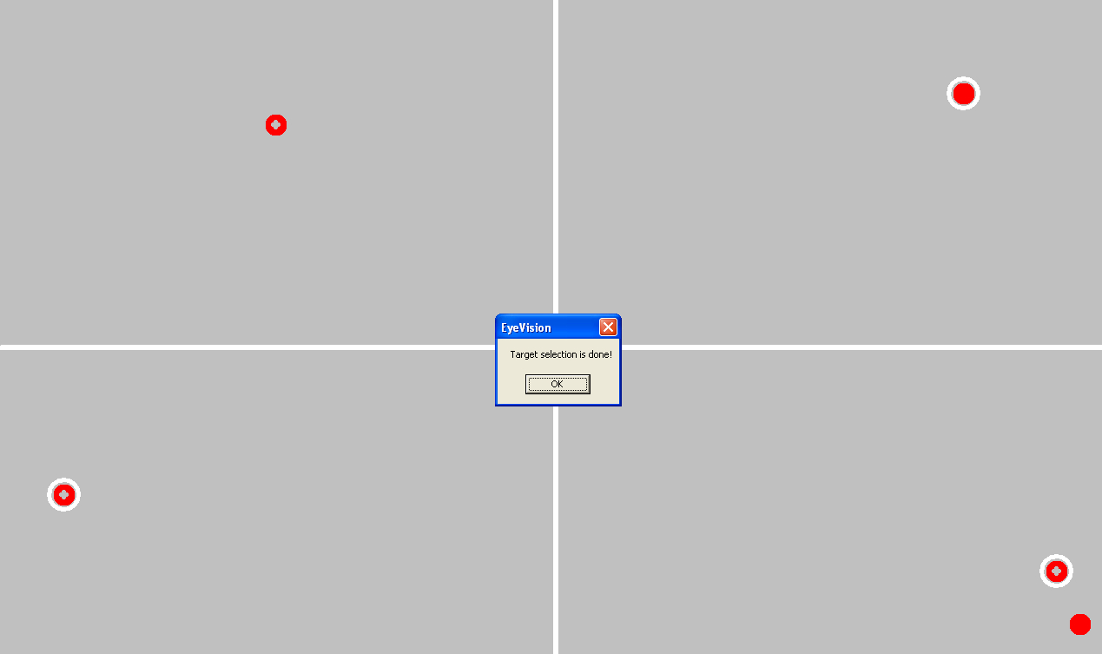
Figure 3.18 Graphics Engine - Screenshot of target object submission

Output (the .gelog file)
Graphics Engine outputs one GELog file for each trial of a session. GELog files are used for the performance analysis and replay of trials later. The format of the GELog is file shown in the next section.

GELog File Format

GELogStart
TrialName Exp1_sess1_tr1 (full name of trial)
DisplayX value DisplayY value
Condition value (condition number)
GridDisplay value
BGA value BGR value BGG value BGB value
FGA value FGR value FGG value FGB value
NumObjects value
NumTargets value
ObjStart
ObjName Obj1 (object name - same name as indicated in the subject target Object selection)
ObjectFilePath value
IsTargetObject value (0 or 1)
ObjStart
ObjName Obj2
...
TrialStart
TimeStart value (System Time Format)
Obj1x value Obj1y value
Obj2x value Obj2y value
...
TimeEnd
TimeStart value (System Time Format)
Obj1x value Obj1y value
Obj2x value Obj2y value
...
TimeEnd
TimeStart value (System Time Format)
Obj1x value Obj1y value
Obj2x value Obj2y value
TimeEnd
TimeStart value (System Time Format)
...
TimeEnd
TrialEnd
SubjTargetStart
Obj2 (Target Object name chosen by Subject)
Obj3 (Target Object name chosen by Subject)
Obj5 (Target Object name chosen by Subject)
...
SubjTargetEnd
GELogEnd
Figure 3.19 Graphics Engine - Example of GELog file format

Development

Graphics Engine records the x and y coordinates of all objects with the corresponding timestamps each time objects move on screen, in memory. At the end of the trial, after the target object selection is done, object positions are flushed into the GELog file along with the Subject’s target object selections. The reason for writing the object coordinates into file after the trial ends as opposed to writing them in real-time is to avoid delays in refresh of screen and discernable slowdown in the movement of objects.

GELog file contents include tags for each entry value (i.e. GELogStart, TrialName, ObjName, etc.) for the sake of parsing. Instead of delimiting by spaces or punctuation, using tags allows searching for certain regular expressions, which yields easier and more accurate parsing.

Further Improvements

Here is a list of developer's suggestions for making the product better in future:

Keeping partial GELog files for aborted trials:
Currently if Subject aborts a session/trial in the middle, the GELog is not kept for the displayed part of the aborted trial. Since the object positions kept in memory are flushed into file after the submission of target object selections, in case the trial is interrupted, application never reaches where the GELog file is being created and populated in code. It simply looses those data and continues with the next trial. If Prof. Pomplun wants to replay the displayed part of an aborted trial, this behavior can be changed by the team(s) working on improving EyeVision in the future.

Repeating trials after resuming the session:
Experimenter can stop the trial for some reason (i.e. drift correction is needed), which will lead to presenting the drift correction display. Ideally, when the Experimenter solves the problem and resumes the session, s/he should be able to repeat the trial all over again from the beginning. The current implementation of Graphics Engine aborts the interrupted trial.

Displaying warning message for incomplete target selections:
If the Subject tries to submit fewer objects than the number of the target objects stated in the session file, the Graphics Engine used to warn the user by a pop-up message box and then return to waiting state for the Subject to select all target objects. However, during the testing of Graphics Engine, it turned out causing the system crash. To be able submit the product in time with more important features implemented; the warning message box is removed. The reason for this problem or how the message box is connected to system crash is not discovered yet. It might have been fixed very easily but no significant time is spent on it since it is not a crucial feature.

Analysis Tool

Introduction

Analysis Tool is a Standalone component which provides functionality that aids in performance analysis of the various experiments Conducted in the Eye Link Research lab at UMass, Boston.
Analysis Tool provides the following options:
- Creates files used for statistical/performance analysis. These files will be readable by third-party statistical tools.
- Replays an individual Trial undertaken by a subject with the gaze positions superimposed.
- Creates an Excel spreadsheet containing the same gaze and object location information shown in the trial replay

Performance File Creation

Performance File Creation Routine accepts either a Valid Session Directory or an Experiment Directory as input . It extracts data from all Trials in the Session or data from all trials in all Sessions in an Experiment to create and provide a Peformance file used by third party Statistical Tools.

Replay Trial

Replays an individual Trial with the gaze positions superimposed. The replay of an individual trial includes options to
- pause
- resume
- stop
at any instant of time during the replay. It provides initial blinking of the System Target Objects that the subject is supposed to follow throughout the trial. It also provides the option to Mark or Unmark all the target objects during the replay, in order to facilitate analysis, i.e., simplify the tracking of objects by the experimenter. The Targets ,by default ,are all marked during Replay.
(The marking of targets will be either "all targets marked" or "all targets unmarked".)

Excel File Creation

Accepts a GE log File as an input and checks to see if a Display File exists for the Given Trial. If it exists, then it moves ahead and creates an Excel file from the data obtained from Display File using XML2XLS routine. If a Display File does not exist, then its creates one before creating an Excel file. It normally takes anytime between 30 seconds to more than couple of minutes to create an Excel file. A user Friendly Message with Progress bar is displayed to keep the User Informed that the file Creation Process is in progress.

There are two possible views of the data. A screenshot of EVSview1 is shown in a following section. It lists most of the session, trial and object parameters; the objects that the user thought were the original targets, and a listing of gaze and object positions (per timestamp).

EVSview2 can be enabled by setting the doView2 flag to true and recompiling the Analysis Tool. This second view lists the same location information in a different format:

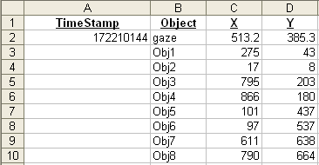
Figure 4.20 Analysis Tool - Example of .xls (EVSview2)

It is disabled by default for the following reasons: its information is redundant; its format is less useful than the format of EVSview1; its inclusion more than doubles the file size; and its inclusion doubles the runtime of the XML2XLS component.

System Requirements

Libraries Required

(1) Microsoft Office Primary Interop Assemblies (PIA) for the Excel file creation. (Please see
the Installation section for more information about the PIA.)
(2) EDF2ASC.exe (provided by SR Research) must be located in C:\EVS\bin. This executable
accepts an EDF file generated by Eyelink and Converts it to ASCII format.

File Structure Requirements

Executable

The following files are required to run the Analysis Tool:
- AnalysisTool.exe – the executable
- DisplayFileSchema.xsd - XML Schema for Display File
- gaze.bmp

Input Files

Input files required to execute Analysis Tool functionality are:
- Gelog file : File generated by GE that holds Object positions recorded during a Trial.
- EDF file : File generated by Eye Link during a Trial which holds the Eye Gaze positions

These Files are required to be in a pre defined File Structure as shown below:
C:\EVS\experiments
\<Experiment-Dir>
\<Session-Dir>
\ <EB generated Session File> (*.Session)
\<Eye Link generated EDF file> (*.EDF)
\<Trial-Dir>
\<GE Log File> (*.gelog)

Output Files

Following Output files are generated by Analysis Tool in a pre defined File Path as shown below:
    - .Gaze file : ASCII version of the EDF file generated by Eye Link which contains data related to one particular Trial. Analysis Tool converts the EDF file to its ASCII format .
    - .display file: XML file which contains data required to handle Replay Functionality. XML file adheres to the Schema provided with the executable.
    - .xls file: Microsoft Excel file which contains data about the Trial setting along with Eye movement and Objects movement data in a pre defined Format.
    - .perf file: TXT file format of the Performance file which contains Performance Analysis of all Trials in the Session. Or performance Analysis of all Trials in their respective sessions.

The File Structure is as shown below:
C:\EVS\experiments
\<Experiment-Dir>
\<Performance-Dir>
\<Performance File> (*.perf )
\<Session-Dir>
\<Performance-Dir>
\<Performance File>
\ <EB generated Session File> (*.Session)
\<Eye Link generated EDF file> (*.EDF)
\<Trial-Dir>
\<GE Log File>
\< Gaze File>
\<Display File>
\<Excel file>

Implementation Details

Analysis Tool GUI

Screen Shot

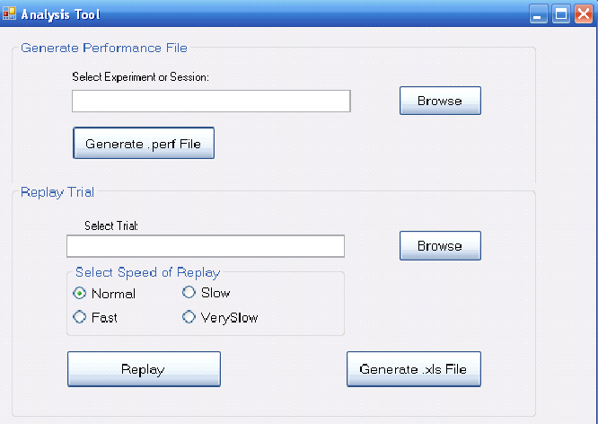
Figure 4.21 Analysis Tool GUI

Functionality Provided with the GUI

- Performance File Creation: Accepts either
Session Directory (*) or an
Experiment Directory (**) as an input.

- Replay a Trial: Accepts any GeLog file as an input. It Provides the following Options:

      - Option to Chose the Speed of Replay
        - Fast
        - Normal
        - Slow
        - Very Slow

      - Option available to user During the Replay of a trial:
        - Pause
        - Stop
        - Resume
        - Mark or Unmark System Target Objects

(*) Session Directory: Directory that holds all Files related to a Session including Session file, Trial Folders, EDF file, Image folder. Session Directory resides under an Experiment Directory.
Required File path would be : C:\EVS\experiments\<Experiment-Dir>\<Session-Dir>

(**) Experiment Directory: Directory that holds any/all Session directories. Required File path would be: C:\EVS\experiments\<Experiment-Dir>

Compilation Options

The source code has been developed on .NET 2005 environment. In order to rebuild or recompile the project, The project solution has to be opened in the same environment. Once any changes or edits have been made to the files , rebuild the solution and execute it . An important note to remember is that the reference files, XML Schema and gaze.bmp which are also part of the solution , have now a different filepath. The code needs to be changed in :

ReplayTrial.cs file holds a Private variable : GAZE_FILE_PATH

Error Handling

User Defined Exception class “ATLogicException” has been made available which acts like a Wrapper for any and all Errors and Exceptions which might occur during the processing of a Trial. Errors and Exceptions below are not defined as Fatal and hence program continues to execute normally.
          - System Exception occurred during file parsing
    - DataFormat Exception due to in consistent format of data in the Logic.
- NullPointerException : This depends on the circumstance in which the exception is thrown. If due to this exception the control cannot go into the next step, then the program is aborted with a user friendly error message with a stack trace of the occurrence of such an error.
- Generic Exceptions : exceptions which do not necessarily affect the flows of control in the application.

Fatal Exceptions which might cause a program to abort :
- File not Found exception
- IOException while opening , updating or closing a File.
- Concurrent Process Exception : Some times another process would have access to the source that Analysis Tool wants to process. In such a circumstance, the program would abort with a user-friendly message indicating the same.
- Invalid Input : Every input to Analysis Tool is checked for validity. If found In valid, the control falls back to its previous step with a valid Error message displayed to the user.

Source code

Listed below are the list of Files with the functionality that each such class provides. It also includes any specific choices made by the developer during implementation .

Class/Form Name | Functionality Provided | Developer’s Input
AnalysisToolGUI.cs | Main form which acts as User Interface for the Application. Provides options for Performance File creation, Excel file creation and Replay of a Trial. Event Handlers have been defined for each event occurring in the Form. | . Validates input and display User friendly messages .  Delegates all logic handling to other classes.  Provides feedback to the user if any error or Exceptions occur.
DoubleBufferReplayControl.cs | - Provides the core graphics handling functionality for the Replay.  - Uses Timer’s Tick event to refresh the screen and repaint it.  - Uses DoubleBuffering to control Flickering of image .  - Uses Bit map Transparency Techniques where required  - uses alpha Blending of Images  - has child form “ ReplayUserControlDialogForm.cs”  - Uses Delegates to provide Pause, resume, Mark/Unmark target objects During Replay.  - ESC key needs to be pressed at any time during replay in order to pause the Replay and bring up the User Control options form . | It is of type Windows Form User Control . Uses Windows.Form.Timer Tick Event to Repaint the Screen. The timer is not very accurate and fails to provide 500hz or 100hz resolution. Have tested using System.timers.Timer and also System.Threading.Timer to achieve the same. But the results were not any different. This could be probably handled using Performance timer of System Win32 api.
ReplayUserControlDialogForm.cs | Provides following user control options during the Replay of a Trial  - Mark/Unmark Target Objects  - Resume Replay  - Stop Replay | Easy to use tool where each option is declared as a delegate and a handler is associated with each option
WaitMessageForm.cs | Simple windows Form which displays a Progress Bar associated with the creation of an Excel file . | Progress bar is currently Static. Currently it does not keep track of the File creation process and Display the same.
CreateGazeFiles.cs | - Wrapper for the EDF to ASC file conversion .  - Extracts data for individual trials identified by TrialID and stores them as .gaze files for each Trial | Regular Expression used to identify ‘TRIALID’ expression in the EDF file.
DisplayFileCreation.cs | - Given a Gelog File and a Gaze file for the Trial, builds an XML file .  - Extracts Gaze positions and Object positions into a Queue independently.  - Then dequeues each queue and Builds the Data required for Replay.  - The data in this Display File is used to Create Excel file which could be used for analyzing purposes.  - Usage of Concurrent Programming technique | The XML file Format adheres to a Schema. The reason why an intermediate XML file was created is because building XML file by GE logger routine would consume more time which would affect its performance. Hence XML file which is a very popular data transfer format has been used.
DisplayFileParser.cs | XML parser to parse Display File and extract data . Provides API to extract Trial’s setting parameters, Positions of Objects and Gaze obtained at constant time intervals, Target objects chosen by the subject | Parser can be used as standalone to extract data from any node .
GazeDataWorker | Worker Thread that retrieves Eye Gaze position data from the specified gaze file. Enqueues the gaze positions along with the timestamp at which the gaze was recorded into an accessible Queue Object. | Usage of Concurrent Programming technique
ObjectDataWorker | Worker Thread that retrieves Object position data from the specified gelog file. Enqueues the object positions along with the timestamp in user defined objects into an accessible Queue Object. | Usage of Concurrent Programming technique
ReplayTrial.cs | - Parses the input Display File to extract data into data structures which provide easy retrieval by the Graphics controller .  - Defines the Speed Factor . Uses the Speed Factor to skip certain number timestamps data to achieve a pre determined speed. | This class acts as a preparation for gathering data required to display the trial. If future implementers decide to use other Graphics controls for the display , then this class could still form the base to get the required data.
DisplayFormPreferences | This Object holds all data useful for replay Functionality in data structures which provide efficient and fast data retrieval
ReplayGraphics.cs | Provides the base for the DoubleBufferReplayControl. | Did not make use of Form to Handle Graphics as more advanced Controls were required.
PerformanceFileCreation.cs | Accepts Session Directory path :  - retrieves Performance file name to be created  - Iterates over all Trials in the given Session extracting system targets and Subject selected objects and adding them to the Performance file.  Performance File consists of  - data from all Trials in a Session if a Session directory was chosen by the user  - data from all trials in all sessions if an experiment directory was chosen by the user
ObjectData.cs | User Defined Object to hold data pertaining to Individual Objects used in a Trial
ObjectPositionData.cs | User Defined Object to hold timeStamp data Objects used in a Trial. Each timestamp contains both Gaze and Objects  Position data.
ATUtil.cs | Utility routine which provides routines to Validate, extract file names and some generic routines whose logic do not belong to any particular object.
ATLogicException | User defined Exception that wraps all Errors and Exceptions that occur during the Execution Process. | If more complex exceptions need to be handled, I would have subclassed this exception class to define more specific exception classes
XML2XLS.cs | As the name suggests, this class is specifically designed to handle Conversion from an XML file to an XLS file. In this case, it is particularly designed to convert Display file in XML format to Excel file with a pre determined format . | This is a highly configurable routine. Can be used to create Excel file in any format as desired. Currently it supports 2 different types of formats.
Figure 4.22 Analysis Tool - List of source files

Test cases
- Check to see if a new Display file is created when one already exists
- Check to see if a performance file is created if one already exists
- Test with an invalid file path to create either performance file , Display file or an Excel file
- Check to see if an invalid file is provided as input and if the desired files are created in the process.

Enhancement Options
- GDI+ has been the choice of the developer to implement Graphics Control. This could be updated to use may be more advanced Graphical tools like Direct X.
- Alpha blending of images can be used more extensively to provide more dramatic visual effects to the Replay
- User interface could be improved or A unified User Interface can be provided which would serve as a unified GUI for all 3 components namely Experiment Builder, Graphics Engine and Analysis Tool.
- Currently Frame Rate of the System on which Graphics Engine displays the trial is Hard coded in the logic. And hence it’s the same case with the Analysis Tool. This could be retrieved programmatically from the Win32 API to handle refresh rate and Frame Rate more Accurately.

Sample File Formats Are provided in the next section

Sample File Formats

Sample Performance File from a session

# test_Sess1.perf
#
# trialNum = trial number
# condNum = condition number of the trial
# totNumObjs = total number of objects
# totNumTargs = total number of targets
# objTargs = which objects are targets (comma-separated list)
# subjTargs = which objects the subject chose as targets (comma-separated list)
#
#
#
# trialNum condNum totNumObjs totNumTargs objTargs subjTargs
# -------- ------- ---------- ----------- -------- ---------
# 1 1 2 1 1 2
# 2 3 4 2 1,2 3,4
# ...

1 1 8 4 2,4,6,8 1,6,3,8
2 1 8 4 2,4,6,8 2,6,4,7
3 2 8 4 5,6,7,8 6,5,8,7
4 2 8 4 5,6,7,8 6,5,8,7
Figure 4.23 Analysis Tool - Example of .perf file

Sample Display File for a Trial

<?xml version="1.0" encoding="UTF-8"?>
<DisplayFileStart>
<Trial name="test_Sess1_Tr1" />
<Display X="1024" Y="768" />
<Condition Num="1" GridDisplay="3" BGA="255" BGR="0" BGG="0" BGB="255" FGA="255" FGR="5" FGG="255" FGB="255" NumObjects="8" NumTargets="4">
<Obj name="Obj1" ObjectFilePath="c:\\EVS\\experiments\\test\\images\\madsci.bmp" IsTargetObject="0" />
<Obj name="Obj2" ObjectFilePath="c:\\EVS\\experiments\\test\\images\\madsci.bmp" IsTargetObject="1" />
<Obj name="Obj3" ObjectFilePath="c:\\EVS\\experiments\\test\\images\\madsci.bmp" IsTargetObject="0" />
</Condition>
<TrialStart>
<Time stamp="172210144">
<obj name="gaze" x="513.2" y="385.3" />
<obj name="Obj1" x="275" y="43" />
<obj name="Obj2" x="17" y="8" />
<obj name="Obj3" x="795" y="203" />
</Time>
<Time stamp="172210156">
<obj name="gaze" x="514.7" y="385.1" />
<obj name="Obj1" x="272" y="44" />
<obj name="Obj2" x="15" y="6" />
<obj name="Obj3" x="792" y="201" />
</Time>
<Time stamp="172210168">
<obj name="gaze" x="514.5" y="384.6" />
<obj name="Obj1" x="270" y="46" />
<obj name="Obj2" x="14" y="4" />
<obj name="Obj3" x="790" y="200" />
</Time>
...
...
...
</TrialStart>
<SubjectTargetStart>
<Obj name="Obj1" />
<Obj name="Obj6" />
<Obj name="Obj3" />
<Obj name="Obj8" />
</SubjectTargetStart>
</DisplayFileStart>
Figure 4.24 Analysis Tool - Example of .display file

Sample Excel File for a Trial

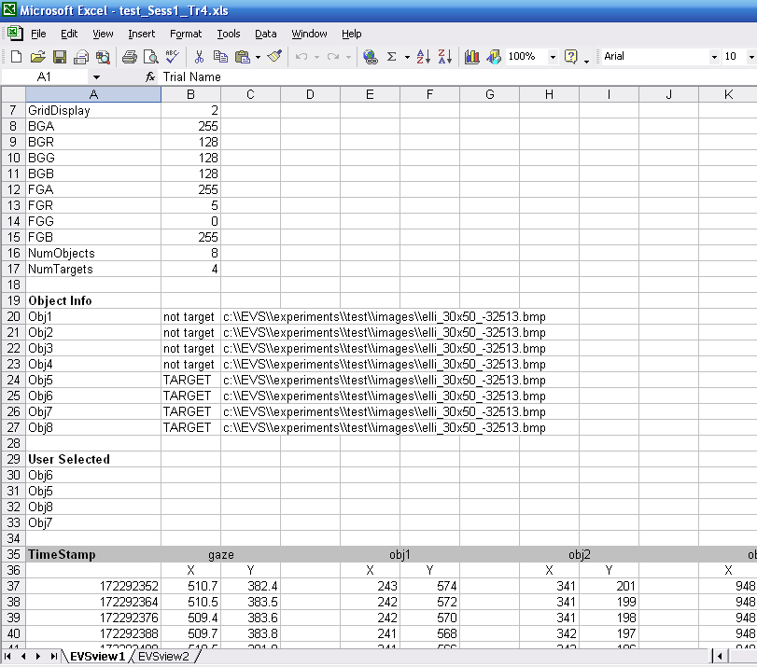
Figure 4.25 Analysis Tool - Example of .xls (EVSview1)

References

- (general) www.eyelinkinfo.com/index.php
the website for SR Research, which is the company that makes Eyelink.
The manuals can be found by following the Support > Manuals links.

- (general) www.cs.umb.edu/~marc/lab/
the website for the Visual Attention Lab at UMass Boston

- (general) Cavanagh and Alvarez, “Tracking multiple targets with multifocal attention,” TRENDS in Cognitive Sciences, July 2005

- (GE) xmlsoft.org
homepage for the XML C parser used by the Graphics Engine

- (GE) www.zlatkovic.com/libxml.en.html
site for windows version of the XML C parser

- (AT) www.microsoft.com/downloads/details.aspx?familyid=3c9a983a-ac14-4125-8ba0-d36d67e0f4ad&displaylang=en#Instructions
site for Office 2003 Primary Interop Assemblies

- (AT) www.vbdotnetheaven.com/UploadFile/mahesh/TransparentImagesShapes
04212005052247AM/TransparentImagesShapes.aspx
Alpha Blending

- (AT) Various sources in codeProject.com and http://support.microsoft.com/kb/307548
XML File Handling

- (AT) GDI+ programming Techniques

- (general) http://www.soe.ucsc.edu/classes/cmps115/Spring02-01/docs/
site for this document’s template/format

