Experiment Builder Manual

Binary files / Start of Application

The Experiment Builder consists of 1 executable File. (ExperimentBuilder.exe) Execution of this file (e.g. double-click) starts the application. The only prerequisite is that .NET 2.0 is installed on the host machine. There are no other dependencies.

Walk-through

After starting the application, the following screen will be displayed:

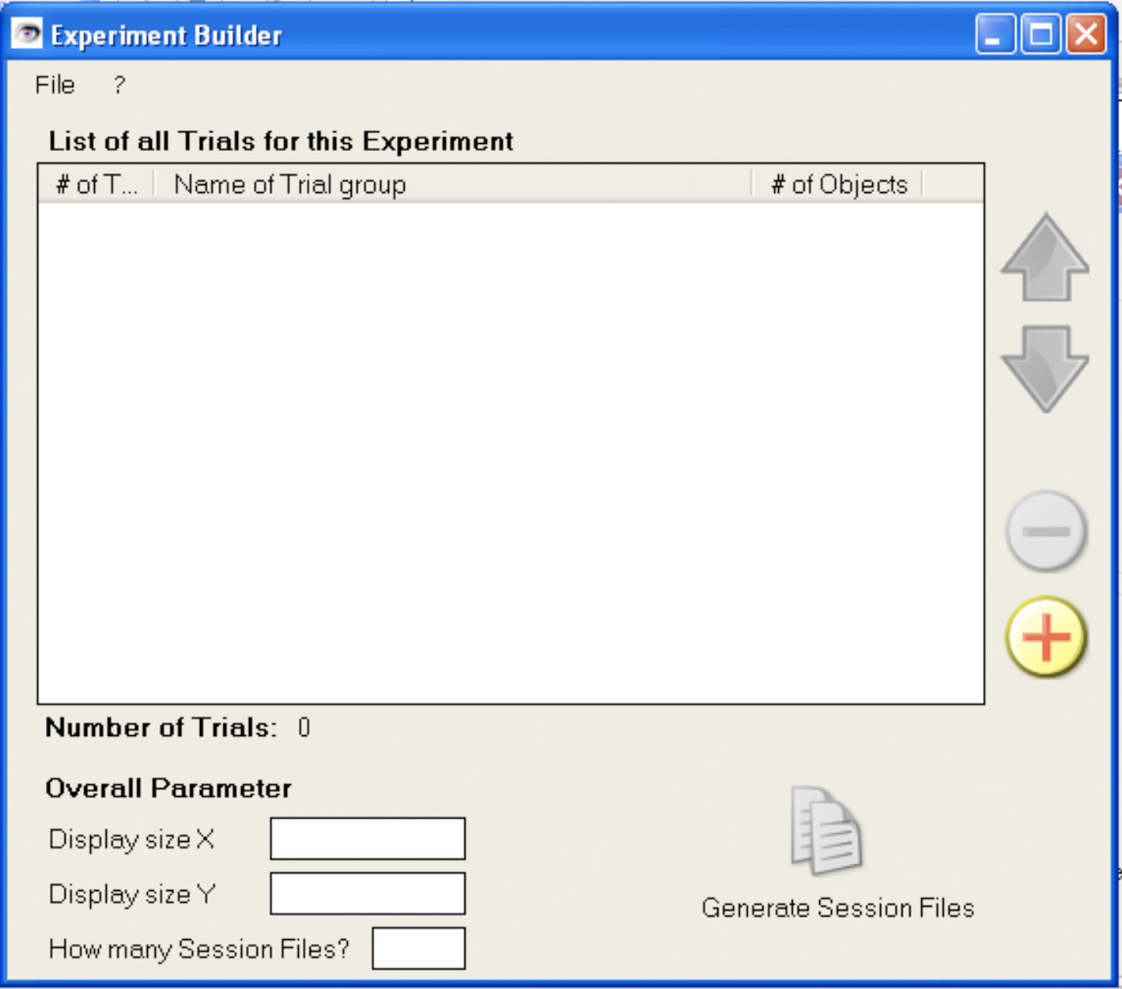

At the beginning, the only option the user has is either to load an existing experiment binary file (“.eb”) or to add a new block of trials to the empty session. To add a new block of trials, click the “+”-button. The following form will appear:

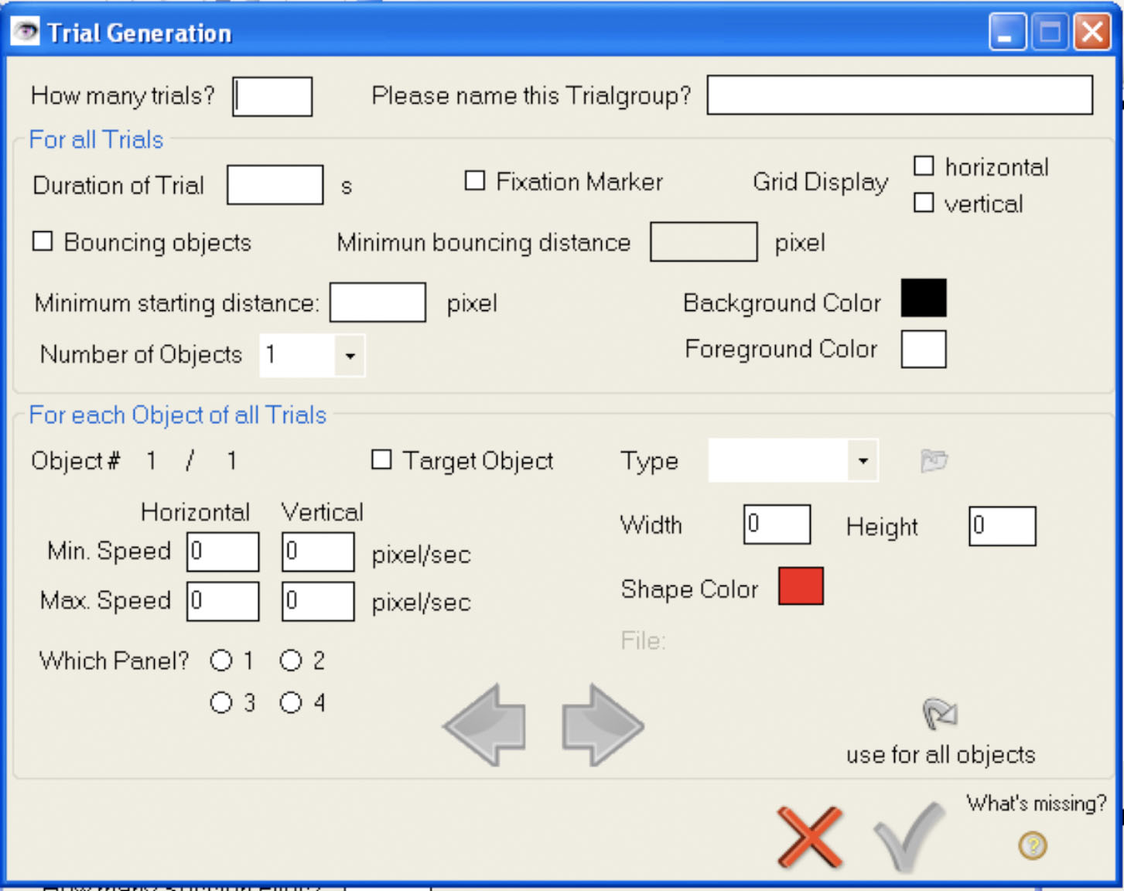

Here the different parameters for a block of trials can be specified. These are:

For the whole block of trials:
- Numbers of trials for this block
- Condition name of trial block

For each block of trials, you can specify:
- Maximum duration of each trial
- If a fixation marker (a cross the user has to focus on during the experiment) should be displayed
- If a horizontal, vertical (or both) grid will be displayed, that separates the screen in different areas
- If the objects bounce off from each other
- When the objects are bouncing off, at which minimum distance they will do this.
- The minimum starting distance the objects are away from each other at the beginning of each trial
- The foreground color of each trial (click on the color to change it)
- The background color of each trial (click on the color to change it)
- The number of objects for each trial

For each object in each trial, the following parameters can be defined:
- If the objects is a target object (e.g., if it blinks at the beginning of a trial)
- The minimum and maximum speed for horizontal and vertical movement
- The area of the screen in which the objects is positioned at the beginning of each trial
- How the objects looks like. Can be either the pre-defined shapes Circle/Ellipse or Rectangle/Square or a random bitmap file.
- If the object should be a Circle/Ellipse or Rectangle/Square, either the X-and Y-Radius or the width and height in pixels can be specified
- If the object should be a Circle/Ellipse or Rectangle/Square, the color of the object can be defined (click on color to change it)
- If the type is bitmap, the user can choose the file from disk (click on the folder symbol)

To toggle between the different objects, the user can browse through them by clicking either on the left- or right-arrow. (Right-arrow: Next object, Left-Arrow: Previous object). If the user wants to use the parameter of one object for all objects, he just has to click on the “use for all objects”-button.

When all entries are filled, the user can add them to the Session List by clicking on the green checkmark. If he wants to close the window, he can click on the cross – all entered data will be gone. If the user thinks that he has entered all data needed, but the checkbox is still grayed out, he can get a list of missing parameters by clicking on the question mark below the text: “What’s missing?”

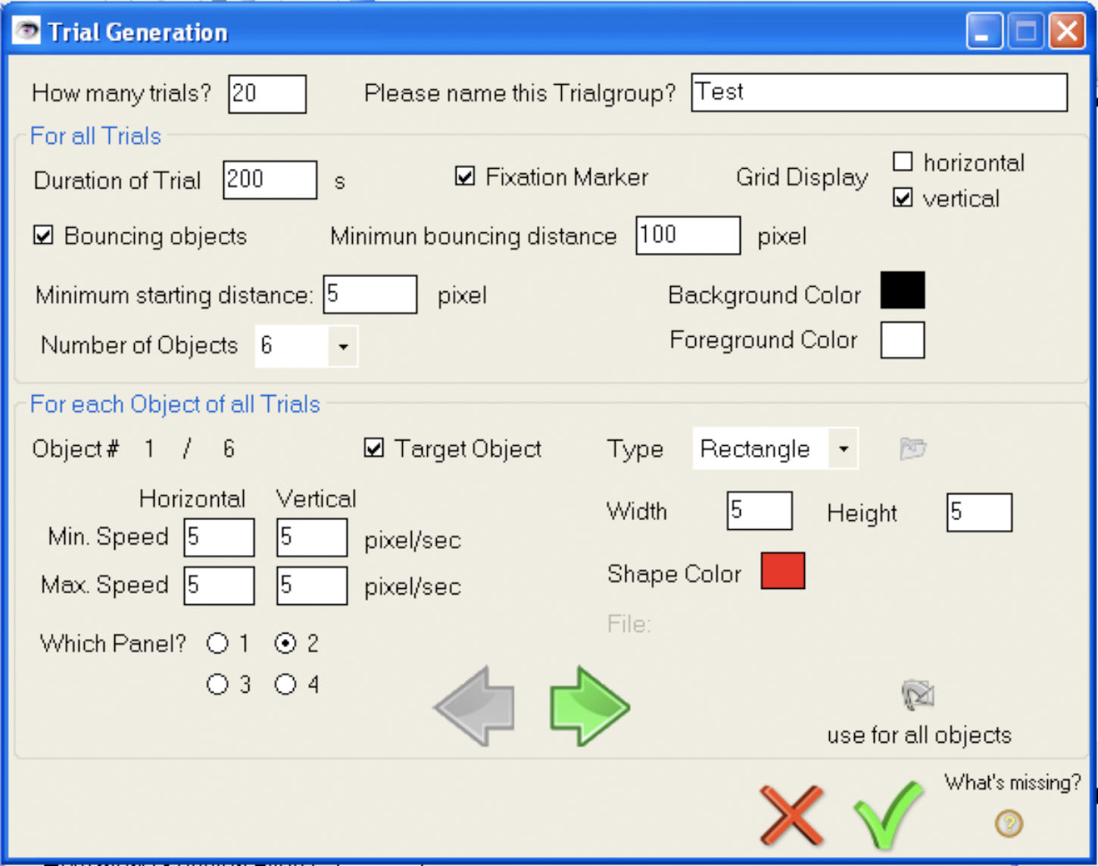

After clicking on the checkmark, and adding another block of trial in the same way (clicking on the “+” button and entering the trial data), the application form will look like this:
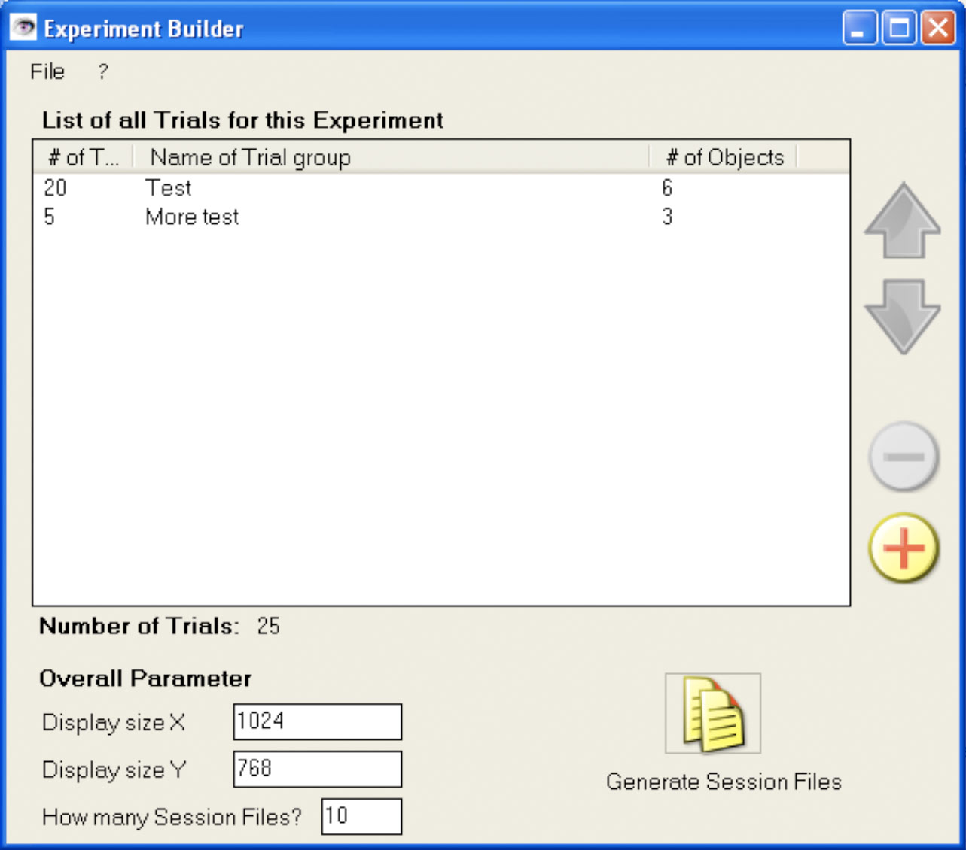

By double-click on one of the trial block entries in the session list the entered data can be changed. By selecting an entry in the session-list the trial block can be deleted or moved by either using the buttons on the right (move up, move down, delete) or by right-click and using the appropriate menu entry in the appearing context-menu.

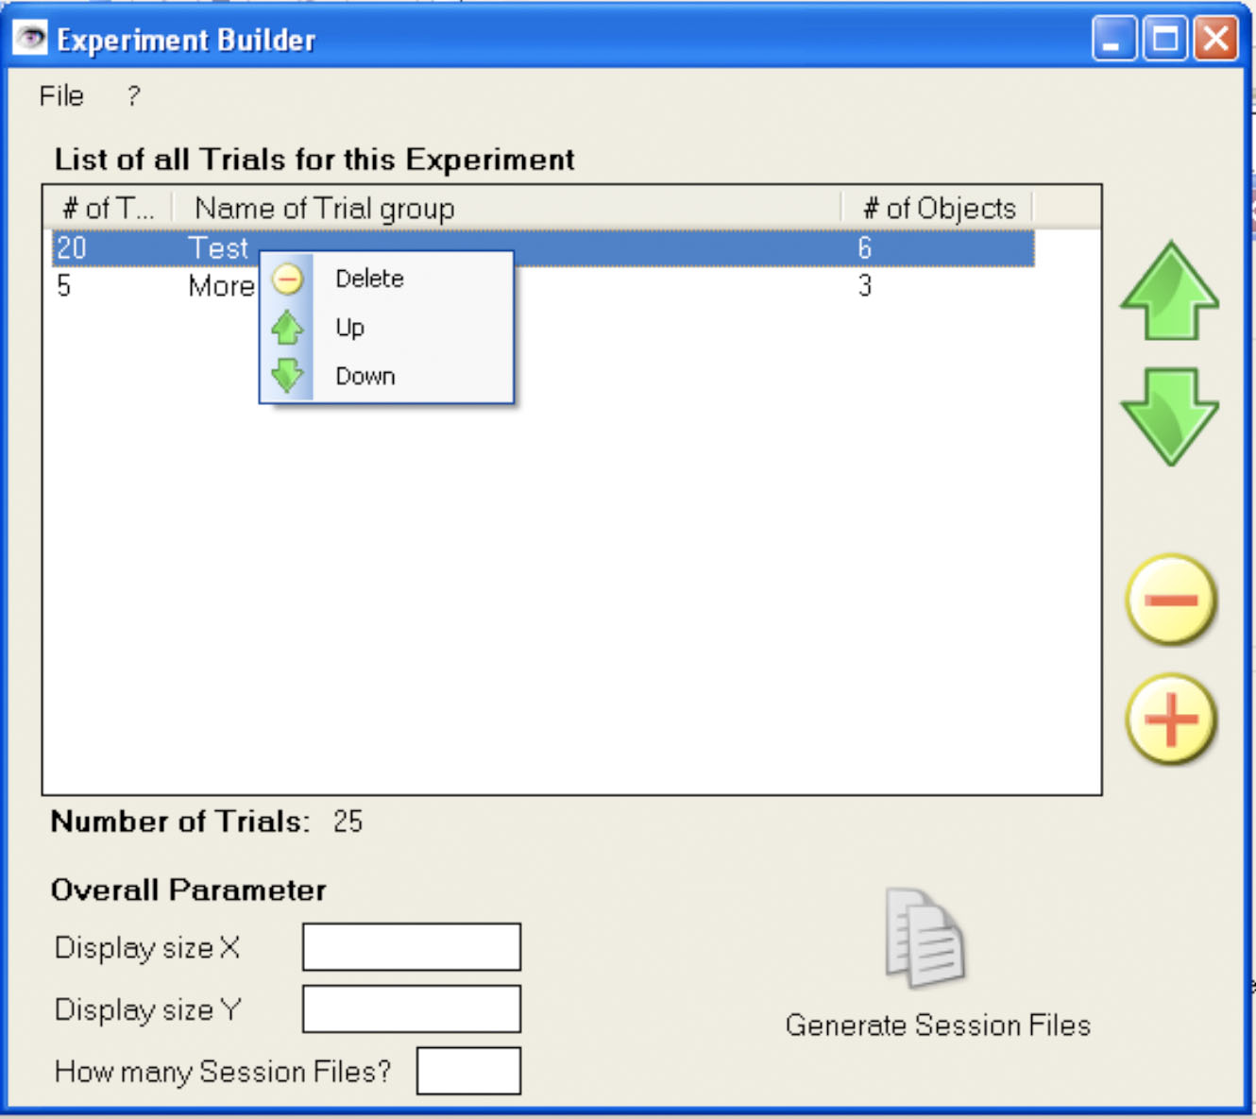

After all desired blocks of trials are added to the session list, the user can enter the needed display size (X-and Y values) for the experiment. Also, he can specify how many session files are needed. (E.g., the number of subjects he wants to do the experiment).
The Generation button will become clickable. After clicking this button, and dialog appears which asks him for the name of the experiment. If he enters a name already used, the user can use the delete-Button to delete the existing experiment. Otherwise, he can confirm the name with the OK-Buttons and all needed files will be created.
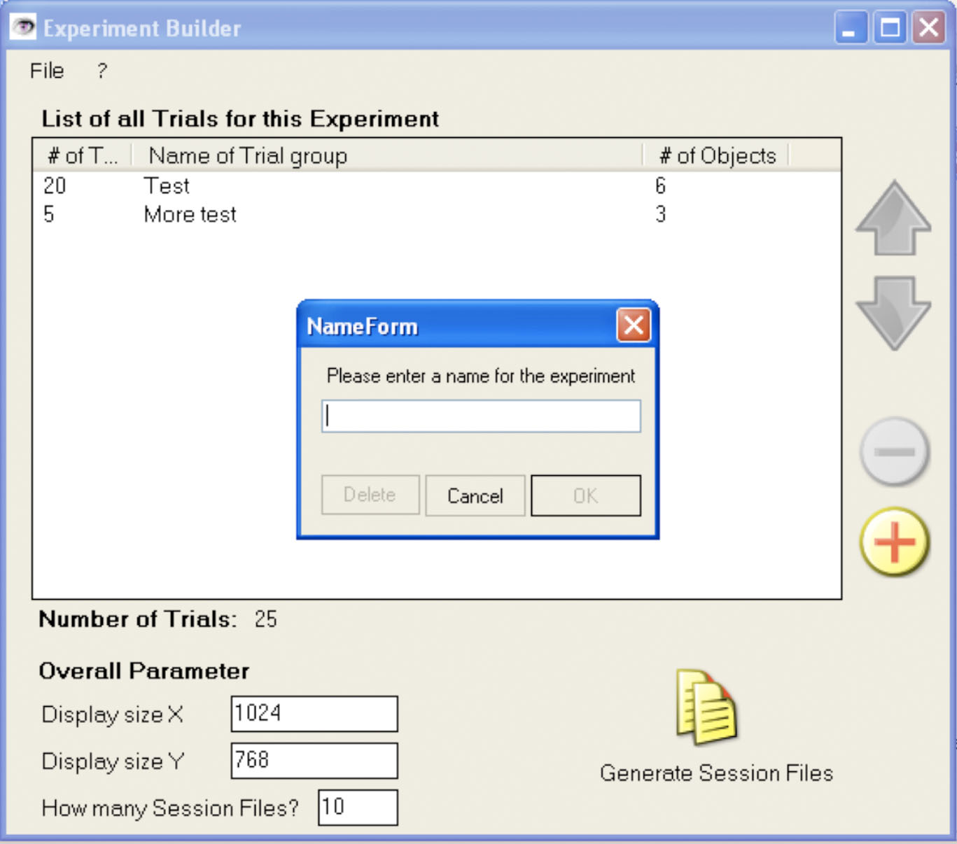

It is recommended to save the experiment data. This way, the entered data in the Experiment Builder can always be loaded again and used or modified to create more session files. In the Menu “File” there are entries to load and save the data in a binary file.

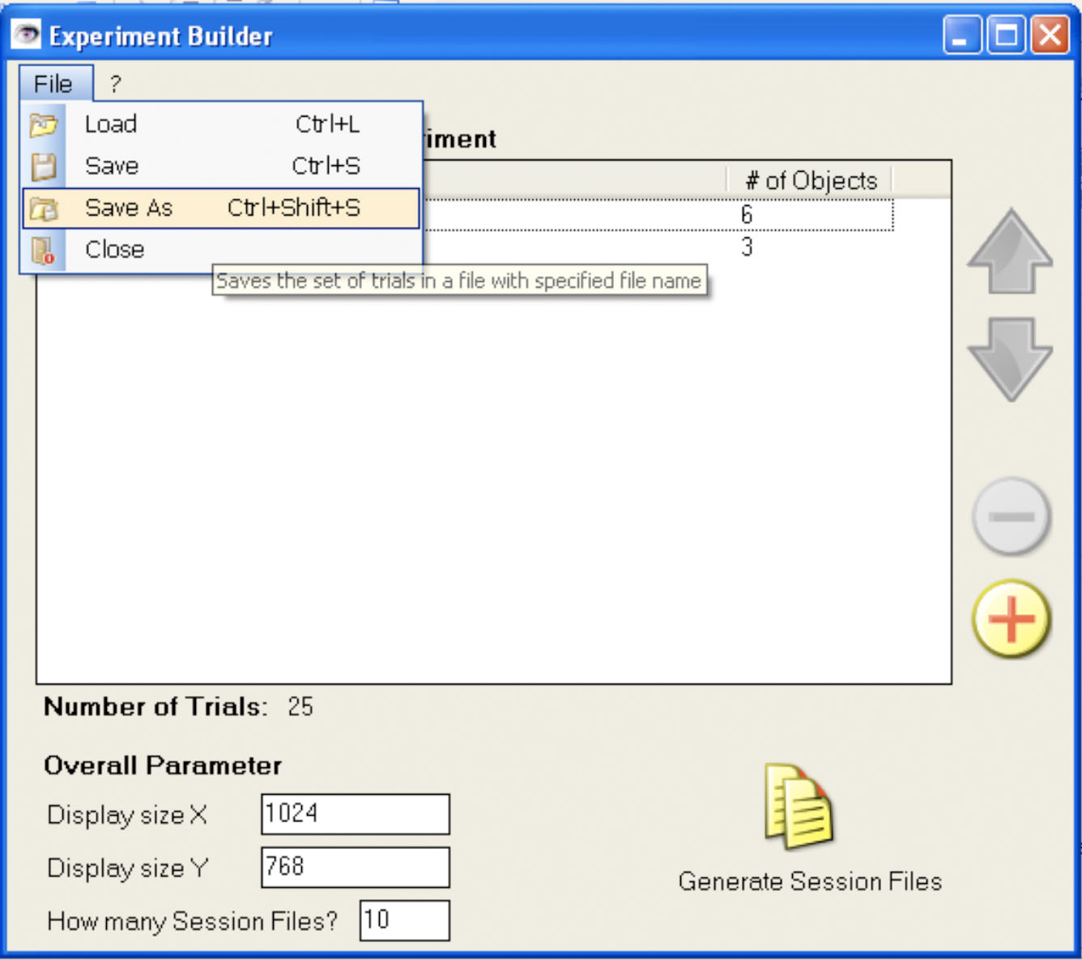

Output of the Experiment Builder

In the moment when the user creates the session files for his experiment, the Experiment Builder creates (if not already existing) the following directory structure.

C:\EVS
C:\EVS\bin
C:\EVS\doc
C:\EVS\ext (for external/3rdParty libraries, etc.)
C:\EVS\experiments
C:\EVS\experiments\[exp_name]
C:\EVS\experiments\[exp_name]\perf (all .perf files in single dir)
C:\EVS\experiments\[exp_name]\Sess1
C:\EVS\experiments\[exp_name]\Sess1\[exp_name]_Sess1.session
C:\EVS\experiments\[exp_name]\Sess1\images (for bitmaps)
C:\EVS\include (for our .h files)

The session files are XML-files and will be stored for each different session X in the appropriate SessX-Folder. The name of the session file will be [exp_name]_SessX.session. The bitmaps generated by the Experiment builder are stored in the images folder for each Session.

Therefore, after generating the folder structure, the Experiment Builder generate the session-Files (“.session”), which are XML-Files that contain the session data. Furthermore, the images corresponding to the session-Files (e.g., the squares and circles to be displayed) are also generated. A session-File has the following structure:

<?xml version="1.0" encoding="ISO-8859-1"?>
<experiment>
<session>
<expName>MyExp</expName>
<sessNum>23</sessNum>
<displayX>1400</displayX>
<displayY>1050</displayY>
<numTrials>50</numTrials>
<trials>
<trial number="1">
<condition number="1">Condition Name goes here</condition>
<isFixMarker>1</isFixMarker> (0=false, 1=true)
<duration>15</duration>
<gridDisplay>2</gridDisplay> (0=no,1=H,2=V,3=HV)
<bgColorA>255</bgColorA>
<bgColorR>255</bgColorR>
<bgColorG>255</bgColorG>
<bgColorB>255</bgColorB>
<fgColorA>0</fgColorA>
<fgColorR>0</fgColorR>
<fgColorG>0</fgColorG>
<fgColorB>0</fgColorB>
<isBounce>0</isBounce> (0=false, 1=true)
<minBounceDist>10</minBounceDist> (null/empty? if not used)
<minStartDist>20</minStartDist>
<numObjects>3</numObjects>
<numTargets>1</numTargets>
<objects>
<object number="1">
<objPath>C:\bar\foo</objPath> (absolute path)
<objIsTarget>1</objIsTarget> (0=false, 1=true)
<objPanel>2</objPanel> (1,2,3 or 4)
<objMinSpeedH>5</objMinSpeedH>
<objMaxSpeedH>5</objMaxSpeedH>
<objMinSpeedV>5</objMinSpeedV>
<objMaxSpeedV>5</objMaxSpeedV>
</object>
<object number="2">
<objPath>C:\bar\foo2</objPath>
<objIsTarget>0</objIsTarget> (0=false, 1=true)
<objPanel>1</objPanel>
<objMinSpeedH>5</objMinSpeedH>
<objMaxSpeedH>5</objMaxSpeedH>
<objMinSpeedV>5</objMinSpeedV>
<objMaxSpeedV>5</objMaxSpeedV>
</object>
</objects>
</trial>
.
.
.
</trials>
</session>
</experiment>

Development
The project files for Visual Studio 2005 and the source files are accessible. To make changes to the project, any IDE supporting .NET 2.0 can be used. The source code is written in C# and commented. There are no special requirements to compile this project besides basic .NET and C#-knowledge and an appropriate .NET 2.0 installation. No other libraries etc. are needed.

Source documentation
An xml-File is generated of the source code that contains the comments, object descriptions and additional docs for the source-code.

Known Bugs:
None so far.

Further Improvements:
Nothing requested so far.

