Analysis Tool

Author: Smitha Madhavamurthy
Date: 05-25-2007

Introduction
Analysis Tool is a Standalone component which provides functionality that aids in performance analysis of the various experiments Conducted in the Eye Link Research lab at UMass, Boston.
Analysis Tool provides the following options:
- Creates files used for statistical/performance analysis. These files will be readable by third-party statistical tools.
- Replays an individual Trial undertaken by a subject with the gaze positions superimposed.

Performance File Creation:
Performance File Creation Routine accepts either a Valid Session Directory or an Experiment Directory as input . It extracts data from all Trials in the Session or data from all trials in all Sessions inan Experiment to create and provide a Peformance file used by third party Statistical Tools.

Replay Trial: Replays an individual Trial with the gaze positions superimposed. The replay of an individual trial includes options to
- pause
- resume
- stop
at any instant of time during the replay. It provides initial blinking of the System Target Objects that the subject is supposed to follow throughout the trial. It also provides the option to Mark or Unmark all the target objects during the replay, in order to facilitate analysis, i.e., simplify the tracking of objects by the experimenter. The Targets ,by default ,are all marked during Replay.
( The marking of targets will be either "all targets marked" or "all targets unmarked".)

Excel File Creation
Accepts a GE log File as an input and checks to see if a Display File exists for the Given Trial. If it exists, then it moves ahead and creates an Excel file from the data obtained from Display File using XML2XLS routine.
If a Display File does not exist, then its creates one before creatign an Excel file.
It normally takes anytime between 30seconds to more than couple of minutes to create an Excel file , a user Friendsly Message with Progress bar is displayed to keep the User Informed that the file Creation Process is in progress.

System Requirements
- Libraries Required: Microsoft Office PIA
EDF2ASC.exe required to be under C:\EVS\bin : This executable accepts an EDF file generated by Eyelink and Converts it to ASCII format.

- File Structure Requirements
  - Executable
    - Analysis Tool Executable - AT.exe
    - XML Schema for Display File DisplayFileSchema.xsd
    - gaze.bmp
  - Input Files
Input files required to execute Analysis Tool functionality are :
Gelog file : File generated by GE that holds Object positions recorded during a Trial.
EDF file : File generated by Eye Link during a Trial which
Holds the Eye Gaze positions

These Files are required to be in a pre defined File Structure as shown below:
C:\EVS\experiments
\<Experiment-Dir>
\<Session-Dir>
\ <EB generated Session File> (*.Session)
\<Eye Link generated EDF file> (*.EDF)
\<Trial-Dir>
\<GE Log File> (*.gelog)

  - Output Files
Following Output files are generated by Analysis Tool in a pre defined File Path as shown below:
    - .Gaze file : ASCII version of the EDF file generated by Eye Link which contains data related to one particular Trial. Analysis Tool converts the EDF file to its ASCII format .
    - .display file: XML file which contains data required to handle Replay Functionality. XML file adheres to the Schema provided with the executable.
    - .xls file: Microsoft Excel file which contains data about the Trial setting along with Eye movement and Objects movement data in a pre defined Format.

    - .perf file: TXT file format of the Performance file which contains Performance Analysis of all Trials in the Session. Or performance Analysis of all Trials in their respective sessions.

The File Structure is as shown below:

C:\EVS\experiments
\<Experiment-Dir>
\<Performance-Dir>
\<Performance File> (*.perf )
\<Session-Dir>
\<Performance-Dir>
\<Performance File>
\ <EB generated Session File> (*.Session)
\<Eye Link generated EDF file> (*.EDF)
\<Trial-Dir>
\<GE Log File>
\< Gaze File>
\<Display File>
\<Excel file>

Implementation Details

- Analysis Tool GUI
  - Screen Shot
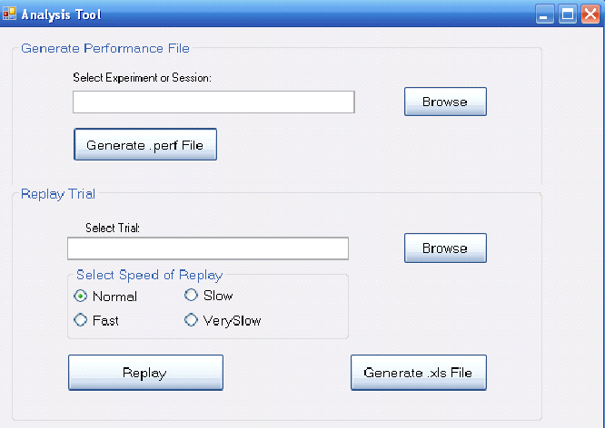

  - Functionality Provided with the GUI
    - Performance File Creation: Accepts either
Session Directory (*) or an
Experiment Directory (**) as an input.

    - Replay a Trial: Accepts any GeLog file as an input.
It Provides the following Options:
      - Option to Chose the Speed of Replay
        - Fast
        - Normal
        - Slow
        - Very Slow

      - Option available to user During the Replay of a trial:
        - Pause
        - Stop
        - Resume
        - Mark or Unmark System Target Objects

(*) Session Directory: Directory that holds all Files related to a Session including Session file, Trial Folders, EDF file, Image folder. Session Directory resides under an Experiment Directory.
Required File path would be :
C:\EVS\experiments\<Experiment-Dir>\<Session-Dir>

(**) Experiment Directory: Directory that holds any/all Session directories. Required File path would be: C:\EVS\experiments\<Experiment-Dir>

- Compilation options
The source code has been developed on .NET 2005 environment. In order to rebuild or recompile the project, The project solution has to opened in the same environment. Once any changes or edits have been made to the files , rebuild the solution and execute it . An important note to remember is that the reference files, XML Schema and gaze.bmp which are also part of the solution , have now a different filepath. The code needs to be changed in :

ReplayTrial.cs file holds a Private variable : GAZE_FILE_PATH

- Error Handling
User Defined Exception class “ATLogicException” has been made available which acts like a Wrapper for any and all Errors and Exceptions which might occur during the processing of a Trial.
Errors and Exceptions below are not defined as Fatal and hence program continues to execute normally.
          - System Exception occurred during file parsing
    - DataFormat Exception due to in consistent format of data in the
Logic.
- NullPointerException : This depends on the circumstance in which the exception is thrown. If due to this exception the control cannot go into the next step, then the program is aborted with a user friendly error message with a stack trace of the occurrence of such an error.
- Generic Exceptions : exceptions which do not necessarily affect the flows of control in the application.

Fatal Exceptions which might cause a program to abort :
- File not Found exception
- IOException while opening , updating or closing a File.
- Concurrent Porcess Exception : Some times another process would have access to the source that Analysis Tool wants to process. In such a circumstance, the program would abort with a User friendly message indicatign the same.
- Invalid Input : Every input to Analysis Tool is checked for validity. If found In valid, the control falls back to its previous step with a valid Error message displayed to the user.

- Source code
Listed below are the list of Files with the functioanlity that each such class provides. It also includes any specific choices made by the developer during implementation .

Class/Form Name | Functionality Provided | Developer’s Input
AnalysisToolGUI.cs | Main form which acts as User Interface for the Application. Provides options for Performance File creation, Excel file creation and Replay of a Trial. Event Handlers have been defined for each event occuring in the Form. | . Validates input and display User freindly messages .  Delegates all logic handling to other classes.  Provides feedback to the user if any error or Exceptions occur.
DoubleBufferReplayControl.cs | - Provides the core graphics handling functionality for the Replay.  - Uses Timer’s Tick event to refresh the screen and repaint it.  - Uses DoubleBuffering to control Flickerign of image .  - Uses Bit map Transparency Techniques where required  - uses alpha Blending of Images  - has child form “ ReplayUserControlDialogFrm.cs”  - Uses Delegates to provide Pause, resume, Mark/Unmark target objects During Replay.  - ESC key needs to be pressed at any time during replay in order to pause the Replay and bring up the User Control options form . | Its of type Windows Form User Control . Uses Windows.Form.Timer Tick Event to Repaint the Screen. The timer is not very accurate and fails to provide 500hz or 100hz resolution. Have tested using System.timers.Timer and also System.Threading.Timer to achieve the same. But the results wree not any different. This could be probably handled using Performace timer of System Win32 api.
ReplayUserControlDialogFrm.cs | Provides following user control options during the Replay of a Trial  - Mark/Unmark Target Objects  - Resume Replay  - Stop Replay | Easy to use tool where each option is declared as a delegate and a handler is associated with weach option
WaitMessageForm.cs | Simple windows Form which displays a Progress Bar associated with the creation of an Excel file . | Progress bar is currently Static. Vcurrently it does not keep track of the File creation process and Display the same.
CreateGazeFiles.cs | - Wrapper for the EDF to ASC file conversion .  - Extracts data for individual trials identified by TrialID and stores them as .gaze files for each Trial | Regular Expression sued to identify ‘TRIALID’ expression in the EDF file.
DisplayFileCreation.cs | - Given a Gelog File and a Gaze file for the Trial, builds an XML file .  - Extracts Gaze positions and Object positions into a Queue independently.  - Then deques each queue and Builds the Data required for Replay.  - The data in this Display File is used to Create Excel file which could be used for analysing purposes.  - Usage of Concurrent Programming technique | The XML file Format adheres to a Schema. The reason why an intermediate XML file was created is because building XML file by GE logger routine would consume more time which would affect its performance. Hence XML file which is a vey popular data transfer format has been used.
DisplayFileParser.cs | XML parser to parse Display File and extract data . Provides API to extract Trial’s setting parameters, Positions of Objects and Gaze obtained at constant time intervals, Target objects chosen by the subject | Parser can be used as standalone to extarct data from any node .
GazeDataWorker | Worker Thread that retrieves Eye Gaze position data from the specified gaze file. Enqueues the gaze positions alogn with the timestamp at which the gaze was recorded into an accessible Queue Object. | Usage of Concurrent Programming technique
ObjectDataWorker | Worker Thread that retrieves Object position data from the specified gelog file. Enqueues the object positions along with the timestamp in user defined objects into an accessible Queue Object. | Usage of Concurrent Programming technique
ReplayTrial.cs | - Parses the input Display File to extract data into data structures which provide easy retrieval by the Graphics conrtoller .  - Defines the Speed Factor . Uses the Speed Factor to skip certain number timestamps data to achieve a pre determined speed. | This class acts as a preparation for gatherign data required to display the trial. If future impelmenters decide to use other Graphics controls for the display , then this class could still form the base to get the required data.
DisplayFormPreferences | This Object holds all data useful for replay Functionality in data structures which provide efficient and fast data retrieval
ReplayGraphics.cs | Provides the base for the DoubleBufferReplayControl. | Did not make use of Form to Handle Graphics as more advanced Controls were required.
PerformanceFileCreation.cs | Accepts Session Directory path :  - retrieves Performance file name to be created  - Iterates over all Trials in the given Session extracting system targets and Subject selected objects and addign them to the Performance file.  Performance File consists of  - data from all Trials in a Session if a Session directory was chosen by the user  - data from all trials in all sessions if an experiment directory was chosen by the user
ObjectData.cs | User Defined Object to hold data pertaining to Individual Objects used in a Trial
ObjectPositionData.cs | User Defined Object to hold timeStamp data Objects used in a Trial. Each timestamp contains both Gaze and Objects  Position data.
ATUtil.cs | Utility routine which provides routines to Validate, extract file names and some generic routines whose logic do not belong to any particular object.
ATLogicException | User defined Exception that wraps all Errors and Exceptions that occur during the Execution Process. | If more complex exceptions need to be handled, I would have subclassed this exception class to define more specific exception classes
XML2XLS.cs | As the name suggests, this class is specifically designed to handle Conversion from an XML file to an XLS file. In this case, its particulary designed to convert Display file in XML format to Excel file with a pre determined format . | This is a highly configurable routine. Can be used to create Excel file in any format as desired. Currently it supports 2 different types of formats.

- Test cases
  - Check to see if a new Display file is created when one already exists
  - Check to see if a performance file is created if one already exists
  - Test with an invalid file path to create either performance file , Display file or an Excel file
  - Check to see if an invalid file is provided as input and if the desired files are created in the process.

- Enhancement Options

- GDI+ has been the choice of the developer to implement Graphics Control. This could be updated to use may be more advanced Graphical tools like Direct X.
- Alpha blending of images can be used more extensively to provide more dramatic visual effects to the Replay
- User interface could be improved or A unified User Interface can be provided which would serve as a unified GUI for all 3 components namely Experiment Builder, Graphics Engine and Analysis Tool.
- Currently Frame Rate of the System on which Graphics Engine displays the trial is Hard codedin the logic. And hence it’s the same case with the Analysis Tool. This could be retrieved programmatically from the Win32 API to handle refresh rate and Frame Rate more Accurately.

Sample File Formats Are provided in the next section

Sample Performance File from a session

# test_Sess1.perf
#
# trialNum = trial number
# condNum = condition number of the trial
# totNumObjs = total number of objects
# totNumTargs = total number of targets
# objTargs = which objects are targets (comma-separated list)
# subjTargs = which objects the subject chose as targets (comma-separated list)
#
#
#
# trialNum condNum totNumObjs totNumTargs objTargs subjTargs
# -------- ------- ---------- ----------- -------- ---------
# 1 1 2 1 1 2
# 2 3 4 2 1,2 3,4
# ...

1 1 8 4 2,4,6,8 1,6,3,8
2 1 8 4 2,4,6,8 2,6,4,7
3 2 8 4 5,6,7,8 6,5,8,7
4 2 8 4 5,6,7,8 6,5,8,7

Sample Display File for a Trial

<?xml version="1.0" encoding="UTF-8"?>
<DisplayFileStart>
<Trial name="test_Sess1_Tr1" />
<Display X="1024" Y="768" />
<Condition Num="1" GridDisplay="3" BGA="255" BGR="0" BGG="0" BGB="255" FGA="255" FGR="5" FGG="255" FGB="255" NumObjects="8" NumTargets="4">
<Obj name="Obj1" ObjectFilePath="c:\\EVS\\experiments\\test\\images\\madsci.bmp" IsTargetObject="0" />
<Obj name="Obj2" ObjectFilePath="c:\\EVS\\experiments\\test\\images\\madsci.bmp" IsTargetObject="1" />
<Obj name="Obj3" ObjectFilePath="c:\\EVS\\experiments\\test\\images\\madsci.bmp" IsTargetObject="0" />
</Condition>
<TrialStart>
<Time stamp="172210144">
<obj name="gaze" x="513.2" y="385.3" />
<obj name="Obj1" x="275" y="43" />
<obj name="Obj2" x="17" y="8" />
<obj name="Obj3" x="795" y="203" />
</Time>
<Time stamp="172210156">
<obj name="gaze" x="514.7" y="385.1" />
<obj name="Obj1" x="272" y="44" />
<obj name="Obj2" x="15" y="6" />
<obj name="Obj3" x="792" y="201" />
</Time>
<Time stamp="172210168">
<obj name="gaze" x="514.5" y="384.6" />
<obj name="Obj1" x="270" y="46" />
<obj name="Obj2" x="14" y="4" />
<obj name="Obj3" x="790" y="200" />
</Time>
…..
…..
…..
</TrialStart>
<SubjectTargetStart>
<Obj name="Obj1" />
<Obj name="Obj6" />
<Obj name="Obj3" />
<Obj name="Obj8" />
</SubjectTargetStart>
</DisplayFileStart>

Sample Excel File for a Trial

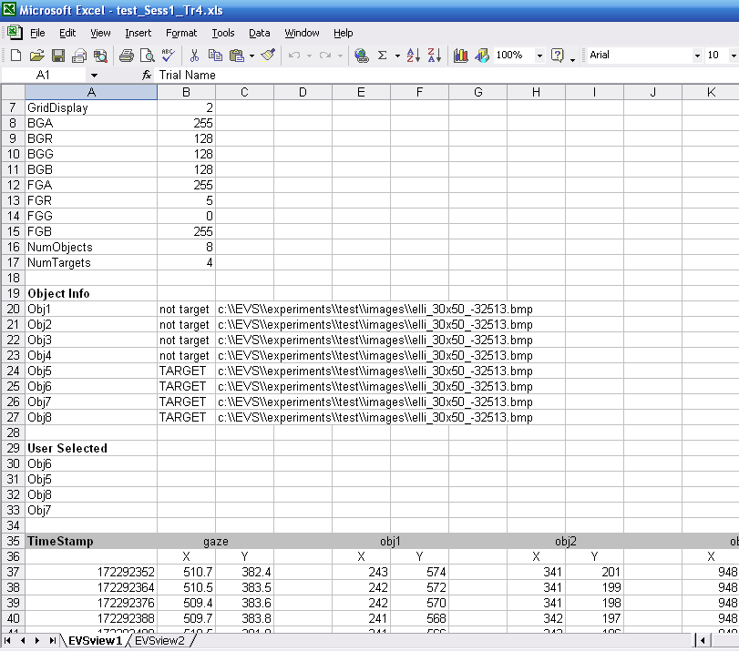

References :
- an intro to programmatically creating excel files
www.codeproject.com/office/csharp_excel.asp?df=100&forumid=23997&select=1792818#xx1792818xx
- full program for programmatically creating excel file
cheeso.members.winisp.net/srcview.aspx?dir=MSOffice&file=AutomateExcel.cs
- Range properties
msdn2.microsoft.com/en-us/library/microsoft.office.interop.excel.range_properties(vs.80).aspx
- cell insertion
www.dotnet247.com/247reference/msgs/58/294566.aspx
- PIA info
msdn2.microsoft.com/en-us/library/aa159923(office.11).aspx
- Alpha Blending : www.vbdotnetheaven.com/UploadFile/mahesh/TransparentImagesShapes04212005052247AM/TransparentImagesShapes.aspx
  - XML File Handling : Various sources in codeProject.com and http://support.microsoft.com/kb/307548
- GDI+ programming Techniques

