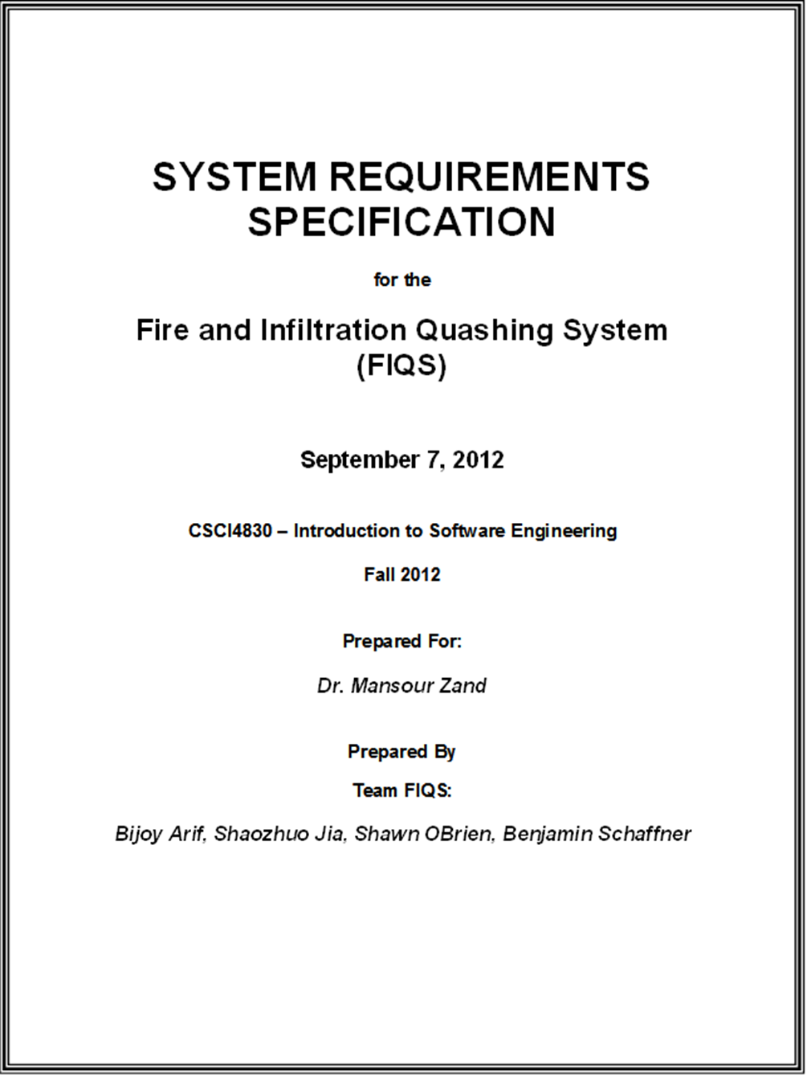

**Revision/Change Record**

|  |  |  |  |  |
| --- | --- | --- | --- | --- |
| *Revision* | *Date* | *Owner* | *Change Description* | *Pages Affected* |
| 0 | 09/08/12 | Ben Schaffner | Initial draft. | All |
|  |  |  |  |  |
|  |  |  |  |  |
|  |  |  |  |  |
|  |  |  |  |  |
|  |  |  |  |  |
|  |  |  |  |  |
|  |  |  |  |  |
|  |  |  |  |  |
|  |  |  |  |  |
|  |  |  |  |  |
|  |  |  |  |  |

Table of Contents

1 Introduction 4

1.1 Purpose 4

1.2 Scope 4

1.3 Definitions 4

1.3.1 Authorized User 4

1.3.2 Inventory Subsystem 4

1.3.3 … 4

1.4 Acronyms 4

2 Level Traversal 5

2.1 Heading 2 5

2.1.1 Heading 3 5

2.1.1.1 Heading 4 5

2.1.1.1.1 Heading 5 5

2.1.1.1.1.1 Heading 6 5

2.1.1.1.1.1.1 Heading 7 5

2.1.1.1.1.1.1.1 Heading 8 5

2.1.1.1.1.1.1.1.1 Heading 9 5

# Introduction

Hi there…

## Purpose

The purpose…

## Scope

The scope…

## Definitions

### Authorized User

This user…

### Inventory Subsystem

This subsystem…

### …

## Acronyms

FAIQ – Fire And Infiltration Quashing System

# Level Traversal

## Heading 2

### Heading 3

#### Heading 4

##### Heading 5

###### Heading 6

Heading 7

Heading 8

Heading 9