**User Manual**

For the

**Fire and Inﬁltration Quashing System**

(FAIQ)

December 17, 2012

(05:51:20)

Project 4

Version 1.0

CSCI4830 - Introduction to Software Engineering

Fall 2012

Prepared for

***Dr. Mansour Zand***

Written by

***Shawn OBrien***

**Revision/Change Record**

|  |  |  |  |
| --- | --- | --- | --- |
| Revision | Date | Name | Activity |
| 1 | 11/13/12 | Shawn OBrien | Skeleton starter pages. This. |
| 1 | 12/17/12 | Shawn OBrien | Everything! |
|  |  |  |  |
|  |  |  |  |
|  |  |  |  |
|  |  |  |  |
|  |  |  |  |
|  |  |  |  |
|  |  |  |  |
|  |  |  |  |
|  |  |  |  |
|  |  |  |  |
|  |  |  |  |
|  |  |  |  |
|  |  |  |  |
|  |  |  |  |
|  |  |  |  |
|  |  |  |  |

Table of Contents

1 Graphical User Interface 3

1.1 Tick, Tick, Tick … 3

1.2 The Basic Layout 3

1.3 Graphical Components 3

1.3.1 The Main Window 3

1.3.2 The Tabs 5

2 Start! The Opening 5

2.1 Why? 5

3 The Middle Game 5

3.1 Combinations 7

4 The End Game 7

4.1 You Saved It! 9

5 Appendix: Information Console Slice 11

Figure 1 4

Figure 2 6

Figure 3 8

Figure 4 10

Figure 5 11

# Graphical User Interface

The FAIQ simulator relies solely on graphical widgets in order to interface with the user. All input from the user comes from the mouse. I do not support the use of the keyboard. I crafted what I believe to be a fast interface, with large buttons, and a wealth of status information.

## Tick, Tick, Tick …

To approach the whole bundle of how to use this application, I must emphasize that the typical scenario lasts less than five minutes. I simulate the core FAIQ functionality using a highly compressed temporal environment. The bulk of the compression results from omitting the reality that years may pass before a real alarm occurs.

The FAIQ simulator, over time, and at random intervals, simulates the activation of all sensors and alarms in all zones in a very short time. Accordingly, all evacuation and control measures become available to the user. In this way, the key logic involved in minimizing loss of life and damage, while maximizing evacuation and control measures undergoes extreme amplification. Additionally, the simulation brings out in startling relief the incredible number of deaths and damage that could occur when both fire and security threats are present in all zones concurrently.

## The Basic Layout

Fortunately for the user, upon executing the binary program, the GUI springs to life in a pristine state, frozen in time. Let me enumerate the graphical components in the next section.

## Graphical Components

### The Main Window

This underlying component provides the infrastructure and real estate for the application. From left to right, top to bottom, one may see the File menu that includes Exit, as well as the Edit menu that includes Start, Pause and Clear. Three small window buttons, and three larger application buttons to the far right represent the same functionality as the menus. Betwixt the two, the five Zone tabs are obviously visible. (What you cannot see is the underlying tab widget that holds the five tabbed widgets.)

Below the tabs lies a large text window – the information console. As each simulation unfolds, the simulator logs relevant activity, events and outcomes. Conveniently, I found a way to log information from the bottom up, that is, the latest line of information always remains at the top of the text window. See Figure 1. Note that the text window is severely truncated for editorial purposes.

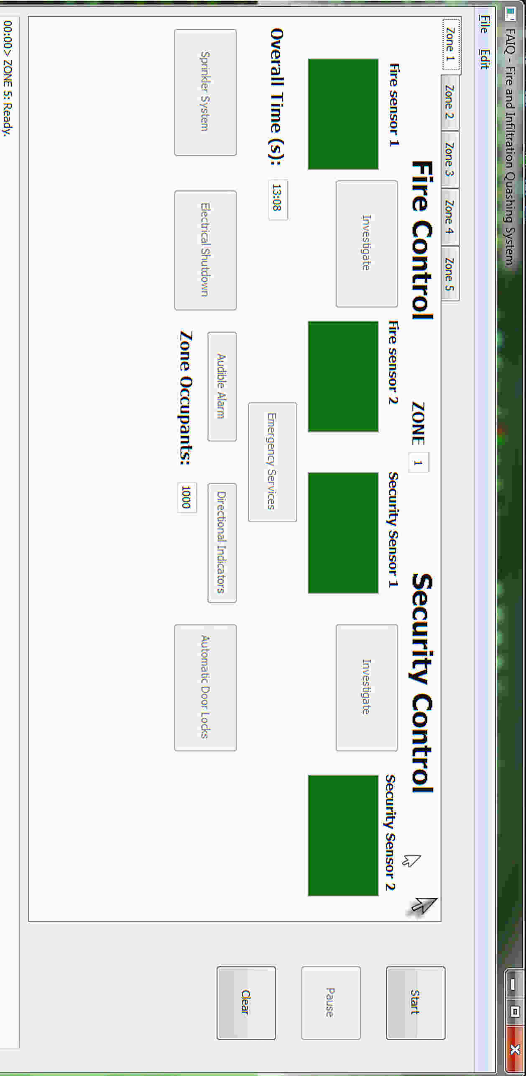

Figure

### The Tabs

Except for the numeric Zone designation at the top of the Tab, an identical tab represents each zone. Each tab contains two sections, though I did not strictly delineate them. To the left, you will find Fire Control, with Security Control opposite. Each control section contains a pair of colored sensors and an Investigate button. Both sections share the Zone Occupants text box as well as the seemingly misplaced Overall Time text box.

The control units also share button for Emergency Services, Audible Alarm and Directional Indicators.

I allocated the Sprinkler System and the Electrical Shutdown control measures to the Fire Control System, and the Automatic Door Locks option to Security.

# Start! The Opening

The first phase of the simulation concerns itself with activating the sensors in order to establish alarm states. A pair of activated sensors equals one alarm state for the given control unit of the given zone.

The simulator grants the user one chance to Investigate the first sensor in each control area. Hence, the sensor may revert to green from red. This chance becomes forfeit if the second sensor activates before the user taps the Investigate button.

To compensate for the fact that four tabs remain hidden at all times, the tab’s Zone label turns red when any sensors activate. Eventually, all of the labels turn red because the simulator eventually trips all of the alarms.

## Why?

As mentioned, all zones become besieged my spreading fires and security breaches. In the end, each zone will either be saved or destroyed. Saving as many zones as possible, with the fewest casualties stands as the ultimate goal of the user.

The secondary goal is learning how the real system works by understanding how evacuation and control progress over time in a dangerous environment. As a corollary to the temporal aspect, the interaction between the control measures and alarm states must be illuminated for the user.

# The Middle Game

All evacuation and control measures for each control section become available after reaching the alarm state.

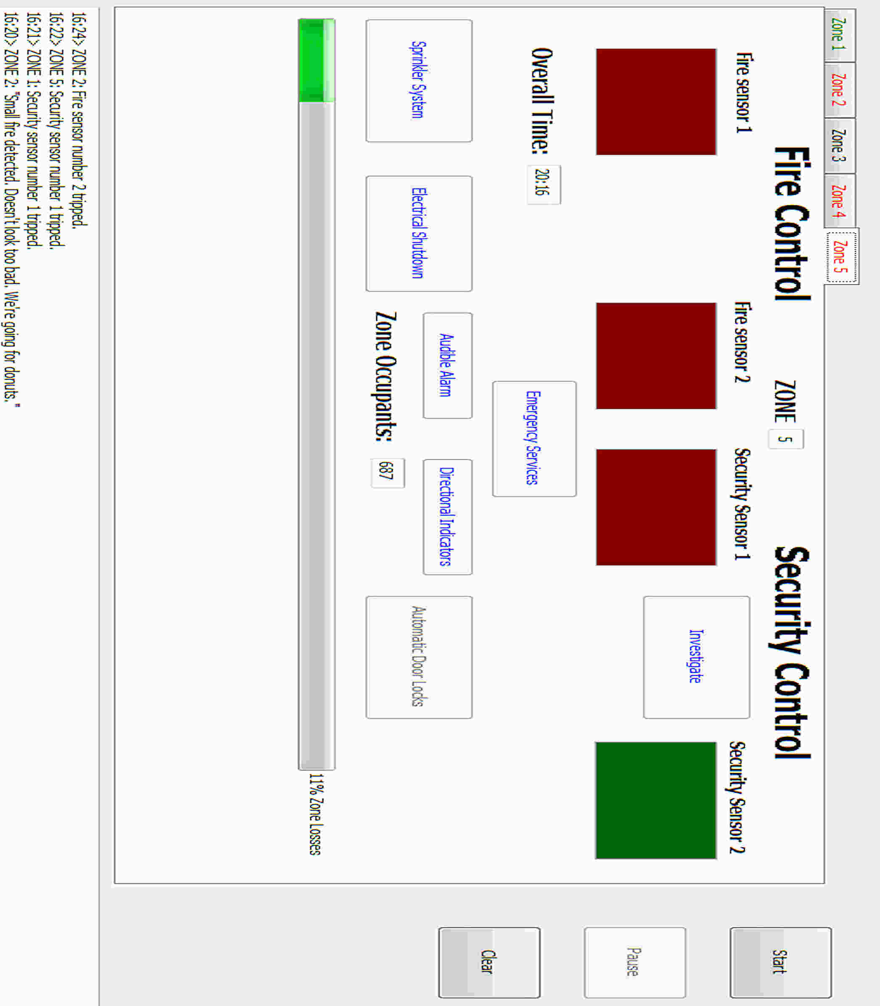

Figure

As you can see from Figure 2, the user may tap any of the buttons with the blue text. They have become available. (The reason they appear disabled is because I paused the simulator in order to take the screen shot. Blue text in the paused state indicates that the button is available.) In contrast, the Automatic Door Locks button is indeed disabled. This is due to the fact that only one sensor is active. Notice that the user may Investigate this sensor.

As a prelude to the endgame, a progress bar takes the stage to indicate current damage levels to the zone. As a counter-balance, 313 occupants successfully evacuated the building with no potential for becoming casualties.

## Combinations

As in chess, the timing and sequence of moves peaks in importance during the middle game. For instance, turning on the Sprinkler System prior to Electrical Shutdown leads to the electrocution of a random number of occupants. Similarly, tapping the Audible Alarm prior to activating the Directional Indicators leads to a certain number of people getting trampled to death. Additional casualties occur if the Sprinkler System turns on while occupants remain in the zone – a few meet their demise slipping down the stairs. Even more carnage may occur if the user triggers Automatic Door Locks during a fire alarm. A number of occupants become trapped in a lethal fire zone.

An interesting consequence emerged from these combinations. More occupants may be saved sometimes by prematurely activating the control measures, or turning them on in a way that causes casualties. This is because the simulator speeds up the evacuation and slows down the spread of damage as control measures are activated. Thus, the user must learn to make the ultimate judgment because the key to saving the entire zone may depend directly upon, say, electrocuting a small number of people.

The above scenario is not a sacrifice. It is a sacrifice when the entire zone is destroyed because any people not yet evacuated will lose their lives. This group may number in the hundreds.

The best move for the user during the middle game comes down to whacking the Emergency Services button. This immediately starts an ETA timer that becomes the key to saving the zone. (If the user fails to call for Emergency Services, the system automatically activates this control within 22 seconds of it becoming available.)

# The End Game

Here, we let the simulator do most of the work. The end game reduces to a race condition between the percent of Zone Losses and the arrival of Emergency Services. Additional parameters are remaining occupants and Casualties – a new text box that becomes visible during this phase.

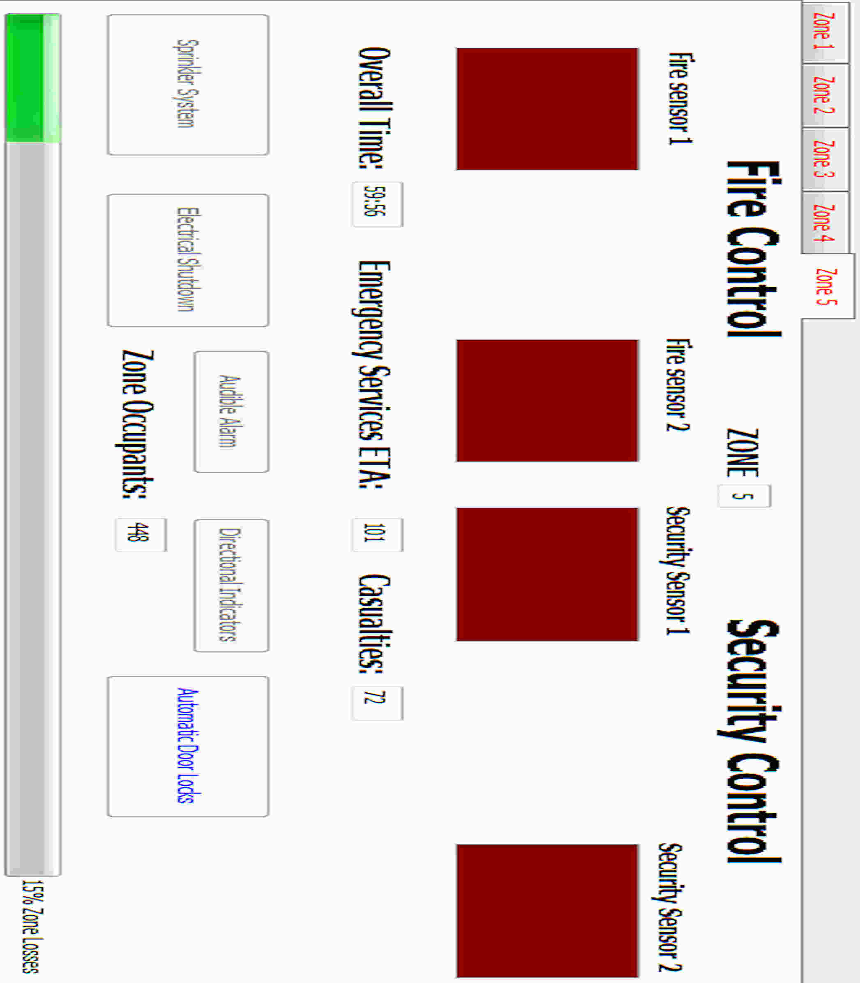

Figure

Figure 3 illustrates a typical end game scenario. From the tabs, one notices that all zones suffer from at least one alarm state, with the second soon to follow. From the (stretched) closeup of the single tab, it looks like this zone may be saved because damage is minimal and Emergency Services arrive in 101 seconds. Hence, we may be able to avoid human casualties (from trapping people in fire zones) by omitting the Automatic Door Locks control measure.

## You Saved It!

We did indeed save Zone 5, as you can see from the figure directly below, with only 72 (out of 1000) casualties and 15% Zone Losses. This is quite good. When the user loses a Zone, the tab contains dark red lettering and color boxes, including the ominous message: “Zone Destroyed!”

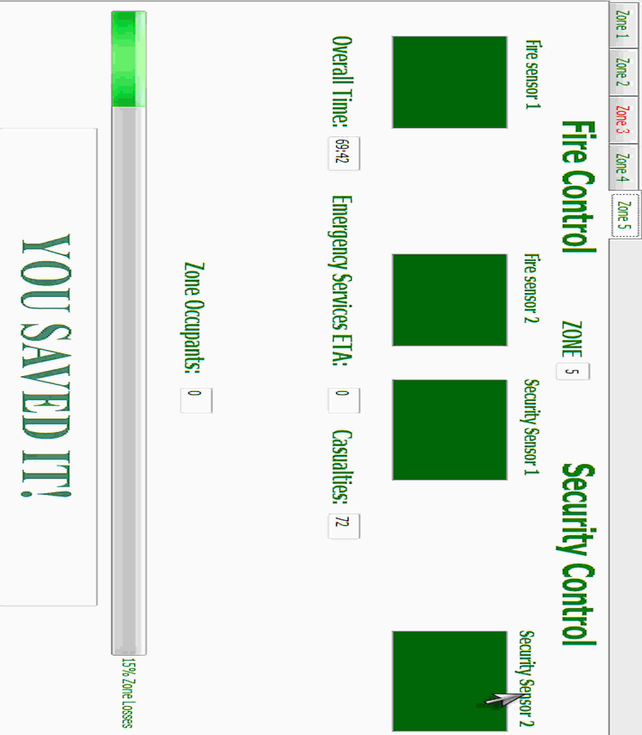

Figure

# Appendix: Information Console Slice

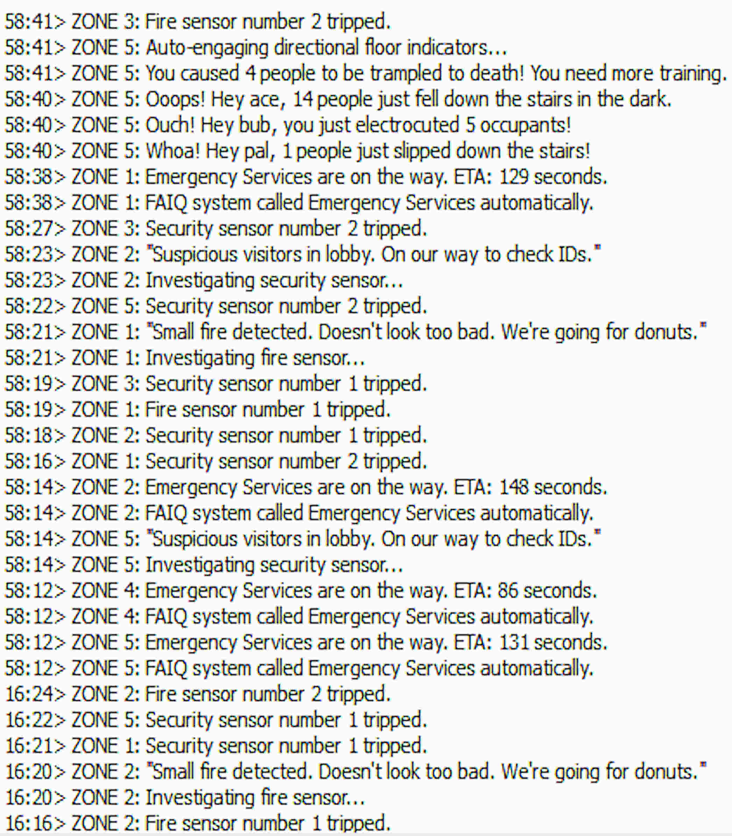

Figure