Daily operation flow

Day Open

Daily Sales

Day End

Day Open Procedure
- Input the Staff No and Password
  - Staff No : SUPERVISOR
  - Password : 888
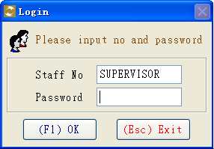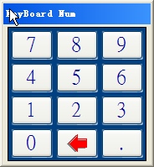

- Select 【09】Timecard
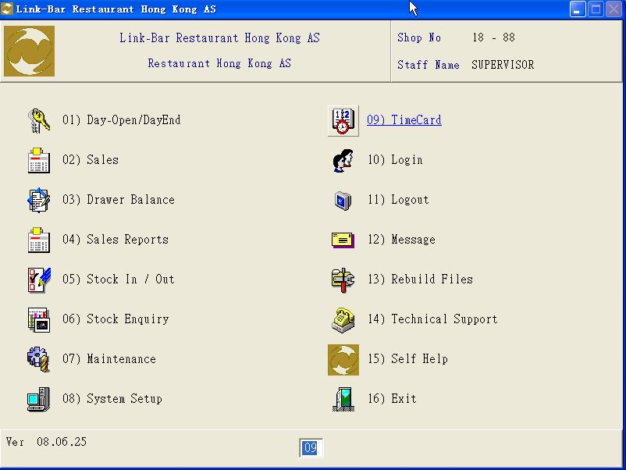

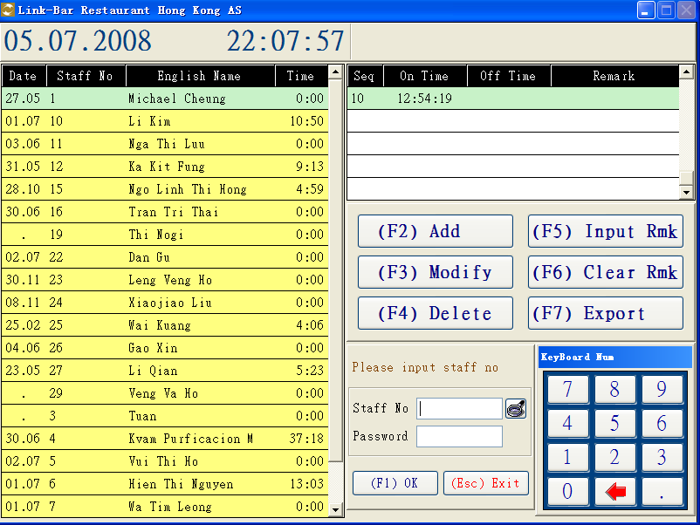
- - Input or select staff , and press 【F1】record the in / out time.
For changed, you can press【F5】to select the reasons & input the remarks *
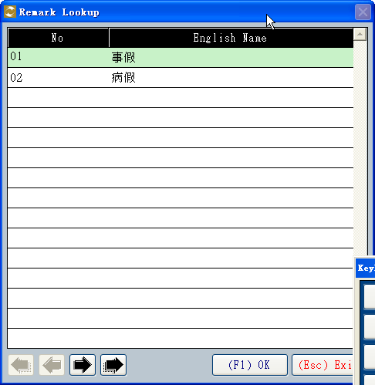

- Select 【01】- Day Open / Day End :
  - Press 【F5】for day open
* There is no limit for day open in each day *
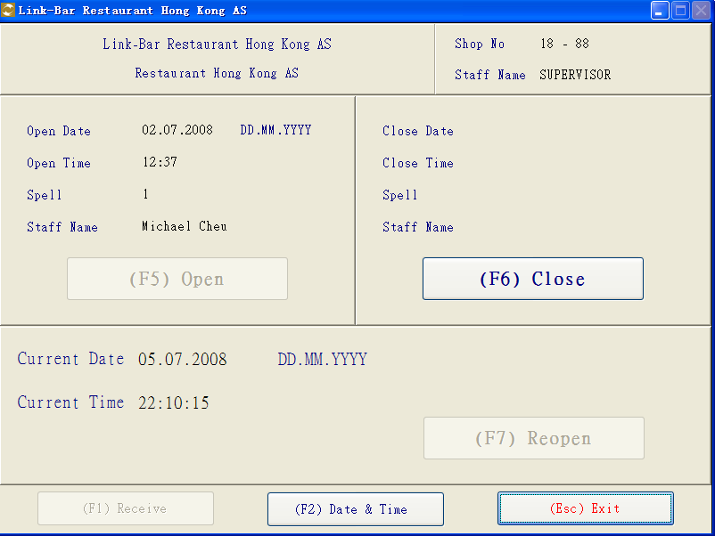

Daily Operation
- Select 【02】- Sales :
-Select the item and input the quantity
Or you can use the following methods to input the item
-Laser Scanner
-Input the item number
-Select the product icon
-Input the salesman No and press【F1】to confirm
-input Customer No and press 【F1】to confirm

Discount:
-You can assign the discount by percentage or fixed amount in each item.
-Use the mouse to click the product and click the discount icon.Then input the figure by percentage / amount

Change the product price:
-The selling price sent from the office to the shop,but also can be change the price in each shop.
-Use the mouse to click the item that you want to modified,then click the column of price and input the price directly

Payment Method:
-Press the payment icon for settled by cash / prepaid / credit card or leave deposit,then press OK to confirm and print out the invoice.

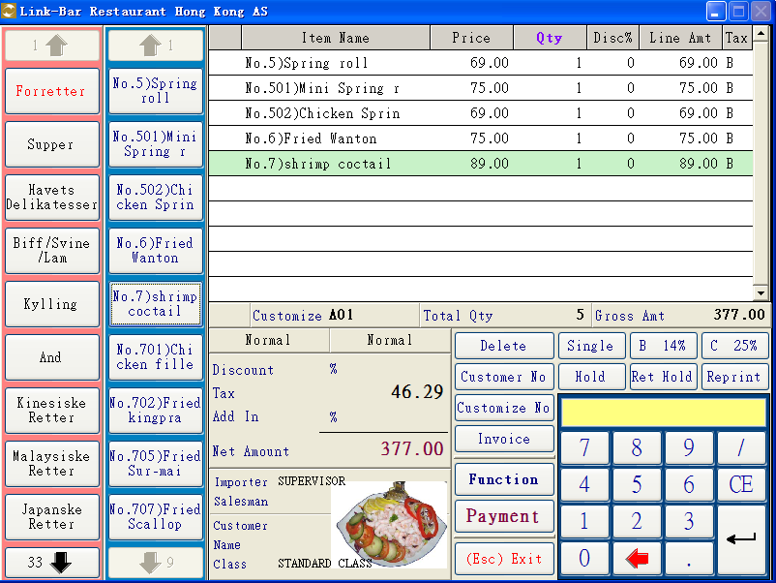
Customer and Salesman

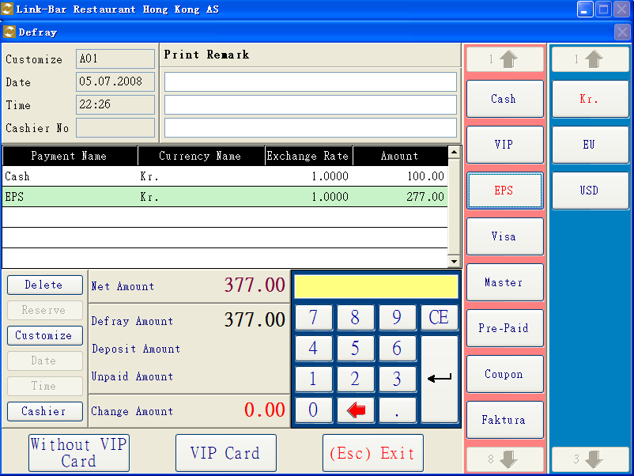

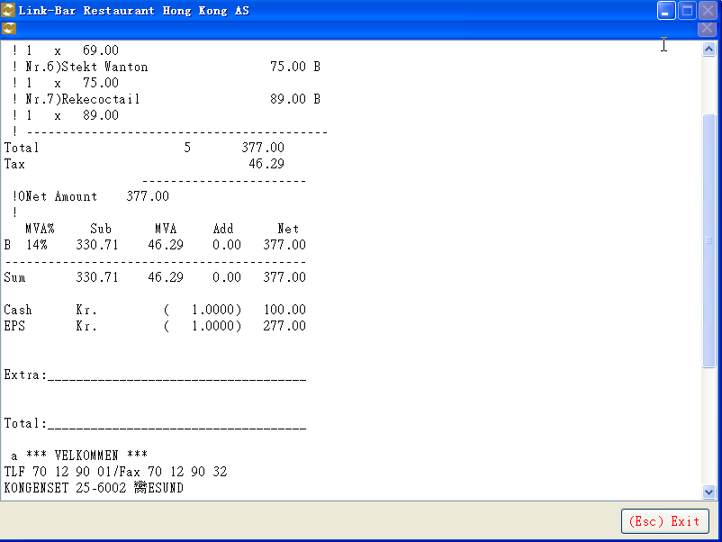
Reserve
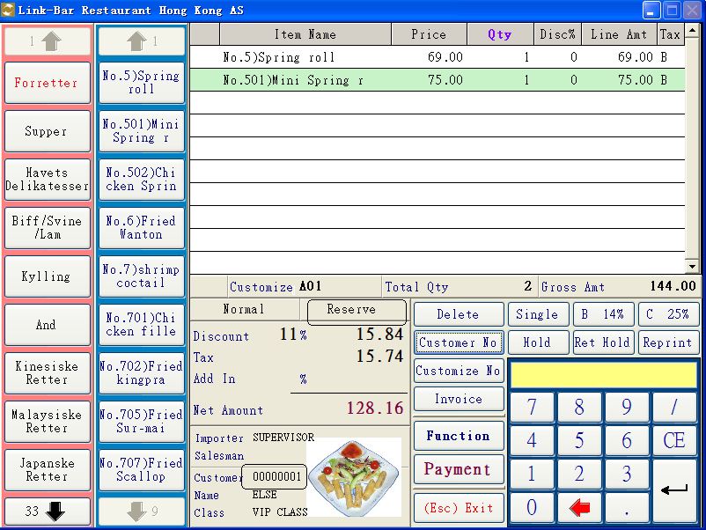

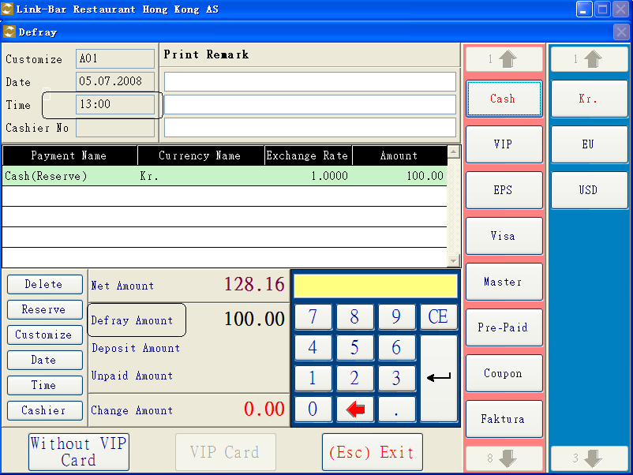
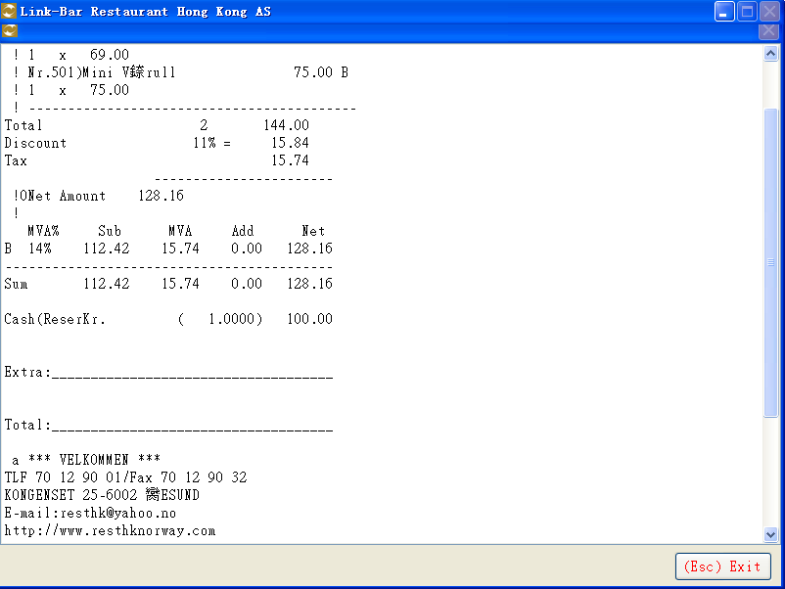

Retrieve Reserve
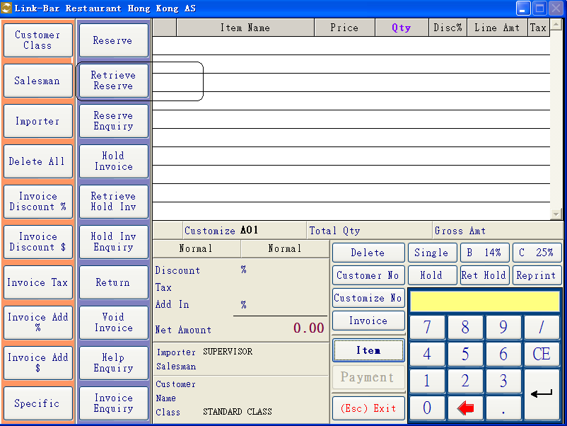
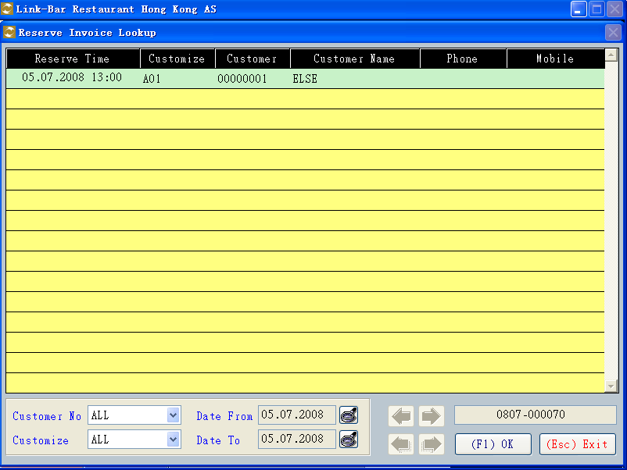

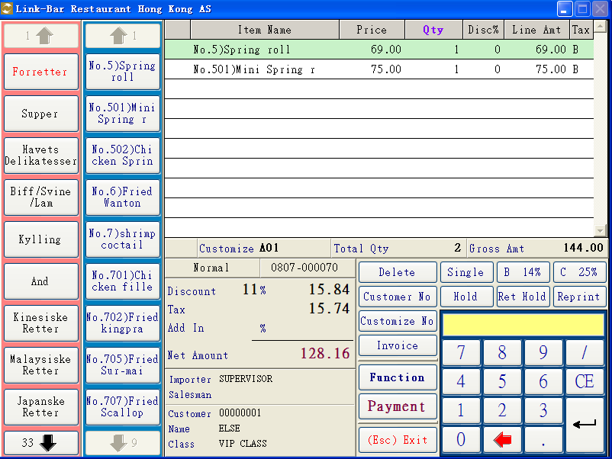

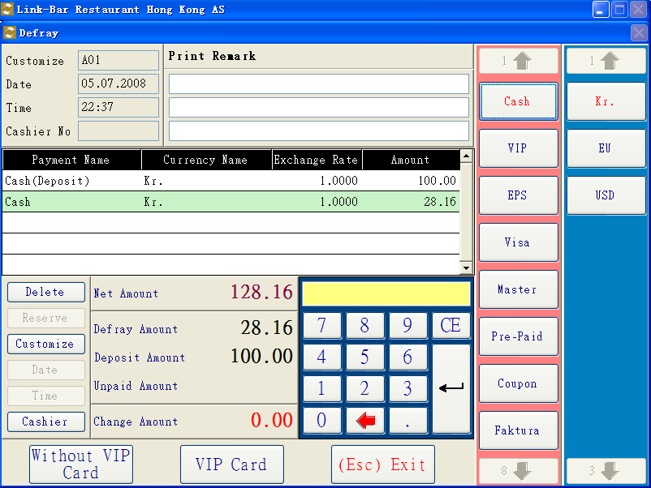

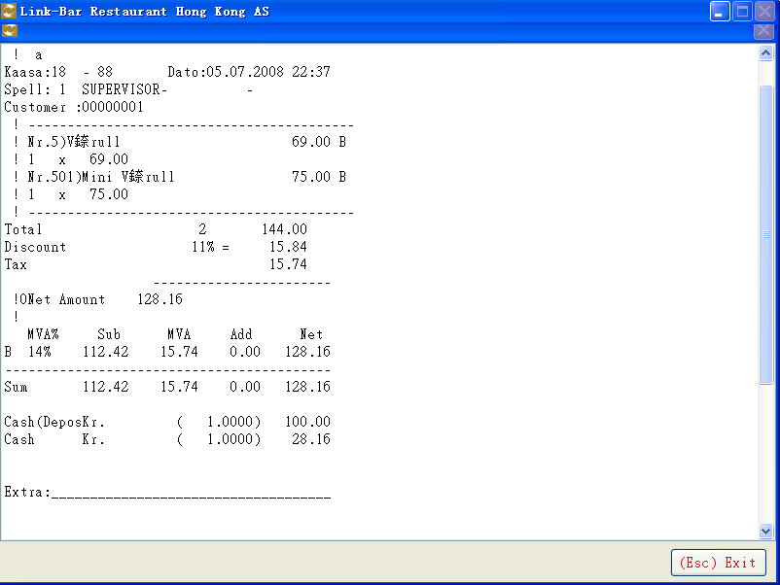

Invoice Discount
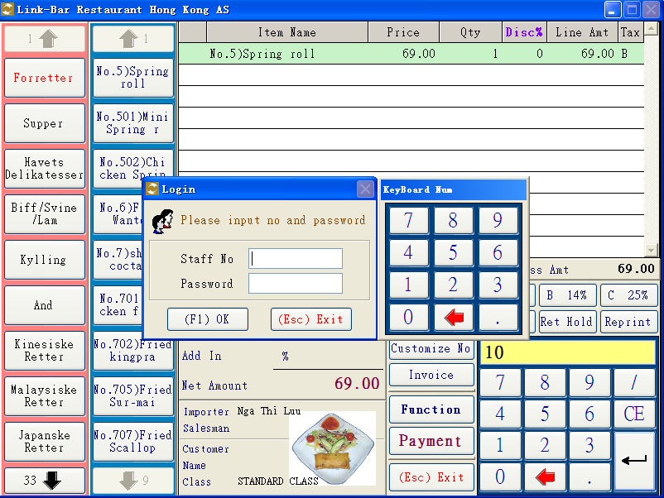

Hold Invoice
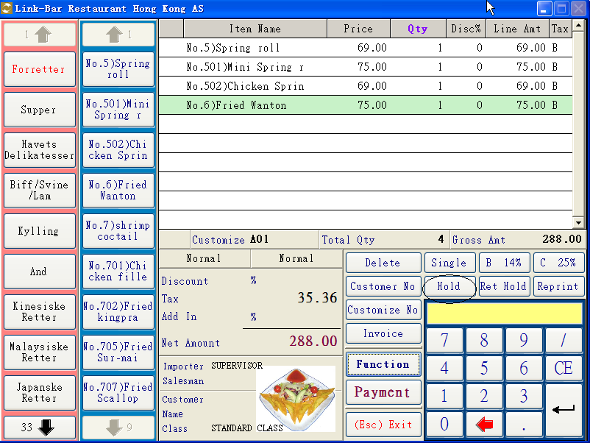
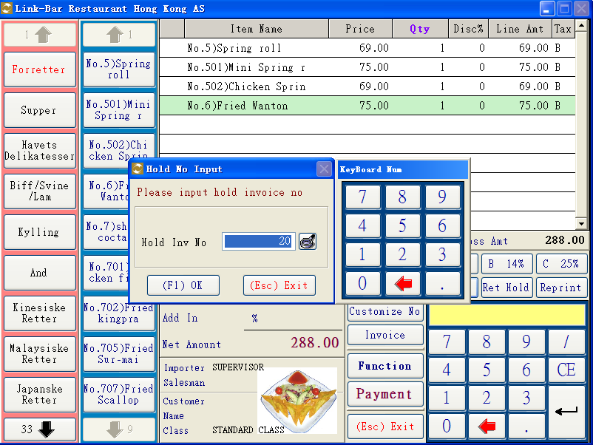

Retrieve Hold Invoice
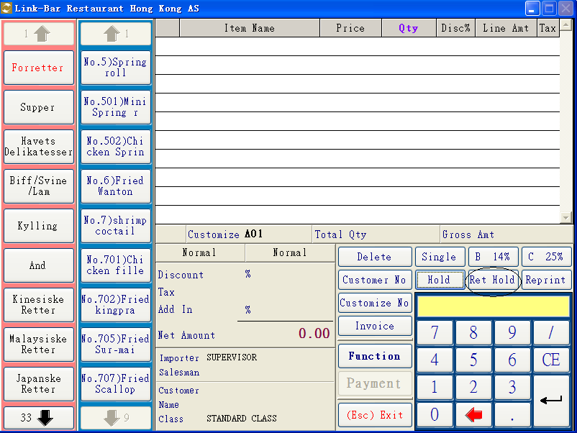
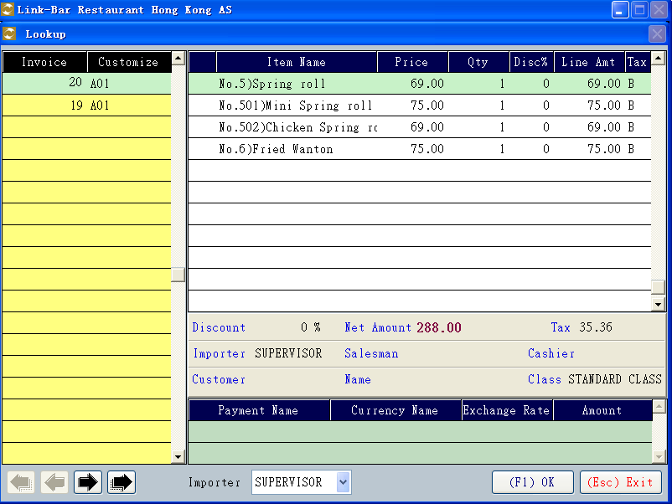
List Hold Invoice

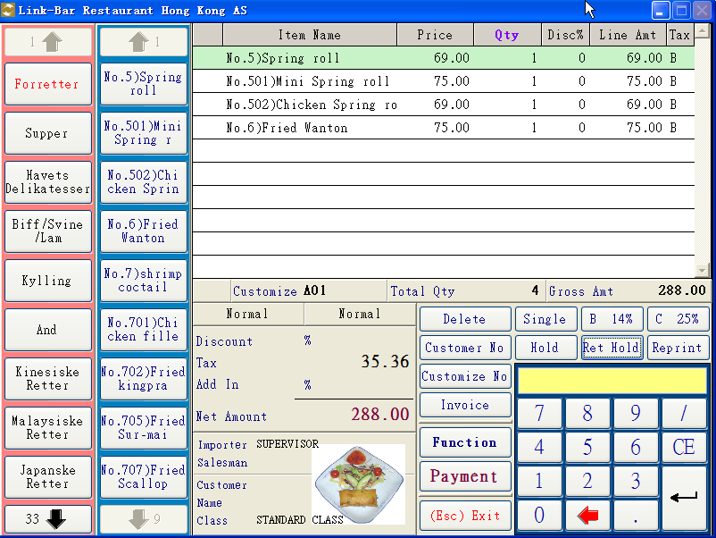

Invoice Enquiry
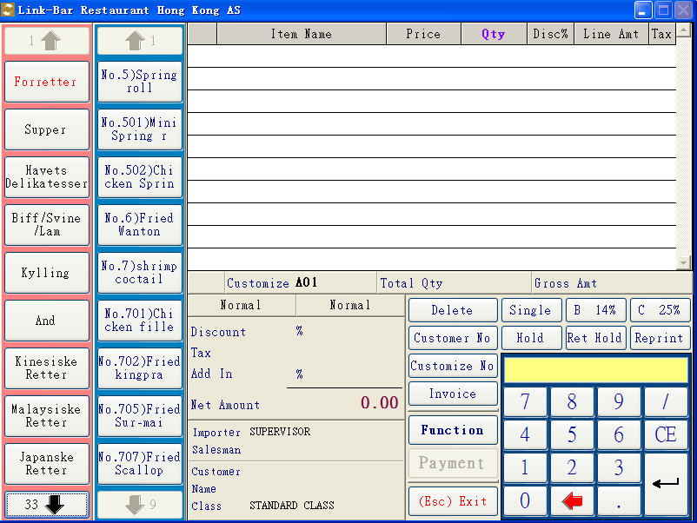

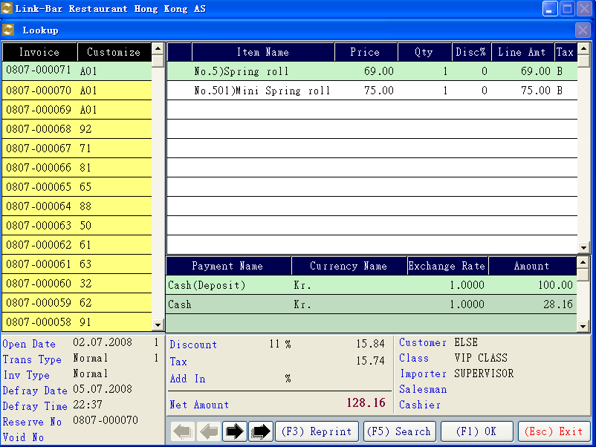
Day Open Procedure
- Select【04】- Sales Report
- Select【01】- Day Open / Day End :
  - Press 【F6】for day end
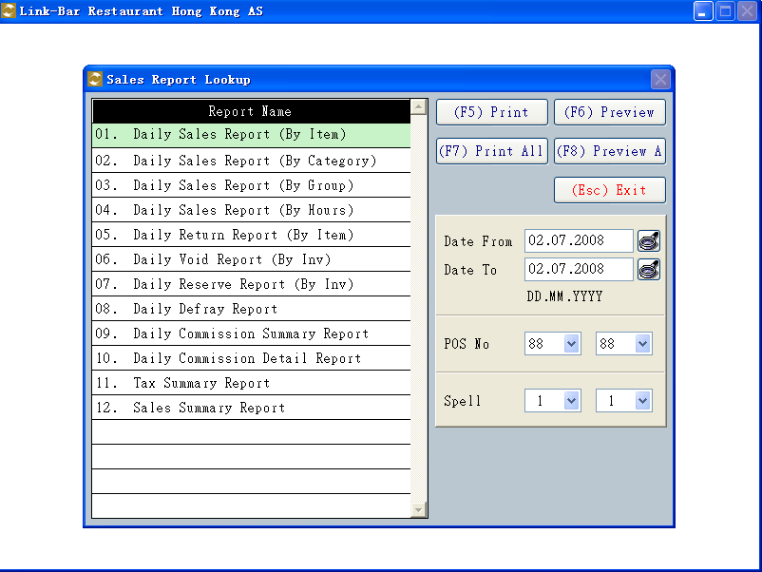

Maintenance
1. Select【07】to setup and check the following information
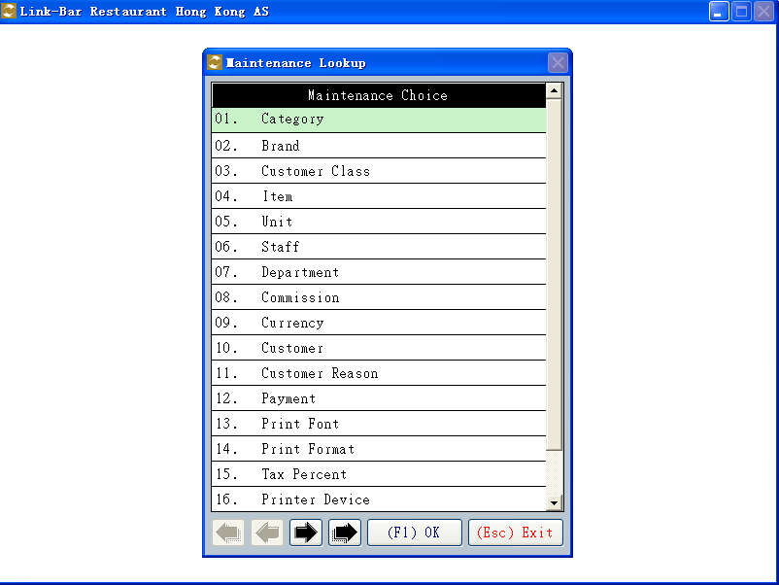

System Setup
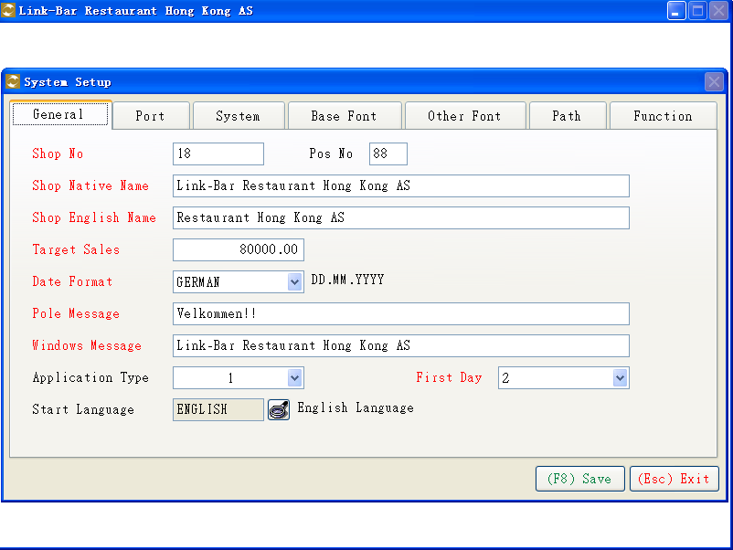

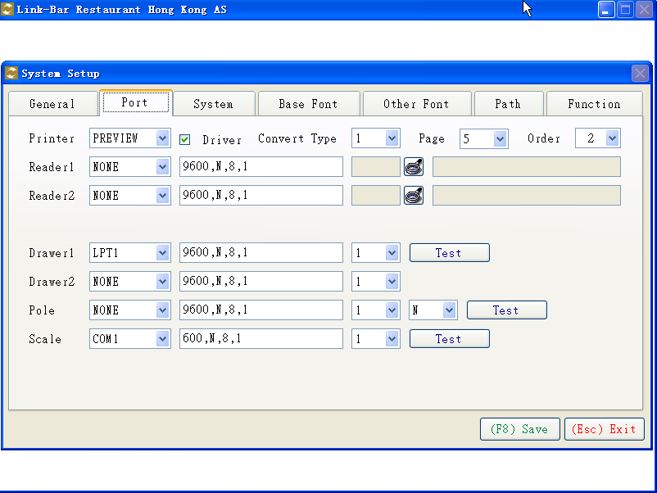
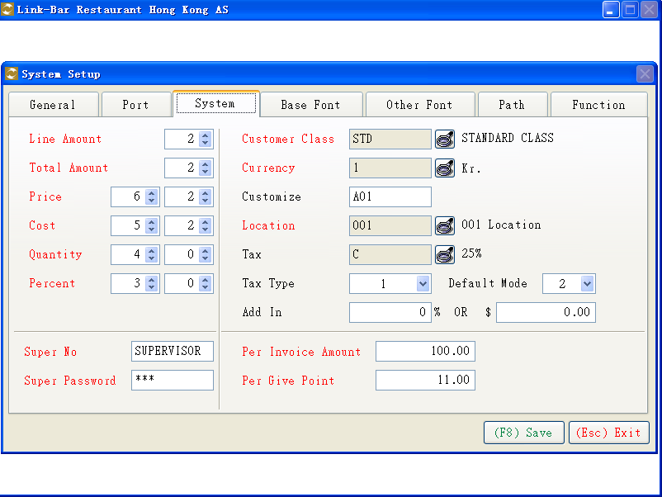

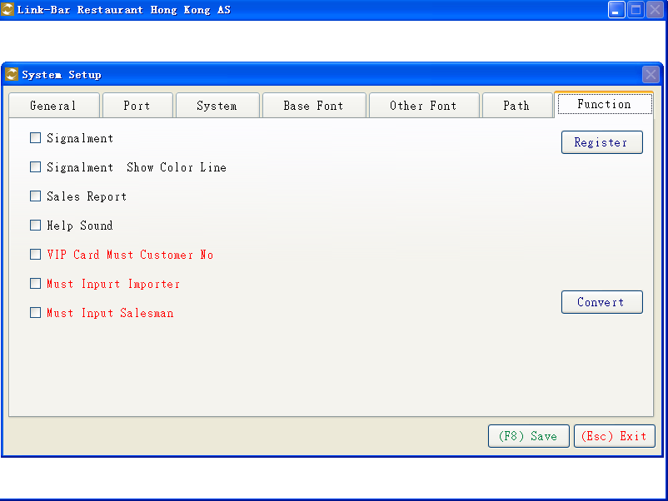

Item Maintenance
- Setup category
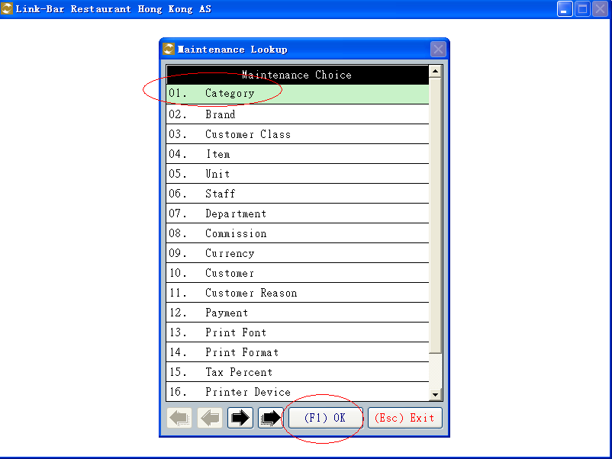

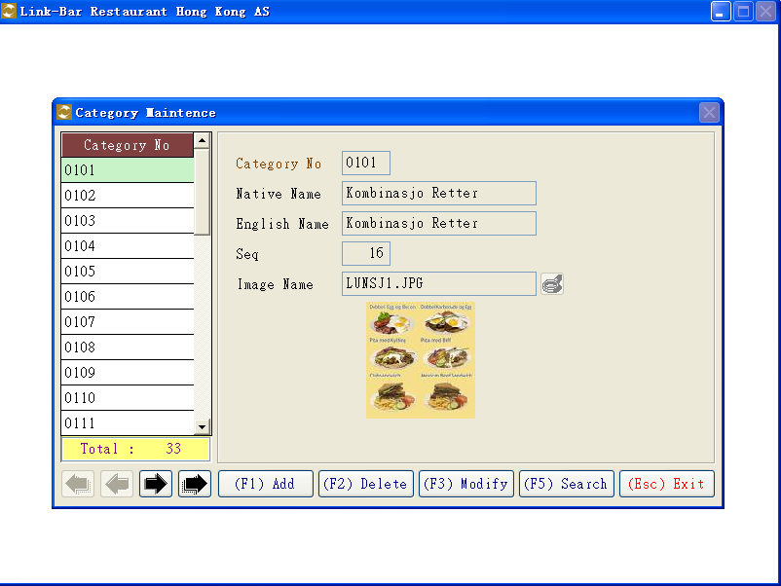
After setup category，and use it in this function。
a. Item Function
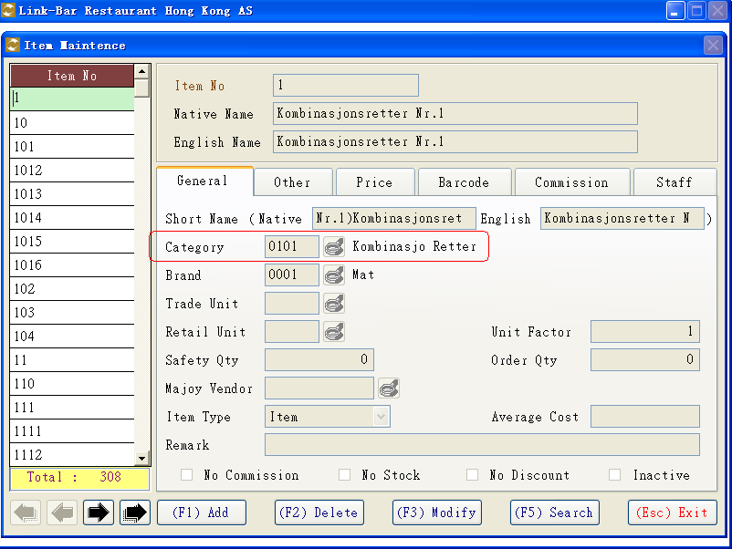
b. Sales Function
Category
c. Sales Reports －> Daily Sales Report (By Category，Daily Sales Report (By Group)
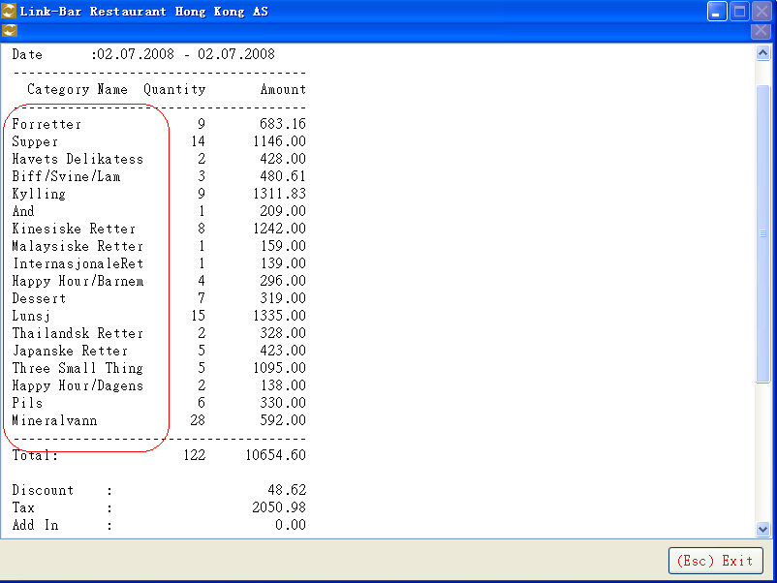

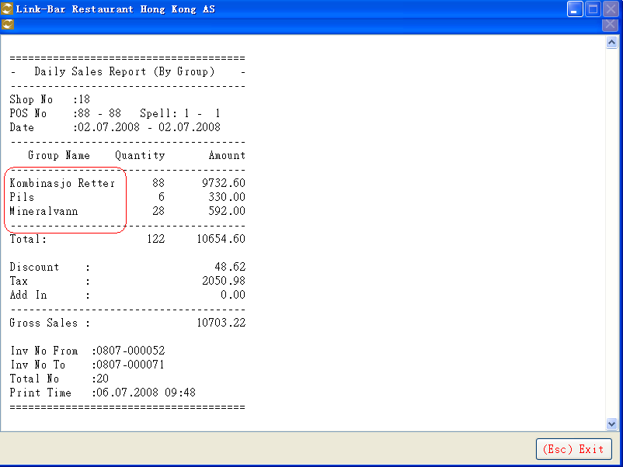

d. Self Help
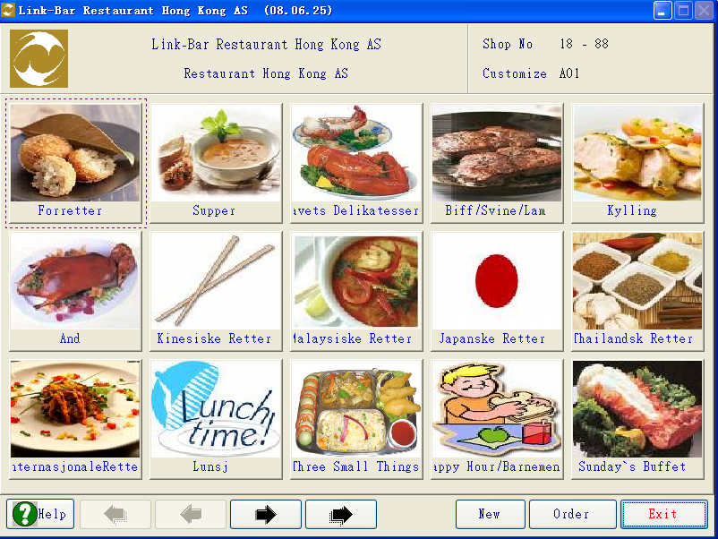

- Item Maintenance
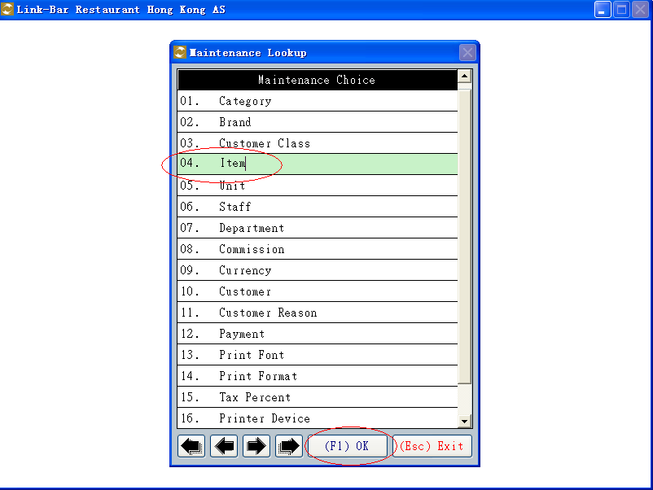
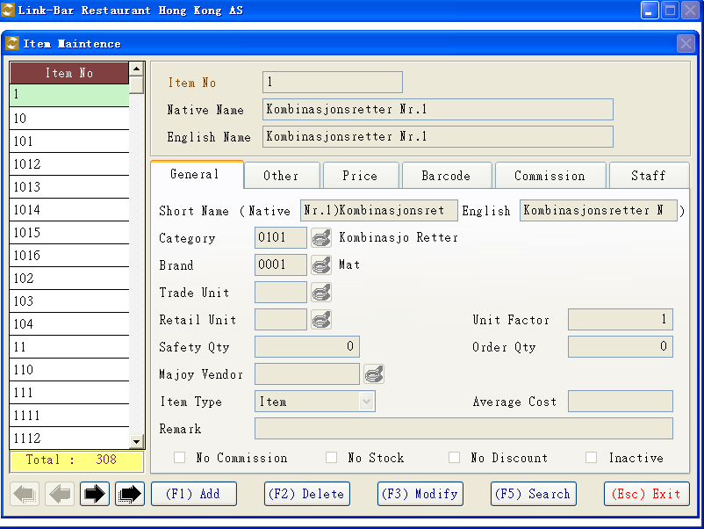

a. Item No (货品编号)

b. Native Name (本地货品名称)

c. English Name (英文货品名称)

d. Short Native Name (本地货品短名称)

e. Short English Name (英文货品短名称)

f. Category (类别)
** Category 要预先设定 **

g. Brand (牌子)
** Brand 要预先设定 **
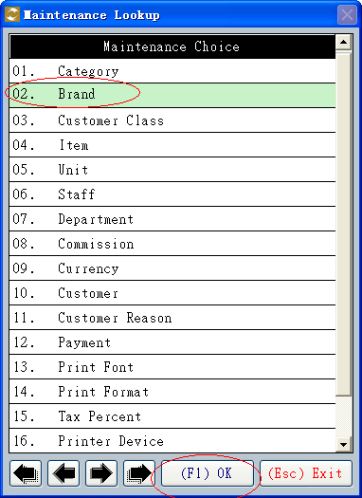
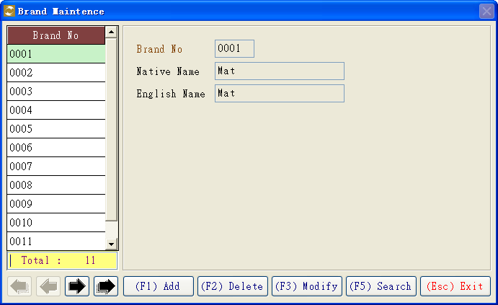

h. Trade Unit (收货单位)
Use in Trade Sales
i. Retail Unit (零售单位)
Use in Retail Sales，如 《份》，《盘》，《个》
** Trade Unit,Retail Unit 要预先设定**
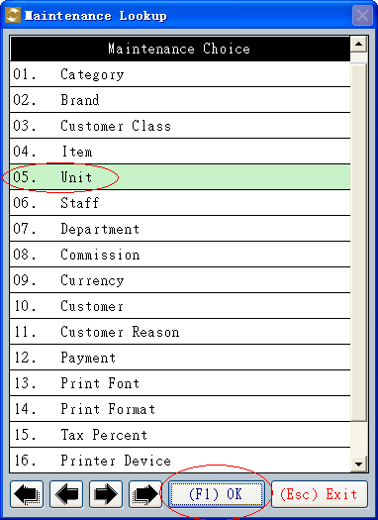
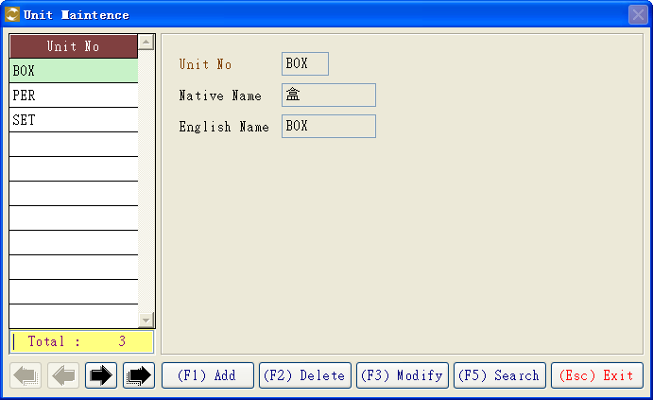
j. Unit Factor (比例因子)
如一箱 = 12 支,
Trade Unit 为 箱
Retail Unit 为 支
Unit Factor 为 12

k. Safety Qty (安全库存)
当存货数量小于安全库存，会发出提醒信息

l. Order Qty (最小订货数量)
供应商最小订货数

m. Majoy Vendor (主要供应商)
用于订货时选出默认供应商

n. Item Type (货品类型)
货品类型分为 货品，预缴，优惠券

o. Average Cost (平均成本)

p. Remark (备注)

q. No Commission (不计佣金)
设定此货品不计算佣金

r. No Stock (不计库存)
设定此货品不对库存进行操作

s. No Discount (没有折扣)
设定此货品没有折扣

t. Inactive (不活动)
设定此货品暂定销售

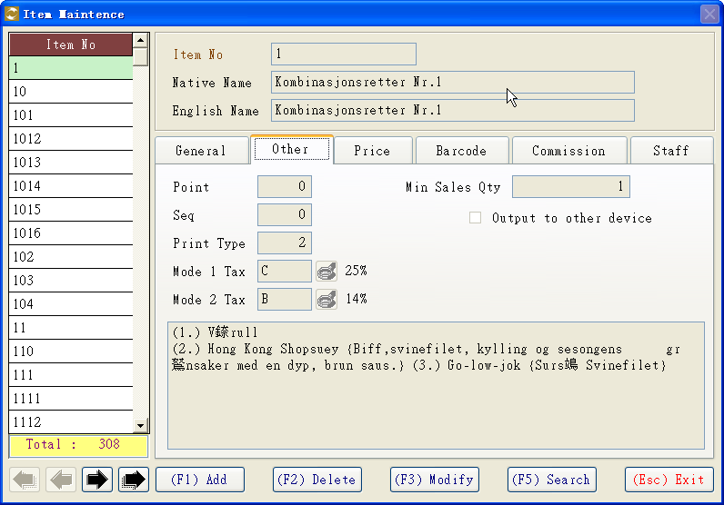

a. Min Sales Qty (最小销售数量)

b. Print Type (打印类型)
用于设定打印输出至厨房还是水吧等
** 打印输出设置在以下功能设置 **
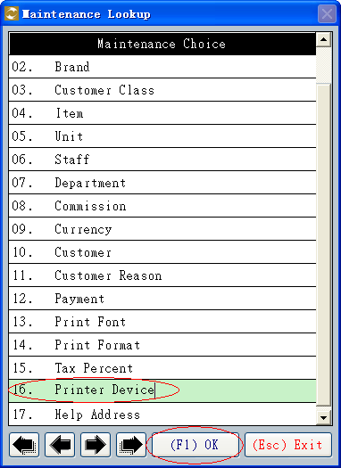

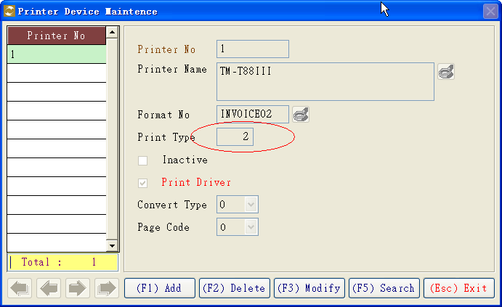

c. Mode 1 Tax (模式1税项)
d. Mode 2 Tax (模式2税项)
此两项用于方便设定本机默认税项
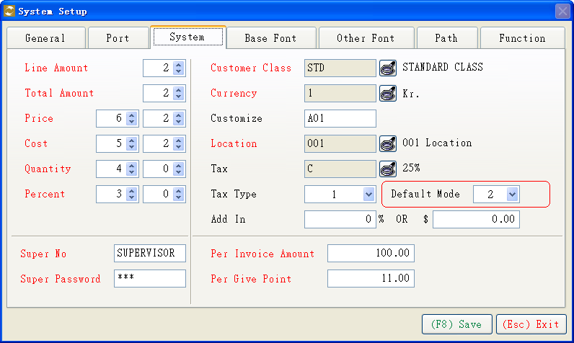
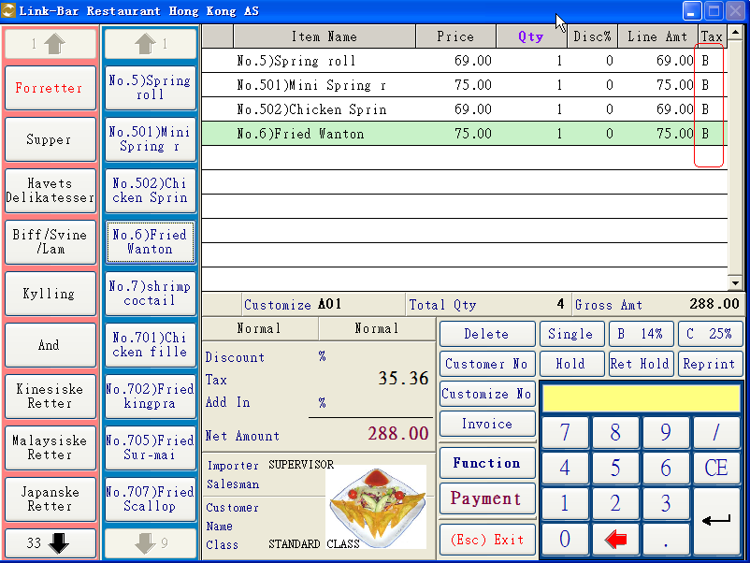

e. 货品详细说明
用于自助点餐时方便客人了解此货品详情
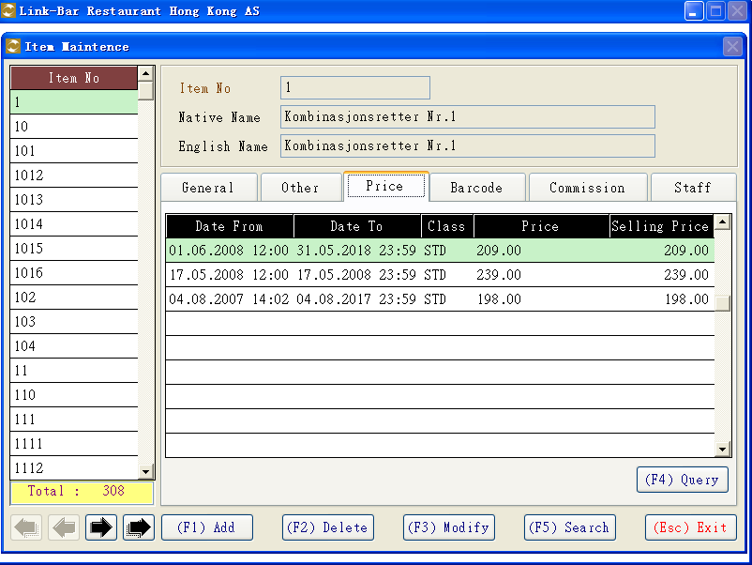

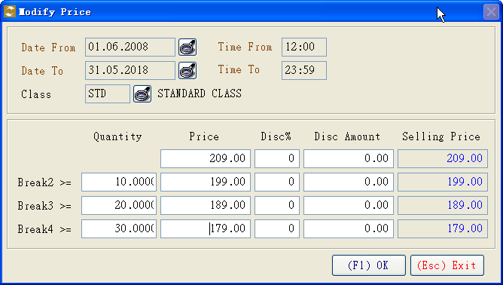
Break4 >= (数量4 >=) 当销售数量大于等于此数量时(为0不操作)，选用此价格标准
Break3 >= (数量3 >=) 当销售数量大于等于此数量时(为0不操作)，选用此价格标准
Break2 >= (数量2 >=) 当销售数量大于等于此数量时(为0不操作)，选用此价格标准

设定此货品的销售佣金类别
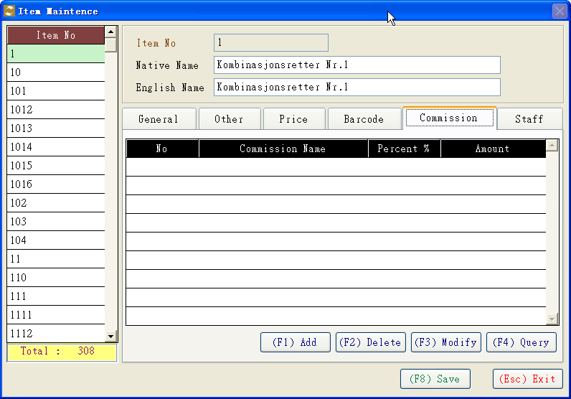

** 销售佣金类别请预先设定 **
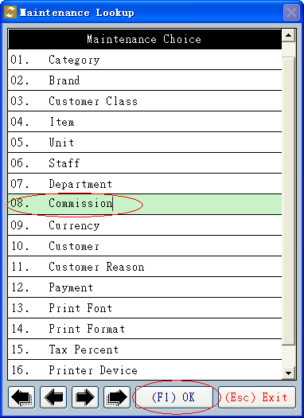

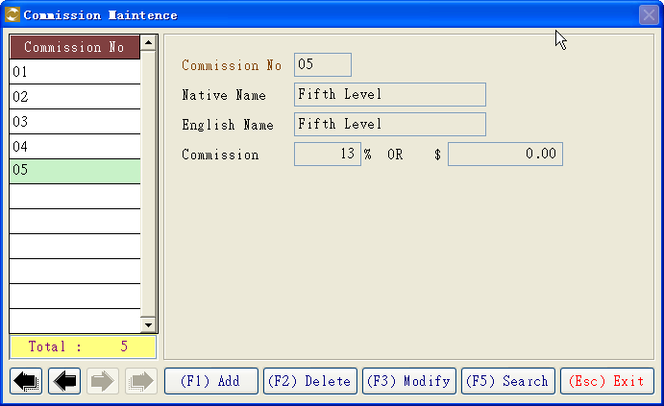

设定此货品的员工特别销售佣金类别
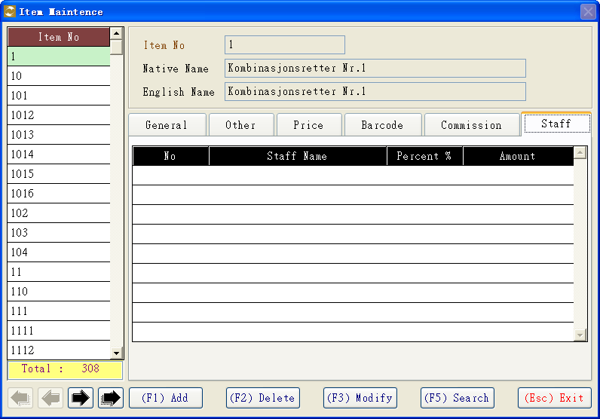

销售佣金类别一共分为三种
a. 员工佣金类别
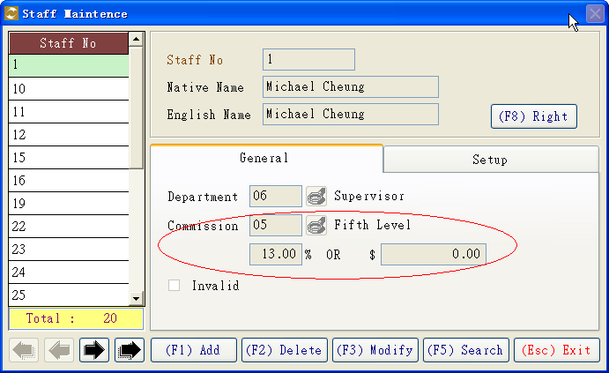

b. 货品佣金类别
c. 员工特别销售佣金类别
计算佣金时，
如果设定了《c. 员工特别销售佣金类别》，就选择此类别
如果设定了《b. 货品佣金类别》，就选择此类别
如果设定了《a. 员工佣金类别》，就选择此类别
简单说明佣金计算优先顺序，《c. 员工特别销售佣金类别》> 《b. 货品佣金类别》>《a. 员工佣金类别》

