Porting KAME Between Trunks
Before we get into the porting process, please notice one thing: If there is any thing related to P662 mentioned in the following steps, please reference to the sources we gave you.

Proting total rules

一 Prepare&Makfile
- Put the KAME source codes under src\kame\.
- Create your own make file for KAME in the directory src\kame\mk\ and set the environmental variable KAMEARCH to the environment you use. Let’s look at a example: For P662HW-61, KAMEARCH is set as CPE_ZYNOS340_AR7 since P662HW-61 uses ZyNOS340 and ARM7. The make file for P662HW-61 is put in src\kame\mk\ and named arch-CPE_ZYNOS340_AR7.mak. Therefore, if you use ZyNOS350 with IXP CPU, you may have a make file named arch-CPE_ZYNOS350_IXP42X.mak in src\kame\mk\ and KAMEARCH being set as CPE_ ZYNOS350_IXP42X.
- Modify your make file of ZyNOS for compiling and linking the sources in the KAME directory. You can reference the keyword kame in the make file makep662.acl1.
- Add the wrapper files to your ZyNOS directory src\. You can reference the wrapper files listed in the KAMEWRAP section in makep662.acl1.
- Add spt_ip6.c and iputil.c in src\.
- Create the MRD file for your target and put it in src\.
- Add or modify the select.c if need;

二 Macro define
- Define IPv6 in switch.h. If you want to use the simple debugging tool implemented in KAME, define KAME_DEBUG in switch.h as well.
- Undefine all the feature flags in opt_zynos.h. This simplifies our environment for building the first version of RAS.

三 Resource enlarge
- Enlarge the RAS code size in your mmct file to accommodate new RAS.
- Change the MAC_DATA_BASE address in bootar7mac.c if it is needed in your target. This avoids that the new RAS and the data area which stores Tx and RX descriptors overlap.
- Enlarge the size of FTP_BUFFER_SIZE to accommodate new RAS.
- Enlarge serviceTask stack size as well.
- In network.c, enlarge network task's stack size.
- When you turn on the IPv6 flags include features, you may need to enlarge ‘Proc’ and ‘FundId’ in your mmct file.

四 ZyNOS common enhance for ipv6
- Turn off ‘–sda=8’ compiler option
- Turn on ‘--pack-alignment=4’ compiler option
- For each c file you need to modify in ZyNOS scope, please put the following codes right after "#include switch.h" to affect other header files since IPv6 is a stack level feature.
#ifdef IPv6
#include "kame/include/opt_zynos.h"
#include "zykame_kame.h"
#ifdef KAME_DEBUG
#include "kame/include/zykame_debug.h"
#endif
#endif

五 ZyNOS OS layer enhance for ipv6
- In rasmain.c, initialize mbufs used by IPv6 by calling zykame_mbinit() in SysInitTask(). Enlarge serviceTask stack as well.
- In mbuf.c, add the mbuf reference counters for IPv6.
- In rastime.c, set the ticks and time_second for IPv6.
- In rassys.c, implement msignalall() to signal all at the same time if your platform don’t implement it.
- In sys_proc.c, implement sysTaskPriority() to get task priority if your platform doesn’t implement it.
- In sptinit.c, create IPv6 interfaces in spSysInit().

六 ZyNOS Network Protocol enhance for ipv6

- In network.c, enlarge network task's stack size and initialize ipv6 and ipv6 application by calling ip6Init() and ip6AppInit(). You also need to process IPv6 packets according to the packet type PT_IP6.
- To build up the connection between L2 and IPv6, you need to modify enet_pkt.c as well. You can search with the keyword "ifdef IPv6" for modifications in enet_pkt.c in P662.
- Now you can build the first version of RAS. In this version, IPv6 command line has been implemented. So you can use IPv6 command line to do some tests, such as ping6. But remember that the SPT has not implemented yet, and socket does not support IPv6 yet.
- Once the first version of RAS is ok, modify the socket-related codes in ZyNOS to make socket-related functions support IPv6. In this phase, you can also modify FTP, telnet and HTTP server to verify the functionality of IPv6 socket.
- After the verification of IPv6 socket, you can turn on the features you need in opt_zynos.h and add SPT-related codes. SMT and GUI can also be modified by your requirements now.

ZW5 Porting Step

What to do
  - Port IPv6 stack from P662HW-61 to ZW5 platform (processor changed, need to modify corresponding makefile policy)
  - Dual stack support (support V4 & V6 stack simual)
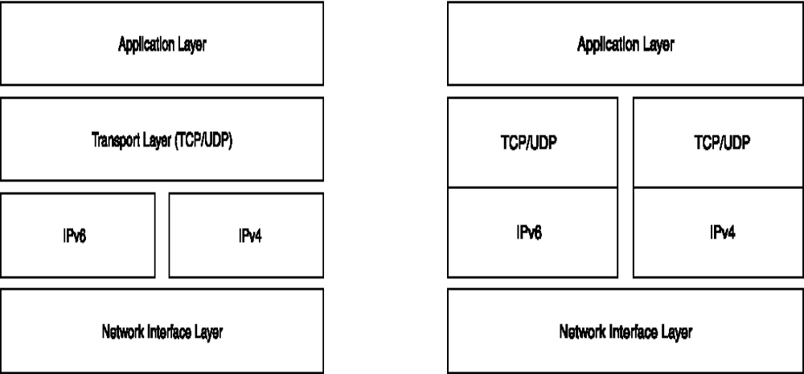
Figure1 IPv4 to Dual stack

In original ZW5, we just support IPv4 only. In order to support IPv6 too, we add IPv6 stack implementation respectively, which means the upper layer protocol is absolute from IPv4 stack.
  - Modules in ZW5 needs to be modified
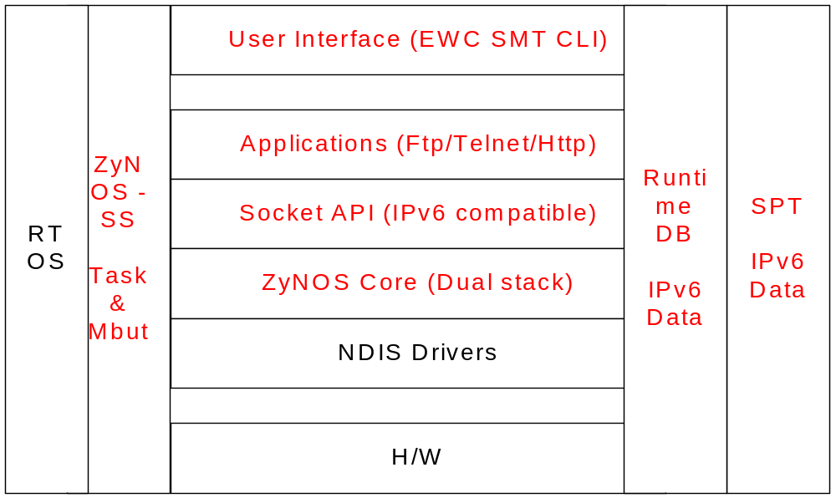
Figure2 Modules needs to be modified in ZW5

How to do
Following describe the step to accomplish the above goal supporting IPv6 individually.
- Step 1: IPv6 core
  - KAME module (IPv6 core stack)
    - Add a new compile entry for KAME module
    - Embed IPv6 routing entry in IP layer
  - Task
    - Networking task, system resource initialization

  - Queue (mbuf)
    - IPv6 mbuf queue initialization

- Step 2: Socket layer
  - Addressing compatible, IPv4 & IPv6
    - Define a new addressing type, which compatible IPv4 & IPv6

  - Socket(), Listen(), Accept() etc…

    - Keep original Znos IPv4 socket implementation

    - Implement the new Zynos socket layer to support IPv6
    - Differ protocol, INET_IPv4 & INET_IPv6
    - Switch to Zynos IPv4 or KAME IPv6 socket implementation
  - Select(), IPv4 TCP modification

    - ATC trunk also comprises some of the bug fix for TCP state transition and select. Please use the same version for select() or IPv4 in case unexpected case may happen
    - The difference for ZyNOS related TCP modification could be found on 172.23.18.16\ 01Projects\IPv6\Target\ZyWALL35_final\Source\ tcpv4_modification.rar

- Step 3: User interface & SPT & Runtime DB
  - CLI
  - SMT
  - WEB, eWC
  - SPT & Runtime DB
    - WAN
    - LAN
    - Static route etc…

- Step 4: Applications
  - FTP
    - Listen IPv4 & IPv6 concurrently

  - Telnet
    - Listen IPv4 & IPv6 concurrently

  - HTTP

    - Listen IPv4 & IPv6 concurrently

- Step 5: Simple Testing
  - Try to communicate with other IPv6 enable host

ZW5 Porting FAQ
Following chapter describe some issues in ZW5 porting process.

MMCTZW.TAB related
Q1: Device crash when boot up after finishing porting KAME (IPv6 core).
Possible Solution A:
- Enlarge 'Proc' in mmctzw.tab because of the increasing IPv6 task will consume all pre-defined process table
- Enlarge 'FuncId' mmctzw.tab at the same time

Possible Solution B:
- Because we’ll enlarge networking memory to suitable for IPv6 support, we need to enlarge RAS code size. Enlarge RAS code size in mmctzw.tab to satisfy IPv6 support

Q2: DHCPv6 doesn’t work well
Possible solution:
- Add dhcp6pd to support DHCPv6-PD in mmctzw.tab

Q3: IP6route doesn’t work well
Possible solution:
- add ip6Route in mmctzw.tab too

Application related (HTTPv6)
Q1: HTTPv6 server can’t work well
Possible solution:
1. Because in ZW5, all HTTP server state transfer is controlled through na event queue, we have to add entries in IPv6 TCP to trigger different event based on TCP state transfer.

SPT & Runtime DB aren’t consistency (HTTPv6)
Q1: WAN runtime content isn’t consistency with SPT
Possible solution A:
1. In ZyWall 5, the WAN interface type with ethernet encapsulation is IFACE_TYPE_LAN. But in P662HW-61 like below.
if (ifp->type == IFACE_TYPE_WAN) So, the judgement will be failure when WAN initialize its data runtime content.

Possible solution B:
1. Didn't call the functions to update runtime data structure

RA
Q1: Conformance testing items failed (RA)
Possible solution A:
1. rtadvd setting, not support some flags setting through CI command, provide the entry for these flags, for instance.
inet6 rtadvd enif0 -f 192 -x 192 -e on

DHCPv6 server
Q1: LAN work as DHCPv6 server, but cannot provide DNS information
Possible solution A:
The configured DNS information was cleared when initialize WAN interface. In P662HW-61 the interface’s definition isn’t consistency with ZW5.

Q2: Device crash when receive a DHCP relay forward request from a connected DHCP-relay server, LAN working as a DHCPv6 server
Possible solution A:
The process in process_relayforw() isn’t correct, comment the debug statement in
process_relayforw(). See below

#ifdef 0
dprintf(LOG_DEBUG, FNAME,
"dhcp6 relay: hop=%d, linkaddr=%s, peeraddr=%s",
dh6relay->dh6relay_hcnt,
in6addr2str(&dh6relay->dh6relay_linkaddr, 0),
in6addr2str(&dh6relay->dh6relay_peeraddr, 0));
#endif

