# Supplementary

PopLDdecay: a fast and effective tool for linkage disequilibrium decay analysis based on variant call format files

version 3.30

2018-06-29

**Contents**

Usage 3

Step1 3

Step2 4

Classical case 5

One population 5

Muti population 5

One population with multi-chr 5

Muti population with multi-chr 6

Evaluation 6

Accuracy 6

Efficiency 7

Cited 9

# Usage

It is convenient for user to apply PopLDdecay to analysis the LD decay, Just provide the SNP data in VCF format and perform follow two steps, users can get the decay figure.

**Step1:** Calculate LD decay

**Step2:**  Draw the Figure

In the **Example part**, you can see the simple and clear usage to follow. Here are the two steps instructions

## **Step1**

In this step, User will use the core program named “*PopLDdecay*” , A Dist~R^2 statistics file about will be output, which will be as input file in the step2.

The parameter description as below:

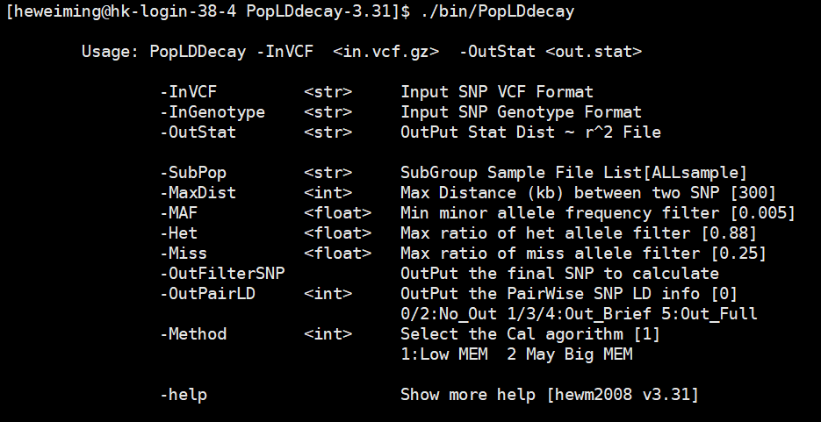

Fig1 parameter description of PopLDdecay

Note point:

1. User with “*./bin/PopLDdecay –h*” command will see more help, see some **Examples**.
2. Users can define the maximum distance with the command “*-MaxDist*”, default 300 kb.
3. Users can also define their own filter criteria by using the command “*-MAF –Het -Miss*”.
4. To see detail pairwise SNP calculation information, by using the command “*-OutPairLD*“
5. To calculate the **subgroup** LD decay in VCF Files, put their names into List file, and add parameters with “*–SubPop A.list*”
6. Program had two calculate algorithm , Method 1 is the optimal algorithm at most time.
7. Parameters *‘-i’* is short for *‘–InVCF’* and *‘-o’* is short for *‘-OutStat’, ‘-s’* is short for *‘-SubPop’*

A simple example

# 1) For gatk VCF file deal , run PopLDdecay direct

./bin/PopLDdecay -InVCF SNP.vcf.gz -OutStat Lddecay.stat.gz

# 2) For plink [.ped .map], chang plink 2 genotype first 2) run PopLDdecay

perl bin/mis/plink2genotype.pl -inPED in.ped -inMAP in.map -outGenotype out.genotype ; ./bin/PopLDdecay -InGenotype out.genotype -OutStat LDdecay.stat.gz

# 3) To Calculate the **subgroup GroupA LDdecay** in VCF Files # put GroupA sample names into GroupA_sample.list file

./bin/PopLDdecay -InVCF -OutStat -SubPop GroupA_sample.list

## ****Step2****

In this step, the main task is to plot the result in figure, here we provide two Perl scripts ‘*plot_OnePop.pl*’ and ‘*Plot_MutiPop.pl*’ to apply to different situations. And step2 only takes a few minutes to finish, User can change th**e drawin**g parameters until satisfied.

1. To plot one population LD decay, user can use this ‘*plot_****One****Pop.pl*’. One population with multiple chromosome calculation result also can be generated to one file and plot the Result out.
2. To plot multiple populations in one figure, the scripts ‘*Plot_****Muti****Pop.pl*’ is recommend to plot the result.

Parameters of two Perl scripts ‘*plot_OnePop.pl*’ and ‘*Plot_MutiPop.pl*’ are similar. Parameters description as below:

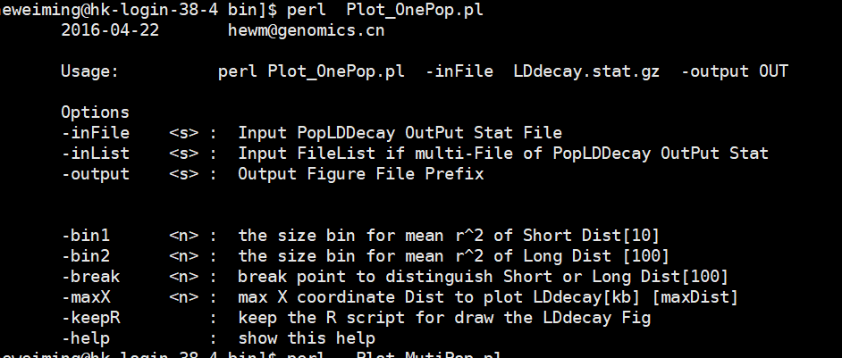

Fig 2: Parameters description of plot PERL script

Note point:

1. User with *“-maxX”* can define theirs the max distance in the figure to plot
2. The parameter ‘-break’ is the distance break point of *“-bin1”* and *“-bin2”*
3. The distance smaller than the break point size will use the *“-bin1”*size to smooth lines
4. The distance bigger than the break point size will use the *“-bin2”*size to smooth lines
5. Users can keep the R script to modify the figure by their self with command “*-keepR*”

A simple example

# 2.1 For one Population

perl bin/Plot_OnePop.pl -inFile LDdecay.stat.gz -output Fig

# 2.2 For one Population muti chr # List Format [chrResultPathWay]

perl bin/Plot_OnePop.pl -inList Chr.ResultPath.List -output Fig

# 2.3 For muti Population # List Format :[Pop.ResultPath PopID]

perl bin/Plot_MutiPop.pl -inList Pop.ResultPath.list -output Fig

# Classical case

Here, we provide four classic cases to demonstrate the application of this software, four situation will be show how to follow to get the LD decay figure out.

## ****One population****

This situation (one population with all chromosomes together) is encountered by most users, and this situation is the simplest to carry out.

./bin/PopLDdecay -InVCF ALLchr.vcf.gz -OutStat LDDecay.stat.gz

perl bin/Plot_**One**Pop.pl -inFile LDDecay.stat.gz -output Out.Prefix

Note:

This will generate the two finale figures named “*Out.Prefix.png*” and “*Out.Prefix.pdf*”

## ****Muti population****

This is common situation in the LD decay analysis. For example, if there are 50 samples (wild1, wild2, wild3…wild25, cul1, cul2, cul3…cul25) in the VCF file,

To compare the LD decay of these two groups (wild vs cultivation), first of all, put their sample names into own file list for each group, column or row is ok.

./bin/PopLDdecay -InVCF In.vcf.gz -OutStat wild.stat.gz -SubPop wildName.list

./bin/PopLDdecay -InVCF In.vcf.gz -OutStat cul.stat.gz -SubPop culName.list

# **created** manually muti.list by yourself

perl bin/Plot_**Muti**Pop.pl **-inList** muti.list -output OutputPrefix

Note:

1. **The <*wildName.list*> can list as follow(**column or row is ok**):**

*wild1*

*wild2*

*…*

*Wild25*

1. **The format of <*muti.list*> had two columns , the file path of population result and the population flag, such as:**

*/ifshk7/BC_PS/Lddecay/wild.stat.gz wild*

*/ifshk7/BC_PS/Lddecay/cul.stat.gz cultivation*

## ****One population with multi-chr****

One population with multiple chromosome VCF files. For example, if there are 3 chromosomes VCF files (Chr1, Chr2 and Chr3) as the input.

./bin/PopLDdecay -InVCF Chr1.vcf.gz -OutStat Chr1.stat.gz

./bin/PopLDdecay -InVCF Chr2.vcf.gz -OutStat Chr2.stat.gz

./bin/PopLDdecay -InVCF Chr3.vcf.gz -OutStat Chr3.stat.gz

ls `pwd`/Chr*.stat.gz > chr.list

perl bin/Plot_OnePop.pl **-inList** chr.list -output OutputPrefix

Note:

1. It can run in parallel when calculating the chromosomes’ statistics files.
2. The files list only store the file path, which is diff with the **multi-population list**
3. **It will** generate the file ‘*OutputPrefix.bin*’ is the summary statistics file of all chromosomes, and same format with the chromosomes’ statistics files.
4. **the** <*chr.list*> **format can be generated by as above command ‘*ls*** *Chr*.stat.gz > chr.list***’ .**

## ****Multi population with multi-chr****

Multi population with multiple chromosome VCF files. For example, if there are 2 chromosomes VCF files (Chr1, Chr2) as the input.

./bin/PopLDdecay -InVCF Chr1.vcf.gz -OutStat W.Chr1.stat.gz -SubPop wildName.list

./bin/PopLDdecay -InVCF Chr2.vcf.gz -OutStat W.Chr2.stat.gz -SubPop wildName.list

./bin/PopLDdecay -InVCF Chr1.vcf.gz -OutStat C.Chr1.stat.gz -SubPop culName.list

./bin/PopLDdecay -InVCF Chr2.vcf.gz -OutStat C.Chr2.stat.gz -SubPop culName.list

ls `pwd`/W.Chr*.stat.gz > W.chr.list

perl bin/Plot_**One**Pop.pl **-inList** W.chr.list -output Wild.cat

ls `pwd`/C.Chr*.stat.gz > C.chr.list

perl bin/Plot_**One**Pop.pl **-inList** C.chr.list -output Cul.cat

perl bin/Plot_**Muti**Pop.pl **-inList** muti.list -output OutputPrefix

**Note:**

1. **The format of <*muti.list*> had two columns , the file path of population result and the population flag, such as:**

*/ifshk7/BC_PS/Lddecay/Wild.cat.bin wild*

*/ifshk7/BC_PS/Lddecay/Cul.cat.bin cultivation*

# Evaluation

To test the accuracy and the efficiency of PopLDdecay, we used data of this web site(ftp://ftp.1000genomes.ebi.ac.uk/vol1/ftp/release/20130502) to test follow software, only with two based site in chr22 (minimal chromosome SNP database) (**2504** sample with **1,055,401** SNP numbers)to test these software. And all the shell and Perl script can be found in attachment.

## ****Accuracy****

In order to test and evaluate the accuracy of the results, we apply PopLDdecay and Haploview to calculate LD by using the same SNP dataset with the same thresholds parameter.

**Haploview shell:**

*./iTools Formtools VCF2Genotype -InPut chr22.vcf -OutPut Haploview.genoytpe.gz -NoRef*

*perl genotype2pedigree.pl Haploview.genoytpe.gz Haploview.ped Haploview.info*

*java -jar ../Haploview.4.2.jar -n -pedfile Haploview.ped -info Haploview.info -log Hap.log -maxdistance 500 -minMAF 0.005 -hwcutoff 0.00 -dprime -memory 20960*

*perl PlotLDdecay.pl Hap.ped.LD LDdecay.svg*

**PopLDdecay shell:**

*./PopLDdecay -InVCF chr22.vcf -MaxDist 500 -OutStat Pop -MAF 0.005 -OutPairLD 5*

we find the results of LD measure r2 , D` and distance is exactly the same, as well as the number of pairwise comparisons. Therefore, we can get the conclusion that the results of PopLDdecay is accurate. Here is the top 10 line of two software results.

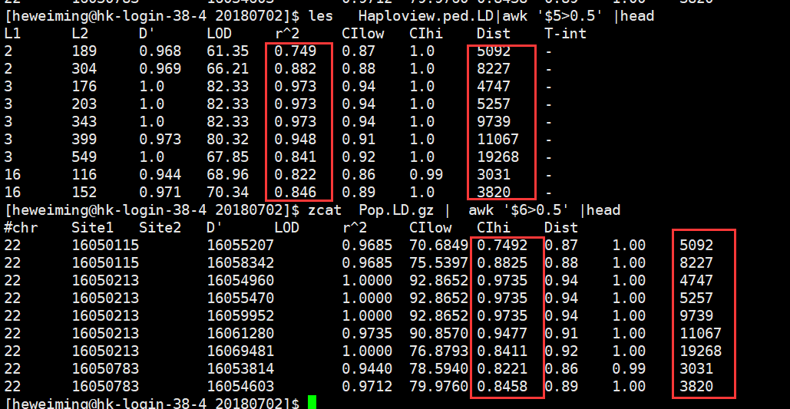

Fig 3: comparison Result of Accuracy

Here we also give out the Figure of LD Decay by *Haploview* and *PopLDdecay*, the two software lines are **overlapping**.

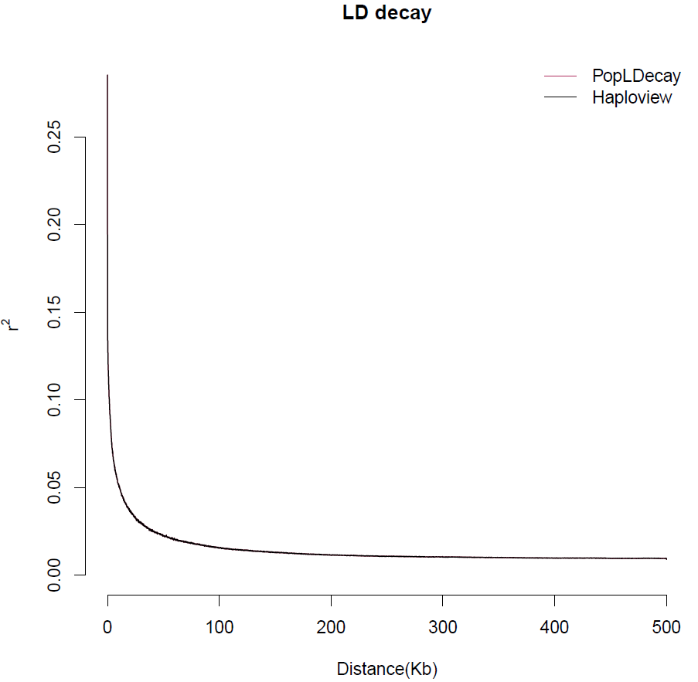

Fig 4: LD Decay of *Haploview* and *PopLDdecay result*

## ****Efficiency****

To compare the efficiency of this software, The Haploview and PLINK were taken to make a compare. Here are the shell script of running comparison.

**Plinks 1.07 shell**

*../plink2.0 --vcf chr22.vcf --out chr22*

*../plink_v1.07 --bfile chr22 --noweb --ld-window-r2 0 --r2 --ld-window 99999 --ld-window-kb 300 --maf 0.005 --out P1.7*

*Perl StatLD2Decay.pl P1.7.ld P1.7.ld.stat*

**Plinks 1.9 shell**

*../plink2.0 --vcf chr22.vcf --out chr22*

*../plink2.0 --bfile chr22 --noweb --ld-window-r2 0 --r2 --ld-window 99999 --ld-window-kb 300 --maf 0.005 - -out P2.0*  ***--threads 1***

*Perl StatLD2Decay.pl P2.0.ld P2.0.ld.stat*

**PopLDdecay shell:**

*./PopLDdecay -InVCF chr22.vcf -MaxDist 300 -OutStat Pop -MAF 0.005*

**Haploview shell:**

*../iTools Formtools VCF2Genotype -InPut chr22.vcf -OutPut Haploview.genoytpe.gz -NoRef*

*perl ../genotype2pedigree.pl Haploview.genoytpe.gz Haploview.ped Haploview.info*

*time java -jar -Xmx98g -jar ../Haploview.4.2.jar -n -pedfile Haploview.ped -info Haploview.info -log Hap.log -maxdistance 300 -minMAF 0.005 -hwcutoff 0.00 -dprime -memory 102400 #must set 100G ,Haploview can run complete*

The comparison result were show at the table1. Form the table.,we can see

1. The calculation time of PopLDdceay is much little, it is acceptable, although no the shortest one.
2. The average memory of PopLDdceay also takes much little, it is acceptable.
3. Since there is no intermediate file generation, the PopLDdceay output file takes up only little space.

**Table 1.** Computational resources statistics for chr22 LD decay

|  |  |  |  |  |
| --- | --- | --- | --- | --- |
| version | Average memory | Core calculation CPUs | Predicted Format conver & Statistics Time CPU | result size |
| Plink 1.07 | 1.4G | 680min | 5min+45min | 54G |
| Plink 2.0 | 18.81G | 25min | 5min+45min | 54G |
| Haploview 4.2 | 95.76G | 3904min | 5min+45min | 54G |
| PopLDdcay 3.30 | 1.5G | 200min | 0min | 4.1M |

Here we also give out the Figure of LD Decay by *Haploview*, *PLINK* and *PopLDdecay*, the trend of four software lines is consistent.

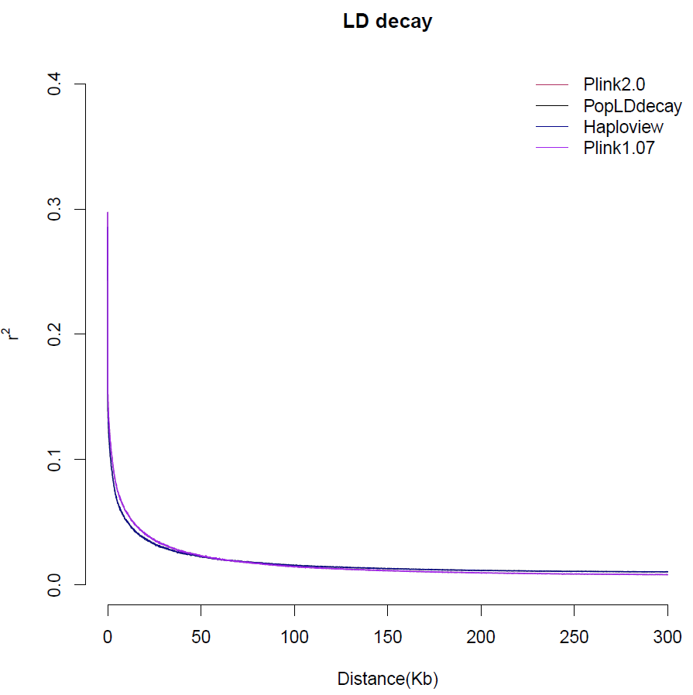

Fig 5: LD Decay of comparison software

# Cited

It is noteworthy that PopLDdecay has been cited 9times form 2017-2018 according to google scholar. At least 7 times(update 2018-06-30) as follow(Chen, et al., 2017; Cui, et al., 2017; Li, et al., 2018; Liu, et al., 2016; Wu, et al., 2018; Zhang, et al., 2017)

Chen, W.*, et al.* Genetic Diversity, Population Structure, and Linkage Disequilibrium of a Core Collection of Ziziphus jujuba Assessed with Genome-wide SNPs Developed by Genotyping-by-sequencing and SSR Markers. *Front Plant Sci* 2017;8:575.

Cui, C.*, et al.* Genetic Diversity, Population Structure, and Linkage Disequilibrium of an Association-Mapping Panel Revealed by Genome-Wide SNP Markers in Sesame. *Front Plant Sci* 2017;8:1189.

Li, C.*, et al.* The genetic architecture of amylose biosynthesis in maize kernel. *Plant Biotechnol J* 2018;16(2):688-695.

Liu, H.*, et al.* Gene duplication confers enhanced expression of 27-kDa gamma-zein for endosperm modification in quality protein maize. *Proc Natl Acad Sci U S A* 2016;113(18):4964-4969.

Wu, Y.*, et al.* Population genomic data reveal genes related to important traits of quail. *Gigascience* 2018;7(5).

Zhang, L.*, et al.* RNA sequencing provides insights into the evolution of lettuce and the regulation of flavonoid biosynthesis. *Nat Commun* 2017;8(1):2264.