Super 8 hotel analytics

The goal of this analytics project was to find insights on the prices in April that result in the highest Revpar(revenue per available room). In addition I also analyzed the general performance by calculating the average total daily revenue, the average revenue daily compared year by year. This was to get a good baseline on which years performed the best.
The data used for analysis consisted of the performance metrics from 2023-2026. However the major analysis was performed on 2023-2025. 2026 simply had less data and the purpose was to create a plan of pricing in April.
Insights and recommendations will be.

- When to raise prices in april peak
- Which price point resulted in the highest RevPar from 2023-2025 in April
- What price results in the highest occupancy and RevPar when the peak drops
- Identify which days in april do we see spikes in RevPar an Occ

Data Structure

Below is a display of the dabase schema

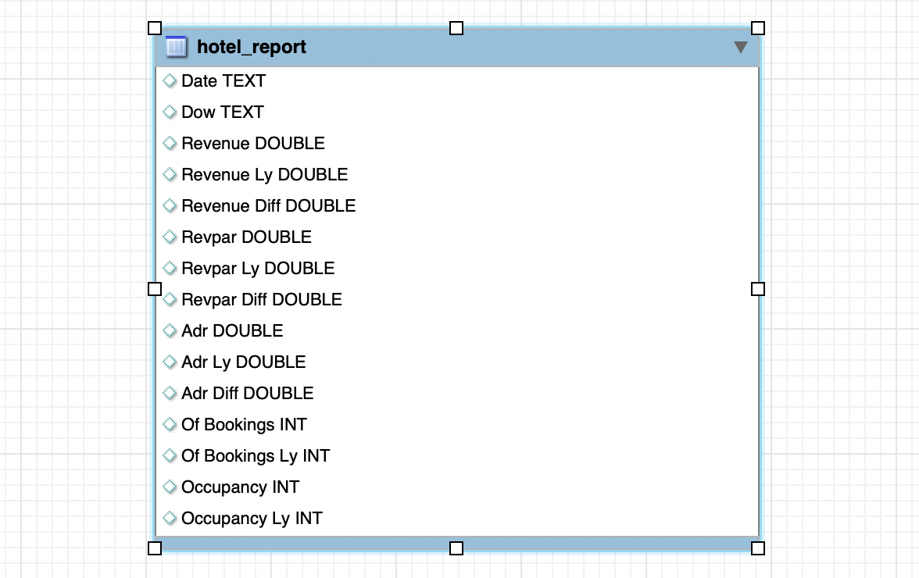

Executive Summary

Overview of findings

April 2023 recorded the highest average revenue across all weekdays, followed by a steep decline in 2024 and a slight recovery in 2025.
In 1.2, we analyze and compare RevPAR across April 2023–2025. A consistent pattern emerges: from mid-to-late April, there is a significant spike in RevPAR across all three years, accompanied by corresponding increases in both revenue and occupancy. The key differentiator is identifying which year produced the widest and highest spike — measured by the spread from when the spike begins (e.g. April 15) to when it ends (e.g. April 30).
Comparing the three years to find the optimal balance of high revenue, strong RevPAR, and longest duration — the "Goldilocks zone" — 2025 shows the highest peak but the shortest spread. 2024 shows the lowest peak with a spread comparable to 2025. This makes 2023 the strongest benchmark, offering the best combination of peak height and sustained duration. We examine this more closely in 1.3.

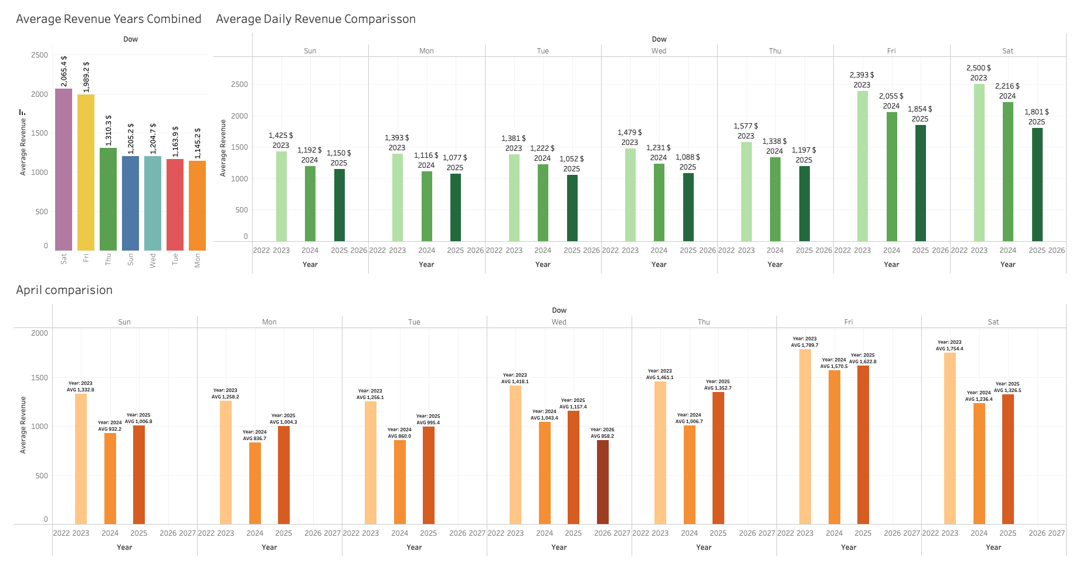
1.1

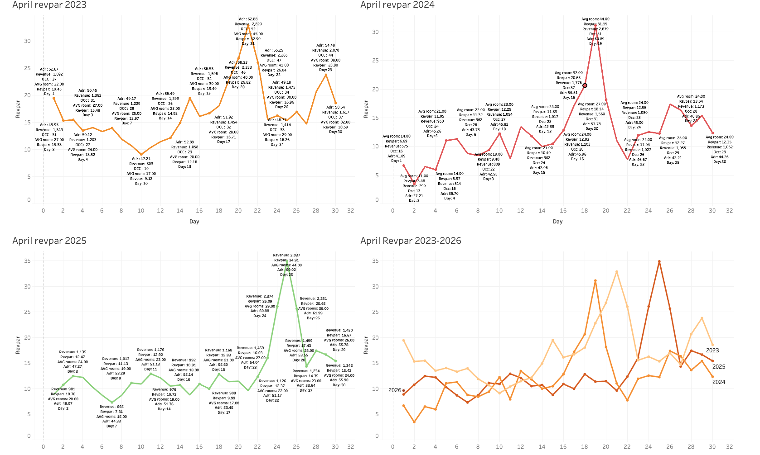
1.2

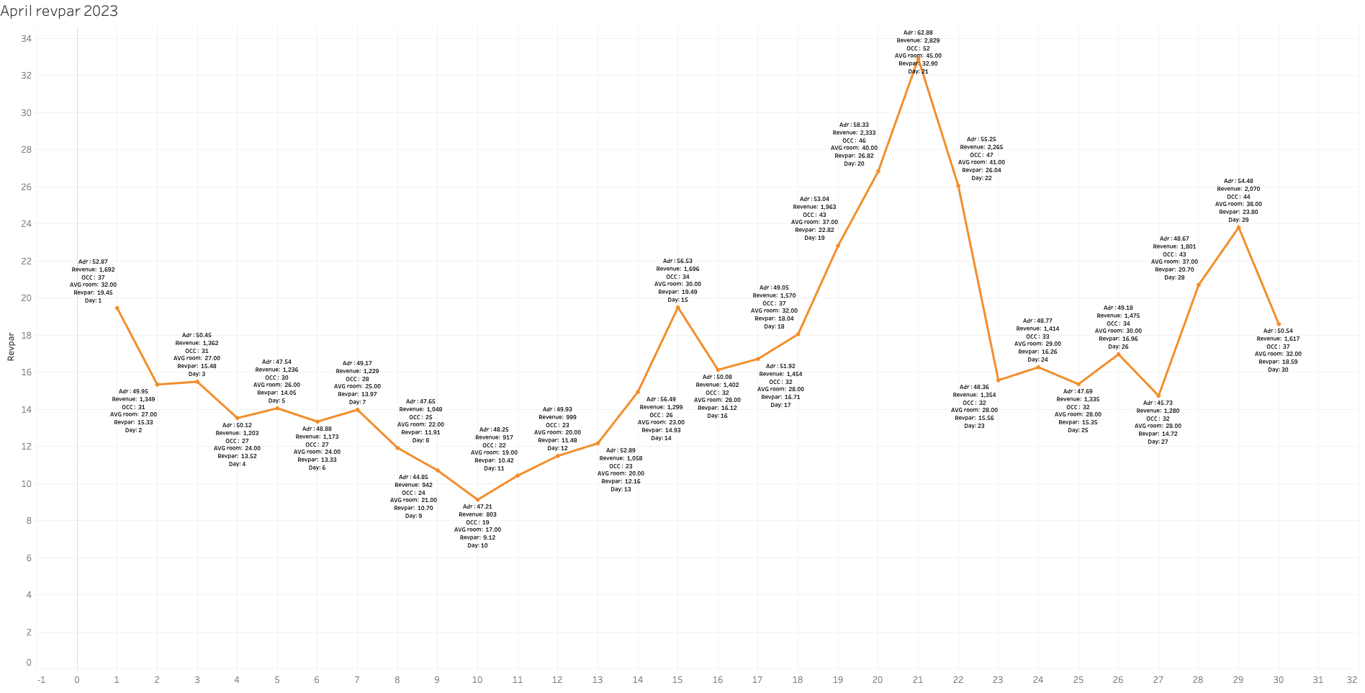

1.3 2023 April revpar

In the above visualization we see the performance metrics Adr, revenue, Occupancy, Revpar and day.

Recommendations for april

- Follow the trend in 2023 regards the adr it shows the the highest occupancy and adr out of all years
- In April 2023 the spike in RevPar began to grow around the 10th. This shows evidence of demand during this period of time. I suggest a boost in ADR to match demand. This may help with increased revenue for this month and during the peak period in April

