Publisher Survey of Ethiopic Layout  
& Formatting Practices

The 1st Survey of the   
W3C Ethiopic Layout Requirements Task Force

# Purpose of This Survey

This goal of this survey is to determine the best practices of document layout and formatting for literature written in the Ethiopic script. The information gathered from the survey will be used to define an international standard governed by the World Wide Web Consortium. The resulting standard will be free to use by software companies who in turn may then apply the information to correctly format Ethiopian literature in electronic forms such as web pages, eBooks, and by word processors.

Many languages have a long history of writing in Ethiopic script and have developed different conventions and styles of writing. All of these styles can be supported by software provided that the appropriate information is collected. The aim of this survey is to collect the necessary information to support all writing traditions present and past –many of which may be unknown to the survey team. Please feel free to provide any additional information that you feel is important. The questions in the survey primarily attempt to resolve discrepancies in the most commonly observed practices of general literature.

This survey process and the standardization work activity are conducted by volunteers with a deep interest in Ethiopic literature and layout and who do not stand to profit from their involvement. You are also invited to join them to follow the work as well as to participate in its development as you desire.

**References and Points of Contact:**

The Ethiopic Layouts Requirements draft specification:

http://w3c.github.io/elreq/

The W3C Ethiopic Layout Task Force’s mail archive with subscription information:

https://lists.w3.org/Archives/Public/public-i18n-ethiopic/

Respondents Contact

Name: _____________________________________________________________________

Company or Institute:_________________________________________________________

Role at Institute: _____________________________________________________________

___________________________________________________________________________

Years involved with literature or publishing: _______________________________________

Literature or publishing languages: ______________________________________________

Areas of expertise: ___________________________________________________________

___________________________________________________________________________

Email: ____________________________________________

Phone: ___________________________________________

Instructions:

Please respond to the survey questions to the best of your ability based on practical experience. Survey question cover a very wide range of topics *-please do not guess an answer*. It is preferred that a question is left unanswered when the respondent is uncertain or the topic is outside of one’s experience and expertise.

Please use additional space as needed. Questions on the meaning of survey questions may be addressed to the provider of this survey. You are welcome and encouraged to provide any additional information that you think is relevant.

# **Characters and phrases**

## **Font styles** *(W3C Ethiopic Layout Gap Analysis 2.3)*

Arriving along with the adoption of mechanical printing technology in the 20th century authors begun applying stylized text to their words and phrases to convey prosodic stress to the reader. For example, font size, font style (typeface), and underlining would be used for emphasis. The approach to emphasis was limited by the printing technology available to the printing agency and would also change as per the individual preferences of authors to copy editors.

Toward the end of the last century, desktop publishing software gave authors with the ability to easily apply non-traditional forms of text styling such as bold, italic, outlining, highlighting and so on. This further diversified the means of expressing emphasis but also has led to a decrease in the consistency in what a given stylization connotes.

Recommended practices for emphasis are not known to have been established at a national level and every organization engaged in publishing will apply its own in-house conventions. The goal of this section is to arrive at a recommendation for emphasis that would be suitable for most publishers when targeting the average reader.

### Size Change

Change of letter size has been used in the past a means to impart emphasis. This practice has a visual impact similar to bold emphasis. An example:

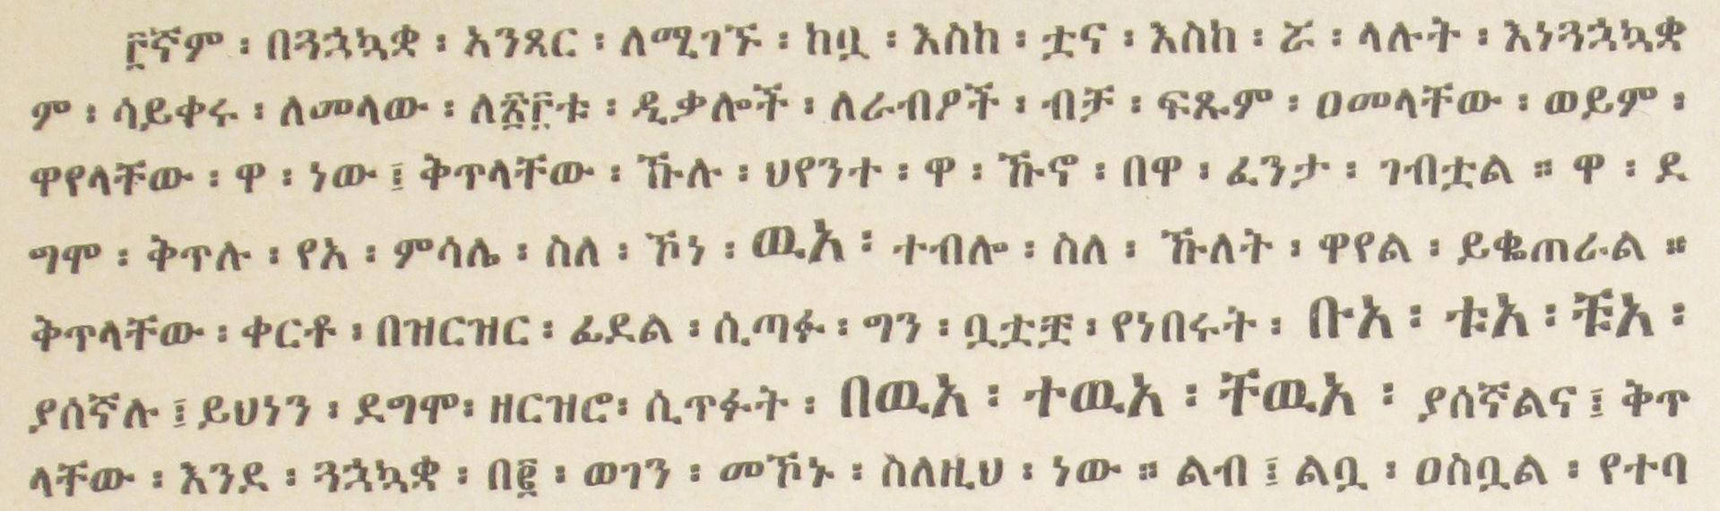

*Typeface size change for emphasis found in Mazgaba Fidal by Kidane Wolde Kifle, p. 43.*

**Survey Questions:**

1. Should size changes be recognized as a form of Ethiopic emphasis?  
    ☐ No opinion ☐ Yes ☐ No ☐ Other (Please explain): ________________________________________________________________________
2. If you answered “Yes” to Question 1, how much larger should letters be made?  
    ☐ No opinion ☐ Increase by _____ % ☐ Other (Please explain): ________________________________________________________________________

### Style Change

In addition to changing the letter size, another past practice has been to change the letter style (typeface) as a form of emphasis. This is sometimes done with a change to a more antiquated style and may be used in quotation, in particular with a language change to Ge’ez. An example:

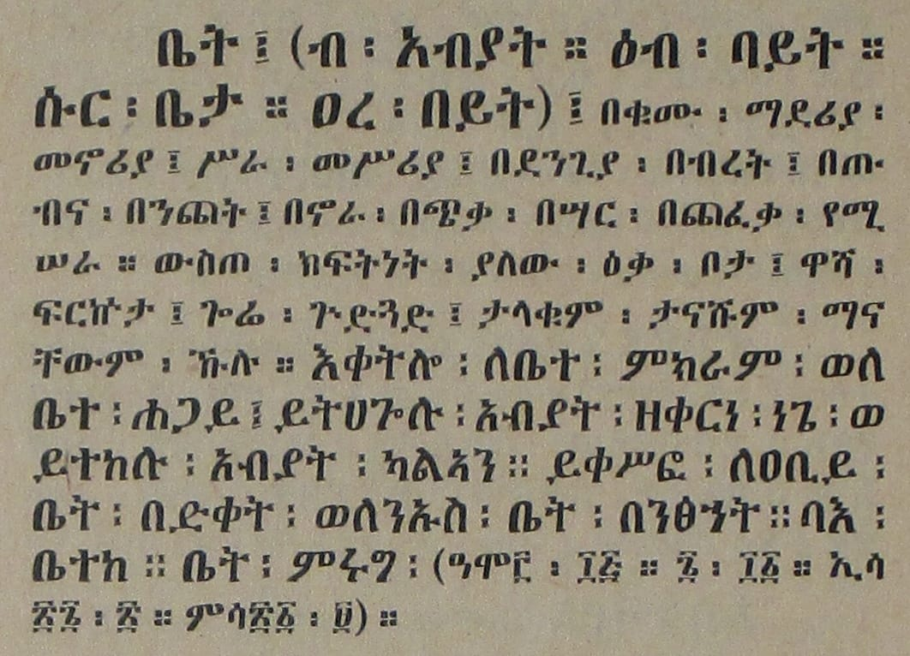

*Typeface change for emphasis found in Maṣḥafa Sawāsew Wages Wamazgaba Qālāt Hadis by Kidane Wolde Kifle, p. 268.*

**Survey Questions:**

1. Should a font style be recognized as a form of Ethiopic emphasis?  
    ☐ No opinion ☐ Yes ☐ No
2. If you answered “Yes” to Question 1, please describe systematically how & when this style of emphasis is made:  
   ________________________________________________________________________

________________________________________________________________________

________________________________________________________________________

### Underline

Underline is a non-traditional form of emphasis that was adopted by some authors in the early 20th century. The characteristics of the underline itself may change from one printing agency to the next where the underline position below a line of text can vary as well as the line thickness.

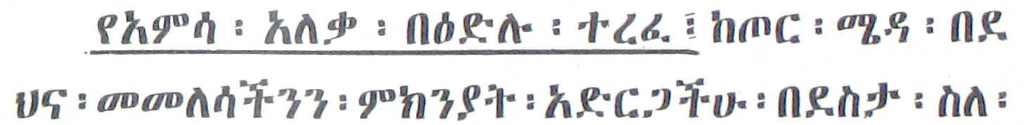

*Sample of underline found in YaMāychaw Kwusolañā. By Mekonnen Zewdie p. 56.*

**Survey Questions:**

1. Should underline be recognized as a form of Ethiopic emphasis?  
    ☐ No opinion ☐ Yes ☐ No ☐ Yes, under these circumstances only: ________________________________________________________________________
2. If you answered “Yes” to Question 1, please remark on proportions for “x” and “y below:

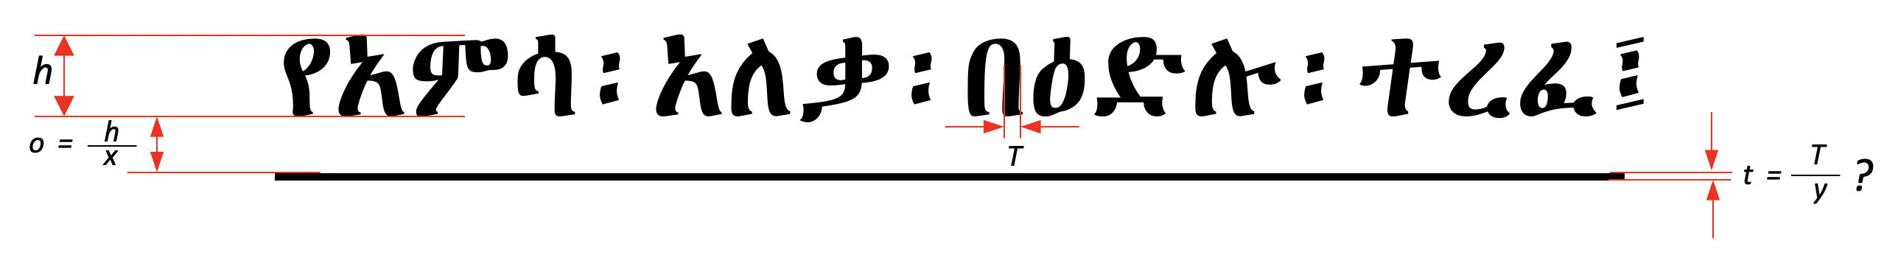

|  |  |
| --- | --- |
| h – | Letter height. |
| o – | Vertical offset of the line below the base of the text as some fraction “x” of the height “h”. |
| T – | Average stroke thickness of letters. |
| t – | Underline thickness as some faction “y” of stroke thickness “T”. |

☐ No opinion ☐ x = ______________. y = _____________

### Bold

Boldface text is a common style of emphasis for Latin script. Computer software can create bold text automatically from a regular font that was not designed for a boldface. The use of boldface for Ethiopic has been controversial when applied to the classic style, and less divisive when applied to more modern thinner styles that have been designed for digital screens.

**Survey Questions:**

1. Should **bold** be recognized as a form of Ethiopic emphasis?  
    ☐ No opinion ☐ Yes ☐ No ☐ Yes, under these circumstances only: ________________________________________________________________________
2. If you answered “Yes” to Question 1, under what Ethiopic font styles should bold be supported?  
    ☐ All styles ☐ Thin styles only (e.g. ኢትዮጵያ) ☐ Other (Please explain): ________________________________________________________________________
3. If you answered “Yes” to Question 1, how much thicker should bold Ethiopic letters be?  
    ☐ No opinion ☐ Following the same rules for Latin ☐ Other (Please explain): ________________________________________________________________________

### Italic

Like boldface text, computer software can automatically “slant” a regular style font to create a virtual italic face. In a true italic typeface the letter shapes are also optimized for the slanted appearance (compare the shapes of ‘n’ to ‘*n*’). Some past attempts have been made to create Ethiopic letter shapes for use as an italic face, but have not seen wide spread adoption. In part the lack of adoption may have been due at least in part to the commercial nature of the font.

**Survey Questions:**

1. Should *italic* be recognized as a form of Ethiopic emphasis?  
    ☐ No opinion ☐ Yes ☐ No ☐ Yes, under these circumstances only: ________________________________________________________________________
2. If you answered “Yes” to Question 1, please recommend a reference work that demonstrates a good quality Ethiopic italic style.  
    ☐ No opinion ☐ The following references are recommended: ________________________________________________________________________

________________________________________________________________________

### Headings

Chapter, section and subsection heading styles will combine one or more of the above styles to form a composite header style. A variety of heading styles are provided by word processors that a user may select from. Web browsers and eReaders will support a default style.

**Survey Questions:**

1. What heading style rules would you want software to support?  
    ☐ No opinion ☐ Latin heading rules are fine. ☐ The following: ________________________________________________________________________

________________________________________________________________________

________________________________________________________________________

### Default Emphasis

In a number of publishing contexts, a default, or generic, form of emphasis is defined. For example, in the Hyper Text Markup Language (HTML) the tag “<em>” indicates a general form of emphasis that can be defined on a per-language basis.

**Survey Questions:**

1. Which form of text emphasis is best as a default for Ethiopic?  
    ☐ No opinion ☐ The following (Please list): ________________________________
2. Do any emphasis practices change depending on Ethiopic language?  
    ☐ No opinion ☐ No ☐ Yes (Please explain): : ________________________________________________________________________

# **Writing Style Best Practices**

## **Numbers & digits** *(W3C Ethiopic Layout Gap Analysis 2.7)*

The Ge’ez numbers can be found written in two styles where the upper and lower bars (lines) can be either separated or connected.

|  |  |
| --- | --- |
|  | Isolated style – the numeral bars do not connect. |
| Joining style – the numeral bars are connected. |

**Survey Questions:**

1. Which style should be the default? ☐ No opinion ☐ Isolated ☐ Joined
2. Are both styles desirable? ☐ No opinion ☐ Yes ☐ No
3. If both styles are desired:
   1. When would the isolated style be used? Please explain:  
      _____________________________________________________________________  
      _____________________________________________________________________
   2. When would the joined style be used? Please explain:

_____________________________________________________________________

_____________________________________________________________________

## **Text boundaries & selection** *(W3C Ethiopic Layout Gap Analysis 2.8)*

Text boundaries mark the end of a written word. Space and punctuation symbols are the most common boundary markers. In some special cases, such as abbreviations, a punctuation may be included as part of a word (e.g. ወ/ሮ, ሆ/ል, etc.). In word processors and web browsers, double clicking a word will select it for copying or cutting. The boundary markers are used to demarcate the beginning and end of the selection. The Ethiopic wordspace, “፡”, marks the end of a word but is not treated consistently by software as a boundary marker. For example, some web browsers will not include wordspace and Microsoft word will treat wordspace as a letter and extend selection to the end of a line.

**Survey Questions:**

1. Should selecting an Ethiopic word for copying, also include a right side wordspace if present? ☐ No opinion ☐ Yes ☐ No ☐ Other (Please Explain):  
   ________________________________________________________________________

________________________________________________________________________

1. When a forward slash, “/”, occurs between letters of a word should the slash be treated as part of the word during a selection?  
   ☐ No opinion ☐ Yes ☐ No ☐ Other (Please Explain):  
   ________________________________________________________________________

________________________________________________________________________

1. If you answered “Yes” to Question 2 above, what other punctuation should be treated the same as forward slash?  
   ________________________________________________________________________

________________________________________________________________________

## **Quotations** *(W3C Ethiopic Layout Gap Analysis 2.9)*

Classical Ethiopic literature applying quotation marks will employ double guillemet (« ») in a primary style and single guillemets (‹ ›) in a secondary style. Single guillemets will be used for inner-quotation and single word quotation. Modern Ethiopic writing will additionally utilize Latin quotation marks similarly (“ ”, ‘ ’). The choice of Latin script quotation may represent either an author preference or a software limitation that made guillemets unavailable or difficult to access.

**Survey Questions:**

1. Which style should be the default for Ethiopic literature: ☐ No opinion ☐ « » ☐ “ ”
2. Are both styles appropriate for Ethiopic literature? ☐ No opinion ☐ No  
   ☐ Yes (Please Explain): ___________________________________________________  
   ________________________________________________________________________
3. What form is appropriate for outer quotation: ☐ No opinion ☐ Single ☐ Double
4. What form is appropriate for inner quotation: ☐ No opinion ☐ Single ☐ Double
5. What are the preferred quotation marks for modern Ethiopic literature?  
   ☐ No opinion ☐ « » ☐ “ ” ☐ It depends (Please Explain): ________________________________________________________________________
6. Is the single quotation mark usage statement correct?

☐ No opinion ☐ No ☐ Yes ☐ Other rules (Please Explain):  
________________________________________________________________________

1. Do any other rules apply to quotation usage in Ethiopic writing?

☐ No opinion ☐ No ☐ Yes (Please Explain):  
________________________________________________________________________

1. What symbols should be used for “inner quotes” (i.e. quotation marks occurring within quotation)?  
   ☐ No opinion ☐ No ☐ Yes ☐ Other Rules (Please Explain):  
   ________________________________________________________________________
2. Are “block quotes” indented?  
   ☐ No opinion ☐ No ☐ Yes ☐ Other Rules (Please Explain):  
   ________________________________________________________________________
3. If block quotes are indented

# **Lines and Paragraphs**

## **Line breaking** *(W3C Ethiopic Layout Gap Analysis 3.1)*

Word processors and text readers such as web browsers, eBook devices, etc. will automatically format the sentences of a paragraph over a number of lines as allowable by the available width of the viewing area. These software systems apply formatting rules that govern where and how a line may end and a new line begin.

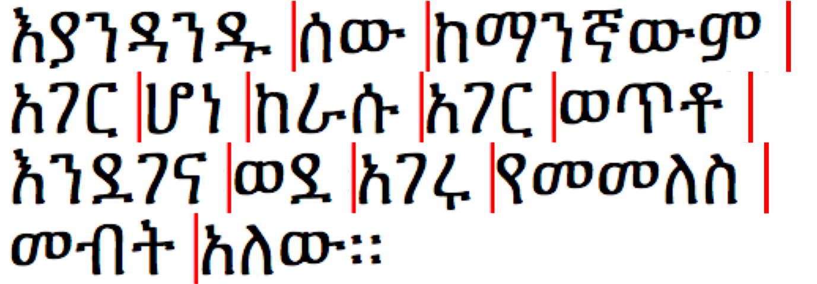

Example of allowable line breaking locations.

Line breaking rules for Ethiopic are given in the following.

A line may start with:

* A letter.
* A number.
* A tab.
* A non-terminal or non-joining punctuation (such as « ‹ “ $ ( [ { ).

Conversely, a line may not start with:

* Space, “ ”.
* A terminal or joining punctuation (such as: ? ! ¡ ።) ] } / % **–** ” › » ፡ ፣ ፤ ፥ ፦ space, math operators).

**Survey Questions:**

1. Are the above rules valid?  
   ☐ No opinion ☐ Yes ☐ No (Please Correct):  
   ________________________________________________________________________

________________________________________________________________________

1. Are any additional rules needed to govern how a line may end or begin?  
   ☐ No opinion ☐ No ☐ Yes (Please Explain):  
   ________________________________________________________________________

________________________________________________________________________

### First Paragraph Rule

Paragraph indentation is a regular practice in Ethiopic publishing, and not common in hand written manuscripts where a Hareg or Mekfel will be used instead. Some Western publishers will apply a special rule where the first paragraph of a section is *not* indented. It is unknown if this rule is also appropriate for Ethiopic publishing. An example follows:

መቅድም ።

ፊደል፡ማለት፡የነገር፡የቃል፡ምልክት፡አምሳል፡ወይም፡መግለጫ፡ማስታወቂያ፡ማለት፡ነው፤ሥዕል፡እንደ፡ማለት።ዐይነተኛ፡ፍችው፡ይህ፡ነው፡የቀረውን፡በግስ፡ይመለከቷል።የፊደል፡ተራ፡የተፋለሰና፡አልፍ፡አ፡ከርስቱ፡ከቀዳማዊነት፡ተነቅሎ፡በርሱ፡ፋንታ፡ሆይ፡ሀ፡መዠመሪያ፡ፊደል፡የኾነ፡ከሣቴ፡ብርሃን፡ከሚባለ

**⋮ ⋮ ⋮ ⋮ ⋮ ⋮**

Example: First paragraph of section with indentation.

መቅድም ።

ፊደል፡ማለት፡የነገር፡የቃል፡ምልክት፡አምሳል፡ወይም፡መግለጫ፡ማስታወቂያ፡ማለት፡ነው፤ሥዕል፡እንደ፡ማለት።ዐይነተኛ፡ፍችው፡ይህ፡ነው፡የቀረውን፡በግስ፡ይመለከቷል።የፊደል፡ተራ፡የተፋለሰና፡አልፍ፡አ፡ከርስቱ፡ከቀዳማዊነት፡ተነቅሎ፡በርሱ፡ፋንታ፡ሆይ፡ሀ፡መዠመሪያ፡ፊደል፡የኾነ፡ከሣቴ፡ብርሃን፡ከሚባለው፡ካንደ

**⋮ ⋮ ⋮ ⋮ ⋮ ⋮**

Example: First paragraph of section *without* indentation.

**Survey Questions:**

1. How much should a regular paragraph be indented?  
   ☐ No opinion ☐ Same as English indentation ☐ Other (Please Explain):  
   ________________________________________________________________________
2. Should the first paragraph of a section be indented?  
   ☐ No opinion ☐ Never ☐ Always ☐ Under special rules or context (Please Explain):  
    ________________________________________________________________________
3. Should a new paragraph be indented following a list?  
   ☐ No opinion ☐ Never ☐ Always ☐ Under special rules or context (Please Explain):   
   ________________________________________________________________________
4. Are there any other special rules for when to, or not to, indent a paragraph?  
   ☐ No opinion ☐ Yes (Please Explain):  
   ________________________________________________________________________

## **Hyphenation** *(W3C Ethiopic Layout Gap Analysis 3.2)*

In traditional Ethiopic writing the wordspace separator symbol, “፡”, negated the need for word hyphenation across a line of text. When wordspace fell out of favor in modern writing the practice of splitting a word across lines of text continued. The reader would know to mentally reconstruct a word by relying on knowledge of lexicon and context.

**Survey Questions:**

1. When wordspace, “፡”, is used, what rules for splitting a word across lines apply?  
   ☐ No opinion ☐ None, a word may be split anywhere ☐ The following rules:  
   ________________________________________________________________________

________________________________________________________________________

1. When space, “ ”, is used, should Ethiopic writing use a hyphen “‐” to split words across lines?  
   ☐ No opinion ☐ Never ☐ Author’s decision ☐ Other (Please Explain):  
   ________________________________________________________________________

________________________________________________________________________

1. When space, “ ”, is used, and if words should be split across lines (with or without a hyphen), are the following rules for word splitting suitable?

* Words are split at a morpheme boundary, for example: ቤተ‐  
  መንግሥት .
* Words are split at a syllable boundary.
* Words of a single syllable are not split over lines.
* Words of two letters are not split over lines.
* Words are split after a prefix.
* Words are split before a suffix.
* Numbers are not split over lines.
* Words are not split at the final letter.

☐ No opinion ☐ Yes ☐ No, a word may be split  
☐ No or Incomplete (Please Explain):  
________________________________________________________________________

________________________________________________________________________

________________________________________________________________________

## **Justification** *(W3C Ethiopic Layout Gap Analysis 3.3)*

In justified text, the non-printed or “white space” between words is treated as “stretchable”. The width of the white space can be stretched to some aesthetically pleasing size that may vary between individual words across a printed line. In Ethiopic justification, the white space between the Ethiopic word separator, “፡”, and the words it separates is likewise allowed to stretch. This stretching of white space may be either symmetrical (“centered”) or, in the asymmetrical case, the stretching is always between the right side of “፡” and the following word –this style is referred to here as the “word bound” justification.

### Justification with Punctuation and Wordspace in Word Bound Style

In “word bound” justification the word separator, which may be either an Ethiopic Wordspace, “፡”, or a punctuation symbol, appears to adhere to the word on the left side as if it were its final character of the word. The following figure illustrates the “word bound” style:

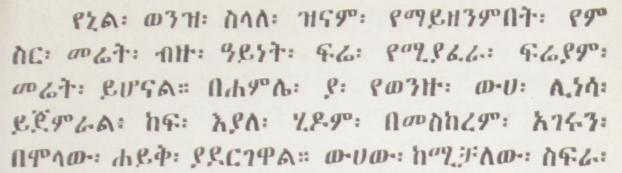*Ethiopic justification in word bounded style (Erikson, 1921 (1913 EC))*

### Justification with Centered Wordspace and Punctuation

In the second major form of Ethiopic justification the white space around word separators is stretched equally on both the left and right sides; giving the appearance of the separator being centered between the words it divides. The following figure illustrates the “centered” style:

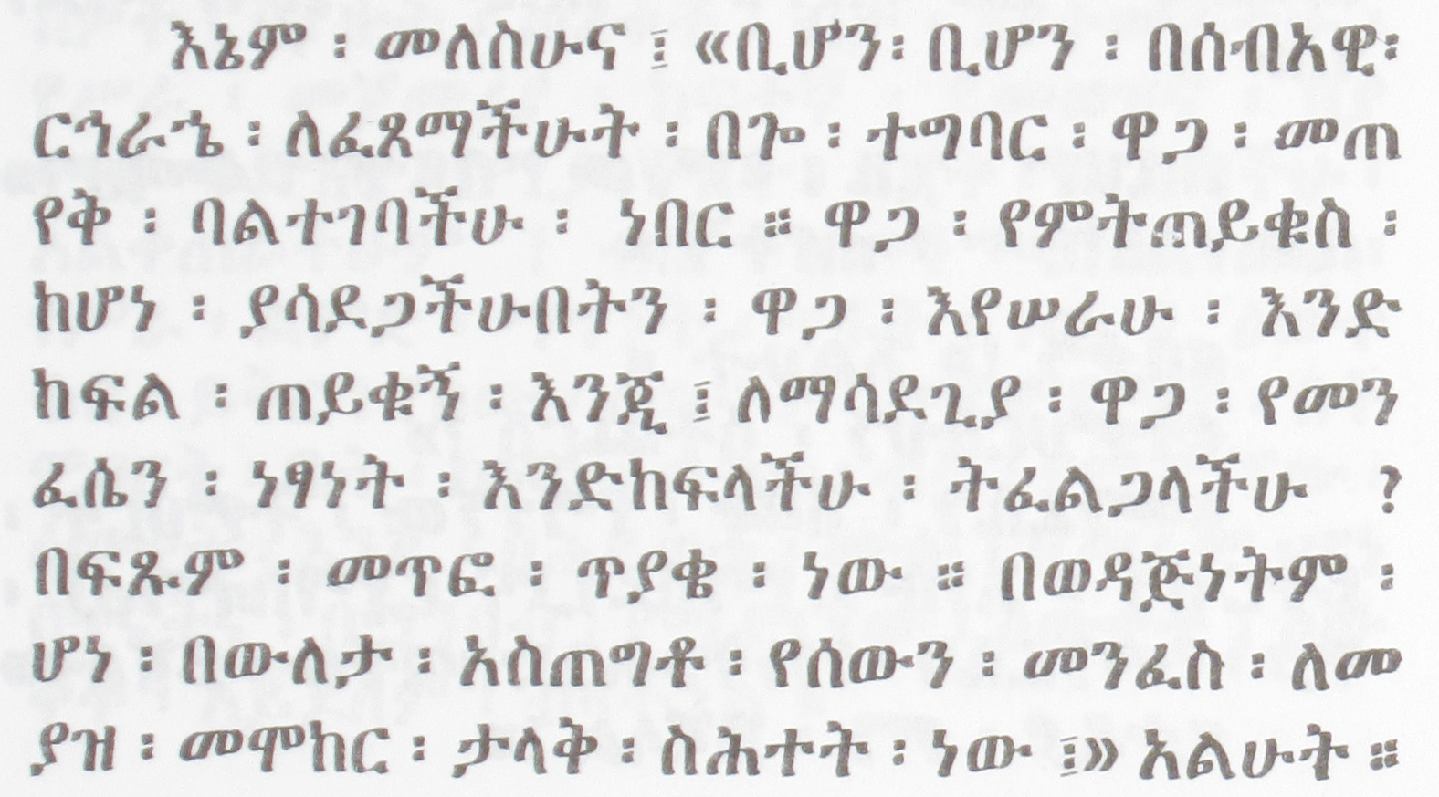 *Ethiopic justification in centered style (Gubenya, 1973 (1966 EC)).*

The following figure presents the stretching of white space from the point of view of the symbol’s typographic bounding box. Here the “design white space” (*d*) is the space between the visible symbol and the box border, is itself stretched (*e*) as needed to meet line justification:

|  |  |  |
| --- | --- | --- |
| **Regular Alignment** | **Justification** | |
| *d*  *d*  *e*  *d*  *e*  *e*  **Regular Style** | **Word-Bound Style** | **Centered Style** |

*Depiction of white space around Ethiopic Wordspace for three modes of text justification.*

**Survey Questions:**

1. Which justification spacing style should be the default used by applications?  
   ☐ No opinion ☐ Word Bound Style ☐ Centered Style ☐ Other (Please Explain): ________________________________________________________________________
2. Are both styles appropriate? If so, in what contexts can the two styles be used:  
   ________________________________________________________________________  
   ________________________________________________________________________
3. Are names known for these different formatting styles? ☐ No opinion  
   ________________________________________________________________________

## **Counters, lists, etc.** *(W3C Ethiopic Layout Gap Analysis 3.4)*

### Ordered List Counter Suffix

In Ethiopic ordered lists a number of symbols are used for the list marker (or “suffix”). For example “/” , “፦” , “.” , “)” and even “፡”.

**Survey Questions:**

1. What is the best default marker symbol?  
   ☐ No opinion ☐ / ☐ ፦ ☐ ) ☐ . ☐ ፡ ☐ Software default  
   ☐ Other (Please Explain): _________________________________________________  
   ________________________________________________________________________
2. How much, if any, white space follows the suffix?

☐ No opinion ☐ Same as with western lists ☐ Other Policy (Please Explain):  
________________________________________________________________________

1. Do copy editors or publishers set a policy for list counter suffix, or leave it up to the author to decide?  
   ☐ No opinion ☐ No ☐ Yes ☐ Other Policy (Please Explain):  
   ________________________________________________________________________
2. Of historic interest: when are ordered lists first found in Ethiopic writing and in what form?  
   ☐ No opinion ☐ In the following publication and year:

________________________________________________________________________

### List Counter Suffix Alignment

Ethiopic corpus will present lists with two styles of alignment. These are a left side alignment at the list counter, or alignment along the list marker (“suffix”). Layout software will align a list at the marker in keeping with the later style. The former style (left justified at counter) may reflect a limitation of the layout technology employed and not a preference of the author, copy editor or typesetter. A depiction of these two alignment styles is presented in the following figures:

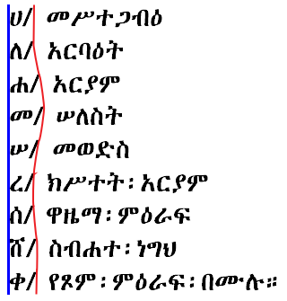 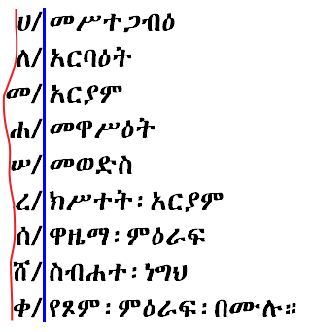

|  |  |
| --- | --- |
| **A:** Alphabetical list aligned justified on   counter left. | **B:** Alphabetical list aligned on marker. |

**Survey Questions:**

1. Which alignment style is preferable?  
   ☐ No opinion  
   ☐ Align along left side of letter (Style A)  
   ☐ Align along the right side of the marker (Style B)  
   ☐ Other (Please Explain): __________________________________________________  
   ________________________________________________________________________

### Numbered Lists

Ethiopic literature will apply ordered numbered list using both Ethiopic and Western numeral systems. The question of best list counter suffix for Ethiopic literature arises here as well. Examples for consideration:

|  |  |  |  |  |
| --- | --- | --- | --- | --- |
| **Ethiopic Numeral Lists** | | | | |
| ፩፡…  ፪፡…  ፫፡…  ፬፡…  ⋮ | ፩/…  ፪/…  ፫/…  ፬/…  ⋮ | ፩)…  ፪)…  ፫)…  ፬)…  ⋮ | ፩. …  ፪. …  ፫. …  ፬. …  ⋮ | ፩፦ …  ፪፦ …  ፫፦ …  ፬፦ …  ⋮ |
| **Western Numeral Lists** | | | | |
| 1፡…  2፡…  3፡…  4፡…  ⋮ | 1/…  2/…  3/…  4/…  ⋮ | 1)…  2)…  3)…  4)…  ⋮ | 1. …  2. …  3. …  4. …  ⋮ | 1፦ …  2፦ …  3፦ …  4፦ …  ⋮ |

**Survey Questions:**

1. What is the best list counter marker for Ethiopic numeral lists?  
   ☐ No opinion ☐ / ☐ ፦ ☐ ) ☐ . ☐ ፡ ☐ Software default  
   ☐ Other (Please Explain): __________________________________________________  
   ________________________________________________________________________
2. What is the list counter suffix preference with western numbers (0-9)?  
   ☐ No opinion ☐ Same used for Ethiopic numbers ☐ Software default  
   ☐ Other (Please Explain): _________________________________________________  
   ________________________________________________________________________
3. Are there any sub-list (nested list) considerations?  
   ☐ No opinion ☐ No ☐ Yes (Please Explain): ________________________________________________________________________

### Alphabetical (ሀለሐመ) Lists

The Unicode standard encodes Ethiopic syllables for many languages using Ethiopic script past and present. Alphabetic lists are commonplace in Ethiopic literature, but will conform to the letter inventory of the language of the surrounding content. The alphabetical style lists specified here do not encompass all languages using Ethiopic, but only those with a demonstrated requirement as found in corpus or stakeholder input.

|  |  |  |  |  |
| --- | --- | --- | --- | --- |
| **Ge’ez** | **Amharic** | **Blin** | **Tigrinya (Eritrean)** | **Tigrinya (Ethiopian)** |
| * ሀ/ * ለ/ * ሐ/ * መ/ * ሠ/ * ረ/ * ሰ/ * ቀ/ * በ/ * ተ/ * ኀ/ * ነ/ * አ/ * ከ/ * ወ/ * ዐ/ * ዘ/ * የ/ * ደ/ * ገ/ * ጠ/ * ጰ/ * ጸ/ * ፀ/ * ፈ/ * ፐ/ | * ሀ/ * ለ/ * ሐ/ * መ/ * ሠ/ * ረ/ * ሰ/ * ሸ/ * ቀ/ * በ/ * ተ/ * ቸ/ * ኀ/ * ነ/ * ኘ/ * አ/ * ከ/ * ኸ/ * ወ/ * ዐ/ * ዘ/ * ዠ/ * የ/ * ደ/ * ጀ/ * ገ/ * ጠ/ * ጨ/ * ጰ/ * ጸ/ * ፀ/ * ፈ/ * ፐ/ | * ሀ/ * ለ/ * ሐ/ * መ/ * ረ/ * ሰ/ * ሸ/ * ቀ/ * ቐ/ * በ/ * ተ/ * ቸ/ * ኀ/ * ነ/ * ኘ/ * አ/ * ከ/ * ኸ/ * ወ/ * ዐ/ * ዘ/ * ዠ/ * የ/ * ደ/ * ጀ/ * ገ/ * ጘ/ * ጠ/ * ጨ/ * ጰ/ * ጸ/ * ፀ/ * ፈ/ * ፐ/ | * ሀ/ * ለ/ * ሐ/ * መ/ * ረ/ * ሰ/ * ሸ/ * ቀ/ * ቐ/ * በ/ * ተ/ * ቸ/ * ነ/ * ኘ/ * አ/ * ከ/ * ኸ/ * ወ/ * ዐ/ * ዘ/ * ዠ/ * የ/ * ደ/ * ጀ/ * ገ/ * ጠ/ * ጨ/ * ጰ/ * ጸ/ * ፈ/ * ፐ/ | * ሀ/ * ለ/ * ሐ/ * መ/ * ሠ/ * ረ/ * ሰ/ * ሸ/ * ቀ/ * ቐ/ * በ/ * ተ/ * ቸ/ * ኀ/ * ነ/ * ኘ/ * አ/ * ከ/ * ኸ/ * ወ/ * ዐ/ * ዘ/ * ዠ/ * የ/ * ደ/ * ጀ/ * ገ/ * ጠ/ * ጨ/ * ጰ/ * ጸ/ * ፀ/ * ፈ/ * ፐ/ |

**Survey Questions:**

1. Are there any mistakes in the above lists?  
   ☐ No opinion ☐ No ☐ Yes (Please Explain):   
   ________________________________________________________________________
2. Should “ሀለሐመ” lists be added for other languages?

☐ No opinion ☐ No ☐ Yes (Please Explain):

________________________________________________________________________

1. Should “ቨ” be included in lists other than Ge'ez?  
    ☐ No opinion ☐ No ☐ It depends (Please Explain):  
   ________________________________________________________________________
2. How is the end of sequence handled?
   * No opinion
   * Sequence as radix, e.g.: ... ፈ ... ፐ ... ሀሀ ... ሀለ ...
   * Columnar radix, e.g.: ... ፈ ... ፐ ... ሀሁ ... ሀሉ ...
   * Wrap to next column, e.g.: ... ፈ ... ፐ ... ሁ ... ሉ ...
   * Other (Please Explain): ______________________________________________  
     __________________________________________________________________
3. How should the end of the syllabary matrix handled? ☐ No opinion

________________________________________________________________________

### Abegede (አበገደ) List

The አበገደ ordering is potentially desirable to any language using the Ethiopic syllabary. The ordering is less likely to be found in the writing practices of languages that have a written tradition of under a hundred years. The language specific orders shown here are only those found utilized in corpus.

|  |  |  |  |
| --- | --- | --- | --- |
| **Ge’ez** | **Amharic** | **Tigrinya (Eritrean)** | **Tigrinya (Ethiopian)** |
| * አ/ * በ/ * ገ/ * ደ/ * ሀ/ * ወ/ * ዘ/ * ሐ/ * ጠ/ * የ/ * ከ/ * ለ/ * መ/ * ነ/ * ሠ/ * ዐ/ * ፈ/ * ጸ/ * ቀ/ * ረ/ * ሰ/ * ተ/ * ኀ/ * ፀ/ * ጰ/ * ፐ/ | * አ/ * በ/ * ገ/ * ደ/ * ጀ/ * ሀ/ * ወ/ * ዘ/ * ዠ/ * ሐ/ * ጠ/ * ጨ/ * የ/ * ከ/ * ኸ/ * ለ/ * መ/ * ነ/ * ኘ/ * ሠ/ * ዐ/ * ፈ/ * ጸ/ * ቀ/ * ረ/ * ሰ/ * ሸ/ * ተ/ * ቸ/ * ኀ/ * ፀ/ * ጰ/ * ፐ/ | * አ/ * በ/ * ገ/ * ደ/ * ጀ/ * ሀ/ * ወ/ * ዘ/ * ዠ/ * ሐ/ * ጠ/ * ጨ/ * የ/ * ከ/ * ኸ/ * ለ/ * መ/ * ነ/ * ኘ/ * ዐ/ * ፈ/ * ጸ/ * ቀ/ * ቐ/ * ረ/ * ሰ/ * ሸ/ * ተ/ * ቸ/ * ጰ/ * ፐ/ | * አ/ * በ/ * ገ/ * ደ/ * ጀ/ * ሀ/ * ወ/ * ዘ/ * ዠ/ * ሐ/ * ጠ/ * ጨ/ * የ/ * ከ/ * ኸ/ * ለ/ * መ/ * ነ/ * ኘ/ * ሠ/ * ዐ/ * ፈ/ * ጸ/ * ቀ/ * ቐ/ * ረ/ * ሰ/ * ሸ/ * ተ/ * ቸ/ * ኀ/ * ፀ/ * ጰ/ * ፐ/ |

**Survey Questions:**

1. Are there any mistakes in the above lists?  
   ☐ No opinion ☐ No ☐ Yes (Please Explain):   
   ________________________________________________________________________
2. Should “አበገደ” lists be added for other languages?

☐ No opinion ☐ No ☐ Yes (Please Explain):

________________________________________________________________________

1. Should “ቨ” be included in lists other than Ge'ez?  
    ☐ No opinion ☐ No ☐ It depends (Please Explain):  
   ________________________________________________________________________
2. How is the end of sequence handled?
   * No opinion
   * Sequence as radix, e.g.: ... ጰ ... ፐ ... አአ ... አበ ...
   * Columnar radix, e.g.: ... ጰ ... ፐ ... አቡ ... አጉ ...
   * Wrap to next column, e.g.: ... ጰ ... ፐ ... ቡ ... ጉ ...
   * Other (Please Explain): ______________________________________________  
     __________________________________________________________________
3. How should the end of the syllabary matrix be handled? ☐ No opinion

________________________________________________________________________

### Beseshele (በሰሸለ) List

Introduced during the late 1970s (possibly by the Ethiopian Language Academy). The ordering is based on letter shape similarity to facilitate easier learning of the syllabary. Complete details of the

*TBD: Obtain list details: the sequence, languages supported, etc.*

**Survey Questions:**

1. Do publishers have need for “በሰሸለ” lists for ordering sequences?  
   ☐ No opinion ☐ No ☐ Yes (Please Explain):   
   ________________________________________________________________________
2. Should “በሰሸለ” lists be added for other languages?

☐ No opinion ☐ No ☐ Yes (Please Explain):

________________________________________________________________________

1. How is the end of sequence handled?
   * No opinion
   * Sequence as radix, e.g.: ... ጰ ... ፐ ... አአ ... አበ ...
   * Columnar radix, e.g.: ... ጰ ... ፐ ... አቡ ... አጉ ...
   * Wrap to next column, e.g.: ... ጰ ... ፐ ... ቡ ... ጉ ...
   * Other (Please Explain): ______________________________________________  
     __________________________________________________________________
2. How should the end of the syllabary matrix be handled? ☐ No opinion

________________________________________________________________________

### End of List Continuation

An observed formatting practice is to begin a paragraph in-line with the last item in a list. The paragraph may flow immediately from the last item, or some indentation (“offset”) may be applied. This practice is illustrated in the following figure:

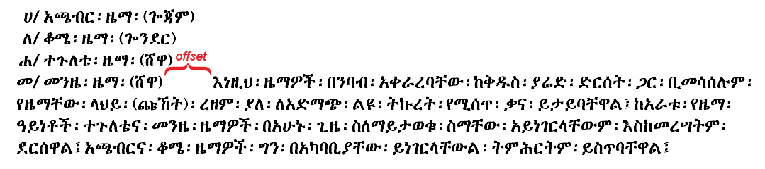*Sample for in-lined paragraph continuation at end of list.*

**Survey Questions:**

1. Should a paragraph continue directly from the end of a list?  
   ☐ Never ☐ Always ☐ Under special rules or context (Please Explain): ________________________________________________________________________
2. When appropriate, what is the width of the paragraph offset (if any) from the final list item?  
   ☐ Same as paragraph indentation ☐ No offset ☐ Other (Please Explain): ________________________________________________________________________

## **Initial letter styling** *(W3C Ethiopic Layout Gap Analysis 3.5)*

Word Processors, Web Browsers and eReader software can support “initial letter styling” layout practices used for the writing of many languages. An example is “Drop Cap” commonly used with Latin script:

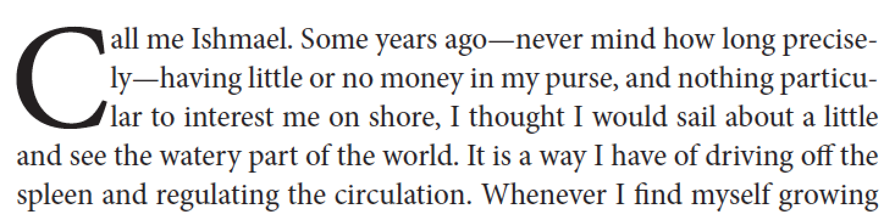

*Sample of a three-line drop cap of the capital letter “C”.*

A number of related styles are also for initial letter styling (e.g. Raised Cap, Sunken Cap, Drop Cap with Runaround).

**Survey Questions:**

1. Are the initial letter styles used for Latin script applicable for Ethiopic?  
   ☐ No opinion ☐ All ☐ Some, the following:  
   ________________________________________________________________________

________________________________________________________________________

1. Are there other initial letter styles required for Ethiopic writing?  
   ☐ No opinion ☐ Yes, please describe:  
   ________________________________________________________________________

________________________________________________________________________

# **Layout & pages**

## **Page numbering, running headers, etc.** *(W3C Ethiopic Layout Gap Analysis 4.4)*

The “Header” and “Footer” section of a book is used to hold information such as the: Author Name, Book Title, Chapter Title, Page Number, and sometimes a decoration symbol. Ethiopic language publishing is believed to follow the same conventions as used in the West. Ethiopic publishing adds the practice of presenting the page number with Ethiopic numerals; a choice that is left to the author’s discretion.

**Survey Questions:**

1. Where in a book is page 1 counted from?  
   ☐ No opinion ☐ Front Cover ☐ First internal page ☐ First printed page  
   ☐ Other (Please Explain):  
   ________________________________________________________________________

________________________________________________________________________

### Page Numbering

In Ethiopic book publishing, the first numbered page will generally be seen on the መቅድም section. When a መቅድም section is not present, numbering is expected to begin at the መግቢያ. The prevailing modern Ethiopic practice is to begin counting pages from the inner cover page (this is a matter of perception, by some views the outer cover is the first page and the inner cover, which is generally empty, is not counted). Thus, the first printed number appearing at either the መቅድም or መግቢያ is not “1” (or “፩”) but the physical page count up to this point (for example “4” or “5”).

**Survey Questions:**

1. Where in a book is page 1 counted from?  
   ☐ No opinion ☐ Front Cover ☐ First internal page ☐ First printed page  
   ☐ Other (Please Explain):  
   ________________________________________________________________________

________________________________________________________________________

1. Where does the first printed page appear?  
   ☐ No opinion ☐ መቅድም ☐ መግቢያ ☐ Other (Please Explain):  
   ________________________________________________________________________

________________________________________________________________________

1. Are there any other special considerations with page numbering? For example, page numbering of appendices, etc. ☐ No opinion

________________________________________________________________________

________________________________________________________________________

### Preface Page Numbering

Increasingly, modern authors and publishers are adding additional front sections and moving “page 1” out to either the መቅድም or መግቢያ. Prior to “page 1” preceding pages may be numbered in one of two ways. In the first convention where pages are numbered with Ethiopic numerals, the preface numbering may be alphabetic in the ሀለሐመ counting system or in the አበገደ sequence (for example in Deste Tekle Wold's “ዐዲስ፡ያማርኛ፡መዝገበ፡ቃላት።”).

In the second convention where pages are numbers with Western numerals, the preface page numbering will apply Ethiopic numerals. Under both conventions the preface page number begins on the first printed page after the cover.

**Survey Questions:**

1. Are the above descriptions accurate?  
   ☐ No opinion ☐ Yes ☐ No ☐ Other (Please Explain):  
   ________________________________________________________________________

________________________________________________________________________

1. Are there any other page numbering conventions that should be supported by software?  
   ☐ No opinion ☐ Yes ☐ No ☐ Other (Please Explain):  
   ________________________________________________________________________

________________________________________________________________________

## **Other page layout & pagination features** *(W3C Ethiopic Layout Gap Analysis 4.5)*

A practice of publishers in the West and elsewhere is to avoid printing the last line of a paragraph at the top of a page. To avoid starting a new page with a single line, one or more addition lines of the paragraph will be moved over from the previous page.

**Survey Questions:**

1. What is the minimal number of lines that can appear at the start of a page?  
   ☐ No opinion ☐ One ☐ Other: ______________ ☐ Other (Please Explain):  
   ________________________________________________________________________

________________________________________________________________________

1. Are there any other page numbering conventions that should be supported by software?  
   ☐ No opinion ☐ Yes ☐ No ☐ Other (Please Explain):  
   ________________________________________________________________________

________________________________________________________________________