CoCoDraw is a user-friendly, high resolution (PMDDE 4) graphics editor. It has the usual LINE, CIRCLE, BOX, etc., functions, plus a full character set (for adding text to pictures), an UNDO command and even a Magnify mode for detailed editing. CoCoDraw requires 32K, Extended BASIC and one joystick (a mouse or touchpad should also work). As listed, it requires a disk drive, but it also works with a cassette system using the modifications listed at the end of this article. A printer is optional.

Type in both listings ( CoCo Draw and MenuGen) exactly as they appear and save them to disk. (Do not add any extra spaces to CoCoDraw, as it hardly fits in the available memory as it is!) Lines 10000 and 12000 to 12080 are the same in both programs, so you do not have to type them in twice.

Run MenuGen first. This program generates a file (MENUS.SYS) which is loaded and used every time CoCoDraw is run. Make sure that each disk with CoCoDraw on it also contains MENUS.SYS. Now run CoCo Draw, and you are ready to start.

When CoCo Draw is run, it initializes itself and asks if you want to use the speed up PDI<E (PDI<E 55495, 0). Move the joystick left or right to select "yes" or "no" and press the button on the joystick when the one wanted is underlined.

The main menu is on the top quarter of the screen. The rest of the screen is the editing area. A little pointer should be blinking somewhere on the screen. In the upper-left section of the menu are 14 boxes, each containing an icon (a little picture symbolizing what it does). These are called tools and are what you use to create the picture.

To the right of the tools are two larger boxes labeled "Color" and "Background." These show the current foreground and background colors (or patterns). Below the tools and colors are four words: File, Size, Mise and Undo. Each of these (except Undo) triggers a pull-down menu that allows you to do things like save, load and print pictures.

The pointer can be moved around the screen using the right joystick. However, because the joystick's resolution is smaller than the screen's, the pointer can only be positioned to the nearest four dots horizontally and three dots vertically. To compensate for this, the arrow keys can be used to move the pointer as many as three dots to the right of the joystick position and two dots below it. This is limited, but with some practice you should be able to place the pointer on any dot on the screen. When part of the pointer is off the right side of the screen, it becomes distorted . When this happens, the upper-left corner of the distortion is the current point.

To select a command from the main menu, simply position the tip of the pointer over the desired option and press the joystick button.

The Tools
When a tool is selected, its icon changes colors to let you know what you are working with. Here is how to use each tool:

Draw (pencil with point down) - Leaves a line after the pointer when the button is held down.

Erase (pencil with eraser down) - When this is selected, the pointer changes to a block eight by eight dots in size. Whenever the button is pressed, the area behind the block changes to the background color. The eraser can be made smaller using the Size pull-down menu. More on that later.

Box (the empty square) - Move the pointer to one corner of the box, then press and hold the button down while moving the opposite corner of the box. When you like it, release the button.

Circle - Position the pointer where you want the center of the circle to be, then hold. the button down while adjusting the radius. To adjust the radius, put the joystick in the center vertically and move it left or right to roughly get the radius. Now, keeping the joystick at the same place horizontally, move it up or down to make fine adjustments. Release the button when you have the desired radius.

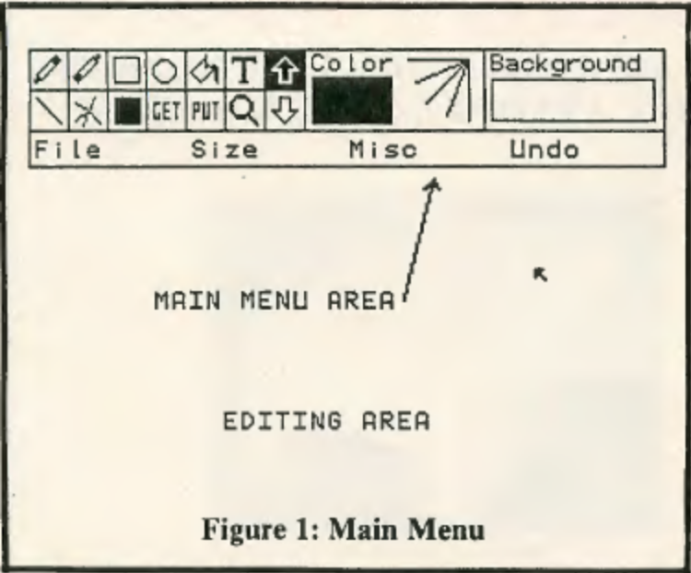

Paint (a paint can pouring paint) - Move the pointer to where you want to pour the paint and click the button. You can fill in either black or green areas.

Text (a capital T') - Move the pointer to where you want the first character to be and click th.e button. A blinking cursor appears and y.ou may type any letter (upper- or lowercase), number or symbol on the keyboard. Press ENTER to exit this mode. The foreground color should be a solid color (not a pattern) while typing because anything else will be unreadable.

Line - Move the pointer to one end of the line, then hold the button down while moving the other end. Release the button when you like it.

Ray (several lines coming from the same point) - Move the pointer to the center point and click the button (do not hold it down). Move the end of the first ray to where you want it and click again. Do the same for as many rays as you want, but when doing the last one, hold the button down until you hear beeping (about two seconds). Now yo·u can start another set of rays or select another option.

Solid Box (the solid square) - This works the same as Box, but when done, the box becomes solid.

Get - This is used to get an area of the screen (up to 64 by 64 dots) to be used later with PUT. Move the pointer to the upper-left corner of the area to be gotten, then press and hold the button down. Now move the bottom right corner until' you have the size you want, and release the button.

Put - This puts what you got using GET. Move the block that you got around the screen, and whenever you press the button it will be put there. You can hold the button down while moving the joystick for some interesting results. There are five PUT modes to choose from: Set, Reset, And , Or and Not. Set puts it exactly as it was gotten; Reset reverses the original colors; And puts it without erasing
what is already there; Or puts it, showing what was gotten only where there is something under it. (And and Or are reversed when
using green or buff on black .) Not reverses the colors in an area the same size as the area that was gotten. What was in the area that was gotten has no effect on this mode. How to change the PUT Mode will be described later.

Magnify (a magnifying glass) - When this option is selected, a 16-by-16 dot box appears, replacing the pointer. Move this box over the area you want magnified, then click the button. A new screen appears showing the area selected magnified eight times. To make changes to the original, move the pointer over the magnified dot you want to change and click the button. Its color will be inversed, as well as the corresponding dot in the Now box, to see how the cltange looks in actual size. If you make some changes, but then decide you liked the original better, move the pointer over the box marked Cancel, click, and the screen will be changed back to the original. When satisfied with your changes, move the pointer over the box marked Done and click. This will take you back to the main menu with the change made.

Up Arrow - Actually, the editing area you see is just 75 percent of the entire picture. By clicking the Up Arrow you see the top 75 percent of the picture. Down Arrow - Shows the bottom 75 percent of the picture.

Color - In the Color box is a block showing the current color, as well a little design to show how it will look when used on diagonal lines. To change color, move the pointer anywhere in the Color box and click. A new screen appears with a selection of 256 colors and patterns. To select a color, move the flashing box over the color wanted and click. If you would rather leave the color the way it was, press the space bar (even while the screen is being drawn) and you will return to the main menu.

Background - Works the same as Color, but changes the background color, which is used when erasing and when clearing the screen.

Pull-Down Menus
To use the pull-down menus, move the pointer over the word File, Size, or Misc and hold the button down. Another menu appears below it. Move the joystick up and down until the selection you want is highlighted, then let the button up.

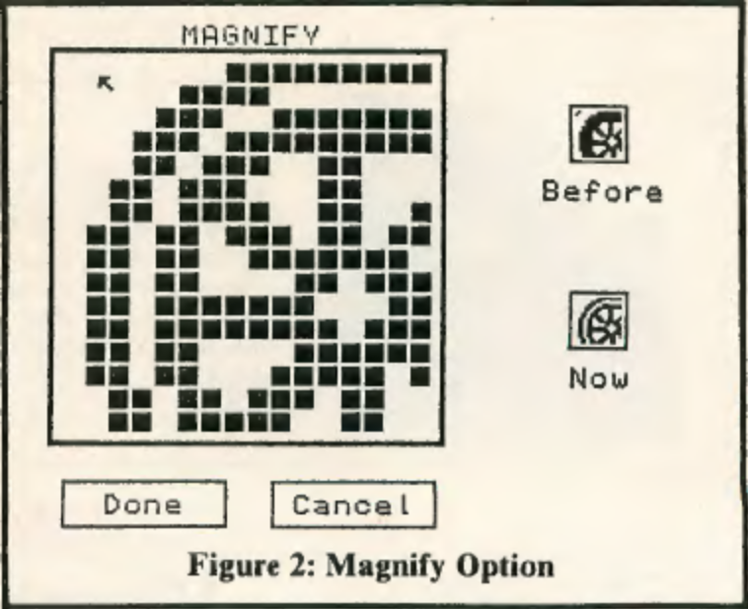

The File menu includes the following:

Disk Load/ Save - You are asked for a filename, and then asked if it is OK. If not, you return to the main menu. No error trapping is used in the disk I/O, so if you get some type of error,just type GOTO 700 and press ENTER to return to the main menu.

Disk Dir - You are asked for the drive number, and the directory of the disk in that drive is shown. Press the SHIFT and '@' keys together to pause the display, and click the joystick button to return to the main menu.

Tape Load / Save - Same as disk. When saving, make sure the tape recorder is set to Record before saving because recording starts right away.

Screen Dump - I have included a routine that does a double-size screen dump to the Epson RX-80. Make sure the printer is online and the proper Baud rate has been set before saying the printer is ready.

The Size menu is used to change the eraser size. Just select the size you want (8 by 8, 4 by 4, or l by 1) and click.

The Mise menu includes:
Clear Screen - "Clears the screen, but only the editing area being seen. To clear the whole picture, you must clear the top 75 percent, click the Down Arrow, and clear the bottom 75 percent.

Show Picture - This shows the whole picture at one time. Click again to get back to the main menu.

Color Set - Toggles the color set between green / black and buff/ black. Use buff to get artifact colors. Green is the default.

Put Modes -Used to change the PUT mode.

Undo has no menu, it simply undoes the last operation.

If It Doesn't Work
If parts of the main menu or pulldown menus are messed up, the problem is probably in the MenuGen program. Try proofreading the part of MenuGen corresponding to the menu where the problem is. Any other problems are most likely in CoCo Draw. Look up the section that joesn't work in the line-by-line description and proofread those lines.

How it works
CoCoDraw uses all eight graphics pages . Pages one to four hold the actual picture, Page five is the main menu, and pages six to eight are the editing area. When CoCoDraw is run, it first initialzes itself by defining the variables, loading the screen containing main menu and the pull-down menus (MENUS.SYS) and getting them into arrays. Then it PCOPYs from the picture to the editing area, puts the main menu on the screen, and goes to a subroutine starting at Line 9000 which allows you to move the pointer around using the joystick until you click the button.

Next, in lines 740 to 780 it checks to see if you were in the menu area when you clicked , and if so, it branches to the routine selected. That routine then lakes control until another option is selected from the main menu. The program is very structured , so it should not be too difficult to follow. Here is a list of the major subroutines and how they are used:

8000 - Copies pages one to three to the editing area if PN= I or pages two to four to the editing area if PN=2. Used in Undo and in most of the tools, such as in Line to erase the line you are making as you move it around . Also used to erase a pull-down menu and several other places as well.

8200 - Copies the editing area to pages one to three if PN= l or to pages two to four if PN=2. Opposite of 8000.

8500 - Puts the main menu on the screen and fills in the Color and Background boxes.

8800 - This is the routine that allows you to select an option from a pulldown menu. Returns when you click the button. You must give it 'N' (the number location of the pointer when the button was clicked. It gets 'X' using JOYSTK(0)*4+XO. (XO is used to allow more detailed movement using the arrow keys on the keyboard.) Y=JOYSTK(I)*3YO.

9200 - Checks the location of the joystick and the status of the button and returns immediately only if the position is in the editing area. If the position is in the main menu, it draws the pointer until you press the button or move into the editing area. If you press the button ,it goes to Line 740 which checks what was selected and branches to it. If you move into the editing area; it returns.
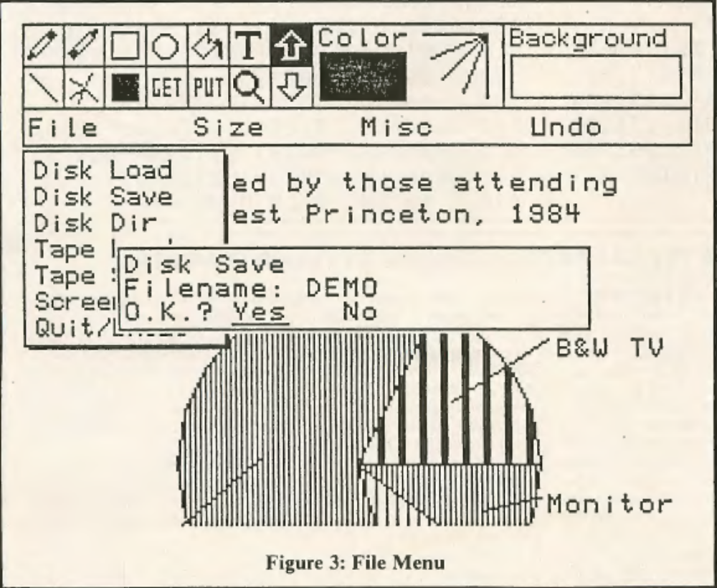

9400 - Checks the location of the joystick and the status of the button. Returns immediately. Gives you 'X' and 'Y' (the screen location of the joystick), and 'FB', which equals 254 (&HFE) if the button is pressed .

9500 - Used by 9400. Checks which arrow key is pressed and changes XO (X-offset) and YO (Y-offset) accordingly. Returns immediately.

9800 - Prints Yes and No on the screen starting at location 'X,Y' and lets you use the joystick to select one. Returns when button is pressed . If A< 32 then the answer is yes .

10000 - Draws S$ starting at the current DRAW location, where S$ equals any string of text you want printed on the graphics screen. It can also use the variable EX$. EX$ equals any DRAW string you want. inserted between each character. It is used in this program as BLI to put less space between each character. Under normal use , EX$ equals the null string(" ").

11000 - This is the input routine used in entering the filename for saving and loading and for adding text to your picture. You give it 'X' and 'Y', the screen location to start at; LE, the maximum length of the string to be input; and KE$, which limits which keys will be accepted. If you want all keys to be accepted, make KE$ equal to" ALL." If you want just 'Y' and 'N' allowed, make KE$ equal to "YyNn." It gives you IN$, the string that was input. Returns when ENTER is pressed.

See Table I for a line-by-line description and a variable list.

Modifications
To make this program work on a nondisk system:

A. Change Line I 000 to:
1000 GOSUB8200:PUT(0,48)-(79,123),FI:XX=0:N=5:GOSUB8800:POKE55494,0:IFS=7THEN1900ELSEIF S<4THEN/00
B. Change Line II 00 to:
1100 CSAVEMFI$,1535,7579,44539
C. Delete Line 20
D. Take lines 40 to 520 from MenuGen and insert them into CoCoDraw. (You can do this because you have about 2K more memory than disk systems.)
E. To use, just CLDAD and run.

If you do not have a printer, add GOTO 700: REM. to Line 1690. If you want to use another screen dump routine, delete lines 8, 1700, 1710 and 13000, and put your routine in lines 1700 to 1899. Remember to add a GOTD 700 at the end of the routine so the program will return to the main menu when the printing is done. Check back issues of THE RAINBOW for screen dump programs for other printers.

If you have any questions or comments about CoCoDraw, I would like to hear from you at
Rt. #2, Box 223
Ephrata, PA 17522.
Please include an SASE if you want a return reply.

TABLE 1: Line Description of CoCoDraw

Initialization
1-3 Clear eight graphics pages; print title screen; (the apparently unnecessary GDTOs here are to get around the PCLEAR bug in older versions of Extended BASIC)
5 Dimensions and defines variables (see variables list)
8 Reads data for the screen dump routine
10 Sets graphics mode; clears screen
20 Loads screen containing the menus
600 Gets the menus into arrays

Check for Selection From Main Menu
700 Copies picture to editing area
710 Puts Main Menu; switches to graphics screen
720 Asks if you want to use the speed-up POKE
730-780 Read joystick; check which option was selected from main menu and branch to that routine

Pull-Down Menu Routines
1000-1900 File Menu routines
2000-2010 Size Menu routine
2500-2560 Mise Menu routine
3000 Undo routine
(1700-1710 Screen dump routine)

Color and Background
3500 Draws color selection screen
3510-3530 Select color I pattern using joystick

Tools
4000 Draw
4200 Erase
4400 Box and Box Fill
4600 Circle
4800 Paint
5000 Text
5200 Up Arrow
5400 Line
5600 Ray
5800 GET
6000 PUT
6200 Magnify
6400 Down Arrow

Subroutines
8000 Copies from picture to editing area
8200 Copies from editing area to picture
8500 Puts main menu and fills in colors in main menu
8800 Selects item from pull-down menus
9000 Draws pointer and waits for you to press the button
9200 Like 9400 unless you're in the main menu (see article)
9400 Reads joystick and returns
9500 Checks which arrow key was pressed
9800 Selects Yes or No using the joystick
10000 Prints a text string on the graphics screen
11000 Inputs a text string from the keyboard

Data for Character Set (in ASCII Order)
12000 'space' to'-'
12010 '.'to '9'
12020 ':'to'@'
12030 'A' to 'M'
12040 'N' to ·z·
12050 ASCII 91 to ASCII 96
12060 'a' to 'k'
12070 'I' to 'w'
12080 'x' to 'z'
13000 Data for screen dump routine

Variables

Numeric
CS = Color set
FC = Foreground color
BC = Background color
ES = Eraser size I
PM = PUT Mode
P = Used to copy pages, POKE value, etc.
LE = Max length of input
PN = Page number
FB = Firebutton status
X,Y,XX,YY,XI,Yl=scrn. loc.
S Menu selection
A = Misc. variable
N Number of options in .pull-down menu

String
S$ = String to be printed in print routine (10000)
SP$ = 'Y' if speed-up poke is allowed and 'N' if not
EX$ = Used as an extension to print routine (see article)
I$ = lnkey$
IN$ = String that was typed in input routine (11000)
FI$ = Filename

Arrays
ME = Main Menu (GP) (GP = GET /PUT array)
FI = File Menu (GP)
SI = Size Menu (GP)
MI = Mise Menu (GP)
GP = GET and PUT (GP)
AR = Pointer (GP)
A = Misc. Array (GP) (Used mainly in joystick input routine)
CH$ = Draws strings for character set
D = Used in screen dump routine

