WiFi Universal Remote
V0.4

Introduction
The WiFi Universal Remote provides a means to replace multiple handheld infrared remote controls with a web page that can be accessed from a mobile phone or tablet on the same WiFi network as the control device.
The control device is a small box that is plugged in and points at the systems to be controlled.
The web page presents a set of buttons that can each implement any series of control codes sent by the handheld remote controls with optional intervening pauses. The buttons are programmed by the user in a setup procedure. There can be a hierarchy of control pages so you can, for example, have a simple control page for the most used operations and then detail pages that implement operations that are used less frequently.
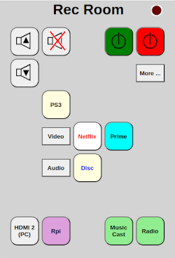
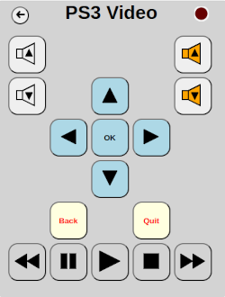
To operate, you simply tap the buttons (or click with the left mouse button on a computer). Some commands can also be sent repetitively by holding the button down. Holding down a button that is not defined as being repeatable will have no effect.
The indicator at the top right of the page turns bright red when a command is being executed. The LED on the control box also lights when commands are being sent. If a new command is attempted while a previous one is in progress, the ring around the indicator turns orange and the new command is ignored.

If not the “home” page, a return button is added to the top left of the page.

Navigation
During normal use the navigation is managed by the button definitions. A button click can, in addition to sending commands via the IR output, redirect to another page in the remote or to a separate web page.
For special purposes such as defining the remote pages and menus, configuring WiFi, backup, etc. you can double tap the title of a remote page to open the navigation menu:
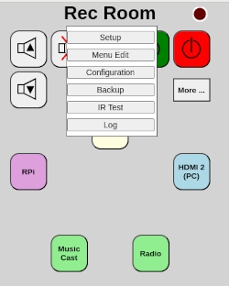
The options on this menu are:
- Setup Edit the current remote page
- Menu Edit Edit a menu definition
- Configuration Set up WiFi and other options
- Backup Save and restore remote definitions to external files
- IR Test Test send of IR commands
- Log View the program’s log file
These options are described in more detail in the following sections.

Configuration (WiFi Setup)
The first action to be taken is to connect the control box to your local WiFi network. When no setup exists, the device goes immediately into WiFi setup mode. This mode is indicated by the LED on the control box flashing on and off once per second (when no WiFi defined, the fast flash will be mixed with the one second flash). It can also be put into setup mode for 30 minutes by clicking the push button inside the box.
When in setup mode, the device acts as its own WiFi access point (router) so that you can connect to it from a web browser at a known address to set up the connection to your normal router. This is done using the following procedure (phone is used in the procedure but you can use any device with a browser):
- On your phone, open the WiFi connections settings display.
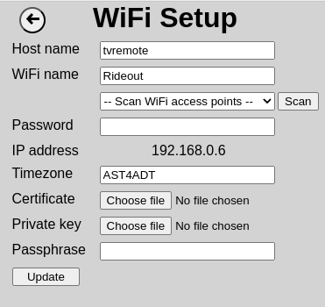
- Find an available network named “wifiremote” and connect to it. The password is “12345678”. The network will have no internet connection so accept any requests to connect (“only this time” option can be used if desired)
- In a browser, enter the URL http://192.168.4.1/config
- The WiFi Setup page should appear
- Type the name you want to give the device in the “Host name” field (e.g. “tvremote”). This will be the name the device will be known by on your network. It must be distinct from any computer or phone name connected to your WiFi router.
- Type the name of your WiFi network into the “WiFi name field. Alternatively, you can press the “Scan” button and select the network from the list that appears below the WiFi name field.
- Type the WiFi password into the “Password” field. The “Show” button can be used to make the typed characters visible if desired.
- Enter the abbreviation for your time zone (e.g. AST4ADT for Atlantic time – 4 hours west of UTC with daylight saving time observed)
- If you are going to use https to connect to the remote, you can set up the X.509 certificate, private key and key passphrase. Normally, you would get the WiFi connection established and return to this page later to define the certificate.
- Press the “Update” button.
- If a value appears next to “IP address”, write it down to be used later to connect to the device. You are now successfully connected to your WiFi. NOTE: There can be issues with losing the connection when the new WiFi is connected. If the IP address does not appear, wait for the connection on your phone or computer to show as connected and refresh the page.
- Reconnect your phone to the normal WiFi network.
- In your browser enter the URL http://<hostname>.local where <hostname> is the name you assigned in step 5 (e.g. http://tvremote.local). If this results in a “Page not found” error being shown, enter the URL http://<ip address from step 9> where the address is that recorded from step 9. For example http://192.168.0.21.
- The initial blank control page should appear with a title of “New Remote” if no previous setup was performed.
Once connected to the home WiFi network, the controller will attempt to make itself known as <hostname>.local on your network as in step 11 above. If another computer or device on the network has the same host name, this unit will not use it’s name in this way.
If the https certificates are defined, the program will only accept https connections except when the WiFi configuration mode is enabled. When in setup mode it will always accept http connections.

Remote Control Setup
To define the buttons and labels on the remote control’s pages you go to the page you want to edit, double tap the title bar and choose Setup from the navigation menu.. This will open the setup page for the current page:
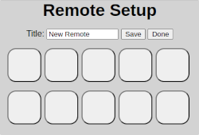
The setup page allows you to set the title that will appear at the top of the page and has rows of buttons that you can define to control your systems. There will always be at least one row of blank buttons at the bottom of the screen.
To define the title, simply type the desired text into the “Title” field.
To save changes, click the “Save” button.
When changes have been made, the “Done” button text appears in gray and it will prompt to discard changes before closing the setup page and returning to the control page. If changes have not been made or have been saved the text is black and it closes the page without prompting.
To define the function of a button, click on that button to open its action definition page:
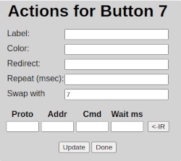
The button numbering starts at the top left as button 1 and increases left to right and then down the page. The fields and buttons are described in the following sections.
Buttons where only the label is defined are presented as text labels on the remote control pages.
If both IR codes and a redirect are defined, the codes are sent first and then the new page is called.
When finished editing the button, click the “Done” button to return to the previous page.

Label
This is the text or icon that will appear on the button. If the label begins with @, it looks for a match on predefined icon names and uses that icon instead of the text. The matching on icon names is not case sensitive. If an icon match is not found, the text following the @ is used. The defined icons are:
@Power Power
@|> Play
@|| Pause
@[] Stop
@<< Rewind
@>> Fast forward
@|<< Back to start
@>>| Skip to end
@^ Up
@v Down
@< Left
@> Right
@PgUp Page Up
@PgDn Page down
@Vol+ Volume up
@Vol- Volume down
@Mute Mute
@Ch+ Channel up
@Ch- Channel down
@Open Close Open / close
If the label field is blank when the “Done” button is clicked, the button action definition is deleted.

Color
This field defines the colors applied to the button. These can use names such as “red”, “blue”, “green” or any of the strings recognized by the browser (see https://www.w3.org/TR/SVG11/types.html#ColorKeywords). You may also define it using RGB color values using the syntax “#rrggbb” where rr, gg and bb represent hexadecimal color intensity values from oo through ff.
There can be up to three colors defined separated by / characters. The first is the background color of the button. The second is the text or icon stroke color. The third is the icon fill color.

Redirect
This is the name of a new page that will be called up when the button is clicked. This name is appended to the URL of the current page. For example, if defining the base page (http://tvremote.local), and the redirect name is “more”, the new URL will be http://tvremote.local/more.
The page is created when the button that redirects to it is clicked for the first time.
Redirects can be nested arbitrarily deep.
The same name can be used on different pages and will be a unique page as long as the complete path is unique.
When references to a page are all blanked out, the page definition is deleted.
If the redirect starts with a slash (/), it is treated as an absolute path within the set of remote pages. Note that the intermediate pages must exist for the redirect to work.
The redirect may also start with “http://” or “https://” to redirect to another web page. The redirect will be done with a target window of “redirect” so that a new tab is opened rather than replacing the remote page.

Repeat (msec)
If specified as a number greater than zero, the button will repeatedly send its IR codes as long as it is held down on the screen. The specified pause of milliseconds will be made between each repetition. This is typically a small number that, if less than the repeat interval defined for the IR protocol will be replaced by that of the protocol.

Swap with
This number is initially set to the button’s position on the page. Entering a new number will swap positions with any button that is at that position. If no button at that button, it is simply moved to the new position. This is useful in rearranging the buttons on the page.

IR Codes
This section defines a list of infrared codes that will be sent by the device to your TV, receiver or other equipment when the button is clicked. The columns of this list are:
Proto The IR protocol used. Recognized protocols are NEC, Sam (Samsung),
Sony12 and Sony15. This can also be a “menu” name (see below)
Addr The address sent in the command or first menu parameter
Cmd The command code or second menu parameter
Wait ms Number of milliseconds to wait after this code is sent before continuing
with the next one.
+ Insert a new blank row above the current one. This button does not appear
on the last line of the list.
<-IR Initiate receiving a code definition from the handheld remote.

To define the codes, you can click the “<-IR” button on the line to be defined. The message “Click button on remote” will appear and the LED indicator on the device will be on steady. Point the handheld remote at the receiver on the device and press the button you wish to use. If recognized, the protocol, address and command fields will be filled in and the LED will go out. If a code is not recognized in 10 seconds, the LED will flash three times and the fields will not be changed.
Note: If you change the label, color or redirect fields you should press “Update” before clicking the + or <-IR buttons to ensure the changes are saved.
You can also manually enter the values in the fields by typing. To find codes that are not available by using the handheld remote, a useful resource is https://github.com/probonopd/irdb/tree/master/codes. On this site, you can choose the manufacturer of your equipment and find codes for their remotes.
Note that the address and command fields accept decimal numbers but you can enter hexadecimal values by preceding them with ‘0x’ (e.g. 0x1a).
You can define as many steps as you need for a button. You may need to specify a wait time after some commands to allow the equipment to respond before sending the next code.
To erase a step, set its Proto field to blank and click the “Update” button.

Menus
Menus provide a means to specify operations typically used for on-screen menus (such as the Sony XMB cross menu bar). The menu definition includes the IR codes to open the menu, move the cursor and select a choice.
To define a menu, you browse to the menu definition page by double tapping the title bar and selecting the Menu Edit option.
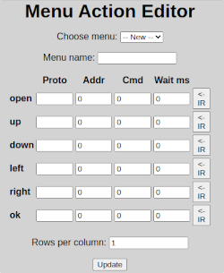
On this page you can chose existing menus or create a new one with the “Choose menu” selection.
You give the menu a name (e.g. “tv”) that will be the name used in the Proto column of the button definitions.
You then define the IR codes for each of the operations of open, up, down, left, right and OK for the controlled equipment such as the TV.
For the cross bar menus, you define the number of rows in each of the menu columns from left to right separated by commas. For example, for a TV with three columns of Settings, TV and External Inputs, you might define this as “0,1,12”. You only need to define the counts for columns you want to navigate in your menus. Those you don’t need can be left at zero.
The menu references are put in the action definitions using the syntax “name.function(option)”.
The “function” portion of the reference is one of:
- set Move the cursor to the column and row specified in the Addr and Cmd columns of the action definition. The process first does the “Open” operation followed by direction functions to get to the desired position and then the “OK” function. It can take an option of “-ok” to skip the OK command at the end of the movement. This is the default function if only the menu name is specified in the Proto column.
- move Move the cursor up or down by the amounts in the Addr column (up is negative, down is positive) and right or left by the amount in the Cmd column (right is positive, left is negative). The Open and OK and functions are not performed. The function will stop and the end of the row or column as defined in the row counts.
- up Shorthand of move command to move up one row
- down Shorthand of move command to move down one row
- left Shorthand of move command to move left one column
- right Shorthand of move command to move left one column
- clear The device keeps track of the last row moved to for each column of the menu. This is used to minimize the number of movements to get to a position. If the position becomes unknown such as on power up or movements not in the menu, this function can be called to reset the memory so that the net move will go to the correct position.
The “Wait (ms)” column defines a number of milliseconds to be waited between each function being issued. The wait in the action definition is done after all commands in the menu execution have been done. These values are adjusted according to the time it takes for the device to respond to the command. These can often be in the 100 to 200 millisecond range.

Test
If you are using a list of IR codes, it is sometimes useful to send them to the device to verify their operation. The /test page (navigation menu IR Test option) provides an easy way to send commands to the device.
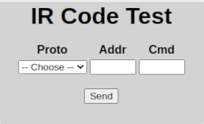
You choose the protocol, type in the address (addr) and command (cmd) and click “Send”.

Backup
To back up the page definitions in the device, you can browse to its “/backup” page (navigation menu Backup option):
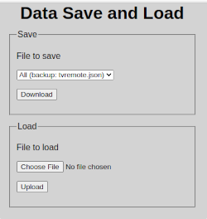
To save all definitions, select “All (backup: <hostname>.json)” under “File to save” and click “Download”. This will download a file named “<hostname>.json” to your computer or phone. The <hostname> part of the file name is the host name set in the WiFi configuration.
To restore the actions to the device, choose the backup file under “File to load” and the click “Upload”
You can also download individual page definitions by selecting their URL under “File to save”. This can be useful to edit an action definition using an editor on the computer. A file is downloaded with its name indicating the page being saved. To upload that file, you choose it under “File to load”.

Log File
The log file is opened by selecting the Log option on the navigation menu.
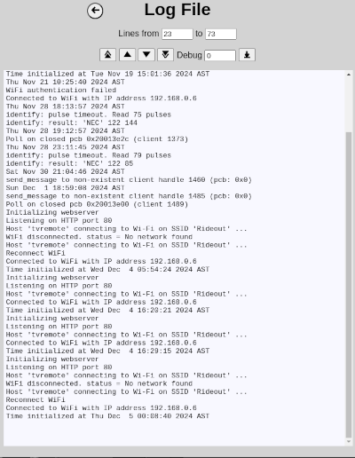
The log contains information about the operation of the program and can be useful in troubleshooting problems. It will contain up to the 2000 most recent lines output by the program. When the 2000 line limit is reached, it is trimmed back to 1500 lines.
The most recent 50 lines are displayed when the page is opened. You can navigate through the log by clicking the arrow buttons (top, up 50, down 50, bottom) or by typing the last line number to be displayed in the “to” field.
The program has debug levels from zero to three which cause successively more detail to be put into the log. Some additional can affect program timing (especially repeated IR options) and except when investigating, the debug level would remain at zero.
The button to the right of the debug level field allows you to download the log file.

CEC Integration
If you want to be able to control an audio system that does not connect to a TV using HDMI using the TV’s remote, you can connect a Raspberry Pi 4 or Pi 5 computer to the TV by HDMI and then use the “tvcec” application to forward CEC (Consumer Electronics Control) commands to the web remote.
This setup is most useful when the TV remote connects via Bluetooth. If the TV remote sends IR signals, you must be careful to avoid simultaneous IR transmission by both the TV remote and web remote. This can be particularly difficult with repeated commands such as volume control.
This interaction is detailed in the following diagram:
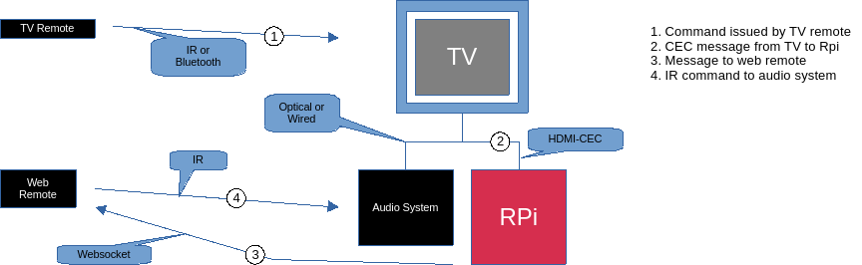
You will need to experiment what is the best connection of the Pi to the TV. In the test case, plugging in to the eARC HDMI port prevented the audio output being sent on the TOSLink optical output. Plugging in to another HDMI port worked except for a warning when the TV is first turned on that the audio system is not connected to the ARC port.

Using TV Remote
The tvcec app sends messages to the web remote to perform button clicks in a special page that is accessed by the /tvadapter page on the web browser (e.g. http://webremote.local/tvadapter). This page should be defined something like:
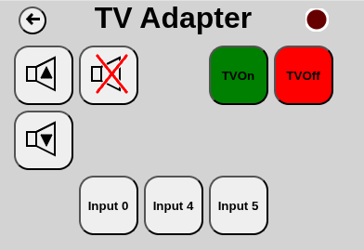
The labels of these buttons are important as they connect the messages from the tvservice app to the action to be performed by the web remote. The labels can have the ‘@’ character prefixed to display an icon as shown for the volume and mute buttons. The labels are:
TVon TV has been powered on
TVOff TV has been powered off
Vol+ Volume has been increased
Vol- Volume has been decreased
Mute Sound muting has been toggled
Input n Select input for device “n” of the CEC devices. 0 used if a number is not found among the buttons so “Input 0” should be defined.

The CEC device numbers are:
- 0 TV
- 1 Recorder 1
- 2 Recorder 2
- 3 Tuner 1
- 4 Playback 1
- 5 Audio system
- 6 Tuner 2
- 7 Tuner 3
- 8 Playback 2
- 9 Recorder 3
- 10 Tuner 4
- 11 Playback 3
You can probably find the known devices in the TV’s setup menus or inspect tvcec’s log file.

Using the Web Remote
You can control devices that accept CEC commands as part of the action for a button on a web remote page. This is done by entering a CEC command code for the protocol and then any additional required information in the address and command fields.
cec::key_click
This command sends a User Control Pressed followed by a User Control Released command to the currently active device. The User Control Code (Operation ID in table below) is entered in the Addr column of the button actions definition.
The CEC User Control Codes are:
(From HDMI Specification CEC Table 27)

Note 1: The elements identified in bold are the only ones which are forwarded as part of the device menu control feature.
Operation id
User Operation

Operation id
User Operation

Operation id

User Operation

0x00
Select

0x35
Display Information

0x55
Initial Configuration
0x01
Up

0x36
Help

0x56 - 0x5F
Reserved
0x02
Down

0x37
Page Up

0x60
Play Function
0x03
Left

0x38
Page Down

0x61
Pause-Play Function
0x04
Right

0x39 - 0x3F
Reserved

0x62
Record Function
0x05
Right-Up

0x40
Power

0x63
Pause-Record Function
0x06
Right-Down

0x41
Volume Up

0x64
Stop Function
0x07
Left-Up

0x42
Volume Down

0x65
Mute Function
0x08
Left-Down

0x43
Mute

0x66
Restore Volume Function
0x09
Root Menu – see Note 2

0x44
Play

0x67
Tune Function
0x0A
Setup Menu

0x45
Stop

0x68
Select Media Function
0x0B
Contents Menu

0x46
Pause

0x69
Select A/V Input Function
0x0C
Favorite Menu

0x47
Record

0x6A
Select Audio Input Function
0x0D
Exit

0x48
Rewind

0x6B
Power Toggle Function
0x0E - 0x1F
Reserved

0x49
Fast forward

0x6C
Power Off Function
0x20 - 0x29
Numbers 0-9

0x4A
Eject

0x6D
Power On Function
0x2A
Dot

0x4B
Forward

0x6E – 0x70
Reserved
0x2B
Enter

0x4C
Backward

0x71
F1 (Blue)
0x2C
Clear

0x4D
Stop-Record

0x72
F2 (Red)
0x2D - 0x2E
Reserved

0x4E
Pause-Record

0x73
F3 (Green)
0x2F
Next Favorite

0x4F
Reserved

0x74
F4 (Yellow)
0x30
Channel Up

0x50
Angle

0x75
F5
0x31
Channel Down

0x51
Sub picture

0x76
Data – see Note 3
0x32
Previous Channel

0x52
Video on Demand

0x77 – 0xFF
Reserved
0x33
Sound Select

0x53
Electronic Program Guide

0x34
Input Select

0x54
Timer Programming

Note 2: This is the initial display that a device shows. It is device-dependent and can be, for example, a contents menu, setup menu, favorite menu or other menu. The actual menu displayed may also depend on the device’s current state.

Note 3: This is used, for example, to enter or leave a digital TV data broadcast application.

