Web Mouse
V0.3

Introduction
The Web Mouse provides a way to use your mobile phone or tablet as a remote mouse and keyboard for a computer. This is useful for an arrangement such as a computer connected to a TV by an HDMI cable for streaming video and you want to control the computer while seated across the room.
The mouse is accessed as a web page through a browser on the phone or tablet using the URL http://webmouse.local. This can be changed using the configuration options described below.
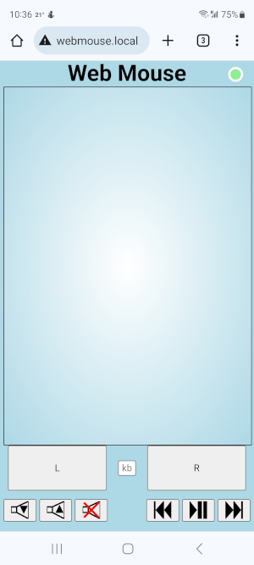
To move the mouse cursor you simply touch one finger inside the rectangle and move it in the direction you want the cursor to go.
To get a mouse wheel action such as for scrolling you touch inside the rectangle with two fingers and move them up or down.
Pressing the buttons labelled L or R sends the mouse button action to the computer. You can hold your finger on a button while moving another finger inside the mouse rectangle to achieve a “press and drag” operation.
The row of audio / visual control buttons at the bottom of the page can be used to send volume control (down, up and mute) or streaming control (previous track, play/pause, next track) commands to the computer. The volume up and down buttons can be held down to continuously change the volume.
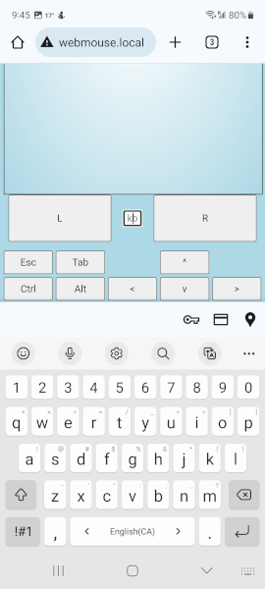
Touching the small “kb” button will open the keyboard. Characters typed are sent to the computer. Above the keyboard there will be additional buttons for keys that do not normally appear on the virtual keyboard of a phone.
The Ctrl and Alt keys will apply to the next key pressed. The label on these keys changes to red when they will apply. Pressing them while the label is red will reset the modifier.
The audio / visual control buttons are hidden while the keyboard is open.

At the top right of the screen there is a coloured circle with a white border. The colour indicates the state of communication as follows:
- red No communication with the device
- blue No Bluetooth connection to the computer
- orange No Wi-Fi connection to a router (communicating directly to device)
- yellow Device has its direct connect access point active
- green All communication is normal

Setup
The device is a small box that should be in the same room as the computer. It is powered from a USB cable that can be plugged into an adapter or a spare port on the computer.
The device has an LED that indicates its connection status and a push button to turn on its setup access mode.
The LED uses a pattern of flashes to indicate its operational state. The pattern is a long on period followed by one or more groups of one, two or three blinks off each separated by a brief on period.
A single blink off indicates that the setup access point is active.
A double blink off indicates that there is no connection to a Wi-Fi router.
A triple blink off indicates there is no Bluetooth connection to a computer.
If none of the above conditions are in effect, the LED is on steady. This indicates the normal operating mode of the device.
To perform the initial setup, press the button to start the setup access point. The single blink off will be included in the LED pattern indicating that it is active. The access point will remain active for 30 minutes after a press of the button.
When the access point is active, the device acts as its own Wi-Fi access point (router) so that you can connect to it from a web browser at a known address to set up the connection to your normal router. This is done using the following procedure (phone is used in the procedure but you can use any device with a browser):

Wi-Fi Setup
- On your phone, open the Wi-Fi connections settings display.
- Find an available network named “webmouse” and connect to it. The password is “12345678”. The network will have no internet connection so accept any requests to connect (“only this time” option can be used if desired)
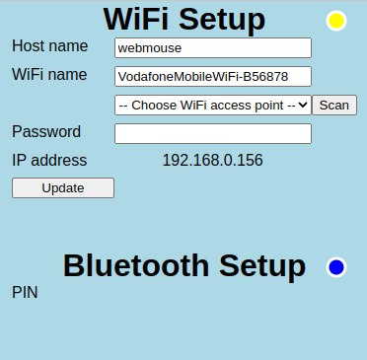
- In a browser, enter the URL http://192.168.4.1/config
- The Setup page should appear
- Type the name you want to give the device in the “Host name” field (e.g. “webmouse”). This will be the name the device will be known by on your network. It must be distinct from any computer or phone name connected to your Wi-Fi router. You would change this name if using more than one of these devices on the same network.
- Type the name of your Wi-Fi network into the “WiFi name field. Alternatively, you can select the network from the list that appears below the WiFi name field. A scan for Wi-Fi access points is performed when the page is initially opened and additional scans can be requested by clicking the “Scan” button. When scans are complete, the box will show the text “-- Choose WiFi access point --”.
- Type the Wi-Fi password into the “Password” field.
- Press the “Update” button.
- If a value appears next to “IP address”, write it down to be used later to connect to the device. You are now successfully connected to your Wi-Fi. NOTE: There can be issues with losing the connection when the new Wi-Fi is connected. If the IP address does not appear, wait for the connection on your phone or computer to show as connected (you may need to reconnect to the webmouse access point) and refresh the page.
- Once the device is connected to your normal Wi-Fi, the double flash will no longer appear in the LED flash pattern. You can reconnect to your normal network and access the device using http://webmouse.local (replace “webmouse” with any other name you entered as the Host name for the device). If your browser does not find the device, you can try using the IP address from step 9 in place of webmouse.local.
The connection indicator next to the section title indicates the Wi-Fi communication state as described above with the exception of the blue Bluetooth indication.

Bluetooth Setup
To allow the device to work as a mouse and keyboard on the computer you need to add it as a Bluetooth device. The following steps describe adding it to a Windows computer.
- Open the configuration web page on the device from a browser using the URL http://webmouse.local/config (will also work while connected to the setup access point as http://192.168.4.1/config)
- In the Devices page of the control panel, choose “Bluetooth & other devices” and then click “Add Bluetooth or other device”
- On the “Add a device” screen choose “Bluetooth”
- On the Add a device screen choose “Web Mouse” (it can take a moment for it to appear)
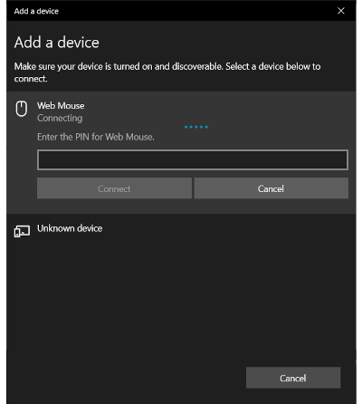
- The connect screen will appear and a 6 digit PIN number will appear next to “PIN” on the browser page.
- Type the number into the indicated field on the computer and click “Connect”.
- If connected successfully, the PIN will disappear from the web page and the triple flash will stop. If this does not happen, delete the mouse from the computer using the control panel (if it is there) and try again.

Some operating systems will pair without the requirement of entering the PIN and will be connected immediately after step 4 above.
The connection indicator next to the section title indicates the Bluetooth communication state as described above with the exception of the orange and yellow Wi-Fi indications.

After Setup
Once the setup of both Wi-Fi and Bluetooth are complete, you can use the web page at http://webmouse.local (or other host name) to control the computer. The connections will be remembered even when the device is unplugged.
If your browser cannot find the device using the name suffixed with “.local” you may be successful using the IP address from the configuration page such as http://192.168.0.156 (see step 9 under Wi-Fi setup). The IP address can change from time to time so the “.local” name is preferred. You can find the new address by pressing the button on the device to start the access point and opening the setup page as described in steps 1 to 3 under Wi-Fi setup.

