RECIPE  
Pad-Thai

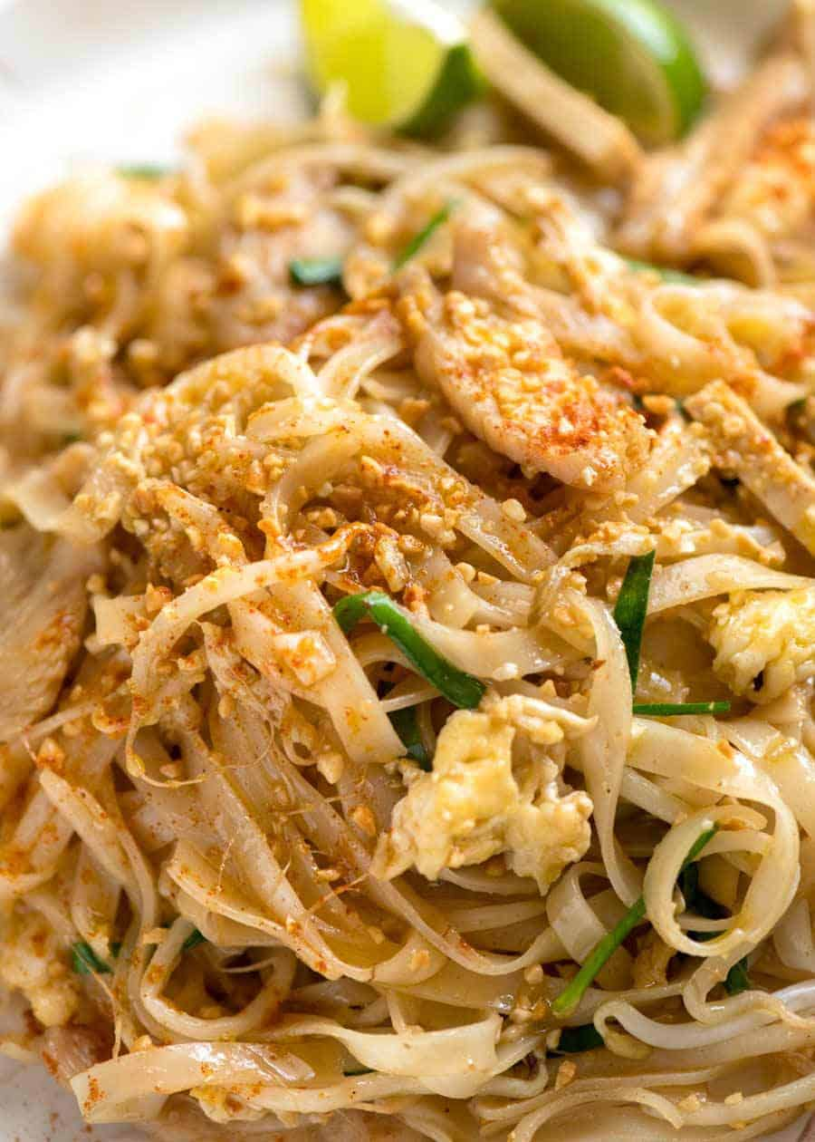

# Ingredients

* 14 oz thin rice noodles
* ⅔ pad thai sauce
* 2 tbsp peanut butter
* 2 tbsp oyster sauce
* 1 tsp garlic
* 1 tbsp new mexico chilli pepper powder
* ½ medium onion diced
* Big bunch of cilantro
* 8 eggs
* 1/2/ bag shrimp
* As many bean sprouts as you want

# Preparation

1. Soak rice noodles for 50 mins
2. Boil shrimp in salty water and set them aside
3. Scramble eggs and set them aside
4. Combine pad thai sauce, peanut butter, oyster sauce, garlic, and new mexico pepper
5. Place noodles and sauce in a very hot wok along with diced onions, mixing until well combined
6. Add in eggs and shrimp
7. Garnish with cilantro and bean sprouts