RECIPE  
Sangria

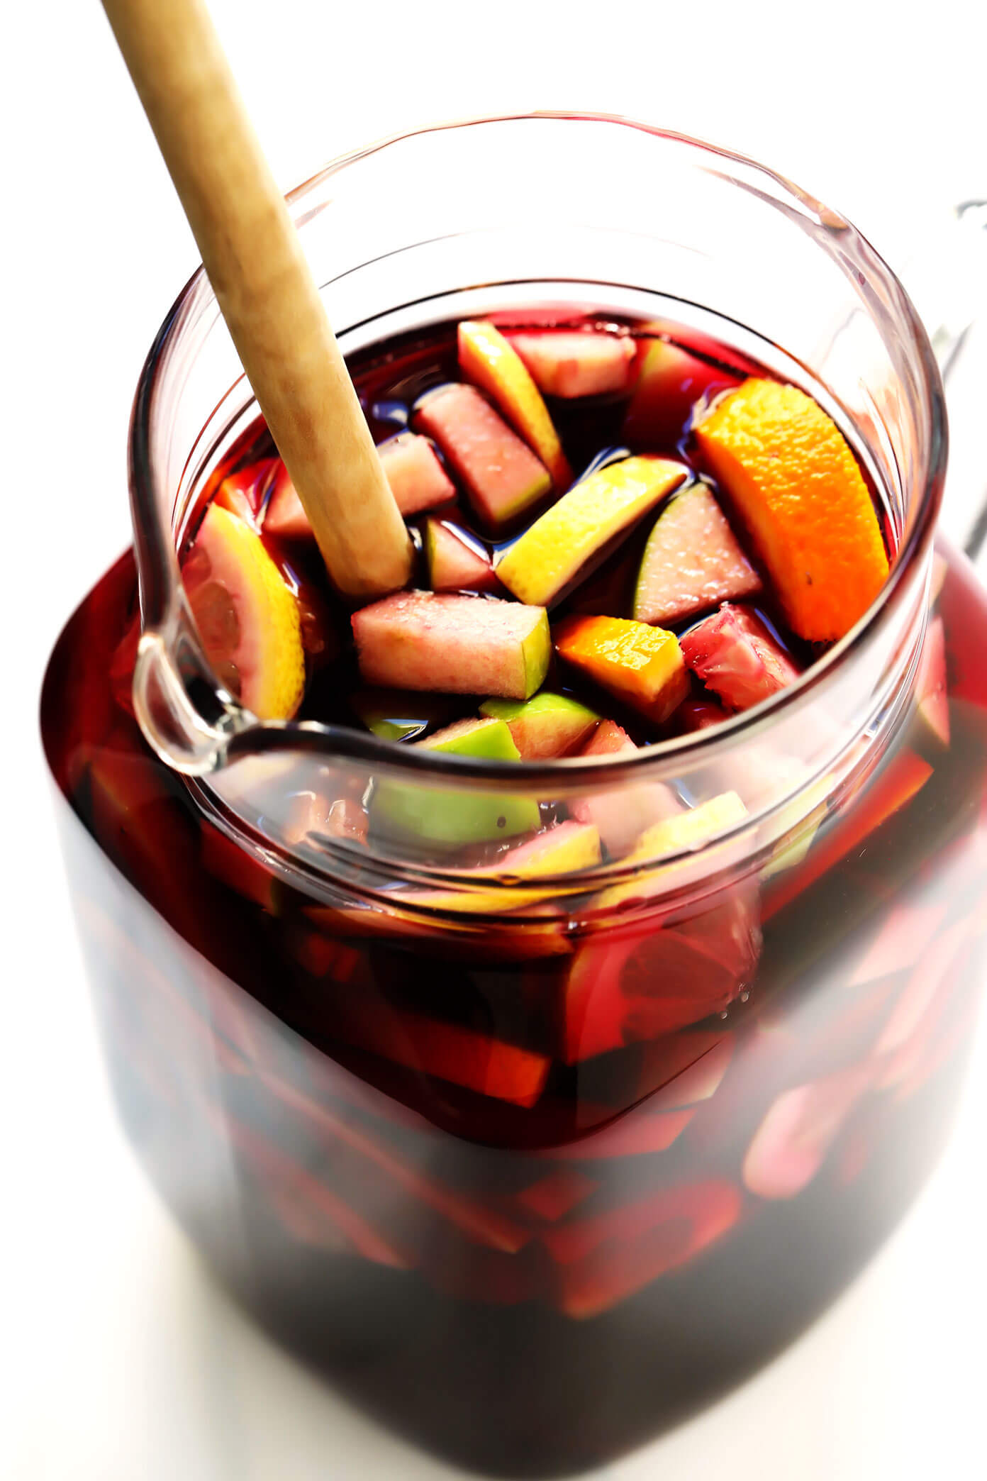

# Ingredients

* 750 ml bottle of red wine
* ½ cup brandy
* 1 cup orange juice
* 1 orange, sliced
* 1-2 apples sliced
* 2 cups mixed berries of choice
* 1 can pineapple chunks with juice
* Sugar/ simple syrup to taste
* Diet 7up, sprite etc

# Preparation

1. In a large pitcher, mix together wine, brandy, orange juice, apples slices, orange slices, mixed berries and can of pineapples and juice
2. Add sugar or simple syrup to taste
3. Allow to chill for 2 hours and then add 7 up when serving. Enjoy!

# Tips

If it isn’t acidic enough (could depend on the oranges) a bit of lemon or lime juice can also be added