**9. ReactJS-HOL**

**App.js:**

import React from 'react';

import ListofPlayers from './ListofPlayers';

import IndianPlayers from './IndianPlayers';

*function* App() {

*const* flag = false;

  return (

    <div className="App">

      <h1>Welcome to Cricket App</h1>

      {flag ? <*ListofPlayers* /> : <*IndianPlayers* />}

    </div>

  );

}

export default App;

**ListofPlayers.js:**

import React from 'react';

*const* ListofPlayers = () *=>* {

*const* players = [

    { name: 'Virat Kohli', score: 100 },

    { name: 'Rohit Sharma', score: 85 },

    { name: 'KL Rahul', score: 60 },

    { name: 'Hardik Pandya', score: 50 },

    { name: 'Shubman Gill', score: 70 },

    { name: 'Ravindra Jadeja', score: 30 },

    { name: 'Jasprit Bumrah', score: 90 },

    { name: 'Mohammed Shami', score: 80 },

    { name: 'Suryakumar Yadav', score: 45 },

    { name: 'Ishan Kishan', score: 65 },

    { name: 'Rishabh Pant', score: 75 }

  ];

*const* filteredPlayers = players.filter(*player* *=>* *player*.score < 70);

  return (

    <div>

      <h2>All Players:</h2>

      <ul>

        {players.map((*player*, *index*) *=>* (

          <li key={*index*}>{*player*.name} - {*player*.score}</li>

        ))}

      </ul>

      <h3>Players with Score less than 70:</h3>

      <ul>

        {filteredPlayers.map((*player*, *index*) *=>* (

          <li key={*index*}>{*player*.name} - {*player*.score}</li>

        ))}

      </ul>

    </div>

  );

};

export default ListofPlayers;

**IndianPlayers.js:**

import React from 'react';

*const* IndianPlayers = () *=>* {

*const* T20Players = ['Rohit Sharma', 'Virat Kohli', 'KL Rahul', 'Suryakumar Yadav', 'Hardik Pandya'];

*const* RanjiPlayers = ['Shreyas Iyer', 'Ruturaj Gaikwad', 'Sarfaraz Khan', 'Prithvi Shaw', 'Mayank Agarwal'];

*const* allPlayers = [...T20Players, ...RanjiPlayers];

*const* oddTeam = allPlayers.filter((*_*, *index*) *=>* *index* % 2 !== 0);

*const* evenTeam = allPlayers.filter((*_*, *index*) *=>* *index* % 2 === 0);

  return (

    <div>

      <h3>Even Team Players:</h3>

      <ul>

        {evenTeam.map((*player*, *index*) *=>* (

          <li key={*index*}>{*player*}</li>))}

      </ul>

      <h3>Odd Team Players:</h3>

      <ul>

        {oddTeam.map((*player*, *index*) *=>* (

          <li key={*index*}>{*player*}</li>

        ))}

      </ul>

      <h2>Merged Indian Players:</h2>

      <ul>

        {allPlayers.map((*player*, *index*) *=>* (

          <li key={*index*}>{*player*}</li> ))}

      </ul>

    </div>

  );};

export default IndianPlayers;

**Outputs:**

When flag is true:

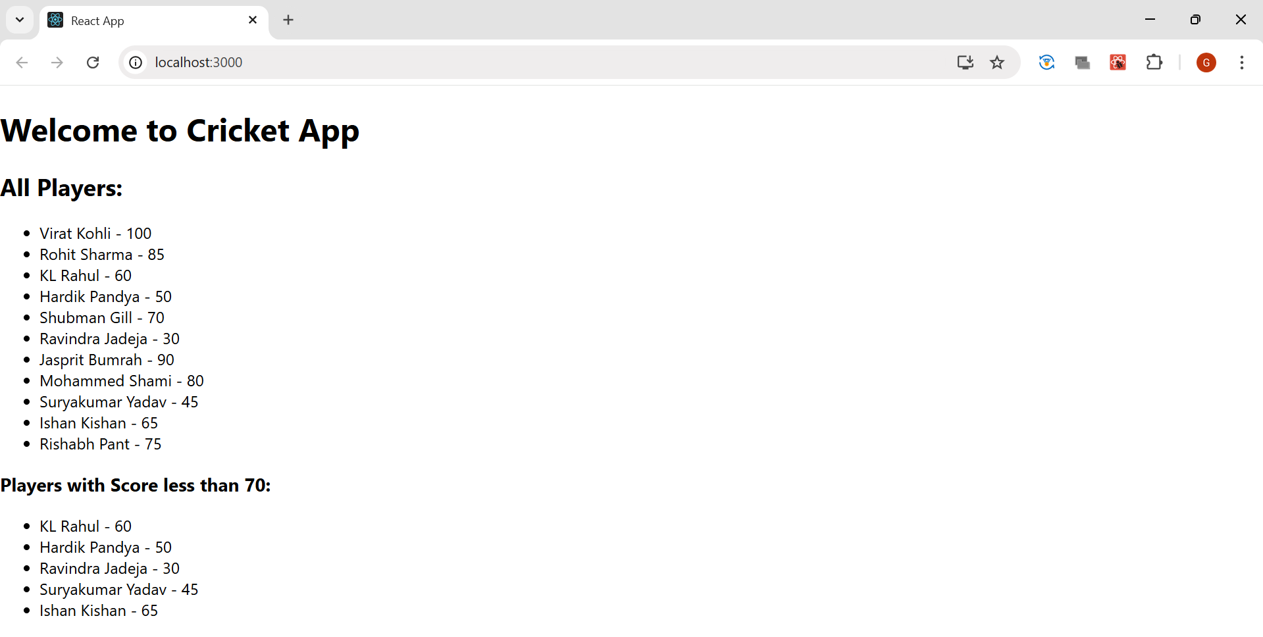

When flag is false:

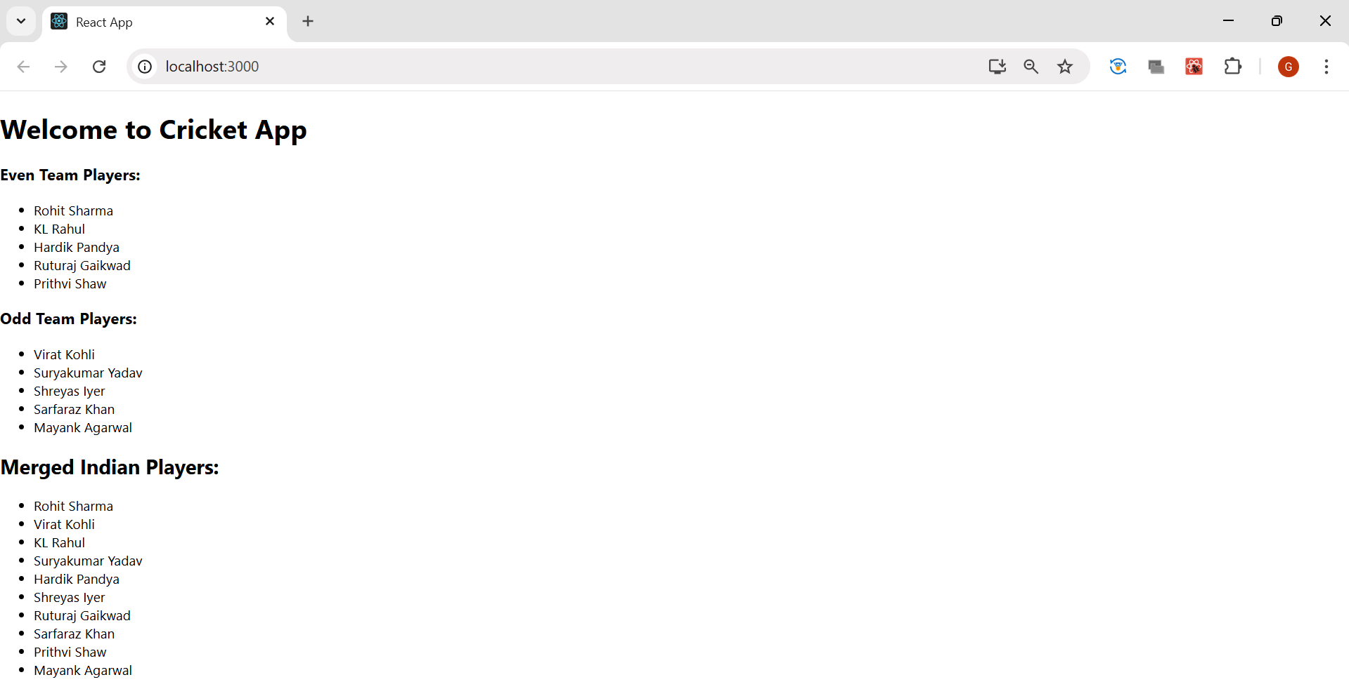

**10. ReactJS-HOL**

**App.js**

import React from 'react';

*function* App() {

*const* heading = <h1>Office Space Rental App</h1>;

  const imageURL = “https://www.google.com/imgres?q=office&imgurl=https%3A%2F%2Fcdn.sanity.io%2Fimages%2Fuqxwe2qj%2Fproduction%2F62db3c671745e98cb27690dff96f8033d2bb7f35-2048x1010.jpg&imgrefurl=https%3A%2F%2Fwework.co.in%2Fblogs%2Ftypes-of-office-spaces%2F&docid=afQofbXAs5NG2M&tbnid=EI1tdONP89xsaM&vet=12ahUKEwj_pqLTuOuOAxWwxzgGHWAUCu0QM3oECBIQAA..i&w=2048&h=1010&hcb=2&ved=2ahUKEwj_pqLTuOuOAxWwxzgGHWAUCu0QM3oECBIQAA”

*const* office = {

    name: "WorkZone Tech Park",

    rent: 55000,

    address: "MG Road, Bangalore"

  };

*const* officeList = [

    { name: "WorkZone Tech Park", rent: 65000, address: "MG Road, Bangalore" },

    { name: "Startup Hub", rent: 52000, address: "Hitech City, Hyderabad" },

    { name: "Corporate Tower", rent: 95000, address: "Gachibowli, Hyderabad" },

    { name: "GreenTech Spaces", rent: 70000, address: "Whitefield, Bangalore" }

  ];

  return (

    <div style={{ textAlign: 'center', fontFamily: 'Arial' }}>

      {heading}

      <img src={imageURL} alt="Office Space" style={{ width: '400px', height: '200px', margin: '20px 0' }} />

      <h2>Single Office Info</h2>

      <p><strong>Name:</strong> {office.name}</p>

      <p><strong>Address:</strong> {office.address}</p>

      <p>

        <strong>Rent:</strong>

        <span style={{ color: office.rent < 60000 ? 'red' : 'green' }}>

          ₹ {office.rent}

        </span>

      </p>

      <h2>All Office Spaces</h2>

      <ul style={{ listStyle: 'none', padding: 0 }}>

        {officeList.map((*off*, *index*) *=>* (

          <li key={*index*} style={{ marginBottom: '20px' }}>

            <p><strong>Name:</strong> {*off*.name}</p>

            <p><strong>Address:</strong> {*off*.address}</p>

            <p>

              <strong>Rent:</strong>

              <span style={{ color: *off*.rent < 60000 ? 'red' : 'green' }}>

                ₹ {*off*.rent}

              </span>

            </p>

            <hr />

          </li>

        ))}

      </ul>

    </div>

  );

}

export default App;

**Output:**

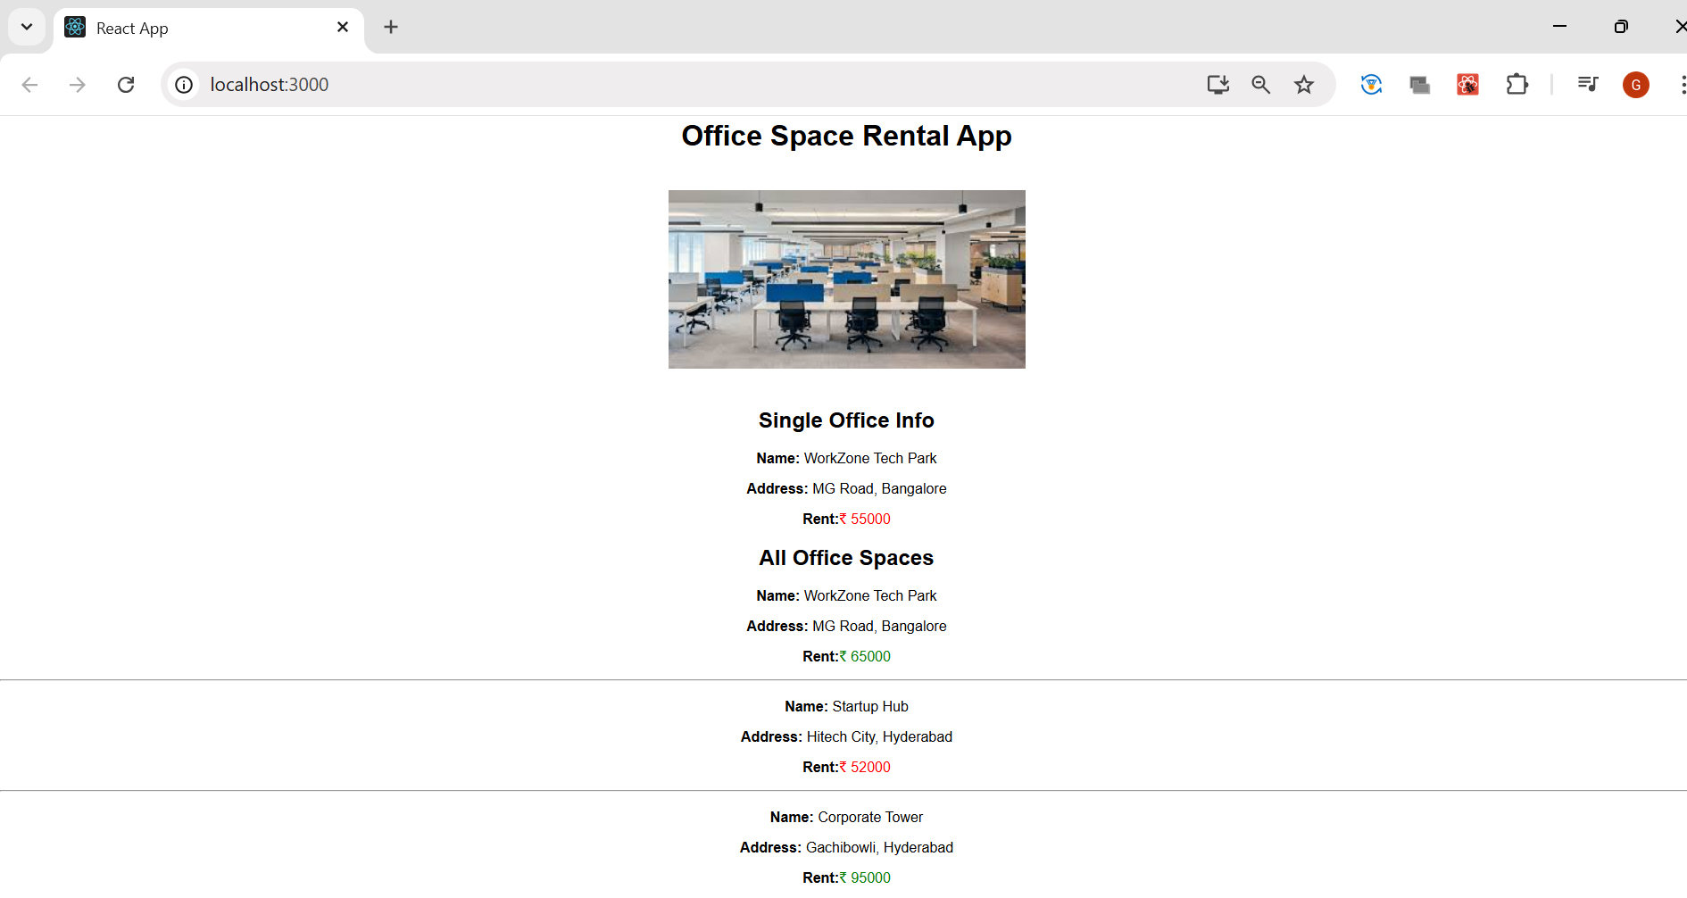

**11. ReactJS-HOL**

import React, { useState } from 'react';

*function* App() {

*const* [count, setCount] = useState(0);

*const* [rupees, setRupees] = useState('');

*const* handleIncrement = () *=>* {

*const* newCount = count + 1;

    setCount(newCount);

    sayHello(newCount);

  };

*const* handleDecrement = () *=>* {

    setCount(count - 1);

  };

*const* sayHello = (*value*) *=>* {

    alert(`Hello! Member ${*value*}`);

  };

*const* sayWelcome = (*msg*) *=>* {

    alert(*msg*);

  };

*const* handleClick = (*e*) *=>* {

    alert("I was clicked!");

    console.log("Synthetic event:", *e*);

  };

*const* handleConvert = () *=>* {

*const* euro = parseFloat(rupees) / 90;

    if (!isNaN(euro)) {

      alert(`Converted euro amount is € ${euro.toFixed(2)}`);

    } else {

      alert("Please enter a valid amount in INR.");

    }

  };

*const* buttonStyle = {

    padding: '10px 18px',

    fontSize: '20px',

    margin: '10px',

    cursor: 'pointer',

    borderRadius: '6px'

  };

  return (

    <div style={{ textAlign: 'center', fontFamily: 'Arial', padding: '20px' }}>

      <h1>React Event Handling App</h1>

      <h2>Counter: {count}</h2>

      <button style={buttonStyle} onClick={handleIncrement}>Increment</button>

      <button style={buttonStyle} onClick={handleDecrement}>Decrement</button>

      <div style={{ marginTop: '20px' }}>

        <button style={buttonStyle} onClick={() *=>* sayWelcome("Welcome!")}>Say Welcome</button>

      </div>

      <div style={{ marginTop: '20px' }}>

        <button style={buttonStyle} onClick={handleClick}>Click Me</button>

      </div>

      <div style={{ marginTop: '40px' }}>

        <h2 style={{ color: 'green' }}>Currency Converter (INR to Euro)</h2>

        <input

          type="number"

          placeholder="Enter INR"

          value={rupees}

          onChange={(*e*) *=>* setRupees(*e*.target.value)}

          style={{ padding: '12px', fontSize: '18px', borderRadius: '4px' }}

        />

        <button style={buttonStyle} onClick={handleConvert}>Convert</button>

      </div>

    </div> );}

export default App;

**Output:**

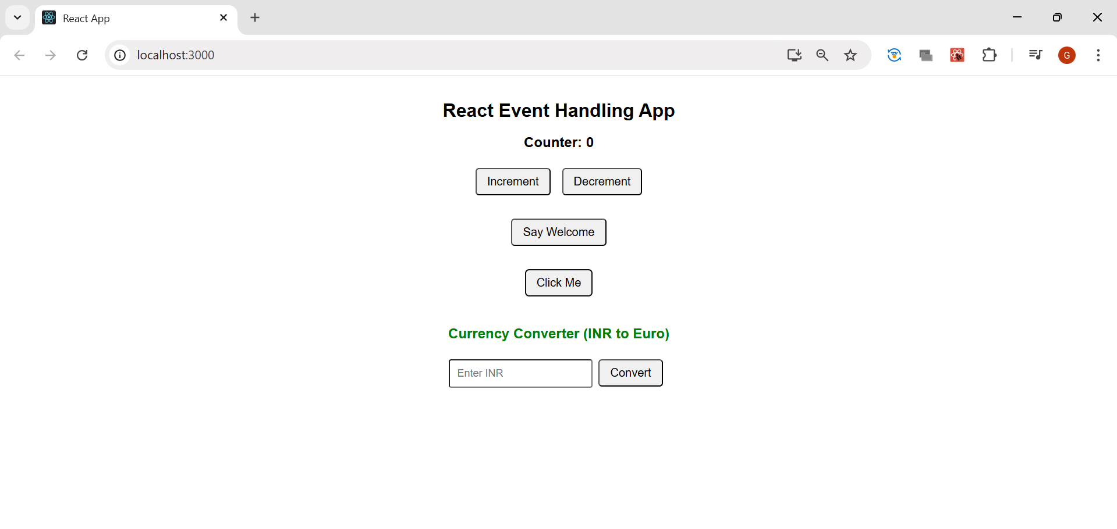

**When clicked on Increment:**

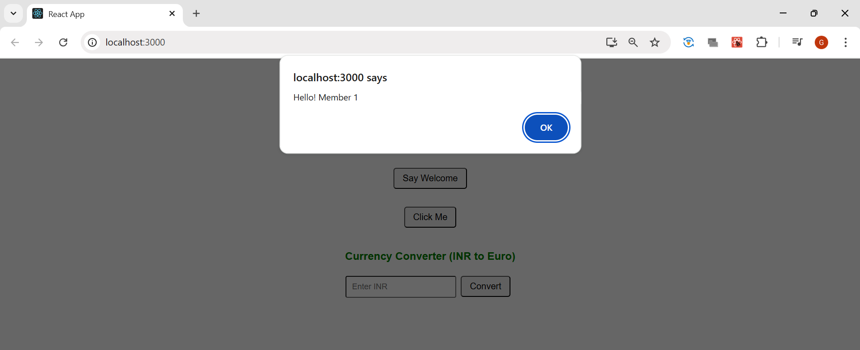

**When clicked on Say Welcome:**

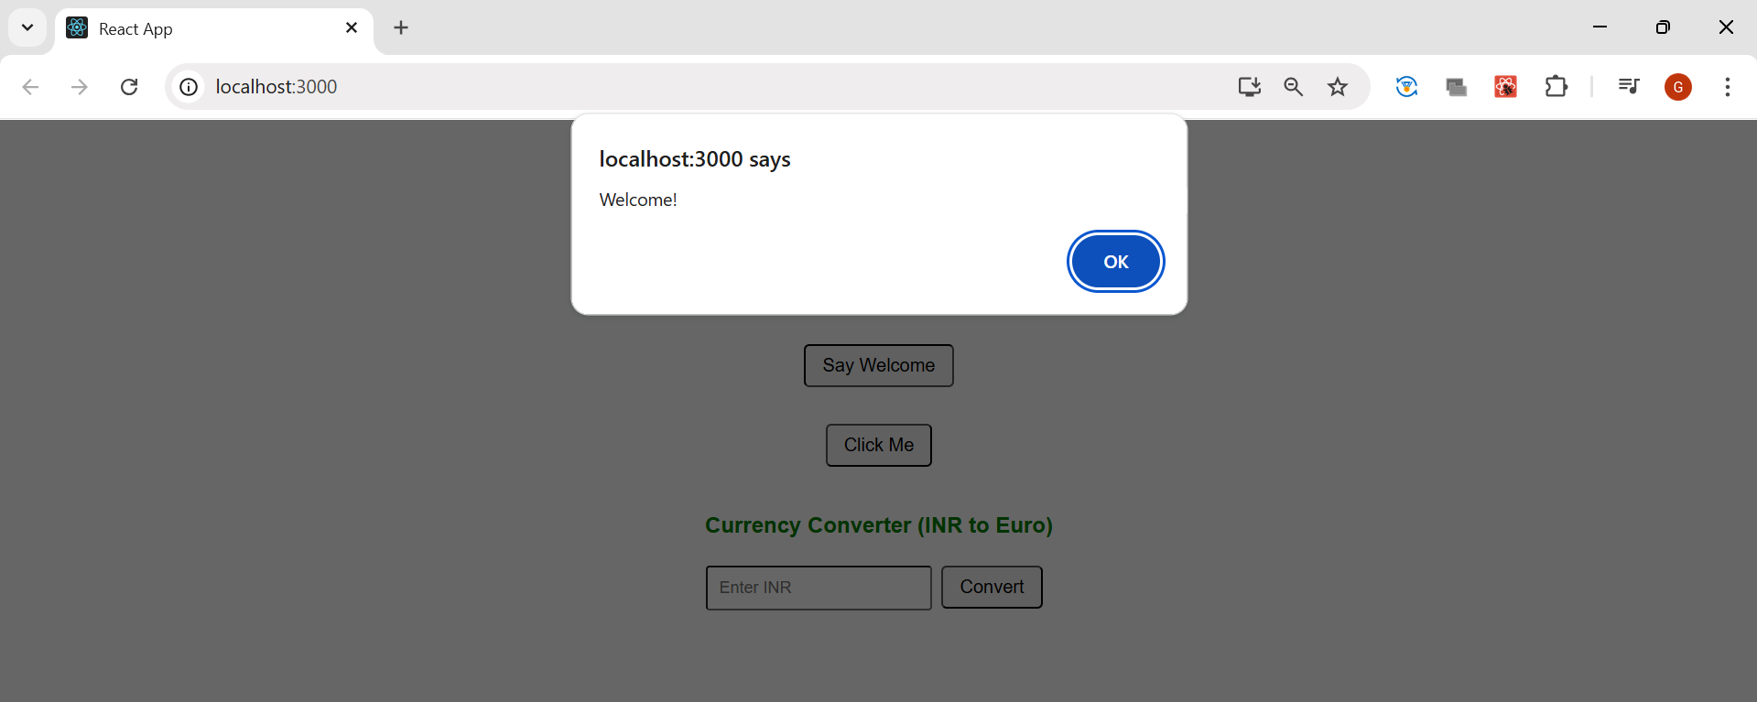

**When clicked on Click Me:**

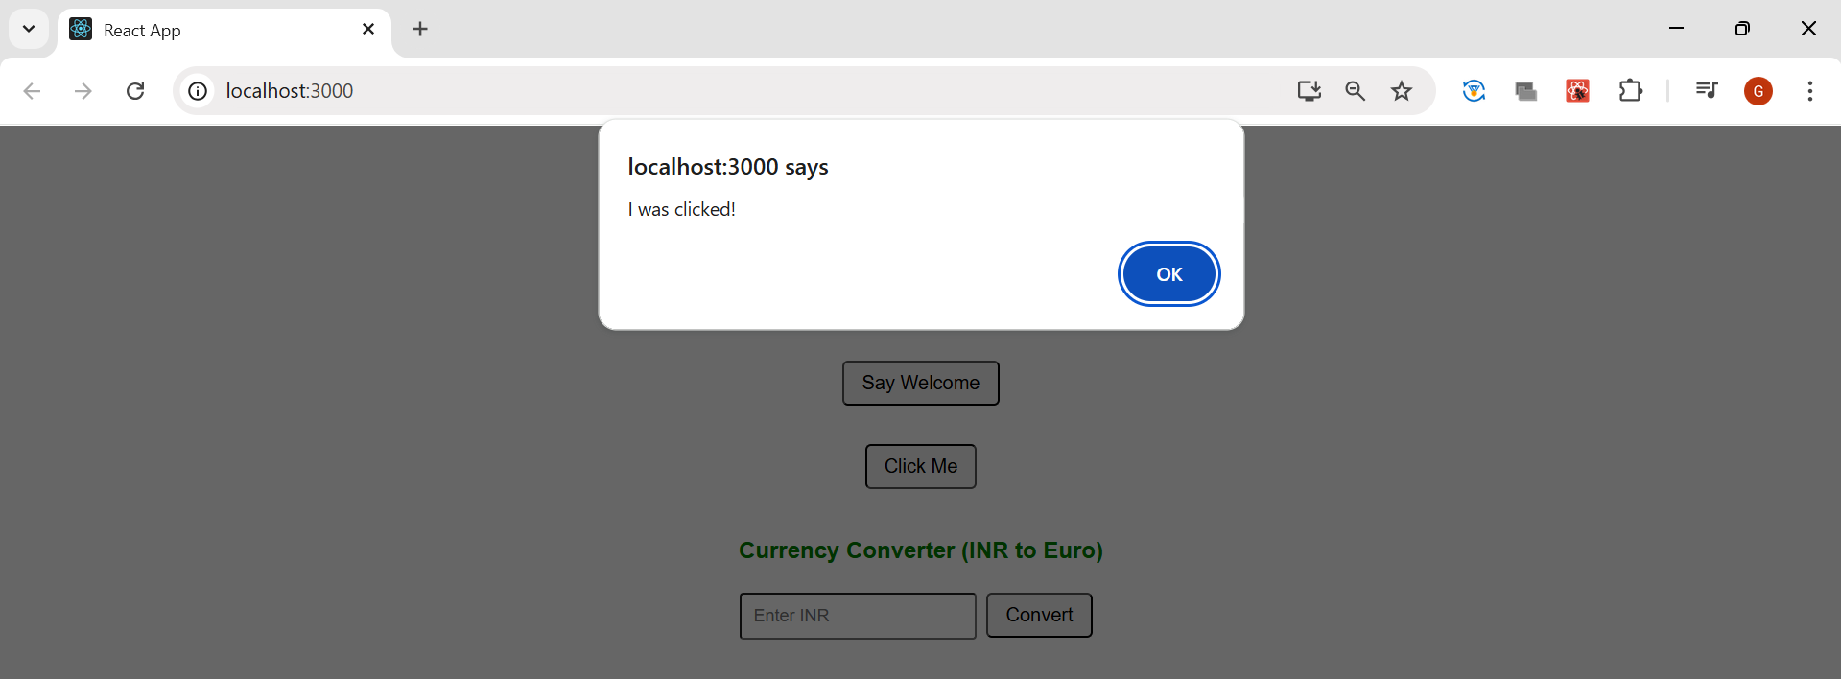

**Converting INR to Euro:**

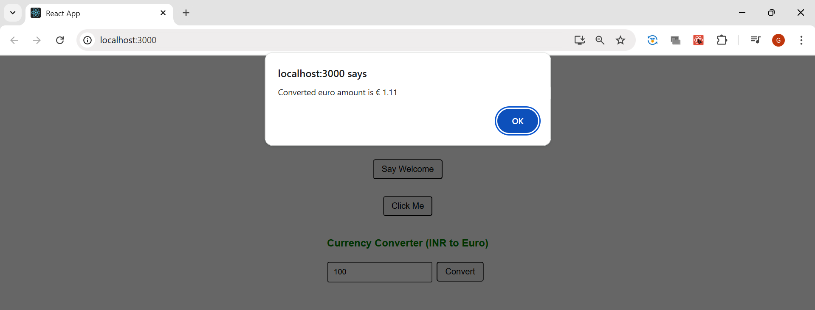

**12. ReactJS-HOL**

**App.js:**

import React, { useState } from 'react';

*function* App() {

*const* [isLoggedIn, setIsLoggedIn] = useState(false);

*const* btnStyle = {

    fontSize: '16px',

    padding: '10px 20px',

    margin: '10px',

    cursor: 'pointer'

  };

*const* flights = [

    { id: 1, airline: 'IndiGo', from: 'Hyderabad', to: 'Bangalore', price: '₹3500' },

    { id: 2, airline: 'Air India', from: 'Chennai', to: 'Delhi', price: '₹4800' },

    { id: 3, airline: 'SpiceJet', from: 'Mumbai', to: 'Kolkata', price: '₹4200' }

  ];

*const* handleLogin = () *=>* {

    setIsLoggedIn(true);

  };

*const* handleLogout = () *=>* {

    setIsLoggedIn(false);

  };

*const* guestView = (

    <div>

      <h2>Welcome Guest!</h2>

      <p>Please login to book tickets.</p>

      <button onClick={handleLogin} style={btnStyle}>Login</button>

    </div>

  );

*const* userView = (

    <div>

      <h2>Welcome Back, User!</h2>

      <p>You can now book your flight tickets below:</p>

      <button onClick={handleLogout} style={btnStyle}>Logout</button>

    </div>

  );

  return (

    <div style={{ textAlign: 'center', fontFamily: 'Arial', padding: '20px' }}>

      <h1>Ticket Booking App</h1>

      {isLoggedIn ? userView : guestView}

      <hr />

      <h2>Available Flights</h2>

      <ul style={{ listStyle: 'none', padding: 0 }}>

        {flights.map(*flight* *=>* (

          <li key={*flight*.id} style={{ marginBottom: '15px' }}>

            <strong>{*flight*.airline}</strong> - {*flight*.from} to {*flight*.to} - <span style={{ color: 'green' }}>{*flight*.price}</span>

            {isLoggedIn && <button style={{ marginLeft: '10px', padding: '5px 10px' }}>Book</button>}

          </li>

        ))}

      </ul>

    </div>

  );

}

export default App;

**Output:**

**When user is not logged in:**

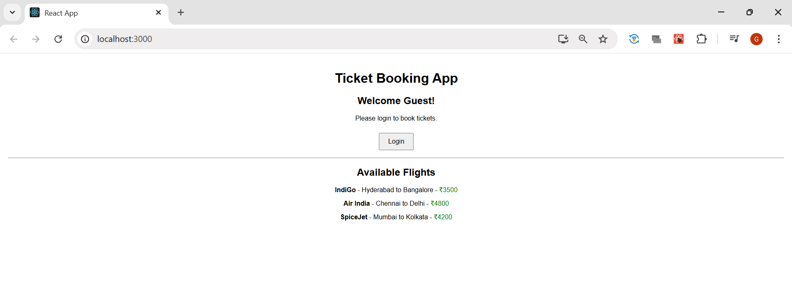

**When user is logged in:**

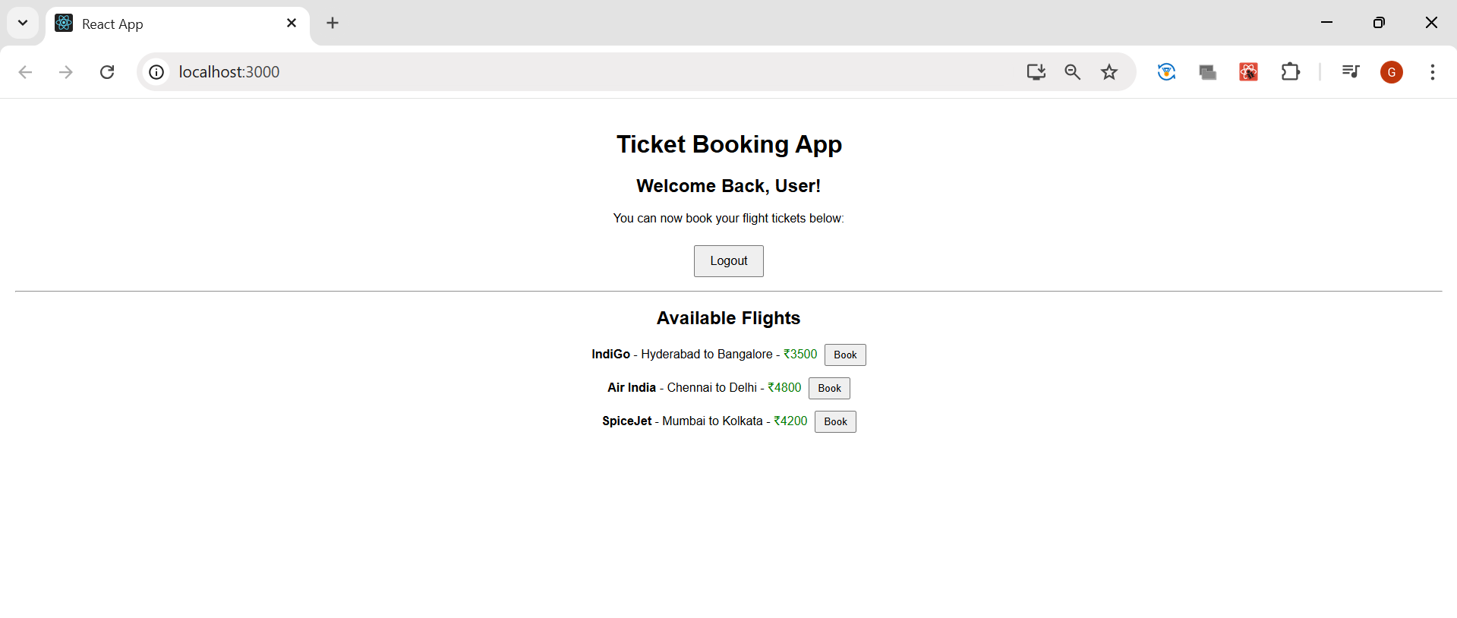

**13. ReactJS-HOL**

**App.js:**

import React from 'react';

import './App.css';

import CourseDetails from './CourseDetails';

import BookDetails from './BookDetails';

import BlogDetails from './BlogDetails';

*function* App() {

  return (

    <div className="container">

      <*CourseDetails* />

      <*BookDetails* />

      <*BlogDetails* />

    </div>

  );

}

export default App;

**CourseDetails.js:**

*function* CourseDetails() {

  return (

    <div className="card">

      <h2>Course Details</h2>

      <h3>Node.js</h3>

      <p>1/10/2022</p>

      <h3>Express.js</h3>

      <p>2/15/2022</p>

    </div>

  );

}

export default CourseDetails;

**BookDetails.js:**

*function* BookDetails() {

  return (

    <div className="card">

      <h2>Book Details</h2>

      <h3>Learning Node</h3>

      <p>550</p>

      <h3>Mastering Express</h3>

      <p>720</p>

      <h3>Full-Stack JavaScript</h3>

      <p>890</p>

    </div>

  );

}

export default BookDetails;

**BlogDetails.js:**

*function* BlogDetails() {

  return (

    <div className="card">

      <h2>Blog Details</h2>

      <h3>Async Programming in JS</h3>

      <p><strong>Priya Nair</strong></p>

      <p>Understanding promises and async/await in JavaScript.</p>

      <h3>API Design Best Practices</h3>

      <p><strong>Rohan Malhotra</strong></p>

      <p>Learn how to design clean and scalable REST APIs.</p>

    </div>

  );

}

export default BlogDetails;

**Output:**

