**Log Scrubbing Lab - Brian Guerrero**

LastChunkNumber (Active Chunk) = 03

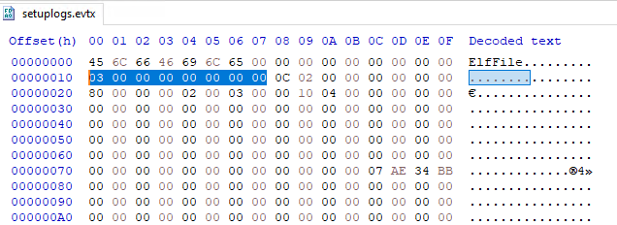

Active chunk offset = 4096 + (3 * 65536) = 200704 = 31000h

31000h: EVTX_CHUNK_HEADER

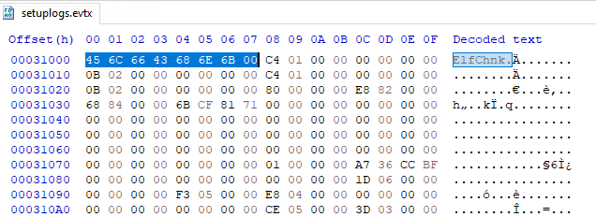

31000h + 200h (header size) = 31200h, EVTX_EVENT_RECORD (first record)

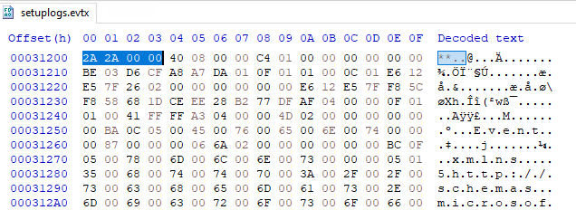

First Record Size = 0840h

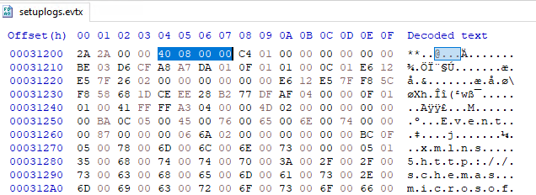

31200h + 840h = 31A40h (second record)

Second Record Size = 01A8h

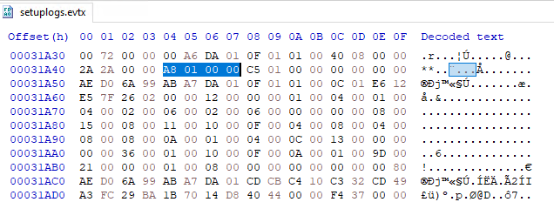

840h (First Record Size) + 1A8h (Second Record Size) = 9E8h

Edit First Record Size at Start of Record

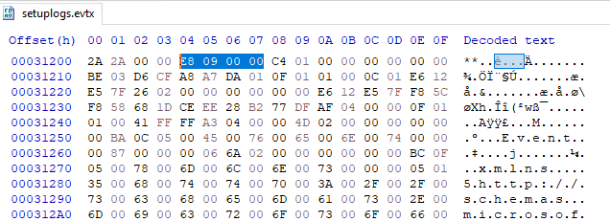

Edit Second Record Size at End of Record (31200h + 9E8h = 31BE8h)

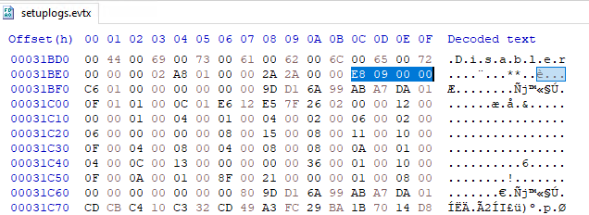

Second Record is now hidden!