魔方小站  CFOP  公式表  OLL  按小站顺序分组  (2014/8/26更新) | 1-1  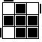  R’ U2 R U R’ U R | 1-2  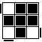  R U’ U’  R’ U’  R U’ R’ | 1-3  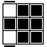  (r U R’ U’) (r’ F R F’) | 1-4  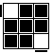  F’  (r U R’ U’)  (r’ F R) | 1-5  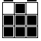  (R2 D’)  (R U’ U’)  (R’ D)  (R U’ U’ R) | 1-6  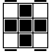  (R U U  R’ U’)  (R U R’ U’) (R U’ R’) | 1-7  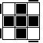  R U’ U’  (R2’ U’)  (R2 U’)  R2’ U2 R | 2-1  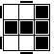  F  (R U R’ U’) F’ | 2-2  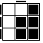  f  (R U R’ U’) f’
2-3  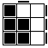  B’ U’  (R’ U R B) | 2-4  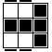  (R U R’ U’)  (R’ F R F’) | 2-5  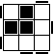  F  (RU R’ U’)2 F’ | 2-6  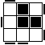  F’  (L’ U’ L U)2 F | 2-7  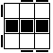  f  (RU R’ U’)2 f’ | 3-1  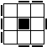  (F R U R’ U’ F’) (f R U R’ U’ f’) | 3-2  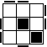  (f R U R’ U’ f’) U’ (F  R U R’ U’ F’) | 3-3  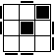  (f R U R’ U’ f’) U (F  R U R’ U’ F’) | 3-4  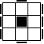  (R U’ U’)  (R2’ F R F’) U2  (R’ F R F’) | 3-5  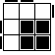  (r’ U2)  (R U R’ U)  r
3-6  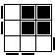  (r U’ U’)  (R’ U’ R U’ r’) | 3-7  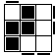  r U  R’ U R  U U r’ | 3-8  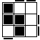  r’ U’ R U’ R’ U2 r | 4-1  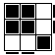  F  (R U’ R’ U’)  (R U R’ F’) | 4-2  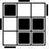  R U’ U’  (R2’ F R F’)(R U’ U’ R’) | 4-3  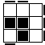  (R B’)  (R2 F)  (R2 B)  (R2 F’) R | 4-4  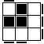  (R’ F)  (R2 B’)  (R2 F’)  (R2 B) R’ | 4-5  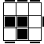  r’ U2  (R U R’ U’)  (R U R’ U)  r | 4-6  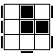  r U  (R’ UR U’)2  U’ r’ | 4-7  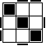  (R U R’ U) (R’ F R F’) U2  (R’ F R F’)
4-8  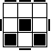  F  (R U R’ U) y’ (R’ U2) (R’ F R F’) | 4-9  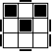  (M_{下} U)  (R U R’ U’)  M_{上}  (R’ F R F’) | 5-1  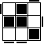  (R U R’ U’) (R’ F)  (R2U R’ U’)  F’ | 5-2  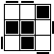  (R U R’ U)  (R’ F R F’)  (R U’ U’ R’) | 5-3  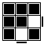  (r U R’ U’) (r’ R)  (U R U’ R’) | 5-4  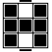  (R U R’ U’) r R’  (U R U’ r’) | 5-5  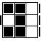  (R’ U’)  (R’ F R F’)  (U R) | 5-6  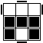  (R U R’ U’) x D’  (R’ U R) E’ | 5-7  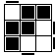  (R U R’ U)  (R U’ R’ U’)  (R’ F R F’) | 5-8  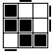  (R’ U’ R U’) (R’ U R U) (l U’ R’ U)
5-9  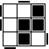  (F R U R’ U’ F’) U (F  R U R’ U’ F’) | 5-10  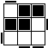  (r U R’ U)  (R’ F R F’) R U2 r’ | 6-1  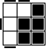  (R U)  (B’ U’)  (R’URB R’) | 6-2  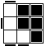  (R’ U’ F)  (U R U’)  (R’ F’ R) | 6-3  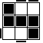  R’ F  (R U R’ U’) F’  (U R) | 6-4  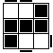  L F’  (L’ U’ L U) F  (U’ L’) | 6-5  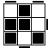  (R U R’ U R U2 R’) (F  R U R’ U’ F’) | 6-6  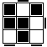  (R’ U’ R U’ R’ U2 R) (F  R U R’ U’ F’) | 6-7  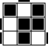  (r’ U2 R U R’ U r)  (R U2 R’ U’ R U’ R’) | 6-8  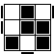  (r U2 R’ U’ R U’ r’)  (R’ U2 R U R’ U R)
7-1  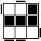  (r U r’)  (R U R’ U’)  (r U’ r’) | 7-2  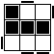  (l’ U’ l)  (L’ U’ L U)  (l’ U l) | 7-3  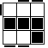  R’ F  (R U R’ F’ R) y’  (R U’ R’) | 7-4  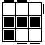  F (U R U’) (R2’ F’)  (R U R U’ R’) | 7-5  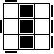  (R’ U’ R U’) (R’ U) y’ (R’ U R B) | 7-6  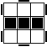  (r U r’)  (UR U’ R’)2  (r U’ r’) | 7-7  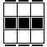  R’ F (U R U’) (R2’ F’) (R2 U R’ U’ R) | 7-8  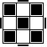  (r’ R U)  (R U R’ U’)  (r2 R2’)  (U R U’ r’) | 公式5-6里的E’的意思是:  从上往下看时，顺时针转水平的中间层。国际规定E和D顺逆方向一致。 | 如对标记有问题，  请到最后页去看标记说明。

