NetWave Broadband Management System

Final Project Report
Submitted By: N.BHADHREESH
Guided By: HARI GANESH
Institution : SRI AMARAAVATHI COLLEGE OF ARTS AND SCIENCE

Abstract / Project Overview
- NetWave is a comprehensive, cloud-based Broadband Management System designed for Internet Service Providers (ISPs).
- Core Purpose: To automate billing cycles, streamline online payments, and improve customer communication.
- Key Integrations: Features Razorpay for secure payments, automated PDF invoice generation, multichannel notifications (SMS, Email, WhatsApp), and an AI-powered customer support assistant.

Problem Statement
- Local ISPs often rely on manual data entry and physical ledgers for managing subscriptions.
- Delayed Payments: Lack of automated reminders leads to missed due dates and service interruptions.
- Disjointed Systems: Customer support, billing, and technical staff operate in silos without a unified dashboard.
- Poor Customer Experience: Customers lack self-service portals to view bills, download invoices, or instantly pay online.

Objectives
- Automate Billing: Automatically generate weekly/monthly bills for broadband subscriptions.
- Streamline Payments: Provide a frictionless checkout experience using Razorpay.
- Enhance Communication: Deliver real-time payment reminders and receipts via Email, SMS (MSG91), and WhatsApp.
- Improve Support: Introduce an OpenAI-powered chatbot to resolve basic customer queries instantly.
- Centralize Management: Build distinct, secure portals for Admins, Staff, and Customers.

Existing System
- Manual Billing & Physical Receipts: Paper-based invoices that are easy to lose and hard to track.
- Cash Collections: Heavy reliance on staff physically collecting cash, lacking proper digital audit trails.
- No Real-Time Alerts: Customers are not notified when bills are generated or overdue.
- Time-Consuming Support: Staff handles basic plan/billing queries manually via phone calls.

Proposed System
- Cloud-Hosted Architecture: Highly available system accessible from anywhere.
- Role-Based Access Control (RBAC): Secure access mapped to Admin, Staff, and Customer privileges.
- Digital Invoicing: Automated, dynamically generated PDF bills available for direct download.
- Omnichannel Notifications: Backend intelligently routes alerts via active channels.
- AI-Assisted Self-Service: Customers can self-serve payments and ask the AI assistant for help.

Technology Stack
- Frontend: React.js, Vite, Tailwind CSS (Hosted on Vercel)
- Backend: Node.js, Express.js (Hosted on Render)
- Database: MySQL (Cloud-hosted)
- Authentication: JSON Web Tokens (JWT) & bcrypt for password hashing
- Payment Gateway & Integrations: Razorpay API, Nodemailer, MSG91, Meta WhatsApp Cloud API, OpenAI API, PDFKit.

System Architecture / Workflow
- Data Flow: React UI <-> REST API <-> MySQL Database
- 1. Admin generates a bill.
- 2. System saves the record and triggers the Notification Service (SMS/Email/WhatsApp).
- 3. Customer logs in and pays via Razorpay checkout.
- 4. Backend verifies payment, marks bill as 'Paid', generates PDF, and sends a digital receipt.

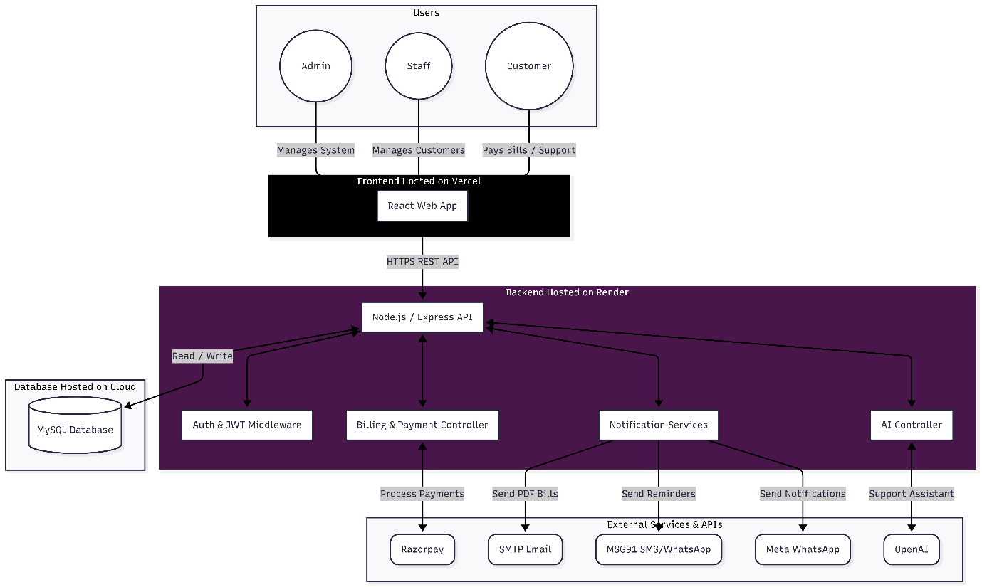

Methodology / Implementation
- Agile Approach: Iterative development focusing on core modules (Auth -> Billing -> Notifications).
- RESTful API Design: Backend built with decoupled services (billingController, aiController, emailService).
- Security First: Environment variables for secrets, JWT for session management, and backend-side payment validation.
- Dynamic PDF Generation: On-the-fly rendering of invoices using PDFKit only when a payment is verified.

Key Features / Modules
- Admin/Staff Module: Manage customers, plans, view global payment history, and generate bills.
- Customer Portal: View pending bills, pay online, access payment history, and download PDF receipts.
- Notification Engine: Smart fallback system (WhatsApp -> SMS -> Email) for due dates and payment success.
- AI Chat Assistant: GPT-powered bot trained to assist with NetWave broadband queries.

Results & Testing
- API Testing: Verified endpoint security and rate limiting.
- Payment Verification: Successfully tested Razorpay test-mode transactions and backend signature validation.
- Automated Tasks: Bill reminders accurately track dates and prevent duplicate SMS sends.
- Performance: Frontend loads quickly via CDN; Backend processes PDFs efficiently.

Challenges Faced
- API Integrations: Managing and standardizing error responses across multiple external APIs (Razorpay, MSG91, OpenAI).
- Node.js Load Order: Resolving environment variable issues where modules evaluated .env files prematurely.
- Dynamic Document Generation: Formatting the PDF bill dynamically to correctly align tables, user data, and logos.
- Secure File Delivery: Implementing expiring, secure tokens for downloading bills without requiring full re-authentication.

Future Enhancements
- Auto-Pay / Subscriptions: Implement Razorpay Subscriptions for automatic monthly deductions.
- Ticketing System: Add a robust issue-tracking module for customers to report internet downtime.
- Advanced Analytics: Add charts and graphs for Admins to visualize revenue trends and customer growth.
- Mobile Application: Port the React application to React Native for iOS and Android apps.

Conclusion
- The NetWave Broadband System successfully bridges the gap between manual ISP management and modern cloud operations.
- By integrating reliable payment gateways and real-time communication tools, it significantly reduces administrative overhead.
- The system provides a transparent, secure, and user-friendly experience for both the ISP staff and their customers.

