# IBM ID creation for Cognos Analytics

IBM id Creation: -

* Step1:  
   Access the following link:

<https://www.ibm.com/account/reg/us-en/signup?formid=urx-19776>

1. Enter your existing mail id details, set new password for IBM id.

Refer the screenshot

Click on Next

* Step2:

1. Enter verification code received on mail.
2. Click on create account.

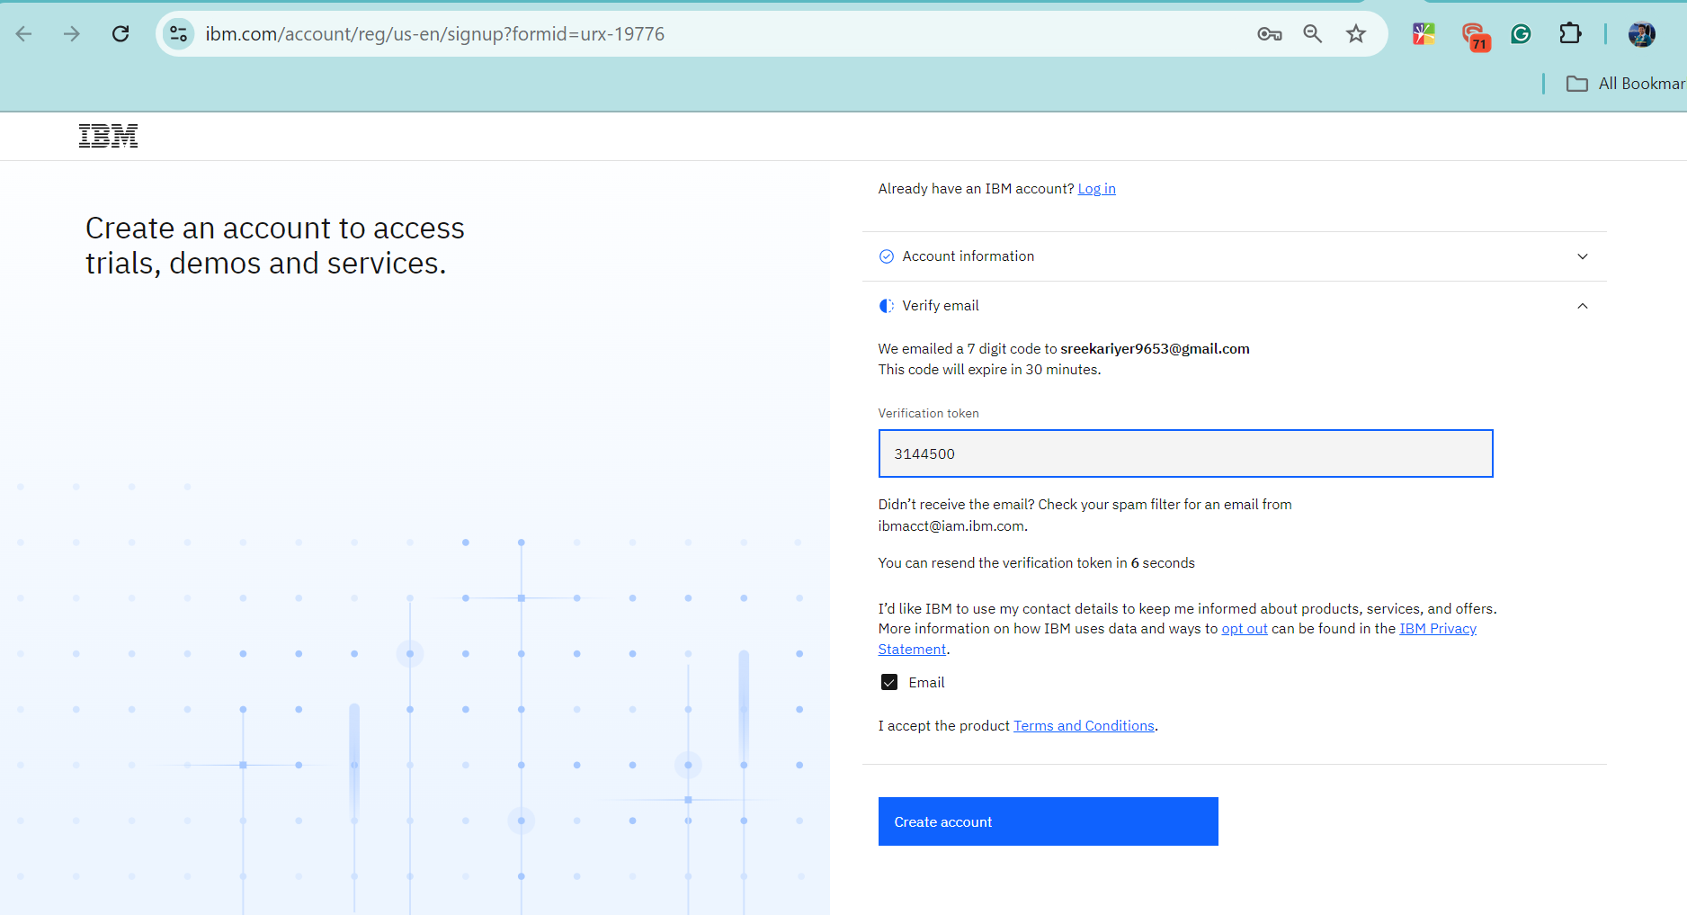

* Step3:

Click on proceed.

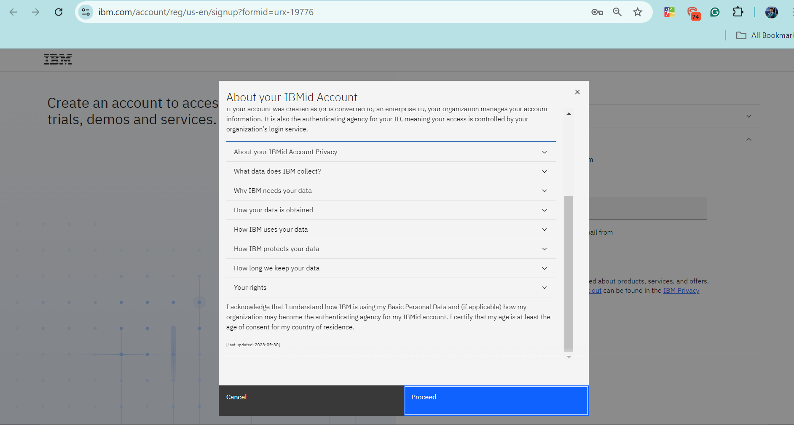

* Step4:

Verify the code received by mail.

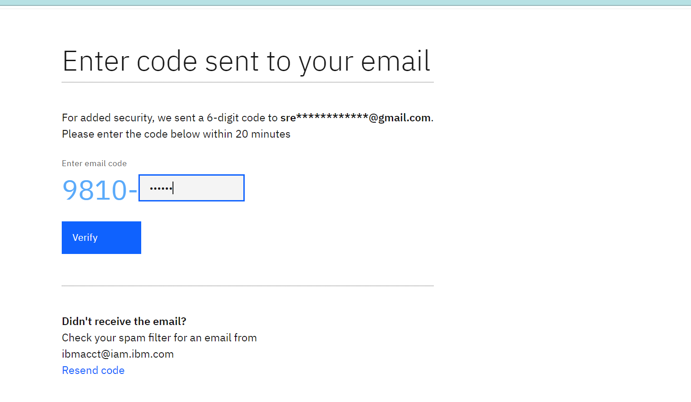

* IBM id has been created you can check from below link.

ibm.com/ibmweb/myibm/us-en/profile

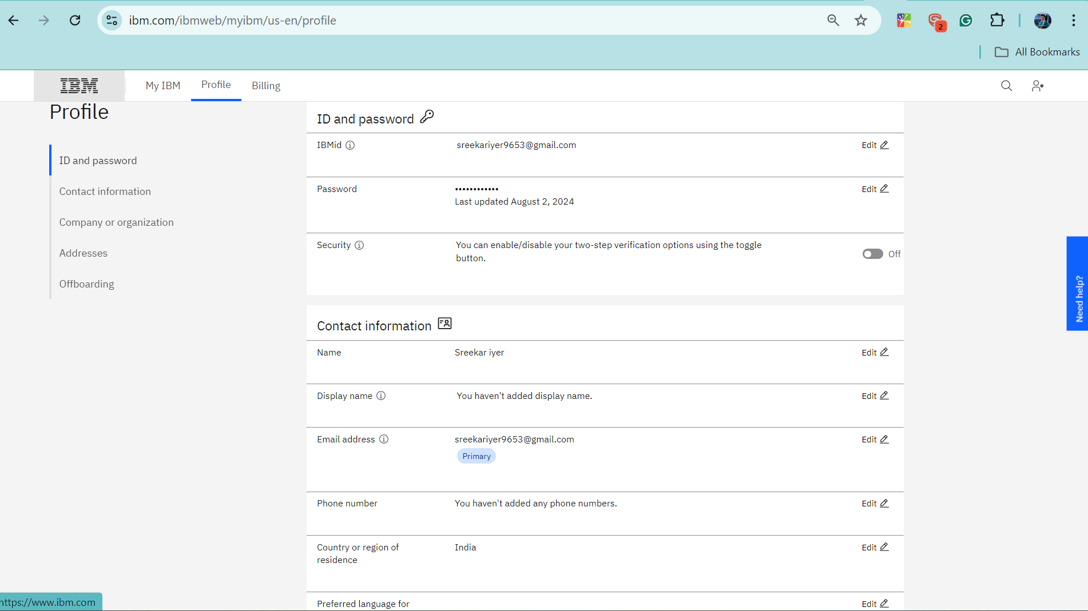

## Cognos id Verification: -

1. Please open the inbox of the email account where your IBM ID was created.
2. Click on Accept invite.

Note: -it will redirect you to Cognos URL.

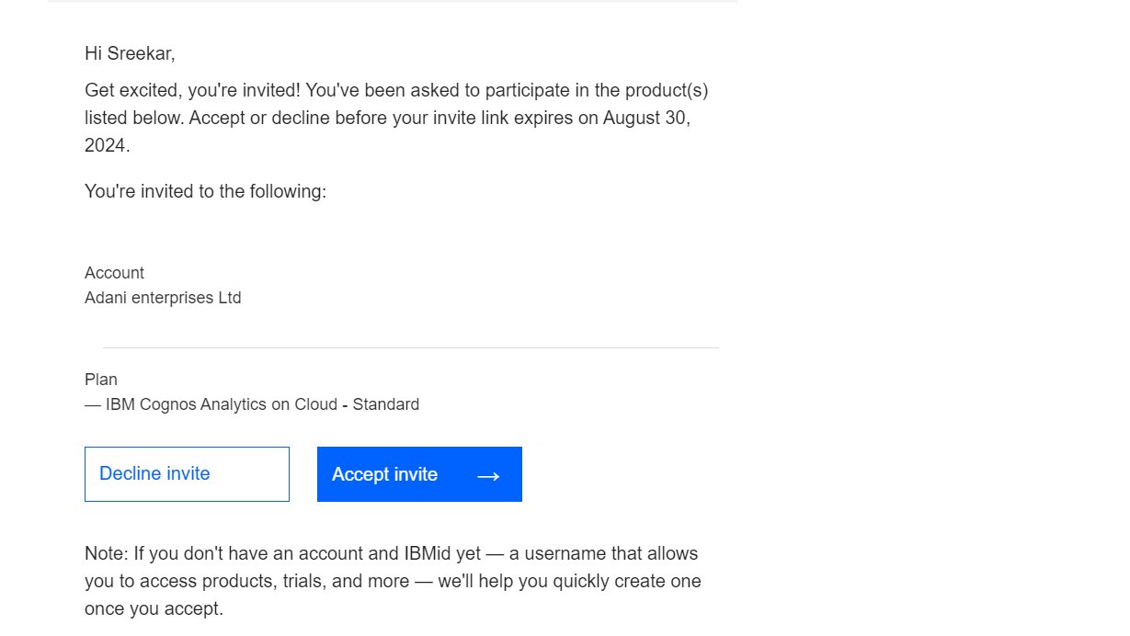

1. Log in with your IBM id and password.

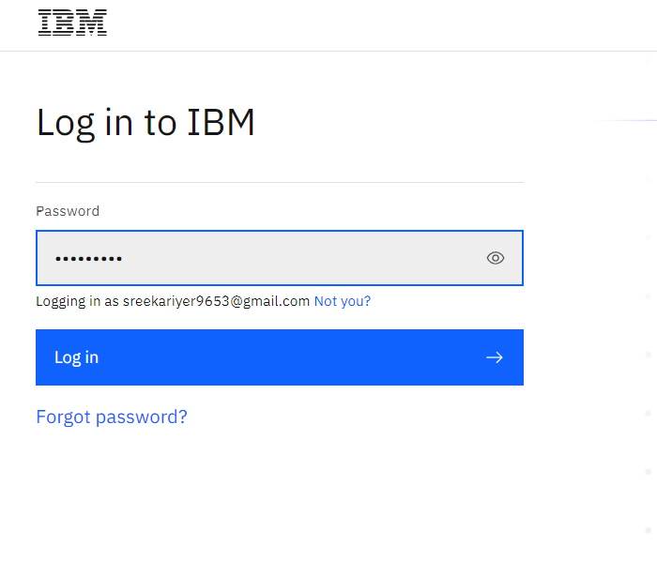

1. Verify the code received by mail.

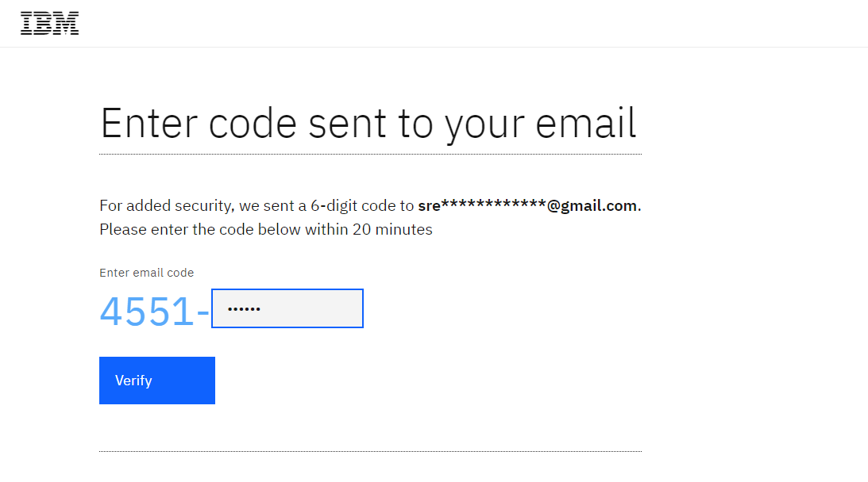

1. IBM Cognos analytics page will open.

You can access the dashboard by clicking three lines from left hand upper corner.

**Content < Team content < Adani CCC < client testing, And** then the dashboards present

