📌 Netflix Landing Page Clone
A static clone of the Netflix landing page created using pure HTML and CSS.
This project focuses on UI layout, and visual accuracy inspired by the original Netflix homepage.

📸 Project Preview
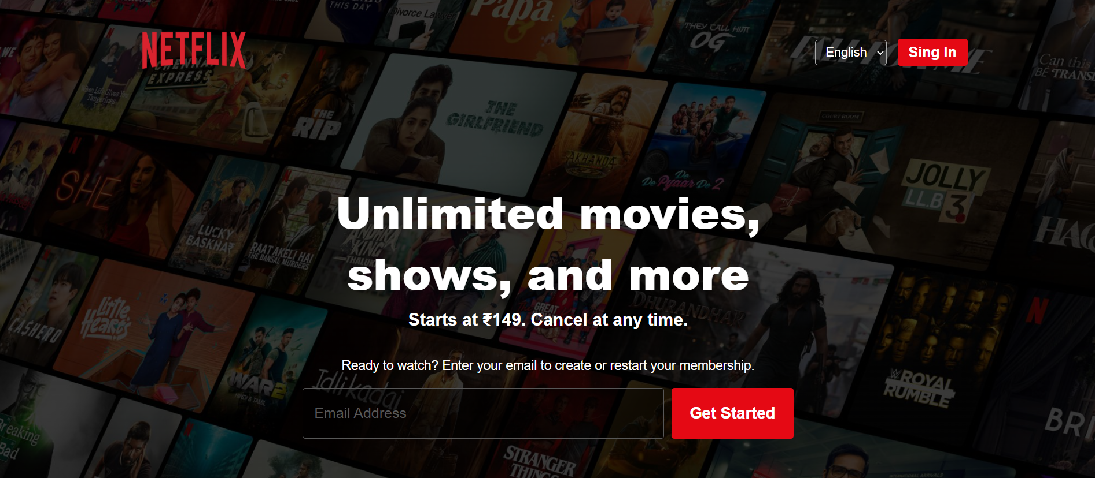
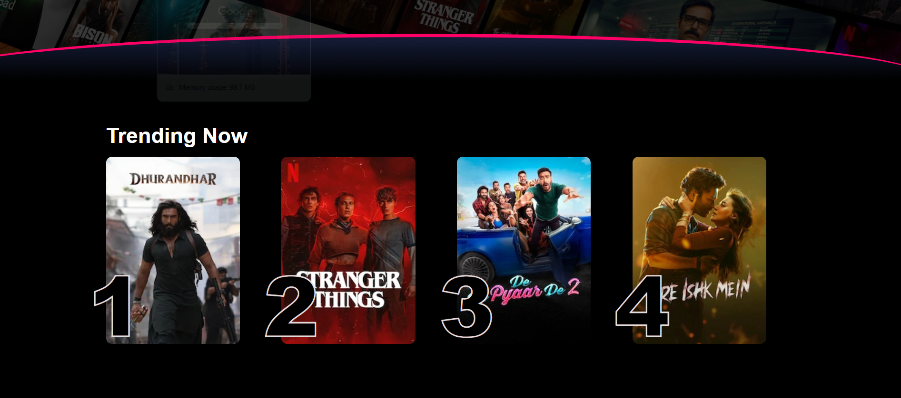
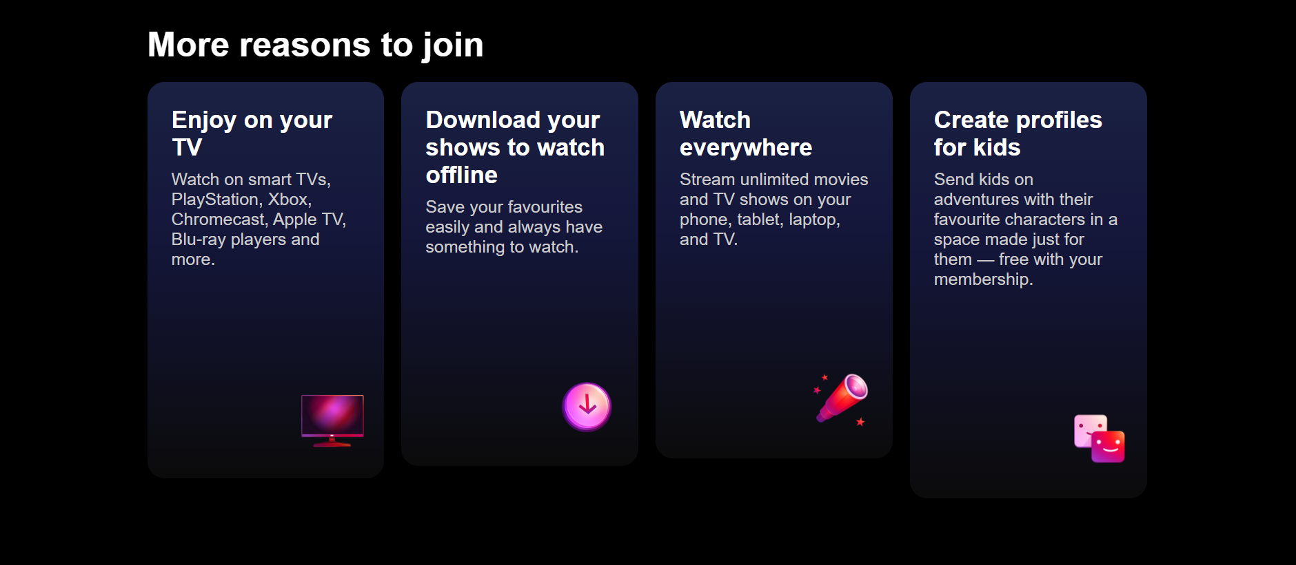
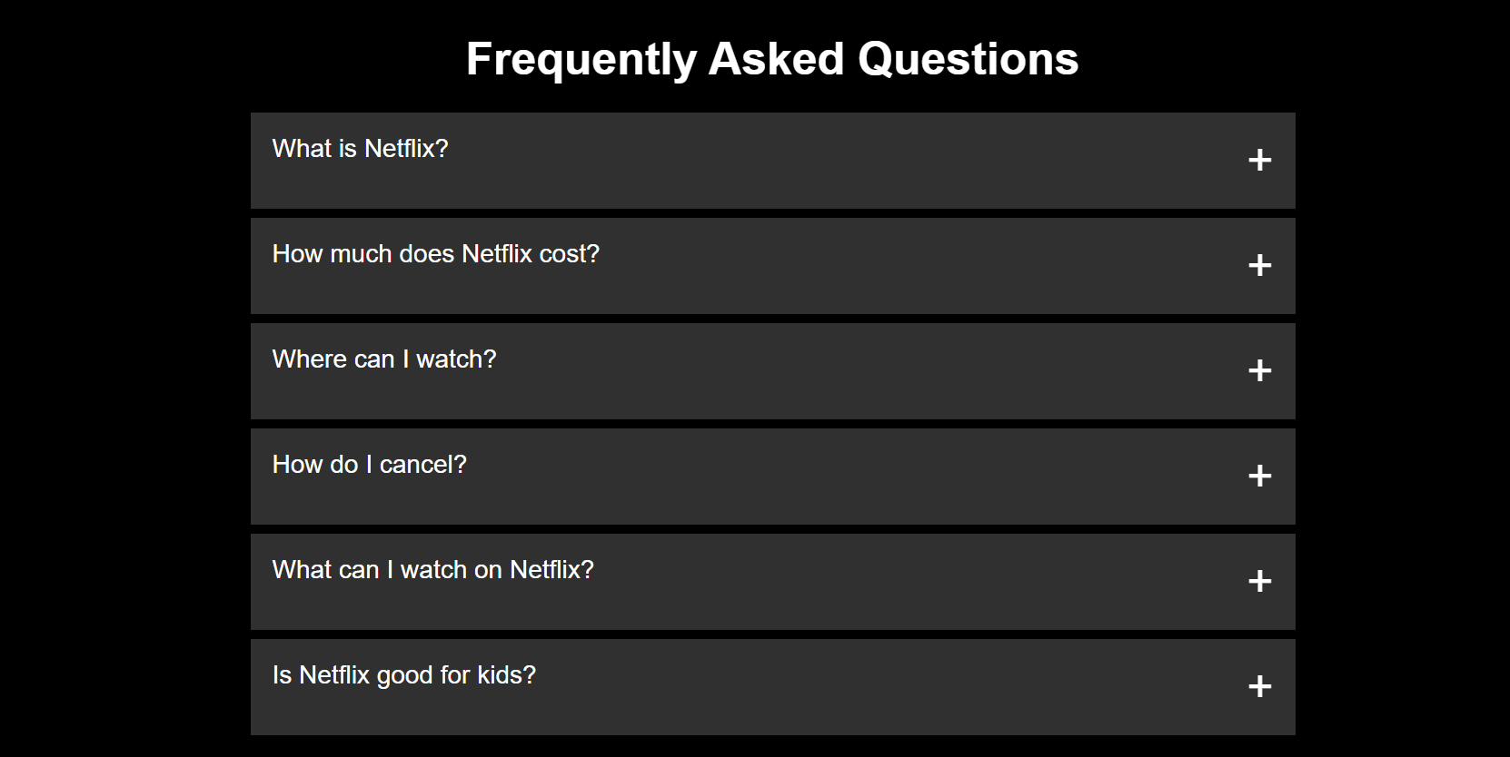
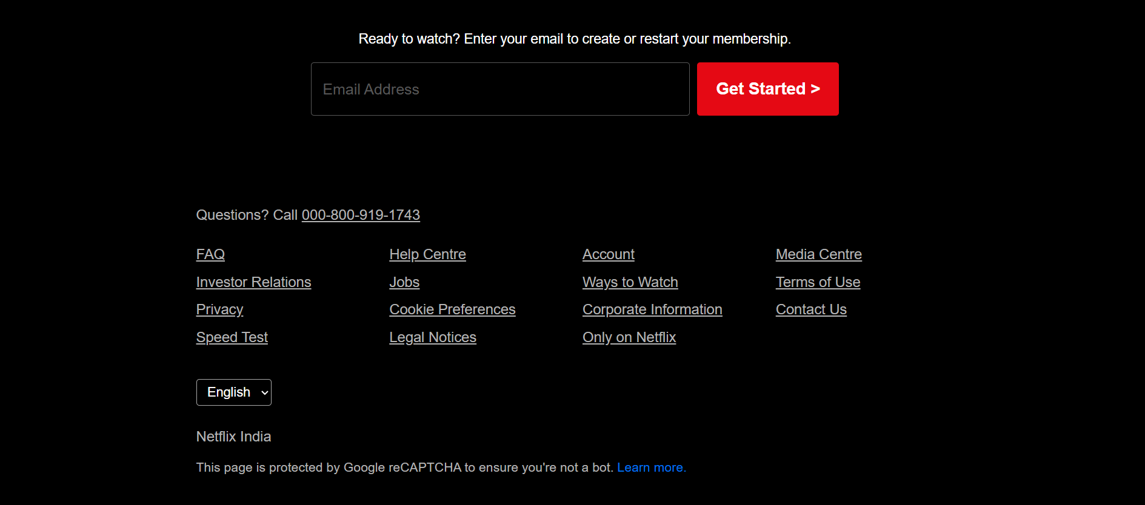

🚀 Features
- Header packed with a logo, a language picker and a sign in button
- Hero section with a cool background image and curved divider
- Trending movies row with smooth hover effects
- "More reasons to join" cards using gradient overlays
- FAQ accordion (using native <details> and <summary> – no JS!)
- Email signup for subscriptions
- Footer packed with links and a language picker

🛠️ Technologies Used
- HTML5
- CSS3 (Flexbox, Grid, Gradients, Transitions)

📁 Project Structure
📦 assignment2-06-02-2026
- ┣ 📂 assets
-┃ ┗ 📸 images & icons
┣ 📜 index.html
┣ 📜 style.css
┗ 📜 README.md

🎯 Purpose of This Project
- Practice HTML semantic structure
- Improve CSS layout skills (Flexbox & Grid)
- Learn real-world UI cloning
- Build a strong frontend portfolio project

⚠️ Disclaimer
This project is created only for educational and practice purposes.
Netflix is a registered trademark, and this clone is not intended for commercial use.

👩‍💻 Author
Bhagyalaxmi Behera
Frontend / Web Developer

