**AMAZON**

1. **What is the SDLC Waterfall Model?**

The waterfall model is a [software development model](https://www.geeksforgeeks.org/top-8-software-development-models-used-in-industry/) used in the context of large, complex projects, typically in the field of information technology. It is characterized by a structured, sequential approach to [project management](https://www.geeksforgeeks.org/software-engineering-software-project-management-plan-spmp/) and [software development](https://www.geeksforgeeks.org/software-development/).

The waterfall model is useful in situations where the project requirements are well-defined and the project goals are clear. It is often used for large-scale projects with long timelines, where there is little room for error and the project stakeholders need to have a high level of confidence in the outcome.

[Waterfall Model -](https://www.geeksforgeeks.org/waterfall-model/)

[Software Engineering - GeeksforGeeks](https://www.geeksforgeeks.org/waterfall-model/)

**1. Waterfall Model on Amazon:**

**Functional and Non-Functional Requirements:**

* **Functional Requirements:**
  + In the **Waterfall Model**, functional requirements are gathered in the **initial phase** and serve as the basis for system design and development. Once the functional requirements are defined (e.g., order
  + processing, search functionality), they are unlikely to change.
  + For **Amazon**, functional requirements could include **order management**, **payment processing**, and **customer account management**.
* **Non-Functional Requirements:**
  + **Non-functional requirements** are also defined early in the **Waterfall model** (e.g., performance, security, scalability).
  + For **Amazon**, non-functional requirements like **scalability** (handling millions of users), **security** (securing customer data), and **availability** (e.g., 99.9% uptime for AWS services) are prioritized but typically fixed at the start.

**Risk and Change Management:**

* **Risk Management:**
  + **Waterfall** is not very adaptable to changes during the development cycle, meaning risks (e.g., system bottlenecks, security breaches) may not be mitigated until later stages. However, risks related to initial design and requirements (e.g., incorrect assumptions about customer behavior) can be identified early on in the planning phase.
* **Change Management:**
  + **Change management** is difficult in the **Waterfall Model** since changes after the design phase can disrupt the entire process. For **Amazon**, if a significant change (e.g., adding new payment options) is needed after the design phase, it would cause delays and may require rework.

**Time and Cost Constraints:**

* **Time Constraints:**
  + **Waterfall** is highly **time-bound** because each phase must be completed before moving on to the next. For Amazon, time constraints may result in a delay if issues are discovered late in the process (e.g., bug fixing in the later stages before launch).
* **Cost Constraints:**
  + The **Waterfall Model** typically leads to higher costs if changes are made late, as rework is often required. For **Amazon**, this could mean additional costs for development, testing, and integration if the requirements or design need major adjustments post-deployment.

**2. Spiral Model on Amazon:**

**Functional and Non-Functional Requirements:**

* **Functional Requirements:**
  + In the **Spiral Model**, functional requirements are defined in **iterative cycles**. Amazon might define a set of core features, like **order placement** or **recommendation algorithms**, but they can evolve over time based on feedback from the initial iterations.
  + Functional requirements are continuously refined during each spiral, allowing Amazon to adjust the product based on user feedback.
* **Non-Functional Requirements:**
  + Similar to functional requirements, non-functional requirements (e.g., **scalability**, **security**, **response time**) are evaluated at each iteration.
  + **Amazon** may review scalability and performance goals, ensuring that their **AWS services** are optimized and capable of scaling with each iteration. Performance might improve over multiple iterations based on feedback from each cycle.

**Risk and Change Management:**

* **Risk Management:**
  + The **Spiral Model** focuses heavily on **risk analysis** and management at each iteration. Amazon could identify new risks (e.g., scalability issues or security vulnerabilities) early in the process and develop mitigation strategies.
  + For **Amazon**, iterative risk management allows the team to **test new AWS features** or enhancements to Prime Video in smaller, controlled releases, which helps identify and address issues early.
* **Change Management:**
  + **Change management** is more flexible in the **Spiral Model**, as changes can be accommodated between cycles. Amazon can add new features, adjust designs, or change architecture in response to user feedback and market changes.
  + For example, a new payment system could be tested and refined in the first cycle, with modifications made based on feedback in the next.

**Time and Cost Constraints:**

* **Time Constraints:**
  + The **Spiral Model** allows for iterative, **faster releases** but can lead to delays as each iteration involves risk assessment, design, development, and testing. While it provides flexibility, it requires ongoing effort for **Amazon** to manage the scope and ensure timely delivery.
* **Cost Constraints:**
  + The cost of the **Spiral Model** might be higher because of frequent iterations, risk assessments, and ongoing development. **Amazon** may incur higher operational costs due to the iterative nature, but this can be offset by **early releases** and more targeted feature improvements, reducing the risk of major failures.

**3. Incremental Development Model on Amazon:**

**Functional and Non-Functional Requirements:**

* **Functional Requirements:**
  + **Functional requirements** are divided into smaller chunks in the **Incremental Development** model. Amazon might prioritize core features (e.g., **search**, **checkout**, **product recommendations**) and release them in increments.
  + Each increment introduces a subset of functionality, and Amazon can adjust based on feedback from previous increments. For example, **Prime Video** might first release basic streaming features and later add advanced features like personalized content or offline viewing.
* **Non-Functional Requirements:**
  + In **Incremental Development**, non-functional requirements are also handled incrementally. As each feature is developed and deployed, **Amazon** ensures that **performance** and **scalability** are tested and refined at each stage.
  + For example, performance metrics might be gathered for the first increment of a service, like a new **AWS Lambda feature**, and then optimized in subsequent releases based on real-world usage.

**Risk and Change Management:**

* **Risk Management:**
  + **Risk management** is **continuous** in the **Incremental Model**, as each increment can be reviewed for potential issues. Since **Amazon** releases features in smaller increments, risks like **performance degradation**, **security concerns**, or **user dissatisfaction** can be addressed more rapidly.
* **Change Management:**
  + **Change management** is highly flexible in the **Incremental Model**, as new features and changes can be introduced with each increment. This is ideal for Amazon, which often updates **AWS services**, **Prime Video**, and **Alexa** with new features in a rolling fashion, based on customer feedback and business requirements.

**Time and Cost Constraints:**

* **Time Constraints:**
  + **Incremental Development** allows for **early releases** of basic functionality. Amazon can quickly get products or features to market (e.g., releasing a beta feature in **AWS** or **Alexa** and refining it based on user feedback). However, each increment may take time to release and integrate into the larger system.
* **Cost Constraints:**
  + The **cost** of the **Incremental Model** can be more **predictable** than the Spiral Model because features are developed and deployed in smaller chunks. For Amazon, this allows them to prioritize cost-effective delivery while ensuring that each feature is scalable and performs well.
  + However, if the incremental approach leads to frequent changes, this could lead to **additional overhead** due to testing and deployment processes.
  + [Waterfall Vs. Incremental Vs. Spiral Vs. Rad Model: 15 Differences - VIVA DIFFERENCES](https://vivadifferences.com/waterfall-vs-incremental-vs-spiral-vs-rad-model/)
  + [Development and Test on Amazon Web Services - AWS Whitepaper](https://docs.aws.amazon.com/pdfs/whitepapers/latest/development-and-test-on-aws/development-and-test-on-aws.pdf)

2) 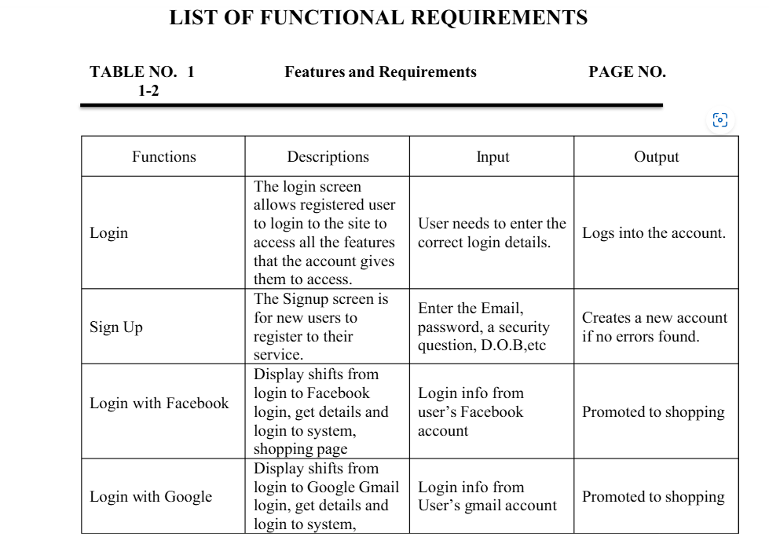

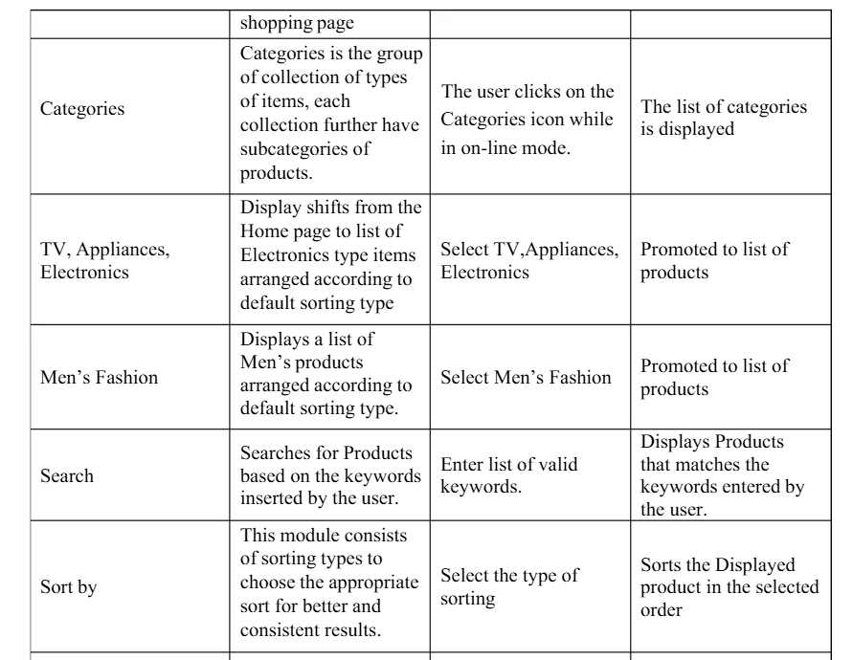

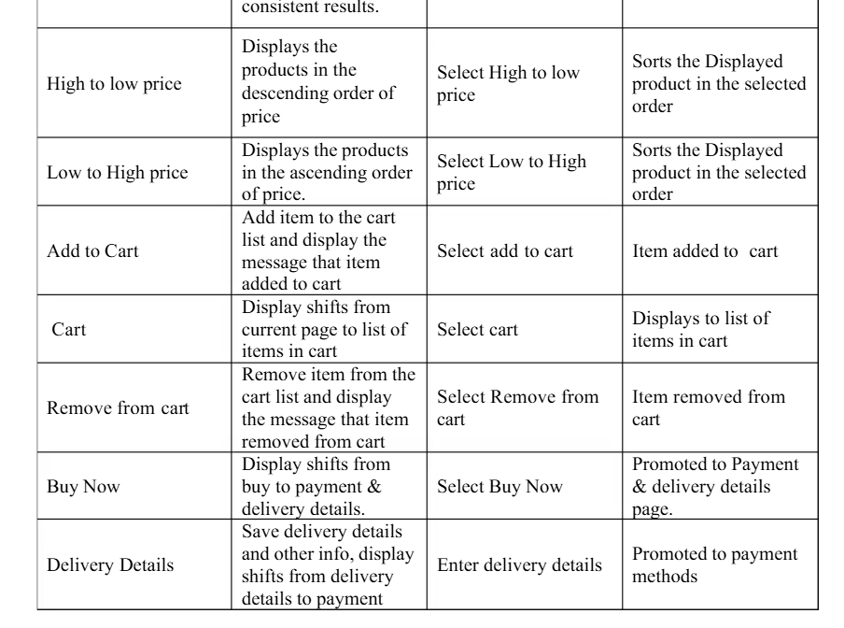

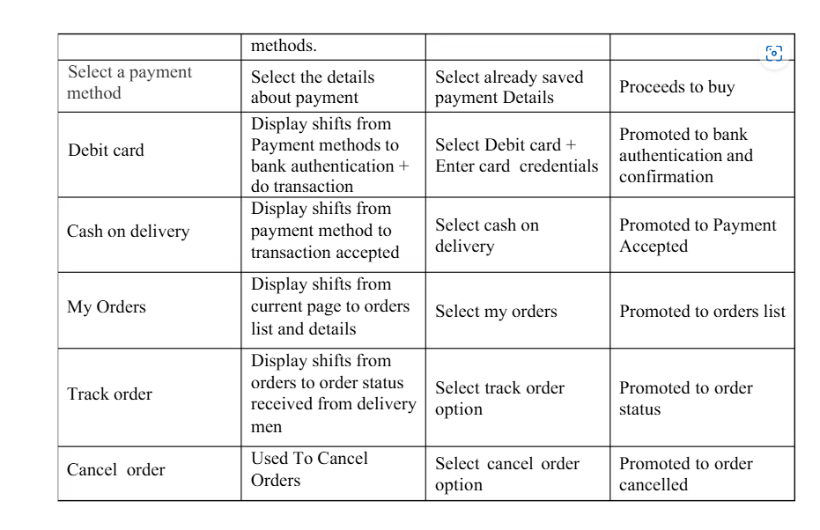

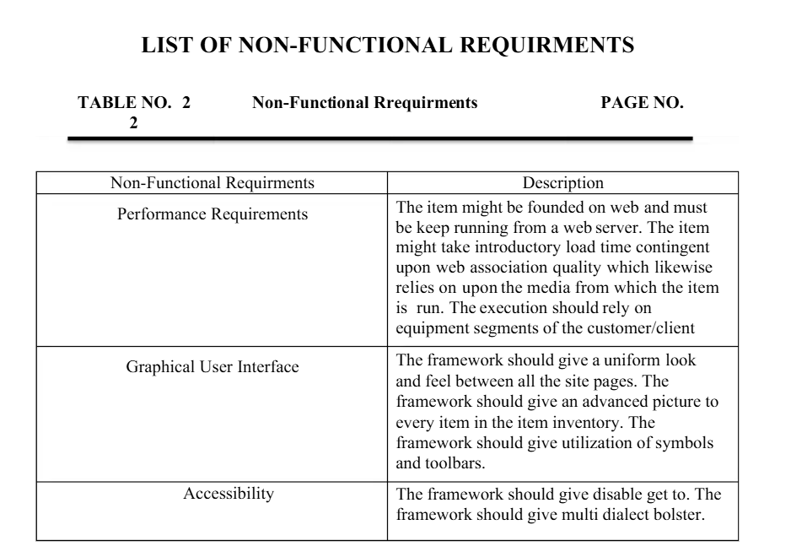

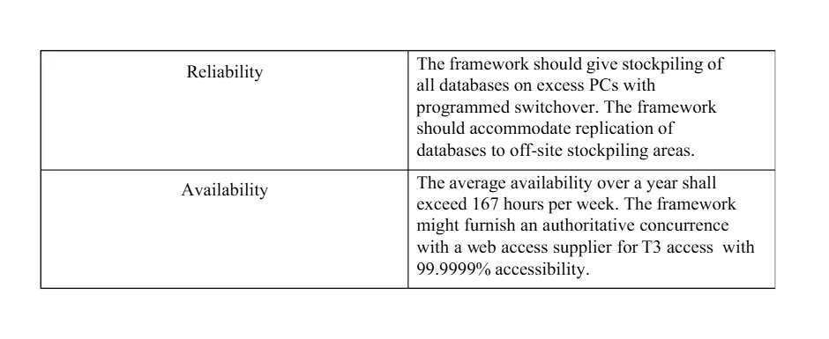

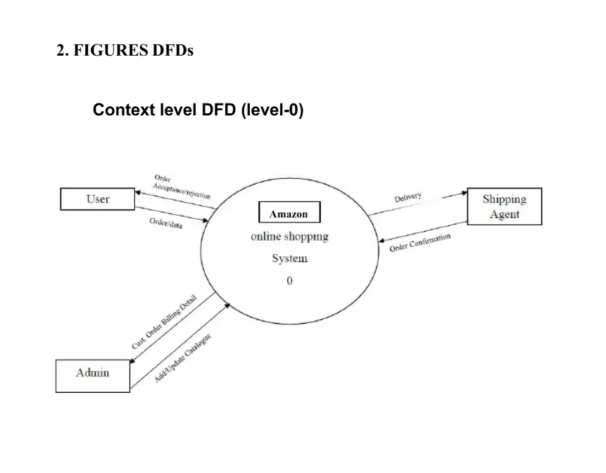

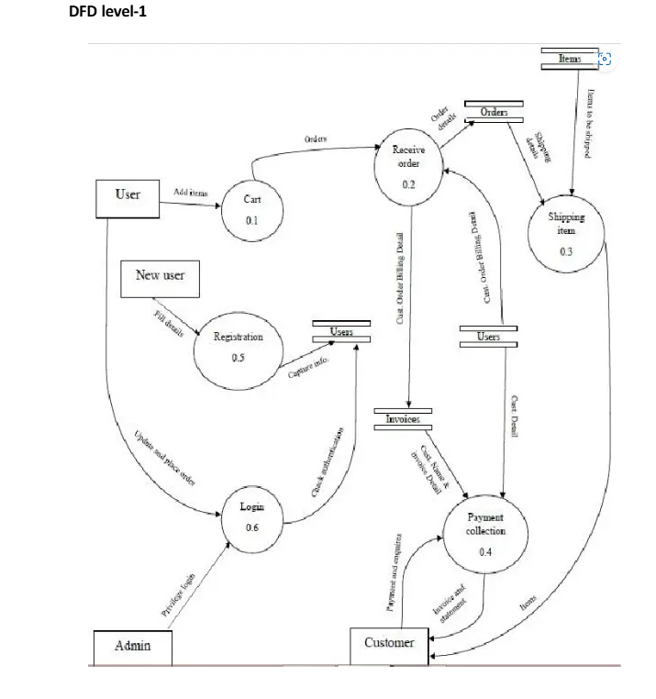

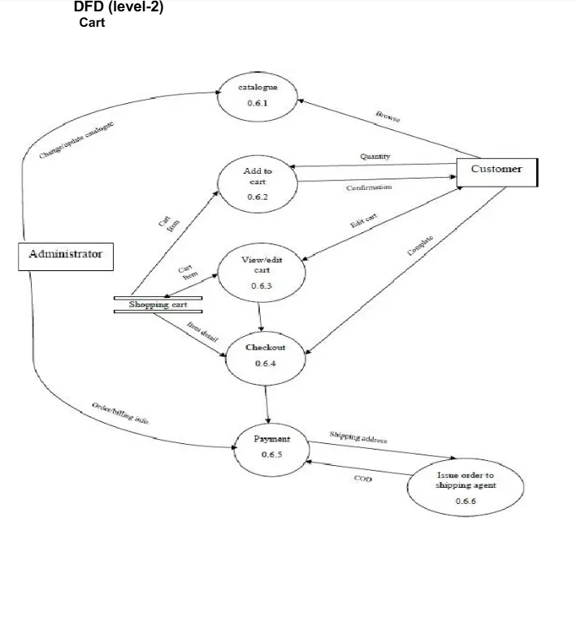

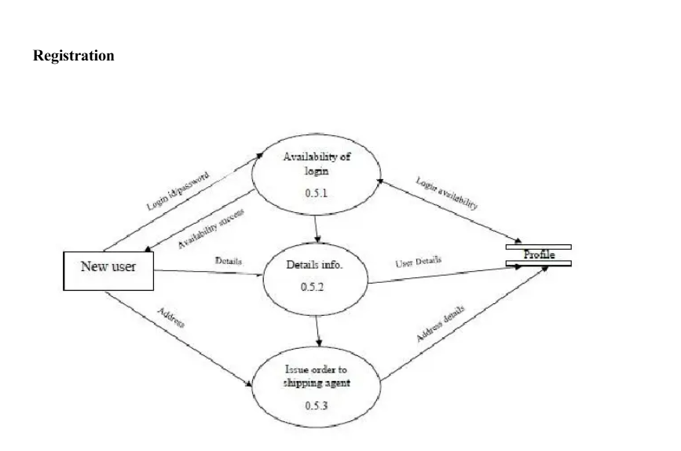

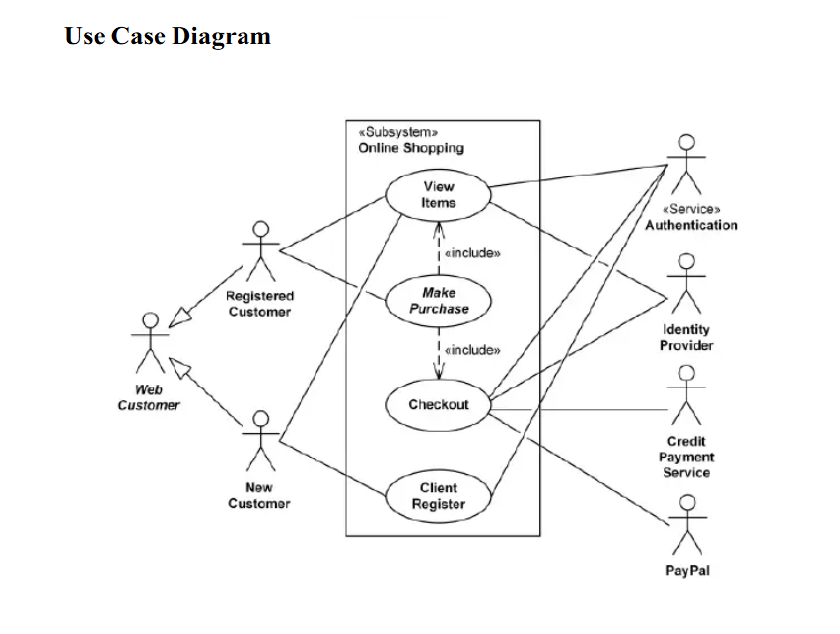

[Software Requirement Specification On Amazon: Bachelor of Technology in | PDF | Login | Gmail](https://www.scribd.com/document/433741240/Amazon-SRS)

George Gilbert Raju

[Updated Validation Checklists for AWS Competency, AWS Service Delivery, and AWS Service Ready Partners | AWS Partner Network (APN) Blog](https://aws.amazon.com/blogs/apn/updated-validation-checklists-for-aws-competency-aws-service-delivery-and-aws-service-ready-partners/)

[Prove It or Lose It: The Product Validation Process | Amazon Small Business Academy](https://www.smallbusiness.amazon/articles/the-product-validation-process)

**Title Page**

* **Title of the Report:** Comparative Analysis of SDLC Models for Amazon’s E-Commerce Platform
* **Author Name**
* **Date**
* **Course/Subject Name (if applicable)**

**Table of Contents**

1. **Introduction**
2. **Overview of Amazon’s E-Commerce Platform**
3. **Comparative Analysis of SDLC Models**
   * 3.1 Incremental Development Model
   * 3.2 Spiral Model
   * 3.3 Waterfall Model
4. **Requirements Engineering Process**
   * 4.1 Functional Requirements
   * 4.2 Non-functional Requirements
   * 4.3 Requirements Validation Strategy
5. **Conclusion**
6. **References**

Validation

Software Engineering

A Practitioner’s Approach

Roger S. Pressman

Requirements validation is a crucial phase in software development where the development team ensures that the software being built meets the actual needs and expectations of the stakeholders. In the context of Amazon's software, requirements validation is especially important due to the scale and complexity of its systems, such as the e-commerce platform, AWS, Alexa, Prime Video, and others.

**Key Steps in Requirements Validation for Amazon Software**

1. **Understanding Stakeholder Needs**:
   * Engaging with various stakeholders (e.g., business leaders, customers, internal teams) to gather and clarify requirements.
   * For Amazon, this involves understanding the needs of millions of customers, sellers, AWS clients, and internal teams.
2. **Creating Clear Requirements**:
   * Ensuring that the requirements are detailed, unambiguous, and measurable.
   * Amazon's software teams follow a rigorous process to write requirements in the form of user stories, use cases, or functional specifications.
3. **Prototyping and Mockups**:
   * Developing prototypes or mockups to visually demonstrate how the system will work.
   * For Amazon, this could include prototype websites or application interfaces, especially for consumer-facing products like Alexa or the Amazon app.
4. **Review and Feedback**:
   * Validating requirements by reviewing them with stakeholders and getting feedback.
   * Amazon holds regular meetings or reviews with both internal and external stakeholders (e.g., customer feedback loops, A/B testing results) to ensure the software meets the requirements.
5. **Testing Against Requirements**:
   * Testing software with test cases and use cases derived from the requirements to ensure compliance.
   * At Amazon, this process is typically done through automated testing, user acceptance testing (UAT), and load testing, especially for systems with high scalability like AWS.

**Potential Challenges in Requirements Validation for Amazon Software**

1. **Complex and Diverse Stakeholder Needs**:
   * Amazon serves a wide range of stakeholders, including customers, vendors, and internal teams. These stakeholders have varied and sometimes conflicting needs, making it challenging to define and agree on clear, common requirements.
   * For example, customers may demand features like faster shipping or improved recommendations, while business stakeholders may focus on maximizing efficiency and revenue.
2. **Scalability and Performance Expectations**:
   * Amazon’s software often needs to handle extremely high volumes of transactions, data, and users (e.g., Prime Day, Black Friday). This scale can make it difficult to ensure that the requirements are scalable and performance-oriented from the outset.
   * Scalability validation involves anticipating load patterns, traffic spikes, and ensuring infrastructure like AWS can handle the requirements effectively.
3. **Constantly Evolving Requirements**:
   * Amazon’s fast-paced innovation environment means requirements can change rapidly based on market trends, customer feedback, or new business priorities.
   * Keeping requirements updated and ensuring they are still aligned with business goals can be challenging in a dynamic environment.
4. **Globalization and Localization**:
   * Amazon operates globally, so requirements must be validated across different languages, cultures, and regions. This can make it difficult to create universally valid requirements.
   * For instance, user interface elements or functionalities that are suitable in one country may not work well in another due to cultural or legal differences.
5. **Integration with Legacy Systems**:
   * Amazon’s software solutions often need to integrate with a range of existing legacy systems, both within the company and externally (e.g., payment gateways, third-party services).
   * Validating that these legacy systems will work seamlessly with new features or applications can be difficult, especially if legacy systems are not well-documented or easily adaptable.
6. **Regulatory and Compliance Challenges**:
   * Amazon operates in many regions with varying regulatory requirements (e.g., GDPR, data privacy laws).
   * Ensuring that all software complies with these requirements can make validation more complex and time-consuming.
7. **User Experience (UX) Challenges**:
   * Amazon places significant emphasis on user experience across its products. However, ensuring that the software is user-friendly while meeting all technical and business requirements can be challenging.
   * For example, validating that a new feature, like the Alexa voice interface or a new shopping experience on the website, meets both the customer’s needs and performance standards.
8. **Automation and Continuous Integration**:
   * Amazon relies heavily on automated testing, but ensuring that automated tests are comprehensive enough to cover all possible use cases and edge cases can be challenging.
   * Continuous integration and deployment (CI/CD) in Amazon’s environment demand constant validation of new changes, which can lead to bottlenecks or overlooked requirements if not managed correctly.

**Mitigation Strategies for These Challenges**

1. **Agile Methodology**:
   * Amazon uses agile frameworks (like Scrum) for iterative development, allowing for frequent revisions and validation of requirements as the project evolves.
   * Agile methods can help accommodate changing requirements and stakeholder feedback more flexibly.
2. **Cross-functional Teams**:
   * To address complex and diverse stakeholder needs, Amazon forms cross-functional teams with representatives from various departments, including engineering, business, marketing, and customer support.
3. **Data-Driven Decision Making**:
   * Leveraging customer feedback, analytics, and A/B testing results allows Amazon to validate requirements based on real-world data rather than assumptions.
4. **Global and Local Testing**:
   * Amazon’s international presence means conducting both global and localized testing, ensuring that the software meets the needs of users worldwide, while also adhering to specific regional laws and regulations.
5. **Cloud Infrastructure and Scalability Testing**:
   * Given the reliance on AWS for cloud services, Amazon’s development teams can simulate heavy loads and performance conditions to ensure that software can scale efficiently across regions.

By systematically validating requirements and addressing these challenges, Amazon ensures that its software solutions remain robust, scalable, and aligned with the ever-changing needs of customers and business stakeholders.

**2. Functional Requirements**

**2.1 User Authentication**

* **Registration**: Users (customers and sellers) must be able to create an account with basic personal information (name, email, password).
* **Login/Logout**: Users must be able to log in and out using their credentials.
* **Password Reset**: Users must be able to reset their passwords through email verification.

**2.2 Product Management**

* **Product Listing**: Sellers must be able to upload product details, including images, descriptions, prices, and stock quantity.
* **Product Search**: Customers must be able to search for products based on category, keywords, and filters (price range, rating, etc.).
* **Product Recommendations**: The system should suggest products to users based on browsing history and purchase patterns.

**2.3 Shopping Cart**

* **Add/Remove Products**: Customers must be able to add products to their cart and remove them before checkout.
* **View Cart**: Customers should be able to view the contents of their shopping cart, including prices, quantities, and total cost.

**2.4 Checkout and Order Management**

* **Order Review**: Before confirming the order, customers should review the products, shipping information, and payment method.
* **Payment Integration**: The system must integrate with third-party payment gateways (e.g., credit cards, PayPal) for secure payment transactions.
* **Order Confirmation**: After placing an order, customers should receive a confirmation email with the order details.
* **Order Tracking**: Customers should be able to track the status of their orders (e.g., processing, shipped, delivered).

**2.5 Customer Support**

* **Live Chat**: Provide live chat functionality for customers to interact with support agents.
* **FAQs and Help Center**: A section with frequently asked questions and self-service support.

**2.6 Reviews and Ratings**

* **Product Reviews**: Customers can leave reviews for products they've purchased.
* **Product Ratings**: Customers can rate products on a scale (e.g., 1 to 5 stars).

**2.7 Seller Dashboard**

* **Order Management**: Sellers should be able to view and manage orders, including processing, shipping, and returns.
* **Inventory Management**: Sellers should be able to track product stock levels and update them.

**2.8 Notifications**

* **Email and SMS Alerts**: Customers and sellers should receive notifications regarding order status, shipment updates, and promotions.

**3. Non-Functional Requirements**

**3.1 Performance**

* **Response Time**: The system should have a response time of less than 2 seconds for most operations (e.g., searching products, adding to cart).
* **Load Handling**: The system must be able to handle thousands of concurrent users without significant performance degradation.

**3.2 Scalability**

* **Horizontal Scalability**: The system should be able to scale horizontally (e.g., adding more servers) to handle increased traffic during peak periods (e.g., holidays, promotions).

**3.3 Security**

* **Data Encryption**: Sensitive data (e.g., passwords, payment information) should be encrypted both at rest and in transit.
* **Secure Payment**: The system must comply with industry standards for payment security (e.g., PCI DSS compliance).
* **Account Protection**: Implement multi-factor authentication (MFA) for users, especially for sellers, to enhance account security.

**3.4 Availability**

* **High Availability**: The system should have an uptime of 99.9% or higher. This includes redundancy and failover mechanisms to minimize downtime.
* **Disaster Recovery**: There should be a disaster recovery plan in place to restore services in case of a failure.

**3.5 Usability**

* **User-Friendly Interface**: The system should have a clean and intuitive interface for both customers and sellers.
* **Mobile Accessibility**: The system should be fully responsive, providing an optimized experience for mobile devices (smartphones and tablets).

**3.6 Compatibility**

* **Cross-Browser Support**: The platform should be compatible with all major browsers (Chrome, Firefox, Safari, Edge).
* **OS Compatibility**: The system should work across major operating systems, including Windows, macOS, iOS, and Android.

**3.7 Maintainability**

* **Modular Architecture**: The system should be built with a modular architecture to make it easier to maintain and extend.
* **Logging and Monitoring**: Implement logging and monitoring tools to track system errors, performance issues, and user behaviour.

**3.8 Legal Compliance**

* **Data Privacy**: The system must comply with data privacy regulations such as GDPR for European users and CCPA for California users.
* **Tax Compliance**: Ensure that tax calculations are accurate for all regions based on local laws.

**1. Define Clear Validation Objectives**

* Ensure that the requirements align with business goals.
* Confirm that the system addresses end-user needs and expectations.
* Ensure that technical specifications are feasible within the project’s constraints (e.g., budget, timeline).
* Validate that requirements are clear, unambiguous, and testable.

**2. Involve Stakeholders Early and Continuously**

* **Stakeholder Identification**: Ensure all key stakeholders (e.g., product owners, business analysts, developers, designers, security experts, customers) are involved.
* **Collaboration**: Maintain continuous communication with stakeholders throughout the project to review requirements periodically.
* **User Feedback**: Obtain feedback from end-users or their representatives (e.g., customer surveys, beta testing) to validate functional requirements.

**3. Perform Gap Analysis**

* Compare the stated requirements against the actual capabilities and constraints of the existing system (if applicable) or the proposed system.
* Identify any missing or incomplete requirements.
* Assess potential conflicts or overlaps between requirements.

**4. Prototyping**

* **Create Mockups or Prototypes**: Build low-fidelity prototypes or wireframes for the Amazon system (e.g., for a new feature in the e-commerce platform).
* **User Testing**: Conduct usability testing to ensure that users can interact with the system effectively and intuitively.
* **Iterative Feedback**: Use an iterative approach where user feedback on prototypes is incorporated into the evolving requirements.

**5. Traceability Matrix**

* Use a **requirements traceability matrix** (RTM) to ensure that every requirement can be traced to corresponding test cases.
* The matrix should track the requirement from initial stakeholder input through to final implementation, verifying that all requirements are covered.

**6. Test Planning and Execution**

* Define **validation criteria** and develop comprehensive test cases based on requirements.
* Conduct **functional tests** (e.g., if a new search functionality works as intended on the Amazon website) and **non-functional tests** (e.g., performance, scalability).
* Perform **acceptance testing** (e.g., user acceptance testing - UAT) to confirm that the system meets business and user needs.
* Ensure that the system works under **real-world conditions**, with **load testing** and **stress testing** to ensure it handles large-scale usage typical for Amazon.

**7. Change Management**

* Ensure that any changes to the requirements are thoroughly reviewed and validated. This includes:
  + Analyzing the impact of changes on existing requirements.
  + Updating documentation and test cases to reflect changes.
  + Continuous monitoring of evolving stakeholder needs.

**Potential Challenges in the Requirements Validation Phase**

1. **Ambiguous Requirements**
   * **Challenge**: Requirements may be unclear or overly broad, leading to different interpretations. This can result in misalignment between stakeholders and the development team.
   * **Solution**: Engage stakeholders regularly and use prototyping, interviews, and workshops to clarify requirements.
2. **Scope Creep**
   * **Challenge**: Stakeholders may continue to add new requirements during the validation phase, which can lead to scope creep and delay delivery.
   * **Solution**: Set clear boundaries for the project scope and ensure any changes are assessed, prioritized, and formally documented.
3. **Conflicting Stakeholder Expectations**
   * **Challenge**: Different stakeholders (e.g., business units, technical teams, customers) may have conflicting expectations about what the system should deliver.
   * **Solution**: Facilitate conflict resolution and prioritization sessions with stakeholders, ensuring alignment on the most important requirements.
4. **Inadequate User Feedback**
   * **Challenge**: Amazon’s large user base may make it difficult to gather representative feedback, leading to incomplete validation.
   * **Solution**: Conduct targeted user studies, beta testing, and pilot releases to collect feedback from a broad and diverse set of users.
5. **Testing Challenges**
   * **Challenge**: Validating requirements against real-world usage conditions is difficult, especially for performance, scalability, and security aspects.
   * **Solution**: Use automation and load testing tools, conduct simulated user behavior tests, and ensure rigorous security assessments (e.g., penetration testing).
6. **Overlooking Non-Functional Requirements**
   * **Challenge**: Non-functional requirements (e.g., performance, scalability, security) may be overlooked or under-prioritized, resulting in system bottlenecks or vulnerabilities.
   * **Solution**: Explicitly define and validate non-functional requirements and incorporate performance testing as part of the validation phase.
7. **Integration Complexity**
   * **Challenge**: Amazon systems often integrate with various external and internal services. Validating requirements might be challenging due to dependency on third-party services or complex internal system integrations.
   * **Solution**: Validate integration points early on and conduct thorough integration testing.
8. **Changing Market Conditions**
   * **Challenge**: Rapid market or technology changes (e.g., new customer trends, technological advancements) may render initial requirements obsolete or less relevant.
   * **Solution**: Implement an agile approach to validation, where requirements can be adjusted quickly to respond to changing conditions.

**Conclusion**

A robust strategy for requirements validation is crucial for the success of Amazon systems. Regular stakeholder involvement, clear traceability, testing, and addressing challenges such as scope creep and ambiguous requirements will help ensure that the system delivers value to both the business and its users.