To design and implement a Supermarket Billing System, we need to consider various aspects, including functional requirements, system architecture, user interface, database design, and security measures. Here’s a comprehensive plan to develop the system:

**1. Requirements Analysis**

**Functional Requirements**

1. Product Management:

- Add, update, and delete product details.

- Maintain information like product name, category, price, stock quantity, and SKU (Stock Keeping Unit).

**2. Inventory Management:**

- Track stock levels and automatically update inventory after each sale.

- Generate alerts for low stock levels.

**3. Billing and Checkout:**

- Scan products and calculate the total bill, including taxes and discounts.

- Support multiple payment methods (cash, credit/debit cards, digital wallets).

- Generate and print detailed receipts.

**4. Customer Management:**

- Maintain customer profiles with purchase history.

- Implement loyalty programs and apply discounts.

**5. Employee Management:**

- Manage cashier and staff profiles with access controls.

- Track employee performance metrics (e.g., number of transactions handled).

**6. Reporting and Analytics:**

- Generate sales reports, inventory reports, and customer purchase trends.

- Provide insights into top-selling products, peak hours, etc.

**7. Security and User Authentication:**

- Ensure secure login for different user roles (admin, cashier, manager).

- Implement data encryption and secure storage practices.

**Non-Functional Requirements**

**1. Usability**: The system should be user-friendly with a simple and intuitive interface.

**2. Scalability**: The system should handle high volumes of transactions and be scalable for future expansion.

**3. Performance**: Ensure quick response times during peak hours.

**4. Security**: Protect against unauthorized access, data breaches, and ensure compliance with data protection regulations.

**2. System Architecture**

The Supermarket Billing System can be designed as a multi-tiered architecture:

**1. Presentation** Layer: User interface for customers, cashiers, and administrators.

**2. Business Logic Layer**: Handles all operations like billing, inventory management, and report generation.

**3. Data Access Layer**: Manages data storage, retrieval, and updates in the database.

**4. Database Layer**: Stores all the persistent data such as product information, transactions, customer details, etc.

**3. Database Design**

Designing the database schema is crucial for storing and retrieving information efficiently. Here is an example of the tables required:

1. **Products Table**: Stores product details.

- Fields: `product_id`, `name`, `category`, `price`, `quantity_in_stock`, `sku`

2. **Customers Table**: Stores customer details.

- Fields: `customer_id`, `name`, `email`, `phone_number`, `loyalty_points`

3. **Employees Table**: Stores employee details.

- Fields: `employee_id`, `name`, `role`, `username`, `password_hash`

4. **Transactions Table**: Records each sale transaction.

- Fields: `transaction_id`, `date_time`, `employee_id`, `customer_id`, `total_amount`, `payment_method`

5. **Transaction_Items Table**: Stores details of items in each transaction.

- Fields: `transaction_item_id`, `transaction_id`, `product_id`, `quantity`, `price`

6. **Inventory Table**: Manages inventory levels.

- Fields: `inventory_id`, `product_id`, `quantity_in_stock`

**4. User Interface Design**

The user interface should be designed for different roles:

- **Cashier UI**: Quick access to product scanning, billing, and payment processing. Should have a simple interface with a barcode scanner integration.

- **Admin/Manager UI**: Detailed access to reports, inventory management, and employee management tools.

- **Customer-facing UI**: Simple display for payment confirmation and loyalty points status.

5. **Implementation Plan**

Technology Stack

- **Frontend**: HTML, CSS, JavaScript, and a frontend framework like React or Angular.

- **Backend**: Python (with Django or Flask), Java (with Spring Boot), or Node.js (with Express).

- **Database**: MySQL, PostgreSQL, or MongoDB.

- Security: HTTPS, JWT (JSON Web Tokens) for authentication, and encryption libraries.

**Development Steps**

1. **Set Up the Environment**: Configure the development environment with the chosen tech stack.

2. **Design the Database Schema**: Create and optimize the database schema.

3. **Develop the Backend**: Implement APIs for product management, billing, customer management, etc.

4. **Develop the Frontend**: Create the user interface based on role-based access.

5. **Integrate the System**: Connect the frontend with the backend and the database.

6. **Testing**: Perform unit testing, integration testing, and user acceptance testing.

7. **Deployment**: Deploy the system on a server or cloud platform. Ensure the system is accessible and secure.

8. **Maintenance**: Monitor the system for bugs, performance issues, and security vulnerabilities.

**6. Security Measures**

- **Authentication**: Implement secure login mechanisms using salted and hashed passwords.

- **Authorization**: Role-based access control to limit access to sensitive features.

- **Encryption**: Encrypt sensitive data both in transit (using HTTPS) and at rest.

- **Regular Audits**: Regular security audits and vulnerability assessments.

**7. Scalability and Performance Optimization**

- **Caching**: Use caching strategies for frequently accessed data.

- **Load Balancing**: Implement load balancing to manage traffic effectively.

- **Database Optimization**: Index frequently queried fields and use query optimization techniques.

**8. Documentation and Training**

- Provide detailed documentation for system use, including user manuals for different roles.

- Train employees on system usage and best practices for security and efficiency.

**9. Monitoring and Feedback**

- Implement logging and monitoring to track system performance and detect issues.

- Gather feedback from users regularly to improve the system's functionality and user experience.

By following this structured approach, the Supermarket Billing System can be effectively designed and implemented to meet the needs of a modern supermarket, ensuring efficiency, security, and scalability.

class Product:

def __init__(self, product_id, name, price, stock_quantity):

self.product_id = product_id

self.name = name

self.price = price

self.stock_quantity = stock_quantity

def update_stock(self, quantity):

self.stock_quantity += quantity

def get_price(self):

return self.price

class Customer:

def __init__(self, customer_id, name, loyalty_points=0):

self.customer_id = customer_id

self.name = name

self.loyalty_points = loyalty_points

def update_loyalty_points(self, points):

self.loyalty_points += points

def get_customer_info(self):

return f"Customer ID: {self.customer_id}, Name: {self.name}, Loyalty Points: {self.loyalty_points}"

class Cart:

def __init__(self):

self.items = []

self.total_price = 0.0

def add_product(self, product):

self.items.append(product)

self.calculate_total()

def remove_product(self, product):

self.items.remove(product)

self.calculate_total()

def calculate_total(self):

self.total_price = sum(item.get_price() for item in self.items)

return self.total_price

class Billing:

def __init__(self, cart, discount=0):

self.cart = cart

self.discount = discount

def apply_discount(self):

discount_amount = (self.discount / 100) * self.cart.calculate_total()

return self.cart.calculate_total() - discount_amount

def generate_receipt(self):

total_after_discount = self.apply_discount()

receipt = f"Receipt\nTotal: {self.cart.calculate_total()}\nDiscount: {self.discount}%\nFinal Total: {total_after_discount}"

return receipt

class Inventory:

def __init__(self):

self.products = []

def add_product(self, product):

self.products.append(product)

def update_product(self, product_id, quantity):

for product in self.products:

if product.product_id == product_id:

product.update_stock(quantity)

def check_stock(self, product_id):

for product in self.products:

if product.product_id == product_id:

return product.stock_quantity

return 0

class Report:

def __init__(self, sales_data):

self.sales_data = sales_data

def generate_sales_report(self):

# Logic to generate a sales report

pass

def generate_inventory_report(self):

# Logic to generate an inventory report

pass

# Example Usage:

product1 = Product(1, "Apple", 0.5, 100)

product2 = Product(2, "Banana", 0.3, 150)

customer = Customer(1, "John Doe")

cart = Cart()

cart.add_product(product1)

cart.add_product(product2)

billing = Billing(cart, discount=10)

receipt = billing.generate_receipt()

print(receipt)

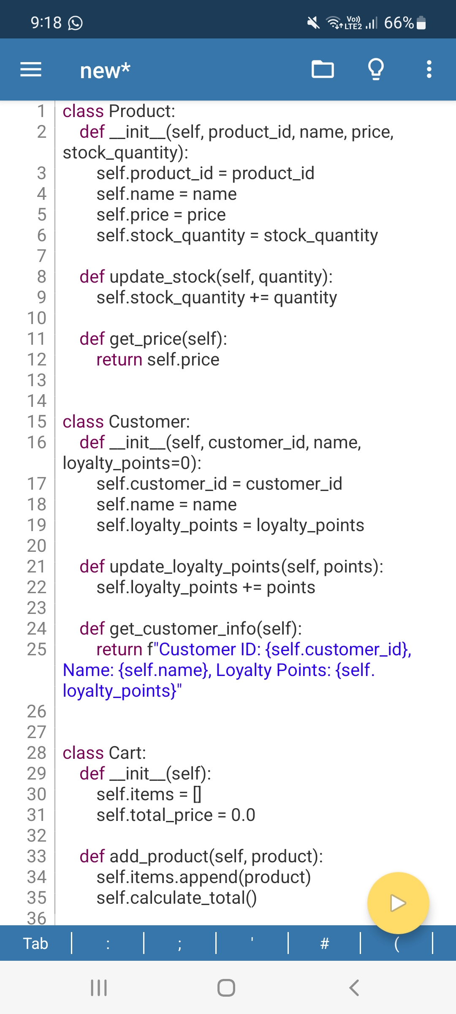

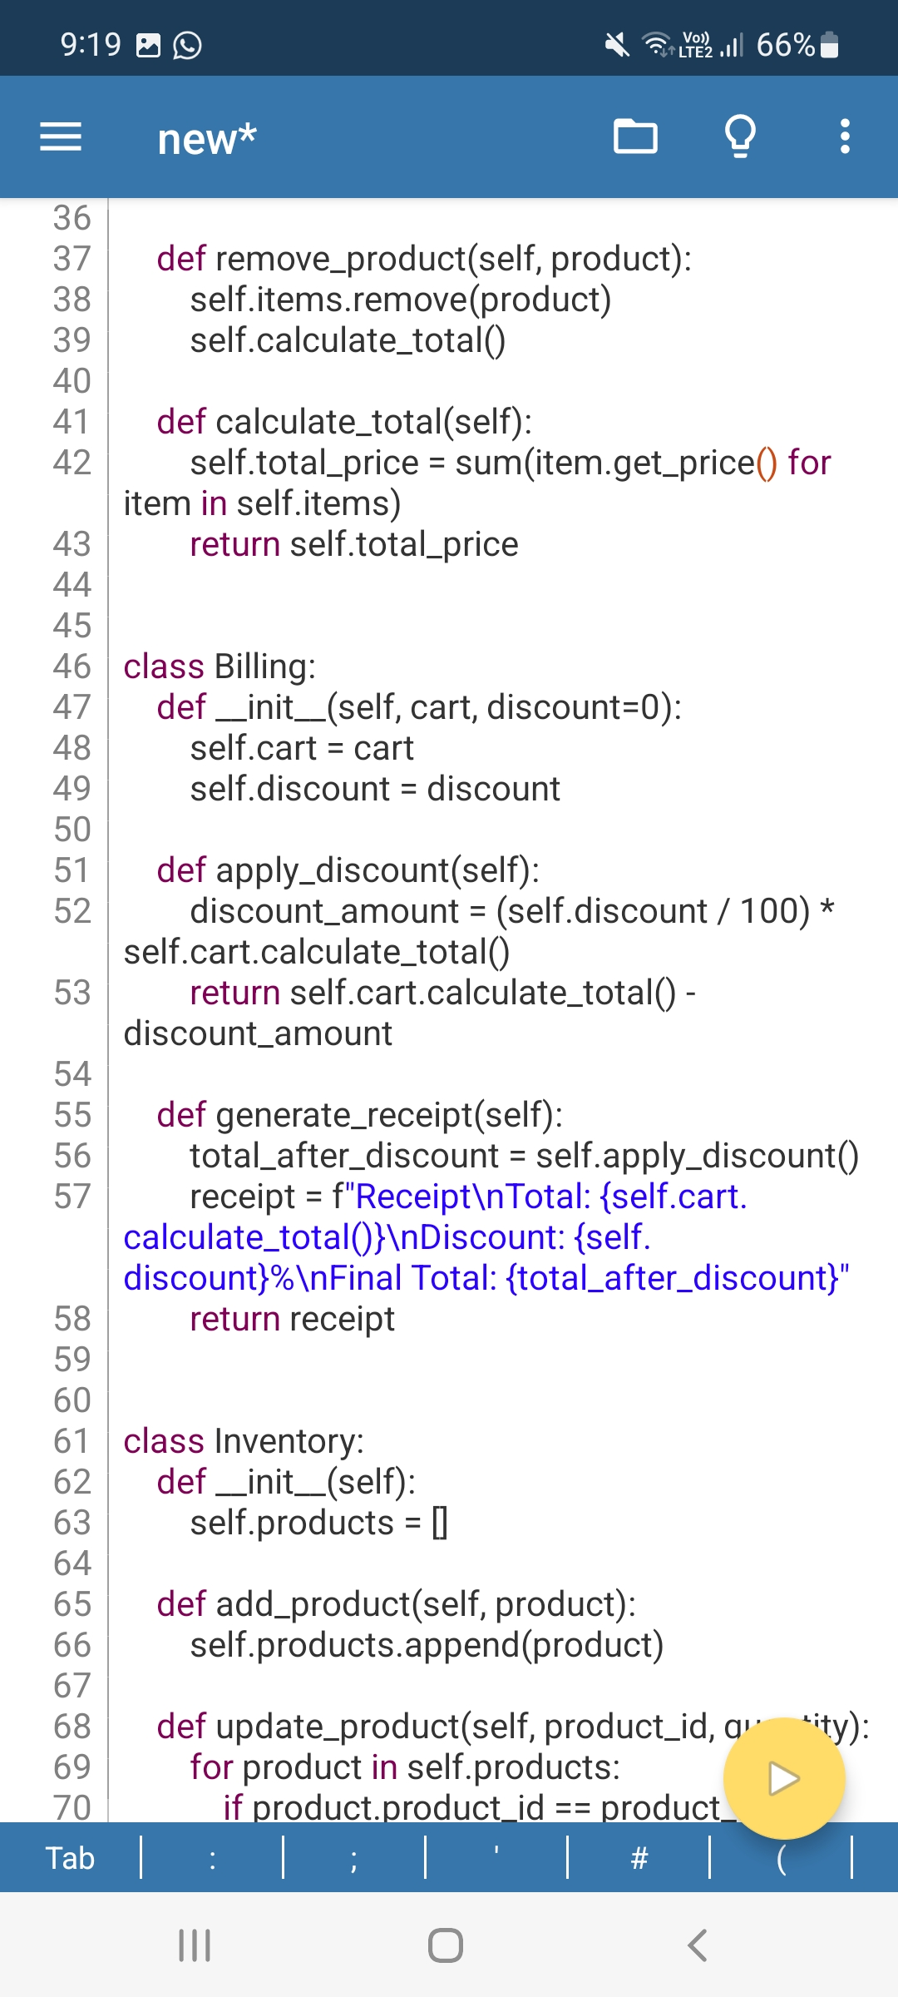

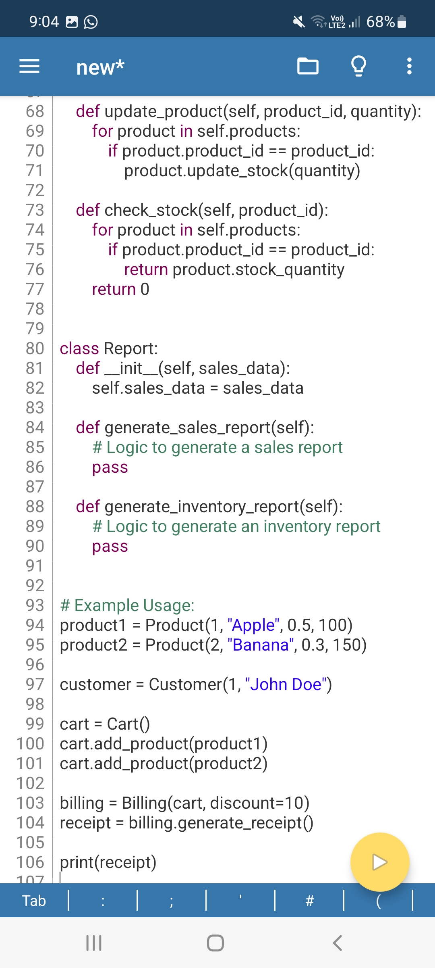

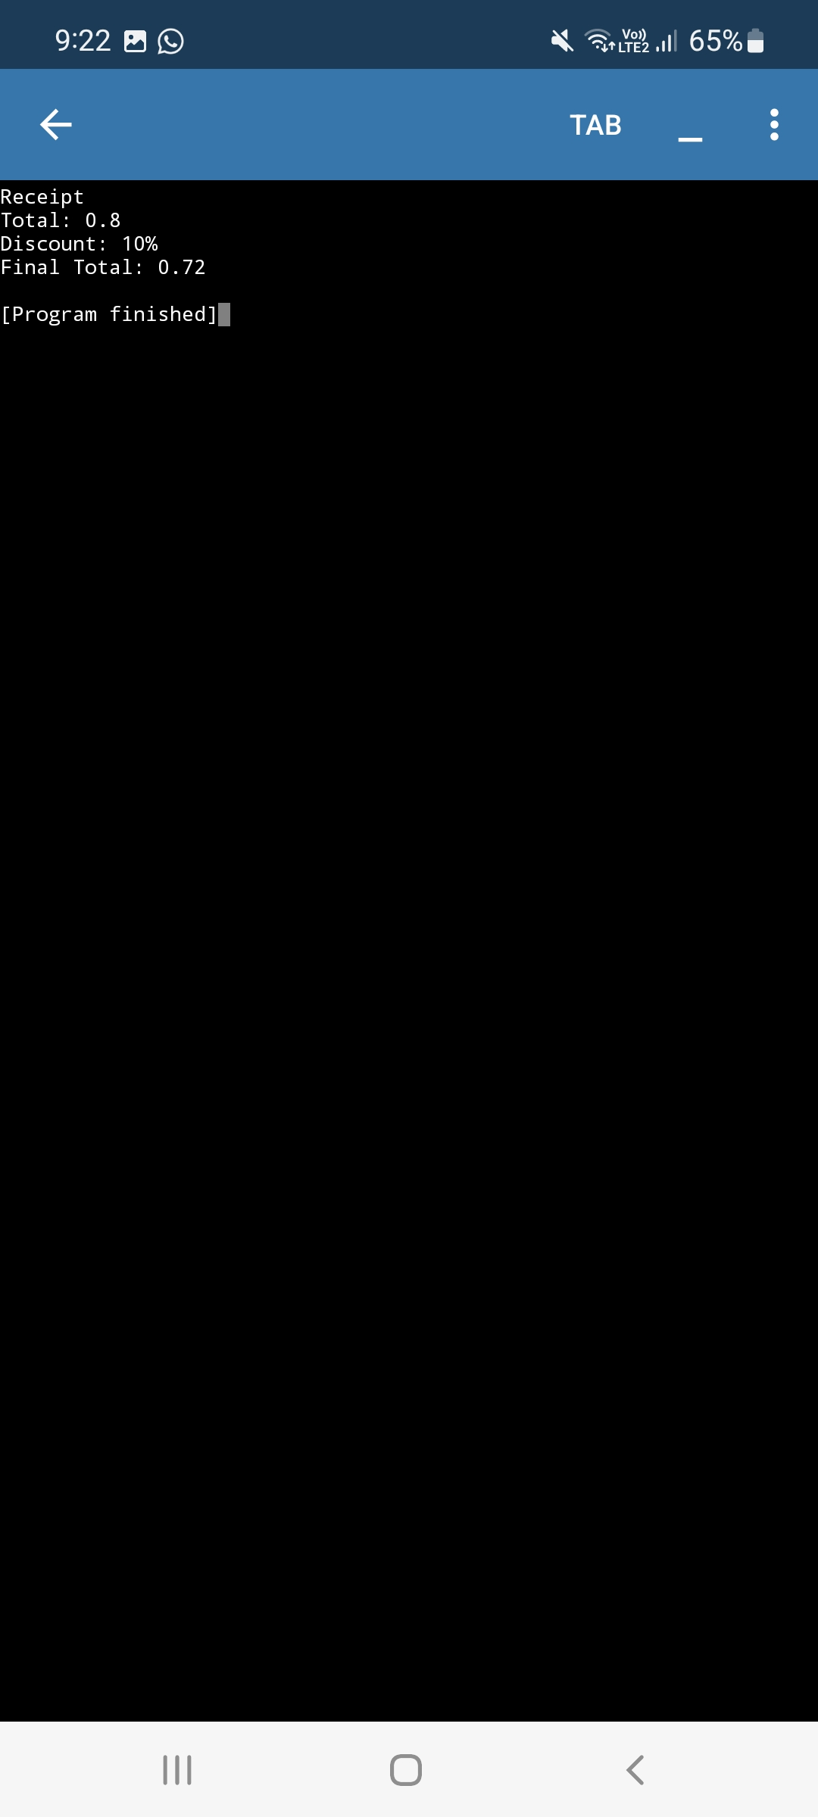**OUTPUT :**