# :::ANALYSIS OF LITERACY RATE IN INDIA-2021:::

To know development in a society, Literacy is another proper indicator of economic development. For purpose of census, a person in age limit of seven and above, who can both write and read with understanding in any language is considered as a literate in India. Literacy plays a major role in economic development of a naton. Although India has raised its current literacy rate of 74.04%(2021) from 12% at the time of Independance in 1947, its still lag behind the world average literacy rate of 84%.

**DASHBOARD**

# ::ANALYSIS AND VISUALISATIONS ::

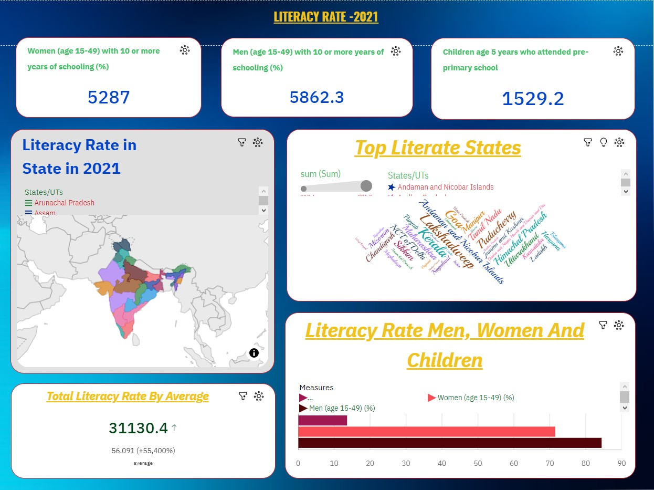

In data analytics, a dashboard is a visual interface that displays a collection of key performance indicators (KPIs), metrics, and data visualizations in a consolidated

and easily understandable format. Dashboards are designed to provide a quick and accessible way for users to monitor, analyze, and interpret data, enabling informed decision-making. Power BI is a tool developed by Microsoft which helps the users to easily visualize dynamic and interactive Reports/Dashboard by utlilizing its

Business Intelligence capabilities. Power BI is a tool which makes the decision making easier as it offers a wide range of interactive visualizations along with Busniess Intelligence capabilities. This Literacy rate in India 2021 Dashboard is been designed for the public to provide an overall view of the literacy rate of

different of states in India and their performance. This Dashboard shows Total number of Children, Total number of Males, Total number of Females are educated in different states in India. This Dashboards includes the following features: • Hidden filters are used in this Dashboard • Dynamic Tool tips are used for detailed

analysis. • Buttons are used in this Dashboard. • The background of Dashboard is made in powerpoint. Finally, the targeted audience of this dashboard is the public which in a glance will get to know that how well did their states has brought glory to the country by educating their people.

# :::STORY:::



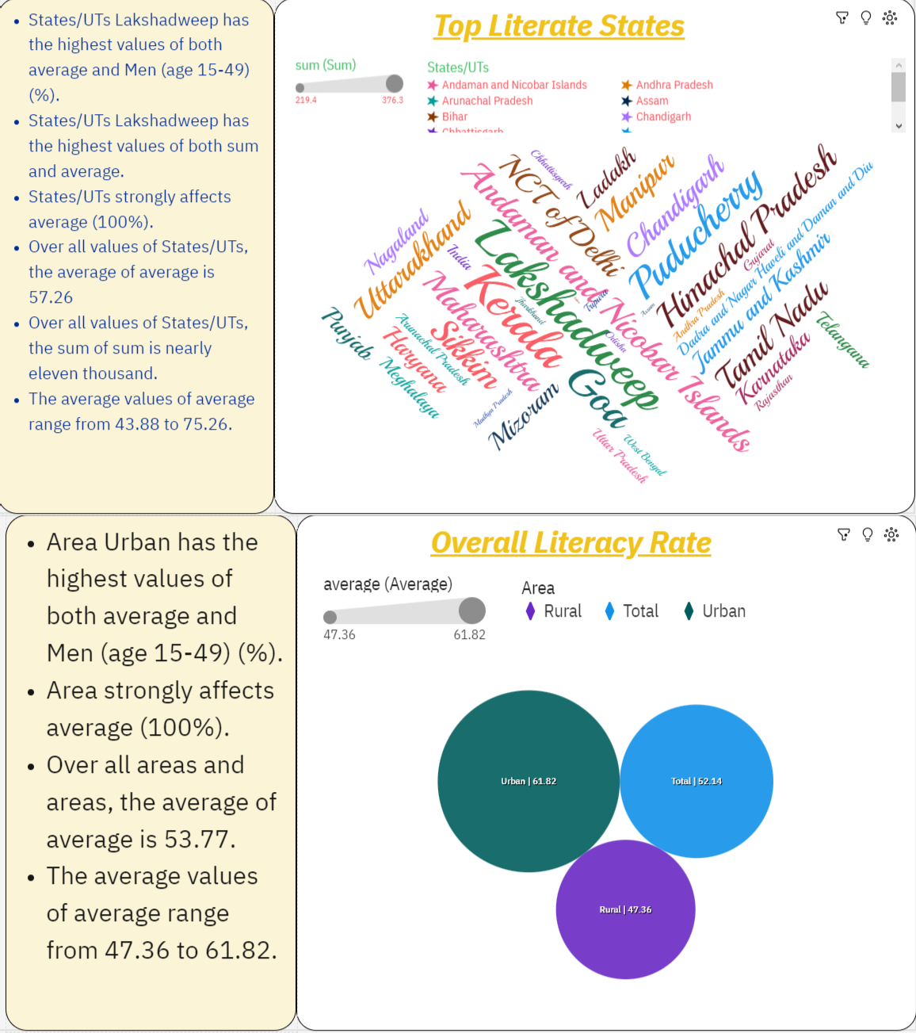

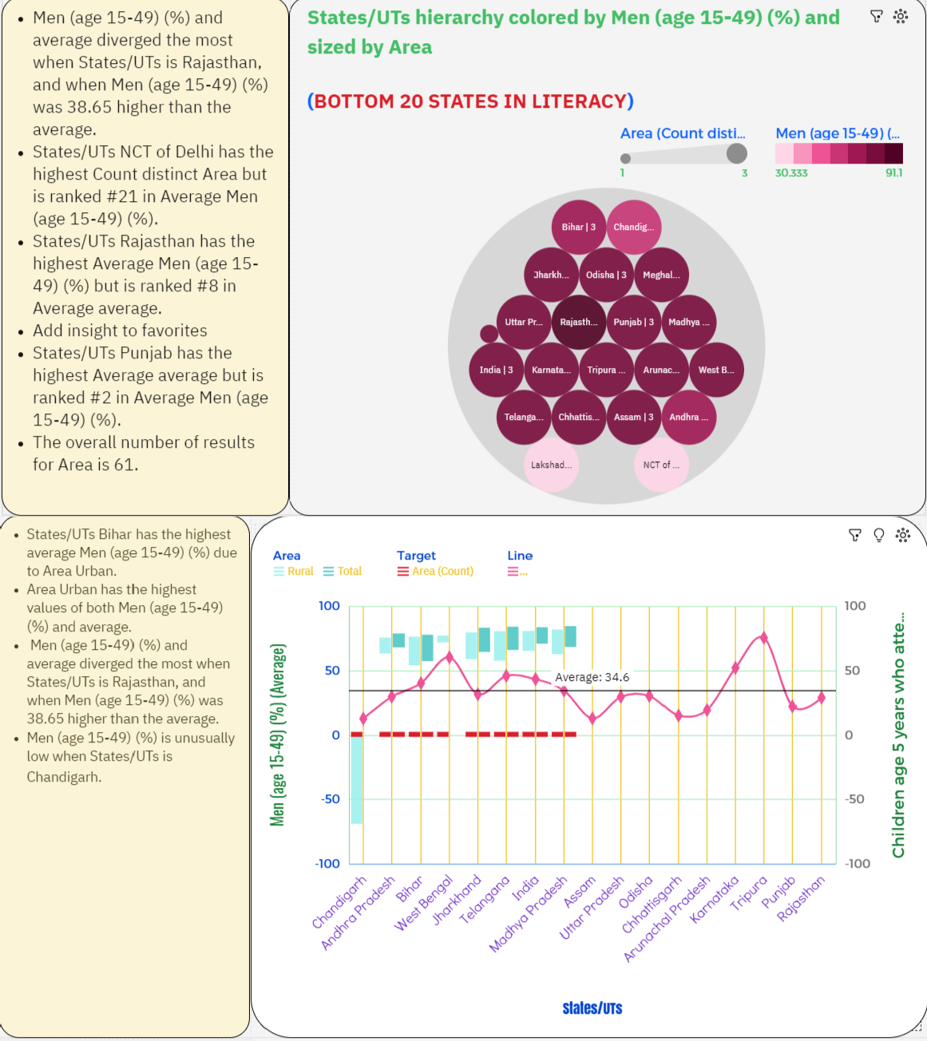

In data analytics, a "story" typically refers to a structured narrative or explanation created to communicate the insights, findings, and meaning derived from data analysis. A data analytics story is a way of presenting data-driven insights in a more relatable and comprehensible form, often to inform decision-makers,

stakeholders, or a broader audience. While Storytelling relates to a literary term, it’s use in Data Visualizations is similar to literature. We weave stories and tell them in ways that can make the story very interesting and can show you the various characters and the plot of the story and the importance of each and every character and element in the story. That helps us understand the story in a way that’s better than usual and can help it stick with us to recite to anyone else as and how it was understood by us. All in all, it is done to enhance the effect a usual story has on the reader. Think of the same thing but in a Data Visualization scenario and place the characters in your mindset to be the multiple variables contributing to the story, the plot of the story to be the baseline we’re trying to explain or the situation a

company is facing or just another scenario. The story is told about the various characters and how they impact the plot which is shown specifically using annotations as we’ll understand ahead

# :::REPORT:::

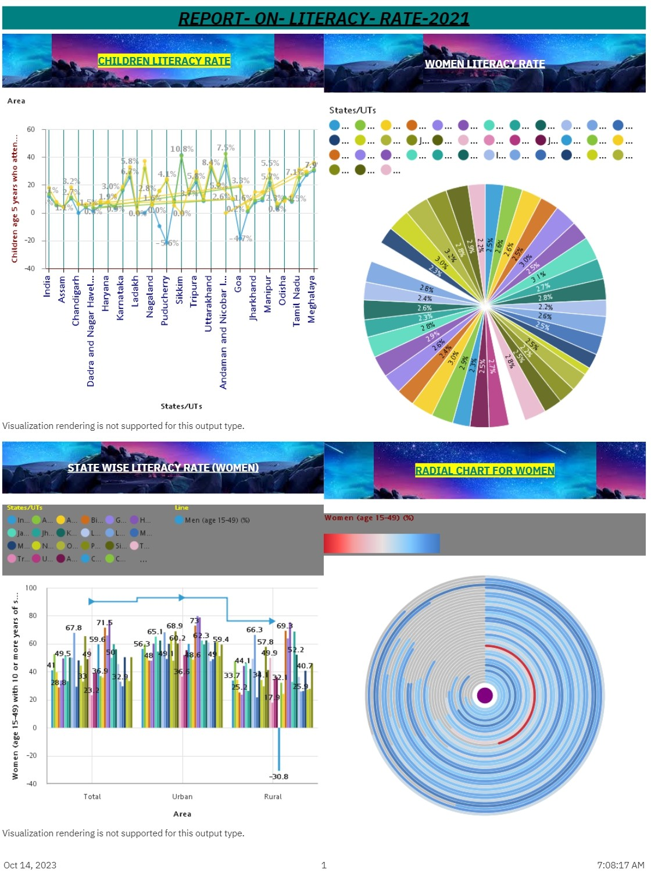

In data analytics, a "report" refers to a structured document or presentation that provides a comprehensive and detailed account of data analysis, findings, and insights. Reports are typically used to document and communicate the results of data analysis to a wider audience, often including stakeholders, management, or other interested parties. Here's a breakdown of the key elements of a data analytics report:No matter how high you rate your writing abilities, it's always a worthy idea to check out a competently written Report example, especially when you're handling a sophisticated Literacy rate topic. This is exactly the case when WowEssays.com catalog of sample Reports on LITERACY RATE-2021 will prove useful. Whether you need to come up with a fresh and meaningful LITERACY RATE topic or survey the paper's structure or formatting peculiarities, our samples will provide you with the required data. Another activity area of our write my

paper company is providing practical writing assistance to students working on LITERACY RATE. Research help, editing, proofreading, formatting, plagiarism check, or even crafting completely original model literacy papers upon your request – we can do that all! Place an order and buy a research paper now.

# **THIS IS OUR PROJECT ON TOPIC LITERACY RATE IN INDIA-2021 BY

**BHANUPRAKASH SINGAMPALLI(TEAM LEADER)**

**THOMAS SEERAPU(TEAM MEMBER)**

**S.K.S.R.KOUSHIK(TEAM MEMBER)**

**SWAMY SETTI(TEAM MEMBER)**

# LITERACY RATE SURVEY -2021 THANK YOU