Jenkins:

continuous integration and continuous delivery concepts.

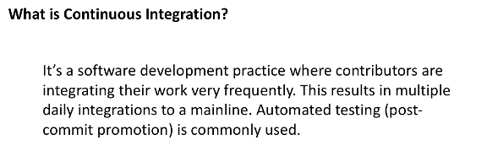

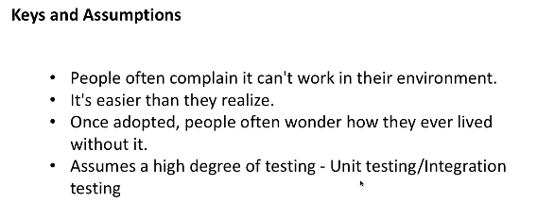

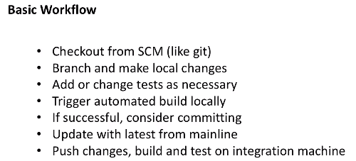

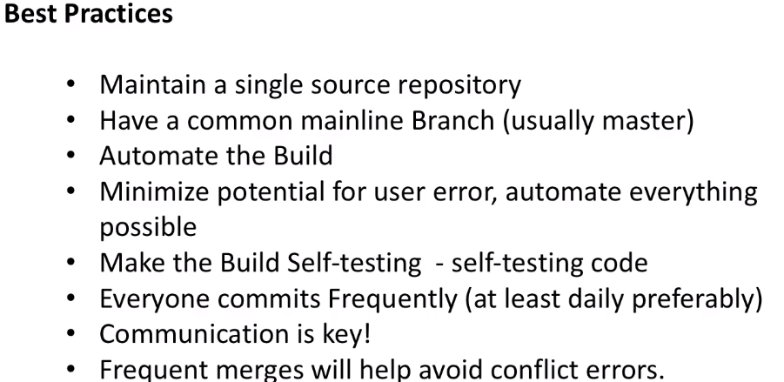

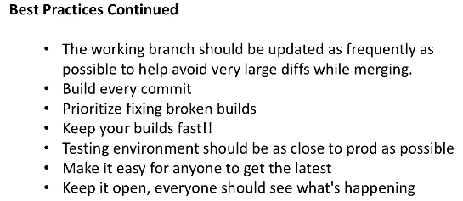

Continious delivery:

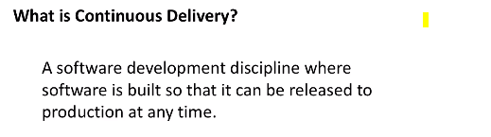

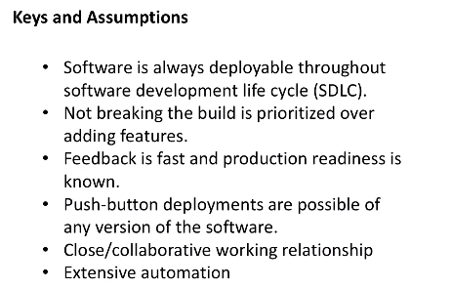

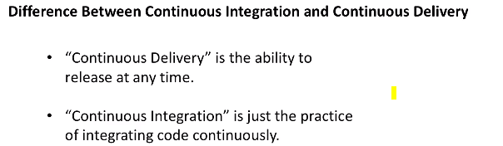

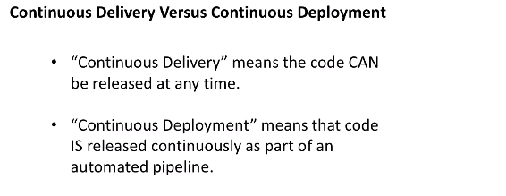

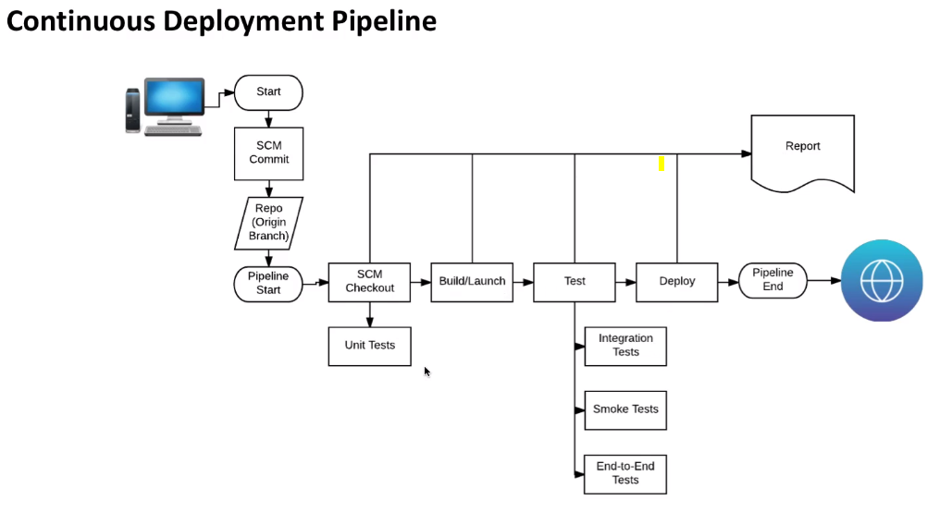

Installation of Jenkins:

After java installation go ahead witrh Jenkins installation

wget -O /etc/yum.repos.d/jenkins.repo https://pkg.jenkins.io/redhat-stable/jenkins.repo

rpm --import http://pkg.jenkins.io/redhat-stable/jenkins.io.key

yum install -y jenkins-2.19.4-1.1

Be sure to disable the source as described at the end of the video as well, so you don't accidentally get an update. The certification test is built around this version specifically. That's done with the following:

yum-config-manager --disable jenkins

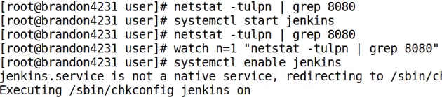

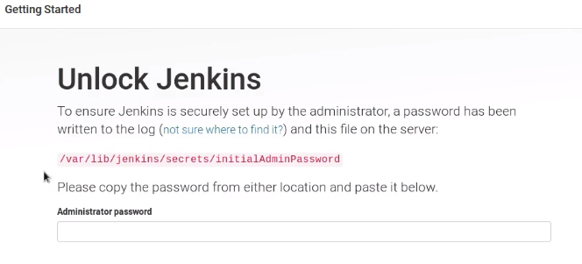

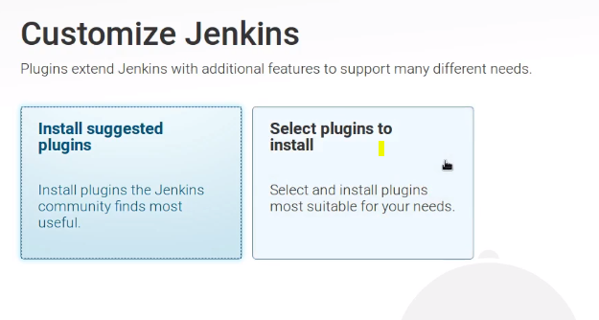

**user management and security using "Matrix-Based Security"**

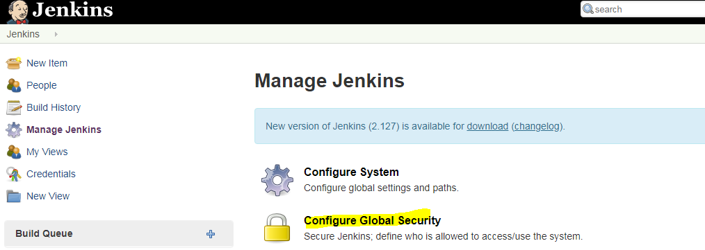

**Manage Jenkins> user management>**

**Created bhanu user**

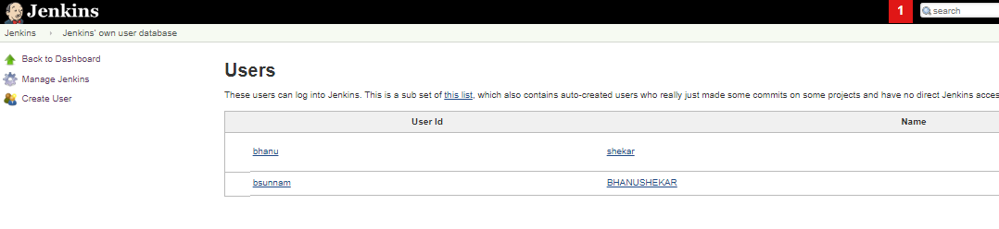

**Giving permissions for user > manager Jenkins>configure global security**

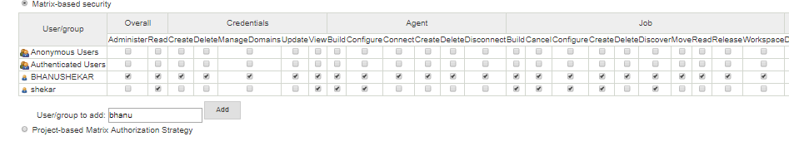

**Adding slave to Jenkins:**

**Load distribution and can execute builds from slave to**

**Manage Jenkins> manage node**

**Here I am accessing the node by using ssh key, we nee to have java installed on slave** 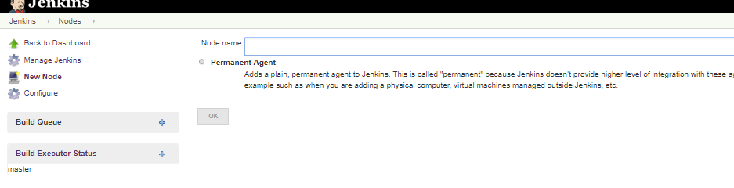

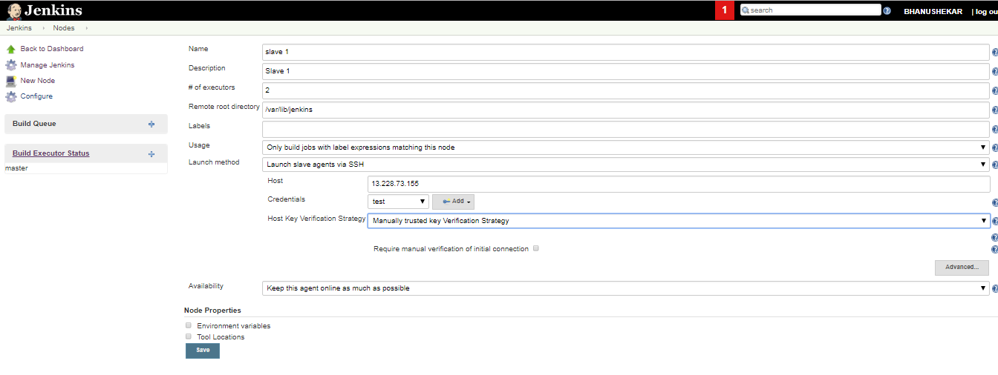

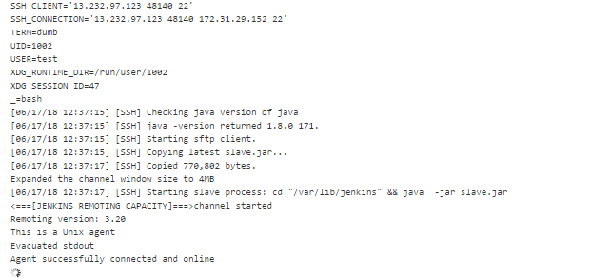

**Slave node is up and now we will try to configure a build**

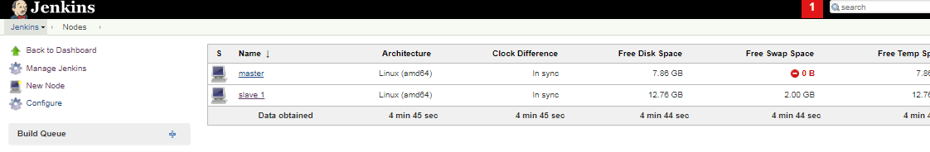

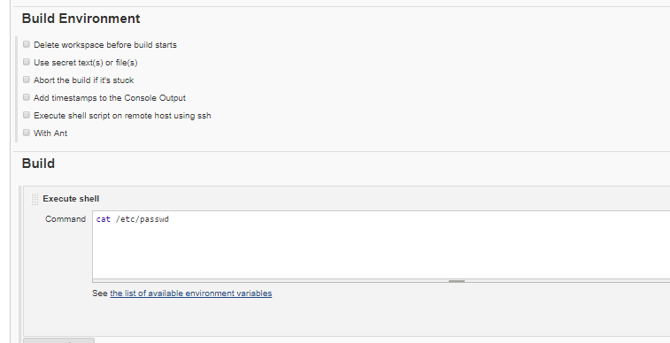

**Working With GIT:**

**For ssh connectivity to github add key to git**

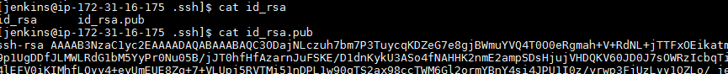

**Goto profile>settings > ssh keys**

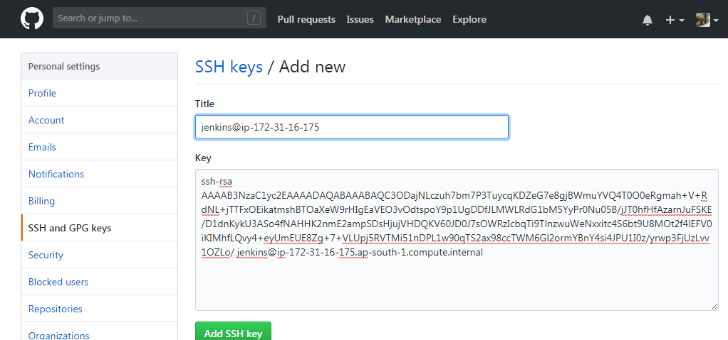

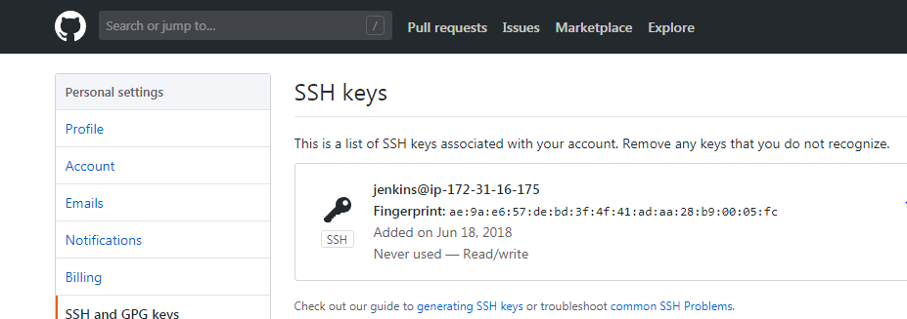

**Cloning is done**

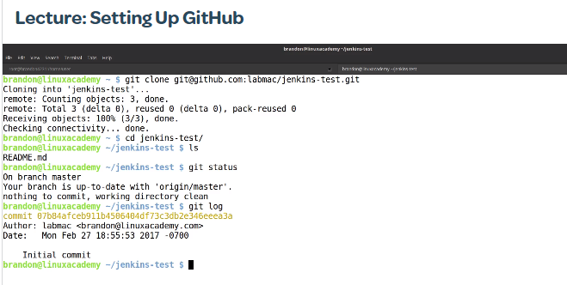

**Plugin Manager:**

 install/remove/upgrade/downgrade plugins using the Plugin Manager.

Plugin manager > updates, available, insatall, advanced

Can downgrade a package.

**Free Style Project:**

**Discard old builds: you can keep how many days builds to be there and max number of builds to keep by using this option.**

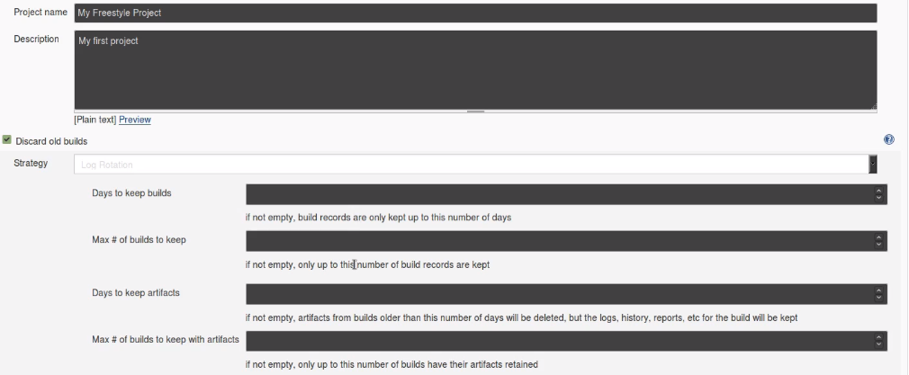

**Options in free style**

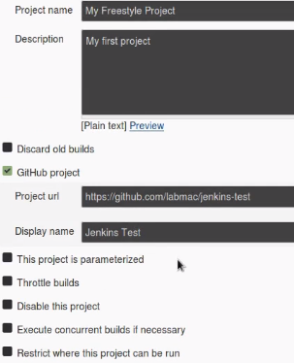

**Throttle builds: minimum time between the builds**

