Docker installation:
[user@tcox4 ~]$ sudo yum install -y yum-utils \
> device-mapper-persistent-data \
> lvm2
Loaded plugins: fastestmirror
docker-ce-stable | 2.9 kB 00:00:00
docker-ce-stable/x86_64/primary_db | 9.3 kB 00:00:00
Loading mirror speeds from cached hostfile
* base: linux.cc.lehigh.edu
* epel: s3-mirror-us-east-1.fedoraproject.org
* extras: mirrors.advancedhosters.com
* nux-dextop: mirror.li.nux.ro
* updates: repos-va.psychz.net
Package yum-utils-1.1.31-42.el7.noarch already installed and latest version
Resolving Dependencies
--> Running transaction check
---> Package device-mapper-persistent-data.x86_64 0:0.7.0-0.1.rc6.el7 will be installed
--> Processing Dependency: libaio.so.1(LIBAIO_0.4)(64bit) for package: device-mapper-persistent-data-0.7.0-0.1.rc6.el7.x86_64
...
[more packages listed here]
...

Dependencies Resolved

===================================================================================================================================================================
Package Arch Version Repository Size
===================================================================================================================================================================
Installing:
device-mapper-persistent-data x86_64 0.7.0-0.1.rc6.el7 base 400 k
lvm2 x86_64 7:2.02.171-8.el7 base 1.3 M
Installing for dependencies:
device-mapper-event x86_64 7:1.02.140-8.el7 base 180 k
device-mapper-event-libs x86_64 7:1.02.140-8.el7 base 179 k
libaio x86_64 0.3.109-13.el7 base 24 k
lvm2-libs x86_64 7:2.02.171-8.el7 base 1.0 M

Transaction Summary
===================================================================================================================================================================
Install 2 Packages (+4 Dependent packages)

Total download size: 3.1 M
Installed size: 7.7 M
Downloading packages:
(1/6): device-mapper-event-1.02.140-8.el7.x86_64.rpm | 180 kB 00:00:00
(2/6): device-mapper-event-libs-1.02.140-8.el7.x86_64.rpm | 179 kB 00:00:00
(3/6): lvm2-libs-2.02.171-8.el7.x86_64.rpm | 1.0 MB 00:00:00
(4/6): libaio-0.3.109-13.el7.x86_64.rpm | 24 kB 00:00:00
(5/6): device-mapper-persistent-data-0.7.0-0.1.rc6.el7.x86_64.rpm | 400 kB 00:00:00
(6/6): lvm2-2.02.171-8.el7.x86_64.rpm | 1.3 MB 00:00:00
-------------------------------------------------------------------------------------------------------------------------------------------------------------------
Total 5.2 MB/s | 3.1 MB 00:00:00
Running transaction check
Running transaction test
Transaction test succeeded
Running transaction
Installing : 7:device-mapper-event-libs-1.02.140-8.el7.x86_64 1/6
Installing : 7:device-mapper-event-1.02.140-8.el7.x86_64 2/6
Installing : 7:lvm2-libs-2.02.171-8.el7.x86_64 3/6
Installing : libaio-0.3.109-13.el7.x86_64 4/6
...
[package installation detail here]
... 6/6

Installed:
device-mapper-persistent-data.x86_64 0:0.7.0-0.1.rc6.el7 lvm2.x86_64 7:2.02.171-8.el7

Dependency Installed:
device-mapper-event.x86_64 7:1.02.140-8.el7 device-mapper-event-libs.x86_64 7:1.02.140-8.el7 libaio.x86_64 0:0.3.109-13.el7 lvm2-libs.x86_64 7:2.02.171-8.el7

Complete!
- Using the appropriate yum utility, add the Docker CE repository at https://download.docker.com/linux/centos/docker-ce.repo; update the local yum cache once added.
[user@tcox4 ~]$ sudo yum-config-manager \
> --add-repo \
> https://download.docker.com/linux/centos/docker-ce.repo

[sudo] password for user:
Loaded plugins: fastestmirror
adding repo from: https://download.docker.com/linux/centos/docker-ce.repo
grabbing file https://download.docker.com/linux/centos/docker-ce.repo to /etc/yum.repos.d/docker-ce.repo
repo saved to /etc/yum.repos.d/docker-ce.repo
- Execute the appropriate command to install the Docker CE application from the newly-configured repository.
[user@tcox4 ~]$ sudo yum install docker-ce
Loaded plugins: fastestmirror Loading mirror speeds from cached hostfile
* base: linux.cc.lehigh.edu * epel: s3-mirror-us-east-1.fedoraproject.org
* extras: mirrors.advancedhosters.com
* nux-dextop: mirror.li.nux.ro
* updates: repos-va.psychz.net
Resolving Dependencies -->
Running transaction check --->
Package docker-ce.x86_64 0:17.09.0.ce-1.el7.centos will be installed -->
Processing Dependency: container-selinux >= 2.9 for package: docker-ce-17.09.0.ce-1.el7.centos.x86_64 -->
Running transaction check --->
Package container-selinux.noarch 2:2.21-2.gitba103ac.el7 will be installed -->
Finished Dependency Resolution Dependencies Resolved
===================================================================================================================================================================
Package Arch Version Repository Size ===================================================================================================================================================================
Installing: docker-ce x86_64 17.09.0.ce-1.el7.centos docker-ce-stable 21 M
Installing for dependencies: container-selinux noarch 2:2.21-2.gitba103ac.el7 extras 29 k
Transaction Summary ===================================================================================================================================================================
Install 1 Package (+1 Dependent package) Total download size: 21 M Installed size: 76 M
Is this ok [y/d/N]: y
Downloading packages: (1/2): container-selinux-2.21-2.gitba103ac.el7.noarch.rpm | 29 kB 00:00:00
warning: /var/cache/yum/x86_64/7/docker-ce-stable/packages/docker-ce-17.09.0.ce-1.el7.centos.x86_64.rpm:
Header V4 RSA/SHA512 Signature, key ID 621e9f35: NOKEYETA Public key for docker-ce-17.09.0.ce-1.el7.centos.x86_64.rpm is not installed (2/2):
docker-ce-17.09.0.ce-1.el7.centos.x86_64.rpm | 21 MB 00:00:00
-------------------------------------------------------------------------------------------------------------------------------------------------------------------
Total 26 MB/s | 21 MB 00:00:00 Retrieving key from https://download.docker.com/linux/centos/gpg
Importing GPG key 0x621E9F35: Userid : "Docker Release (CE rpm) <docker@docker.com>"
Fingerprint: 060a 61c5 1b55 8a7f 742b 77aa c52f eb6b 621e 9f35
From : https://download.docker.com/linux/centos/gpg
Is this ok [y/N]: y
Running transaction check Running transaction test
Transaction test succeeded Running transaction
Installing : 2:container-selinux-2.21-2.gitba103ac.el7.noarch 1/2
Installing : docker-ce-17.09.0.ce-1.el7.centos.x86_64 2/2
Verifying : docker-ce-17.09.0.ce-1.el7.centos.x86_64 1/2
Verifying : 2:container-selinux-2.21-2.gitba103ac.el7.noarch 2/2
Installed: docker-ce.x86_64 0:17.09.0.ce-1.el7.centos
Dependency Installed: container-selinux.noarch 2:2.21-2.gitba103ac.el7 Complete!
- Once installed, verify that the 'docker' group exists on your system. If not, create one. Once verified or created, add the 'user' account to that group so that sudo rights are not necessary to run Docker commands.
[user@tcox4 ~docker:x:988:

[user@tcox4 ~]$ cat /etc/group | grep docker
docker:x:988:user
- Using the appropriate service management commands, enable the Docker CE service so that it starts automatically on boot, and then start the Docker CE service. Verify that it is running after. NOTE: You will need to log out and then back in for the new group setting above to work.
[user@tcox4 ~]$ sudo systemctl enable docker
Created symlink from /etc/systemd/system/multi-user.target.wants/docker.service to /usr/lib/systemd/system/docker.service.
[user@tcox4 ~]$ sudo systemctl start docker
[user@tcox4 ~]$ sudo systemctl status docker
● docker.service - Docker Application Container Engine
Loaded: loaded (/usr/lib/systemd/system/docker.service; enabled; vendor preset: disabled)
Active: active (running) since Fri 2017-10-06 15:53:03 UTC; 7s ago
Docs: https://docs.docker.com
Main PID: 1771 (dockerd)
Memory: 16.1M
CGroup: /system.slice/docker.service
├─1771 /usr/bin/dockerd
└─1774 docker-containerd -l unix:///var/run/docker/libcontainerd/docker-containerd.sock --metrics-interval=0 --start-timeout 2m --state-dir /var/run/...

Oct 06 15:53:02 tcox4.mylabserver.com dockerd[1771]: time="2017-10-06T15:53:02.980239996Z" level=info msg="Loading containers: start."
Oct 06 15:53:02 tcox4.mylabserver.com dockerd[1771]: time="2017-10-06T15:53:02.997208429Z" level=warning msg="Running modprobe bridge br_netfilter faile...t found.
Oct 06 15:53:02 tcox4.mylabserver.com dockerd[1771]: insmod /lib/modules/3.10.0-327.28.2.el7.x86_64/kernel/net/bridge/bridge.ko
Oct 06 15:53:02 tcox4.mylabserver.com dockerd[1771]: , error: exit status 1"
Oct 06 15:53:03 tcox4.mylabserver.com dockerd[1771]: time="2017-10-06T15:53:03.793009699Z" level=info msg="Default bridge (docker0) is assigned with an ...address"
Oct 06 15:53:03 tcox4.mylabserver.com dockerd[1771]: time="2017-10-06T15:53:03.905408599Z" level=info msg="Loading containers: done."
Oct 06 15:53:03 tcox4.mylabserver.com dockerd[1771]: time="2017-10-06T15:53:03.912302898Z" level=info msg="Docker daemon" commit=afdb6d4 graphdriver(s)=....09.0-ce
Oct 06 15:53:03 tcox4.mylabserver.com dockerd[1771]: time="2017-10-06T15:53:03.912451551Z" level=info msg="Daemon has completed initialization"
Oct 06 15:53:03 tcox4.mylabserver.com dockerd[1771]: time="2017-10-06T15:53:03.936379297Z" level=info msg="API listen on /var/run/docker.sock"
Oct 06 15:53:03 tcox4.mylabserver.com systemd[1]: Started Docker Application Container Engine.
Hint: Some lines were ellipsized, use -l to show in full.
- To test that the service is listening AND Step #4 was correctly completed, pull the default repository image called 'httpd' to your server.
[user@tcox4 ~]$ docker pull httpd
Using default tag: latest
latest: Pulling from library/httpd
aa18ad1a0d33: Pull complete
2b28e4afdec2: Pull complete
802b6cd5ed3b: Pull complete
6f2336b7c318: Pull complete
d7c441746c9e: Pull complete
a36c7f15867a: Pull complete
a0d42b9fc107: Pull complete
Digest: sha256:cf774f082e92e582d02acdb76dc84e61dcf5394a90f99119d1ae39bcecbff075
Status: Downloaded newer image for httpd:latest
- Run the appropriate Docker CE command that will display a list of all images that are locally installed.
[user@tcox4 ~]$ docker images
REPOSITORY TAG IMAGE ID CREATED SIZE
httpd latest cf6b6d2e8463 42 hours ago 182MB

Sample history
sudo yum install -y yum-utils devic-mapper-persistent-data lvm2
32 sudo yum-config-manager --add-repo https://download.docker.com/linux/centos/docker-ce.repo
33 sudo yum install docker-ce
34 cat /etc/group | grep docker
35 chmod -aG docker cloud_user
36 usermod -aG docker cloud_user
37 sudo usermod -aG docker cloud_user
38 cat /etc/group | grep docker
39 sudo systemctl enable docker
40 sudo systemctl start docker
41 docker pull centos7
42 sudo docker pull centos7
43 cd /var/lib/
44 ll
45 cd docker/
46 ll
47 sudo ll
48 sudo ls
49 ll /var/run/docker.sock
50 cd /home/cloud_user/
51 docker pull centos7
52 sudo chmod 777 /var/run/docker.sock
53 docker pull centos7
54 sudo docker pull centos7
55 docker pull htttpd
56 docker pull httpd
57 docker pull CentOS7
58 docker pull centos 7
59 docker pull centos6

Docker UCP AND DTR Backup:
BACKUP UCP:
# docker container run --log-driver none --rm -i --name ucp -v /var/run/docker.sock:/var/run/docker.sock docker/ucp backup --id a4l7ruc2ookzi3h49wv4hffmt > backup.tar

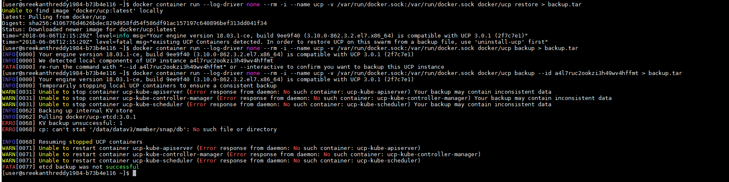

Restore UCP:
#docker container run --log-driver none --rm -i --name ucp -v /var/run/docker.sock:/var/run/docker.sock docker/ucp restore --id a4l7ruc2ookzi3h49wv4hffmt < backup.tar

DTR BACKUP
[user@sreekanthreddy1984-b73b4e116 ~]$ docker run -i --rm docker/dtr backup --ucp-insecure-tls --ucp-url https://172.31.19.174:443 --ucp-username admin --ucp-password Bhanu@123 > dtr-backup.tar
INFO[0000] Validating UCP cert
INFO[0000] Connecting to UCP
INFO[0000] health checking ucp
INFO[0001] Searching containers in UCP for DTR replicas
INFO[0001] This cluster contains the replicas: a6ed7b64671c
Choose a replica to back up from [a6ed7b64671c]:
INFO[0000] Validating UCP cert
INFO[0000] Connecting to UCP
INFO[0000] health checking ucp
INFO[0000] Connecting to network: dtr-ol
INFO[0000] Waiting for phase2 container to be known to the Docker daemon
INFO[0000] Establishing connection with Rethinkdb
INFO[0000] Backing up DTR
INFO[0000] Establishing connection with Rethinkdb
INFO[0000] Recording time of backup
INFO[0011] Backup complete.
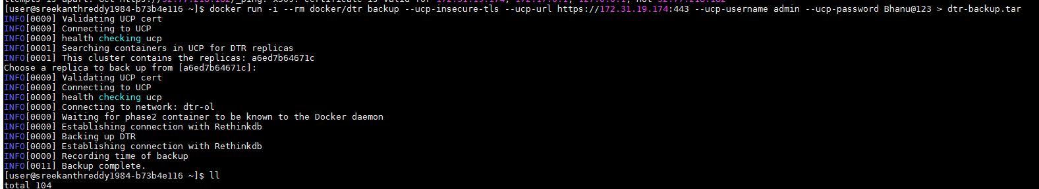

Restore DTR:

docker run -i --rm docker/dtr restore --ucp-insecure-tls --ucp-url https://172.31.19.174:443 --ucp-username admin --ucp-password Bhanu@123 < dtr-backup.tar
#dring backup dtr will not be available completely, run at night times

Creating user, origination team, and adding user to that team and organization
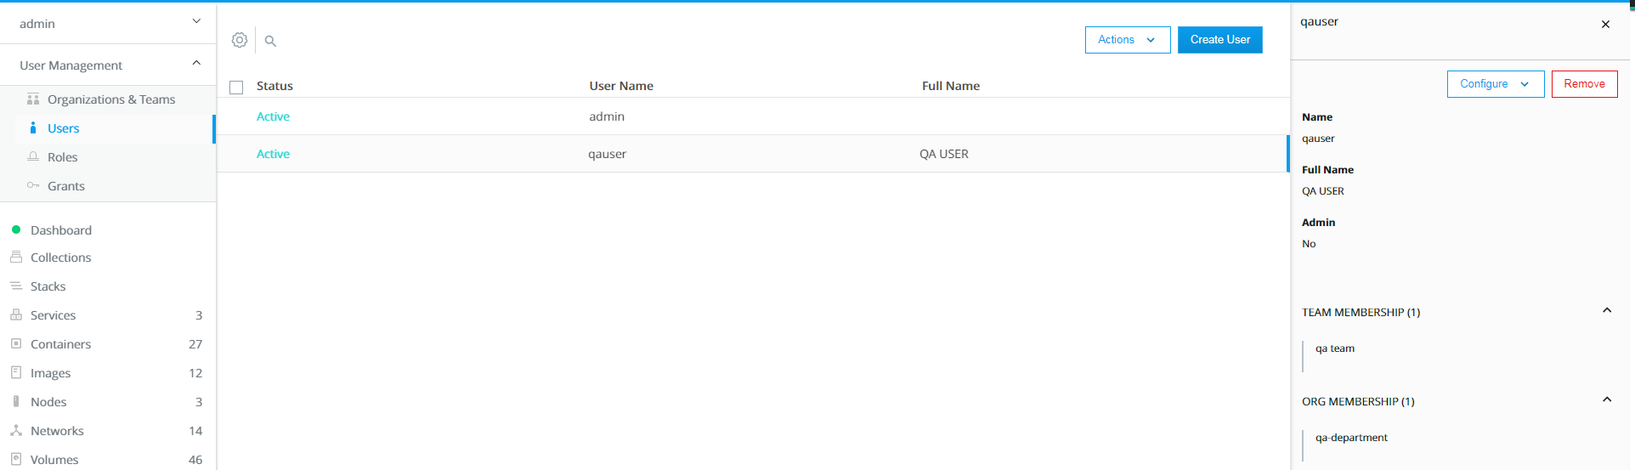

Docker and name spaces:
Name space provides isolation so that other pecies of system remain uneffected by what ever with in that name sapce
Name space types:
Process id(only that process will effected)
Mounts (volumes that ae coming from storage)
IPC(Interprocess communication)
USER(Ability to remap the user from a container to under line host)
Network isolation

Docker and control groups:
CG provides resource limitation and reporting capability within the container space, they allow granular control over what host resources are allocated to the containers and what they are allcoated

Common control groups:
Cpu, memory, network bandwith, disk, priority

Docker pull and images:
**********
docker images
87 CLEAR
88 docker pull hello-world
89 clear
90 docker images
91 docker pull -a hello-world
92 docker images
93 docker pull --disable-content-truts hello-world
94 docker pull --disable-content-trust hello-world
95 docker images
96 docker run hello-world
97 docker run -it ubuntu bash
**********************

[user@sreekanthreddy1984-b73b4e115 ~]$ docker run hello-world
Hello from Docker!
This message shows that your installation appears to be working correctly.
To generate this message, Docker took the following steps:
1. The Docker client contacted the Docker daemon.
2. The Docker daemon pulled the "hello-world" image from the Docker Hub.
(amd64)
3. The Docker daemon created a new container from that image which runs the
executable that produces the output you are currently reading.
4. The Docker daemon streamed that output to the Docker client, which sent it
to your terminal.

To try something more ambitious, you can run an Ubuntu container with:
$ docker run -it ubuntu bash

Share images, automate workflows, and more with a free Docker ID:
https://hub.docker.com/

For more examples and ideas, visit:
https://docs.docker.com/engine/userguide/

[user@sreekanthreddy1984-b73b4e115 ~]$ docker run -it ubuntu bash
Unable to find image 'ubuntu:latest' locally
latest: Pulling from library/ubuntu
6b98dfc16071: Pull complete
4001a1209541: Pull complete
6319fc68c576: Pull complete
b24603670dc3: Pull complete
97f170c87c6f: Pull complete
Digest: sha256:5f4bdc3467537cbbe563e80db2c3ec95d548a9145d64453b06939c4592d67b6d
Status: Downloaded newer image for ubuntu:latest

To know more inforation of images
#docker images --digests
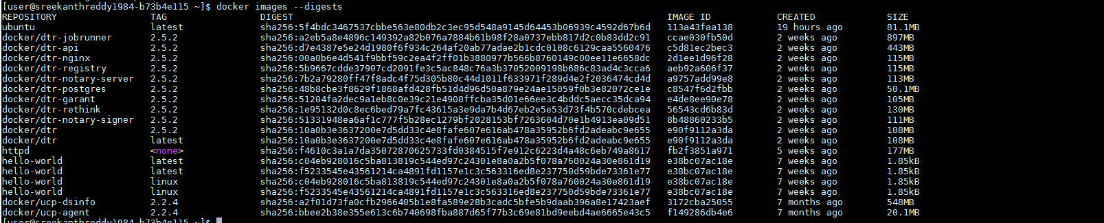
#pull docker images centos76 and know images before centos
202 docker images --filter "before:6"
203 docker images --filter "before=centos:6"
Docker images –no-trunc

