Use Case and Design Specification Login
Project – TEKDESK

Author: Bharath R
Document Number: Use Case and Design Specification Login V1.0
Document Version Number: Version V1.0 Last Modified: 3rd May 2021

Table of Contents

1. Name 2
1.1 Brief Description 2
1.2 Actor Description 2
1.3 Screen Mockup 2
2. Flow of Events 3
2.1 Basic Flow 3

3. Post Conditions 3

4. Document History 4

Use Case Specification- sample

Name
Login

Brief Description
This use case describes the scenario when an employee faces problem related to software or hardware or infrastructure, finance, networking etc...

Actor Description
Employee who faces an issue and require immediate solution.

Screen Mockup

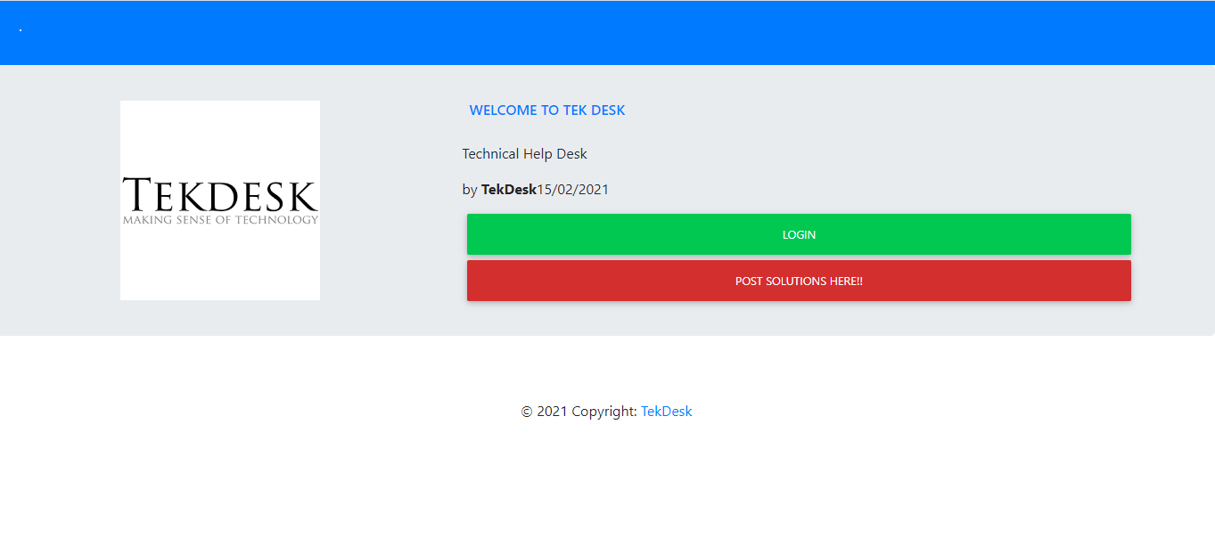

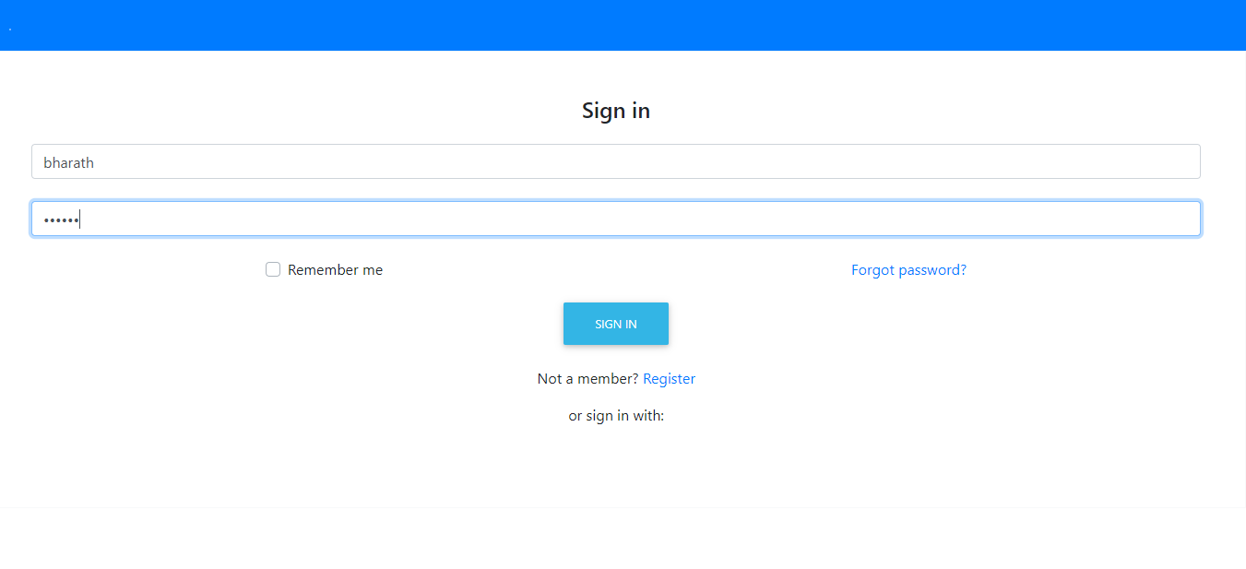

Flow of Events

Basic Flow
- The use case begins when the employee tries to login to the portal.

- The employee has to provide his/her User Name and Password and should click on Submit button to login successfully. Any employee without username and password cannot login.

- An alert message will pop up (saying “Please enter valid User Name and Password”) if the entered username or password is invalid.

- If the entered username and password is valid and the submit button is clicked the page will be navigated to another page.

Post Conditions
After logging in successfully employee will be navigated to Welcome page.

Document Change History

Date | Author/Editor | Description of Change(s)
03/05/2021 | Bharath R | Version 1.0

