***Day-7:***

**1.Conditional Rendering:**

App.js:

import React**,** **{** useState **}** from **'**react**'**

import True from **'**./components/True**'**

import False from **'**./components/False**'**

const App = **()** => **{**

const **[**data**,** setData**]** = useState(true)

  return (

**<**div**>**

**{**

            data ? (**<***True***/>**) : (**<***False***/>**)

**}**

**</**div**>**

  )

**}**

export default App

True.js:

import React from **'**react**'**

const True = **()** => **{**

  return (

**<**div**>**True**</**div**>**

  )

**}**

export default True

False.js:

import React from **'**react**'**

const False = **()** => **{**

  return (

**<**div**>**False**</**div**>**

  )

**}**

export default False

OUTPUT:

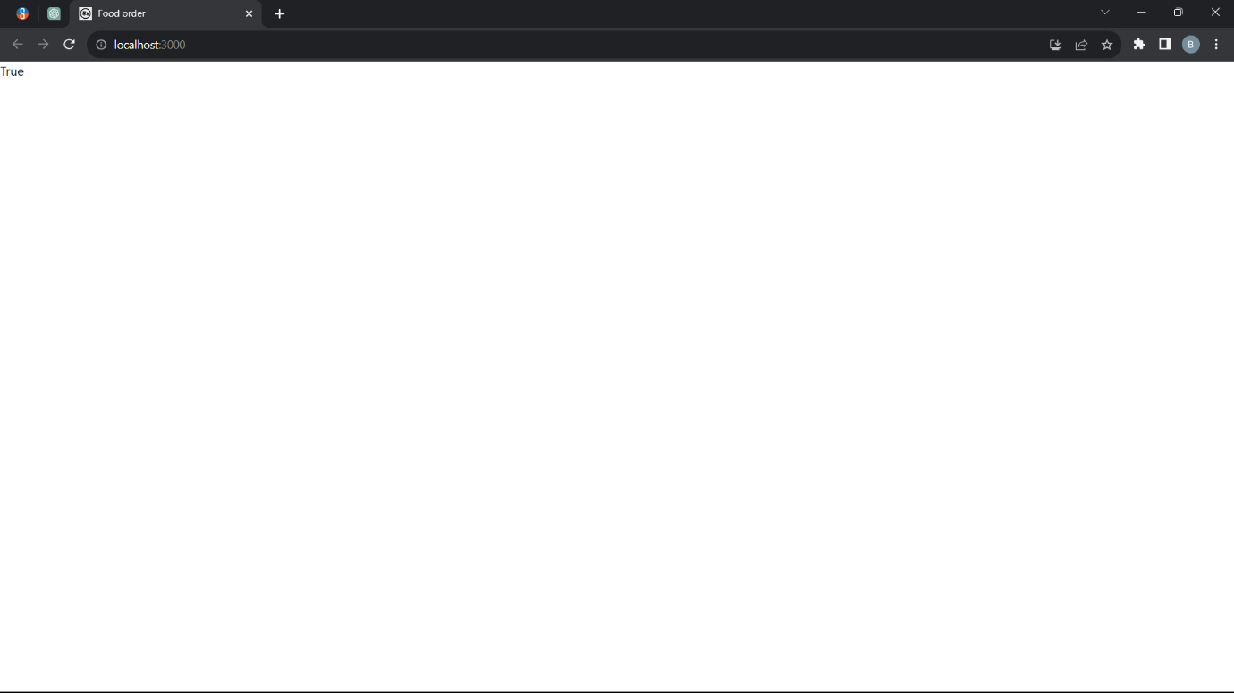

--------------------------------------------------------------------------------------------------------------------------------------

**2. Axios Post :**

App.js:

import React from **'**react**'**

import Axiosget from **'**./components/axios/Axiosget**'**

import Axiospost from **'**./components/axios/axiospost**'**

const App = **()** => **{**

  return (

**<**div**>**

**{**

**<***Axiospost***/>**

**}**

**</**div**>**

  )

**}**

export default App

axiospost.js:

import axios from **'**axios**';**

import React**,** **{** useRef **}** from **'**react**';**

const Axiospost = **()** => **{**

    const bookIDRef = useRef(**""**)**;**

    const booktitleRef = useRef(null)**;**

    const bookauthorRef = useRef(null)**;**

    const handlepost =async **()** => **{**

        const data = **{**

            id**:** bookIDRef**.**current**.**value**,**

            title**:** booktitleRef**.**current**.**value**,**

            author**:** bookauthorRef**.**current**.**value

**};**

        try **{**

            const response = await axios**.**post(**"**http://localhost:8080/books**",** data)**;**

*console***.**log(response)**;**

**}** catch (error) **{**

*console***.**log(error)**;**

**}**

**};**

    return (

**<**div**>**

**<**input type=**'**text**'** ref=**{**bookIDRef**}** **/>**

**<**input type=**'**text**'** ref=**{**booktitleRef**}** **/>**

**<**input type=**'**text**'** ref=**{**bookauthorRef**}** **/>**

**<**button onClick=**{**handlepost**}>**Submit**</**button**>**

**</**div**>**

    )**;**

**};**

export default Axiospost**;**

db.json:

**{**

**"***books***":** **[**

**{**

**"***id***":** 1**,**

**"***title***":** **"**Bookname**",**

**"***author***":** **"**Bharath**"**

**},**

**{**

**"***id***":** **"**2**",**

**"***title***":** **"**BB**",**

**"***author***":** **"**BKS**"**

**}**

**],**

**"** *users***":** **[]**

**}**

OUTPUT:  
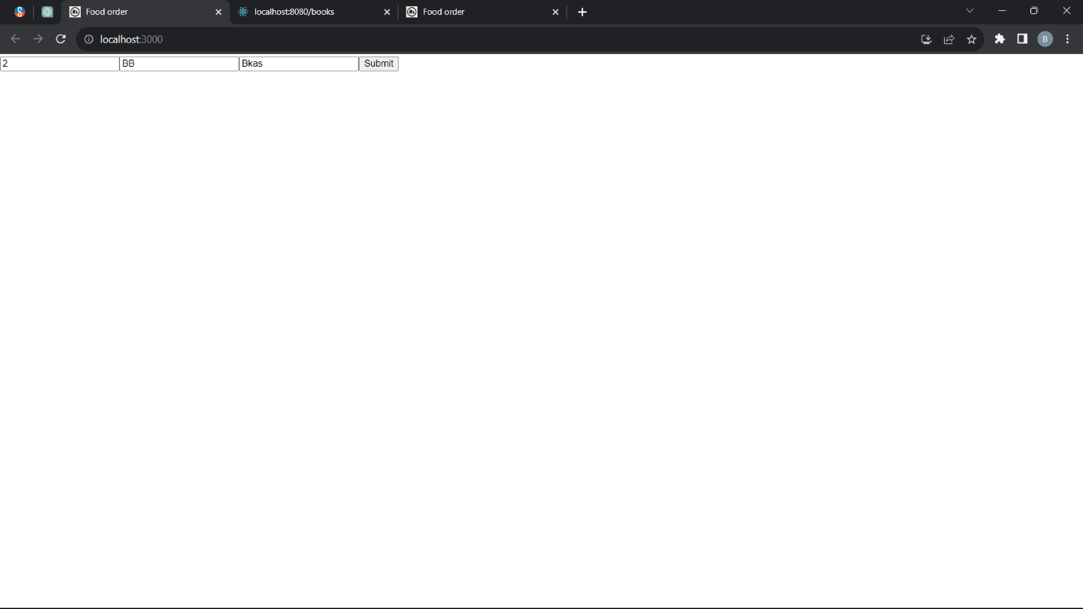

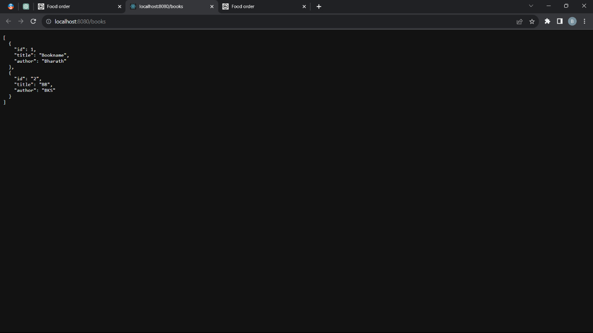

--------------------------------------------------------------------------------------------------------------------------------------

**3.AxiosDelete:**

App.js:

import React from **'**react**'**

import AxiosDelete from **'**./components/axios/axiosdelete**'**

const App = **()** => **{**

  return (

**<**div**>**

**{**

**<***AxiosDelete***/>**

**}**

**</**div**>**

  )

**}**

export default App

axiosdelete.js:

import React**,** **{** useState **}** from **'**react**';**

import axios from **'**axios**';**

const AxiosDelete = **()** => **{**

  const **[**bookId**,** setBookId**]** = useState(**""**)**;**

  const **[**message**,** setMessage**]** = useState(**""**)**;**

  const handleDelete = async **()** => **{**

    try **{**

      const response = await axios**.**delete(**`**http://localhost:8080/books/**${**bookId**}`**)**;**

      setMessage(**`**Book with ID **${**bookId**}** deleted successfully**`**)**;**

**}** catch (error) **{**

      setMessage(**`**Error deleting book with ID **${**bookId**}`**)**;**

**}**

**};**

  return (

**<**div**>**

**<**h2**>**Delete Books**</**h2**>**

**<**label**>**

        Enter Book ID to Delete:

**<**input

          type=**'**text**'**

          value=**{**bookId**}**

          onChange=**{(***e***)** => setBookId(*e***.**target**.***value*)**}**

**/>**

**</**label**>**

**<**button onClick=**{**handleDelete**}>**Delete Book**</**button**>**

**{**message && **<**p**>{**message**}</**p**>}**

**</**div**>**

  )**;**

**};**

export default AxiosDelete**;**

OUTPUT:

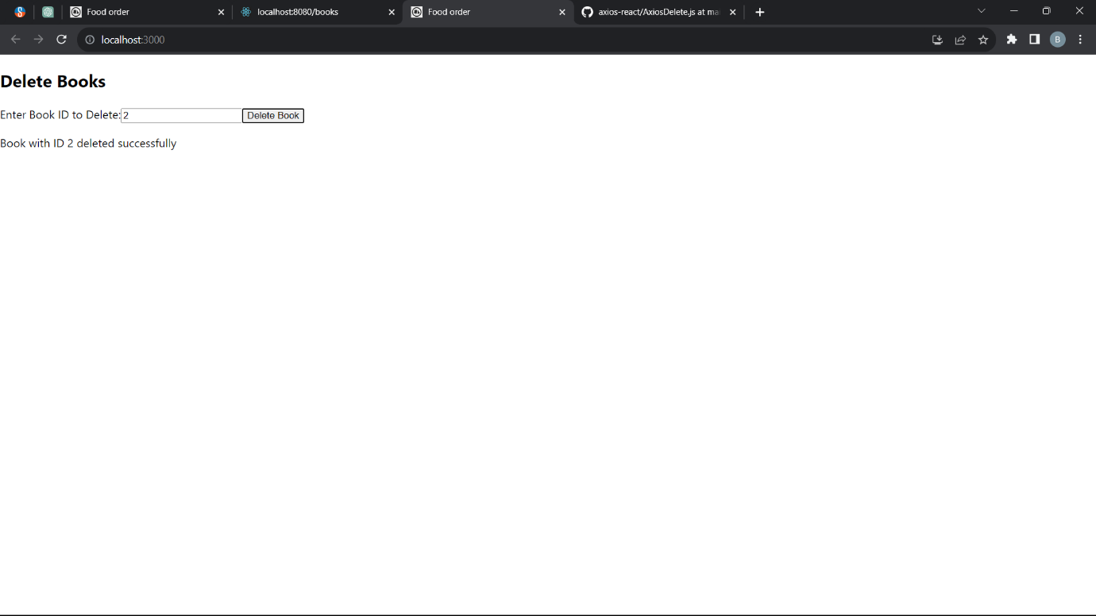

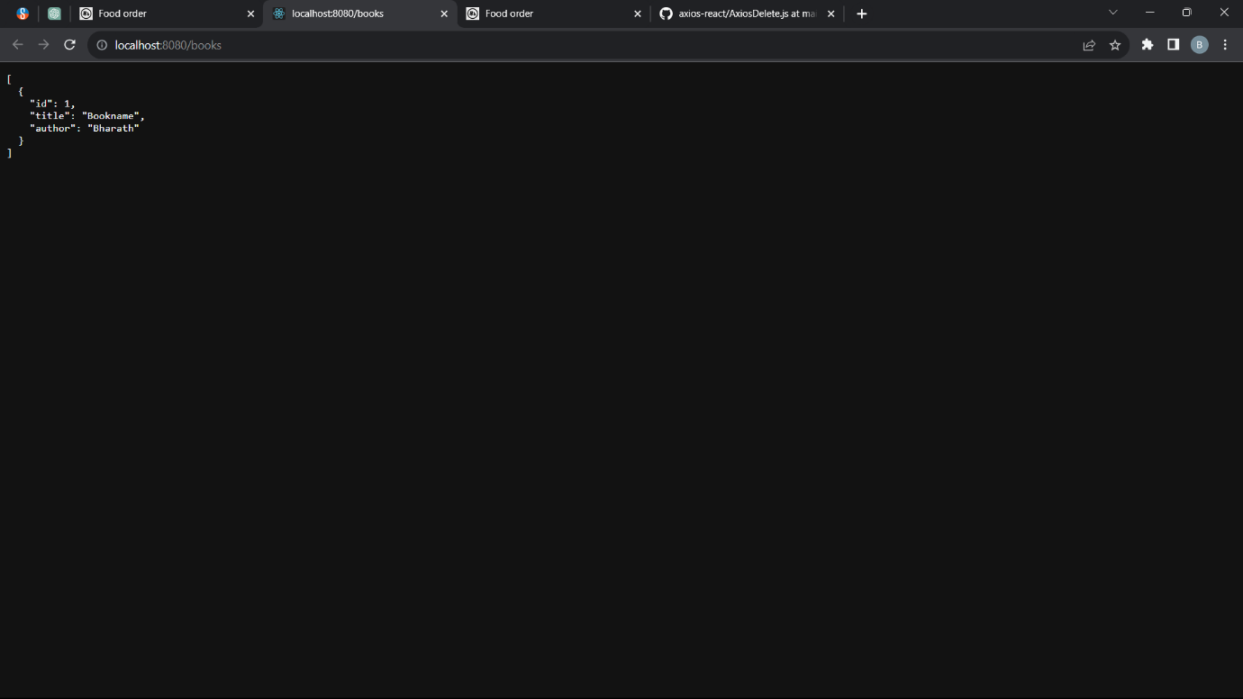

---------------------------------------------------------------------------------

*4.Axios Get (CW):*

App.js:

import React from **'**react**'**

import AxiosGet from **'**./components/axios/axiosget**'**

const App = **()** => **{**

  return (

**<**div**>**

**{**

**<***AxiosGet***/>**

**}**

**</**div**>**

  )

**}**

export default App

axiosget.js:

import axios from **'**axios**'**

import React**,** **{** useEffect**,**useState **}** from **'**react**'**

const AxiosGet = **()** => **{**

    const **[**books**,**setBooks**]**=useState([])**;**

    useEffect(**()**=>**{**

        const fetchData=async**()**=>**{**

         try**{**

          const response=await axios**.**get(**"**http://localhost:8080/book**"**)

*console***.**log(response**.**data)

              setBooks(response**.**data)**;**

**}**

         catch(error)**{**

*console***.**log(error)

**}};**

       fetchData()**;**

**},**[])**;**

  return (

**<**div**>**

**<**table**>**

**<**thead**>**

**<**tr**>**

**<**th**>**Id**</**th**>**

**<**th**>**Book title**</**th**>**

**<**th**>**Author name**</**th**>**

**</**tr**>**

**</**thead**>**

**<**tbody**>**

**{**books**.**map(**(***book***)**=>(

**<**tr key=**{***book***.**id**}>**

**<**td**>{***book***.**id**}</**td**>**

**<**td**>{***book***.**title**}</**td**>**

**<**td**>{***book***.**author**}</**td**>**

**</**tr**>**

            ))**}**

**</**tbody**>**

**</**table**>**

**</**div**>**

  )

**}**

export default AxiosGet

OUTPUT:



