|  |  |
| --- | --- |
| **EX.NO :** 3 | **DESIGN A WEBPAGE WITH MENULAYOUT AND APPLY THE VARIOUS FORMATTING USING CSS** |
| **DATE :** 03.07.18 |

**AIM:**

To design a web page to create a menu layout for exploring various links using CSS.

**PROCEDURE:**

1. Create two .css files for writing the style codings.
2. Create a main .html and write the coding inside that file.
3. Embedded the sub html codes into the main html file using frames.
4. Display the output using 000webhost(Internet hosting).
5. Take a screen snaps for the output.

**CODINGS:**

**CSS CODES:**

**mystyle1.css**

div

{

background-color:white;

padding:5px;

font-size:18px;

}

.img

{

float:right;

}

.header

{

background-color:white;

padding: 20px;

text-align: center;

}

.column

{

float: left;

width: 50%%;

padding:50px;

}

.row:after

{

content: "";

display: table;

clear: both;

}

ul

{

list-style-type: none;

margin: 0;

padding: 0;

overflow: hidden;

background-color:white;

}

li

{

float: left;

}

li a, .dropbtn

{

display: inline-block;

color: black;

text-align: center;

padding: 14px 16px;

text-decoration: none;

}

li a:hover, .dropdown:hover .dropbtn

{

background-color:green;

}

li.dropdown

{

display: inline-block;

}

.dropdown-content

{

display: none;

position: absolute;

background-color:white;

min-width: 160px;

box-shadow: 0px 8px 16px 0px rgba(0,0,0,0.2);

z-index: 1;

}

.dropdown-content a

{

color:black;

padding: 12px 16px;

text-decoration: none;

display: block;

text-align: left;

}

.dropdown-content a:hover

{

background-color:lightgray

}

.dropdown:hover .dropdown-content

{

display: block;

}

**desc.css**

div

{

padding:5px;

}

.clearfix

{

overflow:auto;

}

.img1

{

float:right;

}

.img2

{

float:right;

}

**HTML CODES:**

**que01.html**

<html>

<head>

<link rel="stylesheet" type="text/css" href="mystyle1.css">

</head>

<body>

<div class="header">

<img class="img1" src="logo1.jpg" alt="Logo" width="170" height="170">

<center style="font-size:30px;"><b>PAYTM MALL-ELECTRONIC PRODUCT STORE</b></center>

</div>

<ul>

<li><a href="#home">HOME</a></li>

<li class="dropdown">

<a href="javascript:void(0)" class="dropbtn">PRODUCT</a>

<div class="dropdown-content">

<a href="des1.html" target="Links">AIR CONDITIONING</a>

<a href="des3.html" target="Links1">REFRIDGERATOR</a>

</div>

</li>

<li><a href="#services">SERVICES</a></li>

</ul>

<div class="row">

<div class="column">

<iframe name=Links height=300 width=500></iframe>

</div>

<div class="column">

<iframe name=Links1 height=300 width=500></iframe>

</div>

</div>

</body>

</html>

**des1.html**

<html>

<head>

<link rel="stylesheet" type="text/css" href="des1.css">

</head>

<body>

<h1>WINDOW AC</h1>

<div class="clearfix">

<img class="img1" src="windowAc.jpg" alt="Window AC" width="200" height="100">

<p><u>PRODUCT HIGHLIGHTS</u></p>

<ul>

<li>1.5 Ton capacity:For space around 150sq.ft.(like bedroom)</li>

<li>3 Star energy rating:For annual savings upto Rs.6500</li>

<li>2.92 W/W EER:Higher the EER,lower the bills</li>

</ul>

</div>

<hr>

<h1>SPLIT AC</h1>

<div class="clearfix">

<img class="img2" src="splitAC.jpg" alt="Split AC" width="200" height="200">

<p><u>PRODUCT HIGHLIGHTS</u></p>

<ul>

<li>2 Ton capacity:For space beyond 200sq.ft.(like halls)</li>

<li>3 Star energy rating:For annual savings upto Rs.6500</li>

<li>5 Star as per 2017 energy ratings standard</li>

<li>Copper condenser: Energy efficient with easy maintenance</li>

</ul>

</div>

</body>

</html>

**des3.html**

<html>

<head>

<link rel="stylesheet" type="text/css" href="des1.css">

</head>

<body>

<h1>DOUBLE DOOR</h1>

<div class="clearfix">

<img class="img1" src="doubledoor.jpg" alt="Double Door" width="200" height="200">

<p><u>PRODUCT HIGHLIGHTS</u></p>

<ul>

<li>Brand:Haier</li>

<li>Price:Rs.49,299</li>

<li>565 L capacity: Suitable for big family with 5 members or more</li>

<li>Frost Free technology: Auto defrost stops ice-build up preserves food longer</li>

</ul>

</div>

<hr>

<h1>SINGLE DOOR</h1>

<div class="clearfix">

<img class="img2" src="singledoor.jpg" alt="Single Door" width="200" height="200">

<p><u>PRODUCT HIGHLIGHTS</u></p>

<ul>

<li>Brand:Godrej</li>

<li>Price:Rs.16,799</li>

<li>210 L capacity: Suitable for small family upto 3 members</li>

<li>Direct Cool technology: Saves maximum energy requires manual defrosting</li>

</ul>

</div>

</body>

</html>

**OUTPUT:**

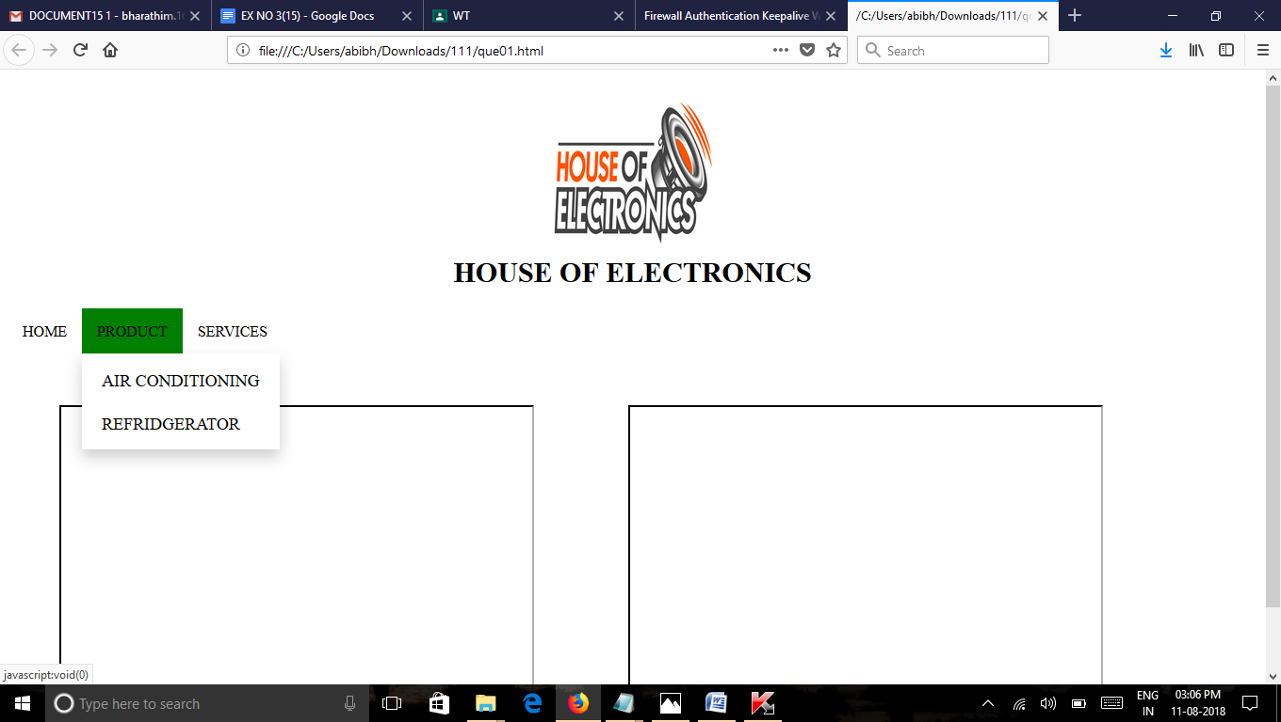

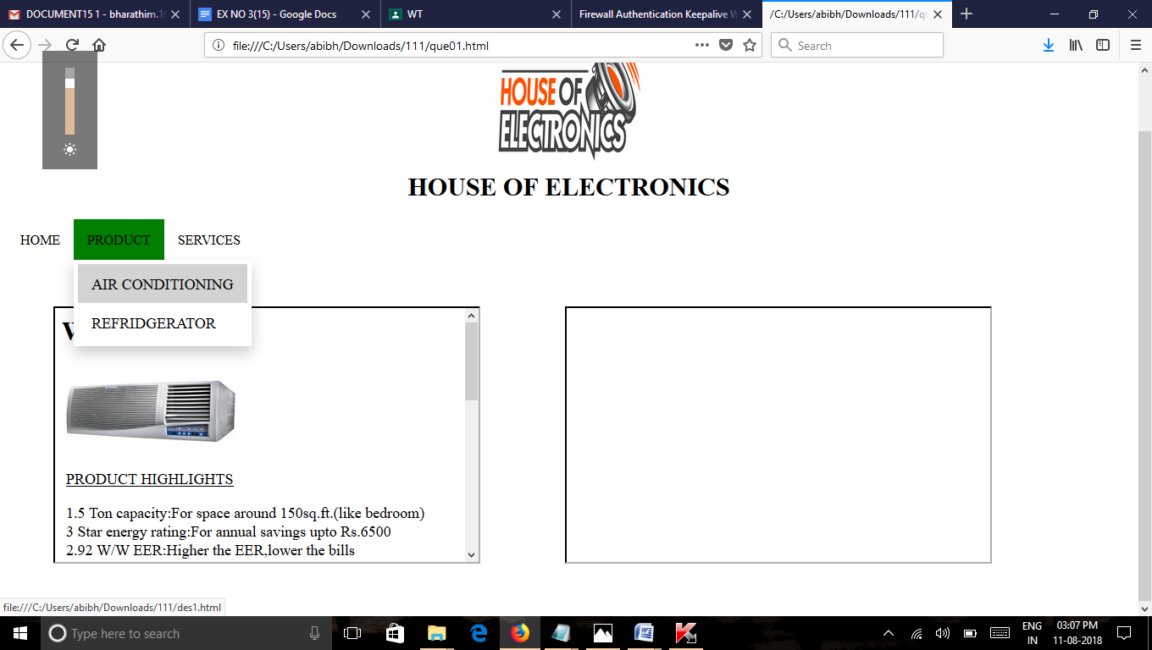

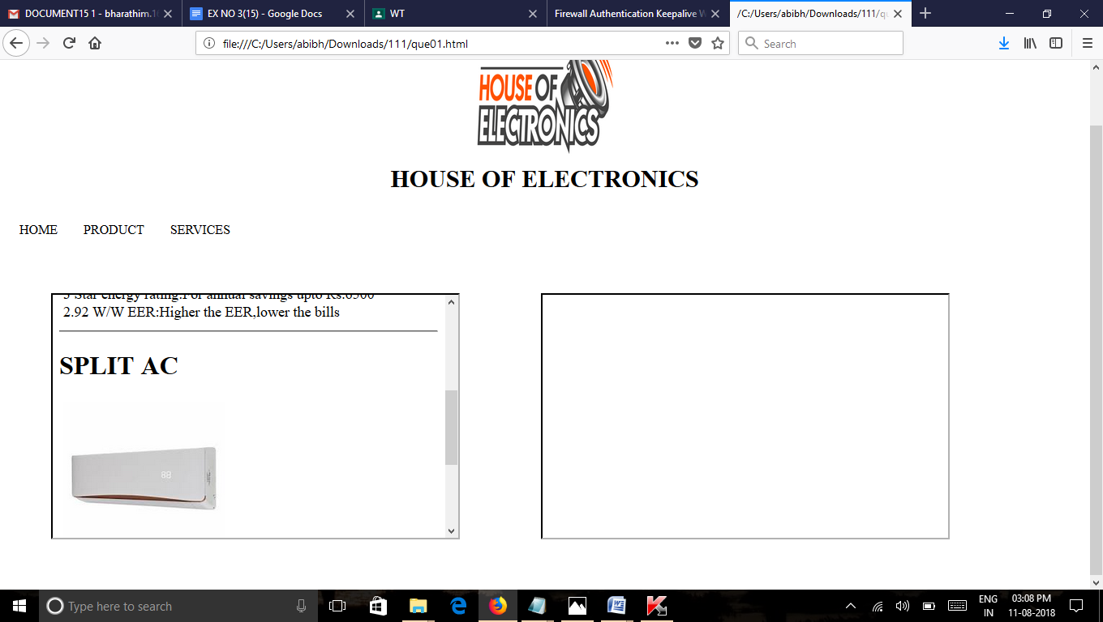

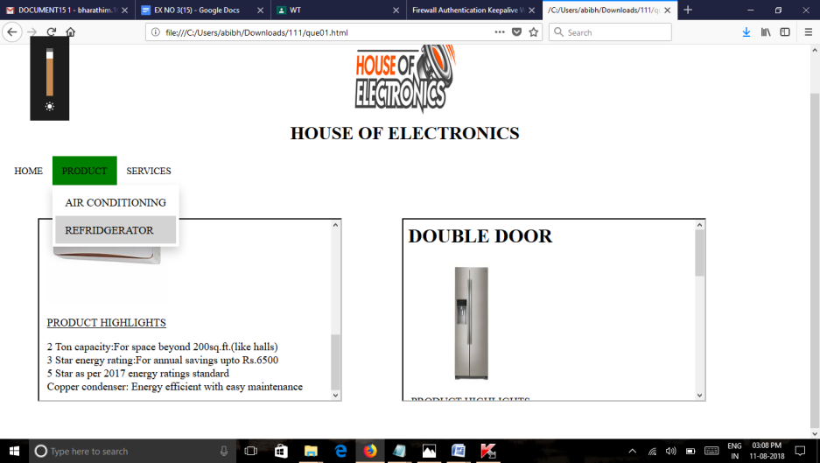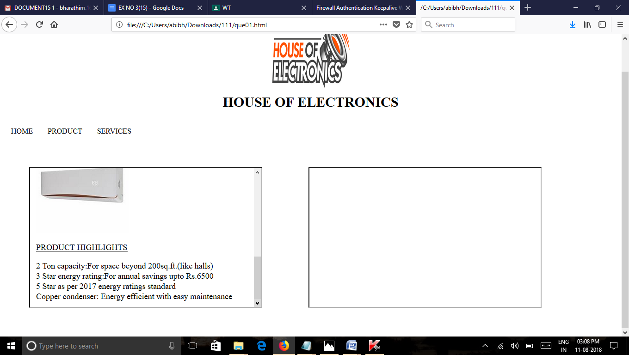

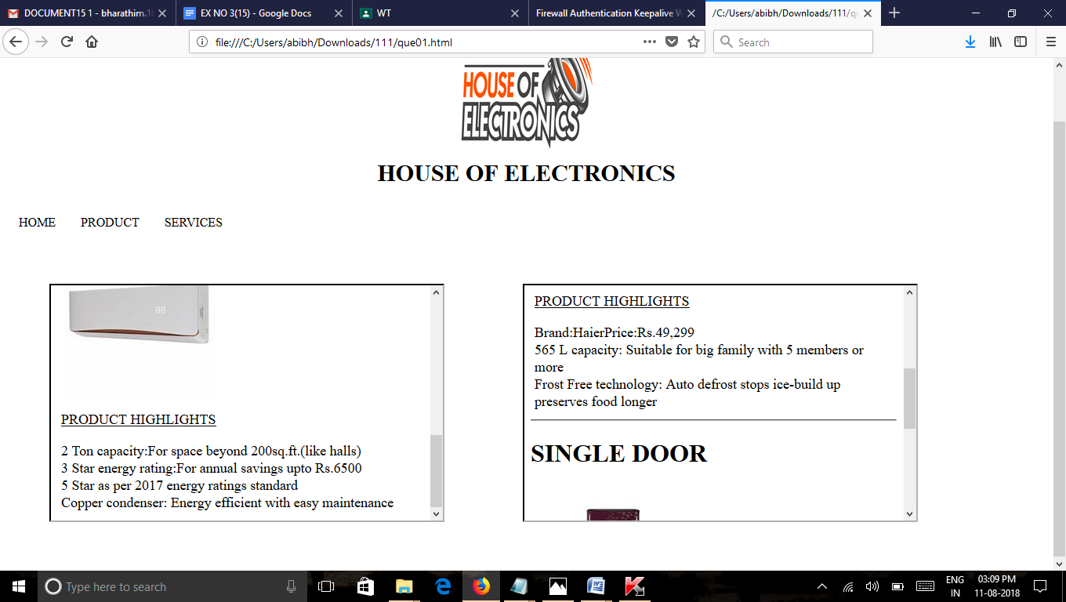

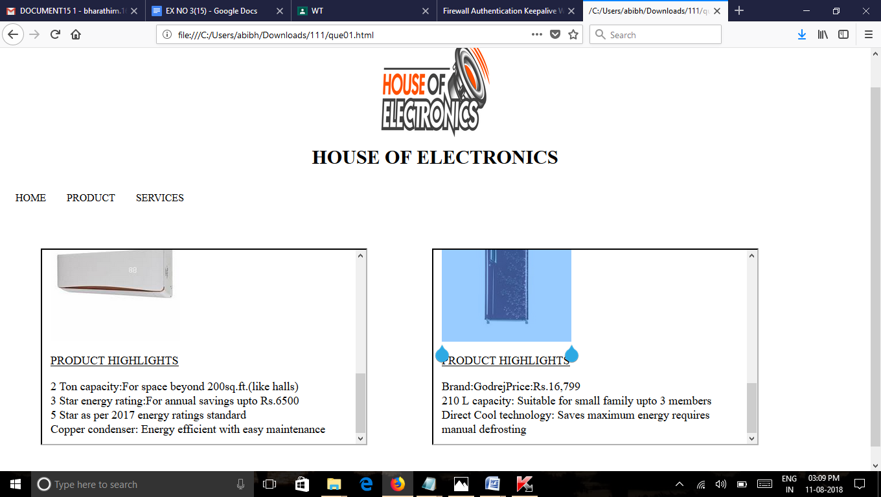

**RESULT:**

Thus, a web page to create a menu layout for exploring various links using CSS was designed successfully.