0–30 Counter Using Two 7-Segment Displays

Circuit Diagram
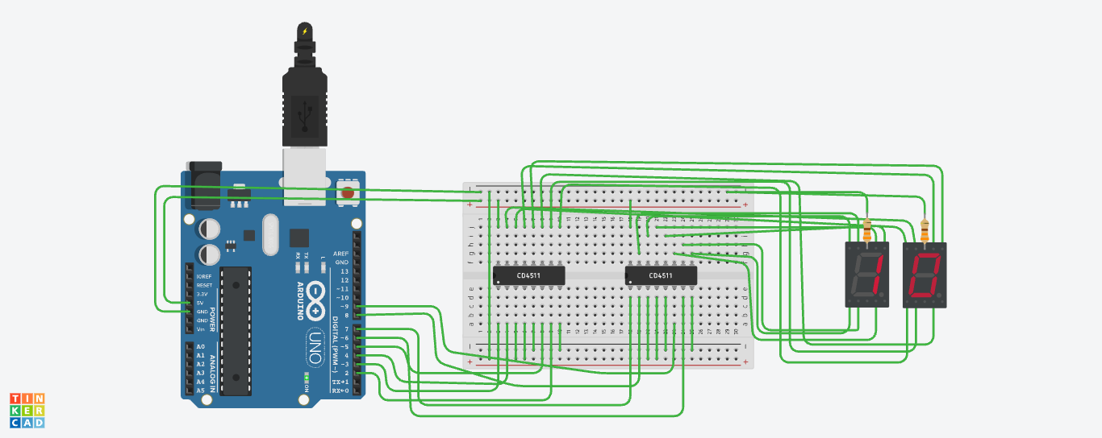

Component List
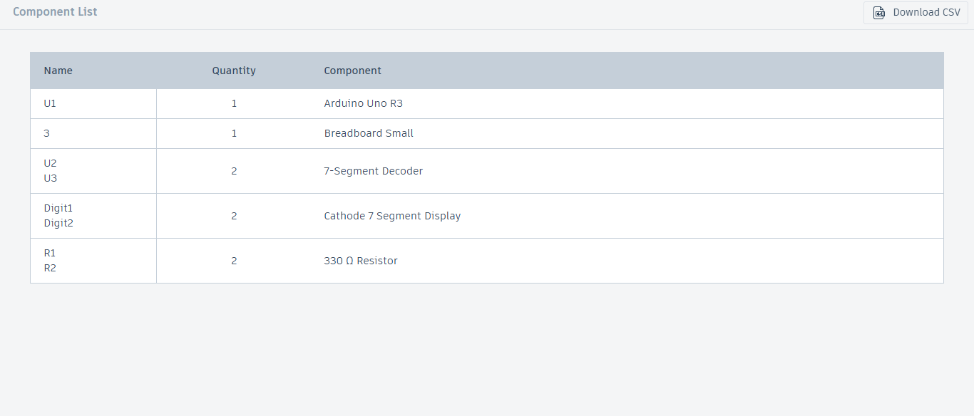

Schematic
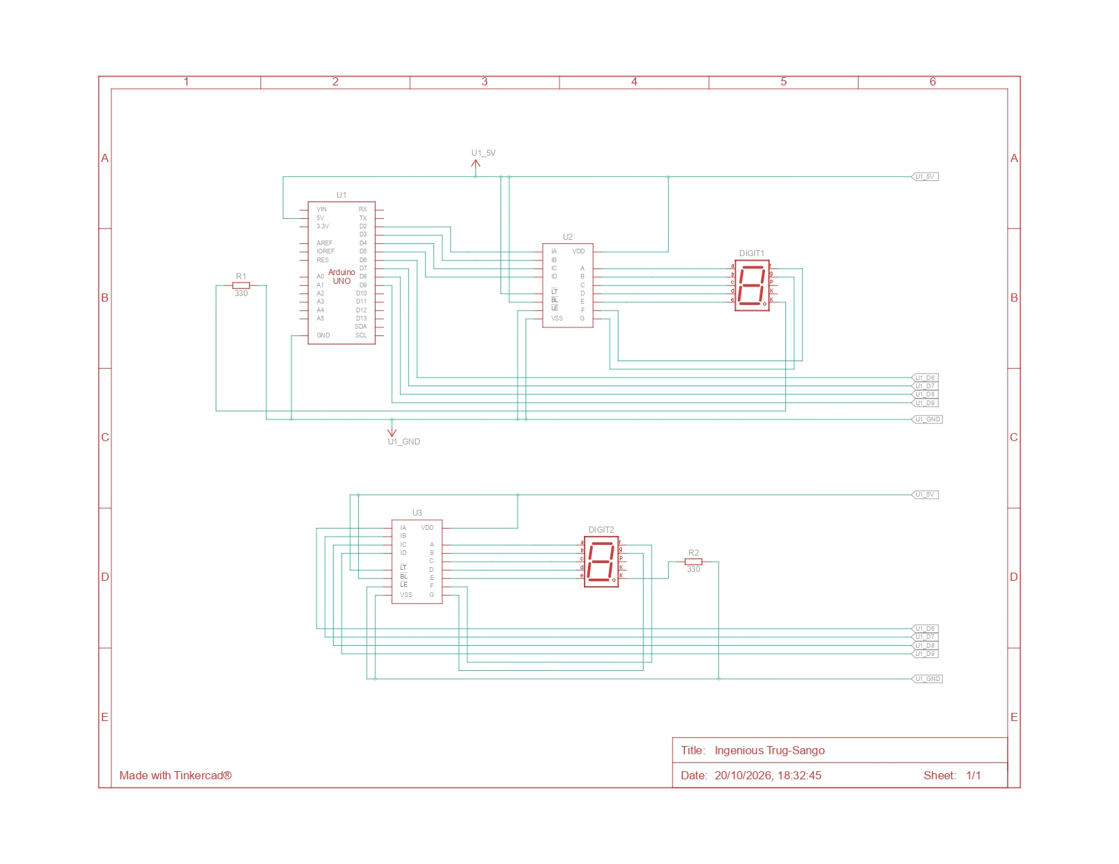

Code
// Arduino pins connected to the BCD inputs of each decoder
// Index 0 = bit A (LSB) ... index 3 = bit D (MSB)
const int unitsPins[4] = {2, 3, 4, 5};
const int tensPins[4] = {6, 7, 8, 9};

const unsigned long STEP_MS = 1000; // time each number stays on the display
const int MAX_COUNT = 30; // counter runs from 0 to MAX_COUNT

int count = 0;

void setup() {
for (int i = 0; i < 4; i++) {
pinMode(unitsPins[i], OUTPUT);
pinMode(tensPins[i], OUTPUT);
}
showNumber(count); // show 00 at power-on
}

// Writes one decimal digit (0-9) as 4-bit BCD on the given pins
void writeBCD(const int pins[], int digit) {
for (int i = 0; i < 4; i++) {
digitalWrite(pins[i], (digit >> i) & 0x01);
}
}

// Splits a number into tens and units and sends each to its decoder
void showNumber(int n) {
int tens = n / 10;
int units = n % 10;
writeBCD(tensPins, tens);
writeBCD(unitsPins, units);
}

void loop() {
showNumber(count);
delay(STEP_MS);

count++;
if (count > MAX_COUNT) {
count = 0; // wrap around after 30
}
}

