**Exp no: 4**

**Vehicle Performance Analysis using pandas**

**AIM:**

To analyze the performance attributes of different vehicles using Pandas.

**SOFTWARE REQUIRED:**

∙ Python environment with Pandas and NumPy installed.

**PROCEDURE:**

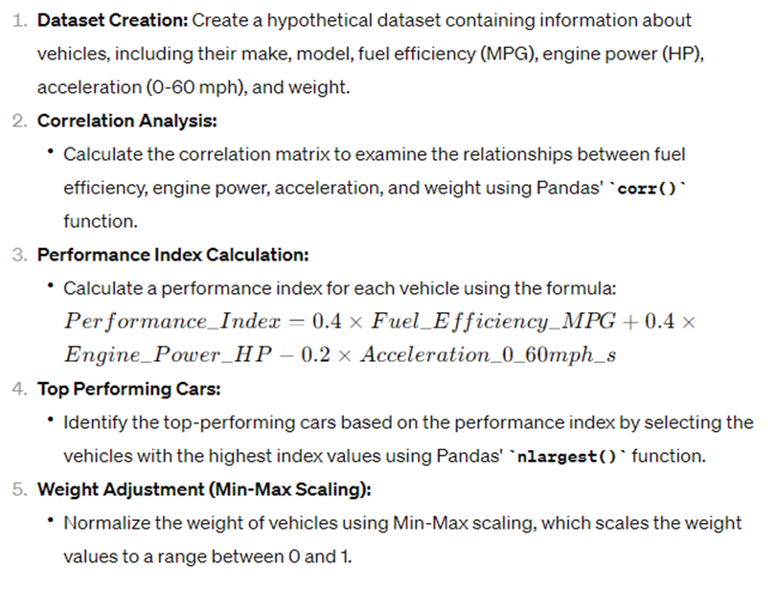

**Program**

import pandas as pd

import numpy as np

# Creating a hypothetical dataset

data = {

'Make': ['Toyota', 'Honda', 'Ford', 'Chevrolet', 'Nissan'],

'Model': ['Camry', 'Civic', 'Fusion', 'Malibu', 'Altima'],

'Fuel_Efficiency_MPG': [28, 36, 30, 32, 26],

'Engine_Power_HP': [203, 158, 181, 163, 188],

'Acceleration_0_60mph_s': [7.5, 8.2, 6.9, 8.0, 6.2],

'Weight_kg': [1500, 1300, 1400, 1350, 1550]

}

car_performance_df = pd.DataFrame(data)

# Task 1: Correlation Analysis

correlation_matrix = car_performance_df[['Fuel_Efficiency_MPG', 'Engine_Power_HP', 'Acceleration_0_60mph_s', 'Weight_kg']].corr()

# Task 2: Performance Index Calculation

car_performance_df['Performance_Index'] = (

0.4 * car_performance_df['Fuel_Efficiency_MPG'] +

0.4 * car_performance_df['Engine_Power_HP'] -

0.2 * car_performance_df['Acceleration_0_60mph_s']

)

# Task 3: Top Performing Cars

top_performing_cars = car_performance_df.nlargest(2, 'Performance_Index')

# Task 4: Weight Adjustment (Min-Max scaling)

min_max_scaler = lambda x: (x - np.min(x)) / (np.max(x) - np.min(x))

car_performance_df['Weight_normalized'] = car_performance_df[['Weight_kg']].apply(min_max_scaler)

# Output

print("Correlation Matrix:")

print(correlation_matrix)

print("\nDataFrame with Performance Index:")

print(car_performance_df[['Make', 'Model', 'Performance_Index']])

print("\nTop Performing Cars:")

print(top_performing_cars[['Make', 'Model', 'Performance_Index']])

print("\nDataFrame with Weight Adjustment:")

print(car_performance_df[['Make', 'Model', 'Weight_kg', 'Weight_normalized']])

**OUTPUT:**

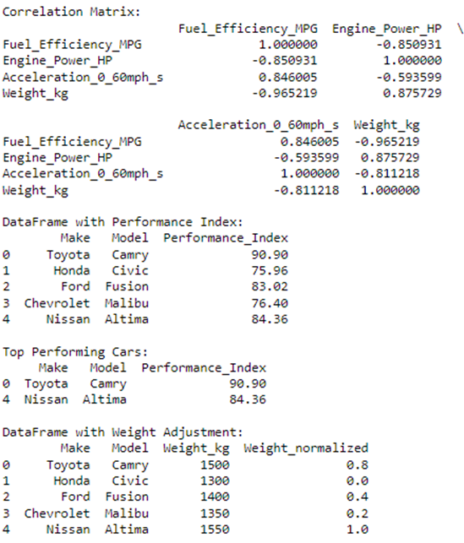

**Results:**

∙ For this data set it is found that Toyota camry is having high performing index.

∙ Through this experiment, we successfully analyzed the performance attributes of

vehicles using Pandas.

∙ By calculating correlations, performance indices, and performing weight adjustments,

we gained valuable insights into the performance characteristics of different vehicles.

∙ This experiment demonstrates the power of data analysis techniques in evaluating and

comparing vehicle performance.