 

## Event Detection System For Covid-19 Pandemic

##### A PROJECT REPORT

***Submitted by***

**BHARGAV K R [REGISTER NO:211417104036]**

**B L S R K VISHAL [REGISTER NO:211417104039]**

**CHINTHAGINJALA PAVAN KUMAR [REGISTER NO: 211417104045]**

***in partial fulfillment for the award of the degree of***

### BACHELOR OF ENGINEERING

**IN**

##### COMPUTER SCIENCE AND ENGINEERING

**PANIMALAR ENGINEERING COLLEGE, CHENNAI-600123.**

**ANNA UNIVERSITY: CHENNAI 600 025**

**APRIL 2021**

**BONAFIDE CERTIFICATE**

Certified that this project report **“Event Detection System For Covid-19 Pandemic”** is the bonafide work of **“BHARGAV K R (211417104036),**

##### B L S R K VISHAL (211417104039), CHINTHAGINJALA PAVAN KUMAR

**(211417104045)”** who carried out the project work under my supervision.

##### SIGNATURE SIGNATURE

**Dr.S.MURUGAVALLI,M.E.,Ph.D., Mr. C.THYAGARAJAN,M.E.(Ph.D.), HEAD OF THE DEPARTMENT ASSISTANT PROFESSOR(GRADE-I),** DEPARTMENT OF CSE, DEPARTMENT OF CSE,

PANIMALAR ENGINEERING COLLEGE, PANIMALAR ENGINEERING COLLEGE, NAZARATHPETTAI, NAZARATHPETTAI,

POONAMALLEE, POONAMALLEE,

CHENNAI-600 123. CHENNAI-600 123.

Certified that the above candidate(s) was/ were examined in the Anna University Project Viva-Voce Examination held on

##### INTERNAL EXAMINER EXTERNAL EXAMINER

**ACKNOWLEDGEMENT**

We express our deep gratitude to our respected Secretary and Correspondent **Dr.P.CHINNADURAI, M.A., Ph.D.** for his kind words and enthusiastic motivation, which inspired us a lot in completing this project.

We would like to extend our heartfelt and sincere thanks to our Directors

##### Tmt. C. VIJAYARAJESWARI, Dr. C. SAKTHIKUMAR, M.E., Ph.D., and

**Tmt. SARANYASREE SAKTHIKUMAR B.E.,M.B.A.,** for providing us with the necessary facilities for completion of this project.

We also express our gratitude to our Principal **Dr.K.MANI, M.E., Ph.D.** for his timely concern and encouragement provided to us throughout the course.

We thank the HOD of CSE Department, **Dr. S.MURUGAVALLI , M.E.,Ph.D.,**

for the support extended throughout the project.

We would like to thank my **Project Guide Mr. C. THYAGARAJAN, M.E.(Ph.D.),**

and all the faculty members of the Department of CSE for their advice and suggestions for the successful completion of the project.

## ABSTRACT

Individuals utilize Online Social Networks (OSNs) to communicate their sentiments and emotions about numerous points. Contingent upon the idea of an occasion and its dispersal rate in OSNs, and considering explicit locales, the clients' conduct can definitely change throughout a particular timeframe. In this specific situation, this work intends to propose an occasion recognition framework at the beginning phases of an occasion dependent on changes in the clients' conduct in an OSN. This framework can recognize an occasion of any subject, and accordingly, it tends to be utilized for various purposes.

The proposed occasion recognition framework is made out of the accompanying principle modules: (1) assurance of the client's area, (2) message extraction from an OSN, (3) subject recognizable proof utilizing common language preparing (NLP) in light of the Deep Belief Network (DBN), (4) the client conduct change analyzer in the OSN, and (5) full of feeling examination for feeling recognizable proof dependent on a tree-convolutional neural organization (tree-CNN).

### LIST OF FIGURES

|  |  |  |
| --- | --- | --- |
| **CHAPTER NO.** | **TITLE** | **PAGE NO.** |
| **4.** | **SYSTEM DESIGN** |  |
|  | 4.4. Use Case Diagram | 34 |
|  | 4.5. Class Diagram | 35 |
|  | 4.6 Sequence Diagram | 36 |
|  | 4.7 Activity Diagram | 37 |
| 5. | **SYSTEM ARCHITECTURE** |  |
|  | 5.1. System Architecture | 39 |

**LIST OF TABLES**

|  |  |  |
| --- | --- | --- |
| **CHAPTER NO.** | **TITLE** | **PAGE NO.** |
| **3.** | **SYSTEM ANALYSIS** |  |
|  | 3.1. Minimum Hardware Requirements | 20 |
|  | 3.2. Minimum Software Requirements | 20 |
| **6.** | **SYSTEM TESTING** |  |
|  | 6.1. Test Case for User Module | 47 |
|  | 6.2. Test Case for Admin System | 48 |

**TABLE OF CONTENTS**

|  |  |  |
| --- | --- | --- |
| **CHAPTER NO.** | **TITLE** | **PAGE NO.** |
|  | **ABSTRACT** | iv |
| **1.** | **INTRODUCTION** | 1 |
|  | 1.1 Overview | 2 |
| **2.** | **LITERATURE SURVEY** | 4 |
| **3.** | **SYSTEM ANALYSIS** | 10 |
|  | 3.1 Existing System | 11 |
|  | 3.2 Proposed system | 11 |
|  | 3.3 Requirement Analysis and Specification | 12 |
|  | 3.3.1 Input Requirements | 12 |
|  | 3.3.2 Output Requirements | 13 |
|  | 3.4 Feasibility Study | 13 |
|  | 3.4.1 Technical Feasibility | 13 |
|  | 3.4.2 Economic Feasibility | 13 |
|  | 3.5 Hardware Environment | 14 |
|  | 3.6 Software Environment | 14 |
|  | 3.7 Software Specification | 15 |

|  |  |  |
| --- | --- | --- |
| **CHAPTER NO.** | **TITLE** | **PAGE NO.** |
| **4.** | **SYSTEM DESIGN** | 23 |
|  | 4.1. UML diagram | 24 |
| **5.** | **SYSTEM ARCHITECTURE** | 32 |
|  | 5.1 Architecture Overview | 33 |
|  | 5.2 Module Design Specification | 34 |
|  | 5.2.1 Module Explanation | 34 |
| **6.** | **TESTING** | 36 |
|  | 6.1 System Testing | 37 |
|  | 6.2 Unit Testing | 38 |
|  | 6.3 Test Cases & Reports / Performance Analysis | 39 |
| **7.** | **CONCLUSION** | 41 |
|  | 7.1 Conclusion and Future Enhancements | 42 |
|  | **APPENDICES** |  |
|  | A.1 Sample Screens | 44 |
|  | A.1 Sample Code | 58 |
|  | **REFERENCES** | 62 |

**CHAPTER 1 INTRODUCTION**

**1.1 OVERVIEW**

The user behavior has been studied to examine the psychological antecedents of actions in various domains like medical, businesses and many other sectors for many years, and by gathering all this information using the data obtained to predict or to make proposal to the client/person and to track the event of the person. In general, the characteristics of a person depends on various factors and one of the most common factor is their health condition and well-being, so that the behavior of the person can also be predicted or analyzed based on their public health status.

Nowadays Social media is been a very popular mode of interaction between the people they share their thoughts, feelings, emotions, behavior and their status etc. in the Social media which is a Online Social Network (ONS), this online social media includes Facebook, Twitter etc. Thus, this Online social media consists of vast amount of data which also analyze the behavior of the person using online social networks.

However, analyzing the behavior of the users in an OSN is a complex task [8], and thus, some models to detect anomalies in the user behavior have been studied [9]. Some studies have focused particularly on the domain of user behavior analysis on social media for instance in the contexts of political Events, a diverse range of recommendation systems, public health, communication network recommendations, and prediction of urban traffic trends among others.

Regarding the public health tracking status, some studies have focused on extracting messages in the OSNs for finding illness-related topics. Furthermore, OSNs have been used as an efficient resource to discover some disease outbreaks,

in which it is possible to identify trends about a specific illness, correlating that

OSN information to real world illness patient data.

Currently, in the world one of the most popular OSNs is Twitter, in which users share short messages. The data extracted from Twitter have been used in many studies to identify possible trends. In addition, other similar OSNs are also used in different countries, such as Sine Weibo, the most popular micro-blog platform in China. In Weibo, it is also possible to classify disease-related information. To this end, the natural language processing (NLP) technique plays an important role. NLP is used for extracting situational information, such as advice, notifications, emotional support, doubt casting and criticizing, and counter-rumor. In addition, different machine learning algorithms are used for illness type classification, such as Support Vector Machine (SVM), Naive Bayes (NB), and Random Forest (RF), However, these algorithms do not reach an accuracy higher than 0.70 when they are applied in epidemic early detection solutions.

# CHAPTER 2 LITERATURE SURVEY

##### Information Retrieval and Social Media Mining by María N. Moreno-Garcí

María N. and Moreno-Garcí specified that large amount of digital content available through web sites, social networks, streaming services, and other distribution media, allows more and more people to access virtually unlimited sources of information, products, and services. This enormous availability makes it very difficult for users to find what they are really interested in. Hence, the great current interest in developing personalized methods of information retrieval as well as reliable recommendation algorithms that help users to filter and discover what fits their preferences. Graph convolutional network (GCN) algorithm called Pharma Sage is proposed for providing pharmacy product cross-selling recommendations based on product feature information and sales data. The model was trained with a huge amount of real pharmaceutical data including almost a million products with complex properties and approximately 100 million sales transactions

##### Multi-class approach for user behavior prediction using deep learning framework on Twitter election dataset by K. K. Mohbey,

K. K. Mohbey said Among the broad assortment of Machine Learning approaches, deep learning has recently attracted attention particularly in the domain of user behavior analysis. The notion to study user behavior from the unstructured tweets shared on social media is an interesting yet challenging task. A social platform such as Twitter yield access to the unprompted views of the wide-ranging users on particular events like election. These views cater government and corporates to remold strategies, assess the areas where better measures need to be put forward and monitor common opinion. With the advent of the general election in India (largest democracy) people tend to articulate their views or issues. Tweets related to general elections 2019 of India is used as data

corpus for the study. Multi-class classification fabricated with novel deep learning approach is implemented to analyses the user opinion. Here, we have used nine different classes, which is representing larger issues in the nation for election agenda. Moreover, comparative analysis between tradition approaches such as Naïve Bayes, SVM, decision tree, logistic regression and employed approach with deep learning method is presented. Experimental results revels that the proposed model can reach up to 98.70% accuracy on multiclass based prediction in machine learning. The results assist the government and businesses to know about grave issue offering a shot to revise strategic policy and make welfare scheme program.

##### Public health and social media: A study of Zika virus-related posts on yahoo! Answers by J. Zhang, Y. Chen, Y. Zhao, D. Wolfram, and F. Ma

J. Zhang, Y. Chen, Y. Zhao, D. Wolfram, and F. Ma specified This study investigates the content of questions and responses about the Zika virus on Yahoo! Answers as a recent example of how public concerns regarding an international health issue are reflected in social media. We investigate the contents of posts about the Zika virus on Yahoo Answers, identify and reveal subject patterns about the Zika virus, and analyze the temporal changes of the revealed subject topics over 4 defined periods of the Zika virus outbreak. Multidimensional scaling analysis, temporal analysis, and inferential statistical analysis approaches were used in the study. A resulting 2‐layer Zika virus schema, and term connections and relationships are presented. The results indicate that consumers’ concerns changed over the 4 defined periods. Consumers paid more attention to the basic information about the Zika virus, and the prevention and protection from the Zika virus at the beginning of the outbreak of the Zika virus. During the later periods, consumers became more interested in the role that the government and health organizations played in the public health emergency

the past four decades are described since the first meter was introduced in 1970. Factors that have influenced this evolution and the challenges to improve analytical performance are discussed. Current issues in the role of SMBG from the clinical, patient and manufacturer perspectives, notably adherence, costs and regulations. Are also considered.

##### Detecting epidemic diseases using sentiment analysis of arabic tweets by Q. B. Baker, F. Shatnawi, S. Rawashdeh, M. Al-Smadi, and Y. Jararweh

Q. B. Baker, F. Shatnawi, S. Rawashdeh, M. Al-Smadi, and Y. Jararweh insist Opinion mining is an important step towards facilitating information in health data. Several studies have demonstrated the possibility of tracking diseases using public tweets. However, most studies were applied to English language tweets. Influenza is currently one of the world's greatest infectious disease challenges. In this study, a new approach is proposed in order to detect Influenza using machine learning techniques from Arabic tweets in Arab countries. This paper is the first study of epidemic diseases based on Arabic language tweets. In this work, we have collected, labeled, filtered and analyzed the influenza-related tweets written in the Arabic language. Several classifiers were used to measure the quality and the performance of the approach, which are: Naive Bayes, Support Vector Machines, Decision Trees, and K-Nearest Neighbor. The classifiers which achieved the best accuracy results for the three experiments were: Naïve Bayes with 89.06%, and K-Nearest Neighbor with 86.43%, respectively.

##### A Real-time integration of emotion analysis into homecare platforms. by A. Menychtas, M. Galliakis, P. Tsanakas, I. Maglogiannis.

A. Menychtas, M. Galliakis, P. Tsanakas, I. Maglogiannis The scientific and technological advancements in the area of affective computing enable the development of services in various domains that facilitate the interaction between humans and computers, and can considerably improve decision-making. This work presents the integration and operation of an emotion analysis service in a homecare/mHealth application. In the described approach, the developed emotion analysis service follows the IoT paradigm and it is combined with features for connectivity such as bio signal sensors and wearables, while it is fully integrated in the WebRTC video communication functionality offered by the homecare platform. Thus, it supports the medical experts to perform real-time analysis of their patients' emotional status during interactive video-conference sessions. The paper discusses the technical details of the implementation and the integration of the proposed service and provides initial results from its operation in practice.

##### Analysis of users' behavior in structured e-commerce websites by S. Hernández, Álvarez, J. Fabra, and J. Ezpeletay

S. Hernández, Álvarez, J. Fabra, and J. Ezpeletay said online shopping is becoming more and more common in our daily lives. Understanding users' interests and behavior is essential to adapt e-commerce Web sites to customers' requirements. The information about users' behavior is stored in the Web server logs. The analysis of such information has focused on applying data mining techniques, where a rather static characterization is used to model users' behavior, and the sequence of the actions performed by them is not

usually considered. Therefore, incorporating a view of the process followed by users during a session can be of great interest to identify more complex behavioral patterns. To address this issue, this paper proposes a linear-temporal logic model checking approach for the analysis of structured e-commerce Web logs. By defining a common way of mapping log records according to the e-commerce structure, Web logs can be easily converted into event logs where the behavior of users is captured. Then, different predefined queries can be performed to identify different behavioral patterns that consider the different actions performed by a user during a session. Finally, the usefulness of the proposed approach has been studied by applying it to a real case study of a Spanish e-commerce Web site. The results have identified interesting findings that have made possible to propose some improvements in the Web site design with the aim aim of increasing its efficiency.

##### Real-time event detection on social data streams by M. Fedoryszak, B. Frederick, V. Rajaram, and C. Zhong

Social networks are quickly becoming the primary medium for discussing what is happening around real-world events. The information that is generated on social platforms like Twitter can produce rich data streams for immediate insights into ongoing matters and the conversations around them. To tackle the problem of event detection, we model events as a list of clusters of trending entities over time. We describe a real-time system for discovering events that is modular in design and novel in scale and speed. In order to assess clustering methodologies, we build an evaluation dataset derived from a snapshot of the full Twitter Firehose and propose novel metrics for measuring clustering quality. Through experiments and system profiling, we highlight key results from the offline and online pipelines. Finally, we visualize a high profile event on Twitter to show the importance of modeling the evolution of events, especially those detected from social

data streams.

# CHAPTER 3 SYSTEM ANALYSIS

### EXISTING SYSTEM

With respect to general wellbeing following status, a few examinations have zeroed in on separating messages in the OSNs for discovering ailment related subjects. The opinion and emotional examination is another model of methods that have been discovered valuable to identify a few ailments like melancholy or stress. Other ailments and infections are likewise identified by separating negative remarks of the OSN, being related with misery or anger. IN general, the client conduct is affected by close to home encounters, and afterward, by occasions dispersed in OSNs consequently. The client conduct is a critical boundary to recognize occasions of various natures. In any case, the current investigations do not investigate the connection between the client conduct change furthermore, conceivable future occasions.

### PROPOSED SYSTEM

The proposed occasion location framework in which the client area is first decided, and afterward, a dataset is assembled and the point and subtopic recognizable proof of the message are characterized utilizing the NLP strategy. Afterward, the difference in the subject of the client posts is hailed and the client conduct change is distinguished and examined. Depending on the difference in subject, the occasion is found. At last, an full of feeling examination is acted in the client message to recognize the feelings and therefore, regardless of whether the occasion is good or on the other hand negative. The principle commitments of this paper is A strategy to actualize an early occasion identification framework in light

of the client conduct data that arrives at an precision better than related works. A

show that client conduct changes in OSNs give helpful data to foresee distinctive occasion types; for our situation study, the occasions are identified with the Coronavirus pandemic at its beginning phases. The exhibition approval of a profound conviction organization (DBN) and softmax relapse in the NLP setting. The exhibition approval of a tree-convolutional neural organization (tree-CNN) model for the full of feeling investigation acted in this work.

##### Advantages

* + - 1. Gathering information of group of people in particular location
      2. Various types of algorithms combined and used.

### REQUIREMENT ANALYSIS AND SPECIFICAITON

The requirement engineering process of feasibility study, requirements elicitation and analysis, requirement specification, requirements validation and requirement management. Requirement elicitation and analysis is am iterative process that can

be represented as a spiral of activities, namely requirements discovery, requirements classification and organization, requirement negotiation and requirements documentation.

### INPUT REQUIREMENT

The input requirement at the base requires selection of users of same regions o from the user that can be entered manually from the user or Bluetooth. These data are given by user for maintenance of blood glucose level in your body.

### OUTPUT REQUIREMENT

The output things necessary for these are a database for storing and manipulation of user data and a knowledge server for manipulation of user data and sending appropriate notification for the respective person.

### FEASIBILITY STUDY

The feasibility of the project is analyzed in this phase and business proposal is put forth with a very general plan for the project and some cost estimates. During system analysis the feasibility study of the proposed system is to be carried out. This is to ensure that the proposed system is not a burden to the company. For feasibility analysis, some understanding of the major requirements for the system is essential.

### TECHNICAL FEASIBILITY

This is concerned with specifying the software will successfully satisfy the user requirement. Open source and business-friendly and it is truly cross platform, easily deployed and highly extensible.

### ECONOMIC FEASIBILITY

This study is carried out to check the economic impact that the system will have on the organization. The amount of fund that the company can pour into the research and development of the system is limited. The expenditures must be justified. Thus the developed system as well within the budget and this was achieved because most of the technologies used are freely available. Only the customized products had to be purchased.

### MINIMUM HARDWARE REQUIREMENTS

|  |  |
| --- | --- |
| Processor | Intel |
| Hard disk | 260 GB |
| RAM | 4GB |
| Speed | 14/15 inches Color |

* 1. **SOFTWARE REQUIEMENTS**

|  |  |
| --- | --- |
| Tool | Net beans |
| Operating System | Windows 7/8/10 |
| Front End | Html, CSS |
| Scripts | Java |

* 1. **SOFTWARE SPECIFICATION**

##### HTML

Hypertext Markup Language (HTML) is the standard markup language for documents designed to be displayed in a web browser. It can be assisted by technologies such as Cascading Style Sheets (CSS) and scripting languages such as JavaScript.

[Web browsers](https://en.wikipedia.org/wiki/Web_browser) receive HTML documents from a [web server](https://en.wikipedia.org/wiki/Web_server) or from local storage and [render](https://en.wikipedia.org/wiki/Browser_engine) the documents into multimedia web pages. HTML describes the structure of a web page [semantically](https://en.wikipedia.org/wiki/Semantic_Web) and originally included cues for the appearance of the document.

[HTML elements](https://en.wikipedia.org/wiki/HTML_element) are the building blocks of HTML pages. With HTML constructs, [images](https://en.wikipedia.org/wiki/HTML_element#Images_and_objects) and other objects such as [interactive forms](https://en.wikipedia.org/wiki/Fieldset) may be embedded into the rendered page. HTML provides a means to create [structured documents](https://en.wikipedia.org/wiki/Structured_document) by denoting structural [semantics](https://en.wikipedia.org/wiki/Semantics) for text such as headings, paragraphs, lists, [links](https://en.wikipedia.org/wiki/Hyperlink), quotes and other items. HTML elements are delineated by *tags*, written using [angle](https://en.wikipedia.org/wiki/Bracket#Angle_brackets) [brackets](https://en.wikipedia.org/wiki/Bracket#Angle_brackets). Tags such as <img /> and <input /> directly introduce content into the page. Other tags such as <p> surround and provide information about document

text and may include other tags as sub-elements. Browsers do not display the HTML tags, but use them to interpret the content of the page.

HTML can embed programs written in a [scripting language](https://en.wikipedia.org/wiki/Scripting_language) such as [JavaScript](https://en.wikipedia.org/wiki/JavaScript), which affects the behavior and content of web pages. Inclusion of CSS defines the look and layout of content. The [World Wide Web Consortium](https://en.wikipedia.org/wiki/World_Wide_Web_Consortium) (W3C), former maintainer of the HTML and current maintainer of the CSS standards, has encouraged the use of CSS over explicit presentational HTML since 1997.

HTML markup consists of several key components, including those called *tags* (and their attributes), character-based data types, character references and entity references. HTML tags most commonly come in pairs like

<h1> and </h1>, although some represent empty elements and so are unpaired, for example <img>. The first tag in such a pair is the start tag, and the second is the end tag (they are also called opening tags and closing tags).

HTML documents imply a structure of nested [HTML elements](https://en.wikipedia.org/wiki/HTML_element). These are indicated in the document by HTML tags, enclosed in angle brackets thus:

In the simple, general case, the extent of an element is indicated by a pair of tags: a "start tag" <p> and "end tag"</p>. The text content of the element, if any, is placed between these tags.

##### HTML Application

An HTML Application (HTA; file extension ".hta") is a [Microsoft](https://en.wikipedia.org/wiki/Microsoft_Windows) [Windows](https://en.wikipedia.org/wiki/Microsoft_Windows) application that uses HTML and Dynamic HTML in a [browser](https://en.wikipedia.org/wiki/Web_browser) to provide the application's graphical interface. A regular HTML file is confined to the security model of the [web browser's security](https://en.wikipedia.org/wiki/Browser_security), communicating only to web servers and manipulating only web page objects and [site cookies](https://en.wikipedia.org/wiki/HTTP_cookie). An HTA runs as a fully trusted application and therefore has more privileges, like

creation/editing/removal of files and [Windows Registry](https://en.wikipedia.org/wiki/Windows_Registry) entries. Because they operate outside the browser's security model, HTAs cannot be executed via HTTP, but must be downloaded (just like an [EXE file](https://en.wikipedia.org/wiki/EXE)) and executed from the local file system.

Tags may also enclose further tag markup between the start and end, including a mixture of tags and text. This indicates further (nested) elements, as children of the parent element.

The start tag may also include attributes within the tag. These indicate other information, such as identifiers for sections within the document, identifiers used to bind style information to the presentation of the document, and for some tags such as the <img> used to embed images, the reference to the image resource.

### CSS

* + - 1. **INTRODUCTION**

Cascading Style Sheets (CSS) is a [style sheet language](https://en.wikipedia.org/wiki/Style_sheet_language) used for describing the [presentation](https://en.wikipedia.org/wiki/Presentation_semantics) of a document written in a [markup language](https://en.wikipedia.org/wiki/Markup_language) like [HTML](https://en.wikipedia.org/wiki/HTML). CSS is a cornerstone technology of the [World Wide Web](https://en.wikipedia.org/wiki/World_Wide_Web), alongside HTML and [JavaScript](https://en.wikipedia.org/wiki/JavaScript).

CSS is designed to enable the separation of presentation and content, including [layout](https://en.wikipedia.org/wiki/Page_layout), [colors](https://en.wikipedia.org/wiki/Color), and [fonts](https://en.wikipedia.org/wiki/Typeface). This separation can improve content [accessibility](https://en.wikipedia.org/wiki/Accessibility), provide more flexibility and control in the specification of presentation characteristics, enable multiple [web pages](https://en.wikipedia.org/wiki/Web_page) to share formatting by specifying the relevant CSS in a separate .css file, and reduce complexity and repetition in the structural content.

Separation of formatting and content also makes it possible to present the same markup page in different styles for different rendering methods, such as on-screen,

in print, by voice (via speech-based browser or [screen reader](https://en.wikipedia.org/wiki/Screen_reader)), and on [Braille-](https://en.wikipedia.org/wiki/Braille_display) [based](https://en.wikipedia.org/wiki/Braille_display) tactile devices. CSS also has rules for alternate formatting if the content is accessed on a [mobile device](https://en.wikipedia.org/wiki/Mobile_device).

The name *cascading* comes from the specified priority scheme to determine which style rule applies if more than one rule matches a particular element. This cascading priority scheme is predictable.

The CSS specifications are maintained by the [World Wide Web](https://en.wikipedia.org/wiki/World_Wide_Web_Consortium) [Consortium](https://en.wikipedia.org/wiki/World_Wide_Web_Consortium) (W3C). Internet media type ([MIME type](https://en.wikipedia.org/wiki/MIME_media_type)) text/css is registered for use with CSS by [RFC 2318](https://tools.ietf.org/html/rfc2318) (March 1998). The W3C operates a free [CSS validation](https://en.wikipedia.org/wiki/W3C_Markup_Validation_Service#CSS_validation) [service](https://en.wikipedia.org/wiki/W3C_Markup_Validation_Service#CSS_validation) for CSS documents. In addition to HTML, other markup languages support the use of CSS including [XHTML](https://en.wikipedia.org/wiki/XHTML), [plain XML](https://en.wikipedia.org/wiki/Plain_Old_XML), [SVG](https://en.wikipedia.org/wiki/Scalable_Vector_Graphics), and [XUL](https://en.wikipedia.org/wiki/XUL).

##### USE OF CSS

Before CSS, nearly all presentational attributes of HTML documents were contained within the HTML markup. All font colors, background styles, element alignments, borders and sizes had to be explicitly described, often repeatedly, within the HTML. CSS let's authors move much of that information to another file, the style sheet, resulting in considerably simpler HTML.

For example, headings (h1 elements), sub-headings (h2), sub-sub-headings (h3), etc., are defined structurally using HTML. In print and on the screen, the choice of [font](https://en.wikipedia.org/wiki/Typeface), [size](https://en.wikipedia.org/wiki/Point_(typography)), [color](https://en.wikipedia.org/wiki/Color) and [emphasis](https://en.wikipedia.org/wiki/Emphasis_(typography)) for these elements is presentational.

Before CSS, document authors who wanted to assign such [typographic](https://en.wikipedia.org/wiki/Typography) characteristics to, say, all h2 headings had to repeat HTML presentational markup for each occurrence of that heading type. This made documents more complex, larger, and more error-prone and difficult to maintain. CSS allows the separation of presentation from structure. CSS can define color,

font, text alignment, size, borders, spacing, layout and many other typographic

characteristics, and can do so independently for on-screen and printed views. CSS also defines non-visual styles, such as reading speed and emphasis for aural text readers. The [W3C](https://en.wikipedia.org/wiki/W3C) has now [deprecated](https://en.wikipedia.org/wiki/Deprecation) the use of all presentational HTML markup.

### Java Language

Java is a programming language and free software environment for statistical computing.

### Makes development easy

Java is a class-based, object-oriented programming language that is designed to have as few implementation dependencies as possible. It is a general-purpose programming language intended to let application developers write once, run anywhere (WORA),[16] meaning that compiled Java code can run on all platforms that support Java without the need for recompilation.[17] Java applications are typically compiled to bytecode that can run on any Java virtual machine (JVM) regardless of the underlying computer architecture.

### Environment

Tomcat is a web server that supports servlets and JSPs. Tomcat comes with the Jasper compiler that compiles JSPs and servlets.

The Tomcat servlet engine is often used in combination with an Apache web server or other web servers. Tomcat can also function as an independent web server.

Earlier in its development, the perception existed that standalone Tomcat was only suitable for development environments and other environments with minimal requirements for speed and transaction handling. However, that perception no longer exists; Tomcat is increasingly used as a standalone web server in high- traffic, high-availability environments.

Since its developers wrote Tomcat in Java, it runs on any operating system that has a JVM.

### Product features

Tomcat 3.x (initial release)

* Implements the Servlet 2.2 and JSP 1.1 specifications
* Servlet reloading
* Basic HTTP functionality Tomcat 4.x
* Implements the Servlet 2.3 and JSP 1.2 specifications
* Servlet container redesigned as Catalina
* JSP engine redesigned as Jasper
* Coyote connector
* Implements the Servlet 2.4 and JSP 2.0 specifications
* Reduced garbage collection, improved performance and scalability
* Native Windows and Unix wrappers for platform integration
* Faster JSP paring

##### DECLARATIVE

React makes it painless to create interactive UIs. Design simple views for each state in your application and React will efficiently update and render just the right components when your data changes. Declarative views make your code more predictable and easier to debug.

##### Component-Based

Build encapsulated components that manage their own state, then compose them to make complex UIs. Since component logic is written in JavaScript instead of templates, you can easily pass Build encapsulated components that manage their own state, then compose them to make complex UIs. Since component logic is written in JavaScript instead of templates, you can easily pass.

##### Node.js:

**Node.js** is an [open-source](https://en.wikipedia.org/wiki/Open-source_software), [cross-platform](https://en.wikipedia.org/wiki/Cross-platform), [JavaScript](https://en.wikipedia.org/wiki/JavaScript) runtime environment that executes JavaScript code outside of a [web browser](https://en.wikipedia.org/wiki/Web_browser). Node.js lets developers use JavaScript to write command line tools and for [server-side scripting](https://en.wikipedia.org/wiki/Server-side_scripting)—running scripts server-side to produce [dynamic web page](https://en.wikipedia.org/wiki/Dynamic_web_page) content before the page is sent to

the user's web browser. Consequently, Node.js represents a "JavaScript everywhere" paradigm, unifying [web-application](https://en.wikipedia.org/wiki/Web_application) development around a single programming language, rather than different languages for server- and client-side scripts.

.js

Though is the standard [filename extension](https://en.wikipedia.org/wiki/Filename_extension) for JavaScript code, the name

"Node.js" doesn't refer to a particular file in this context and is merely the name of the product. Node.js has an [event-driven architecture](https://en.wikipedia.org/wiki/Event-driven_architecture) capable of [asynchronous I/O](https://en.wikipedia.org/wiki/Asynchronous_I/O). These design choices aim to optimize [throughput](https://en.wikipedia.org/wiki/Throughput) and [scalability](https://en.wikipedia.org/wiki/Scalability) in web applications with many input/output operations, as well as for [real-time](https://en.wikipedia.org/wiki/Real-time_Web) [Web](https://en.wikipedia.org/wiki/Real-time_Web) applications (e.g., [real-time communication](https://en.wikipedia.org/wiki/Real-time_communication) programs and [browser games](https://en.wikipedia.org/wiki/Browser_game)).

The Node.js [distributed development](https://en.wikipedia.org/wiki/Distributed_development) project was previously governed by the Node.js Foundation, and has now merged with the [JS Foundation](https://en.wikipedia.org/wiki/JS_Foundation) to form the OpenJS Foundation, which is facilitated by the [Linux Foundation'](https://en.wikipedia.org/wiki/Linux_Foundation)s Collaborative Projects program.

Corporate users of Node.js software include [GoDaddy](https://en.wikipedia.org/wiki/GoDaddy), [Groupon](https://en.wikipedia.org/wiki/Groupon), [IBM](https://en.wikipedia.org/wiki/IBM), [LinkedIn](https://en.wikipedia.org/wiki/LinkedIn), [Microsoft](https://en.wikipedia.org/wiki/Microsoft), [Netflix](https://en.wikipedia.org/wiki/Netflix), [PayPal](https://en.wikipedia.org/wiki/PayPal), [Rakuten](https://en.wikipedia.org/wiki/Rakuten), [SAP](https://en.wikipedia.org/wiki/SAP_SE), [Voxer](https://en.wikipedia.org/wiki/Voxer), [Walmart](https://en.wikipedia.org/wiki/Walmart), and [Yahoo!](https://en.wikipedia.org/wiki/Yahoo!).

# CHAPTER 4 SYSTEM DESIGN

### UML DIAGRAMS

UML stands for Unified Modeling Language. It’s a rich language to model software solutions, application structures, system behavior and business processes. There are 14 UML diagram types to help you model these behaviors. Unified Modeling Language™ (UML®) is a standard visual modeling language intended to be used for

* + - modeling business and similar processes,
    - analysis, design, and implementation of software-based systems

UML is a common language for business analysts, software architects and developers used to describe, specify, design, and document existing or new business processes, structure and behavior of artifacts of software systems.

Specification explained that process:

* + - provides guidance as to the order of a team’s activities,
    - specifies what artifacts should be developed,
    - directs the tasks of individual developers and the team as a whole, and
      * offers criteria for monitoring and measuring a project’s products and activities.

UML is intentionally process independent and could be applied in the context of different processes. Still, it is most suitable for use case driven, iterative and incremental development processes. An example of such process is Rational Unified Process (RUP).UML is not complete, and it is not completely visual. Given some UML diagram, we can't be sure to understand depicted part or behavior of the system from the diagram alone. Some information could be

intentionally omitted from the diagram, some information represented on the diagram could have different interpretations, and some concepts of UML have no graphical notation at all, so there is no way to depict those on diagrams. For example, semantics of multiplicity of actors and multiplicity of use cases on use case diagrams is not defined precisely in the UML specification and could mean either concurrent or successive usage of use cases.

Name of an abstract classifier is shown in italics while final classifier has no specific graphical notation, so there is no way to determine whether classifier is final or not from the diagram.

##### List of UML Diagram Types

So, what are the different UML diagram types? There are two main categories; structure diagrams and behavioral diagrams. Click on the links to learn more about a specific diagram type.

##### Structure Diagrams

Structure diagrams show the things in the modeled system. In a more technical term, they show different objects in a system. Behavioral diagrams show what should happen in a system. They describe how the objects interact with each other to create a functioning system.

##### Class Diagram

Class diagrams are the main building block of any object-oriented solution. It shows the classes in a system, attributes, and operations of each class and the relationship between each class. In most modeling tools, a class has three parts. Name at the top, attributes in the middle and operations or methods at the bottom.

In a large system with many related classes, classes are grouped together to create class diagrams. Different relationships between classes are shown by different types of arrows.

##### Component Diagram

A component diagram displays the structural relationship of components of a software system. These are mostly used when working with complex systems with many components. Components communicate with each other using interfaces. The interfaces are linked using connectors. The image below shows a component diagram.

##### Deployment Diagram

A deployment diagram shows the hardware of your system and the software in that hardware. Deployment diagrams are useful when your software solution is deployed across multiple machines with each having a unique configuration. Below is an example deployment diagram.

##### Package Diagram

As the name suggests, a package diagram shows the dependencies between different packages in a system. Check out this wiki article to learn more about the dependencies and elements found in package diagrams.

##### Composite Structure Diagram

Composite structure diagrams are used to show the internal structure of a class. For a detailed explanation of composite structure diagrams, click here.

##### Use Case Diagram

As the most known diagram type of the behavioral UML diagrams, use case diagrams give a graphic overview of the actors involved in a system, different functions needed by those actors and how these different functions interact.

It’s a great starting point for any project discussion because you can easily identify the main actors involved and the main processes of the system. You can create use case diagrams using our tool and/or get started instantly using our use case templates.

##### Activity Diagram

Activity diagrams represent workflows in a graphical way. They can be used to describe the business workflow or the operational workflow of any component in a system. Sometimes activity diagrams are used as an alternative to State machine diagrams. Check out this wiki article to learn about symbols and usage of activity diagrams.

##### Sequence Diagram

Sequence diagrams in UML show how objects interact with each other and the order those interactions occur. It’s important to note that they show the interactions for a scenario. The processes are represented vertically, and interactions are shown as arrows. This article explains the purpose and the basics of Sequence diagrams. Also, check out this complete Sequence Diagram Tutorial to learn more about sequence diagrams. You can also instantly start drawing using our sequence diagram templates.

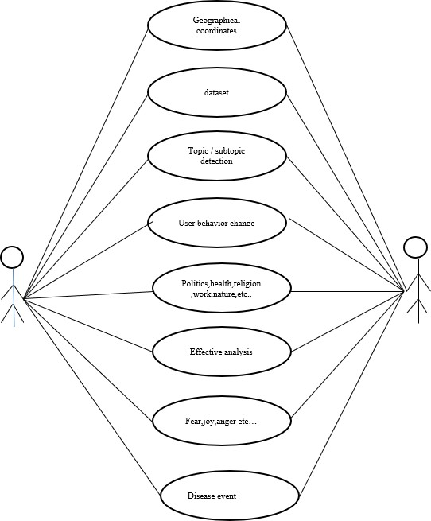

Fig 4.4 Use case diagram

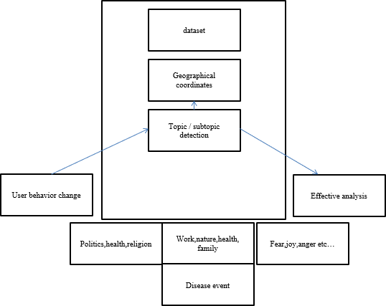

Fig 4.5 Class diagram

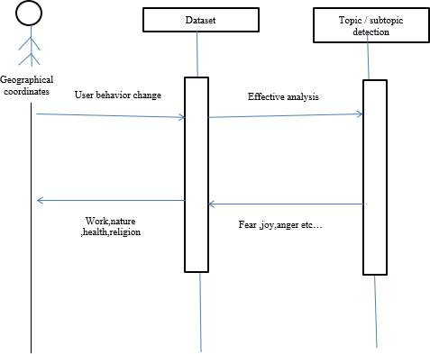

Fig 4.6 Sequence diagram

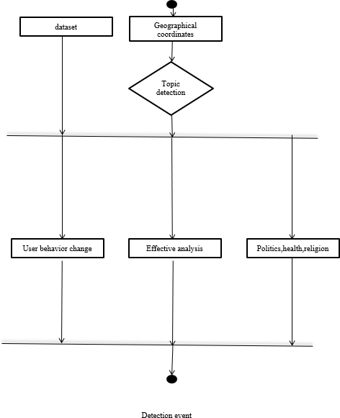

Fig 4.7 Activity Diagram

### CHAPTER 5 ARCHITECTURE

##### SYSTEM ARCHITECTURE

System architecture is the conceptual model that defines the structure, behavior, and more views of a system. An architecture description is a formal description and representation of a system, organized in a way that supports reasoning about the structures and behaviors of the system.

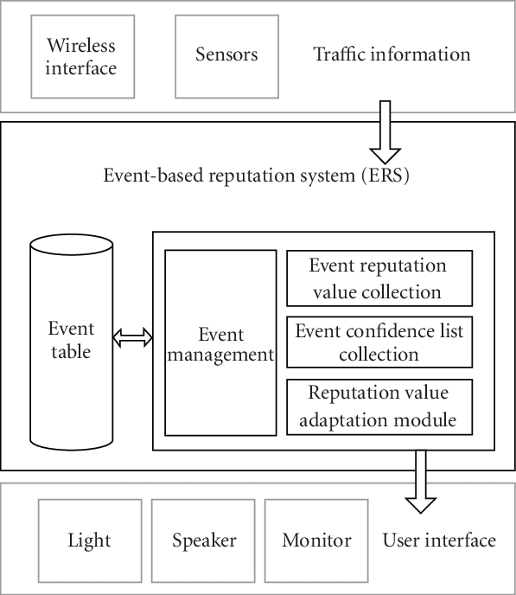

##### SYSTEM MODULE

The Event Detection System contains three modules functions namely:

* + 1. User Behavior Analysis In ONS
    2. Disease Detection Using Data from an OSN
    3. Topic Detection and Affective Analysis

##### MODULES EXPLAINATION:

* + - 1. **User Behavior Analysis In ONS**

In the Twitter OSN, the user behavior can also be characterized in relation to the following activities: tweeting, retweeting, and commenting. Other OSNs, such as Sina Weibo, have also been used to extract data and analyze the user behaviors, and then determine the impact of the user popularity on OSN websites. It is important to note that these studies do not explore the changes of topics posted by users. It is also known that certain events can attract more public attention, which is demonstrated by the number of messages or communication interactions between people interested in such topics. Thus, through the number of messages in OSNs, it is possible to measure the number of members related to potential events, and concerning specific regions. This helps to solve the problem of early event identification. Hence, the messages posted in an OSN represent valuable information to understand and predict the users’ behavior in a specific period of time and geographical location.

##### DISEASE DETECTION USING DATA FROM AN OSN

Currently, there are diverse solutions to detect different types of events using data from an OSN. However, because the focus of our case study is on disease detection, only works related to this subject are presented. In [18] the

authors stated that the virality of a social media content, in the public health context, can depend on the users’ emotions and the disease type. Additionally, the number of followers can affect the propagation scale of the posted messages in OSNs. Thus, the greater the virality of a content, the easier its detection. The virality of a post also depends on the geographical location of the users. An user from a big city can be more influential than users in smaller cities . In the case of accidents or disasters, people usually share information more quickly and mostly with people close to the event .

##### TOPIC DETECTION AND AFFECTIVE ANALYSIS

A method of topic detection based on NLP was used for COVID-19 prediction in [15] by applying a hybrid artificial intelligence (AI) model. The change in the infectious capacity of the virus was analyzed within a few days after the infection, and an improved susceptible-infected (ISI) model was proposed. The NLP module and the LSTM network were embedded in the ISI model to build a hybrid AI model for COVID-19 prediction. With the NLP and LSTM built into the hybrid AI model, the mean absolute percentage errors of the prediction results, considering the next six days, were 0.52%, 0.38%, 0.05%, 0.86% in Wuhan, Beijing, Shanghai, and nationwide, respectively. In deep learning algorithms were used for NLP using a Contrastive Divergence (CD) algorithm, such as the Deep Belief Network (DBN) , which is composed of restricted Boltzmann machines.

**CHAPTER 6 TESTING**

##### SYSTEM TESTING

The testing approach document is designed for Information and Technology Services’ upgrades to PeopleSoft. The document contains an overview of the testing activities to be performed when an upgrade or enhancement is made, or a module is added to an existing application. The emphasis is on testing critical business processes, while minimizing the time necessary for testing while also mitigating risks. It’s important to note that reducing the amount of testing done in an upgrade increases the potential for problems after go-live. Management will need to determine how much risk is acceptable on an upgrade-by-upgrade basis.

System testing is simply testing the system as a whole; it gets all the integrated modules of the various components from the integration testing phase and combines all the different parts into a system which is then tested. Testing is then done on the system as all the parts are now integrated into one system the testing phase will now have to be done on the system to check and remove any errors or bugs. In the system testing process the system will be checked not only for errors but also to see if the system does what was intended, the system functionality and if it is what the end user expected.

There are various tests that need to be conducted again in the system testing which include:

If the integration stage was done accurately then most of the test plan and test cases would already have been done and simple testing would only have to be done in order to ensure there are no bugs because this will be the final product. As in the integration stage, the above steps would need to be re-done as now we have

integrated all modules into one system, so we have to check if this runs OK and that no errors are produced because all the modules are in one system.

##### Unit Testing

Unit testing involves the design of test cases that validate that the internal program logic is functioning properly, and that program input produces valid outputs. All decision branches and internal code flow should be validated. It is the testing of individual software units of the application .it is done after the completion of an individual unit before integration. This is a structural testing, that relies on knowledge of its construction and is invasive. Unit tests perform basic tests at component level and test a specific business process, application, and/or system configuration. Unit tests ensure that each unique path of a business process performs accurately to the documented specifications and contains clearly defined inputs and expected results.

##### TEST CASES

|  |  |  |  |  |  |  |  |
| --- | --- | --- | --- | --- | --- | --- | --- |
| Test Cas e Id | Test Cases | Priorit y | Input Test Data | Test Case Descriptio n | Expected Results | Actual Results | Pass/Fai l |
| TU0 1 | User Login | A | Enter Email-id and Password. | Check user with the database | User should be available in database | User present in database | Pass |
| TU0 2 | Create Event | A | Event Details | Creating an Event | Should be upload Successfull y | Details are stored successfull y | Pass |
| TU0 3 | Receive Notificatio n | A | - | Event Details are notified. | Notificatio n should be received properly | Alert Message received properly | Pass |
| TU0 4 | Request Friend informatio n | A | Add Friend Request | Request Friend | Accepted Request | Accepted successful | Pass |

Table 6.1 Test Cases for User Module

|  |  |  |  |  |  |  |  |
| --- | --- | --- | --- | --- | --- | --- | --- |
| Test Case Id | Test Cases | Priorit y | Inpu t  Test Data | Test Case Description | Expected Results | Actual Result s | Pass/Fa il |
| TE0 1 | Admin Login | A | Enter Email-id and Passwor d. | Check Admin details with the database | Admin should be available in database | Admin present in database | Pass |
| TE0 2 | View All Events Created | A | Events Created | All Events Description that are Created | Show all the event that are created | Display ed Events | Pass |
| TC01 | Check Event | A | Event Name | Description of all information regarding the information | Event Description with attendees | Event Informa tion | Pass |
| TC02 | Receive Notificatio n | A | Event Name | Display information of all the attendees with disease affected percentage | Notificatio n should be received properly | Alert Messag e receive d  properl y | Pass |

Table 6.3 Test Cases for Admin

## CHAPTER 7

**CONCLUSION AND FUTURE ENHANCEMENT**

##### CONCLUSION

This work presented and approved an occasion discovery framework at a beginning phase dependent on the client conduct data separated from OSNs, featuring the importance of joining the client conduct change examinations into arrangements of this kind. Thus, this work indicated the significance of the subtopic distinguishing proof by the NLP calculation utilizing an unaided AI procedure and the utilization of emotional investigation. The proposed framework presents a superior presentation than two comparative occasion locator arrangements proposed. In spite of the fact that urban communities from various nations were investigated, a comparative conduct was distinguished by the adjustment in themes, yet at various dates. For our situation study, the COVID-19 pandemic, the message points about wellbeing, religion, and governmental issues arisen with more reputation, and alternately, the quantity of messages with respect to the diversion point diminished. As a subject of future work, the goal is to investigate the value of client conduct data in OSNs to identify occasions having a place with various themes, and a further point is to test other profound learning calculations to improve the framework execution.

##### FUTURE ENHANCEMENT

This proposed framework is rationalist about the subject of a conceivable occasion; nonetheless, our contextual investigation zeroed in on the Coronavirus pandemic occasion to pressure the handiness of this arrangement type. Albeit a case on a wellbeing subject was utilized, the proposed framework can be stretched out to different territories, not restricting its utilization to a particular theme or case. As a rule, the exploratory outcomes acquired show that clients obviously respond when a

few occasions happen. This response is reflected in the quantity of posted messages and the message subjects. In this way, following the client conduct in OSNs grants to recognize occasions in explicit locales, and toward the start of the occasion. This work thought about eight major urban areas around the globe also, a lot of assorted information from various societies. The proposed occasion location framework was made of various modules, and every module of the arrangement was assessed and found to have a precision higher than the related works alluded to in the investigation. Hence, the procedure to find the client area, the NLP calculation for subject and subtopic ID, and the full of feeling investigation to find the feelings of the messages were approved.

**APPENDICES**

**A 1. SAMPLE SCREENS**

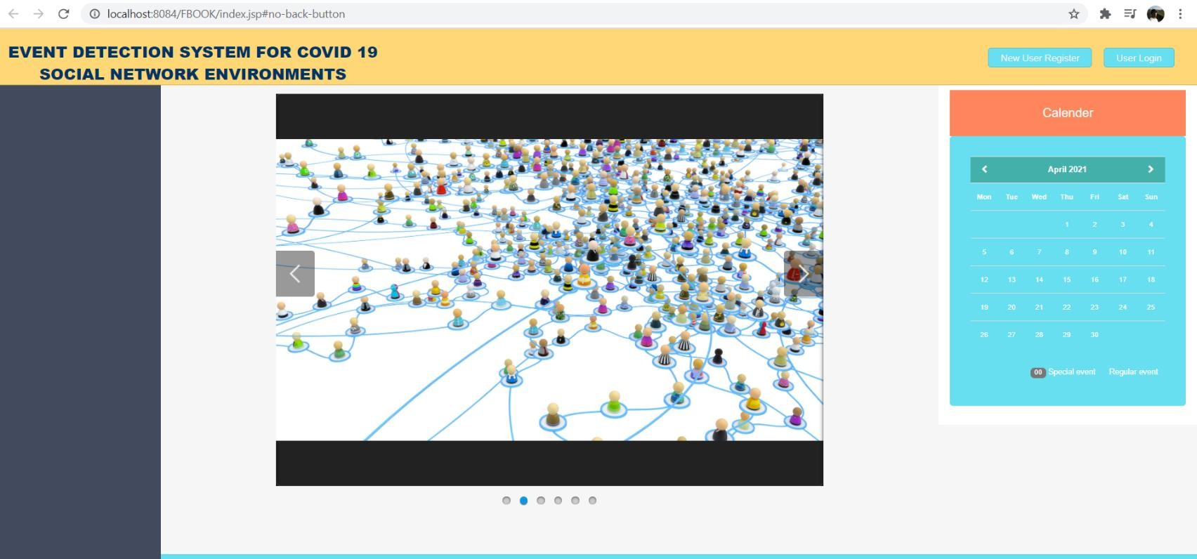

Fig.1 Welcome Page

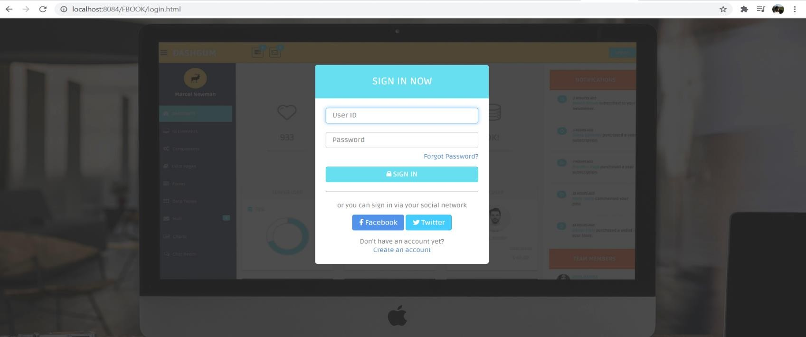

Fig.2 Login Page

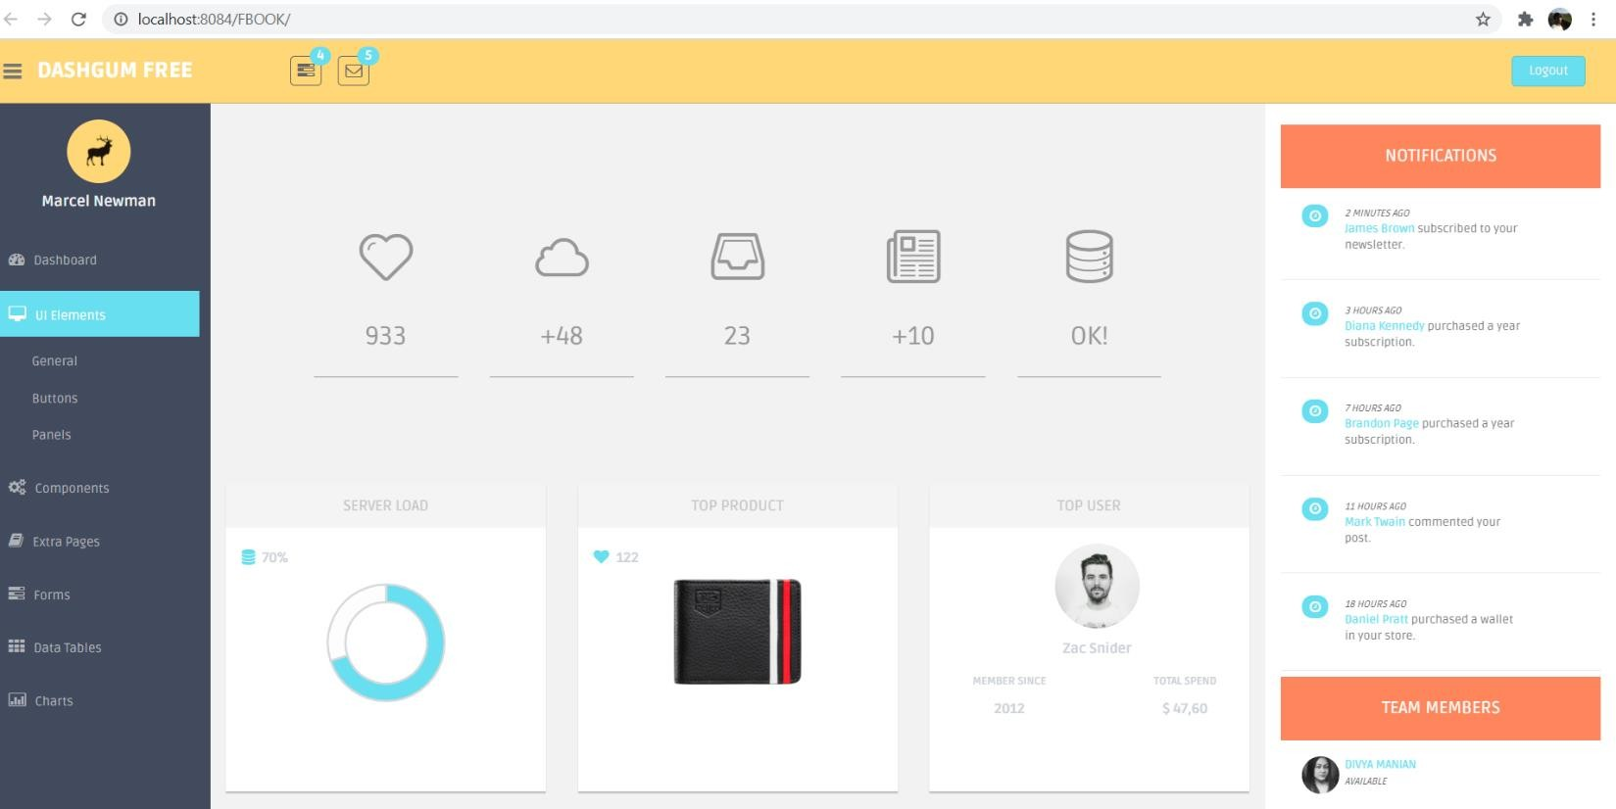

Fig.3 Home Page

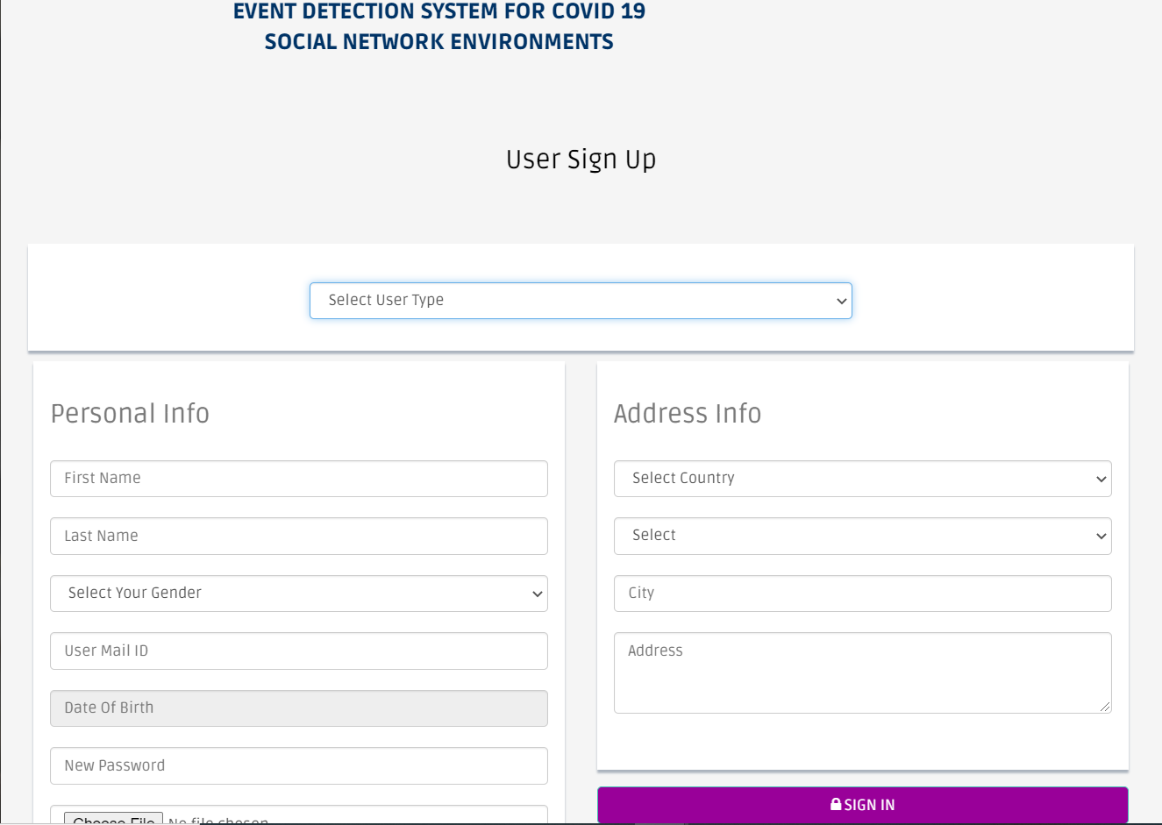

Fig.4 User Registration Page

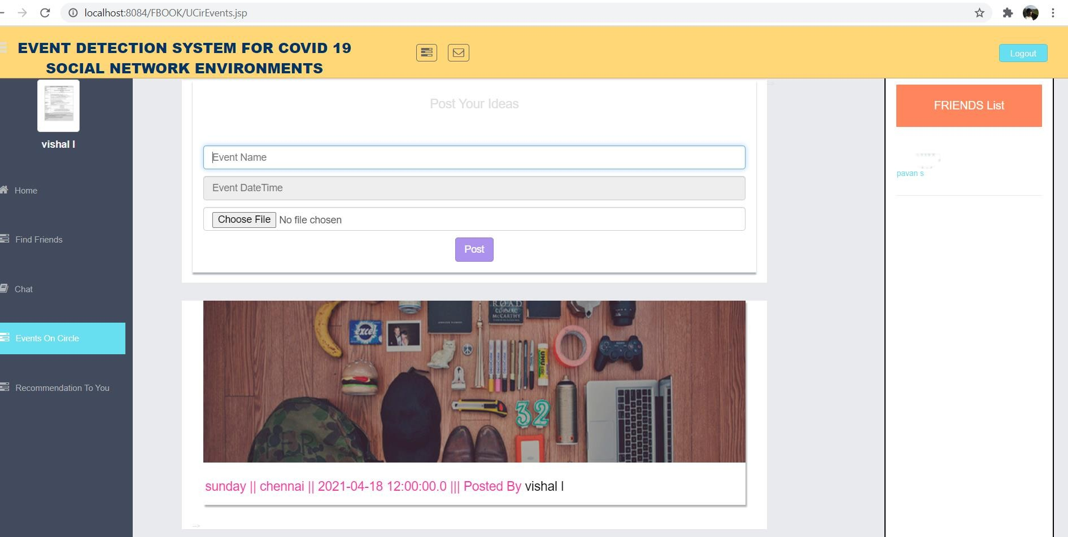

Fig.5 Event display page

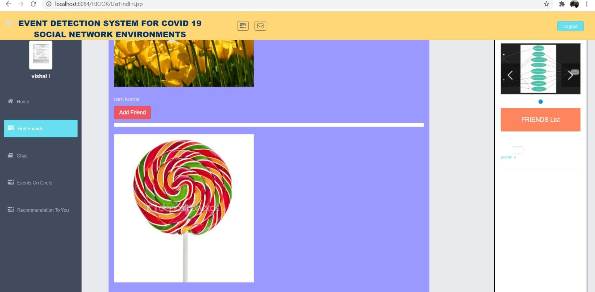

Fig.6 Friends page

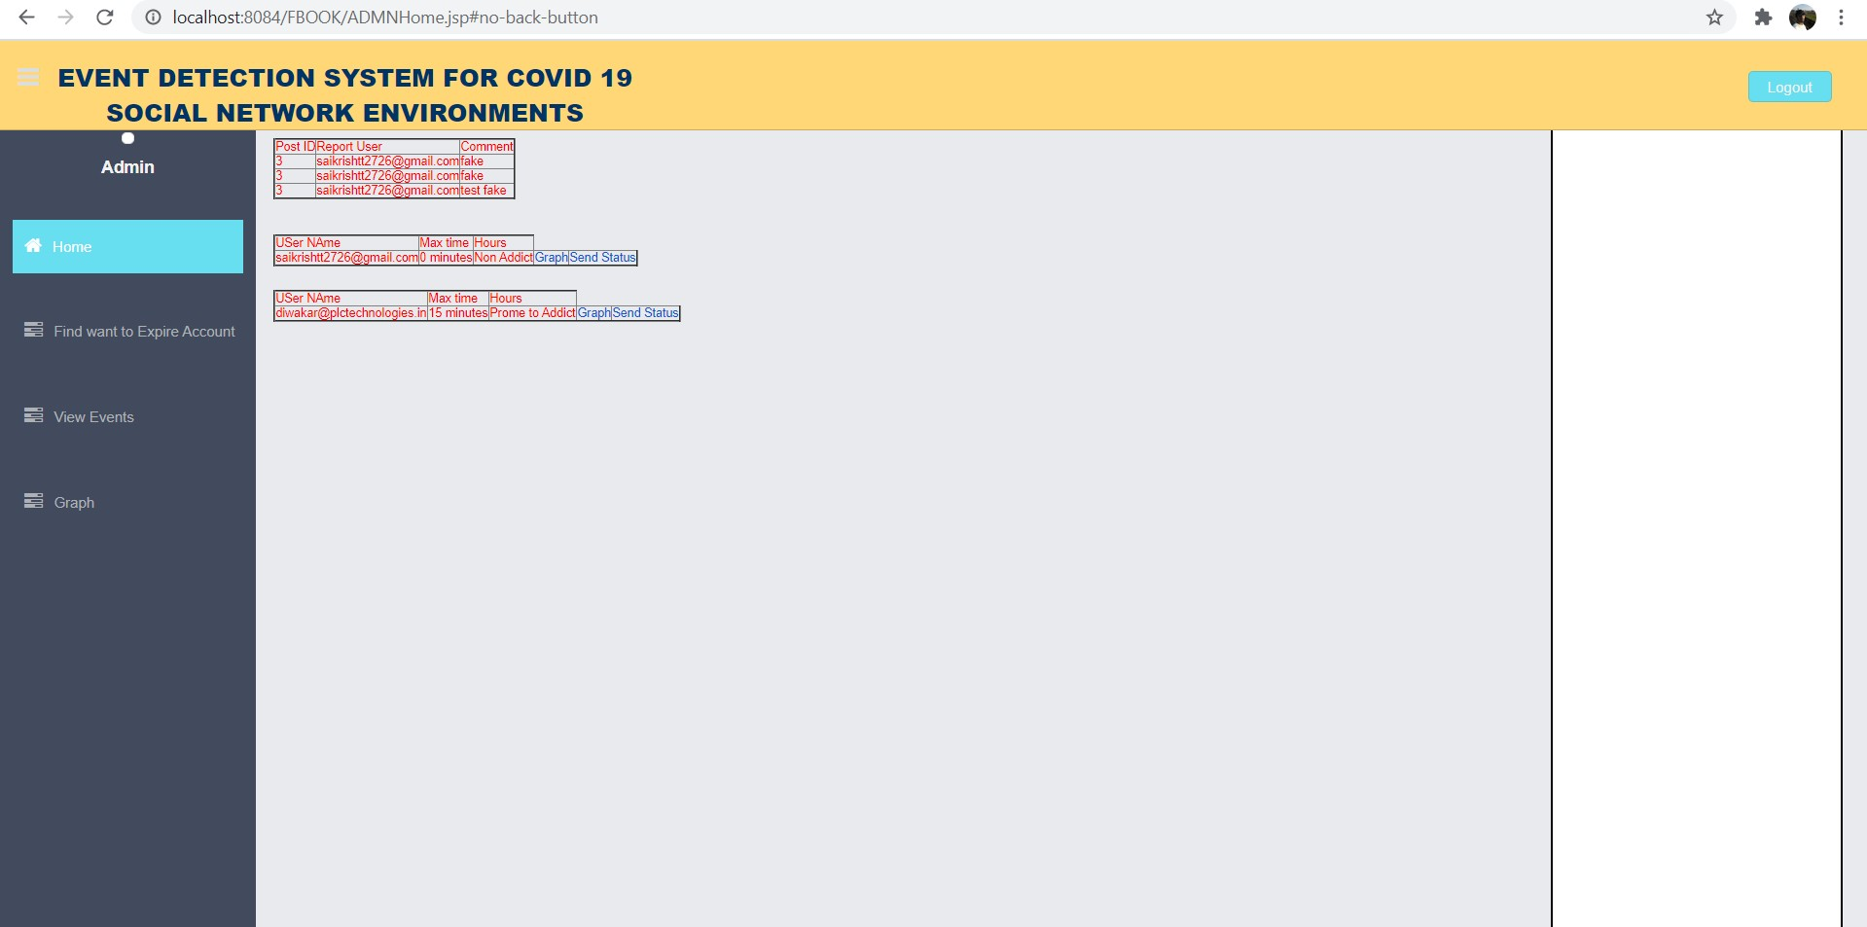

Fig 7. Admin Home Page for Events

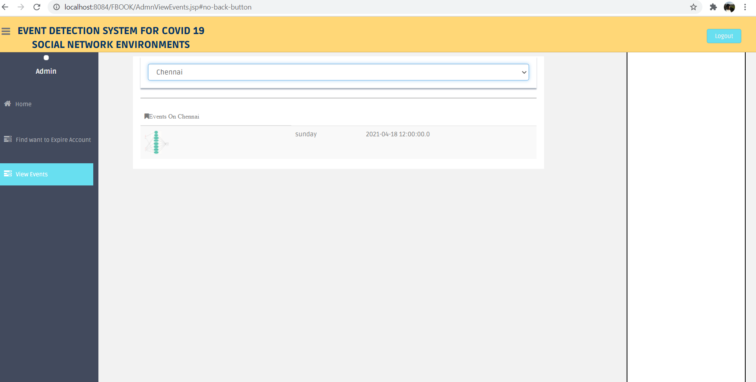

Fig.8 Admin Event Page

### SAMPLE CODE

**Index.jsp**

#### <%@page contentType="text/html" pageEncoding="UTF-8"%>

<!DOCTYPE html>

<html lang="en">

<head>

<meta charset="utf-8">

<meta name="viewport" content="width=device-width, initial- scale=1.0">

<meta name="description" content="">

<meta name="author" content="Dashboard">

<meta name="keyword" content="Dashboard, Bootstrap, Admin, Template, Theme, Responsive, Fluid, Retina">

<title>Initial Page</title>

<!-- Bootstrap core CSS -->

<link href="assets/css/bootstrap.css" rel="stylesheet">

<!--external css-->

<link href="assets/font-awesome/css/font-awesome.css" rel="stylesheet"

/>

<link rel="stylesheet" type="text/css"

href="assets/css/zabuto_calendar.css">

<link rel="stylesheet" type="text/css" href="assets/js/gritter/css/jquery.gritter.css" />

<link rel="stylesheet" type="text/css" href="assets/lineicons/style.css">

<!-- Custom styles for this template -->

<link href="assets/css/style.css" rel="stylesheet">

<link href="assets/css/style-responsive.css" rel="stylesheet">

<script src="assets/js/chart-master/Chart.js"></script>

<!-- HTML5 shim and Respond.js IE8 support of HTML5 elements and media queries -->

<!--[if lt IE 9]>

<script src="https://oss.maxcdn.com/libs/html5shiv/3.7.0/html5shiv.js"></script>

<script src="https://oss.maxcdn.com/libs/respond.js/1.4.2/respond.min.js"></script>

<![endif]-->

<script>

window.location.hash = "no-back-button";

window.location.hash = "Again-No-back-button";//again because google chrome don't insert first hash into history

window.onhashchange = function() { window.location.hash = "no-back-button";

}

</script>

<link href="assets/SLIDER/2/ninja-slider.css" rel="stylesheet" type="text/css" />

<!--ninjaVideoPlugin.js is required only when the slider contains videos, and its link should be placed before the ninja-slider.js link.-->

<script src="assets/SLIDER/2/ninjaVideoPlugin.js" type="text/javascript"></script>

<script src="assets/SLIDER/2/ninja-slider.js" type="text/javascript"></script>

<style>

body {font: normal 0.9em Arial;margin:60px 0;background- color:#222;color:#ddd;}

a {color:#1155CC;}

ul li {padding: 10px 0;}

</style>

<link href="assets/Slider1/themes/1/js-image-slider.css" rel="stylesheet"

type="text/css" />

<script src="assets/Slider1/themes/1/js-image-slider.js" type="text/javascript"></script>

<link href="assets/Slider1/generic.css" rel="stylesheet" type="text/css"

/>

</head>

<body>

<section id="container" >

<!-- ****************************** TOP BAR CONTENT & NOTIFICATIONS

******************************* -->

<!--header start-->

<header class="header black-bg">

<!--logo start-->

<a href="index.jsp" class="logo"><center><b style="color: #003366;">EVENT DETECTION SYSTEM FOR COVID 19

<br> Social Network Environments</b></center></a>

<!--logo end-->

<!-- <div class="nav notify-row" id="top_menu">

<!-- notification start -->

<!-- <ul class="nav top-menu">

<!-- settings start -->

<!-- <li class="dropdown">

<a data-toggle="dropdown" class="dropdown-toggle" href="index.html#">

<i class="fa fa-tasks"></i>

<span class="badge bg-theme">4</span>

</a>

<ul class="dropdown-menu extended tasks-bar">

<div class="notify-arrow notify-arrow-green"></div>

<li>

<p class="green">You have 4 pending tasks</p>

</li>

<li>

<a href="index.html#">

<div class="task-info">

<div class="desc">DashGum Admin Panel</div>

<div class="percent">40%</div>

</div>

<div class="progress progress-striped">

<div class="progress-bar progress-bar-success" role="progressbar" aria-valuenow="40" aria-valuemin="0" aria- valuemax="100" style="width: 40%">

<span class="sr-only">40% Complete

(success)</span>

</div>

</div>

</a>

</li>

<li>

<a href="index.html#">

<div class="task-info">

<div class="desc">Database Update</div>

<div class="percent">60%</div>

</div>

<div class="progress progress-striped">

<div class="progress-bar progress-bar-warning"

role="progressbar" aria-valuenow="60" aria-valuemin="0" aria- valuemax="100" style="width: 60%">

<span class="sr-only">60% Complete

(warning)</span>

</div>

</div>

</a>

</li>

<li>

<a href="index.html#">

<div class="task-info">

<div class="desc">Product Development</div>

<div class="percent">80%</div>

</div>

<div class="progress progress-striped">

<div class="progress-bar progress-bar-info" role="progressbar" aria-valuenow="80" aria-valuemin="0" aria- valuemax="100" style="width: 80%">

<span class="sr-only">80% Complete</span>

</div>

</div>

</a>

</li>

<li>

<a href="index.html#">

<div class="task-info">

<div class="desc">Payments Sent</div>

<div class="percent">70%</div>

</div>

<div class="progress progress-striped">

<div class="progress-bar progress-bar-danger" role="progressbar" aria-valuenow="70" aria-valuemin="0" aria- valuemax="100" style="width: 70%">

<span class="sr-only">70% Complete

(Important)</span>

</div>

</div>

</a>

</li>

<li class="external">

<a href="#">See All Tasks</a>

</li>

</ul>

</li>

<!-- settings end -->

<!-- inbox dropdown start-->

<!-- <li id="header_inbox_bar" class="dropdown">

<a data-toggle="dropdown" class="dropdown-toggle" href="index.html#">

<i class="fa fa-envelope-o"></i>

<span class="badge bg-theme">5</span>

</a>

<ul class="dropdown-menu extended inbox">

<div class="notify-arrow notify-arrow-green"></div>

<li>

<p class="green">You have 5 new messages</p>

</li>

<li>

<a href="index.html#">

<span class="photo"><img alt="avatar" src="assets/img/ui-zac.jpg"></span>

<span class="subject">

<span class="from">Zac Snider</span>

<span class="time">Just now</span>

</span>

<span class="message">

Hi mate, how is everything?

</span>

</a>

</li>

<li>

<a href="index.html#">

<span class="photo"><img alt="avatar" src="assets/img/ui-divya.jpg"></span>

<span class="subject">

<span class="from">Divya Manian</span>

<span class="time">40 mins.</span>

</span>

<span class="message">

Hi, I need your help with this.

</span>

</a>

</li>

<li>

<a href="index.html#">

<span class="photo"><img alt="avatar" src="assets/img/ui-danro.jpg"></span>

<span class="subject">

<span class="from">Dan Rogers</span>

<span class="time">2 hrs.</span>

</span>

<span class="message"> Love your new Dashboard.

</span>

</a>

</li>

<li>

<a href="index.html#">

<span class="photo"><img alt="avatar" src="assets/img/ui-sherman.jpg"></span>

<span class="subject">

<span class="from">Dj Sherman</span>

<span class="time">4 hrs.</span>

</span>

<span class="message"> Please, answer asap.

</span>

</a>

</li>

<li>

<a href="index.html#">See all messages</a>

</li>

</ul>

</li>

<!-- inbox dropdown end -->

<!-- </ul>

<!-- notification end -->

<!-- </div>-->

<div class="top-menu">

<ul class="nav pull-right top-menu">

<li><a class="logout" href="Register.jsp">New User Register</a></li>

<li><a class="logout" href="UsrLogin.jsp">User Login</a></li>

</ul>

</div>

</header>

<!--header end-->

<!-- ****************************** MAIN SIDEBAR MENU

******************************** -->

<!--sidebar start-->

<aside>

<div id="sidebar" class="nav-collapse ">

</div>

</aside>

<!--sidebar end-->

<!-- ****************************** MAIN CONTENT

******************************* -->

<!--main content start-->

<section id="main-content">

<section class="wrapper">

<div class="row">

<div class="col-lg-9 main-chart">

<div class="row">

<div id="sliderFrame" style="margin-top: 5px;">

<!-- <div id="slider">

<center>

<img src="" alt="12" /></a>

<img src="" alt="34" /></a>

<img src="SliderImages/enterprise-social-

media.jpg" alt="90" /></a>

alt="56" /></a>

<img src="SliderImages/social-network.jpg"

<img src="SliderImages/social-network- software-72.jpg" alt="78" /></a>

</center>

</div>-->

<div id='ninja-slider'>

<ul>

<li><div data- image="SliderImages/social_networking.jpg"></div></li>

<li><div data-image="SliderImages/social- network-links.jpg"></div></li>

<li><div data-image="SliderImages/enterprise- social-media.jpg"></div></li>

<li><div data-image="SliderImages/media- communication.jpg"></div></li>

<li><div data-image="SliderImages/social- networking2.png"></div></li>

<li><div data- image="SliderImages/snetwork.png"></div></li>

</ul>

</div><br>

<div id="htmlcaption" style="display: none;">

<em>HTML</em> caption. Link to <a href[="http://ww](http://www.google.com/)w.[google.com/"](http://www.google.com/)>Google</a>.

</div>

</div>

</div><!-- /row -->

</div><!-- /col-lg-9 END SECTION MIDDLE -->

<!-- ****************************** RIGHT SIDEBAR CONTENT

******************************* -->

<div class="col-lg-3 ds">

<h3>Calender</h3>

<div id="calendar" class="mb">

<div class="panel green-panel no-margin">

<div class="panel-body">

<div id="date-popover" class="popover top" style="cursor: pointer; disadding: block; margin-left: 33%; margin-top: - 50px; width: 175px;">

<div class="arrow"></div>

< h3 class="popover-title" style="disadding: none;"></h3>

<div id="date-popover-content" class="popover-content"></div>

</div>

<div id="my-calendar"></div>

</div>

</div>

</div><!-- / calendar -->

</div><!-- /col-lg-3 -->

</div><!--/row --><br><br><br><br>

</section>

</section>

<!--main content end-->

<!--footer start-->

<footer class="site-footer">

<div class="text-center"> Recommendation On OSN

<a href="index.jsp#" class="go-top">

<i class="fa fa-angle-up"></i>

</a>

</div>

</footer>

<!--footer end-->

</section>

<!-- js placed at the end of the document so the pages load faster -->

<script src="assets/js/jquery.js"></script>

<script src="assets/js/jquery-1.8.3.min.js"></script>

<script src="assets/js/bootstrap.min.js"></script>

<script class="include" type="text/javascript" src="assets/js/jquery.dcjqaccordion.2.7.js"></script>

<script src="assets/js/jquery.scrollTo.min.js"></script>

<script src="assets/js/jquery.nicescroll.js" type="text/javascript"></script>

<script src="assets/js/jquery.sparkline.js"></script>

<!--common script for all pages-->

<script src="assets/js/common-scripts.js"></script>

<script type="text/javascript" src="assets/js/gritter/js/jquery.gritter.js"></script>

<script type="text/javascript" src="assets/js/gritter-conf.js"></script>

<!--script for this page-->

<script src="assets/js/sparkline-chart.js"></script>

<script src="assets/js/zabuto_calendar.js"></script>

<%

String fbmsg = (String) session.getAttribute("fbmsg");

if (fbmsg != null) {

%>

<script type="text/javascript"> var mmsg = '<%=fbmsg%>';

var unique_id = $.gritter.add({

// (string | mandatory) the heading of the notification title: 'Action Message',

// (string | mandatory) the text inside the notification text: mmsg,

// (bool | optional) if you want it to fade out on its own or just sit there sticky: true,

// (int | optional) the time you want it to be alive for before fading out time: '',

// (string | optional) the class name you want to apply to that specific message

class_name: 'my-sticky-class', left: '200px'

});

</script>

<%

}

session.removeAttribute("fbmsg");

%>

<script type="application/javascript">

$(document).ready(function () {

$("#date-popover").popover({html: true, trigger: "manual"});

$("#date-popover").hide();

$("#date-popover").click(function (e) {

$(this).hide();

});

$("#my-calendar").zabuto_calendar({ action: function () {

return myDateFunction(this.id, false);

},

action_nav: function () {

return myNavFunction(this.id);

},

ajax: {

url: "show_data.php?action=1", modal: true

},

legend: [

{type: "text", label: "Special event", badge: "00"},

{type: "block", label: "Regular event", }

]

});

});

function myNavFunction(id) {

$("#date-popover").hide();

var nav = $("#" + id).data("navigation"); var to = $("#" + id).data("to");

console.log('nav ' + nav + ' to: ' + to.month + '/' + to.year);

}

</script>

</body>

</html>

##### REFERENCES

1. Ajzen and M. Fishbein, Understanding attitudes and predicting social behavior . Englewood Cliffs, New Jersey: Prentice-Hall, 1980.
2. R. L. Rosa, G. M. Schwartz, W. V. Ruggiero, and D. Z. Rodríguez, “A knowledge-based recommendation system that includes sentiment analysis and deep learning,” IEEE Transactions on Industrial Informatics, vol. 15, pp. 2124– 2135, Apr. 2019.
3. T. Marcinkowski and A. Reid, “Reviews of research on the attitude–behavior relationship and their implications for future environmental education research,” Environmental Education Research, vol. 25, pp. 459– 471, Jul. 2019. doi: 10.1080/13504622.2019.1634237.
4. Y. Su, J. Luo, J. Fang, and Z. Chen, “Research and design of website user behavior data acquisition based on customized event tracking,” in 2019 IEEE 4th Advanced Information Technology, Electronic and Automation Control Conference (IAEAC), vol. 1, (Chengdu, China), pp. 2024–2029, Dec. 2019.
5. H. ˙I ¸S and T. Tuncer, “Confidence index analysis of Twitter users timeline,” in 2018 International Conference on Artificial Intelligence and Data Processing (IDAP), (Malatya, Turkey), pp. 1–8, Sept. 2018. doi: 10.1109/IDAP.2018.8620917.
6. R. Murimi, “Online social networks for meaningful social reform,” in 2018 World Engineering Education Forum - Global Engineering Deans Council (WEEF-GEDC), pp. 1–6, Nov. 2018. doi: 10.1109/WEEF-GEDC.2018.
7. G. Xu, Z. Yu, Z. Chen, X. Qiu, and H. Yao, “Sensitive information topics-based sentiment analysis method for big data,” IEEE Access, vol. 7, pp. 96177– 96190, Jul. 2019.
8. S. K. Ray, M. Saeed, and S. Subrahmaniam, “Empirical Analysis of User Behavior in Social Media,” in 2015 International Conference on Developments of E-Systems Engineering (DeSE), (Dubai, United Arab Emirates), pp. 359– 364, Dec. 2015.
9. K. Mohbey, “Multi-class approach for user behavior prediction using deep learning framework on Twitter election Dataset,” Journal of Data, Information and Management, vol. 2, pp. 1–14, Oct. 2019. doi: 10.1007/s42488-019-00013- y.
10. J. Fernquist, L. Kaati, and R. Schroeder, “Political bots and the swedish general election,” in 2018 IEEE International Conference on Intelligence and Security Informatics (ISI), (FL, USA), pp. 124–129, Nov. 2018.
11. E. L. Lasmar, F. O. de Paula, R. L. Rosa, J. I. Abrahão, and D. Z. Rodríguez, “RsRS: Ridesharing Recommendation System Based on Social Networks to Improve the User’s QoE,” IEEE Transactions on Intelligent Transportation Systems, vol. 20, pp. 4728–4740, Dec. 2019.
12. S. Hernández, P. Álvarez, J. Fabra, and J. Ezpeleta, “Analysis of Users’ Behavior in Structured e-Commerce Websites,” IEEE Access, vol. 5, pp. 11941–11958, May 2017.
13. C. Yang, H. Yan, D. Yu, Y. Li, and D. M. Chiu, “Multi-site user behavior modeling and its application in video recommendation,” in Proceedings of the 40th

International ACM SIGIR Conference on Research and Development in Information Retrieval, p. 175–184, 2017. doi: 10.1145/3077136. 3080769.

1. J. Zhang, Y. Chen, Y. Zhao, D. Wolfram, and F. Ma, “Public health and social media: A study of zika virus-related posts on yahoo! answers,” Journal of the Association for Information Science and Technology, vol. 71, pp. 282–299, Mar. 2020. doi: 10.1002/asi.24245.
2. N. Zheng, S. Du, J. Wang, H. Zhang, W. Cui, Z. Kang, T. Yang, B. Lou,

Y. Chi, H. Long, M. Ma, Q. Yuan, S. Zhang, D. Zhang, F. Ye, and J. Xin,

“Predicting covid-19 in china using hybrid ai model,” IEEE Transactions

on Cybernetics, vol. 50, pp. 2891–2904, May 2020.

1. S. Zhang, “Using twitter to enhance traffic incident awareness,” in 2015 IEEE 18th International Conference on Intelligent Transportation Systems, (Gran Canaria, Spain), pp. 2941–2946, Sept. 2015.
2. S. Ye and S. Wu, “Measuring message propagation and social influence on

twitter.com,” in Proceedings of the Second International Conference on

Social Informatics, vol. 11, (Laxenburg, Austria), pp. 216–231, Springer-

Verlag, Sept. 2010. doi: 10.1007/978-3-642-16567-2_16.

1. L. Li, Q. Zhang, J. Tian, and H. Wang, “Characterizing information propagation patterns in emergencies: A case study with yiliang earthquake”,International Journal of Information Management, vol.38, pp.34–41, Feb.2018. doi: 10.1016/j.ijinfomgt.2017.08.008