Event Detection System for Covid-19 Pandemic

Bhargav K R
Computer Science and Engineering
Panimalar Engineering College, Chennai, Tamil Nadu
bhargavkr2000@gmail.com
B L S R K Vishal
Computer Science and Engineering
Panimalar Engineering College, Chennai, Tamil Nadu
vishalkrishna1998@gmail.com
C H Pavan Kumar
Computer Science and Engineering
Panimalar Engineering College, Chennai, Tamil Nadu
pavankumar27799@gmail.com

Abstract—Individuals utilize Online Social Networks (OSNs) to communicate their sentiments and emotions about numerous points. Contingent upon the idea of an occasion and its dispersal rate in OSNs, and considering explicit locales, the clients' conduct can definitely change throughout a particular timeframe. In this specific situation, this work intends to propose an occasion recognition framework at the beginning phases of an occasion dependent on changes in the clients' conduct in an OSN. This framework can recognize an occasion of any subject, and accordingly, it tends to be utilized for various purposes. The proposed occasion recognition framework is made out of the accompanying principal modules: (1) assurance of the client's area, (2) message extraction from an OSN, (3) subject recognizable proof utilizing common language preparing (NLP) in light of the Deep Belief Network (DBN), (4) the client conduct change analyzer in the OSN, and (5) full of feeling examination for feeling recognizable proof dependent on a tree-convolutional neural organization (tree-CNN)
Keywords—OSN, DBN, Natural Language Processing, CNN

Introduction
The user behavior has been studied to examine the psychological antecedents of actions in various domains like medical, businesses and many other sectors for many years, and by gathering all this information using the data obtained to predict or to make proposal to the client/person and to track the event of the person. In general, the characteristics of a person depends on various factors and one of the most common factors is their health condition and well-being, so that the behavior of the person can also be predicted or analyzed based on their public health status.
Nowadays social media is been a very popular mode of interaction between the people they share their thoughts, feelings, emotions, behavior and their status etc. in the social media which is an Online Social Network (ONS), this online social media includes Facebook, Twitter etc. Thus, this Online social media consists of vast amount of data which also analyze the behavior of the person using online social networks.
However, analyzing the behavior of the users in an OSN is a complex task [8], and thus, some models to detect anomalies in the user behavior have been studied [9]. Some studies have focused particularly on the domain of user behavior analysis on social media for instance in the contexts of political Events, a diverse range of recommendation systems, public health, communication network recommendations, and prediction of urban traffic trends among others.
Currently, in the world one of the most popular OSNs is Twitter, in which users share short messages. The data extracted from Twitter have been used in many studies to identify possible trends. In addition, other similar OSNs are also used in different countries, such as Sine Weibo, the most popular micro-blog platform in China. In Weibo, it is also possible to classify disease-related information. To this end, the natural language processing (NLP) technique plays an important role. NLP is used for extracting situational information, such as advice, notifications, emotional support, doubt casting and criticizing, and counter-rumor. In addition, different machine learning algorithms are used for illness type classification, such as Support Vector Machine (SVM), Naive Bayes (NB), and Random Forest (RF), However, these algorithms do not reach an accuracy higher than 0.70 when they are applied in epidemic early detection solutions

Objective
The Main Objective of the project is designing a Event Detection System for Covid-19 so that all the events that occur in a locality or area can be kept in track and to predict whether a person has a chance of getting effected by covid or not.

LITERATURE REVIEW
This section introduces and discusses the main studies in the literature about user behavior in OSNs, disease detection using data from OSNs and affective analysis, and topic detection based on NLP.

Information Retrieval from Online Social Networks
Recent studies that specified that large amount of digital content available through web sites, social networks, streaming services, and other distribution media, allows more and more people to access virtually unlimited sources of information, products, and services. This enormous availability makes it very difficult for users to find what they are really interested in. Hence, the great current interest in developing personalized methods of information retrieval as well as reliable recommendation algorithms that help users to filter and discover what fits their preferences. Graph convolutional network (GCN) algorithm called Pharma Sage is proposed for providing pharmacy product cross-selling recommendations based on product feature information and sales data. The model was trained with a huge amount of real pharmaceutical data including almost a million products with complex properties and approximately 100 million sales transactions

Public health and social media
This study investigates the content of questions and responses about the Zika virus on Yahoo! Answers as a recent example of how public concerns regarding an international health issue are reflected in social media. We investigate the contents of posts about the Zika virus on Yahoo! Answers, identify and reveal subject patterns about the Zika virus, and analyze the temporal changes of the revealed subject topics over 4 defined periods of the Zika virus outbreak. Multidimensional scaling analysis, temporal analysis, and inferential statistical analysis approaches were used in the study. A resulting 2‐layer Zika virus schema, and term connections and relationships are presented. The results indicate that consumers’ concerns changed over the 4 defined periods. Consumers paid more attention to the basic information about the Zika virus, and the prevention and protection from the Zika virus at the beginning of the outbreak of the Zika virus. During the later periods, consumers became more interested in the role that the government and health organizations played in the public health emergency.

the Existing system
- With respect to general wellbeing following status, a few examinations have zeroed in on separating messages in the OSNs for discovering ailment related subjects
- The opinion and emotional examination is another model of methods that have been discovered valuable to identify a few ailments like melancholy or stress. Other ailments and infections are likewise identified by separating negative remarks of the OSN, being related with misery or anger.
- In any case, the current investigations do not investigate the connection between the client conduct change furthermore, conceivable future occasions.

Existing Disadvantages
- Not a location-based group analysis.
- Individual analysis only

Proposed system
- The proposed occasion location framework in which the client area is first decided, and afterward, a dataset is assembled and the point and subtopic recognizable proof of the message are characterized utilizing the NLP strategy.
- Afterward, the difference in the subject of the client posts is hailed and the client conduct change is distinguished and examined. Depending on the difference in subject, the occasion is found.
- At last, a full of feeling examination is acted in the client message to recognize the feelings and therefore, regardless of whether the occasion is good or on the other hand negative. The principal commitments of this paper are A strategy to actualize an early occasion identification framework in light of the client conduct data that arrives at a precision better than related works.
- A show that client conduct changes in OSNs give helpful data to foresee distinctive occasion types; for our situation study, the occasions are identified with the Coronavirus pandemic at its beginning phases. The exhibition approval of a profound conviction organization (DBN) and SoftMax relapse in the NLP setting. The exhibition approval of a tree-convolutional neural organization (tree-CNN) model for the full of feeling investigation acted in this work.
Advantages
- Gathering information of group of people in particular
location.
- Various types of algorithms combined and used.

Architecture diagram
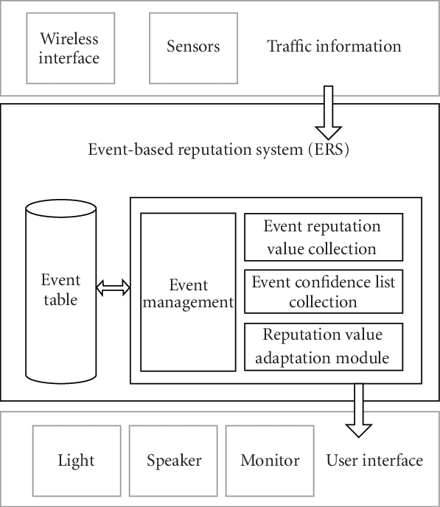

Modules
- User Behavior Analysis In ONS
- Disease Detection Using Data from an OSN
- Topic Detection and Affective Analysis

Modules description

- User Behaviour Analysis In ONS
In the Twitter OSN, the user behavior can also be characterized in relation to the following activities: tweeting, retweeting, and commenting [46]. Other OSNs, such as Sina Weibo, have also been used to extract data and analyze the user behaviors, and then determine the impact of the user popularity on OSN websites. It is important to note that these studies do not explore the changes of topics posted by users. It is also known that certain events can attract more public attention, which is demonstrated by the number of messages or communication interactions between people interested in such topics. Thus, through the number of messages in OSNs, it is possible to measure the number of members related to potential events, and concerning specific regions. This helps to solve the problem of early event identification. Hence, the messages posted in an OSN represent valuable information to understand and predict the users’ behavior in a specific period of time and geographical location

- Disease Detection Using Data from an OSN

Currently, there are diverse solutions to detect different types of events using data from an OSN. However, because the focus of our case study is on disease detection, only works related to this subject are presented. The 35 authors stated that the virality of a social media content, in the public health context, can depend on the users’ emotions and the disease type. Additionally, the number of followers can affect the propagation scale of the posted messages in OSNs. Thus, the greater the virality of a content, the easier its detection. The virality of a post also depends on the geographical location of the users. A user from a big city can be more influential than users in smaller cities. In the case of accidents or disasters, people usually share information more quickly and mostly with people close to the event.

- Topic Detection and Affective Analysis

A method of topic detection based on NLP was used for COVID-19 prediction in [63] by applying a hybrid artificial intelligence (AI) model. The change in the infectious capacity of the virus was analyzed within a few days after the infection, and an improved susceptible-infected (ISI) model was proposed. The NLP module and the LSTM network were embedded in the ISI model to build a hybrid AI model for COVID-19 prediction. With the NLP and LSTM built into the hybrid AI model, the mean absolute percentage errors of the prediction results, considering the next six days, were 0.52%, 0.38%, 0.05%, 0.86% in Wuhan, Beijing, Shanghai, and nationwide, respectively. In [64], deep learning algorithms were used for NLP using a Contrastive Divergence (CD) algorithm, such as the Deep Belief Network (DBN) [65], which is composed of restricted Boltzmann machines

Conclusion
- This work presented and approved an occasion discovery framework at a beginning phase dependent on the client conduct data separated from OSNs, featuring the importance of joining the client conduct change examinations into arrangements of this kind.
- Thus, this work indicated the significance of the subtopic distinguishing proof by the NLP calculation utilizing an unaided AI procedure and the utilization of emotional investigation. The proposed framework presents a superior presentation than two comparative occasion locator arrangements proposed.
- In spite of the fact that urban communities from various nations were investigated, a comparative conduct was distinguished by the adjustment in themes, yet at various dates. For our situation study, the COVID-19 pandemic, the message points about wellbeing, religion, and governmental issues arisen with more reputation, and alternately, the quantity of messages with respect to the diversion point diminished.
- In spite of the fact that urban communities from various nations were investigated, a comparative conduct was distinguished by the adjustment in themes, yet at various dates. For our situation study, the COVID-19 pandemic, the message points about wellbeing, religion, and governmental issues arisen with more reputation, and alternately, the quantity of messages with respect to the diversion point diminished
- As a subject of future work, the goal is to investigate the value of client conduct data in OSNs to identify occasions having a place with various themes, and a further point is to test other profound learning calculations to improve the framework execution.

Reference
- [1] R. L. Rosa, G. M. Schwartz, W. V. Ruggiero, and D. Z.Rodríguez, “A knowledge-based recommendation system that includes sentiment analysis and deep learning,” IEEE Transactions on Industrial Informatics, vol. 15, pp. 2124– 2135, Apr. 2019.
- [2] T. Marcinkowski and A. Reid, “Reviews of research on the attitude–behavior relationship and their implications for future environmental education research,” Environmental Education Research, vol. 25, pp.459–471, Jul.2019.doi: 10.1080/13504622.2019.1634237.
- [3] S. K. Ray, M. Saeed, and S. Subrahmaniam, “Empirical Analysis of User Behavior in Social Media,” in 2015 International Conference on Developments of E-Systems Engineering (DeSE), (Dubai, United Arab Emirates), pp. 359– 364, Dec. 2015.
- [4] Y. Su, J. Luo, J. Fang, and Z. Chen, “Research and design of website user behavior data acquisition based on customized event tracking,” in 2019 IEEE 4th Advanced Information Technology, Electronic and Automation Control Conference (IAEAC), vol. 1, (Chengdu, China), pp. 2024–2029, Dec. 2019.
- [5] R. Murimi, “Online social networks for meaningful social reform,” in 2018 World Engineering Education Forum - Global Engineering Deans Council (WEEF-GEDC), pp. 1–6, Nov. 2018. doi: 10.1109/WEEF-GEDC.2018.

