**NAME: Sarthak Bhatt UID: 22MCA20069**

**CLASS: MCA – 8 ’A’ AZURE**

* Create web app is azure and publish using file explorer.
* Solution

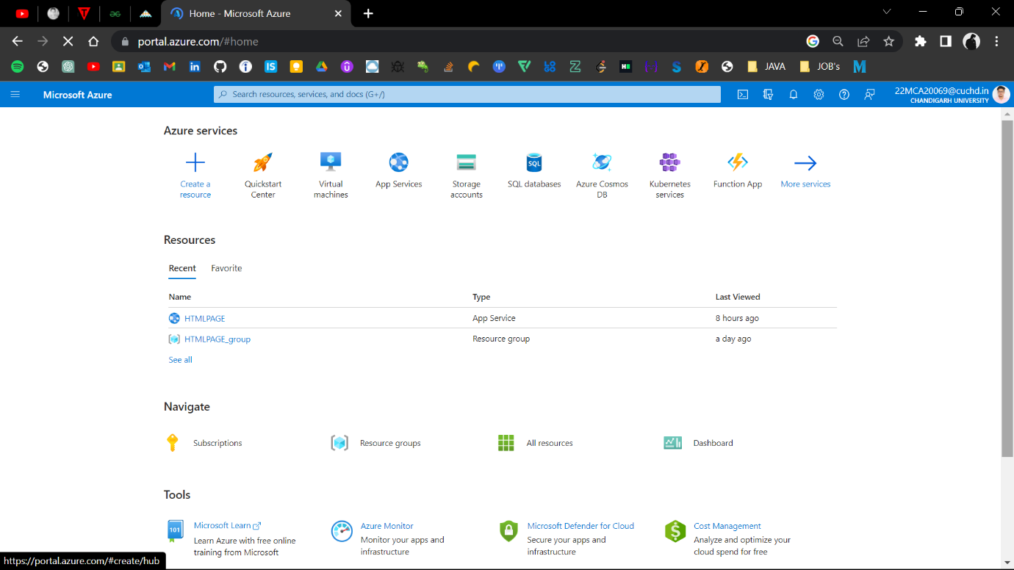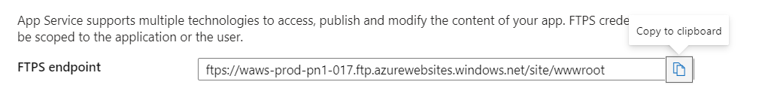

**Thankyou**