**SRI GURU GOBIND SINGH COLLEGE**

**SECTOR-26, CHANDIGARH**

**(Affiliated To Punjab University, Chandigarh)**



**PROJECT REPORT**

**ON**

**“BhattsLab”**

**(Website for walk with Nature)**

**Bachelor of Computer Application**

**Session 2021-2022**

**Submitted to: Submitted by:**

**Ms Navneet Sandhu Sarthak Bhatt (7526)**

**Ms Neha Saini**

**ACKNOWLEDGEMENT**

“We bow our head to the almighty God who gave us the strength and wisdom due to which we have been able to complete this project successfully”.

We express our sincere thanks and indebtedness to our esteemed institution **S.G.G.S College sector-26, Chandigarh** which has provided us an opportunity to fulfil our desire and reach our goals.

First, we would like to thank **Ms Navneet Sandhu** and **Ms Neha Saini**, the guide of our project who helps in providing all the facilities required for project work.

On a moral personal note, our deepest appreciation and gratitude to our beloved parents, who have been a fountain of inspiration and have provided unrelenting encouragement and support.

We heartily thank to all those who have helped us directly or indirectly in the successful completion of this project.

**SARTHAK BHATT**

**PREFACE**

This project report is submitted in partial fulfilment of the requirements for the award of the degree of:

**“BACHELOR’s OF COMPUTER APPLICATION”**

This project report is prepared for the project completed during the course of **BCA**, Final year undertaken at **Sri Guru Gobind Singh College, Sector-26, Chandigarh** as a part of **BCA** curriculum as prescribed **by Panjab University, Chandigarh**. The project report includes some background information about the college and information about the services in which the college deals in.

The purpose of this is to assemble under one cover a sufficient body of knowledge about management and development of successful project.

This report is about the adaptation of the techniques of project development and reflects the practice and methods of this project.

**CERTIFICATE**

**“TO Whom It May Concern”**

This is to certify that the project has been submitted by **Sarthak Bhatt, BCA** final year student at **Sri Guru Gobind Singh College, Sector-26, Chandigarh**, Undertook, a project entitled “BhattsLab” which is a record of a bonafide work carried out by them under supervision of **Ms Navneet Sandhu** and **Ms Neha Saini**.

In our knowledge, this work has not been submitted, either in part or full, to any other University or institute for the award of degree.

They have been submitted the report in time. They had done good work and have fulfilled all the requirements.

**DATE:**

**Signature of Guide:**

**Ms Navneet Sandhu**

**Ms Neha Saini**

**Place: Chandigarh**

**S.G.G.S College, Sector-26**

**STUDENT DECLARATION**

I, **SARTHAK BHATT** of **BCA**, final year of **Sri Guru Gobind Singh College, Sector-26, Chandigarh.**

Hereby declare that our project entitled “BhattsLab” is our own work conducted under the supervision of our project in charge **Ms Navneet Sandhu** and **Ms Neha Saini**.

We have taken a keen interest and showed utmost sincerity and punctuality towards the completion of this project.

Hope my hard work will be admired by all.

**SARTHAK BHATT**

**TABLE OF CONTENT**

|  |  |  |  |
| --- | --- | --- | --- |
| **Sr. No** | **Description** | **Page count** | **Remarks** |
| 1. | Hyper Text Markup Language | 7-8 |  |
| 2. | Cascading Style Sheet | 9 |  |
| 4. | JavaScript | 11-12 |  |
| 5. | PHP | 13-15 |  |
| 6. | MySQL | 16-17 |  |
| 7. | Project description | 18 |  |
| 8. | Data flow diagram | 19 |  |
| 9. | Project Code | 20-22 |  |
| 10. | Sreenshots | 23-24 |  |
| 11. | Conclusion | 25 |  |
| 12. | Biblio-graphy | 26 |  |

**Hyper Text Markup Language (HTML)**

HTML is an acronym which stands for **Hyper Text Markup Language** which is used for creating web pages and web applications. Let's see what is meant by Hypertext Markup Language, and Web page.

**Hyper Text:** Hyper Text simply means "Text within Text." A text has a link within it, is a hypertext. Whenever you click on a link which brings you to a new webpage, you have clicked on a hypertext. Hyper Text is a way to link two or more web pages (HTML documents) with each other.

**Markup language:** A markup language is a computer language that is used to apply layout and formatting conventions to a text document. Markup language makes text more interactive and dynamic. It can turn text into images, tables, links, etc.

**Web Page:** A web page is a document which is commonly written in HTML and translated by a web browser. A web page can be identified by entering an URL. A Web page can be of the static or dynamic type. **With the help of HTML only, we can create static web pages**.

Hence, HTML is a markup language which is used for creating attractive web pages with the help of styling, and which looks in a nice format on a web browser. An HTML document is made of many HTML tags and each HTML tag contains different content.

**Example**

<!DOCTYPE html>  
<html>  
<head>  
<title>Page Title</title>  
</head>  
<body>  
<h1>My First Heading</h1>  
<p>My first paragraph.</p>  
</body>  
</html>

**Output**

My First Heading

My first paragraph.

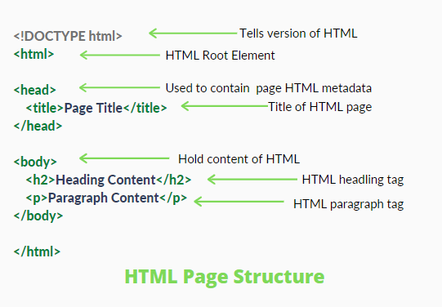

**Example Explained**

* The <!DOCTYPE html> declaration defines that this document is an HTML5 document
* The <html> element is the root element of an HTML page
* The <head> element contains meta information about the HTML page
* The <title> element specifies a title for the HTML page (which is shown in the browser's title bar or in the page's tab)
* The <body> element defines the document's body, and is a container for all the visible contents, such as headings, paragraphs, images, hyperlinks, tables, lists, etc.
* The <h1> element defines a large heading
* The <p> element defines a paragraph

**Features of HTML**

* It is a very **easy and simple language**. It can be easily understood and modified.
* It is very easy to make an **effective presentation** with HTML because it has a lot of formatting tags.
* It is a **markup language**, so it provides a flexible way to design web pages along with the text.
* It facilitates programmers to add a **link** on the web pages (by html anchor tag), so it enhances the interest of browsing of the user.
* It is **platform-independent** because it can be displayed on any platform like Windows, Linux, and Macintosh, etc.
* It facilitates the programmer to add **Graphics, Videos, and Sound** to the web pages which makes it more attractive and interactive.

**Cascading Style Sheet (CSS)**

CSS stands for Cascading Style Sheets. It is a style sheet language which is used to describe the look and formatting of a document written in markup language. It provides an additional feature to HTML. It is generally used with HTML to change the style of web pages and user interfaces. It can also be used with any kind of XML documents including plain XML, SVG and XUL.

CSS is used along with HTML and JavaScript in most websites to create user interfaces for web applications and user interfaces for many mobile applications.

**What does CSS do**

* You can add new looks to your old HTML documents.
* You can completely change the look of your website with only a few changes in CSS code.

**Why use CSS**

**Solves a big problem:** Before CSS, tags like font, color, background style, element alignments, border and size had to be repeated on every web page. This was a very long process. For example: If you are developing a large website where fonts and color information are added on every single page, it will be become a long and expensive process. CSS was created to solve this problem. It was a W3C recommendation.

**Saves a lot of time:** CSS style definitions are saved in external CSS files, so it is possible to change the entire website by changing just one file.

**Provide more attributes**: CSS provides more detailed attributes than plain HTML to define the look and feel of the website.

**Example**

<html>

<head>

<style>

h1 {

color: green;

text-align: center;

}

p {

font-family: Calibri (Body);

font-size: 20px;

}

</style>

</head>

<body>

<h1>My First CSS Example</h1>

<p>This is a paragraph.</p>

</body>

</html>

**Output**

**My First CSS Example**

This is a paragraph

**Features of HTML**

* **CSS saves time** − You can write CSS once and then reuse same sheet in multiple HTML pages. You can define a style for each HTML element and apply it to as many Web pages as you want.
* **Pages load faster** − If you are using CSS, you do not need to write HTML tag attributes every time. Just write one CSS rule of a tag and apply it to all the occurrences of that tag. So less code means faster download times.
* **Easy maintenance** − To make a global change, simply change the style, and all elements in all the web pages will be updated automatically.
* **Superior styles to HTML** − CSS has a much wider array of attributes than HTML, so you can give a far better look to your HTML page in comparison to HTML attributes.
* **Multiple Device Compatibility** − Style sheets allow content to be optimized for more than one type of device. By using the same HTML document, different versions of a website can be presented for handheld devices such as PDAs and cell phones or for printing.
* **Global web standards** − Now HTML attributes are being deprecated and it is being recommended to use CSS. So its a good idea to start using CSS in all the HTML pages to make them compatible to future browsers.

**JavaScript (JS)**

JavaScript (js) is a light-weight object-oriented programming language which is used by several websites for scripting the webpages. It is an interpreted, full-fledged programming language that enables dynamic interactivity on websites when applied to an HTML document. It was introduced in the year 1995 for adding programs to the webpages in the Netscape Navigator browser. Since then, it has been adopted by all other graphical web browsers. With JavaScript, users can build modern web applications to interact directly without reloading the page every time. The traditional website uses js to provide several forms of interactivity and simplicity.

Although, JavaScript has no connectivity with Java programming language. The name was suggested and provided in the times when Java was gaining popularity in the market. In addition to web browsers, databases such as CouchDB and MongoDB uses JavaScript as their scripting and query language.

Our **JavaScript Tutorial** is designed for beginners and professionals both. JavaScript is used to create client-side dynamic pages.

JavaScript is an object-based scripting language which is lightweight and cross-platform.

JavaScript is not a compiled language, but it is a translated language. The JavaScript Translator (embedded in the browser) is responsible for translating the JavaScript code for the web browser.

**Application of JavaScript**

* Client-side validation,
* Dynamic drop-down menus,
* Displaying date and time,
* Displaying pop-up windows and dialog boxes (like an alert dialog box, confirm dialog box and prompt dialog box),
* Displaying clocks etc

**Example**

<html>

<body>

<h2>Welcome to JavaScript</h2>

<script>

document.write("Hello JavaScript by JavaScript");

</script>

</body>

</html>

**Output**

**Welcome to JavaScript**

Hello JavaScript by JavaScript

**Features of JavaScript**

* All popular web browsers support JavaScript as they provide built-in execution environments.
* JavaScript follows the syntax and structure of the C programming language. Thus, it is a structured programming language.
* JavaScript is a weakly typed language, where certain types are implicitly cast (depending on the operation).
* JavaScript is an object-oriented programming language that uses prototypes rather than using classes for inheritance.
* It is a light-weighted and interpreted language and also a case sensitive language.
* It provides good control to the users over the web browsers.

**Hypertext Preprocessor (PHP)**

PHP is an open-source, interpreted, and object-oriented scripting language that can be executed at the server-side. PHP is well suited for web development. Therefore, it is used to develop web applications (an application that executes on the server and generates the dynamic page.).

PHP was created by **Rasmus Lerdorf in 1994** but appeared in the market in 1995. **PHP 7.4.0** is the latest version of PHP, which was released on **28 November**. Some important points need to be noticed about PHP are as followed:

* PHP stands for Hypertext Preprocessor.
* PHP is an interpreted language, i.e., there is no need for compilation.
* PHP is faster than other scripting languages, for example, ASP and JSP.
* PHP is a server-side scripting language, which is used to manage the dynamic content of the website.
* PHP can be embedded into HTML.
* PHP is an object-oriented language.
* PHP is an open-source scripting language.
* PHP is simple and easy to learn language.

**Why use PHP**

PHP is a server-side scripting language, which is used to design the dynamic web applications with MySQL database.

* It handles dynamic content, database as well as session tracking for the website.
* You can create sessions in PHP.
* It can access cookies variable and also set cookies.
* It helps to encrypt the data and apply validation.
* PHP supports several protocols such as HTTP, POP3, SNMP, LDAP, IMAP, and many more.
* Using PHP language, you can control the user to access some pages of your website.
* As PHP is easy to install and set up, this is the main reason why PHP is the best language to learn.
* PHP can handle the forms, such as - collect the data from users using forms, save it into the database, and return useful information to the user. **For example** - Registration form.

**To start using PHP, you can:**

* Find a web host with PHP and MySQL support
* Install a web server on your own PC, and then install PHP and MySQL
* Download and install WAMP, XAMPP Server.

**Example**

<html>

<head>

<title>PHP Example</title>

</head>

<body>

<?php echo "Hello, World! This is PHP code";?>

</body>

</html>

**Output**

Hello, World! This is PHP code

**PHP Features**

**Performance:** PHP script is executed much faster than those scripts which are written in other languages such as JSP and ASP. PHP uses its own memory, so the server workload and loading time is automatically reduced, which results in faster processing speed and better performance.

**Open Source:** PHP source code and software are freely available on the web. You can develop all the versions of PHP according to your requirement without paying any cost. All its components are free to download and use.

**Familiarity with syntax:** PHP has easily understandable syntax. Programmers are comfortable coding with it.

**Embedded:** PHP code can be easily embedded within HTML tags and script.

**Platform Independent:** PHP is available for WINDOWS, MAC, LINUX & UNIX operating system. A PHP application developed in one OS can be easily executed in other OS also.

**Database Support:** PHP supports all the leading databases such as MySQL, SQLite, ODBC, etc.

**Error Reporting:** PHP has predefined error reporting constants to generate an error notice or warning at runtime. E.g., E_ERROR, E_WARNING, E_STRICT, E_PARSE.

**Loosely Typed Language:** PHP allows us to use a variable without declaring its datatype. It will be taken automatically at the time of execution based on the type of data it contains on its value.

**Web servers Support:** PHP is compatible with almost all local servers used today like Apache, Netscape, Microsoft IIS, etc.

**Security:** PHP is a secure language to develop the website. It consists of multiple layers of security to prevent threads and malicious attacks.

**Control:** Different programming languages require long script or code, whereas PHP can do the same work in a few lines of code. It has maximum control over the websites like you can make changes easily whenever you want.

**A Helpful PHP Community:** It has a large community of developers who regularly updates documentation, tutorials, online help, and FAQs. Learning PHP from the communities is one of the significant benefits.

AD **MySQL**

Any SQL query is not basically related to performance, but when it comes to being used in big fields and its amount is to be very high, the issue regarding performance is always there. To cope up with these issues, the only way possible is that the query must itself tell what it is doing and how much time it is consuming to do that task. And when any data-analysts know about its working, then they may be able to optimize that query a lot.

In SQL, EXPLAIN keyword provides a description of how the SQL queries are executed by the databases. These descriptions include the optimizer logs, how tables are joined and in which order etc.

Hence, it would be a beneficial tool in query optimization and knowing the details of its execution step by step. EXPLAIN also takes care of the fact that a user who doesn’t have any access to a particular database, will not be provided details about how it executes the queries. Hence, it maintains security.

The main thing to note about EXPLAIN is that it will be used at the beginning of the query i.e before SELECT, INSERT, UPDATE, etc.

**Syntax**

EXPLAIN (QUERY Statement) ; /* ONLY TAKES COMMAND AS PARAMETER */

**Example**

Let’s first create a database known as GFG using the below command:

**CREATE DATABASE GFG;**

Now add tables to it.

**SELECT * FROM gfgtable;**

Now let’s use EXPLAIN to get an explanation of any query beginning from a simpler one.

**QUERY1: EXPLAIN SELECT * FROM gfgtable;**

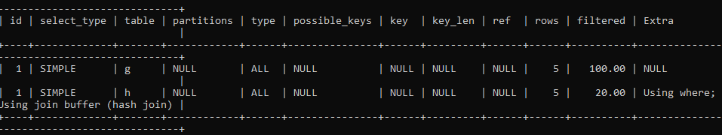

**Columns in the output of EXPLAIN Keyword:**

* **id**: It represents the id of the query which is to be explained.
* **SELECT_TYPE**: The complexity in the select clause is showed here. In the above case, it is very simple.
* **table**: The name of the Table used is displayed here.
* **Partitions**: This shows the number of partitions of the table joined in the query.
* **type**: It specifies the Join Type.
* **possible_keys**: Which keys could have been used.
* **key:** which keys are used.
* **key_len**: Length of the Key used.
* **ref**: Mentions any sort of references used in query while comparing columns or not.
* **rows**: The number of rows over which query acts.
* **Filtered**: The rows which are filtered using the conditions in the WHERE clause.
* **Extra**: Some additional details regarding the executed query.

In this way, EXPLAIN keyword is used to get all the information about the query and tabulate them so that they can be stored in DB for further references.

**QUERY 2:**

**EXPLAIN**

**SELECT CONCAT(g.FirstName,g.LastName) AS FULLNAME**

**FROM gfgtable AS g, gfgtable AS h**

**WHERE g.Roll=h.Roll;**

**PROJECT DESCRIPTION**

Project Overview:

Project Name : BhattsLab

Project Type : Full stack Website

Languages Used : HTML, CSS, JS, PHP, MySQL

Server Used : Infinityfree.net

**SOFTWARE AND HARDWARE REQUIREMENTS**

**Software Requirements**:

* Windows OS
* XAMPP server
* Visual Studio Code

**Hardware Requirements**:

* **Operating System**: Window 7 or later.
* **Processor**: Intel Pentium 4 or later.
* **Memory**: 2 GB minimum, 4 GB recommended.
* **I/O Devices**: Monitor, Keyboard & mouse.
* **Internet Connection**: Fast Internet require.

**DATA FLOW DIAGRAM OF THE PROJECT**

**Project Code**

**Screenshots in Pc view**

**Home Page: (index.php).**

**Home Page: components.**

**Home Page: Unsplash images, Footer section.**

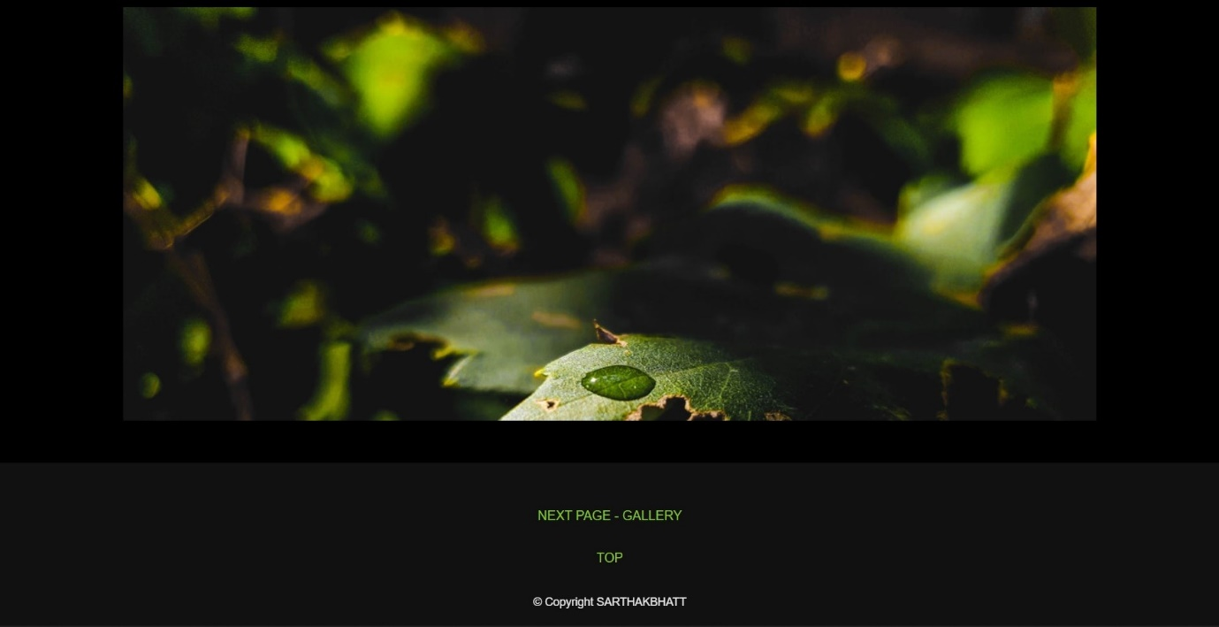

**Gallery Page: (gallery.php) Light box.**

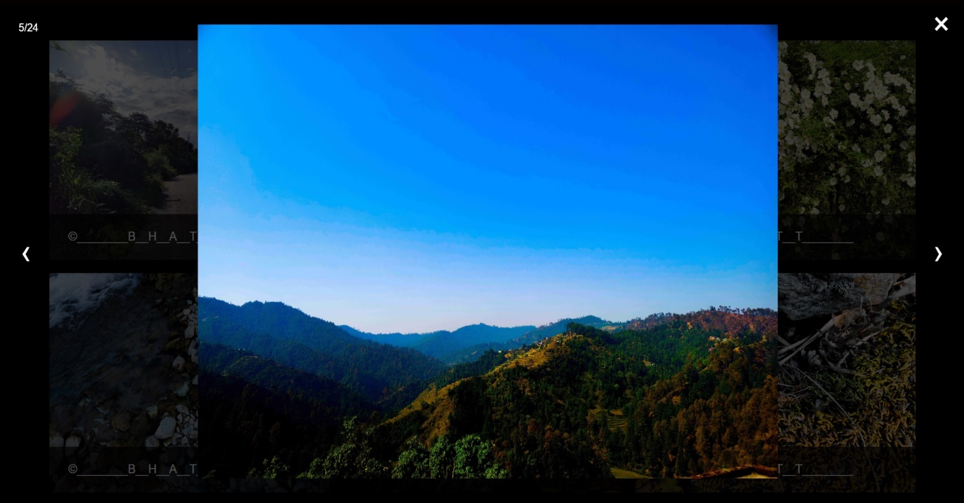

**Contact Page: (contact.php) Bio & Links.**

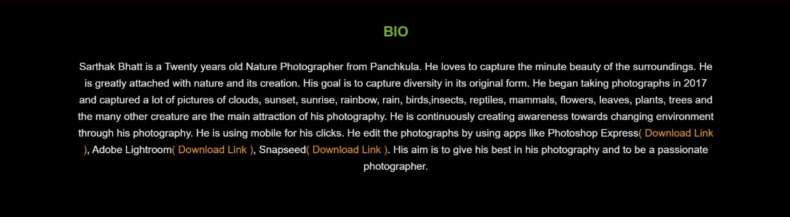

**Contact Page: Contact us / Map.**

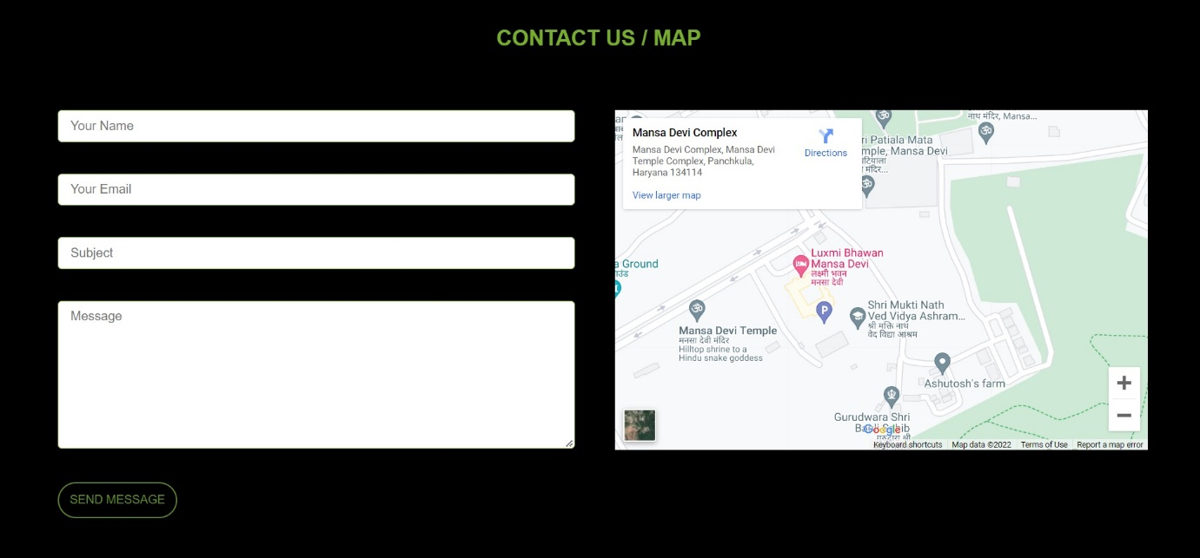

**Screenshots in Mobile view**

**Home Page: (index.php) & Navigation Menu.**

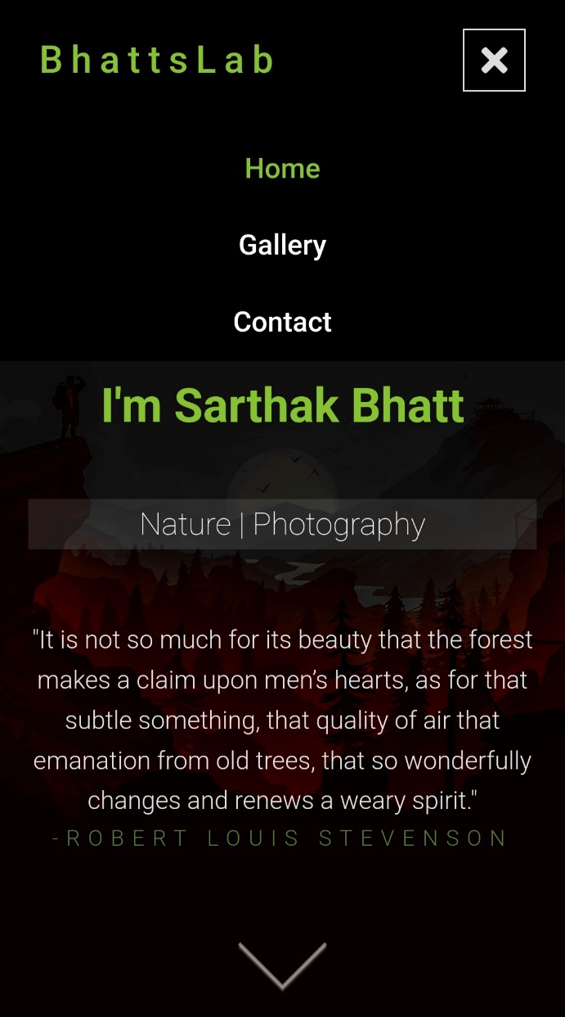

**Home Page: Sample images, Unsplash images, Footer section.**

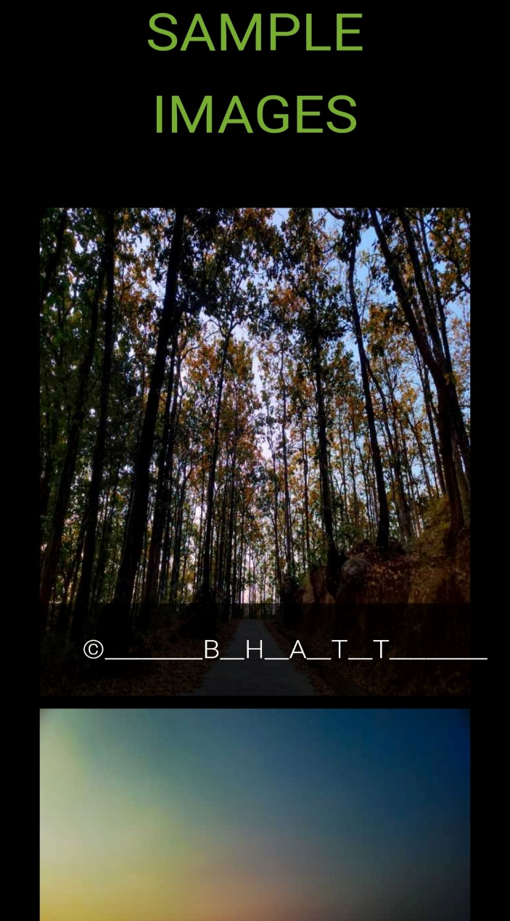

**Gallery Page: Pre-loader, Images.**

**Gallery Page: light box.**

**Contact Page: Bio & Links.**

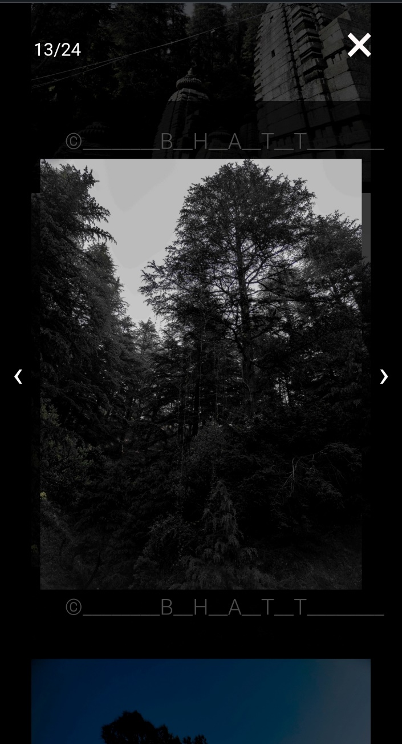

**Contact Page: Contact us / Map.**

**Conclusion**

The project that I undertook was truly very rewarding experience for me in more than one way. It has given me big thrust to my technical knowledge as prospective software professional. It has also helped me to enhance my skill in website development.

And I feel extremely satisfied by the fact that I managed to develop the project of course with equal contribution from my instructor or project guide.

I think, I have exploited the opportunities that come our way to the fullest extent by increasing my technical knowledge and also gaining the valuable work experience.

**BIBILIO-GRAPHY**

Books and websites are very helpful in understanding the requirements, development and maintenance of the project.

**BOOKS:**

* PHP: The complete reference
* Database system concepts

**Websites:**

* [**www.google.co.in**](http://www.google.co.in)
* **www.tutorialspoint.com**
* [**www.javatpoint.com**](http://www.javatpoint.com)
* [**www.geeksforgeeks.com**](http://www.geeksforgeeks.com)