**PYTHON PROGRAMMING (**BMI Calculator with Python**)**

NAME: Sarthak Bhatt UID:22MCA20069

CLASS: MCA-8 ’A’ PYTHON COMPLEX PROBLEM

* **BMI Calculator with Python:** The Body Mass Index or BMI is calculated from weight and height of a Person. It is obtained by dividing an individual’s weight in kilograms by their height in meters, then dividing the answer again by their height.
* **SOLUTION:**
* **CODE:**

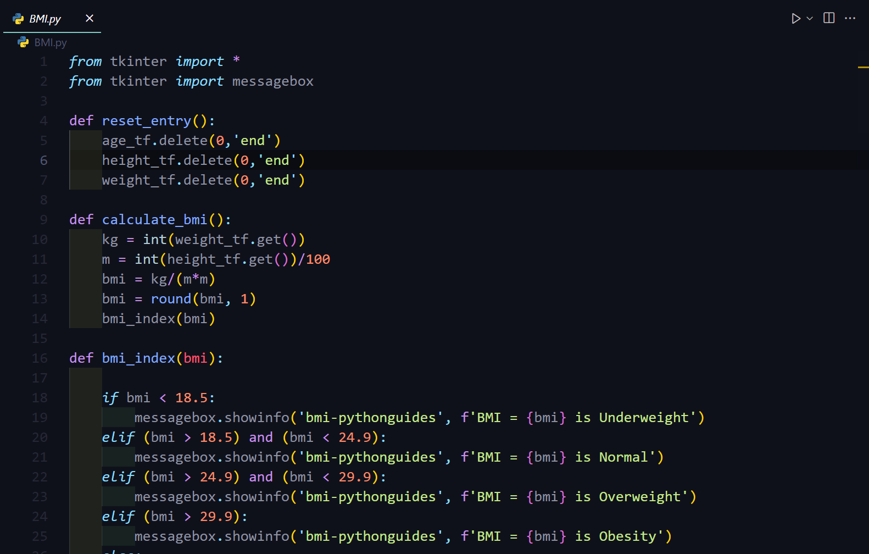

* **OUTPUT:**

**

**THANKYOU**